Supplementary information 2: Stepwise approach to horizon scanning for Invasive Alien Species used as part of a horizon scanning workshop (27-29 November 2019) to predict the arrival and establishment of Invasive Alien Species which have the potential to pose a threat to human health and / or economies within Cyprus. Forty-five experts worked within five thematic groups: plant species (terrestrial and freshwater), freshwater animals (fish and invertebrates), terrestrial invertebrates, terrestrial vertebrates and marine species (primary producers, invertebrates and vertebrates).

The chronological sequence outlined here is to guide and implement Horizon Scanning exercises based on expert consensus for the SBAs and wider island of Cyprus.
Core team
Helen Roy (Chair)
Jodey Peyton (Plant lead)
Elena Tricarico and Kelly Martinou (Freshwater animals leads – including mosquitoes)
Tim Adriaens and Wolfgang Rabitsch (Terrestrial invertebrates lead)
Tim Adriaens and Wolfgang Rabitsch (Terrestrial vertebrate lead)
Niki Chartosia and Voula Karachle (Marine leads)

Step-by-step guide
Step 1: Identify the scope of the exercise:
The scope of the exercise is outlined below:
- Impact: human health and agriculture. The focus will be on prioritising INNS for risk assessment so including consideration of negative impacts only. Species impacting biodiversity will not be considered as this was covered in the original horizon scanning exercise in 2017 – please see https://link.springer.com/article/10.1007/s10530-019-01961-7 for more details on this work.
- Species status within the region: the focus will be limited to species absent from the “wild” (that is beyond captivity or cultivation) within the region.
- Taxonomic breadth or breadth of functional groups: All species other than microoorganisms although diseases will be discussed and noted. It will be important to acknowledge gaps in expertise or information available.
- Geographic range: The focus of the horizon scan are the SBAs of Cyprus, but given the nature of the SBA borders, we will be considering the entire island. Defining the geographical scope for marine species should allow for the effects of major oceanic currents and periodic changes therein.
- Temporal range: limited to species likely to arrive within the next 10 years.

Step 2: Define the thematic groups to be considered and the expert teams for the assessment.
Distinct thematic groups will be terrestrial and freshwater botany, terrestrial and freshwater zoology and marine.
All groups will liaise where a species could be considered to cross thematic groups such as estuarine species, but mosquitoes will be assessed under freshwater animals. The number of experts in each group will vary and will reflect the inherent taxonomic complexities and the natural boundaries of expertise. Each thematic group will be led by an expert who will coordinate the activities of the group. Criteria for the choice of experts should include:
- In combination, the team should be expected to create a comprehensive list of candidate species for their group;
- Every expert should be willing and able to assess all the species on the list they compile while being able to indicate the level of knowledge/uncertainty for each assessment. We recognise that all experts will not have appropriate levels of expertise in all taxa covered by the group but we hope through the discussions that experts will be able to contrast species on the basis of the information provided by the group.

Step 3: The criteria to select species.
The 2017 taxon list will be assessed in the first instance and species impacting human health and economy selected from this list. We will supplement this list with species assessed to impact human health and economy in Gibraltar in a recent horizon scanning workshop (Roy et al. 2019).
When selecting species the following criteria could be useful:
- Present in an adjacent country, region or biogeographical area, connected to the focal area by a direct and feasible dispersal route
- Present in a region with comparable climatic conditions to the focal area
- A history of (recent) invasiveness and impact on the focal concern (e.g. ecosystem services, social and economic impacts)
- Present in an area with strong trade or travel links with the focal area that provide a realistic potential invasion pathway.
Step 4: Parameters for the assessment of selected species.
Parameters to score (all scored on a 1 to 5 scale, with the end-points (1 and 5) either being “highly unlikely” and “highly likely” [arrival & establishment], or “minimal” and “massive” [impacts]):
- Likelihood of arrival.
- Likelihood of establishment. This will reflect what is known about both the fundamental ecology of the IAS and the nature of the recipient habitats and environment.
- Impact of IAS (likelihood and severity), with specific consideration of the following negative impacts
- Impact on human health
- Impact on economy (where relevant)
Guidelines will be provided for the scoring within a spreadsheet.

Step 5: Compile lists of species to consider for prioritization within each group
Experts will be asked to compile lists of species for assessment by the wider thematic group using resources including available databases, but also primary and grey literature and in some cases their own knowledge. Basic factual information should be assembled for each species: taxonomy, functional role, native range, most likely invasion pathway, etc. Sources of information and brief justifications should be provided for each species proposed.

Step 6: Score, re-score and combine.
- Each expert should receive the combined list from their thematic group leader to score independently.
- Scores from all experts should be circulated within the thematic group, so that everyone has a chance to re-consider their own scores, however it is useful to have the original scores retained for subsequent reporting. The Delphi approach can be used during this phase as a structured method for group scoring.
- Team leaders receive the revised scores from all team members and summarize them. Summary scores should reflect a central moment measure (mean, median, mode) and a measure of variation indicating level of agreement within the group. Ideally there will be three scores for each species with corresponding levels of confidence from the scoring experts.
We recognize the scoring system could be more complex, but suggest that the relatively high levels of uncertainty underlying horizon scanning argues against rigorous mathematical treatments, and also that the same uncertainties are accounted for in subsequent consensus discussions.

Step 7: A consensus workshop
Each thematic group brings a consolidated and combined list for their group, ranked according to scores, to the workshop. At the workshop:
- Thematic group leaders introduce the species that their group has collated and the reasoning for the order/ranking given.
- Groups discuss their scores in the context of score, and the reasoning for them, presented by other groups
- Groups have the opportunity to revise scores according to the results of the above discussion.
- Group lists are combined into an overall list according to scores.
- The whole plenum is invited to challenge the rankings in the overall list and the responsible team is asked to defend the ranking of “their species” in the overall list. From this point onward, the rank positions of individual species are argued in relation to those of other species rather than on the basis of original or modified scores. These discussions should consider the confidence that proposing teams have in their rankings.
- Rankings of individual species are adjusted following these discussions.
- Consensus is reached amongst the workshop participants on a final ranked list of species.
One should recognize that it will not always be possibly to differentiate between priorities for individual species, but that groups (e.g. 11 – 20, 21 – 30) would still be useful to stakeholders.

Step 8: Collate the outcome of the workshop into a priority list for stakeholders including all the meta-data compiled through Steps 4 and 5.
Overview of the process
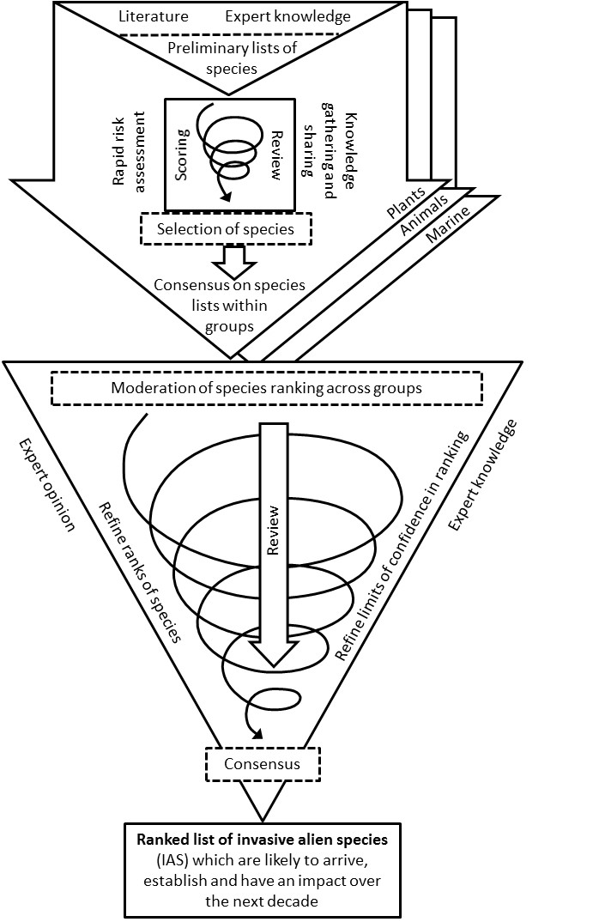
Figure 1 Horizon scanning process, based on consensus method (Sutherland et al. 2011), to derive a ranked list of IAS which are likely to arrive, establish and have an impact over the next decade. The process involves two distinct phases: preliminary consultation between experts within three expert groups (upper arrows) and consensus-building across expert groups (lower triangle).

References for Supplementary Information 2
Roy, H. E., J. Peyton, D. C. Aldridge, T. Bantock, T. M. Blackburn, R. Britton, P. Clark, E. Cook, K. Dehnen-Schmutz, T. Dines, M. Dobson, F. Edwards, C. Harrower, M. C. Harvey, D. Minchin, D. G. Noble, D. Parrott, M. J. O. Pocock, C. D. Preston, S. Roy, A. Salisbury, K. Schonrogge, J. Sewell, R. H. Shaw, P. Stebbing, A. J. A. Stewart, and K. J. Walker. 2014. Horizon scanning for invasive alien species with the potential to threaten biodiversity in Great Britain. Global Change Biology 20:3859-3871.
Roy, H. E., J. Peyton, O. Pescott, and S. Rorke. 2019. Prioritising Invasive Non-Native Species through Horizon Scanning on the UK Overseas Territories. Centre for Ecology & Hydrology, Crowmarsh Gifford, Oxfordshire, OX10 8BB, UK.
Sutherland, W. J., E. Fleishman, M. B. Mascia, J. Pretty, and M. A. Rudd. 2011. Methods for collaboratively identifying research priorities and emerging issues in science and policy. Methods in Ecology and Evolution 2:238-247.

