1. Monosaccharide composition and infrared spectrum analysis of Schisandra chinensis polysaccharide
1.1 Monosaccharide composition of SCP
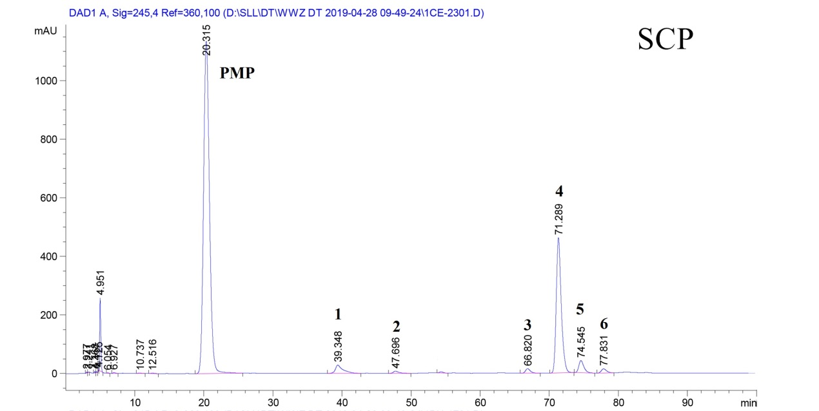
Figure 1. Monosaccharide composition of SCP. Peak 1: D-glucosamine, Peak 2: rhamnose, Peak 3: glucose, Peak 4: D-galactose, Peak 5: D-xylose, Peak 6: D-arabinose.
1.2 Infrared spectrum analysis of SCP
According to the infrared spectrum of SCP in 400 to 4000 cm⁻¹, as shown in Figure 2. The results showed that 3408 cm⁻¹ was the stretching vibration peak of O-H, 2933 cm⁻¹ was the stretching vibration peak of C-H such as sugars CH₃, CH₂ and CH; the absorption peak of 1700-1500 cm⁻¹ was caused by symmetric and asymmetric stretching vibration of C = O; the absorption peak of 1746 cm-1 indicated that the polysaccharide might have uronic acid structure; 1 650-1 500 cm⁻¹ was the stretching vibration peak of C-H There was a strong absorption peak at 550 cm⁻¹, which was the stretching vibration of C = O and the asymmetric stretching vibration of C = O. The polysaccharide may contain - COOH, indicating that it contains acidic polysaccharide; Schisandra chinensis polysaccharide has 834 cm⁻¹ and 892 cm⁻¹ characteristic absorption peaks, indicating that it may contain α - and β - configuration polysaccharides. The absorption peak of 1200-850 cm⁻¹ indicated that the polysaccharide may contain proteoglycan.
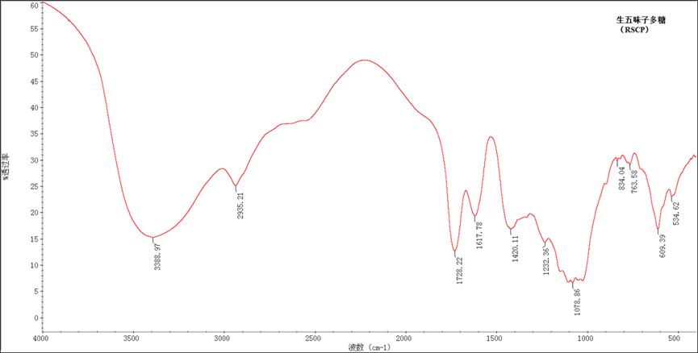
Figure 2 Infrared spectrum analysis of Schisandra chinensis polysaccharide
2. Western blot analyses
Colon tissues (100 mg each) were homogenized in ice-cold lysis buffer (RIPA, 1 mM PMSF, PMSF/RIPA=1/100). Homogenates were centrifuged at 12,000 × g for 15 min at 4 °C. The supernatants were collected and centrifuged again, and the final supernatants were collected for the detection of IL-1β, IL-10, IL-23,TNF-α and IFN-γ. Nuclear and cytoplasmic extracts for western blotting were obtained by using a nuclear/cytoplasmic isolation kit (Solarbio® Biotechnology, Beijing, China). Protein levels were determined using the BCA Protein Assay Kit (Thermo Fisher, 23227). Samples (50 μg each) were separated by denaturing SDS-PAGE and collected on a PVDF membrane (0.45 μm, Merck Millipore, USA) by electrophoretic transfer (Mini-Protean® 3 Cell, Bio-Rad, USA). The membrane was pre-blocked with 5% BSA and 0.1% Tween-20 in Tris-buffered saline (TBST) and incubated overnight with the primary antibody (in TBST with 5% BSA). Each membrane was washed three times for 30 min and incubated with the secondary horseradish peroxidase-linked antibodies (Affbiotech, USA). Quantitation of detected bands was performed with the ImageQuantTM TL analysis software (General Electric, USA). To correlate protein loading, the blots were analyzed for β-actin expression using an anti-β-actin antibody (Proteintech Group, Inc，20536-1-AP，1：10000). Each density was normalized using each corresponding β-actin density as an internal control and averaged from three samples. The density of the control was set at 1.0 to compare other groups.
3. Microbial diversity analysis
3.1 DNA extraction and PCR amplification
Microbial DNA was extracted from 34 samples using the E.Z.N.A.® soil DNA Kit (Omega Bio-tek, Norcross, GA, U.S.) according to the manufacturer’s protocols. The final DNA concentration and purification were determined by NanoDrop 2000 UV-vis spectrophotometer (Thermo Scientific, Wilmington, USA), and DNA quality was checked by 1% agarose gel electrophoresis. The V3-V4 hypervariable regions of the bacteria 16S rRNA gene were amplified with primers 338F (5’- ACTCCTACGGGAGGCAGCAG-3’) and 806R (5’-GGACTACHVGGGTWTCTAAT-3’) by thermocycler PCR system (GeneAmp 9700, ABI, USA). The PCR reactions were conducted using the following program: 3 min of denaturation at 95 °C, 27 cycles of 30 s at 95 °C, 30s for annealing at 55 °C, and 45s for elongation at 72 °C, and a final extension at 72 °C for 10 min. PCR reactions were performed in triplicate 20 μL mixture containing 4 μL of 5 × FastPfu Buffer, 2 μL of 2.5 mM dNTPs, 0.8 μL of each primer (5 μM), 0.4 μL of FastPfu Polymerase and 10 ng of template DNA. The resulted PCR products were extracted from a 2% agarose gel and further purified using the AxyPrep DNA Gel Extraction Kit (Axygen Biosciences, Union City, CA, USA) and quantified using QuantiFluor™-ST (Promega, USA) according to the manufacturer’s protocol.
3.2 Illumina MiSeq sequencing
Purified amplicons were pooled in equimolar and paired-end sequenced (2 × 300) on an Illumina MiSeq platform (Illumina, San Diego, USA) according to the standard protocols by Majorbio Bio-Pharm Technology Co. Ltd. (Shanghai, China).
3.3 Processing of sequencing data
Raw fastq files were quality-filtered by Trimmomatic and merged by FLASH with the following criteria: (i) The reads were truncated at any site receiving an average quality score <20 over a 50 bp sliding window. (ii) Sequences whose overlap being longer than 10 bp were merged according to their overlap with mismatch no more than 2 bp. (iii) Sequences of each sample were separated according to barcodes (exactly matching) and Primers (allowing 2 nucleotide mismatching), and reads containing ambiguous bases were removed.
Operational taxonomic units (OTUs) were clustered with 97% similarity cutoff using UPARSE (version 7.1 http://drive5.com/uparse/) with a novel ‘greedy’ algorithm that performs chimera filtering and OTU clustering simultaneously. The taxonomy of each 16S rRNA gene sequence was analyzed by the RDP Classifier algorithm (http://rdp.cme.msu.edu/) against the Silva (SSU123) 16S rRNA database using the confidence threshold of 70%.
4. Representative total ion flow diagram for GC-MS quantitative analysis of SCFAs
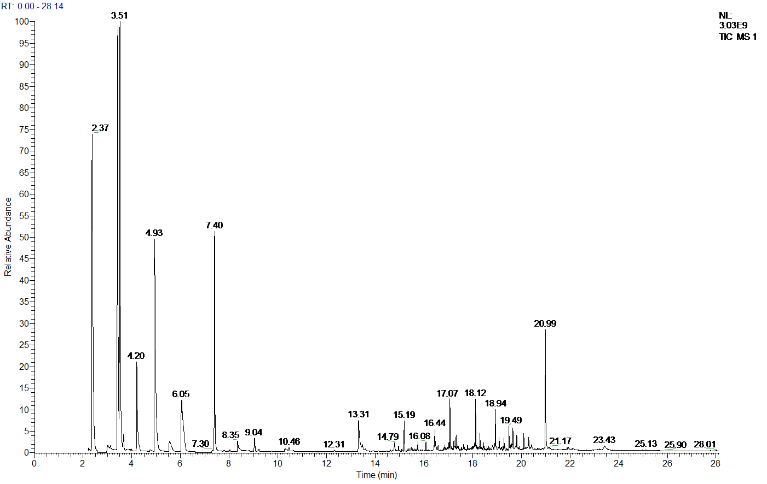
Figure 3 Total ion current diagram of mixed standard of six kinds of SCFAs
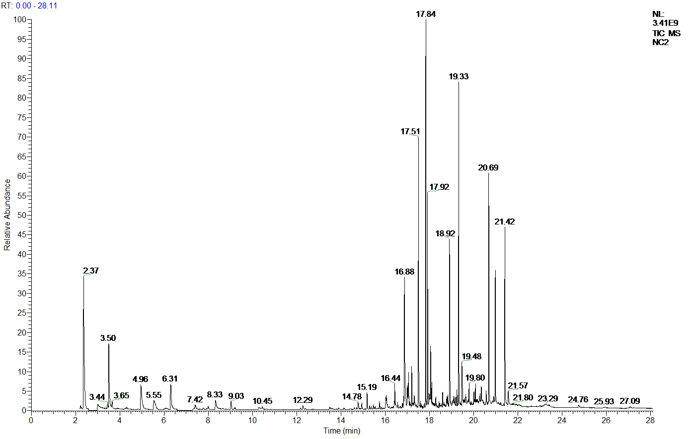
Figure 4 Total ion current diagram of mixed standard of NC group
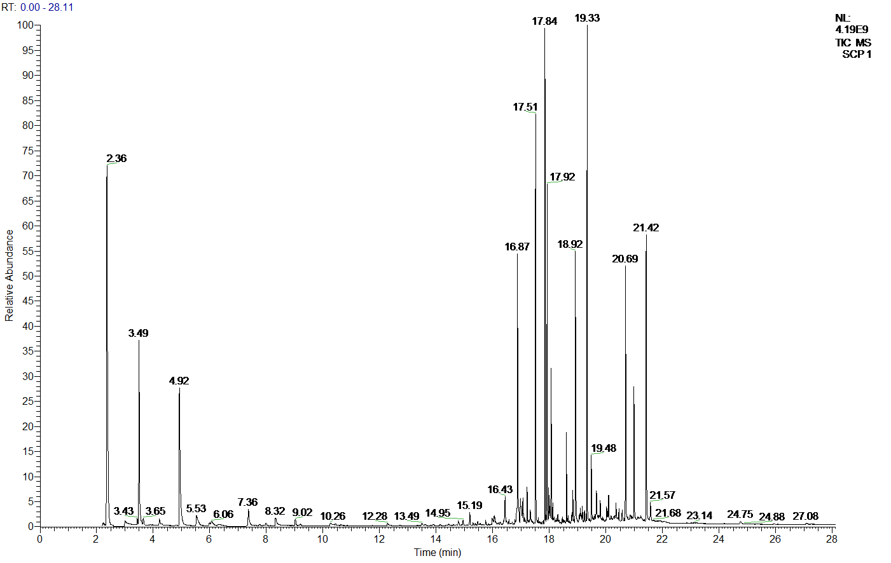
Figure 5 Total ion current diagram of mixed standard of SCP group

