Supplementary Material

Supplementary Data
1. The Campanian Ignimbrite stratigraphy
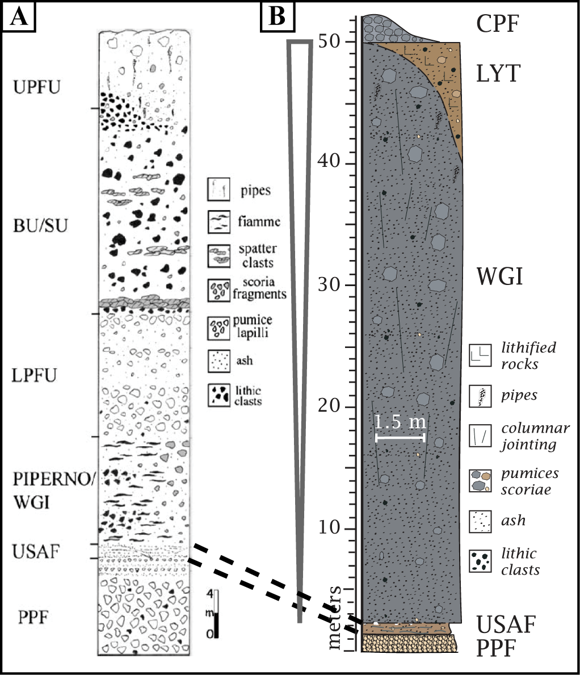
Figure 1. Reconstructed stratigraphy of CI proximal (Fedele et al., 2008) (A) and distal (B) deposits. BU: Breccia Unit; CPF: Coarse Pumice Flow; LPFU: Lower Pumice Fallout; LYT: Lithified Yellow Tuff; PPF: Plinian Pumice Fallout; SU: Spatter Unit; UPFU: Upper Pumice Flow Unit; USAF: Unconsolidated Stratified Ash Flow; WGI: Welded Gray Ignimbrite.

2. Literature and field data
Data from literature inserted into the GIS database are reported in Table 1. Moreover, other papers were used for geological sketches, proximal area isopach maps and isopleths maps (Ortolani and Aprile, 1985; Incoronato and Nardi, 1987; Scandone et al., 1991; Bellucci, 1994; Signorelli et al., 1999; Fedele et al., 2002; Aprile et al., 2004; Fowler et al., 2007; Milia and Torrente, 2007; Giaccio et al., 2008; Pappalardo et al., 2008; Arienzo et al., 2009, 2011; de Vivo et al., 2010; Fedele et al., 2016; Scarpati and Perrotta, 2016; Smith et al., 2016). Outcrops location are reported in Table 2.
ID | Paper | Latitude (°) | Longitude (°) | Thickness (m) | Name
1 | Barberi et al. (1978) | 41.05698 | 14.33346 | 14.9 | S. Nicola La Strada
2 | Barberi et al. (1978) | 41.05573 | 14.70687 | 15.5 | Tufara
3 | Barberi et al. (1978) | 40.94861 | 14.56534 | 41.0 | Tufino
4 | Cappelletti et al. (2003) | 41.06165 | 14.42083 | 7.0 | Balzarama
5 | Cappelletti et al. (2003) | 41.11082 | 14.47346 | 8.3 | Dugenta
6 | Cappelletti et al. (2003) | 40.94280 | 14.60260 | 12.1 | La schiava
7 | Cappelletti et al. (2003) | 41.23293 | 14.50691 | 4.3 | Faicchio
8 | Cappelletti et al. (2003) | 40.77209 | 14.66155 | 20.9 | Castel San Giorgio
9 | Cappelletti et al. (2003) | 40.95816 | 15.00003 | 7.1 | San Mango S. C.
10 | De Vivo et al. (2001) | 40.94472 | 14.16421 | 19.6 | Giugliano
11 | De Vivo et al. (2001) | 40,93534 | 14,56743 | 3.8 | Taurano
12 | De Vivo et al. (2001) | 41.17565 | 14.49265 | 10.1 | Sant'Agata dei Goti
13 | De Vivo et al. (2001) | 41.06337 | 14.70339 | 10.6 | Altavilla
14 | De Vivo et al. (2001) | 40.97126 | 14.54410 | 10.7 | Tufino
15 | De Vivo et al. (2001) | 40.95244 | 14.55400 | 10.1 | Sperone
16 | De Vivo et al. (2001) | 40.87905 | 14.29606 | 8.9 | Ponti Rossi
17 | De Vivo et al. (2001) | 40.88207 | 14.31975 | 5.1 | Poggioreale
18 | De Vivo et al. (2001) | 40.79846 | 14.04573 | 9.0 | Monte di Procida
19 | De Vivo et al. (2001) | 40.62828 | 14.37821 | 10.3 | Sant'Agnello
20 | De Vivo et al. (2001) | 40.87633 | 14.34249 | 6.8 | Arpino
21 | De Vivo et al. (2001) | 40.54981 | 14.23133 | 10.4 | Capri
22 | L. Fedele et al. (2008) | 40.76367 | 14.03370 | 9.8 | Punta della lingua
23 | L. Fedele et al. (2008) | 40.76784 | 14.01611 | 27.0 | Scotto di Carlo
24 | L. Fedele et al. (2008) | 40.79131 | 14.05739 | 25.7 | Monte di Procida
25 | L. Fedele et al. (2008) | 40.84665 | 14.05135 | 10.2 | Cuma
26 | L. Fedele et al. (2008) | 40.89064 | 14.07671 | 6.0 | San Severino
27 | L. Fedele et al. (2008) | 40.88900 | 14.10608 | 17.0 | Spinelli
28 | L. Fedele et al. (2008) | 40.90952 | 14.09640 | 14.0 | Zaccaria
29 | L. Fedele et al. (2008) | 40.92155 | 14.11957 | 24.0 | Qualiano
30 | L. Fedele et al. (2008) | 40.90092 | 14.14108 | 18.9 | Punta Marmolite
31 | L. Fedele et al. (2008) | 40.88169 | 14.16774 | 5.1 | Quarto
32 | L. Fedele et al. (2008) | 40.85687 | 14.18742 | 72.0 | Camaldoli
33 | L. Fedele et al. (2008) | 40.84269 | 14.22948 | 7.4 | San Martino Hill
34 | L. Fedele et al. (2008) | 40.85087 | 14.23347 | 9.1 | Montesanto
35 | L. Fedele et al. (2008) | 40.86016 | 14.22790 | 6.1 | Fontanelle
36 | L. Fedele et al. (2008) | 40.87866 | 14.25874 | 4.5 | Ponti Rossi
37 | L. Fedele et al. (2008) | 40.88394 | 14.27807 | 14.0 | Santa Maria del pianto
38 | Giaccio et al. (2006) | 40.86797 | 14.85653 | 13.1 | Serino
39 | Langella et al. (2013) | 40.88284 | 14.66613 | 3.6 | Moschiano
40 | Langella et al. (2013) | 41.06646 | 14.71668 | 3.7 | Tufara
41 | Langella et al. (2013) | 40.70136 | 14.62501 | 8.8 | Pucara
42 | Langella et al. (2013) | 40.69312 | 14.83241 | 8.2 | Torrente Sordina
43 | Langella et al. (2013) | 41.36129 | 13.86913 | 7.2 | Mortola
44 | Langella et al. (2013) | 40.60310 | 14.35675 | 2.4 | Monticchio
45 | Langella et al. (2013) | 41.12660 | 14.45214 | 8.2 | Dugenta
46 | Langella et al. (2013) | 41.07085 | 14.39716 | 6.5 | Balzarama
47 | Langella et al. (2013) | 41.04894 | 14.38355 | 11.6 | Maddaloni
48 | Langella et al. (2013) | 41.01588 | 14.75955 | 12.1 | Altavilla
49 | Langella et al. (2013) | 40.95232 | 14.58959 | 12.0 | La schiava
50 | Langella et al. (2013) | 41.09617 | 14.45043 | 3.9 | S. Agata dei Goti
51 | Melluso et al. (1995) | 40.84929 | 14.04881 | 15.6 | Cuma
52 | Melluso et al. (1995) | 40.79063 | 14.04569 | 20.1 | Marina di Vitafumo
53 | Melluso et al. (1995) | 40.76432 | 14.03661 | 13.5 | Punta della lingua
54 | Melluso et al. (1995) | 40.76609 | 14.02101 | 23.6 | Scotto di Carlo
55 | Melluso et al. (1995) | 40.76252 | 14.00877 | 10.1 | Cimitero
56 | Milia et al. (2003) | 40.77427 | 14.43946 | 25.2 | Trecase
57 | Orsi and Rosi (1991) | 40.89444 | 14.13328 | 16.0 | Punta Marmolite
58 | Orsi and Rosi (1991) | 40.84473 | 14.04803 | 13.7 | Cuma
59 | Orsi and Rosi (1991) | 40.79548 | 14.04394 | 9.7 | Monte di Procida
60 | Orsi and Rosi (1991) | 40.71367 | 13.95586 | 1.3 | Ischia grotte di terra
61 | Orsi and Rosi (1991) | 40.74482 | 13.99483 | 5.3 | Vivara
62 | Orsi and Rosi (1991) | 40.76353 | 14.01032 | 10.2 | Procida Pozzo vecchio
63 | Orsi and Rosi (1991) | 40.76622 | 14.02152 | 19.8 | Procida scoglio cannone
64 | Orsi and Rosi (1991) | 40.76470 | 14.03672 | 17.2 | Procida Punta della lingua
65 | Orsi and Rosi (1991) | 40.78996 | 14.04678 | 28.5 | Marina di Vitafumo
66 | Orsi and Rosi (1991) | 40.80904 | 14.04393 | 19.5 | Torregaveta
67 | Orsi and Rosi (1991) | 40.87962 | 14.07540 | 5.6 | San Severino
68 | Orsi and Rosi (1991) | 40.85386 | 14.19331 | 79.2 | Camaldoli
69 | Orsi and Rosi (1991) | 40.95268 | 14.11209 | 30.4 | Scarafea
70 | Orsi and Rosi (1991) | 40.87458 | 14.26099 | 8.0 | Ponti Rossi
71 | Orsi and Rosi (1991) | 40.65581 | 14.43023 | 7.6 | Vico Equense
72 | Orsi and Rosi (1991) | 40.92946 | 14.70306 | 0.7 | Acqua Fidia
73 | Orsi and Rosi (1991) | 41.26809 | 14.03841 | 1.6 | Furnolo
74 | Orsi and Rosi (1991) | 41.12338 | 13.90684 | 2.6 | Mondragone
75 | Orsi and Rosi (1991) | 40.71908 | 14.78138 | 0.3 | Pellezzano
76 | Orsi and Rosi (1991) | 41.29998 | 13.99325 | 0.9 | Roccamonfina
77 | Orsi and Rosi (1991) | 41.22075 | 14.12802 | 0.8 | Visciano
78 | Orsi and Rosi (1991) | 41.27260 | 14.52178 | 8.6 | Massa
79 | Orsi et al. (1996) | 40.85020 | 14.20771 | 80.0 | Verdolino Valley
80 | Orsi et al. (1996) | 40.84979 | 14.19188 | 80.0 | Torre di Franco
81 | Orsi et al. (1996) | 40.87559 | 14.31236 | 26.0 | 66
82 | Orsi et al. (1996) | 40.87037 | 14.30095 | 15.3 | 67
83 | Orsi et al. (1996) | 40.87446 | 14.29572 | 48.1 | 4
84 | Orsi et al. (1996) | 40.87704 | 14.29033 | 8.9 | 61
85 | Orsi et al. (1996) | 40.88727 | 14.29953 | 12.4 | 65
86 | Orsi et al. (1996) | 40.87741 | 14.26781 | 30.0 | 51
87 | Orsi et al. (1996) | 40.87480 | 14.24930 | 33.0 | 46
88 | Orsi et al. (1996) | 40.87765 | 14.22415 | 33.1 | 36
89 | Orsi et al. (1996) | 40.90006 | 14.22256 | 28.9 | 34
90 | Orsi et al. (1996) | 40.90738 | 14.24090 | 8.6 | 44
91 | Orsi et al. (1996) | 40.90336 | 14.26784 | 57.2 | 49
92 | Orsi et al. (1996) | 40.84838 | 14.05607 | 15.0 | Cuma
93 | Orsi et al. (1996) | 40.86702 | 14.26767 | 6.0 | Ponti Rossi
94 | Orsi et al. (1996) | 40.87882 | 14.08267 | 17.0 | San Severino
95 | Orsi et al. (1996) | 40.86954 | 14.30927 | 4.0 | Sant'Arpino
96 | Orsi et al. (1996) | 40.88741 | 14.15640 | 18.2 | Trefola
97 | Ort et al. (2003) | 41.01429 | 14.76629 | 34.8 | Altavilla
98 | Ort et al. (2003) | 41.27794 | 14.53083 | 12.5 | Massa
99 | Ort et al. (2003) | 41.13269 | 13.89663 | 6.1 | Mondragone
100 | Pappalardo et al. (2002) | 40.87216 | 14.26782 | 30.1 | Ponti Rossi
101 | Perrotta et al. (2006) | 40.83247 | 14.24658 | 0.0 | 8
102 | Perrotta et al. (2006) | 40.83744 | 14.22889 | 0.0 | 1
103 | Perrotta et al. (2006) | 40.83885 | 14.23355 | 0.0 | 2
104 | Perrotta et al. (2006) | 40.84008 | 14.23731 | 0.0 | 3
105 | Perrotta et al. (2006) | 40.84207 | 14.24123 | 14.4 | 4
106 | Perrotta et al. (2006) | 40.84634 | 14.24016 | 15.5 | 5
107 | Perrotta et al. (2006) | 40.86076 | 14.23170 | 6.2 | 6
108 | Perrotta et al. (2006) | 40.85981 | 14.23585 | 2.0 | I
109 | Perrotta et al. (2006) | 40.83756 | 14.24999 | 10.0 | II
110 | Perrotta et al. (2006) | 40.83270 | 14.24157 | 21.7 | III
111 | Perrotta et al. (2010) | 40.81133 | 14.07042 | 0.0 | 10
112 | Perrotta et al. (2010) | 40.80816 | 14.04338 | 5.6 | 11
113 | Perrotta et al. (2010) | 40.79909 | 14.03731 | 5.6 | 12
114 | Perrotta et al. (2010) | 40.79504 | 14.04368 | 5.6 | 13
115 | Perrotta et al. (2010) | 40.78831 | 14.05603 | 2.9 | 14
116 | Perrotta et al. (2010) | 40.78932 | 14.06303 | 0.9 | 15
117 | Perrotta et al. (2010) | 40.75982 | 14.02430 | 7.4 | 1
118 | Perrotta et al. (2010) | 40.75991 | 14.03198 | 0.0 | 2
119 | Perrotta et al. (2010) | 40.76759 | 14.01905 | 26.3 | 3
120 | Perrotta et al. (2010) | 40.76807 | 14.00989 | 0.0 | 4
121 | Perrotta et al. (2010) | 40.76457 | 14.01012 | 9.2 | 5
122 | Perrotta et al. (2010) | 40.76275 | 14.00877 | 9.8 | 6
123 | Perrotta et al. (2010) | 40.76039 | 14.00850 | 3.0 | 7
124 | Perrotta et al. (2010) | 40.75873 | 14.00936 | 5.2 | 8
125 | Perrotta et al. (2010) | 40.74480 | 13.99123 | 2.1 | 9
126 | Rolandi et al. (2003) | 41.05877 | 14.42550 | 3.1 | Maddaloni
127 | Rolandi et al. (2003) | 41.06104 | 14.46361 | 14.7 | Durazzano
128 | Rolandi et al. (2003) | 40.89955 | 14.65636 | 4.9 | Taurano
129 | Rolandi et al. (2003) | 40.88146 | 14.68907 | 11.1 | Moschiano
130 | Rolandi et al. (2003) | 40.81916 | 14.67199 | 18.8 | Sarno
131 | Rolandi et al. (2003) | 40.80551 | 14.70470 | 7.7 | Siano
132 | Rolandi et al. (2003) | 40.78712 | 14.70638 | 34.4 | Castel San Giorgio
133 | Rolandi et al. (2003) | 40.66237 | 14.44305 | 15.5 | Seiano Valley
134 | Rolandi et al. (2003) | 40.62574 | 14.41407 | 9.9 | Piano di Sorrento
135 | Rolandi et al. (2003) | 40.76290 | 14.03357 | 20.5 | Punta della lingua
136 | Rolandi et al. (2003) | 40.79092 | 14.04556 | 22.0 | Marina di Vitafumo
137 | Rolandi et al. (2003) | 40.81290 | 14.04381 | 27.5 | Torregaveta
138 | Rolandi et al. (2003) | 40.78915 | 14.06432 | 3.0 | Miliscola
139 | Rolandi et al. (2003) | 40.84768 | 14.05100 | 15.4 | Cuma
140 | Rolandi et al. (2003) | 40.89771 | 14.14052 | 13.8 | Punta Marmolite
141 | Rolandi et al. (2003) | 40.85252 | 14.19673 | 58.2 | Camaldoli
142 | Rolandi et al. (2003) | 40.84307 | 14.21673 | 162.0 | Vomero
143 | Rolandi et al. (2003) | 40.84287 | 14.24107 | 17.8 | San Martino
144 | Rolandi et al. (2003) | 40.86743 | 14.27793 | 27.1 | Ponti Rossi
145 | Rolandi et al. (2003) | 40.87120 | 14.29386 | 26.3 | Poggioreale
146 | Rolandi et al. (2003) | 40.87720 | 14.31490 | 5.2 | Arpino
147 | Rolandi et al. (2003) | 40.83655 | 14.25039 | 43.0 | Palazzo Reale
148 | Rolandi et al. (2003) | 40.78112 | 14.44386 | 50.0 | Trecase
149 | Rosi et al. (1988) | 40.71199 | 13.96250 | 0.7 | Grotta di Terra
150 | Rosi et al. (1988) | 40.79707 | 14.04236 | 12.6 | Monte di Procida - 6
151 | Rosi et al. (1988) | 40.78973 | 14.05386 | 5.3 | Monte di Procida - 5
152 | Rosi et al. (1988) | 40.74315 | 13.99227 | 1.6 | Vivara - 2
153 | Rosi et al. (1988) | 40.76072 | 14.00861 | 5.0 | Procida - 3
154 | Rosi et al. (1988) | 40.76522 | 14.01056 | 11.7 | Procida - 4
155 | Rosi et al. (1996) | 40.71287 | 13.95659 | 1.3 | Ischia grotte di terra
156 | Rosi et al. (1996) | 40.74326 | 13.99649 | 5.5 | Vivara
157 | Rosi et al. (1996) | 40.76308 | 14.01249 | 11.0 | Pozzo vecchio
158 | Rosi et al. (1996) | 40.76653 | 14.02035 | 20.4 | Scoglio cannone
159 | Rosi et al. (1996) | 40.76444 | 14.03693 | 16.8 | Punta della lingua
160 | Rosi et al. (1996) | 40.78999 | 14.04661 | 26.6 | Vitafumo
161 | Rosi et al. (1996) | 40.81117 | 14.04389 | 21.0 | Torregaveta
162 | Rosi et al. (1996) | 40.84822 | 14.04739 | 15.1 | Cuma
163 | Rosi et al. (1996) | 40.88104 | 14.07809 | 5.2 | San Severino
164 | Rosi et al. (1996) | 40.89488 | 14.13404 | 21.5 | Punta Marmolite
165 | Rosi et al. (1996) | 40.85590 | 14.19588 | 77.2 | Camaldoli
166 | Rosi et al. (1996) | 40.95234 | 14.11780 | 26.3 | Scarafea
167 | Rosi et al. (1996) | 40.87618 | 14.26290 | 7.4 | Ponti Rossi
169 | Rosi and Sbrana (1987) | 40.85786 | 14.19574 | 25.0 | Camaldoli
170 | Rosi and Sbrana (1987) | 40.90527 | 14.14250 | 13.0 | Punta Marmolite
171 | Rosi and Sbrana (1987) | 40.88230 | 14.06558 | 1.1 | San Severino
172 | Sparice (2015) | 41.40636 | 13.98329 | 10.3 | Mignano Monte Lungo
173 | Sparice (2015) | 41.28622 | 13.99279 | 4.3 | Roccamonfina
174 | Sparice (2015) | 41.26915 | 14.03347 | 10.0 | Furnolo
175 | Sparice (2015) | 41.18818 | 13.97548 | 10.0 | Carinola
176 | Sparice (2015) | 41.12329 | 13.90834 | 4.9 | Mondragone
177 | Sparice (2015) | 41.13758 | 14.25327 | 7.1 | Triflisco
178 | Sparice (2015) | 41.16939 | 14.26525 | 8.0 | Casella1
179 | Sparice (2015) | 41.19606 | 14.23739 | 3.0 | Casella2
180 | Sparice (2015) | 41.20890 | 14.40448 | 5.0 | Ruviano
181 | Sparice (2015) | 41.27236 | 14.46645 | 8.2 | Faicchio
182 | Sparice (2015) | 41.27024 | 14.51387 | 3.2 | S. Lorenzello I
183 | Sparice (2015) | 41.26833 | 14.53105 | 8.2 | San Lorenzello II
184 | Sparice (2015) | 41.12278 | 14.43879 | 8.2 | Dugenta
185 | Sparice (2015) | 41.09454 | 14.48905 | 20.5 | S. Agata dei Goti
186 | Sparice (2015) | 41.08609 | 14.54280 | 4.5 | Moiano
187 | Sparice (2015) | 41.12554 | 14.62174 | 21.0 | Tocco Claudio
188 | Sparice (2015) | 41.02847 | 14.69167 | 4.6 | Roccabascerana
189 | Sparice (2015) | 41.05333 | 14.71525 | 3.6 | Tufara
190 | Sparice (2015) | 41.06472 | 14.88412 | 1.0 | Poeti
191 | Sparice (2015) | 41.00583 | 14.76202 | 20.4 | Altavilla Irpina
192 | Sparice (2015) | 41.06822 | 15.04053 | 3.0 | Grottaminarda
193 | Sparice (2015) | 40.97184 | 14.96672 | 8.5 | S. Mango sul calore
194 | Sparice (2015) | 40.93227 | 14.70449 | 1.1 | Acqua Fidia
195 | Sparice (2015) | 40.91711 | 14.67449 | 6.6 | Monteforte Irpino 1
196 | Sparice (2015) | 40.89668 | 14.66921 | 6.6 | Monteforte Irpino 2
197 | Sparice (2015) | 40.87410 | 14.67623 | 1.7 | Monteforte irpino 3
198 | Sparice (2015) | 40.89039 | 14.63113 | 5.0 | Visciano 1
199 | Sparice (2015) | 40.90129 | 14.62203 | 5.0 | Visciano2
200 | Sparice (2015) | 40.86459 | 14.70745 | 4.7 | Moschiano
201 | Sparice (2015) | 40.87153 | 14.82712 | 0.7 | Aiello sul sabato
202 | Sparice (2015) | 40.83936 | 14.89030 | 4.3 | Serino
203 | Sparice (2015) | 40.82302 | 14.91053 | 7.0 | Sala
204 | Sparice (2015) | 40.81967 | 14.81731 | 0.5 | Montoro superiore
205 | Sparice (2015) | 40.75354 | 14.80000 | 1.5 | Penta
206 | Sparice (2015) | 40.77694 | 14.65092 | 1.9 | S.Anna
207 | Sparice (2015) | 40.73088 | 14.70338 | 0.5 | S.Lucia
208 | Sparice (2015) | 40.71625 | 14.77207 | 5.1 | Cologna
209 | Sparice (2015) | 40.69339 | 14.88640 | 6.9 | Fosso di Prepezzano
210 | Sparice (2015) | 40.67902 | 14.85191 | 16.1 | Sordina
211 | Sparice (2015) | 40.69618 | 14.63176 | 4.6 | Polvica
212 | Sparice (2015) | 40.67848 | 14.63972 | 10.7 | Paterno S. Arcangelo
213 | Sparice (2015) | 40.63868 | 14.40205 | 20.7 | Piano di Sorrento
214 | Sparice (2015) | 40.61669 | 14.38275 | 1.6 | Cesarano
215 | Sparice (2015) | 40.59932 | 14.35159 | 3.4 | Monticchio
216 | Aprile and Toccaceli (2002) | 40.81330 | 14.61202 | 24.3 | Pozzo SSLM6
217 | Aiello et al. (2018) | 41.112175 | 13.904175 | 16.9 | LV4
218 | Costanzo and Nunziata (2019) | 40.83715 | 14.25036 | 10.0 | S97
219 | Costanzo and Nunziata (2019) | 40.84192 | 14.24980 | 4.9 | S95
220 | Nunziata et al. (2004) | 40.86762 | 14.30477 | 16.1 | Site 2 - S67
221 | Nunziata et al. (2004) | 40.87512 | 14.27622 | 8.0 | Site 3
222 | Torrente et al. (2010) | 40.93713 | 14.11618 | 75.6 | 16
223 | Torrente et al. (2010) | 40.82895 | 14.22241 | 18.7 | 67
224 | Torrente et al. (2010) | 40.82960 | 14.24913 | 83.5 | 75
225 | Torrente et al. (2010) | 40.83690 | 14.25605 | 42.9 | 78
226 | Torrente et al. (2010) | 40.84064 | 14.24542 | 13.6 | 81b
227 | Torrente et al. (2010) | 40.84729 | 14.24480 | 13.9 | 81c
228 | Torrente et al. (2010) | 40.85683 | 14.27695 | 29.7 | 100
229 | Torrente et al. (2010) | 40.86468 | 14.29650 | 24.7 | 103
230 | Torrente et al. (2010) | 40.87460 | 14.29625 | 39.8 | 110
231 | Torrente et al. (2010) | 40.88993 | 14.28339 | 39.2 | 114
232 | Torrente et al. (2010) | 40.90919 | 14.31455 | 60.8 | 118
233 | Torrente et al. (2010) | 40.89068 | 14.33805 | 16.1 | 141
234 | Torrente et al. (2010) | 40.87740 | 14.21536 | 107.4 | 590
235 | Torrente et al. (2010) | 40.84317 | 14.22551 | 79.6 | 665
236 | Torrente et al. (2010) | 40.85645 | 14.23688 | 64.0 | 667
237 | Torrente et al. (2010) | 40.89704 | 14.29650 | 50.3 | 1021
238 | Torrente et al. (2010) | 40.98579 | 14.17752 | 37.0 | T163
Table 1. Outcrops used in the GIS database, the relative coordinates were taken from the papers or from the georeferenced map, produced during this work.
ID | Site name | Latitude (°) | Longitude (°) | Altitude (m) a.s.l. | Units | Observed Thickness (m)
1 | Stop 1 - Mignano Montelungo | 41.40661 | 13.98082 | 95 | WGI | 8
2 | Stop 2 - Mignano Montelungo | 41.40628 | 13.98121 | 100 | USAF, WGI | 1
3 | Stop 3 - Mignano Montelungo | 41.40629 | 13.98113 | 110 | USAF, WGI | 1
4 | Stop 4 - Roccamonfina | 41.28944 | 13.99278 | 540 | GL, USAF, WGI | 50
5 | Stop 5 - Roccamonfina | 41.28952 | 13.99265 | 560 | WGI | 4
6 | Stop 6 - Sessa Aurunca | 41.24711 | 13.93903 | 185 | WGI | 12
7 | Ponte Sant'Agata | 41.22863 | 13.93258 | 139 | WGI | 30
8 | SP14 | 41.27269 | 13.9621 | 545 | WGI | 25
9 | Stop 7 - Tavola | 41.29957 | 14.00002 | 610 | USAF, WGI | 2
10 | Stop 8 - Torano A | 41.27172 | 13.99416 | 440 | WGI | 1
11 | Stop 8 - Torano B | 41.269 | 14.04052 | 461 | GL, USAF, WGI | 30
12 | Stop 9 - Furnolo | 41.27165 | 13.99404 | 301 | GL, USAF, WGI | 2
13 | Stop 10 - Furnolo | 41.26993 | 14.0419 | 300 | WGI | 35
14 | Comune Mignano Montelungo | 41.40541 | 13.98322 | 130 | WGI | 6
15 | Stop 11 - Sant'Angelo in Formis | 41.12139 | 14.25682 | 57 | USAF, WGI | 15
16 | Stop 12 - Triflisco | 41.1362 | 14.25528 | 34 | WGI | 5
17 | Stop 13 - Pontelatone A | 41.18584 | 14.25546 | 83 | WGI | 1
18 | Stop 13 - Pontelatone B | 41.1854 | 14.25557 | 81 | WGI | 5
19 | Stop 14 - Pontelatone | 41.18474 | 14.2553 | 78 | USAF, WGI | 5
20 | Stop 15 - Pontelatone SP189 | 41.1906 | 14.25493 | 98 | WGI | 7
21 | Stop 16 - Ruviano | 41.20994 | 14.4079 | 78 | WGI | 2
22 | Stop 17 - Ruviano | 41.20936 | 14.40745 | 70 | WGI | 21
23 | Stop 18 - San Salvatore Telesino | 41.23581 | 14.47714 | 104 | WGI | 2
24 | Stop 19 - Puglianello | 41.22433 | 14.4464 | 62 | WGI | 3
25 | Telese terme | 41.22982 | 14.53457 | 116 | WGI | 2
26 | Ruviano 1 | 41.21043 | 14.41082 | 57 | WGI | 5
27 | Ruviano Fosso | 41.21167 | 14.41127 | 63 | WGI | 8
28 | Ruviano 2 | 41.21055 | 14.41012 | 64 | WGI | 3
29 | Stop 20 - San Lorenzello | 41.26985 | 14.53162 | 190 | USAF, WGI | 19
30 | Stop 21 - San Lorenzello | 41.2692 | 14.53801 | 214 | WGI | 9
31 | Stop 22 - Amorosi | 41.20903 | 14.45779 | 60 | WGI | 2
32 | Stop 23 - Casagiove | 41.08671 | 14.30732 | 67 | WGI | 7
33 | San Lorenzello | 41.26818 | 14.53105 | 196 | WGI | 15
34 | San Lorenzello - Cerreto | 41.27637 | 14.55113 | 232 | WGI | 5
35 | San Lorenzello Ristorante | 41.2685 | 14.52962 | 191 | WGI | 10
36 | Stop 24 - Casagiove | 41.08662 | 14.30278 | 65 | WGI | 14
37 | Stop 25 - Gradillo | 41.12394 | 14.33669 | 166 | WGI | 24
38 | Casagiove SS700 | 41.08747 | 14.30406 | 74 | WGI | 6
39 | Gradillo | 41.12054 | 14.33908 | 193 | WGI | 2
40 | Ruviano 3 | 41.20775 | 14.40391 | 75 | WGI | 3
41 | Ruviano 4 | 41.20849 | 14.40651 | 70 | WGI | 13
42 | Ruviano 5 | 41.21053 | 14.41048 | 57 | WGI | 11
43 | Ruviano - Cimitero | 41.21192 | 14.42011 | 60 | WGI | 1
44 | Ruviano 6 | 41.21258 | 14.42225 | 60 | WGI | 3
45 | Stop 26 - Maddaloni | 41.04716 | 14.37956 | 62 | LYT | 1
46 | Cava abbandonata | 41.06373 | 14.34691 | 56 | LYT | 5
47 | Stop 27 - Caserta | 41.06161 | 14.3455 | 53 | LYT | 4
48 | Stop 28 - Sant'Anna | 41.09116 | 14.44714 | 62 | LYT | 15
49 | SP121 | 41.09902 | 14.46894 | 84 | LYT | 20
50 | Stop 29 - Capellino | 41.09769 | 14.48696 | 112 | LYT | 53
51 | Ponte Sant'Agata dei Goti | 41.08902 | 14.50297 | 148 | WGI | 40
52 | Stop 30 - Durazzano | 41.06417 | 14.45702 | 264 | WGI | 3
53 | Sant'Agata dei Goti top | 41.10065 | 14.50719 | 142 | WGI | 0
54 | Stop 31 - San Pietro | 41.09956 | 14.50764 | 126 | WGI | 43
55 | Stop 32 - Castrone | 41.09163 | 14.51141 | 147 | LYT | 3
56 | Stop 33 - Sant'Agata dei Goti | 41.09217 | 14.50656 | 107 | USAF, GL, WGI | 35
57 | Stop 34 - Sant'Agata dei Goti | 41.09167 | 14.50894 | 123 | WGI, LYT | 35
58 | SP121 bis | 41.10215 | 14.46956 | 84 | LYT | 2
59 | Stop 35 - Tocco Caudio | 41.12213 | 14.62599 | 485 | LYT | 1
60 | Stop 36 - Tufara | 41.05936 | 14.71026 | 198 | PPF, WGI | 20
61 | Stop 37 - Altavilla Irpina B | 41.00774 | 14.76531 | 260 | LYT | 20
62 | Stop 37 - Altavilla Irpina A | 41.00714 | 14.76552 | 244 | PPF, GL, USAF, WGI, LYT | 5
63 | Lungofiume - Altavilla Irpina | 41.00604 | 14.76601 | 222 | WGI, LYT | 14
64 | Stop 38 - Monteforte Irpino | 40.91418 | 14.67142 | 444 | LYT | 14
65 | Stop 39 - Verdolino | 40.85522 | 14.20769 | 153 | PP, BM | 50
66 | Stop 40 - Monte di Procida | 40.791 | 14.04602 | 0 | PP, BM | 3
67 | Stop 41 - Mondragone | 41.12515 | 13.91096 | 30 | WGI | 80
68 | SS430 A | 41.31125 | 13.89634 | 19 | WGI | 12
69 | SS430 B | 41.30749 | 13.89466 | 18 | WGI | 12
70 | Stop 42 - Mortola | 41.34702 | 13.88266 | 23 | WGI | 10
71 | Stop 43 - Mortola 2 | 41.34902 | 13.88048 | 31 | WGI | 3
72 | Stop 44 - Punta Marmolite | 40.89635 | 14.13634 | 64 | BM | 7
73 | Stop 45 - Acqua Fidia | 40.92923 | 14.70025 | 958 | PPF, GL, USAF, WGI | 3
74 | Piano Acqua Fidia | 40.92281 | 14.7134 | 804 | WGI | 2
75 | Cerreto Sannita | 41.31006 | 14.53653 | 246 | WGI | 1
76 | Stop 46 - Civitella | 41.31012 | 14.5368 | 258 | WGI | 1
77 | Stop 47 - Procida | 40.76473 | 14.03531 | 0 | BM | 7
78 | Stop 39 - Verdolino B | 40.85571 | 14.20621 | 145 | PP, LPFU | 80
79 | Stop 48 - Pianura | 40.85935 | 14.18551 | 195 | PP | 10
80 | Stop 49 - Vigna S. Martino 1 | 40.84231 | 14.24247 | 76 | PPF, USAF, BM | 8
81 | Stop 50 - Vigna S. Martino 2 | 40.84301 | 14.24311 | 175 | BM, UPFU | 3
82 | Stop 51 - Vigna S. Martino 3 | 40.84373 | 14.24292 | 152 | PP | 3
83 | Stop 52 - Baiano | 40.91548 | 14.66762 | 400 | PPF
84 | Stop 53 - Cuma | 40.84895 | 14.05028 | 55 | BM, LPFU | 20
85 | Stop 54 - Lago Patria | 40.93363 | 14.05399 | 37 | WGI, BM | 5
86 | Stop 55 - Le Campole | 41.23112 | 14.24032 | 583 | WGI | 1
87 | Stop 56 - Liberi | 41.22711 | 14.30978 | 421 | WGI | 1
88 | Stop 57 - Statigliano | 41.27991 | 14.24541 | 275 | WGI | 1
89 | Stop 58 - Sant'Anna | 40.77986 | 14.65101 | 124 | WGI | 10
90 | Stop 59 - Paterno Sant'Arcangelo | 40.67639 | 14.64385 | 167 | WGI | 5
91 | Stop 60 - Polvica | 40.69385 | 14.63513 | 278 | WGI | 4
92 | Stop 61 - Monticchio | 40.59983 | 14.35433 | 312 | PPF, WGI | 18
93 | Stop 62 - Piano di Sorrento | 40.6369 | 14.40127 | 18 | WGI, LYT | 25
94 | Stop 63 - Fosso di Prepezzano | 40.69748 | 14.88704 | 128 | WGI | 3
95 | Stop 64 - Cologna | 40.72163 | 14.7763 | 154 | WGI | 1
96 | Stop 65 - Serino Cimitero | 40.86696 | 14.85831 | 365 | PPF, WGI | 1
97 | Stop 66 - Serino Ferrovia | 40.85697 | 14.85926 | 390 | WGI | 2
Table 2. Data on outcrop locations: ID, site name, latitude, longitude, elevation, units and observed thickness for each outcrop. Abbreviations of the units: PPF Plinian Pumice Fallout, USAF Unconsolidated Stratified Ash Flow, WGI Welded Gray Ignimbrite, LYT Lithified Yellow Tuff, PP Piperno Unit, BM Breccia Museo, LPFU Lower Pumice Flow Unit, UPFU Upper Pumice Flow unit.
3. Proximal data
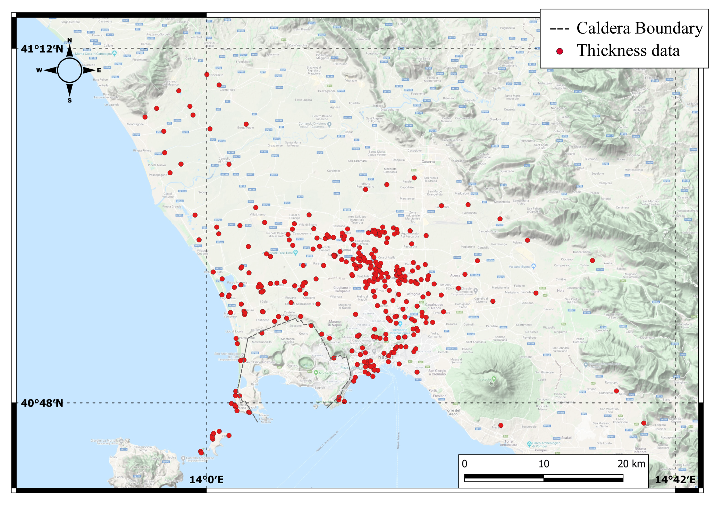
Figure 2. Proximal thickness data used from literature (Ortolani and Aprile, 1985; Scandone et al., 1991; Bellucci, 1994; Rolandi et al., 2003; Torrente et al., 2010; ISPRA, 2011), consist of boreholes, outcrops and data from geological sections. The isopachs were traced considering also partial proximal isopach maps presented in these works.
The enveloped area

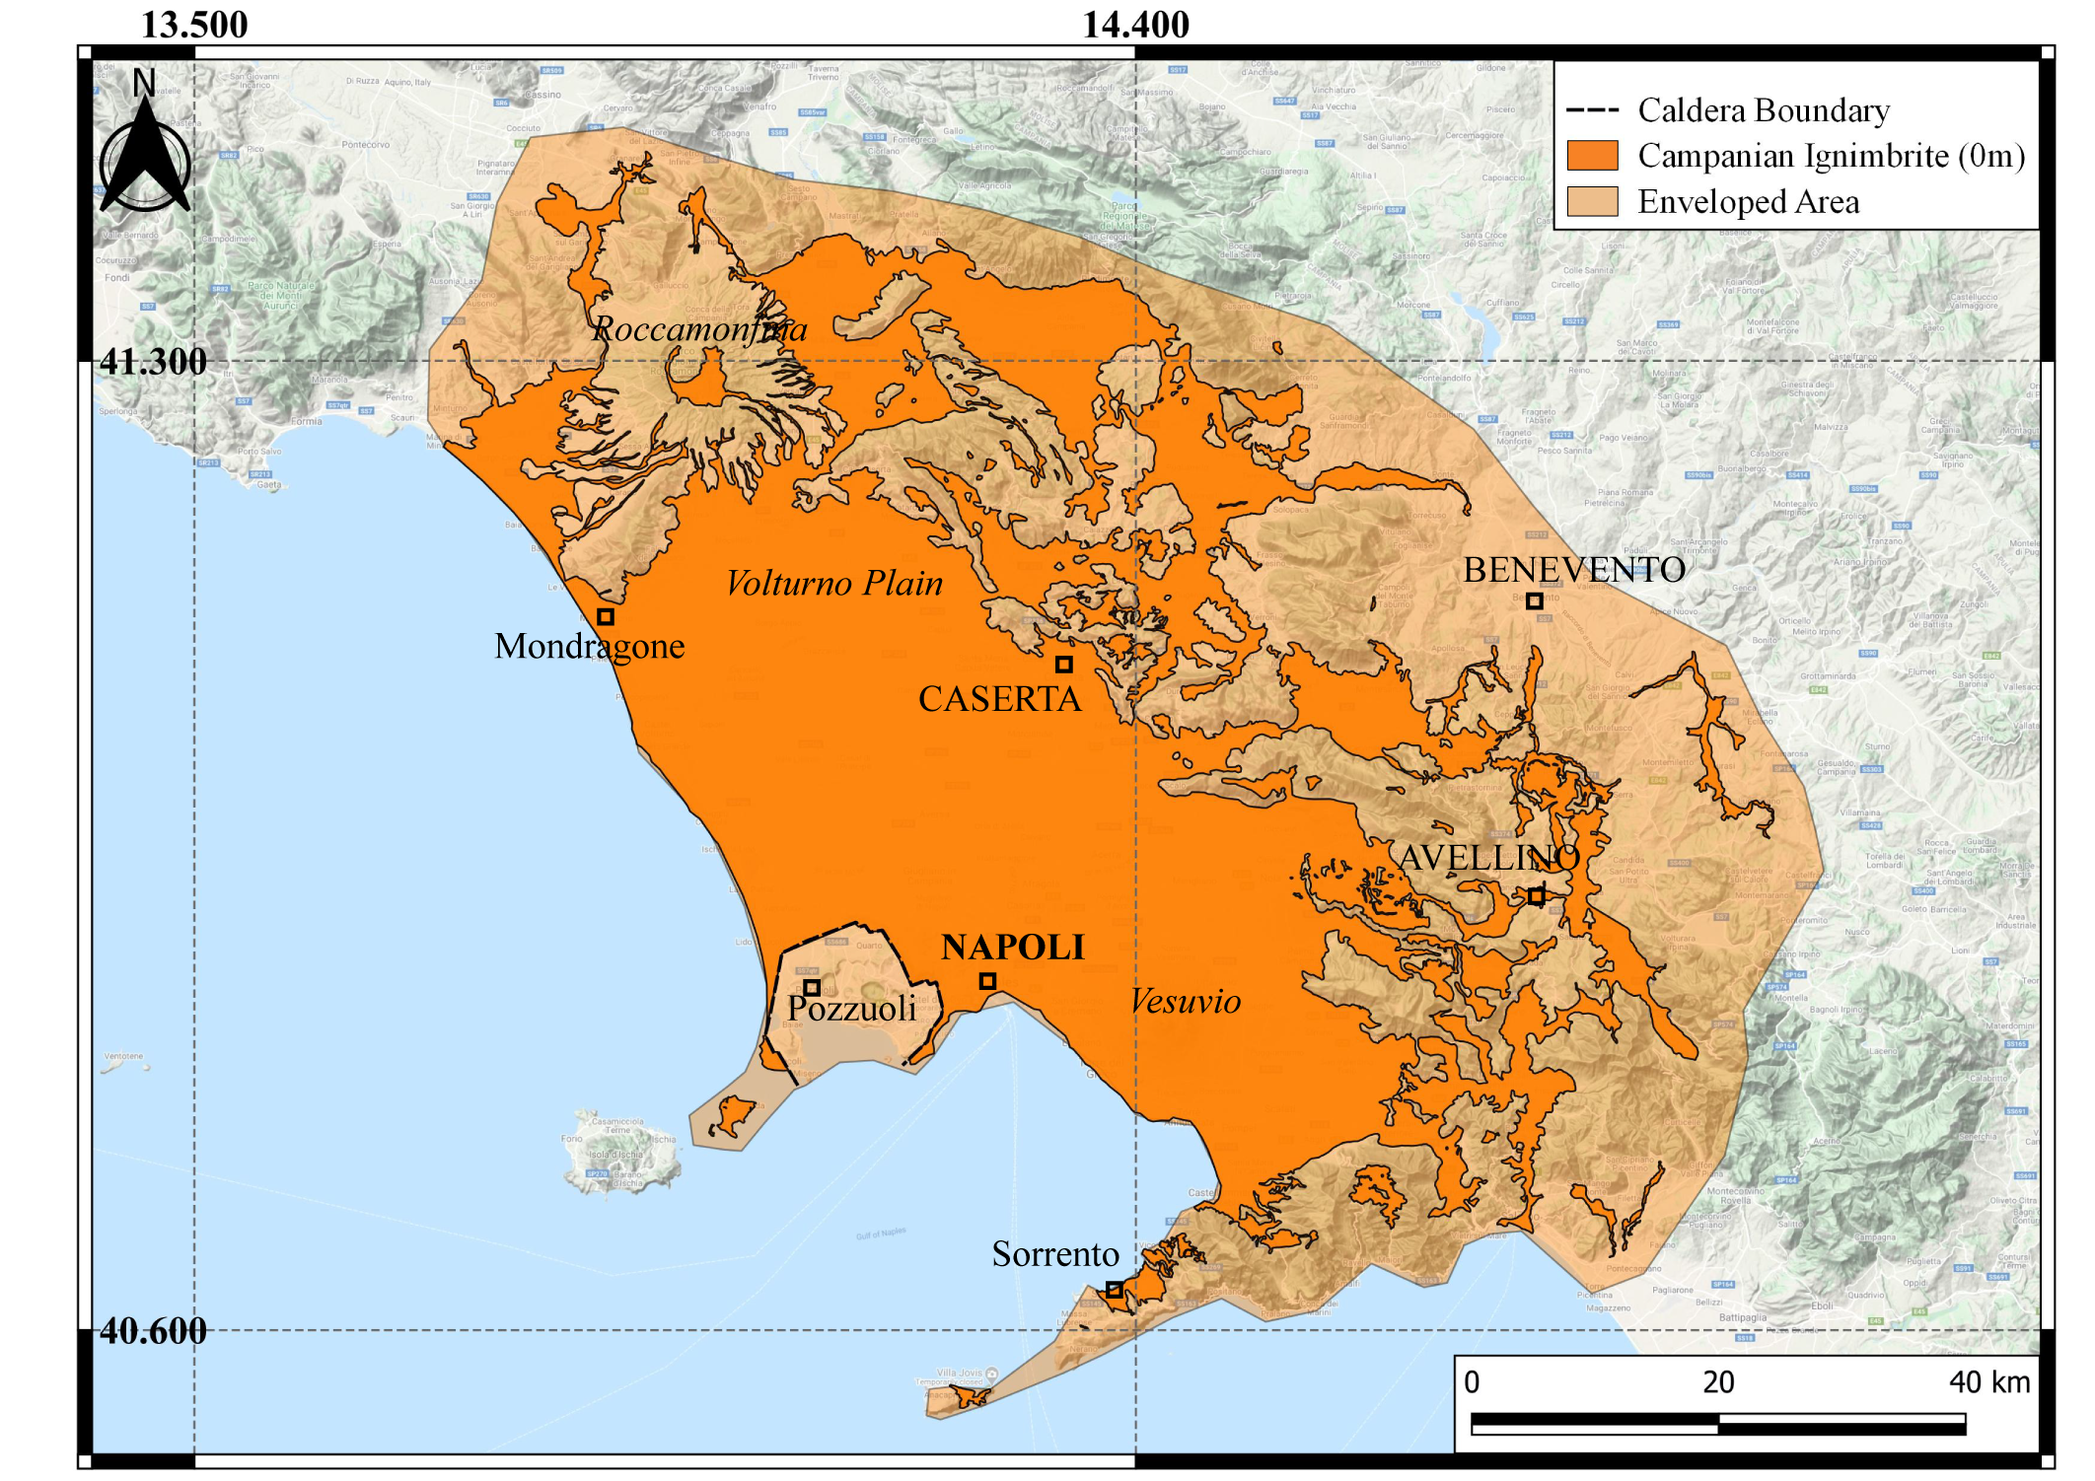
Figure 3. Reconstruction of the areal extent of the CI PDC deposits, enclosed within the 0-m isopach is shown in dark orange. The total area covered by the preserved deposits of CI is 3,216 km², the envelopment with a shape is equal to 6,095 km², which is shown in light orange. The isolated areas from the source are due to the erosion.

4. Density data
Density data used for the DRE volume, are reported in Table 3.
Sample | Unit | ρ bulk (g/cm³) | Standard deviation (g/cm³) | Total porosity (%)
AS01 | WGI | 1.003 | 0.009 | 62
AS07 | WGI | 0.942 | 0.004 | 64
AS09 | WGI | 0.938 | 0.005 | 64
AS10 | WGI | 1.000 | 0.007 | 62
AS13 | WGI | 0.764 | 0.051 | 71
AS14 | WGI | 0.918 | 0.014 | 65
AS16 | WGI | 1.194 | 0.004 | 55
AS21 | WGI | 0.842 | 0.007 | 68
AS24 | USAF-WGI | 0.835 | 0.004 | 68
AS25 | WGI | 0.830 | 0.003 | 68
AS26 | WGI | 0.984 | 0.003 | 62
AS30 | USAF-WGI | 0.799 | 0.005 | 69
AS31 | WGI | 0.888 | 0.002 | 66
AS32 | WGI | 1.000 | 0.011 | 62
AS38 | LYT | 0.830 | 0.014 | 68
AS49 | WGI | 1.064 | 0.005 | 59
AS50 | WGI | 1.088 | 0.002 | 58
AS52 | LYT | 1.151 | 0.019 | 56
AS53 | WGI | 0.925 | 0.013 | 65
AS54 | WGI | 0.987 | 0.003 | 62
AS61 | LYT | 1.060 | 0.010 | 60
AS63 | PIPERNO | 1.283 | 0.001 | 49
AS69 | PIPERNO | 1.275 | 0.008 | 51
AS70 | PIPERNO | 1.302 | 0.002 | 49
AS73 | WGI | 0.816 | 0.003 | 69
AS75 | WGI | 0.959 | 0.005 | 63
ES03 | WGI | 1.008 | 0.014 | 62
ES04 | WGI | 0.843 | 0.057 | 68
ES05 | WGI | 1.050 | 0.010 | 60
ES08 | WGI | 1.155 | 0.011 | 56
ES10 | WGI | 1.330 | 0.003 | 49
ES11 | LYT | 0.885 | 0.021 | 66
ES12 | WGI | 1.047 | 0.003 | 60
ES14 | WGI | 1.063 | 0.004 | 60
ES17 | WGI | 0.999 | 0.014 | 62
ES18 | WGI | 1.080 | 0.012 | 59
ES19 | WGI | 1.002 | 0.023 | 62
ES20 | WGI | 0.745 | 0.015 | 72
ES21 | WGI | 1.074 | 0.019 | 59
ES22 | WGI | 1.153 | 0.006 | 56
Table 3. Values of bulk density (g/cm3), and total porosity (the sum of open and closed porosity) for the analyzed samples. The method is explained in section 4.2. The standard deviation of density is given by the instrument. Samples were taken from all the Campanian Ignimbrite areal distribution and from different units (USAF; Unconsolidated Stratified Ash Flow; WGI: Welded Gray Ignimbrite; LYT: Lithified Yellow Tuff; Piperno).

5. The volume uncertainties
The uncertainties were determined by two different methods, one for the proximal area and one for the distal. In the first case, the proximal isopach map was traced fitting thickness data. In order to avoid subjective interpretation, a second isopach map was delineated tracing isopachs differently, but always consistent with data. A new volume was calculated from this second convincing proximal isopach map. The percentage difference with the first map was estimated (3.06%) corresponding to a volume of 1.7 km³.
The main error in estimating the paleo-valley topography is the extrapolation of the base elevation of the valley itself. For this reason, in the area of Altavilla Irpina, the profiles were modified, and the base elevations were adjusted to reach the maximum difference possible in altitude, always constrained by field data. The volume diverged by 25%, corresponding to a volume of 4.9 km³. The total CI volume uncertainties are 6.6 km³.
Data related to the location of outcrops and density are also reported in the Repository Data online at https://mfr.osf.io/render?url=https%3A%2F%2Fosf.io%2Fc8nea%2Fdownload.
References
Aiello, G., Barra, D., Collina, C., Piperno, M., Guidi, A., Stanislao, C. et al. (2018). Geomorphological and paleoenvironmental evolution in the prehistoric framework of the coastland of Mondragone, southern Italy. Quatern. Int. 493, 70-85. doi:10.1016/j.quaint.2018.06.041
Aprile, F., Sbrana, A., and Toccaceli, R. M. (2004). Il ruolo dei depositi piroclastici nell’analisi cronostratigrafica dei terreni quaternari del sottosuolo della Piana Campana (Italia meridionale). Il Quaternario 17, 547-554.
Aprile, F., and Toccaceli, R. M. (2002). Nuove conoscenze sulla stratigrafia e distribuzione dei depositi ignimbritici quaternari nel sottosuolo della piana del Sarno (Salerno-Campania)—Italia meridionale. Il Quaternario 15(2), 2002.
Arienzo, I., Civetta, L., Heumann, A., Wörner, G., and Orsi, G. (2009). Isotopic evidence for open system processes within the Campanian Ignimbrite (Campi Flegrei–Italy) magma chamber. Bull. Volcanol. 71(3), 285. doi:10.1007/s00445-008-0223-0
Arienzo, I., Heumann, A., Wörner, G., Civetta, L., and Orsi, G. (2011). Processes and timescales of magma evolution prior to the Campanian Ignimbrite eruption (Campi Flegrei, Italy). Earth Planet. Sci. Lett. 306 (3-4), 217-228. doi:10.1016/j.epsl.2011.04.002
Barberi, F., Innocenti, F., Lirer, L., Munno, R., Pescatore, T., and Santacroce, R. (1978). The Campanian Ignimbrite: a Major Prehistoric Eruption in the Neapolitan area (Italy). Bull. Volcanol. 41, 10–31. doi:10.1007/BF02597680
Bellucci, F. (1994). Nuove conoscenze stratigrafiche sui depositi vulcanici del sottosuolo del settore meridionale della Piana Campana. Boll. Soc. Geol. It. 113, 395–420.
Cappelletti, P., Cerri, G., Colella, A., de’Gennaro, M., Langella, A., Perrotta, A., et al. (2003). Post-eruptive processes in the Campanian Ignimbrite. Mineral. Petrol. 79, 79–97. doi:10.1007/s00710-003-0003-7
Costanzo, M. R., amd Nunziata, C. (2019). VS models in the historical centre of Naples (Southern Italy) from noise cross-correlation. J. Volcanol. Geoth. Res. 369, 80-94. doi:10.1016/j.jvolgeores.2018.11.014
De Vivo, B., Petrosino, P., Lima, A., Rolandi, G., and Belkin, H. E. (2010). Research progress in volcanology in the Neapolitan area, southern Italy: a review and some alternative views. Mineral. Petrol. 99 (1-2), 1-28. doi:10.1007/s00710-009-0098-6
De Vivo, B., Rolandi, G., Gans, P. B., Calvert, A., Bohrson, W. A., Spera, F. J., et al. (2001). New constraints on the pyroclastic eruptive history of the Campanian volcanic Plain (Italy). Mineral. Petrol. 73, 47–65. doi:10.1007/s007100170010
Fedele, F. G., Giaccio, B., Isaia, R., and Orsi, G. (2002). Ecosystem Impact of the Campanian Ignimbrite Eruption in Late Pleistocene Europe. Quat. Res. 57, 420–424. doi:10.1006/qres.2002.2331
Fedele, L., Scarpati, C., Lanphere, M., Melluso, L., Morra, V., Perrotta, A., et al. (2008). The Breccia Museo formation, Campi Flegrei, southern Italy: geochronology, chemostratigraphy and relationship with the Campanian Ignimbrite eruption. Bull. Volcanol. 70, 1189–1219. doi:10.1007/s00445-008-0197-y
Fedele, L., Scarpati, C., Sparice, D., Perrotta, A., and Laiena, F. (2016). A chemostratigraphic study of the Campanian Ignimbrite eruption (Campi Flegrei, Italy): Insights on magma chamber withdrawal and deposit accumulation as revealed by compositionally zoned stratigraphic and facies framework. J. Volcanol. Geotherm. Res. 324, 105–117. doi:10.1016/j.jvolgeores.2016.05.019
Fowler, S. J., Spera, F. J., Bohrson, W. A., Belkin, H. E., and De Vivo, B. (2007). Phase equilibria constraints on the chemical and physical evolution of the Campanian Ignimbrite. J. Petrol. 48(3), 459-493. doi:10.1093/petrology/egl068
Giaccio, B., Hajdas, I., Peresani, M., Fedele, F. G., and Isaia, R. (2006). "The Campanian Ignimbrite tephra and its relevance for the timing of the middle to upper paleolithic shift", in When Neanderthals and modern humans met, eds N. J. Conard (Tübingen Publications in Prehistory. Tübingen: Kerns Verlag.), 343–375.
Giaccio, B., Isaia, R., Fedele, F. G., Di Canzio, E., Hoffecker, J. F., Ronchitelli, A., et al. (2008). The Campanian Ignimbrite and Codola tephra layers: Two temporal/stratigraphic markers for the Early Upper Palaeolithic in southern Italy and eastern Europe. J. Volcanol. Geotherm. Res. 177, 208–226. doi:10.1016/j.jvolgeores.2007.10.007
Incoronato, A., and Nardi, G. (1987). Contribution of rock magnetic studies to determine depositional mechanism and parameters of the "Campanian Ignimbrite" deposits. Rendiconti Acc. Sc. Fis. Nat. Special Issue, 201-214.
ISPRA (2011). Geological Map n. 446-447 ‘‘Napoli’’; scale 1:50,000. National Geological Survey of Italy, Regione Campania - Settore Difesa Suolo, Napoli, Italy.
Langella, A., Bish, D. L., Calcaterra, D., and Cappelletti, P. (2013). "L’Ignimbrite Campana (IC)", in Le pietre storiche della Campania dall’oblio alla riscoperta, eds M. De Gennaro, D. Calcaterra and A. Langella (Napoli: Luciano Editore), 155–177.
Melluso, L., Morra, V., Perrotta, A., Scarpati, C., and Adabbo, M. (1995). The eruption of the Breccia Museo (Campi Flegrei, Italy): Fractional crystallization processes in a shallow, zoned magma chamber and implications for the eruptive dynamics. J. Volcanol. Geotherm. Res. 68, 325–339. doi:10.1016/0377-0273(95)00020-5
Milia, A., and Torrente, M. M. (2007). The influence of paleogeographic setting and crustal subsidence on the architecture of ignimbrites in the Bay of Naples (Italy). Earth Planet. Sci. Lett. 263, 192–206. doi:10.1016/j.epsl.2007.08.004
Nunziata, C., Natale, M., and Panza, G. F. (2004). Seismic characterization of Neapolitan soils. In Seismic Ground Motion in Large Urban Areas, eds G. F. Panza, I. Paskaleva and C. Nunziata (Basel: Birkhäuser), 1285-1300. doi:10.1007/s00024-003-2492-z
Orsi, G., and Rosi, M. (1991). Large ignimbrite eruptions of the Phlegraean Fields Caldera: the Neapolitan Yellow Tuff and the Campanian Ignimbrite. In Workshop on explosive volcanism, Napoli, September 1-8.
Orsi, G., de Vita, S., and Di Vito, M. A. (1996). The restless, resurgent Campi Flegrei nested caldera (Italy): constraints on its evolution and configuration. J. Volcanol. Geotherm. Res. 74, 179–214. doi:10.1016/S0377-0273(96)00063-7
Ort, M. H., Orsi, G., Pappalardo, L., and Fisher, R. V. (2003). Anisotropy of magnetic susceptibility studies of depositional processes in the Campanian Ignimbrite, Italy. Bull. Volcanol. 65, 55–72. doi:10.1007/s00445-002-0241-2
Ortolani, F., and Aprile, F. (1985). Principali caratteristiche stratigrafiche e strutturali dei depositi superficiali della piana campana. Boll. Soc. Geol. It. 104, 195–206.
Pappalardo, L., Civetta, L., De Vita, S., Di Vito, M., Orsi, G., Carandente, A., et al. (2002). Timing of magma extraction during the Campanian Ignimbrite eruption (Campi Flegrei Caldera). J. Volcanol. Geotherm. Res. 114(3-4), 479-497. doi:10.1016/S0377-0273(01)00302-X
Pappalardo, L., Ottolini, L., and Mastrolorenzo, G. (2008). The Campanian Ignimbrite (southern Italy) geochemical zoning: Insight on the generation of a super-eruption from catastrophic differentiation and fast withdrawal. Contrib. Mineral. Petrol. 156, 1–26. doi:10.1007/s00410-007-0270-0
Perrotta, A., Scarpati, C., Luongo, G., and Morra, V. (2006). Chapter 5 The Campi Flegrei caldera boundary in the city of Naples. In Developments in Volcanology, eds B. De Vivo (Elsevier), 9, 85–96. doi:10.1016/S1871-644X(06)80019-7.
Perrotta, A., Scarpati, C., Luongo, G., and Morra, V. (2010). Stratigraphy and volcanological evolution of the southwestern sector of Campi Flegrei and Procida Island, Italy. Geol. Soc. Am. Spec. Pap. 464, 171–191. doi:10.1130/2010.2464(09)
Rolandi, G., Bellucci, F., Heizler, M. T., Belkin, H. E., and De Vivo, B. (2003). Tectonic controls on the genesis of ignimbrites from the Campanian Volcanic Zone, southern Italy. Mineral. Petrol. 79, 3–31. doi:10.1007/s00710-003-0014-4
Rosi, M., and Sbrana, A. (1987). Phlegrean Fields. CNR, Quad. La Ricerca Sci. 114, 1–175.
Rosi, M., Sbrana, A., and Vezzoli, L. (1988). Correlazioni tefrostratigrafiche di alcuni livelli di Ischia, Procida e Campi Flegrei. Mem. della Soc. Geol. Ital. 41, 1015–1027.
Rosi, M., Vezzoli, L., Aleotti, P., and Censi, M. (1996). Interaction between caldera collapse and eruptive dynamics during the Campanian Ignimbrite eruption, Phlegraean Fields, Italy. Bull. Volcanol. 57, 541–554. doi:10.1007/BF00304438
Scandone, R., Bellucci, F., Lirer, L., and Rolandi, G. (1991). The structure of the Campanian Plain and the activity of the Neapolitan volcanoes (Italy). J. Volcanol. Geotherm. Res. 48, 1–31. doi:10.1016/0377-0273(91)90030-4
Scarpati, C., and Perrotta, A. (2016). Stratigraphy and physical parameters of the Plinian phase of the Campanian Ignimbrite eruption. Bull. Geol. Soc. Am. 128, 1147–1159. doi:10.1130/B31331.1
Signorelli, S., Vaggelli, G., Francalanci, L., and Rosi, M. (1999). Origin of magmas feeding the Plinian phase of the Campanian Ignimbrite eruption, Phlegrean Fields (Italy): constraints based on matrix-glass and glass-inclusion compositions. J. Volcanol. Geotherm. Res. 91(2-4), 199-220. doi:10.1016/S0377-0273(99)00036-0
Smith, V. C., Isaia, R., Engwell, S., and Albert, P. G. (2016). Tephra dispersal during the Campanian Ignimbrite (Italy) eruption: implications for ultra-distal ash transport during the large caldera-forming eruption. Bull. Volcanol. 78, 45. doi:10.1007/s00445-016-1037-0
Sparice, D. (2015). Definizione delle litofacies e ricostruzione dell’architettura dell’Ignimbrite Campana. [doctoral dissertation/PhD thesis]. [Naples (IT)]: University of Naples Federico II.
Torrente, M. M., Milia, A., Bellucci, F., and Rolandi, G. (2010). Extensional tectonics in the Campania Volcanic Zone (Eastern Tyrrhenian Sea, Italy): New insights into the relationship between faulting and ignimbrite eruptions. Boll. Soc. Geol. It. 129, 297–315. doi:10.3301/IJG.2010.07

