Integrative and Conjugative Elements of Helicobacter pylori Are Hypothetical Virulence Factors Associated With Gastric Cancer

Eduardo Mucito-Varela, Gonzalo Castillo-Rojas, Juan J. Calva and Yolanda López-Vidal

Supplementary Material
a
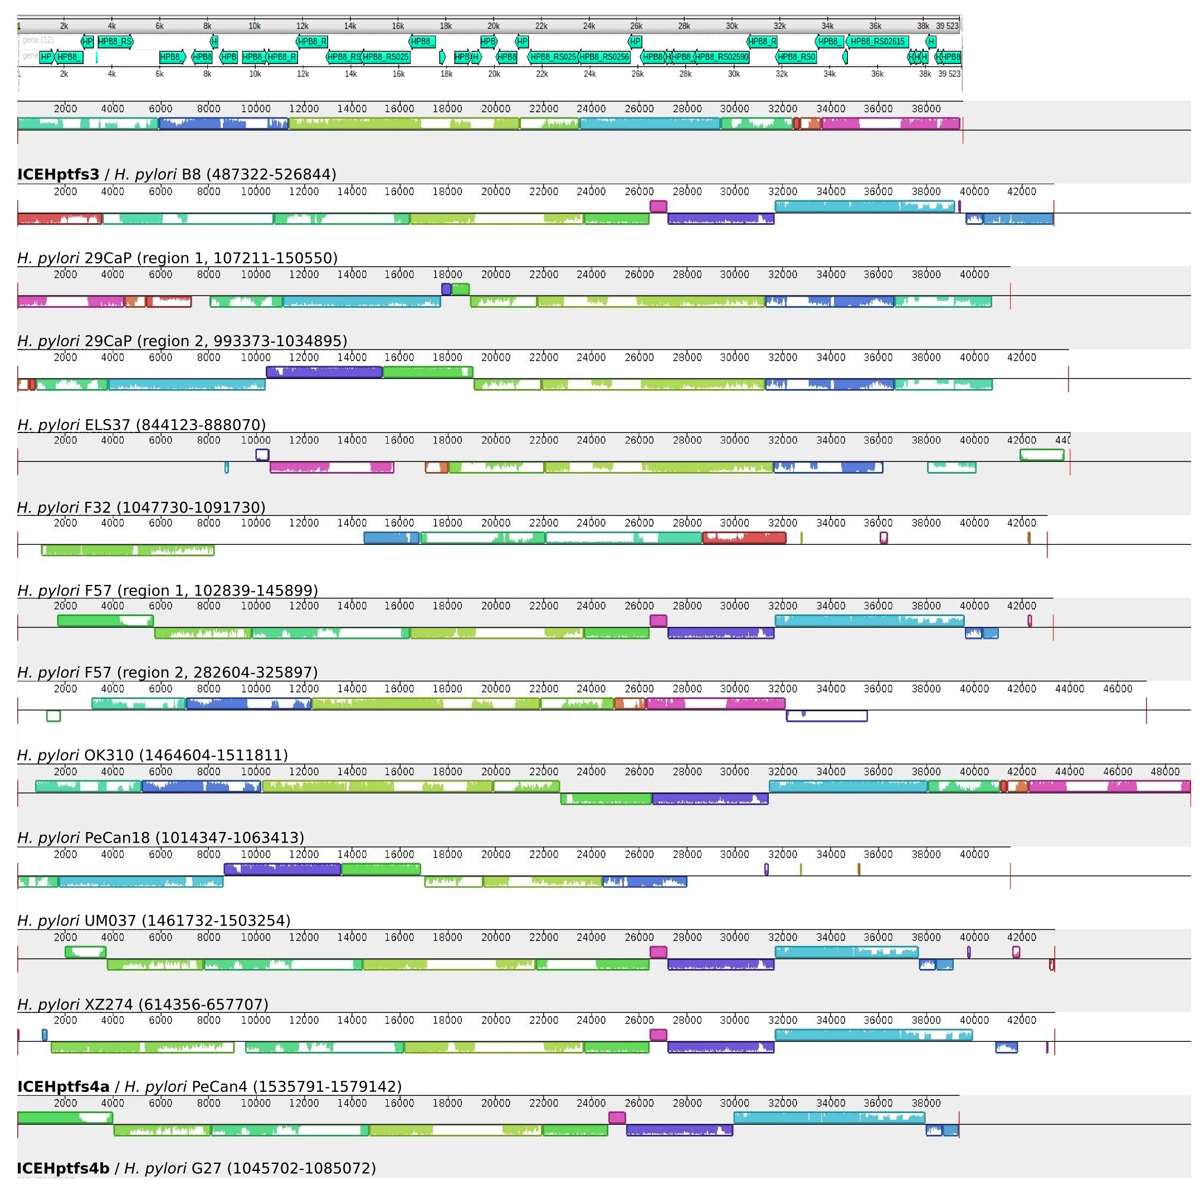
b
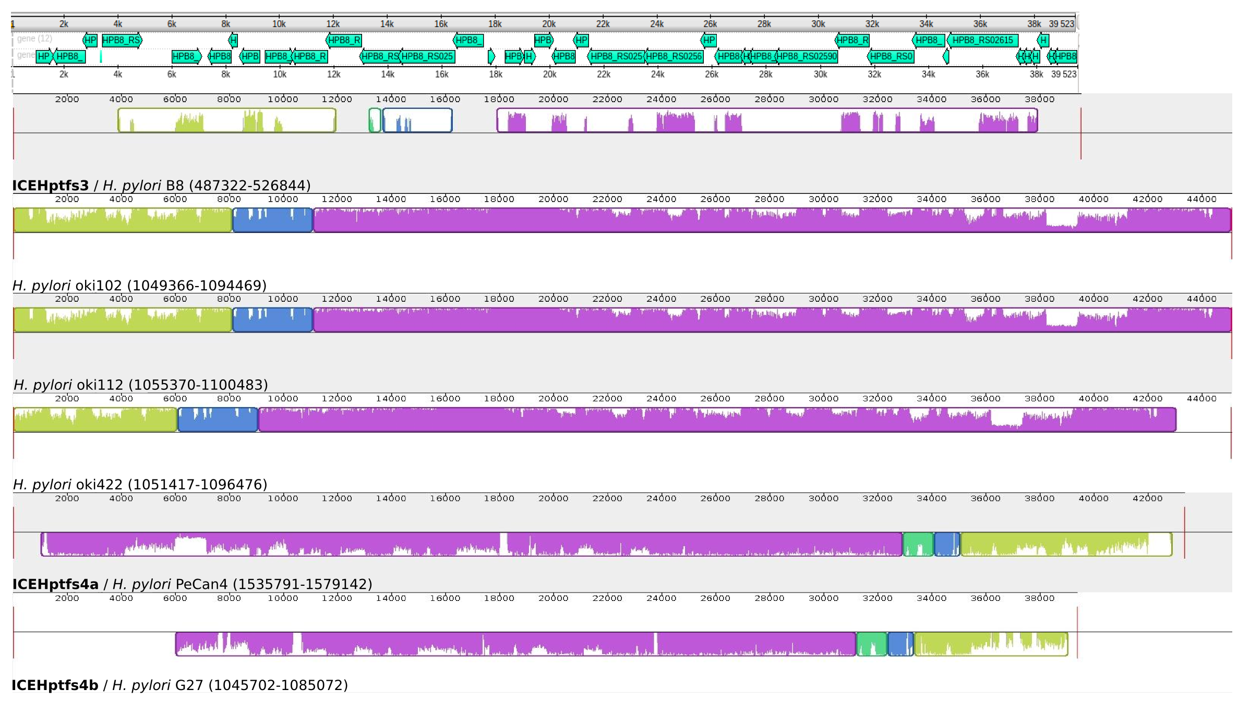

c
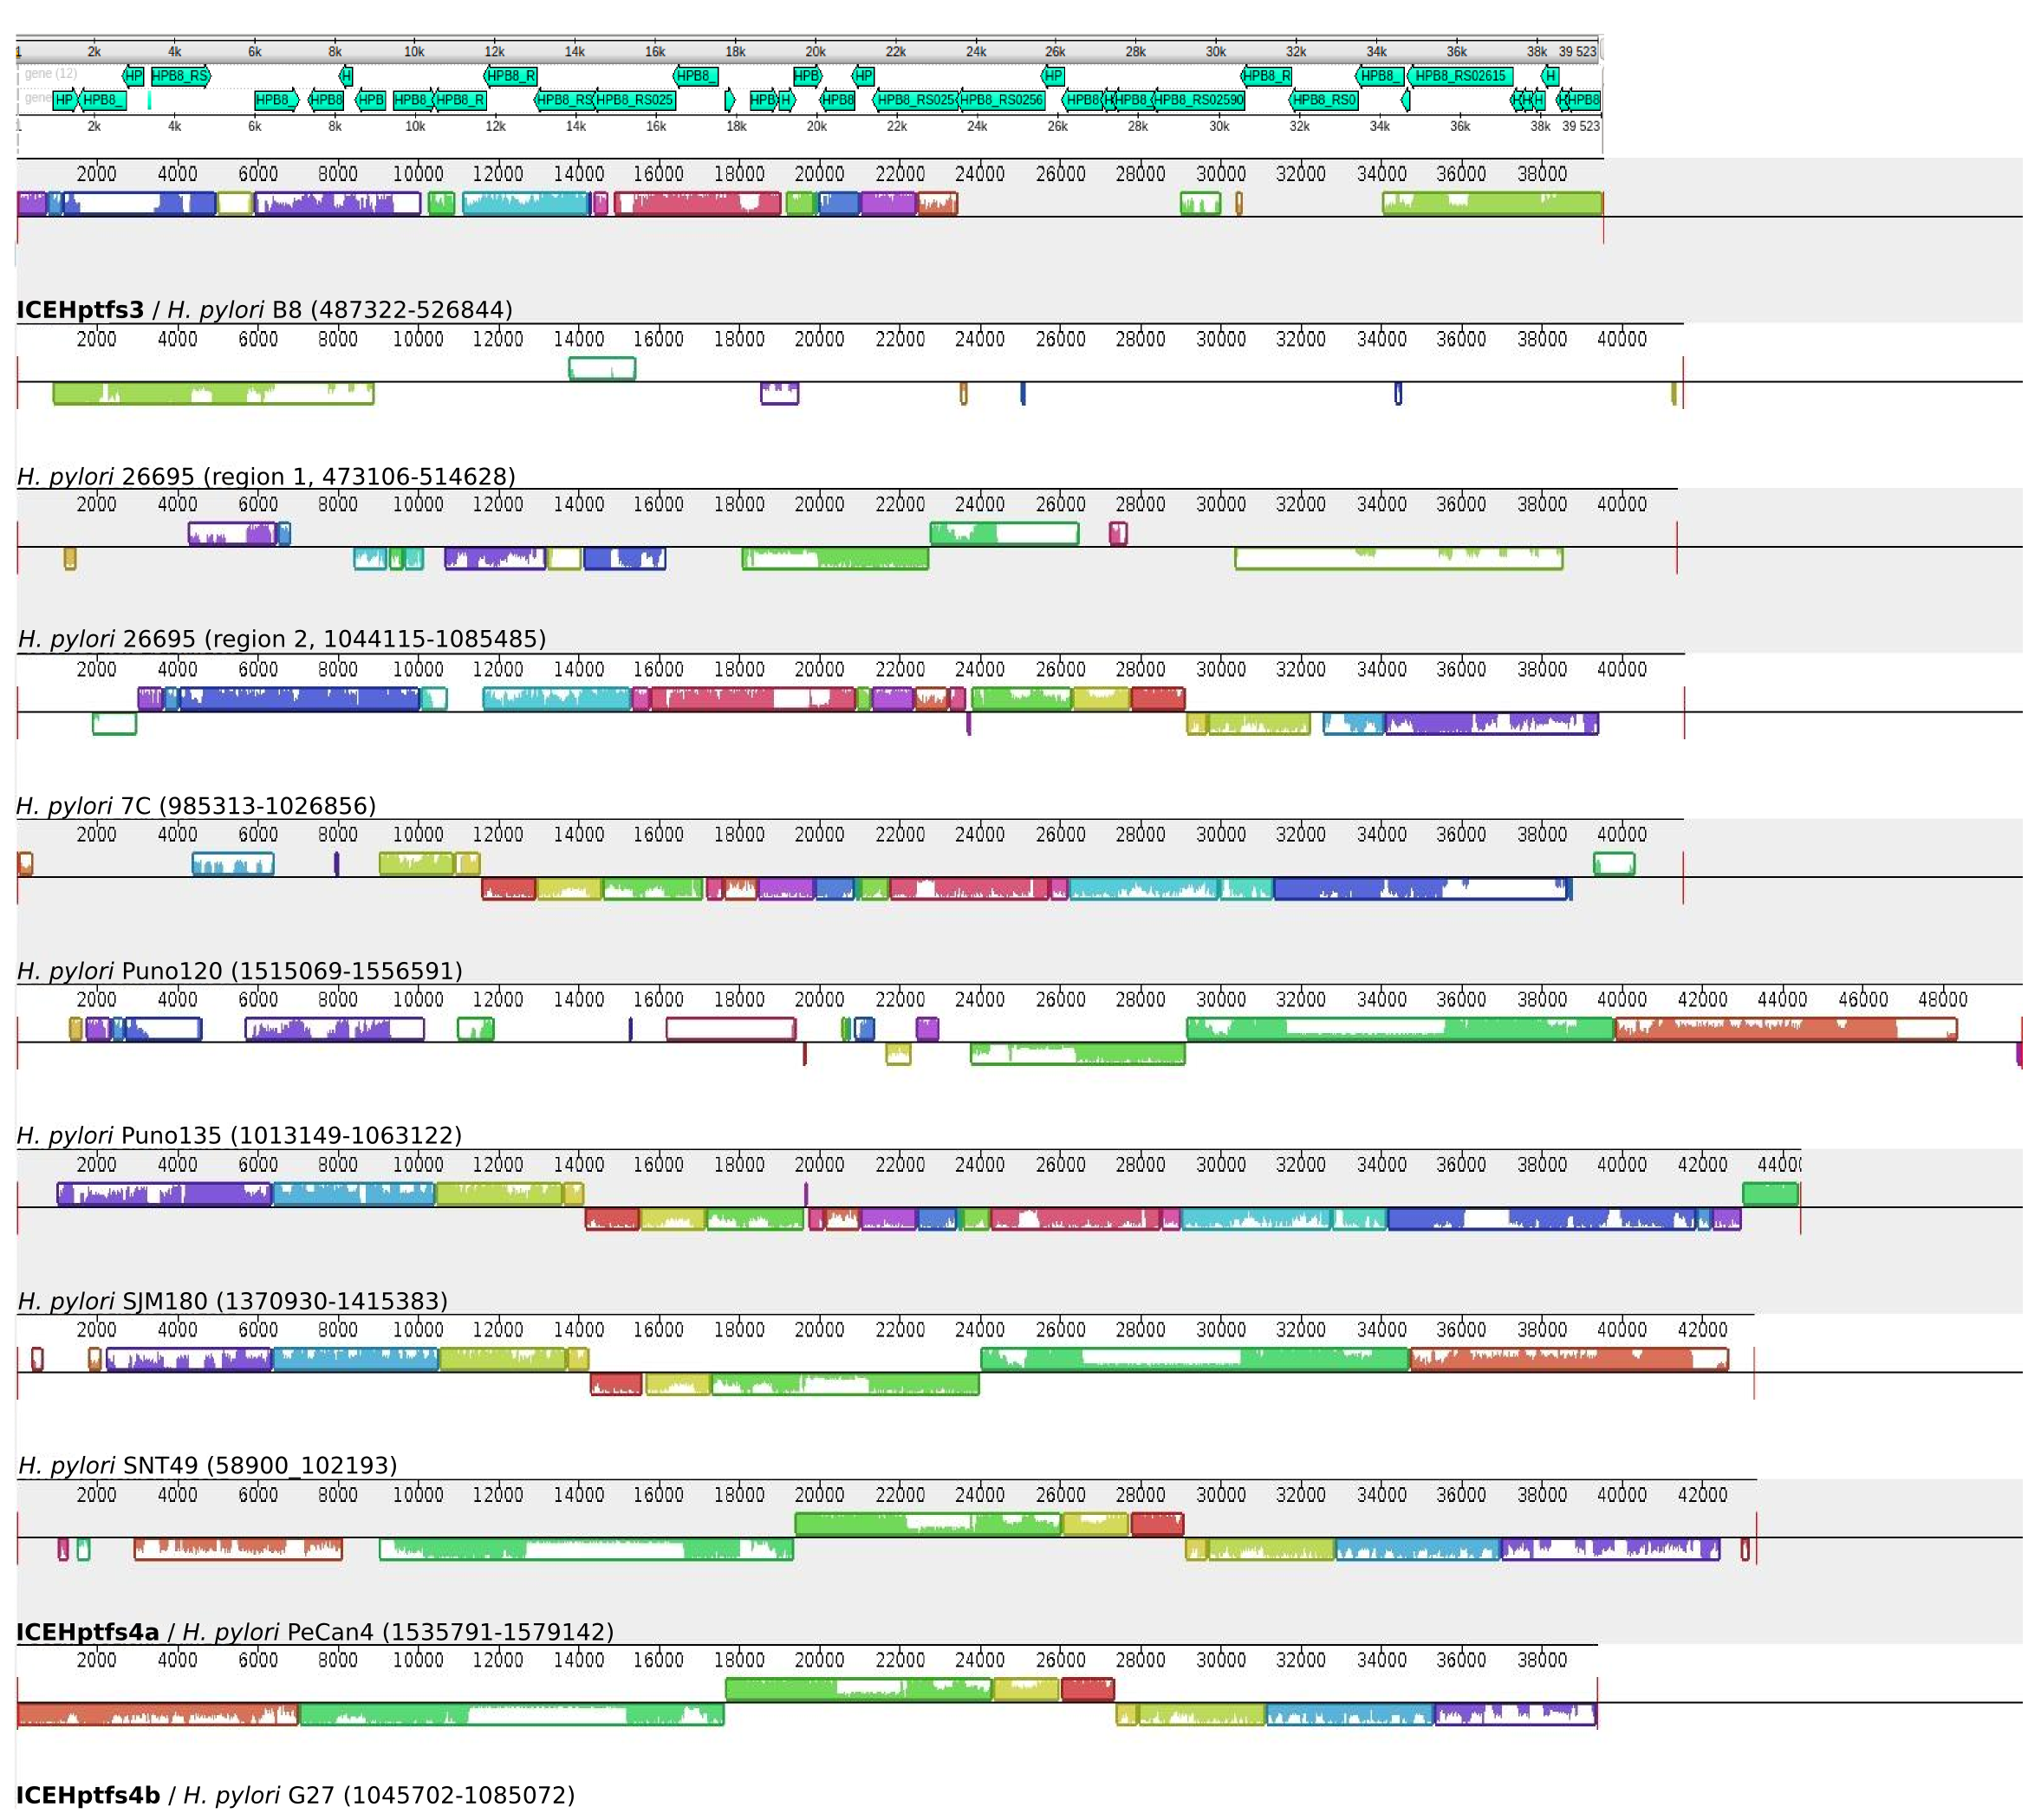

d
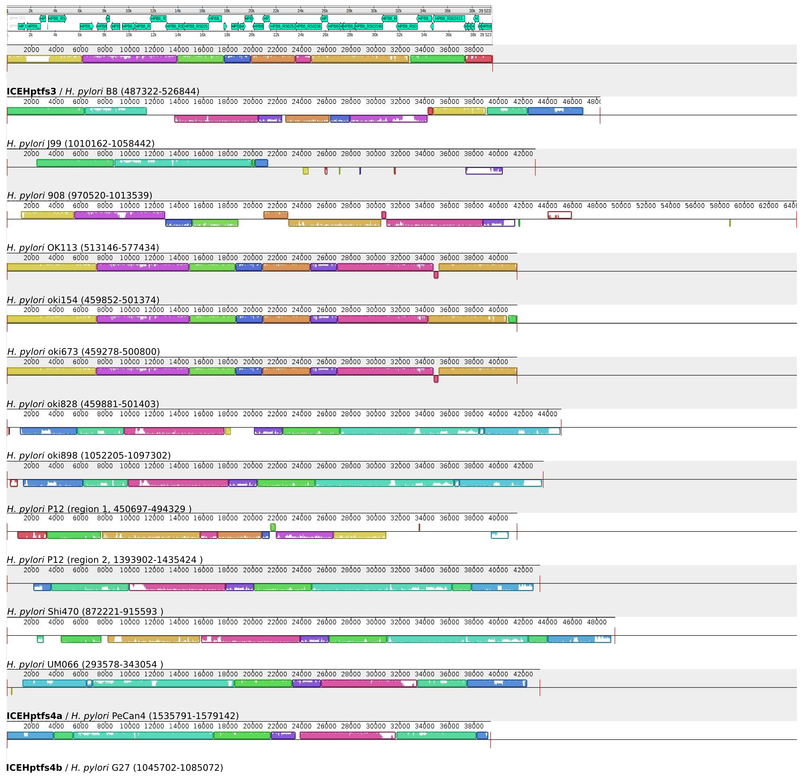

e
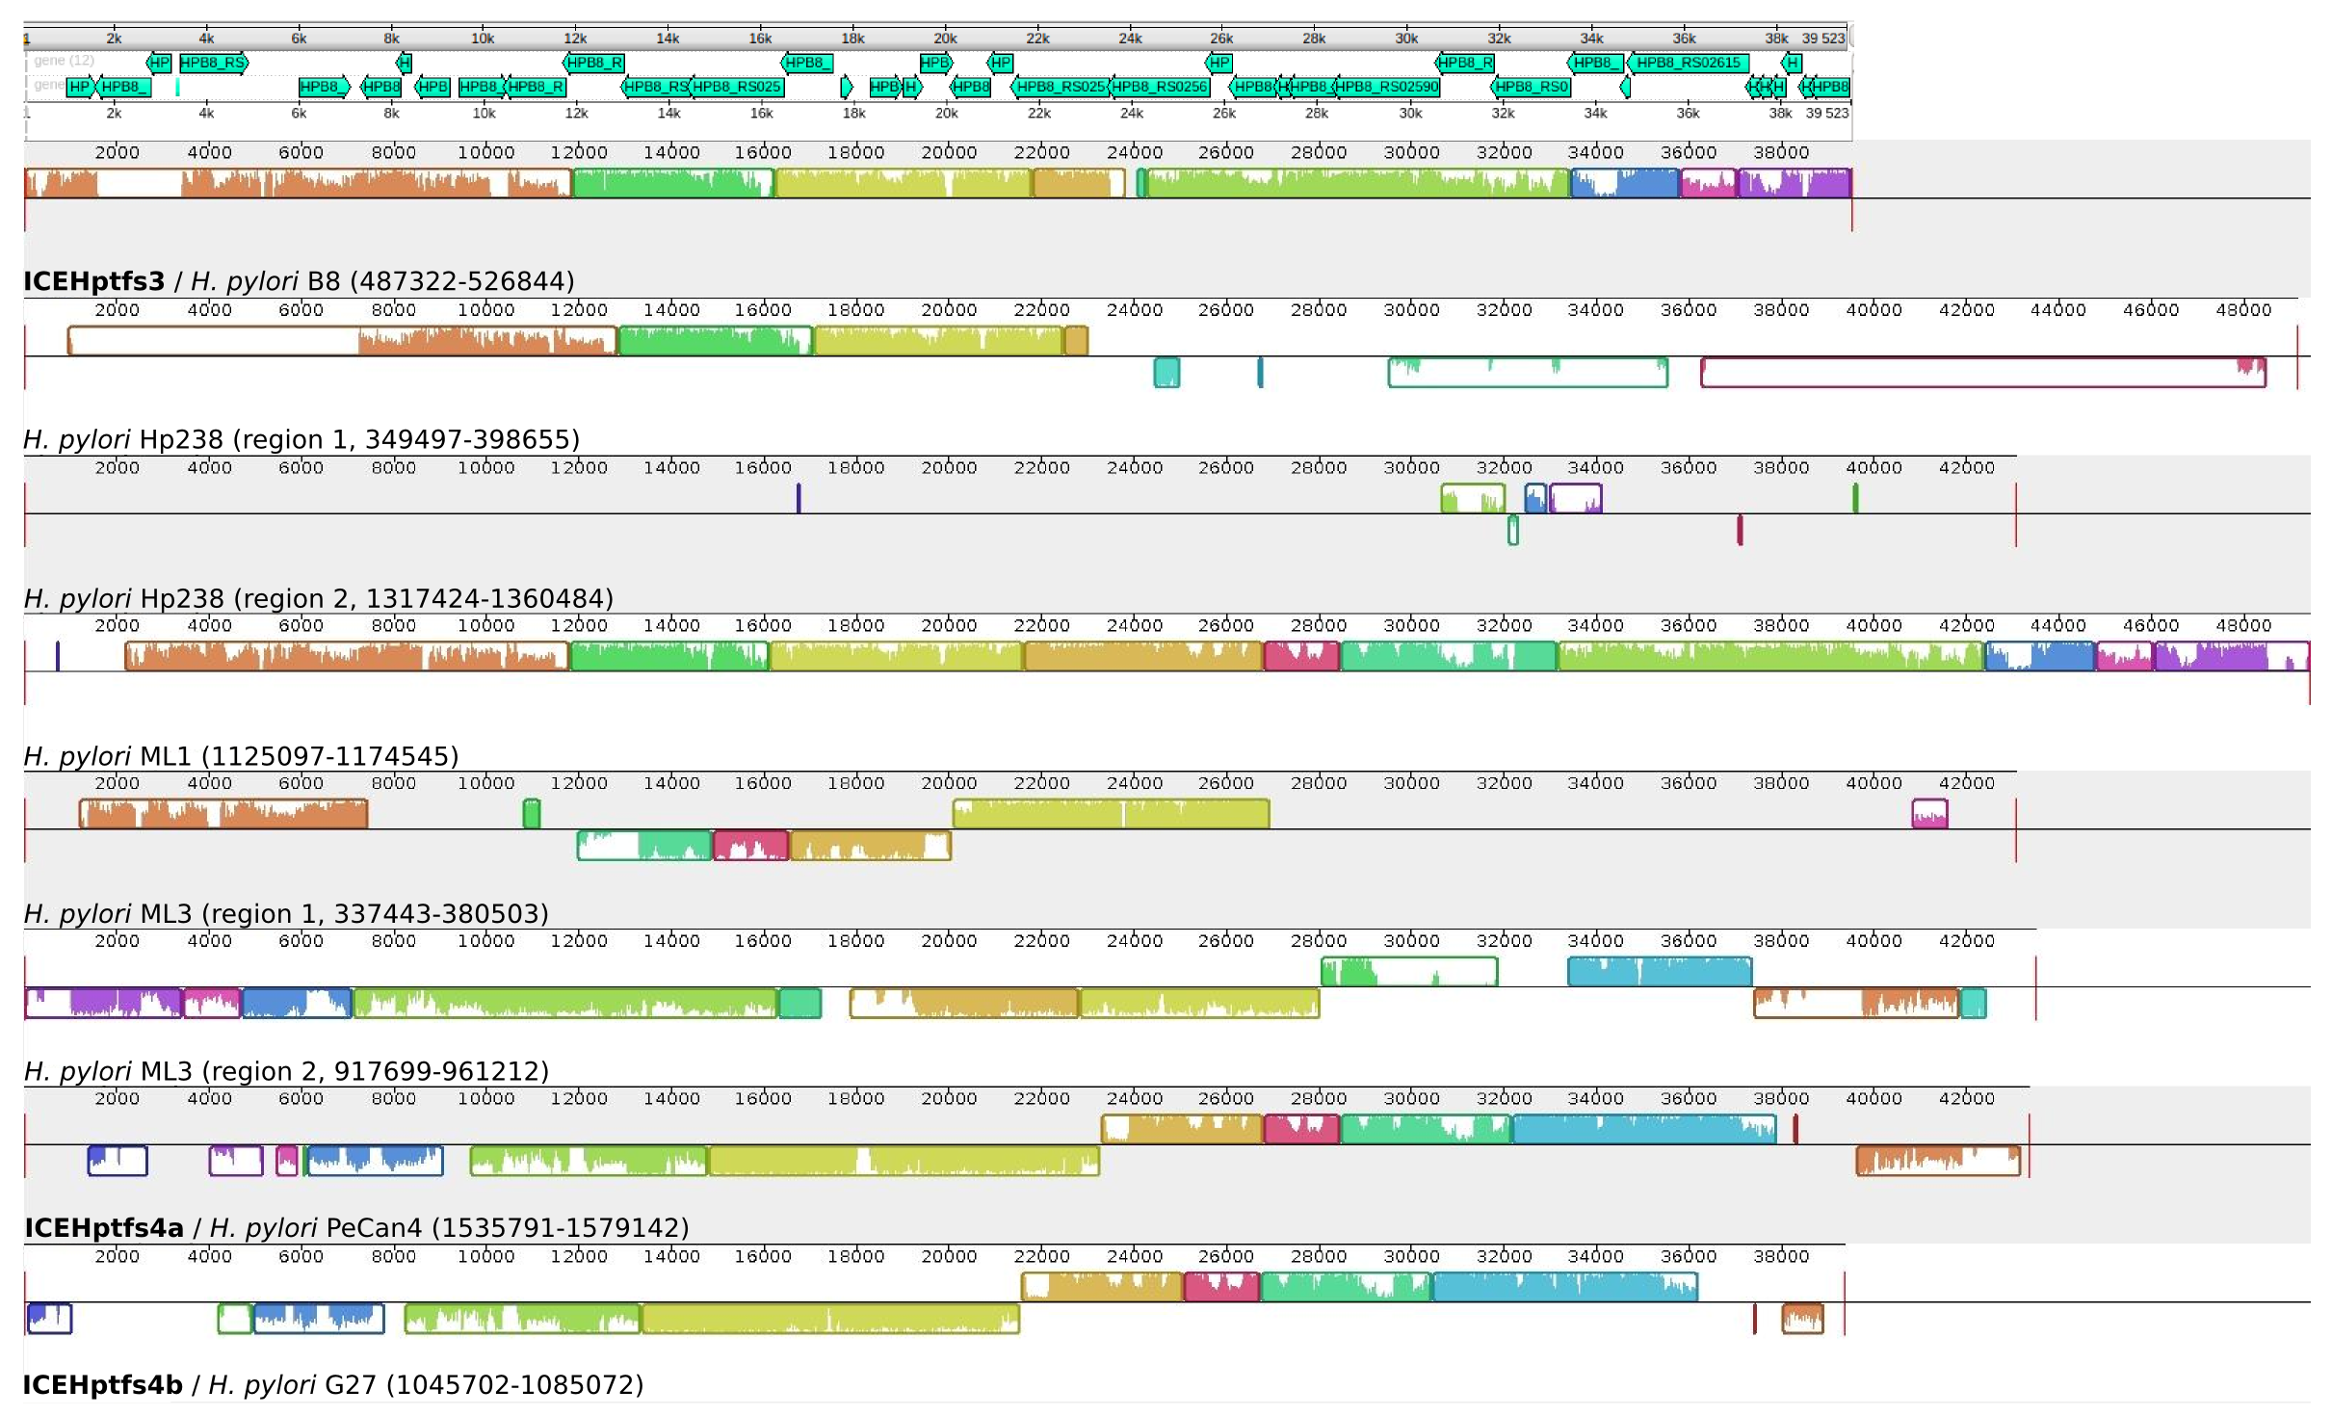
Supplementary Figure 1. Integrative and Conjugative Elements in complete genomes of H. pylori. Multiple sequence alignments show regions similar between H. pylori complete genomes and the reference ICE sequences taken from Fischer et al., 2014. Alignments were performed with the progressive Mauve algorithm from Mauve version 2.4.0 with the default parameters. Each row show the region similar to ICEs in the different H. pylori genomes. The boxes in color represents the regions similar at least to another sequence while the color lines inside the boxes represent the degree of similarity between regions. The complete genomes that does not appear in the figure had no positive alignment. At the top of the figure, a representation of the genes encoded in the ICEHptfs3 element obtained using UGENE genome analysis suite version 1.3. The images were assembled and edited in Inkscape version 0.92.1, to annotate the name of the strains and the position in the genome of the region showed. (a) Genomes of H. pylori isolated from gastric cancer. (b) Genomes of H. pylori isolated from chronic atrophic gastritis. (c) Genomes of H. pylori isolated from peptic ulcer. (d) Genomes of H. pylori isolated from gastritis. (e) Genomes of H. pylori isolated from MALT lymphoma.

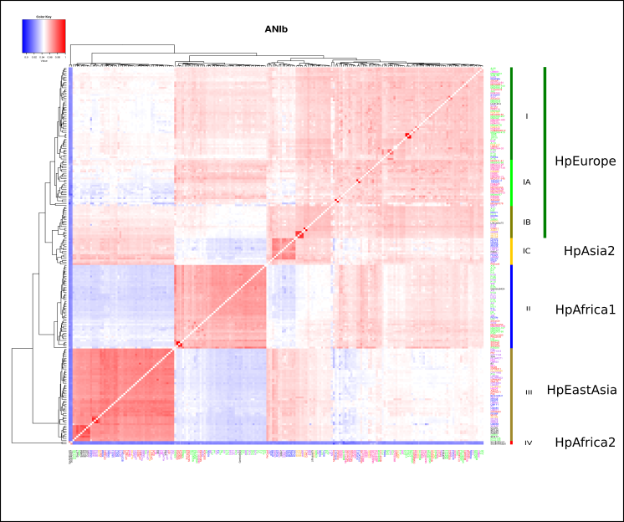
Supplementary Figure 2. Clustering of the H. pylori genomes by Average Nucleotide Identity Using BLAST. The figure was obtained as described in materials and methods. Square colors represent the average percent identity between all pairs of segments matched in each pair of genomes, the scale shown at the left top of the figure indicates blue a percent identity of 90% and red a percent identity of 100%. The names of the H. pylori strains indicate the pathology associated as follows: red = gastric cancer, deep pink = precancerous lesions, orange = chronic atrophic gastritis, green = gastritis, purple = peptic ulcer, magenta = MALT lymphoma, blue = dyspepsia or asymptomatic. At the right of each cluster the correlation with the MLST population structure reported in the literature.
Supplementary table 1. Genomes used in ANI-BLAST analysis and validation set 3
Strain | Pathology | ANI_BLAST | MLST** | fineSTRUCTURE***
7C * | G | I | hpEurope
29CaP * | GC | I | hpEurope
A-14* | G | I | hpEurope | hspEuropeN
A-26* | G | I | hpEurope | hspEuropeN
B38* | L | I | hpEurope | hspEuropeN
CGIMSS-2012* | GC | I | hpEurope
ELS37* | GC | I | hpEurope | hspEuropeS
H-27* | PU-G | I | hpEurope | hspEuropeN
H-43* | PU-DU | I | hpEurope | hspEuropeN
62A9 | PU | I
53C1 | PU | I
11CaC2-9 | GC | I
23CaC2 | GC | I
21CaC3 | D | I
16F10 | G | I
16A8 | G | I
16C4 | G | I
36C | G | I
HUP-B14 | NA | I | hpEurope | hspEuropeS
MC2006-52 | GC | I |  | hspEuropeS
MCms931 | GC | I |  | hspEuropeS
MG2005-100 | G | I |  | hspEuropeS
MG2006-4 | G | I |  | hspEuropeS
MG2006-407 | G | I |  | hspEuropeS
MG2006-479 | G | I |  | hspEuropeS
MGms2 | G | I |  | hspEuropeS
MGms13 | G | I |  | hspEuropeS
MGms15 | G | I |  | hspEuropeS
MGms23 | G | I |  | hspEuropeS
MGms176 | G | I |  | hspEuropeS
MGms203 | G | I |  | hspEuropeS
MM2004-20 | M | I |  | hspEuropeS
MM2006-480 | M | I |  | hspEuropeS
MU2003-84 | M | I |  | hspEuropeS
NQ315* | PC | I |  | hspEuropeColombia
NQ4053* | PC | I | hpEurope | hspEuropeColombia
NQ4076* | CAG | I | hpEurope | hspEuropeColombia
NQ4099* | Pc | I | hpEurope | hspEuropeColombia
NQ4110* | CAG | I |  | hspEuropeS
NQ4161* | CAG | I | hpEurope | hspEuropeColombia
NQ4200* | PC | I |  | hspEuropeColombia
NQ4216* | PC | I | hpEurope | hspEuropeColombia
P-15* | G | I |  | hspEuropeN
P-16* | G | I |  | hspEuropeN
P-23* | G | I |  | hspEuropeN
P-30* | G | I |  | hspEuropeN
P-74* | G | I |  | hspEuropeN
R046Wa* | A | I |  | hspEuropeN
R056a* | A | I
SJM180* | G | I |  | hspEuropeS
UM037* | GC | I
UMBG1* | L | I
18CaC1 | D | IA
34CaC2 | GC | IA
14CaC1 | D | IA
14CaC1-2 | D | IA
MC2011-41 | G | IA |  | hspEuropeS
MC2011-145 | GC | IA |  | hspMiscAmerica
MCms1055 | GC | IA |  | hspEuropeS
MCms1078 | GC | IA |  | hspEuropeS
MCms1080 | GC | IA |  | hspEuropeS
MG2005-98 | G | IA |  | hspEuropeS
MGms167 | G | IA |  | hspMiscAmerica
MM2003-103 | M | IA |  | hspEuropeS
MM2005-72 | M | IA |  | hspMiscAmerica
MM2005-126 | M | IA |  | hspEuropeS
MM2006-56 | M | IA |  | hspEuropeS
MM2012-26 | M | IA |  | hspEuropeS
MU2004-2 | M | IA |  | hspEuropeS
NAD1* | PU-DU | IA | hpEurope
NQ352* | PC | IA
NQ367* | PC | IA
NQ392* | PC | IA |  | hspEuropeColombia
NQ4228* | PC | IA | hpEurope | hspEuropeColombia
PZ5026* | PC | IA |  | hspEuropeColombia
PZ5056* | PC | IA |  | hspEuropeColombia
PZ5080* | CAG | IA |  | hspEuropeColombia
PZ5086* | PC | IA |  | hspEuropeColombia
26695* | G | IB | hpEurope | hspEuropeN
A-11* | PU-DU | IB |  | hspEuropeN
A-27* | G | IB | hpEurope | hspEuropeN
AG0C1* | CAG | IB |  | hspEuropeN
B128* | PU-G | IB | hpEurope
CA4C1* | GC | IB
H-9* | G | IB | hpEurope | hspEuropeN
H-11* | G | IB | hpEurope | hspEuropeN
H-45* | PU-DU | IB | hpEurope | hspEuropeN
HPAG1* | CAG | IB | hpEurope | hspEuropeN
Lithuania75 | NA | IB | hpEurope | hspEuropeN
oki102* | CAG | IB
oki112* | CAG | IB
oki422* | CAG | IB
oki898* | PU-DU | IB
P12* | PU-DU | IB | hpEurope | hspEuropeN
R037c* | A | IB
R038b* | A | IB |  | hspEuropeN
A45* | PU-G | IC
FD423* | D | IC | hpAsia2 | hpAsia2
FD430* | D | IC |  | hpAsia2
FD535* | D | IC | hpAsia2 | hpAsia2
FD662* | D | IC
FD703* | D | IC | hpAsia2 | hpAsia2
FD719* | D | IC | hpAsia2
India7 | NA | IC | hpAsia2 | hpAsia2
NAB47* | PU-DU | IC | hpAsia2 | hpAsia2
PeCan4* | GC | IC |  | Hybrid
R32b* | A | IC |  | hspEuropeN
SNT49 | A | IC |  | hpAsia2
UM067* | PU | IC |  | hpAsia2
UM084* | PU | IC |  | hpAsia2
UM114* | PU | IC |  | hpAsia2
908* | PU-DU | II | hpAfrica1
A-4* | PU-DU | II | hpAfrica1
A-5* | PU-G | II | hpAfrica1 | hspAfrica1NAmerica
A-6* | G | II | hpAfrica1 | hspAfrica1NAmerica
A-8* | G | II | hpAfrica1 | hspAfrica1NAmerica
A-16* | G | II | hpAfrica1 | hspAfrica1NAmerica
A-17* | PU-G | II | hpAfrica1 | hspAfrica1NAmerica
A-20* | PU-DU | II | hpAfrica1 | hspAfrica1NAmerica
Gambia9424 | NA | II | hpAfrica1 | hspAfrica1WAfrica
H-4* | G | II | hpAfrica1 | hspAfrica1NAmerica
H-3* | G | II | hpEurope | hspAfrica1NAmerica
H-6* | G | II | hpEurope
H-16* | PU | II
H-19* | G | II | hpAfrica1 | hspAfrica1NAmerica
H-21* | G | II | hpAfrica1 | hspAfrica1NAmerica
H-23* | G | II | hpAfrica1 | hspAfrica1NAmerica
H-24* | PU-G | II | hpAfrica1 | hspAfrica1NAmerica
H-30* | PU-G | II | hpAfrica1 | hspAfrica1NAmerica
H-34* | G | II | hpAfrica1 | hspAfrica1NAmerica
H-41* | PU-DU | II | hpEurope | hspAfrica1NAmerica
30CaCe | GC | II
52A2 | PU | II
30CaF2 | GC | II
30Ca+5 | GC | II
29CaCe | GC | II
J99* | PU-DU | II | hpAfrica1 | hspAfrica1NAmerica
MCms1054 | GC | II |  | hspMiscAmerica
MCms1063 | GC | II |  | hspMiscAmerica
MG2003-98 | G | II |  | hspMiscAmerica
MG2003-107 | G | II |  | hspMiscAmerica
MGms44 | G | II |  | hspMiscAmerica
MM2006-103 | M | II |  | hspMiscAmerica
P-1* | G | II
P8* | G | II |  | hspAfrica1NAmerica
P-2* | G | II |  | hspAfrica1NAmerica
P-3* | G | II |  | hspAfrica1NAmerica
P-4* | D | II
P-11* | G | II |  | hspAfrica1NAmerica
P-13* | G | II |  | hspAfrica1NAmerica
P-25* | G | II
P-26* | G | II |  | hspAfrica1NAmerica
P-41* | G | II
P-62* | G | II
PeCan18 | GC | II
PZ5004* | G | II |  | hspAfrica1NAmerica
PZ5024* | G | II
R030b* | A | II
35A | NA | IIIA |  | hpEastAsia
51* | PU-DU | IIIA | hpEAsia | hpEastAsia
83 | NA | IIIA |  | hpEastAsia
98-10* | GC | IIIA |  | hpEastAsia
BCS100H1* | A | IIIA
CPY1124* | PU-G | IIIA | hpEAsia | hpEastAsia
CPY1313* | PU-DU | IIIA | hpEAsia | hpEastAsia
CPY1962* | PU-G | IIIA |  | hpEastAsia
CPY3281* | PU-DU | IIIA |  | hpEastAsia
CPY6081* | GC | IIIA | hpEAsia | hpEastAsia
CPY6261* | GC | IIIA | hpEAsia | hpEastAsia
CPY6271* | GC | IIIA |  | hpEastAsia
CPY6311* | GC | IIIA | hpEAsia | hpEastAsia
F16* | G | IIIA | hpEAsia | hpEastAsia
F30* | PU-DU | IIIA | hpEAsia | hpEastAsia
F32* | GC | IIIA | hpEAsia | hpEastAsia
F57* | GC | IIIA | hpEAsia | hpEastAsia
FD506* | D | IIIA |  | hpEastAsia
FD568* | D | IIIA |  | hpEastAsia
FD577* | D | IIIA |  | hpEastAsia
GC26* | GC | IIIA
HLJHP253* | OU-G | IIIA |  | hpEastAsia
HLJHP256* | CAG | IIIA |  | hpEastAsia
HLJHP271* | PU-G | IIIA |  | hpEastAsia
HLJHP193* | CAG | IIIA |  | hpEastAsia
Hp238 | L | IIIA
ML1 | L | IIIA
ML3 | L | IIIA
OK113* | PU-DU | IIIA | hpEAsia | hpEastAsia
OK310* | GC | IIIA | hpEAsia | hpEastAsia
UM023* | PU | IIIA |  | hpEastAsia
UM032* | PU | IIIA |  | hpEastAsia
UM065* | PU | IIIA |  | hpEastAsia
UM066* | PU | IIIA |  | hpEastAsia
UM077* | PU | IIIA |  | hpEastAsia
UM085* | D | IIIA |  | hpEastAsia
UM111* | D | IIIA |  | hpEastAsia
XZ274* | GC | IIIA | hpEAsia | hpEastAsia
oki128* | CAG | IIIB
oki154* | PU-DU | IIIB
oki673* | PU-G | IIIB
oki828* | PU-DU | IIIB
UM038* | D | IIIB |  | hpEastAsia
Cuz20 | NA | IIIC | hspAmerind | hspAmerind
Puno120 | G | IIIC |  | hspAmerind
Puno135 | G | IIIC |  | hspAmerind
Sat464 | NA | IIIC |  | hspAmerind
Shi112 | NA | IIIC |  | hspAmerind
Shi169 | NA | IIIC |  | hspAmerind
Shi417 | NA | IIIC |  | hspAmerind
Shi470 | PU-G | IIIC |  | hspAmerind
v225d* | G | IIIC |  | hspAmerind
SouthAfrica7 | NA | IV |  | hpAfrica2
SouthAfrica20 | NA | IV |  | hpAfrica2
G = Gastritis, GC = Gastric cancer, L = MALT lymphoma, PU = Peptic Ulcer, PU-G = Gastric Ulcer, PU-DU = Duodenal ulcer, M = Intestinal Metaplasia, CAG = Chronic atrophic gastritis, A = Asimptomatic, D = Dyspepsia, PC = Precancerous lesion, NA = Not information available
* Genome sequence included in Validation set 3
* *Data obtained from varios sources
***Data obtained from Thorell K, Yahara K, Berthenet E, Lawson DJ, Mikhail J, et al. (2017) Correction: Rapid evolution of distinct Helicobacter pylori subpopulations in the Americas. PLOS Genetics 13(4): e1006730.

Supplementary Table 2. ICE and gastric cancer related POGs presence in H. pylori draft genomes from strains isolated in Mexico.
Strain | Pathology | cag-PAI | Complete ICE potential | ICE type* | Integrase | TopA 1 | Reference
23CaC2 | GC | + | Y | Hybrid T3/T4 | - | + | This study
29CaCe | GC | + | N | - | - |  | This study
30CaCe | GC | + | Y | Hybrid T3/T4 | - | + | This study
30CaF2 | GC | + | Y | Hybrid T3/T4 | - | + | This study
30Ca+5 | GC | + | Y | Hybrid T3/T4 | - | + | This study
34CaC2 | GC | + | N | - | + |  | This study
11CaC2-9 | GC | + | N | - | + | + | This study
CG-IMSS-2012 | GC | + | N | - | + | - | Mendez-Tenorio, et al., 2014
MC2006-52 | GC | + | Y | ICEHptfs3 | - | - | Thorell K, et al., 2017
MC2011-145 | GC | + | Y | Hybrid T3/T4 | + | + | Thorell K, et al., 2017
MCms1054 | GC | + | N | - | - |  | Thorell K, et al., 2017
MCms1055 | GC | + | N | - |  | + | Thorell K, et al., 2017
MCms1063 | GC | + | Y | Hybrid T4 | - | + | Thorell K, et al., 2017
MCms1078 | GC | + | Y | Hybrid T3/T4 | - | + | Thorell K, et al., 2017
MCms1080 | GC | + | N | - | - |  | Thorell K, et al., 2017
MCms931 | GC | + | Y | Hybrid T4 | - |  | Thorell K, et al., 2017
MM2004-20 | M | + | Y | Hybrid T3/T4 | - | + | Thorell K, et al., 2017
MM2005-72 | M | + | Y | Hybrid T3/T4 | - | + | Thorell K, et al., 2017
MM2006-103 | M | + | Y | Hybrid T3/T4 | - | + | Thorell K, et al., 2017
MM2005-126 | M | + | N | - | - | - | Thorell K, et al., 2017
MM2006-480 | M | + | Y | ICEHptfs3 | + | + | Thorell K, et al., 2017
MM2006-56 | M | + | N | - | + | + | Thorell K, et al., 2017
MM2012-26 | M | + | Y | Hybrid T4 | - | + | Thorell K, et al., 2017
MU2003-84 | M | + | N | - | - | - | Thorell K, et al., 2017
MU2004-2 | M | + | N | - | - | - | Thorell K, et al., 2017
MM2003-103 | M | + | N | - | - | - | Thorell K, et al., 2017
36C | ChG | +/i | Y | Hybrid T3/T4 | - | + | This study
16F10 | G | + | N | - | + | + | This study
16A8 | G | + | N | - | + | + | This study
16C4 | G | + | N | - | + | + | This study
MG2003-107 | G | + | N | - | - | - | Thorell K, et al., 2017
MG2003-98 | G | + | Y | Hybrid T3/T4 | + | + | Thorell K, et al., 2017
MG2005-100 | G | + | N | - | - | - | Thorell K, et al., 2017
MG2005-98 | G | + | N | - | - | - | Thorell K, et al., 2017
MG2006-4 | G | - | N | - | - | - | Thorell K, et al., 2017
MG2006-407 | G | + | Y | Hybrid T3/T4 | + | - | Thorell K, et al., 2017
MG2006-479 | G | + | N | - | + | + | Thorell K, et al., 2017
MG2011-41 | G | + | N | - | + | + | Thorell K, et al., 2017
MGms13 | G | + | N | - | - | + | Thorell K, et al., 2017
MGms15 | G | + | N | - | + | - | Thorell K, et al., 2017
MGms167 | G | + | Y | Hybrid T3/T4 | + | + | Thorell K, et al., 2017
MGms176 | G | + | N | - | + | + | Thorell K, et al., 2017
MGms2 | G | + | N | - | + | + | Thorell K, et al., 2017
MGms203 | G | + | Y | Hybrid T3/T4 | - | + | Thorell K, et al., 2017
MGms23 | G | + | N | - | - | + | Thorell K, et al., 2017
MGms44 | G | + | N | - | - | + | Thorell K, et al., 2017
18CaC1 | D | + | N | - | + | - | This study
14CaC1 | D | + | N | - | - | - | This study
14CaC1-2 | D | + | N | - | - | - | This study
21CaC3 | D | + | N | - | - | + | This study
62A9 | PU | + | Y | Hybrid T3/T4 | - | + | This study
53C1 | PU | + | Y | Hybrid T3/T4 | - | + | This study
52A2 | PU | +/i | N | - | - | + | This study
GC = Gastric cancer, ChG = Chronic gastritis, M = Intestinal Metaplasia, G = Gastritis, D = Dyspepsia, PU = Peptic ulcer.
cag-PAI = cag pathogenicity Island, ICE = Integrative and conjugative element, TopA1 = DNA topoisomerase I.
+ = presence
+/i = incomplete
- = absence
* Denotes the type of ICE element according to Fischer et al. (2014).

Supplementary Table 3. BLAST Koala summary.
 | Genome data set
 | Exploratory | Validation 1 | Validation 2
Annotated proteins | 10/36 (27.8 %) | 2/25 (8%) | 8/25 (32%)
Functional categories | Nucleotide metabolism (4)**  Genetic Information Processing (1)  Environmental Information Processing  Cellular Processes (2)  Unclassified (3) | Genetic Information Processing (1)  Glycan biosynthesis and metabolism (1) | Genetic Information Processing (5)  Cellular Processes (2)  Environmental Information Processing (2)  Glycan biosynthesis and metabolism (1)
** The number in parenthesis indicates the number of genes classified in the functional categories enlisted.

