Supplementary Data
Computational modeling analysis of generation of reactive oxygen species by mitochondrial assembled and disintegrated Complex II.

Nikolay I. Markevich ¹*, Lubov N. Markevich ², Jan B. Hoek ³
¹Institute of Theoretical and Experimental Biophysics RAS, Pushchino, Moscow region, 142290, Russian Federation
²Institute of Cell Biophysics of RAS, Pushchino, Moscow region, 142290, Russian Federation
³MitoCare Center for Mitochondrial Research, Department of Pathology, Anatomy, and Cell
Biology, Thomas Jefferson University, Philadelphia, PA 19107, USA

*Corresponding author.
Present address for correspondence:
Nikolay I. Markevich
Institute of Theoretical and Experimental Biophysics, Russian Academy of Sciences,
3 Institutskaya street,
Pushchino, Moscow region 14290, Russia
Email: markevich.nick@gmail.com
Phone: +7 9160983229

Supplementary Tables
Supplementary Tables S1 and S2 presented below correspond to the kinetic schemes of elecron transfer in Figure 1 in the main text and describe in detail chemical reactions, rate equations and parameter values of all stages of electron transfer and formation of reactive oxygen species in Complex II.
Supplementary Table S1. Reactions and rate equations in Assembled and Disintegrated Complex II.
No | Reaction | Rate equation
Reactions and rate equations in Assembled Complex II
Oxidation of succinate to fumarate
1 | FAD + suc = FAD.suc | V₁=k₁ ∙ ( FAD ∙ suc – FAD.suc / K_{eq1})
2 | FAD.suc = FADH2.fum | V₂=k₂ ∙ ( FAD.suc – FADH2.fum/K_{eq2})
3 | FADH2.fum = FADH2 + fum | V₃=k₃ ∙ ( FADH2.fum – FADH2 ∙ fum / K_{eq3})
4 | FAD + fum = FAD.fum | V₄=k₄ ∙ ( FAD ∙ fum - FAD.fum / K_{eq4})
5 | FADH2 + suc = FADH2.suc | V₅=k₅ ∙ ( FADH2 ∙ suc – FADH2.suc / K_{eq5})
The first electron transfer
6 | FADH2 + [2Fe-2S] = FADH∙ + [2Fe-2S]⁻ + H⁺ | V₆=k₆ ∙ ( FADH2 ∙ [2Fe-2S] – FADH∙ ∙ [2Fe-2S]⁻ ∙ H⁺ / K_{eq6})
7 | [2Fe-2S]⁻ + [4Fe-4S] = [2Fe-2S] + [4Fe-4S]⁻ | V₇=k₇ ∙ ([2Fe-2S]⁻ ∙ [4Fe-4S] – [2Fe-2S] ∙ [4Fe-4S]⁻/ K_{eq7})
8 | [4Fe-4S]⁻ + [3Fe-4S] = [4Fe-4S] + [3Fe-4S]⁻ | V₈=k₈ ∙ ([4Fe-4S]⁻ ∙ [3Fe-4S] – [4Fe-4S] ∙ [3Fe-4S]⁻/ K_{eq8})
9 | [3Fe-4S]⁻ + b = [3Fe-4S] + b⁻ | V₉=k₉ ∙ ([3Fe-4S]⁻ ∙ b – [3Fe-4S] ∙ b⁻ / K_{eq9})
10 | CII + Q = CII.Q | V₁₀=k₁₀ ∙ ( CII ∙ Q – CII.Q / K_{eq10})
11 | CII.Q + b⁻ = CII.Q^{.-} + b | V₁₁=k₁₁ ∙ (CII.Q ∙ b⁻– CII.Q^{.-} ∙ b / K_{eq11})
12 | CII.Q^{.-} + H⁺ = CII.QH. | V₁₂=k₁₂ ∙ (CII.Q^{.-} ∙ H⁺ – CII.QH. / K_{eq12})
13 | CII.Q + [3Fe-4S]⁻ = CII.Q^{.-} + [3Fe-4S] | V₁₃=k₁₃ ∙ (CII.Q ∙ [3Fe-4S]⁻ – CII.Q^{.-} ∙ [3Fe-4S] / K_{eq13})
The second electron transfer
14 | FADH∙ + [2Fe-2S] = FAD + [2Fe-2S]⁻ + H⁺ | V₁₄=k₁₄ ∙ (FADH∙ ∙ [2Fe-2S] – FAD ∙ [2Fe-2S]⁻ ∙ H⁺ / K_{eq14})
15 | [2Fe-2S]⁻ + [4Fe-4S] = [2Fe-2S] + [4Fe-4S]⁻ | V₁₅=k₁₅∙ ([2Fe-2S]⁻ ∙ [4Fe-4S] – [2Fe-2S] ∙ [4Fe-4S]⁻/ K_{eq15})
16 | [4Fe-4S]⁻ + [3Fe-4S] = [4Fe-4S] + [3Fe-4S]⁻ | V₁₆=k₁₆ ∙ ([4Fe-4S]⁻ ∙ [3Fe-4S] – [4Fe-4S] ∙ [3Fe-4S]⁻/ K_{eq16})
17 | [3Fe-4S]⁻ + b = [3Fe-4S] + b⁻ | V₁₇=k₁₇ ∙ ([3Fe-4S]⁻ ∙ b – [3Fe-4S] ∙ b⁻ / K_{eq17})
18 | CII.QH. + b⁻ = CII.QH⁻ + b | V₁₈=k₁₈ ∙ (CII.QH. ∙ b⁻– CII.QH⁻ ∙ b / K_{eq18})
19 | CII.QH⁻ + H⁺ = CII.QH2 | V₁₉=k₁₉ ∙ (CII.QH⁻ ∙ H⁺ – CII.QH2) / K_{eq19})
20 | CII.QH2 = CII + QH2 | V₂₀=k₂₀ ∙ (CII.QH2 – CII ∙ QH2 / K_{eq20})
21 | CII.QH. + [3Fe-4S]⁻ = CII.QH⁻ + [3Fe-4S] | V₂₁=k₂₁ ∙ (CII.QH. ∙ [3Fe-4S]⁻ – CII.QH⁻ ∙ [3Fe-4S] / K_{eq21})
Hydrogen peroxide (H₂O₂) production by Assembled Complex II
22 | FADH2 + O₂ = FAD + H₂O₂ | V₂₂=k₂₂ ∙ (FADH2 ∙ O₂ – FAD ∙ H₂O₂ / K_{eq22})
Superoxide anion (O₂^{.-}) production by Assembled Complex II
23 | FADH2 + O₂ = FADH∙ + O₂^{.-} + H⁺ | V₂₃=k₂₃ ∙ (FADH2 ∙ O₂ – FADH∙ ∙ O₂^{.-} ∙ H⁺ / K_{eq23})
24 | FADH∙ + O₂ = FAD + O₂^{.-} +H⁺ | V₂₄=k₂₄ ∙ (FADH∙ ∙ O₂ – FAD ∙ O₂^{.-} ∙ H⁺ / K_{eq24})
25 | [3Fe-4S]⁻+ O₂=[3Fe-4S] + O₂^{.-} | V₂₅=k₂₅ ∙ ([3Fe-4S]⁻ ∙ O₂ – [3Fe-4S] ∙ O₂^{.-} / K_{eq25})
26 | CII.Q^{.-} + O₂ = CII.Q + O₂^{.-} | V₂₆=k₂₆ ∙ (CII.Q^{.-} ∙ O₂ – CII.Q ∙ O₂^{.-} / K_{eq26})
Competitive inhibition of the Q-site by atpenin A5 (AA5)
27 | CII + AA5 = CII.AA5 | V₂₇=k₂₇ ∙ ( CII ∙ AA5 – CII.AA5 / K_{eq27})
Accompanying reactions in the matrix and inner membrane
Superoxide anion dismutation in the mitochondrial matrix
28 | 2 O₂^{.-} + 2H⁺ → O₂ + H₂O₂ | V₂₈=V_{max28} ∙ O₂^{.-} / (K_{m28} + O₂^{.-})
Ubiquinol (QH2) oxidation in the mitochondrial inner membrane
29 | QH2 → Q + 2H⁺ | V₂₉= k₂₉ ∙ QH2
Release of hydrogen peroxide (H₂O₂) from the mitochondrial matrix to cytosol
30 | H₂O₂ → | V₃₀= k₃₀ ∙ H₂O₂
Complex II assembly/disintegration
31 | ABt + CDt = CIIt | V₃₁=k₃₁ ∙ (ABt ∙ CDt – CIIt / Keq₃₁)
Reactions and rate equations in Disintegrated SDHA/SDHB subunits of Complex II
Oxidation of succinate to fumarate
1d | FADd + suc = FADd.suc | V_{1d}=k_{1d} ∙ ( FADd ∙ suc – FADd.suc / K_{eq1d})
2d | FADd.suc = FADH2d.fum | V_{2d}=k_{2d} ∙ ( FADd.suc – FADH2d.fum / K_{eq2d})
3d | FADH2d.fum=FADH2d + fum | V_{3d}=k_{3d} ∙ ( FADH2d.fum – FADH2d ∙ fum / K_{eq3d})
4d | FADd + fum = FADd.fum | V_{4d}=k_{4d} ∙ ( FADd ∙ fum — FADd.fum / K_{eq4d})
5d | FADH2d + suc = FADH2d.suc | V_{5d}=k_{5d} ∙ ( FADH2d ∙ suc – FADH2d.suc / K_{eq5d})
The first electron transfer
6d | FADH2d + [2Fe-2S]d = FADHd∙ + [2Fe-2S]d⁻ + H⁺ | V_{6d}=k_{6d} ∙ ( FADH2d ∙ [2Fe-2S]d – FADHd∙ ∙ [2Fe-2S]d⁻∙ H⁺ / K_{eq6d})
7d | [2Fe-2S]d⁻ + [4Fe-4S]d = [2Fe-2S]d + [4Fe-4S]d⁻ | V_{7d}=k_{7d} ∙ ([2Fe-2S]d⁻ ∙ [4Fe-4S]d – [2Fe-2S]d ∙ [4Fe-4S]d⁻ / K_{eq7d})
8d | [4Fe-4S]d⁻ + [3Fe-4S]d = [4Fe-4S]d + [3Fe-4S]d⁻ | V_{8d}=k_{8d} ∙ ([4Fe-4S]d⁻ ∙ [3Fe-4S]d – [4Fe-4S]d ∙ [3Fe-4S]d⁻ / K_{eq8d})
The second electron transfer
14d | FADHd∙ + [2Fe-2S]d = FADd + [2Fe-2S]d⁻ + H⁺ | V_{14d}=k_{14d} ∙ (FADHd∙ ∙ [2Fe-2S]d – FADd ∙ [2Fe-2S]d⁻ ∙ H⁺ / K_{eq14d})
15d | [2Fe-2S]d⁻ + [4Fe-4S]d = [2Fe-2S]d + [4Fe-4S]d⁻ | V_{15d}=k_{15d}∙ ([2Fe-2S]d⁻ ∙ [4Fe-4S]d – [2Fe-2S]d ∙ [4Fe-4S]d⁻ / K_{eq15d})
16d | [4Fe-4S]d⁻ + [3Fe-4S]d = [4Fe-4S]d + [3Fe-4S]d⁻ | V_{16d}=k_{16d} ∙ ([4Fe-4S]d⁻ ∙ [3Fe-4S]d – [4Fe-4S]d ∙ [3Fe-4S]d⁻/ K_{eq16d})
Hydrogen peroxide (H₂O₂) production by Disintegrated SDHA/SDHB subunits
22d | FADH2d + O₂ = FADd + H₂O₂ | V_{22d}=k_{22d} ∙ (FADH2d ∙ O₂ – FADd ∙ H₂O₂ / K_{eq22d})
Superoxide anion (O₂^{.-}) production by Disintegrated SDHA/SDHB subunits
23d | FADH2d + O₂ = FADHd∙ + O₂^{.-} + H⁺ | V_{23d}=k_{23d} ∙ (FADH2d ∙ O₂ – FADHd∙ ∙ O₂^{.-} ∙ H⁺ / K_{eq23d})
24d | FADHd∙ + O₂ = FADd + O₂^{.-} + H⁺ | V_{24d}=k_{24d} ∙ (FADHd∙ ∙ O₂ – FADd ∙ O₂^{.-} ∙ H⁺ / K_{eq24d})
25d | [3Fe-4S]d⁻ + O₂ = [3Fe-4S]d + O₂^{.-} | V_{25d}=k_{25d} ∙ ([3Fe-4S]d⁻ ∙ O₂ – [3Fe-4S]d ∙ O₂^{.-} / K_{eq25d})
Reactions and rate equations in Disintegrated SDHC/SDHD subunits of Complex II
Electron transfer in Disintegrated SDHC/SDHD subunits
10d | CD + Q = CD.Q | V_{10d}=k_{10d} ∙ ( CD ∙ Q – CD.Q / K_{eq10d})
11d | CD.Q + b⁻ = CD.Q^{.-} + b | V_{11d}=k_{11d} ∙ (CD.Q ∙ b—CD.Q^{.-} ∙ b / K_{eq11d})
12d | CD.Q^{.-} + H⁺ = CD.QH. | V_{12d}=k_{12d} ∙ (CD.Q^{.-} ∙ H⁺ – CD.QH. / K_{eq12d})
18d | CD.QH. + b⁻ =CD.QH⁻ + b | V_{18d}=k_{18d} ∙ (CD.QH. ∙ b—CD.QH⁻ ∙ b / K_{eq18d})
19d | CD.QH⁻ + H⁺ = CD.QH2 | V_{19d}=k_{19d} ∙ (CD.QH⁻ ∙ H⁺ – CD.QH2 / K_{eq19d})
20d | CD.QH2 = CD + QH2 | V_{20d}=k_{20d} ∙ (CD.QH2 – CD ∙ QH2 / K_{eq20d})
Superoxide anion (O₂^{.-}) production by Disintegrated SDHC/SDHD subunits
26d | CD.Q^{.-} + O₂ = CD.Q + O₂^{.-} | V_{26d}=k_{26d} ∙ (CD.Q^{.-} ∙ O₂ – CD.Q ∙ O₂^{.-} / K_{eq26d})

Note. CIIt, ABt and CDt are the total concentrations of assembled complex II (CII), SDHA/SDHB and SDHC/SDHD subunits in disintegrated Complex II, respectively.

Supplementary Table S2. Parameter values for the model.

Reac-tion  No | Midpoint potential  E_{m}=E, (mV) | Equilibrium constant  K_{eq} | k_{forward} | Other parameters |  | Reference
Reactions and rate equations in Assembled Complex II
Oxidation of succinate to fumarate
1 |  | 0.1 µM⁻¹ | 0.05 µM⁻¹⋅s⁻¹ |  |  | [1]^{b}
2 |  | 3.6∙10^{-4d} | 1∙10³ s⁻¹
3 |  | 50 µM | 5∙10⁴ s⁻¹ |  |  | [1]^{b}
4 |  | 0.004 µM⁻¹ | 1 µM⁻¹⋅s⁻¹ |  |  | [1]^{b}
5 |  | 6.25∙10⁻³ µM⁻¹ | 1 µM⁻¹⋅s⁻¹ |  |  | [1]^{b}
The first electron transfer
6 | E(FADH∙/ FADH2) = -31  E([2Fe-2S]) = 0 | 3.456 µM | 10⁴ µM⁻¹⋅s⁻¹ |  | pH = 7  pH = 7.4 | [2]ª  [3]ª
7 | E([2Fe-2S]) = 0  E([4Fe-4S]) = -260 | 3.04∙10⁻⁵ | 10⁴ µM⁻¹⋅s⁻¹ |  | pH = 7.4 | [3]ª
8 | E([4Fe-4S]) = -260  E([3Fe-4S]) = 60 | 3.6∙10⁵ | 10⁴ µM⁻¹⋅s⁻¹ |  | pH = 7.4 | [3]ª  [4]ª
9 | E([3Fe-4S]) = 60  E(b)=-185 | 5.55∙10⁻⁵ | 843 µM⁻¹⋅s⁻¹ |  |  | [4,5]ª  [6]^{c}
10 |  | 3.33 µM⁻¹ | 10 µM⁻¹⋅s⁻¹ |  |  | [7]^{b}
11 | E(b)=-185  E(Q/Q^{.-}) = -160 | 2.72 | 2.4⋅10⁴ µM⁻¹⋅s⁻¹ |  | pH = 7 | [5,8]ª  [6]^{c}
12 |  | 0.204 µM^{-1e} | 10³ µM⁻¹⋅s⁻¹ |  | pH = 7 | [9]^{b}
13 | E([3Fe-4S]) = 60  E(Q/Q^{.-}) = -160 | 1.5∙10⁻⁴ | 7.2⋅10³ µM⁻¹⋅s⁻¹ |  | pH = 7.4  pH = 7 | [4,8]ª  [6]^{c}
The second electron transfer
14 | E(FAD/ FADH∙) = -127  E([2Fe-2S]) = 0 | 166.77 µM | 10⁴ µM⁻¹⋅s⁻¹ |  | pH = 7  pH = 7.4 | [2,3]ª
15 | E([2Fe-2S]) = 0  E([4Fe-4S]) = -260 | 3.04∙10⁻⁵ | 10⁴ µM⁻¹⋅s⁻¹ |  | pH = 7.4 | [3]ª
16 | E([4Fe-4S]) = -260  E([3Fe-4S]) = 60 | 3.6∙10⁵ | 10⁴ µM⁻¹⋅s⁻¹ |  | pH = 7.4 | [3]ª  [4]ª
17 | E([3Fe-4S]) = 60  E(b)=-185 | 5.55∙10⁻⁵ | 843 µM⁻¹⋅s⁻¹ |  | pH = 7.4  pH = 7 | [4,5]ª  [6]^{c}
18 | E(b)=-185  E(QH./QH⁻) = 190 | 3.269∙10⁶ | 2.4⋅10⁴ µM⁻¹⋅s⁻¹ |  |  | [5,8]ª  [6]^{c}
19 |  | 7.24∙10⁴ µM^{-1e} | 10³ µM⁻¹⋅s⁻¹ |  | pH = 7 | [9]^{b}
20 |  | 0.9 µM | 10³ s⁻¹ |  |  | [7]^{b}
21 | E([3Fe-4S]) = 60  E(QH./QH⁻) = 190 | 181.27 | 7.2⋅10³ µM⁻¹⋅s⁻¹ |  | pH = 7.4 | [4,8]ª  [6]^{c}
Hydrogen peroxide (H₂O₂) production by Assembled Complex II
22 | E(O₂/Н₂O₂)= 690  E(FAD/ FADH2) = -79 | 5.2∙10²⁶ | 0.01 µM⁻¹⋅s⁻¹ |  | pH = 7 | [2]ª
Superoxide anion (O₂^{.-}) production by Assembled Complex II
23 | E(O₂/O₂^{.-}) = -160  E(FADH∙/ FADH2) = -31 | 6∙10⁻³ µM | 0.01 µM⁻¹⋅s⁻¹ |  | pH = 7 | [10]ª  [2]ª
24 | E(O₂/O₂^{.-}) = -160  E(FAD/ FADH∙) = -127 | 0.267 | 0.1 µM⁻¹⋅s⁻¹ |  | pH = 7  pH = 7.4 | [10]ª  [2]ª
25 | E(O₂/O₂^{.-}) = -160  E([3Fe-4S]) = 60 | 1.5∙10⁻⁴ | 1⋅10⁻³ µM⁻¹⋅s⁻¹ |  | pH = 7  pH = 7.4 | [10]ª  [4]ª
26 | E(O₂/O₂^{.-}) = -160  E(Q/Q^{.-}) = -160 | 1 | 0.05 µM⁻¹⋅s⁻¹ |  |  | [10]ª  [8]ª
Competitive inhibition of the Q-site by atpenin A5 (AA5)
27 |  | 2⋅10⁵ µM^{-1h} | 10 µM⁻¹⋅s^{-1h} |  |  | Adjusted values
Accompanying reactions in the matrix and inner membrane
Superoxide anion dismutation in the mitochondrial matrix
28 |  |  |  | V_{max28} = 5.6 ∙ 10⁴ µM⋅s^{-1f}  K_{m28} = 50 µM |  | [11]^{d}
Ubiquinol (QH2) oxidation in the mitochondrial inner membrane
29 |  |  | 1 s⁻¹
Efflux of hydrogen peroxide (H₂O₂) from the mitochondrial matrix to cytoplasm
30 |  |  | 30 s⁻¹ |  |  | [12]^{c}
Complex II assembly/disintegration
31 |  | 1 µM⁻¹ | 1 µM⁻¹⋅s⁻¹ |  |  | Arbitrary values^{g}
Reactions and rate equations in Disintegrated SDHA/SDHB subunits of Complex II
Oxidation of succinate to fumarate
1d |  | 0.1 µM⁻¹ | 0.05 µM⁻¹⋅s⁻¹ |  |  | [1]^{b}
2d |  | 3.6∙10^{-4г} | 1∙10³ s⁻¹
3d |  | 50 µM | 5∙10⁴ s⁻¹ |  |  | [1]^{b}
4d |  | 0.004 µM⁻¹ | 1 µM⁻¹⋅s⁻¹ |  |  | [1]^{b}
5d |  | 6.25∙10⁻³ µM⁻¹ | 1 µM⁻¹⋅s⁻¹ |  |  | [1]^{b}
The first electron transfer
6d | E(FADH∙/ FADH2) =  -31  E([2Fe-2S]) = 0 | 3.456 | 10⁴ µM⁻¹⋅s⁻¹ | pH = 7  pH = 7.4 |  | [2,3]ª
7d | E([2Fe-2S]) = 0  E([4Fe-4S]) = -260 | 3.04∙10⁻⁵ | 10⁴ µM⁻¹⋅s⁻¹ | pH = 7.4 |  | [3]ª
8d | E([4Fe-4S]) = -260  E([3Fe-4S]) = 60 | 3.6∙10⁵ | 10⁴ µM⁻¹⋅s⁻¹ | pH = 7.4 |  | [3]ª  [4]ª
The second electron transfer
14d | E(FAD/ FADH∙) =  -127  E([2Fe-2S]) = 0 | 166.77 | 10⁴ µM⁻¹⋅s⁻¹ | pH = 7  pH = 7.4 |  | [2]ª  [3]ª
15d | E([2Fe-2S]) = 0  E([4Fe-4S]) = -260 | 3.04∙10⁻⁵ | 10⁴ µM⁻¹⋅s⁻¹ | pH = 7.4 |  | [3]ª
16d | E([4Fe-4S]) = -260  E([3Fe-4S]) = 60 | 3.6∙10⁵ | 10⁴ µM⁻¹⋅s⁻¹ | pH = 7.4 |  | [3]ª  [4]ª
Hydrogen peroxide (H₂O₂) production by Disintegrated SDHA/SDHB subunits
22d | E(O₂/Н₂O₂)= 690  E(FAD/ FADH2) = - 79 | 5.2∙10²⁶ | 0.01 µM⁻¹⋅s⁻¹ | pH = 7 |  | [2]ª
Superoxide anion (O₂^{.-}) production by Disintegrated SDHA/SDHB subunits
23d | E(O₂/O₂^{.-}) = -160  E(FADH∙/ FADH2) = - 31 | 6∙10⁻³ | 0.01 µM⁻¹⋅s⁻¹ | pH = 7 |  | [10]ª  [2]ª
24d | E(O₂/O₂^{.-})=  -160  E(FAD/ FADH∙) =  -127 | 0.267 | 0.1 µM⁻¹⋅s⁻¹ | pH = 7  pH = 7.4 |  | [10]ª  [2]ª
25d | E(O₂/O₂^{.-}) = -160  E([3Fe-4S]) = 60 | 1.5∙10⁻⁴ | 1⋅10⁻³ µM⁻¹⋅s⁻¹ | pH = 7  pH = 7.4 |  | [10]ª  [4]ª
Reactions and rate equations in Disintegrated SDHC/SDHD subunits of Complex II
Electron transfer in Disintegrated SDHC/SDHD subunits
10d |  | 3.33 µM⁻¹ | 10 µM⁻¹⋅s⁻¹ |  |  | [7]^{b}
11d | E(b)=-185  E(Q/Q^{.-}) = -160 | 2.72 | 2.4⋅10⁴ s⁻¹ | pH = 7 |  | [5.8]ª  [6]^{c}
12d |  | 0.204 µM^{-1e} | 10³ µM⁻¹⋅s⁻¹ | pH = 7 |  | [9]^{b}
18d | E(b)=-185  E(QH./QH⁻) = 190 | 3.269∙10⁶ | 2.4⋅10⁴ s⁻¹ |  |  | [5,8]ª  [6]^{c}
19d |  | 7.24∙10⁴ μM^{–1e} | 10³ µM⁻¹⋅s⁻¹ | pH = 7 |  | [9]^{b}
20d |  | 0.9 µM | 10³ s⁻¹ |  |  | [7]^{b}
Superoxide anion (O₂^{.-}) production by Disintegrated SDHC/SDHD subunits
26d | E(O₂/O₂^{.-}) = -160  E(Q/Q^{.-}) = -160 | 1 | 0.05 µM⁻¹⋅s⁻¹ |  |  | [10]ª  [8]ª

ª The reference for the midpoint redox potential E_{M}.
^{b} The reference for the equilibrium constant K_{eq}.
^{c} The reference for the rate constant of direct reaction k_{forward}.
^{d} The used value of K_{eq2} is calculated from the relation K_{eq1} ∙ K_{eq2} ∙ K_{eq3} = exp (2 ∙ F ∙ (E (FAD / FADH2) – E (fum / suc)) / R ∙ T) = 0.0018 according to the thermodynamic cycle, where midpoint redox potentials E (FAD / FADH2) = –79 mV [2] (pH 7.0) and E (fum / suc) = 0 mV [13] (pH 7.0), respectively, and F, R, and T have the usual meaning.
^{e} Equilibrium constants K_{eq12} and K_{eq12d} used here correspond to pK_{a} = 5.31 for the pair QH../ Q.–, taken from [9]. К_{eq12} = К_{eq12d} = 10^{5.31} М^{–1} = 0.204 μM^{–1}. By analogy, equilibrium constants K_{eq19} and K_{eq19d} correspond to pK_{a} = 10.86 for the pair QH2./ QH⁻ [9]. К_{eq19} = К_{eq19d} = 10^{10.86} М^{–1} = 7.24∙10⁴ μM^{–1}.
^{f}The used value was taken from [11], which was calculated from experimental data on Mn–SOD activity in mitochondria of cardiac cells [14].
^{g}The value of K_{eq30} determines relation between CIIt, ABt and CDt in steady states and depends on many factors, for instance, such as cardiolipin, mitochondrial pH and Ca²⁺ concentration. The value K_{eq30} = 5.487⋅10-3 used in computations for mixed, assembled and disintegrated, CII (Fig.4 in the main text) results in the following stationary concentrations: CIIt=100, ABt=135 and CDt=135 μM.
Conserved moieties (in µM). The pool of electron carriers. According to [15], the content of complex II in cardiac mitochondria is 0.209 nmol complex II/mg of mitochondrial protein. Translation of whole membrane concentration expressed in nmol/mg mit.prot. to local protein concentration expressed in μM presented in [11]. We have shown earlier [11] that 1 nmol/mg of protein corresponds to 273 μM when normalized to the mitochondrial volume (V_{mit}). If the concentration is normalized to the inner mitochondrial membrane volume (V_{imb}) it should be additionally taken into account that ratio W_{imb}=V_{imb}/V_{mit}=0.24 [11]. Therefore 0.209 nmol complex II/mg of mitochondrial protein corresponds approximately to 235 μM if it is recalculated to the concentration in the inner MM (0.209 ∙ 273 / 0.24 = 237). So, we suggested in the present study that the total concentration of all redox centers localized in complex II, that is, [FAD], [2Fe–2S], [4Fe–4S], and [3Fe–4S], equal to 235 μM. The total concentration of coenzyme Q in the inner membrane was taken to be of 4541 μM as in [11].
Supplementary Table S3. Ajusted parameter values for the model.
Parameter | Values
K_{eq1} | 0.61 µM⁻¹
K_{eq2}* | 6.7∙10⁻⁵
k₃ | 4∙10³ s⁻¹
K_{eq3} | 43.89 µM
k₁₀ | 2.47 µM⁻¹⋅s⁻¹
K_{eq10} | 16.61 µM⁻¹
k₂₂ | 0.027 µM⁻¹⋅s⁻¹
k₂₃ | 0.019 µM⁻¹⋅s⁻¹
k₂₄ | 0.2 µM⁻¹⋅s⁻¹
k₂₅ | 10⁻⁴ µM⁻¹⋅s⁻¹
k₂₆ | 10⁻⁵ µM⁻¹⋅s⁻¹
K_{eq27} | 2⋅10⁵ µM⁻¹
* Since the value of K_{eq2} is calculated from the relation K_{eq1} ∙ K_{eq2} ∙ K_{eq3} = exp (2 ∙ F ∙ (E (FAD / FADH2) – E (fum / suc)) / R ∙ T) = 0.0018, adjusted changes in K_{eq1} and K_{eq3} result in a change in K_{eq2}.
Additionally, it should point that, although the developed model describes well simultaneously various experimental data from different, bovine [16] and rat [10] heart mitochondria with the same ajustable parameter values presented in Table S3, the total concentration of CII, CIIt, has to be different in both cases and equal to 235 and 97 μM for bovine and rat heart mitochondria, respectively.

References

[1] A.B. Kotlyar, A.D. Vinogradov, Interaction of the membrane-bound succinate dehydrogenase with substrate and competitive inhibitors. Biochim. Biophys. Acta 784 (1) (1984) 24–34.
[2] T. Ohnishi, T.E. King, J.C. Salerno, H. Blum, J.R. Bowyer, T. Maida, Thermodynamic and electron paramagnetic resonance characterization of flavin in succinate dehydrogenase. J. Biol. Chem. 256 (11) (1981) 5577–5582.
[3] T. Ohnishi, J.C. Salerno,Thermodynamic and EPR characteristics of two ferredoxin-type iron–sulfur centers in the succinate–ubiquinone reductase segment of the respiratory chain, J. Biol. Chem. 251 (7) (1976) 2094–2104.
[4] T. Ohnishi, J. Lim, D.B. Winter, T.E. King, Thermodynamic and EPR characteristics of a HiPIP-type iron–sulfur center in the succinate dehydrogenase of the respiratory chain, J. Biol. Chem. 251 (7) (1976) 2105–2109.
[5] L. Yu, J. X. Xu, P.E. Haley, C.A. Yu, Properties of bovine heart mitochondrial cytochrome
b560, J. Biol. Chem. 262 (1987) 1137−1143.
[6] R.F. Anderson, S.S. Shinde, R. Hille, R.A. Rothery, J.H. Weiner, S. Rajagukguk,
E. Maklashina, G. Cecchini, Electron-transfer pathways in the heme and quinone-binding domain of complex II (succinate dehydrogenase), Biochemistry 53 (10) (2014) 1637–1646.
[7] C. Hägerhäll, Succinate:quinone oxidoreductases. Variations on a conserved theme.
Biochim. Biophys. Acta 1320 (2) (1997) 107–141.
[8] P.R. Rich, Electron and proton transfers through quinones and cytochrome bc complexes, Biochim. Biophys. Acta 768 (1) (1984) 53–79.
[9] R. Hasegawa, K . Saito, T. Takaoka, H. Ishikita, pK_{a} of ubiquinone, menaquinone, phylloquinone, plastoquinone, and rhodoquinone in aqueous solution, Photosynth. Res. 133(1-3) (2017) 297-304. doi: 10.1007/s11120-017-0382-y.
[10] M.P. Murphy, How mitochondria produce reactive oxygen species, Biochem. J. 417 (1)
(2009)1–13.
[11] N.I Markevich, J.B. Hoek, Computational modeling analysis of mitochondrial superoxide production under varying substrate conditions and upon inhibition of different segments of the electron transport chain, Biochim. Biophys. Acta 1847 (6–7) (2015) 656–679.
[12] N.I. Markevich, J.B. Hoek, Computational modeling analysis of acute and chronic ethanol-
induced oxidative stress, Math. Biol. Bioinformat. 9 (1) (2014) 63–88.
[13] V.G. Grivennikova, V.S. Kozlovsky, A.D. Vinogradov, Respiratory complex II: ROS
production and the kinetics of ubiquinone reduction, Biochim. Biophys. Acta 1858 (2)
(2017) 109–117.
[14] Z.Q. Jin, Zhou H.Z., G. Cecchini, M.O. Gray, J.S. Karliner, MnSOD in mouse heart:
Acute responses ischemic preconditioning and ischemia–reperfusion injury, Am. J. Physiol. Heart. Circ. Physiol. 288 (6) (2005) H2986–2994.

[15] A.P. Wojtovich, K.W. Nehrke, P.S. Brookes, The mitochondrial complex II and ATP-sensitive potassium channel interaction: Quantitation of the channel in heart mitochondria, Acta Biochim. Pol. 57 (4) (2010) 431–434.

[16] I. Siebels, S. Dröse, Q-site inhibitor induced ROS production of mitochondrial complex II is attenuated by TCA cycle dicarboxylates. Biochim. Biophys. Acta. 1827 (2013) 1156-1164.

Supplementary Figures

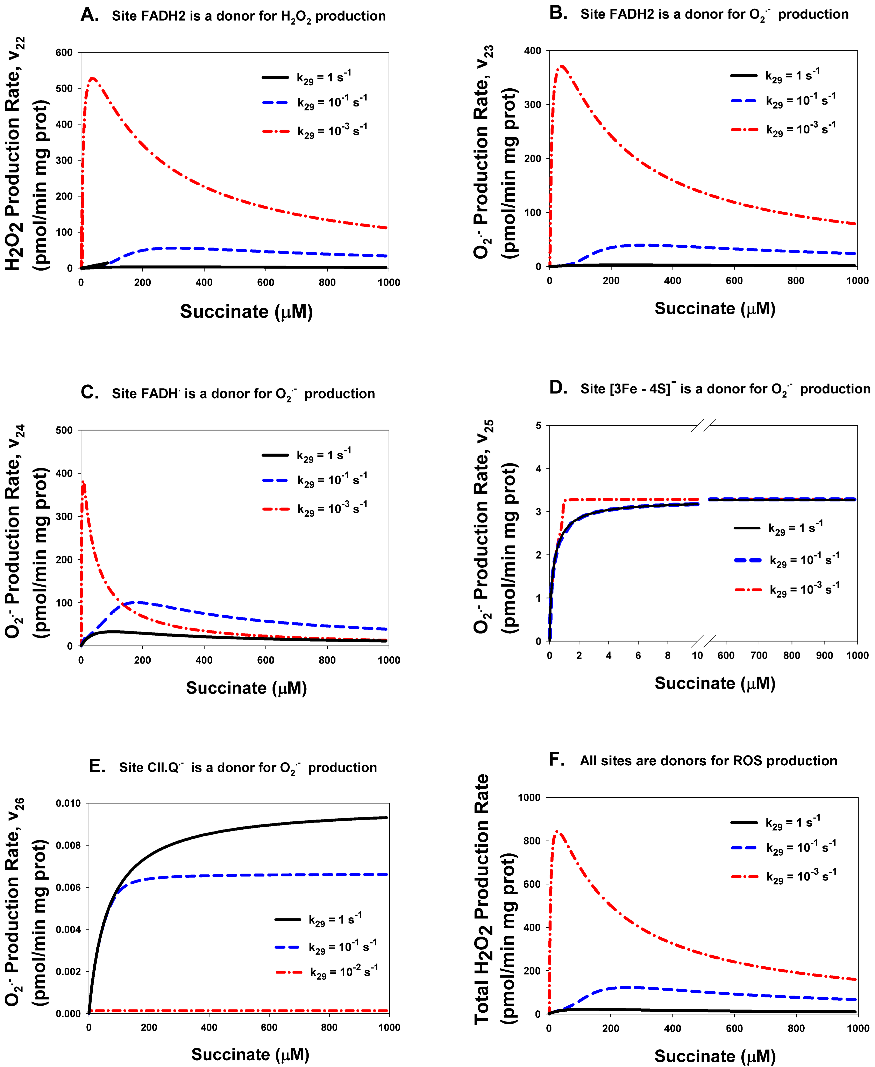

Supplementary Figure S1. Computer simulation of the effect of stigmatellin on the kinetics of ROS production by different sites of the assembled Complex II. The effect of stigmatellin was simulated by a decrease in the rate constant k₂₉ oxidation of QH₂ onto Q in the inner membrane. Values of k₂₉ are shown at the Figure S1. Black solid curves correspond to the k₂₉=1 s⁻¹, blue dashed curves – k₂₉=10⁻¹ s⁻¹, red dash-dot curves – k₂₉=10⁻³ s⁻¹. The total concentration of CII, CIIt, is 97 μM. The rest model parameters are presented in Supplementary Tables S2 and S3.

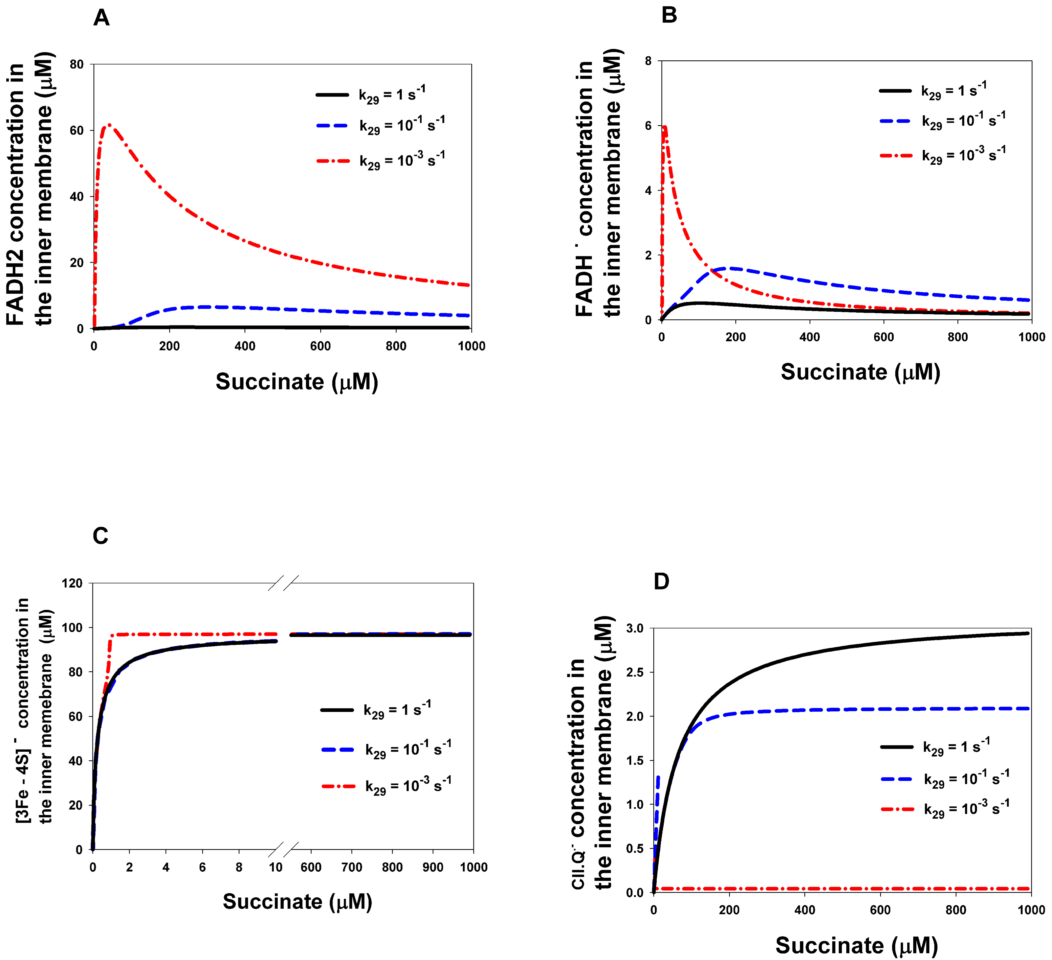
Supplementary Fig. S2. Computer simulation of the effect of stigmatellin on the concentration of different ROS producing sites of the assembled Complex II. The effect of stigmatellin was also as in Figure S1 simulated by a decrease in the rate constant k₂₉ oxidation of QH₂ onto Q in the inner membrane. Values of k₂₉ are shown at the Figure S2. Black solid curves correspond to the k₂₉=1 s⁻¹, blue dashed curves – k₂₉=10⁻¹ s⁻¹, red dash-dot curves – k₂₉=10⁻³ s⁻¹. All parameter values are the same as in Fig. S1.

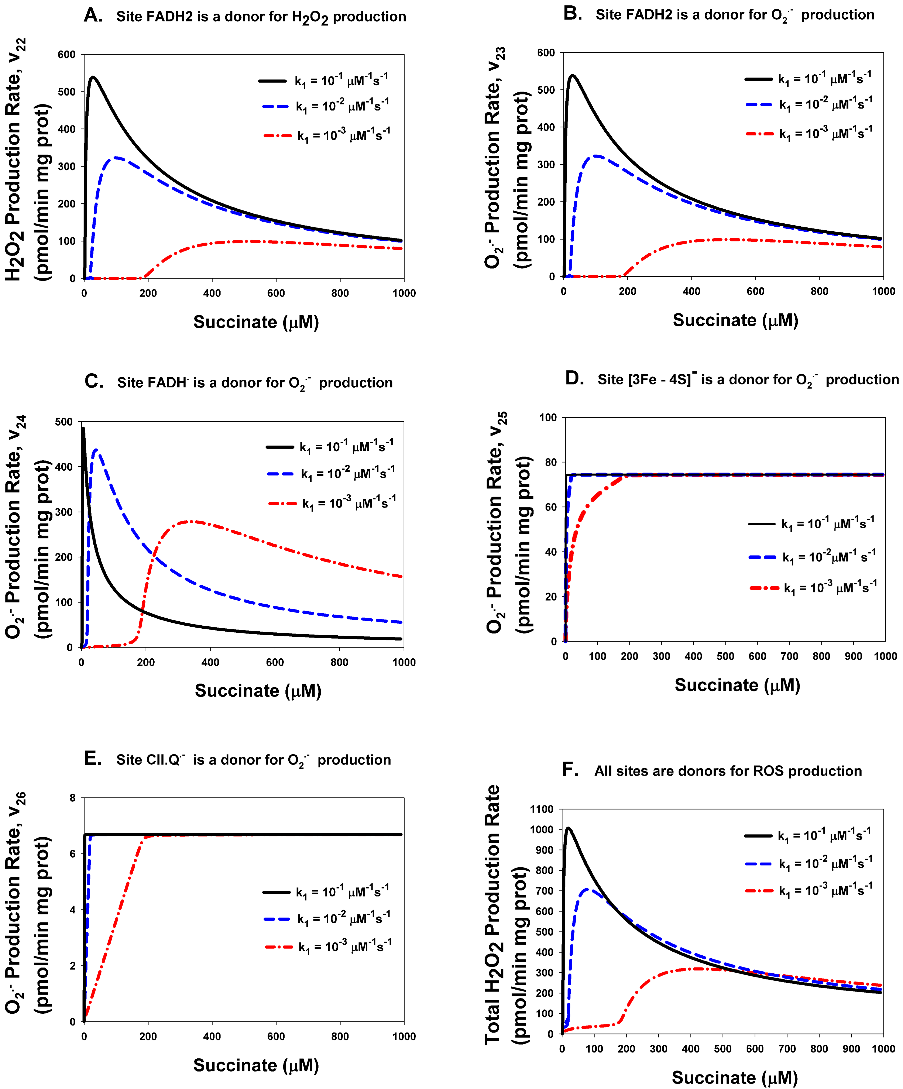
Supplementary Figure S3. Computer simulation of the effect of changes in the rate constant k₁ binding of succinate to FAD on the kinetics of ROS production by different sites of the assembled Complex II. Values of k₁ are shown at the Figure S3. Black solid curves correspond to the k₁=10⁻¹ s⁻¹, blue dashed curves – k₁=10⁻² s⁻¹, red dash-dot curves – k₁=10⁻³ s⁻¹. The rest model parameters are presented in Supplementary Table S2.

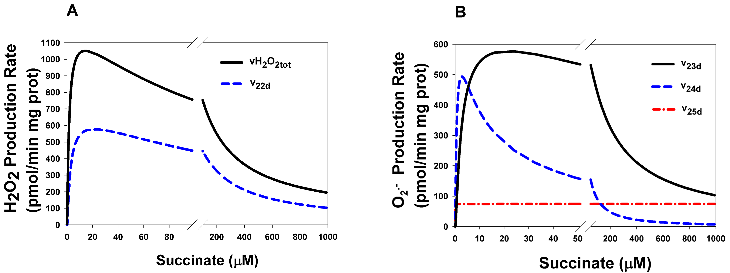
Supplementary Figure S4. Computer simulated stationary rates of O₂^{.-} and H₂O₂ production by different sites in dissociated CDHA/CDHB subcomplex of completely disintegrated CII. (A) The rate of H₂O₂ production by FADH₂ (v_{22d}) and the total rate of H₂O₂ production by all sites (vH₂O_{2tot}) in CDHA/CDHB subcomplex of completely disintegrated CII; (B) The rates of O₂^{.-} production by the following sites in CDHA/CDHB subcomplex of completely disintegrated CII: FADH₂ (v_{23d}); FADH∙(v_{24d}); reduced [3Fe-4S]⁻ cluster (v_{25d}).
Completely disintegrated CII means that all CDHA/CDHB subcomplexes of CII are dissociated from the membrane and located only in the matrix with the concentration of 235 µM.
The black solid curve in Figure S4A corresponds to the total rate of H₂O₂ production by CII (vH₂O_{2tot}) that was computed as the rate of H₂O₂ release from the mitochondrial matrix to cytosol that equal to the summary rate of H₂O₂ production by FADH₂, v_{22d}, and dismutation of O₂^{.-} , v₂₇, in the matrix at the steady state (see below Explicit functions in Mathematical model in the present Supplementary Data). The blue dashed curve in Figure S4A corresponds to the rate of H₂O₂ production by FADH₂, v_{22d}.
The black solid curve in Figure S4B corresponds to the v_{23d}, the blue dashed curve - v_{24d}, the red dash-dot curve - v_{25d}.
All model parameters are presented in Supplementary Table S2.

Mathematical model.
A computational model corresponding to the kinetic schemes in Figure 1 in the main text and Supplementary Tables S1 and S2 consists of 35 ordinary differential equations (ODE) and 15 moiety conservation equations. The model was implemented in DBSolve Optimum software available at website http://insysbio.ru.
Additionally, the model is presented in SBML format by separate file: 2019_cII_Final.xml as Supporting information. It should point out that order of expressions for dependent variables after recover the model from SBML format has to be exactly as in this Supplementary Data. See below Expressions for dependent variables.

The system of ODE. The system of ODE that was analized computationally in the present study can be written as follows:
d(FAD)/dt =-V₁-V₄+V₁₄+V₂₂+V₂₄;
d(FAD_suc)/dt =V₁-V₂;
d(FADH2_fum)/dt =V₂-V₃;
d(FADH2)/dt =V₃-V₅-V₆-V₂₂-V₂₃;
d(FAD_fum)/dt =V₄;
d(FADH2_suc)/dt =V₅;
d(FeS2)/dt =-V₆+V₇-V₁₄+V₁₅;
d(CD_QH2)/dt =V_{19d}-V_{20d};
d(CD_QH∙)/dt =V_{12d}-V_{18d};
d(FeS4)/dt =-V₇+V₈-V₁₅+V₁₆;
d(CD_Q.–)/dt =V_{11d}-V_{12d}-V_{26d};
d(FeS3)/dt =-V₈+V₉+V₁₃-V₁₆+V₁₇+V₂₁+V₂₅;
d(b_d)/dt =V_{11d}+V_{18d};
d(b)/dt =-V₉+V₁₁-V₁₇+V₁₈;
d(CD_Q)/dt =V_{10d}-V_{11d}+V_{26d};
d(Q)/dt =-V₁₀+V₂₉-V_{10d};
d(CII)/dt =-V₁₀+V₂₀ - V₂₇;
d(CII_AA5)/dt = V₂₇
d(CII_Q)/dt =V₁₀-V₁₁-V₁₃+V₂₆;
d(CII_Q.–)/dt =V₁₁-V₁₂+V₁₃-V₂₆;
d(CII_QH∙)/dt =V₁₂-V₁₈-V₂₁;
d(CII_QH)/dt =V₁₈-V₁₉+V₂₁;
d(FeS3m_d)/dt =V_{8d}+V_{16d}-V_{25d};
d(QH2)/dt =V₂₀-V₂₉+V_{20d};
d(H₂O₂)/dt = Wimb/Wmx * (V₂₂+V_{22d}) +V₂₇-V₂₈;
d(Q.–)/dt = Wimb/Wmx * (V₂₃ +V₂₄ +V₂₅ +V₂₆ +V_{23d} + V_{24d} +V_{25d} +V_{26d}) – 2*V₂₇;
d(ABt)/dt =-V₃₀;
d(FeS4m_d)/dt =V_{7d}-V_{8d}+V_{15d}-V_{16d};
d(FeS2_d)/dt =-V_{6d}+V_{7d}-V_{14d}+V_{15d};
d(FAD_d)/dt =-V_{1d}-V_{4d}+V_{14d}+V_{22d}+V_{24d};
d(FAD_suc_d)/dt =V_{1d}-V_{2d};
d(FADH2_fum_d)/dt =V_{2d}-V_{3d};
d(FADH2_d)/dt =V_{3d}-V_{5d}-V_{6d}-V_{22d}-V_{23d};
d(FAD_fum_d)/dt =V_{4d};
d(FADH2_suc_d)/dt =V_{5d};
The expressions for rates V_{i} (i=1, 30) in assembled CII and V_{j} (j=1d, 26d) in disintegrated CII are presented in Table S1, and all the parameters are in Table S2 of this Supplementary Data. Here, the fractional volume ratio of matrix, Vmx (Wmx=Vmx/Vmit) and inner membrane, Vimb (Wimb=Vimb/Vmit) to the total mitochondrial volume Vmit equal approximately 0.24 and 0.652, respectively [10].

Conserved moieties (in µM). The model took into account the laws of conservation of the total concentration in the membrane of both complex II and the pools of different redox centers.
The total concentration of ubiquinone binding centers, CD, in SDHC/SDHD complex of disintegrated CII at different states are:
Pool[1] = CD + CD_QH2 + CD_ H∙ + CD_ Q∙– + CD_Q + CD_QH─ = CDt;
The total concentration of the ubiquinone pool at different states:
Pool[2] = QH2 + Q + CII_Q + CII_Q∙– + CII_QH∙ + CII_QH─ + CII_QH2 + CD_Q + CD_Q∙– + CD_QH∙ + CD_QH─ + CD_QH2 = Qtot;
The total concentration of cyt b in SDHC/SDHD complex of disintegrated CII at different states is:
Pool[3] = b–_d + b_d =CDt;
Total concentration of FAD centers in SDHA/SDHB complex of disintegrated CII at different states is:
Pool [4] = FADHd∙ + FADd + FADd_suc + FADH2d_fum + FADH2d + FADd_fum + FADH2d_suc =ABt;
The total concentration of [3Fe–4S] clusters at different oxidized and reduced states in SDHA/SDHB complex of disintegrated CII:
Pool [5] = [3Fe–4S]d– + [3Fe–4S]d = ABt;
The total concentration of [4Fe–4S] clusters at different oxidized and reduced states in SDHA/SDHB complex of disintegrated CII:
Pool[6] = [4Fe–4S]d– + [4Fe–4S]d = ABt;
The total concentration of [2Fe–2S] clusters at different oxidized and reduced states in SDHA/SDHB complex of disintegrated CII:
Pool[7] = [2Fe–2S]d– + [2Fe–2S]d = ABt;
Total concentration of SDHC/SDHD complexes in assembled and disintegrated CII:
Pool[8] = CDt + CIIt;
The total concentration of SDHA/SDHB complexes in assembled and disintegrated CII:
Pool[9] = CIIt + ABt;
Total concentration of ubiquinone binding centers, CII, in assembled CII at different states is:
Pool[10] = CII_QH2 + CII + CII_AA5 + CII_Q + CII_Q∙– + CII_QH∙ + CII_QH─ = CIIt;
The total concentration of cyt b in assembled CII at different states is:
Pool[11] = b– + b = CIIt;
The total concentration of [3Fe–4S] clusters at different oxidized and reduced states in assembled CII:
Pool[12] = [3Fe–4S]– + [3Fe–4S] = CIIt;
The total concentration of [4Fe–4S] clusters at different oxidized and reduced states in assembled CII:
Pool[13] = [4Fe–4S]– + [4Fe–4S] = CIIt;
The total concentration of [2Fe–2S] clusters at different oxidized and reduced states in assembled CII:
Pool[14] = [2Fe–2S]– + [2Fe–2S] = CIIt;
The total concentration of FAD centers at different states in assembled CII is:
Pool[15] = FADH∙ + FAD + FAD_suc + FADH2_fum + FADH2 + FAD_fum + FADH2_suc = CIIt;
The concentration of pools of all redox centers in assembled and disintegrated CII is taken to be equal to the concentration of corresponding SDHA/SDHB and SDHC/SDHD complexes, i.e. 1 redox center per 1 SDHA/SDHB or SDHC/SDHD complex.
So, total concentration of assembled and disintegrated CII: Pool[8]=Pool[9]= 235 µM.
Pool[2] = 4541 µM; Pool[1] = Pool[3] = CDt; Pool[4] = Pool[5] = Pool[6] = Pool[7] = ABt;
Pool[10] = Pool[11] = Pool[12] = Pool[13] = Pool[14] ] = Pool[15] = CIIt, where the total stationary concentrations CIIt, ABt and CDt are taken 100, 135 and 135 µM, respectively, that corresponds to K_{eq30}=5.487∙10⁻³ µM⁻¹.
The concentration of AA5, inhibitor of the Q-binding site, is taken unchanged in time, i.e. it is used in the model as a parameter.
Expressions for dependent variables. The expressions for the concentration of all 15 dependent variables used in ODE are easily calculated from the pools of different variables and are presented below.
CD_QH = - CD_QH2 – CD_QH∙ - CD_Q∙– - CD_Q – Q – CII_Q – CII_Q∙– - CII_QH∙ - CII_QH─ - QH2 – CII_QH2 + Pool[2];
CD = - CD_QH2 – CD_QH∙ - CD_Q∙– - CD_Q – CD_QH─ + Pool[1];
b─_d = - b_d + Pool[3];
FADHd∙ = - FADd – FADd_suc – FADH2d_fum – FADH2d – FADd_fum –FADH2d_suc + Pool[4];
[3Fe–4S]d = - [3Fe–4S]d─ + Pool[5];
[Fe–4S]d = - [4Fe–4S]d─ + Pool[6];
[2Fe–2S]d─ = - [2Fe–2S]d + Pool[7];
CIIt = - ABt + Pool[9];
CDt = - CIIt + Pool[8];
CII_QH2 = - CII – CII_AA5 – CII_Q – CII_Q∙– - CII_QH∙ - CII_QH─ + Pool[10];
b─ = - b + Pool[11];
[3Fe–4S]─ = - [3Fe–4S] + Pool[12];
[4Fe–4S]─ = - [4Fe–4S] + Pool[13];
[2Fe–2S]─ = - [2Fe–2S] + Pool[14];
FADH─ = - FAD – FAD_suc – FADH2_fum – FADH2 – FAD_fum – FADH2_suc + Pool[15];
Explicit functions. Expressions for some important functions used in computations are presented below.
VO₂∙–_{tot} = V₂₃ + V₂₄ + V₂₅ + V₂₆ + V_{23d} + V_{24d} + V_{25d} + V_{26d}; the total rate of O₂∙– production by assembled and disintegrated CII in µM/s.
VH₂O_{2tot} = (V₂₂ + V_{22d})*Wimb/Wmx + V₂₈; the total rate of H₂O₂ production by assembled and disintegrated CII in µM/s expressed as WHOLE MITO Rates (Wimb=Vimb/Vmit, where Vimb and Vmit are volumes of the inner membrane and whole mitochondria, respectively) and Wimb=0.24 [10].
vO₂∙–_{tot} = VO₂∙–_{tot} *220*Wimb; The total rate of O₂∙– production normalized to the total mitochondria volume in order to compare with experimental data, in pmole/min/mg prot, 1 μM/s = 220 pmol/min mg mitochondrial protein [10].
vH₂O_{2tot} = VH₂O_{2tot} * 220 * Wmx; The total rate of H₂O₂ production normalized to the total mitochondria volume in order to compare with experimental data, in pmole/min/mg prot.
v₂₀ = V₂₀*220*Wimb/1000; the rate of QH₂ production in nmole/min/mg prot
v₆=V₆*220*Wimb/1000; in nmole/min/mg prot.
v_{6f}=V_{6f}*220*Wimb/1000, where V_{6f} is the forward rate of V₆: V_{6f} = k₆ ∙ FADH2 ∙ [2Fe-2S];
v_{6r}=V_{6r}*220*Wimb/1000, where V_{6r} is the reverse rate of V₆: V_{6r} = k₆ ∙ FADH∙ ∙ [2Fe-2S]⁻ ∙ H⁺ / K_{eq6};
v₈=V₈*220*Wimb/1000; v₉=V₉*220*Wimb/1000; v₁₁=V₁₁*220*Wimb/1000; v₁₃=V₁₃*220*Wimb/1000;
Other rates expressed in nmole/min/mg prot in order to compare with experimental data.
v₂₂=V₂₂*220*0.24; v₂₃=V₂₃*220*0.24; v_{23f}=V_{23f}*220*0.24, where V_{23f} = k₂₃ ∙ FADH2 ∙ O₂;
v_{23r}=V_{23r}*220*0.24, where V_{23r} = k₂₃ ∙FADH∙ ∙ O₂^{.-} ∙ H⁺ / K_{eq23};
v₂₄=V₂₄*220*0.24; v₂₅=V₂₅*220*0.24; v₂₆=V₂₆*220*0.24;
v_{22d}=V_{22d}*220*0.24; v_{23d}=V_{23d}*220*0.24; v_{24d}=V_{24d}*220*0.24; v_{25d}=V_{25d}*220*0.24;
v_{26d}=V_{26d}*220*0.24.

