Supplementary Material

Polymorphisms in STING affect human innate immune responses to poxviruses
Richard B. Kennedy, PhD^{1*}; Iana H. Haralambieva, PhD¹; Inna G. Ovsyannikova, PhD¹; Emily A. Voigt, PhD¹; Beth R. Larrabee²; Daniel J. Schaid, PhD²; Michael T. Zimmermann, PhD³; Ann L. Oberg, PhD²; Gregory A. Poland, MD¹
¹Mayo Clinic Vaccine Research Group, Mayo Clinic, 200 First Street SW, Rochester, MN, 55905 USA
²Division of Biomedical Statistics and Informatics, Department of Health Science Research,
Mayo Clinic, 200 First Street SW, Rochester, MN 55905 USA
³Bioinformatics Research and Development Laboratory, Genomics Sciences and Precision Medicine Center, Medical College of Wisconsin, 8701 Watertown Plank Rd., Milwaukee, WI, 53226, USA

Supplementary Figures and Tables

Supplementary Table 1

Supplementary Table 1. Cohort Demographics
Total subjects | 1,653
Gender
Male | 1,365 (82.6%)
Female | 288 (17.4%)
Age | 19 – 41 years old
Ethnicity
Hispanic/Latino | 381 (23%)
Not Hispanic/Latino | 1248 (75.5%)
Unknown | 24 (1.5%)
Race
American Indian/Alaska Native | 26 (1.6%)
Asian, Native Hawaiian, Pacific Islander | 12 (0.7%)
African American | 25 (1.5%)
Caucasian | 1,351 (81.7%)
More than one race | 81 (4.9%)
Other | 120 (7.3%)
Unknown | 38 (2.3%)
Time since immunization
Median | 1.7 years
Range | 1.1 – 2.8 years

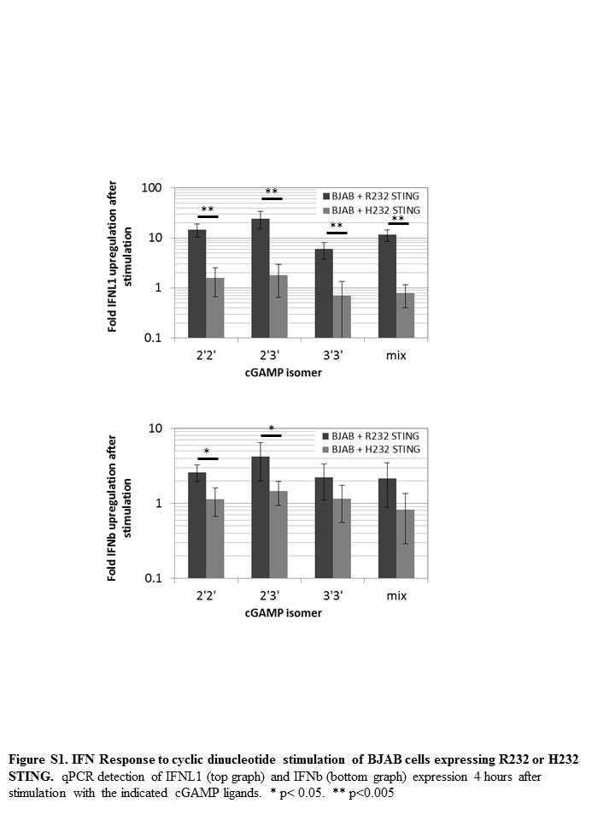Supplementary Figure 1.

Supplementary Figure 2.
