Supplementary Material

Supplementary Figures and Tables

Tables
Table S1: Glacial rock flour (GRF) elemental composition, separated by major and minor elements.
Major Elemental Composition | Percent Composition
SiO₂ | 52.02%
Al₂O₃ | 16.61%
Fe₂O₃ | 9.67%
MnO | 0.17%
MgO | 4.82%
CaO | 8.58%
Na₂O | 1.94%
K₂O | 0.75%
TiO₂ | 0.55%
P₂O₅ | 0.10%
Minor Elemental Composition
Sc | 0.0041%
V | 0.0232%
Cr | 0.002%
Co | 0.0027%
Ni | 0.0011%
Cu | 0.0078%
Zn | 0.0092%
S | 0.113%
Ga | 0.0017%
Ge | 0.00010%
Rb | 0.0009%
Sr | 0.0131%
Y | 0.00223%
Zr | 0.0028%
Nb | 0.00008
Cs | 0.00009%
Ba | 0.0144%
La | 0.0002477%
Ce | 0.0006800%
Pr | 0.0001143%
Nd | 0.0006367%
Sm | 0.0002327%
Eu | 0.00007673%
Gd | 0.000301%
Tb | 0.000056%
Dy | 0.000377%
Ho | 0.000082%
Er | 0.000241%
Tm | 0.0000353%
Yb | 0.000245%
Lu | 0.0000525%
Hf | 0.00009%
Ta | 0.000005%
Th | 0.000031%
U | 0.000024%

Table S2: Taxonomic composition of phytoplankton within each mesocosm tank. Finest taxonomic identification was down to genus (Guiry and Guiry, 2020). Rare taxa, which are defined as those which total less than 5% of total phytoplankton density in each tank, are excluded. Biovolume (BV) and percent composition is given for all genera that comprise more than 5% of the total phytoplankton biovolume in each tank. Phytoplankton were sampled on day 0 and day 9 in chlorophyte-dominated (n= 6), cyanophyte-dominated (n= 8) and control (n= 3) mesocosm tanks.
Day | Tank | Experimental Group | Functional Group | Division | Genus | Percent Composition | BV (mm³ L⁻¹)
0 | 1 | Cyanophyte-Dominated | Potentially Toxigenic Cyanophyta | Cyanobacteria | Raphidiopsis sp. | 35.6 | 26.89
0 | 1 | Cyanophyte-Dominated | Cryptophyta and Dinoflagellates | Cryptophyta | Cryptomonas sp. | 22.1 | 16.70
0 | 1 | Cyanophyte-Dominated | Potentially Toxigenic Cyanophyta | Cyanobacteria | Aphanizomenon sp. | 17.4 | 13.18
0 | 1 | Cyanophyte-Dominated | Potentially Toxigenic Cyanophyta | Cyanobacteria | Dolichospermum sp. | 12.5 | 9.47
0 | 2 | Control | Cryptophyta and Dinoflagellates | Miozoa | Ceratium sp. | 34.1 | 0.38
0 | 2 | Control | Cryptophyta and Dinoflagellates | Cryptophyta | Cryptomonas sp. | 28.9 | 0.32
0 | 2 | Control | Chlorophyta | Chlorophyta | Sphaerocystis sp. | 5.6 | 0.06
0 | 3 | Chlorophyte-Dominated | Cryptophyta and Dinoflagellates | Miozoa | Peridinium sp. | 30.4 | 0.19
0 | 3 | Chlorophyte-Dominated | Cryptophyta and Dinoflagellates | Cryptophyta | Cryptomonas sp. | 24.6 | 0.16
0 | 3 | Chlorophyte-Dominated | Cryptophyta and Dinoflagellates | Cryptophyta | Plagioselmis sp. | 16.3 | 0.10
0 | 3 | Chlorophyte-Dominated | Potentially Toxigenic Cyanophyta | Cyanobacteria | Microcystis sp. | 7.3 | 0.05
0 | 4 | Chlorophyte-Dominated | Chlorophyta | Chlorophyta | Oocystis sp. | 86.9 | 3.02
0 | 4 | Chlorophyte-Dominated | Cryptophyta and Dinoflagellates | Cryptophyta | Cryptomonas sp. | 8.0 | 0.28
0 | 5 | Chlorophyte-Dominated | Chlorophyta | Chlorophyta | Oocystis sp. | 44.3 | 0.76
0 | 5 | Chlorophyte-Dominated | Non-toxin Producing Cyanophyta | Cyanobacteria | Planktolyngbya sp. | 14.1 | 0.24
0 | 5 | Chlorophyte-Dominated | Non-toxin Producing Cyanophyta | Cyanobacteria | Merismopedia sp. | 10.7 | 0.18
0 | 5 | Chlorophyte-Dominated | Chlorophyta | Chlorophyta | Tetraedron sp. | 9.1 | 0.15
0 | 6 | Chlorophyte-Dominated | Chlorophyta | Chlorophyta | Oocystis sp. | 52.9 | 2.62
0 | 6 | Chlorophyte-Dominated | Cryptophyta and Dinoflagellates | Miozoa | Ceratium sp. | 14.7 | 0.73
0 | 6 | Chlorophyte-Dominated | Cryptophyta and Dinoflagellates | Cryptophyta | Cryptomonas sp. | 8.3 | 0.41
0 | 7 | Cyanophyte-Dominated | Chrysophyta | Ochrophyta | Ochromonas sp. | 32.9 | 7.27
0 | 7 | Cyanophyte-Dominated | Non-toxin Producing Cyanophyta | Cyanobacteria | Planktolyngbya sp. | 25.5 | 5.63
0 | 7 | Cyanophyte-Dominated | Potentially Toxigenic Cyanophyta | Cyanobacteria | Aphanizomenon sp. | 17.0 | 3.77
0 | 7 | Cyanophyte-Dominated | Potentially Toxigenic Cyanophyta | Cyanobacteria | Cylindrospermopsis sp. | 11.4 | 2.53
0 | 8 | Chlorophyte-Dominated | Chrysophyta | Haptophyta | Chrysochromulina sp. | 29.2 | 0.76
0 | 8 | Chlorophyte-Dominated | Chlorophyta | Chlorophyta | Oocystis sp. | 20.1 | 0.52
0 | 8 | Chlorophyte-Dominated | Cryptophyta and Dinoflagellates | Cryptophyta | Cryptomonas sp. | 14.5 | 0.38
0 | 8 | Chlorophyte-Dominated | Non-toxin Producing Cyanophyta | Cyanobacteria | Planktolyngbya sp. | 11.5 | 0.30
0 | 8 | Chlorophyte-Dominated | Cryptophyta and Dinoflagellates | Cryptophyta | Plagioselmis sp. | 6.5 | 0.17
0 | 9 | Cyanophyte-Dominated | Potentially Toxigenic Cyanophyta | Cyanobacteria | Aphanizomenon sp. | 39.6 | 30.92
0 | 9 | Cyanophyte-Dominated | Potentially Toxigenic Cyanophyta | Cyanobacteria | Planktothrix sp. | 22.3 | 17.42
0 | 9 | Cyanophyte-Dominated | Non-toxin Producing Cyanophyta | Cyanobacteria | Pseudanabaena sp. | 13.8 | 10.81
0 | 9 | Cyanophyte-Dominated | Potentially Toxigenic Cyanophyta | Cyanobacteria | Dolichospermum sp. | 8.1 | 6.34
0 | 9 | Cyanophyte-Dominated | Non-toxin Producing Cyanophyta | Cyanobacteria | Limnothrix sp. | 6.8 | 5.31
0 | 10 | Control | Chlorophyta | Chlorophyta | Scenedesmus sp. | 35.8 | 0.94
0 | 10 | Control | Cryptophyta and Dinoflagellates | Cryptophyta | Plagioselmis sp. | 18.2 | 0.48
0 | 10 | Control | Chrysophyta | Haptophyta | Chrysochromulina sp. | 12.9 | 0.34
0 | 10 | Control | Cryptophyta and Dinoflagellates | Cryptophyta | Cryptomonas sp. | 12.0 | 0.31
0 | 10 | Control | Chrysophyta | Ochrophyta | Ochromonas sp. | 6.6 | 0.17
0 | 11 | Cyanophyte-Dominated | Cryptophyta and Dinoflagellates | Cryptophyta | Cryptomonas sp. | 39.3 | 2.70
0 | 11 | Cyanophyte-Dominated | Chlorophyta | Chlorophyta | Scenedesmus sp. | 30.7 | 2.11
0 | 11 | Cyanophyte-Dominated | Non-toxin Producing Cyanophyta | Cyanobacteria | Planktolyngbya sp. | 10.1 | 0.70
0 | 12 | Cyanophyte-Dominated | Potentially Toxigenic Cyanophyta | Cyanobacteria | Aphanizomenon sp. | 49.4 | 30.37
0 | 12 | Cyanophyte-Dominated | Non-toxin Producing Cyanophyta | Cyanobacteria | Pseudanabaena sp. | 25.5 | 15.68
0 | 12 | Cyanophyte-Dominated | Non-toxin Producing Cyanophyta | Cyanobacteria | Limnothrix sp. | 9.3 | 5.72
0 | 12 | Cyanophyte-Dominated | Cryptophyta and Dinoflagellates | Cryptophyta | Cryptomonas sp. | 5.4 | 3.35
0 | 13 | Cyanophyte-Dominated | Potentially Toxigenic Cyanophyta | Cyanobacteria | Aphanizomenon sp. | 42.5 | 3.59
0 | 13 | Cyanophyte-Dominated | Potentially Toxigenic Cyanophyta | Cyanobacteria | Dolichospermum sp. | 22.9 | 1.93
0 | 13 | Cyanophyte-Dominated | Chlorophyta | Chlorophyta | Scenedesmus sp. | 5.1 | 0.43
0 | 13 | Cyanophyte-Dominated | Non-toxin Producing Cyanophyta | Cyanobacteria | Cuspidothrix sp. | 12.6 | 1.07
0 | 13 | Cyanophyte-Dominated | Potentially Toxigenic Cyanophyta | Cyanobacteria | Microcystis sp. | 9.6 | 0.81
0 | 14 | Chlorophyte-Dominated | Chlorophyta | Chlorophyta | Sphaerocystis sp. | 17.5 | 0.33
0 | 14 | Chlorophyte-Dominated | Chlorophyta | Chlorophyta | Chlorella sp. | 12.5 | 0.24
0 | 14 | Chlorophyte-Dominated | Chlorophyta | Chlorophyta | Scenedesmus sp. | 12.0 | 0.23
0 | 14 | Chlorophyte-Dominated | Chrysophyta | Bacillariophyta | Cyclotella sp. | 11.4 | 0.22
0 | 14 | Chlorophyte-Dominated | Chrysophyta | Haptophyta | Chrysochromulina sp. | 10.2 | 0.20
0 | 14 | Chlorophyte-Dominated | Chlorophyta | Chlorophyta | Oocystis sp. | 8.4 | 0.16
0 | 14 | Chlorophyte-Dominated | Chrysophyta | Ochrophyta | Ochromonas sp. | 6.3 | 0.12
0 | 14 | Chlorophyte-Dominated | Chlorophyta | Chlorophyta | Chlamydomonas sp. | 5.5 | 0.11
0 | 15 | Control | Chlorophyta | Chlorophyta | Tetraedron sp. | 78.5 | 7.73
0 | 16 | Cyanophyte-Dominated | Potentially Toxigenic Cyanophyta | Cyanobacteria | Dolichospermum sp. | 73.4 | 10.83
0 | 16 | Cyanophyte-Dominated | Chlorophyta | Chlorophyta | Crucigenia sp. | 7.0 | 1.04
0 | 16 | Cyanophyte-Dominated | Potentially Toxigenic Cyanophyta | Cyanobacteria | Microcystis sp. | 5.7 | 0.84
0 | 17 | Cyanophyte-Dominated | Potentially Toxigenic Cyanophyta | Cyanobacteria | Dolichospermum sp. | 56.7 | 8.51
0 | 17 | Cyanophyte-Dominated | Chlorophyta | Chlorophyta | Desmodesmus sp. | 15.5 | 2.33
0 | 17 | Cyanophyte-Dominated | Potentially Toxigenic Cyanophyta | Cyanobacteria | Microcystis sp. | 14.5 | 2.18
9 | 1 | Cyanophyte-Dominated | Potentially Toxigenic Cyanophyta | Cyanobacteria | Raphidiopsis sp. | 34.0 | 10.41
9 | 1 | Cyanophyte-Dominated | Potentially Toxigenic Cyanophyta | Cyanobacteria | Aphanizomenon sp. | 28.0 | 8.59
9 | 1 | Cyanophyte-Dominated | Cryptophyta and Dinoflagellates | Cryptophyta | Cryptomonas sp. | 11.7 | 3.58
9 | 1 | Cyanophyte-Dominated | Chlorophyta | Chlorophyta | Vitreochlamys sp. | 9.9 | 3.02
9 | 1 | Cyanophyte-Dominated | Non-toxin Producing Cyanophyta | Cyanobacteria | Pseudanabaena sp. | 6.1 | 1.87
9 | 2 | Control | Cryptophyta and Dinoflagellates | Miozoa | Ceratium sp. | 52.9 | 0.70
9 | 2 | Control | Cryptophyta and Dinoflagellates | Miozoa | Gymnodinium sp. | 13.9 | 0.18
9 | 2 | Control | Cryptophyta and Dinoflagellates | Cryptophyta | Plagioselmis sp. | 9.4 | 0.12
9 | 3 | Chlorophyte-Dominated | Cryptophyta and Dinoflagellates | Cryptophyta | Cryptomonas sp. | 57.4 | 0.58
9 | 3 | Chlorophyte-Dominated | Cryptophyta and Dinoflagellates | Cryptophyta | Plagioselmis sp. | 16.6 | 0.17
9 | 3 | Chlorophyte-Dominated | Chrysophyta | Ochrophyta | Ochromonas sp. | 8.5 | 0.09
9 | 4 | Chlorophyte-Dominated | Cryptophyta and Dinoflagellates | Cryptophyta | Cryptomonas sp. | 38.4 | 0.46
9 | 4 | Chlorophyte-Dominated | Chlorophyta | Chlorophyta | Oocystis sp. | 31.7 | 0.38
9 | 4 | Chlorophyte-Dominated | Cryptophyta and Dinoflagellates | Cryptophyta | Rhodomonas sp. | 15.8 | 0.19
9 | 5 | Chlorophyte-Dominated | Chlorophyta | Chlorophyta | Sphaerocystis sp. | 22.4 | 0.30
9 | 5 | Chlorophyte-Dominated | Chlorophyta | Chlorophyta | Oocystis sp. | 16.3 | 0.22
9 | 5 | Chlorophyte-Dominated | Chlorophyta | Chlorophyta | Drepanochloris sp. | 15.6 | 0.21
9 | 5 | Chlorophyte-Dominated | Cryptophyta and Dinoflagellates | Cryptophyta | Rhodomonas sp. | 15.7 | 0.21
9 | 6 | Chlorophyte-Dominated | Cryptophyta and Dinoflagellates | Cryptophyta | Cryptomonas sp. | 63.5 | 2.33
9 | 6 | Chlorophyte-Dominated | Chlorophyta | Chlorophyta | Oocystis sp. | 14.5 | 0.53
9 | 6 | Chlorophyte-Dominated | Cryptophyta and Dinoflagellates | Cryptophyta | Rhodomonas sp. | 10.3 | 0.38
9 | 7 | Cyanophyte-Dominated | Cryptophyta and Dinoflagellates | Cryptophyta | Cryptomonas sp. | 93.0 | 114.00
9 | 8 | Chlorophyte-Dominated | Chrysophyta | Haptophyta | Chrysochromulina sp. | 69.4 | 3.09
9 | 8 | Chlorophyte-Dominated | Cryptophyta and Dinoflagellates | Cryptophyta | Cryptomonas sp. | 13.6 | 0.61
9 | 9 | Cyanophyte-Dominated | Non-toxin Producing Cyanophyta | Cyanobacteria | Planktothrix sp. | 35.2 | 7.13
9 | 9 | Cyanophyte-Dominated | Non-toxin Producing Cyanophyta | Cyanobacteria | Pseudanabaena sp. | 24.8 | 5.02
9 | 9 | Cyanophyte-Dominated | Potentially Toxigenic Cyanophyta | Cyanobacteria | Aphanizomenon sp. | 10.5 | 2.12
9 | 10 | Control | Chlorophyta | Chlorophyta | Scenedesmus sp. | 32.9 | 0.77
9 | 10 | Control | Cryptophyta and Dinoflagellates | Cryptophyta | Plagioselmis sp. | 25.8 | 0.60
9 | 10 | Control | Chrysophyta | Haptophyta | Chrysochromulina sp. | 24.0 | 0.56
9 | 10 | Control | Cryptophyta and Dinoflagellates | Cryptophyta | Cryptomonas sp. | 5.9 | 0.14
9 | 10 | Control | Chlorophyta | Chlorophyta | Pandorina sp. | 5.2 | 0.12
9 | 11 | Cyanophyte-Dominated | Cryptophyta and Dinoflagellates | Cryptophyta | Cryptomonas sp. | 49.9 | 6.50
9 | 11 | Cyanophyte-Dominated | Chlorophyta | Chlorophyta | Scenedesmus sp. | 19.6 | 2.56
9 | 11 | Cyanophyte-Dominated | Chrysophyta | Bacillariophyta | Cyclotella sp. | 18.4 | 2.40
9 | 12 | Cyanophyte-Dominated | Cryptophyta and Dinoflagellates | Cryptophyta | Cryptomonas sp. | 91.9 | 24.66
9 | 13 | Cyanophyte-Dominated | Chlorophyta | Chlorophyta | Scenedesmus sp. | 52.6 | 0.17
9 | 13 | Cyanophyte-Dominated | Potentially Toxigenic Cyanophyta | Cyanobacteria | Aphanizomenon sp. | 17.4 | 0.06
9 | 13 | Cyanophyte-Dominated | Chlorophyta | Chlorophyta | Monoraphidium sp. | 6.5 | 0.02
9 | 13 | Cyanophyte-Dominated | Non-toxin Producing Cyanophyta | Cyanobacteria | Eucapsis sp. | 7.2 | 0.02
9 | 14 | Chlorophyte-Dominated | Cryptophyta and Dinoflagellates | Cryptophyta | Cryptomonas sp. | 20.2 | 0.76
9 | 14 | Chlorophyte-Dominated | Cryptophyta and Dinoflagellates | Cryptophyta | Plagioselmis sp. | 14.2 | 0.53
9 | 14 | Chlorophyte-Dominated | Chrysophyta | Haptophyta | Chrysochromulina sp. | 13.7 | 0.51
9 | 14 | Chlorophyte-Dominated | Chlorophyta | Chlorophyta | Sphaerocystis sp. | 12.3 | 0.46
9 | 14 | Chlorophyte-Dominated | Non-toxin Producing Cyanophyta | Cyanobacteria | Planktolyngbya sp. | 9.7 | 0.36
9 | 14 | Chlorophyte-Dominated | Chrysophyta | Ochrophyta | Ochromonas sp. | 6.2 | 0.23
9 | 14 | Chlorophyte-Dominated | Chrysophyta | Bacillariophyta | Cyclotella sp. | 5.6 | 0.21
9 | 14 | Chlorophyte-Dominated | Chlorophyta | Chlorophyta | Scenedesmus sp. | 5.6 | 0.21
9 | 15 | Control | Chlorophyta | Chlorophyta | Tetraedron sp. | 68.7 | 2.92
9 | 15 | Control | Potentially Toxigenic Cyanophyta | Cyanobacteria | Microcystis sp. | 10.0 | 0.42
9 | 15 | Control | Chlorophyta | Chlorophyta | Crucigenia sp. | 5.1 | 0.22
9 | 16 | Cyanophyte-Dominated | Potentially Toxigenic Cyanophyta | Cyanobacteria | Dolichospermum sp. | 30.6 | 1.10
9 | 16 | Cyanophyte-Dominated | Potentially Toxigenic Cyanophyta | Cyanobacteria | Aphanizomenon sp. | 22.1 | 0.80
9 | 16 | Cyanophyte-Dominated | Non-toxin Producing Cyanophyta | Cyanobacteria | Planktolyngbya sp. | 19.5 | 0.70
9 | 16 | Cyanophyte-Dominated | Potentially Toxigenic Cyanophyta | Cyanobacteria | Microcystis sp. | 5.1 | 0.18
9 | 17 | Cyanophyte-Dominated | Chlorophyta | Chlorophyta | Desmodesmus sp. | 40.9 | 3.17
9 | 17 | Cyanophyte-Dominated | Cryptophyta and Dinoflagellates | Cryptophyta | Cryptomonas sp. | 17.3 | 1.35
9 | 17 | Cyanophyte-Dominated | Non-toxin Producing Cyanophyta | Cyanobacteria | Planktolyngbya sp. | 13.6 | 1.05
9 | 17 | Cyanophyte-Dominated | Chlorophyta | Chlorophyta | Scenedesmus sp. | 5.1 | 0.39
9 | 17 | Cyanophyte-Dominated | Potentially Toxigenic Cyanophyta | Cyanobacteria | Microcystis sp. | 7.3 | 0.57
9 | 17 | Cyanophyte-Dominated | Euglenophyta | Euglenophyta | Euglena sp. | 6.9 | 0.54

Table S3: Phytoplankton categorization based on functional group. Phytoplankton were identified to genus and placed into one of six functional groups: potentially toxigenic cyanophyta (Chapman and Foss 2019), non-toxin producing cyanophyta, chlorophyta, euglenophyta, cryptophyta and dinoflagellates, and chrysophyta, including bacillariophytes, chrysophytes, ochrophytes, and haptophytes.
Division | Genus | Functional Group
Cyanobacteria | Aphanizomenon sp. | potentially toxigenic cyanophyta
Cyanobacteria | Cylindrospermopsis sp. | potentially toxigenic cyanophyta
Cyanobacteria | Dolichospermum sp. | potentially toxigenic cyanophyta
Cyanobacteria | Microcystis sp. | potentially toxigenic cyanophyta
Cyanobacteria | Planktothrix sp. | potentially toxigenic cyanophyta
Cyanobacteria | Raphidiopsis sp. | potentially toxigenic cyanophyta
Cyanobacteria | Anathece sp. | non-toxin producing cyanophyta
Cyanobacteria | Aphanocapsa sp. | non-toxin producing cyanophyta
Cyanobacteria | Chroococcus sp. | non-toxin producing cyanophyta
Cyanobacteria | Cuspidothrix sp. | non-toxin producing cyanophyta
Cyanobacteria | Cyanodictyon sp. | non-toxin producing cyanophyta
Cyanobacteria | Eucapsis sp. | non-toxin producing cyanophyta
Cyanobacteria | Limnothrix sp. | non-toxin producing cyanophyta
Cyanobacteria | Merismopedia sp. | non-toxin producing cyanophyta
Cyanobacteria | Planktolyngbya sp. | non-toxin producing cyanophyta
Cyanobacteria | Pseudanabaena sp. | non-toxin producing cyanophyta
Cyanobacteria | Snowella sp. | non-toxin producing cyanophyta
Chlorophyta | Actinastrum sp. | chlorophyta
Chlorophyta | Ankyra sp. | chlorophyta
Chlorophyta | Asterococcus sp. | chlorophyta
Chlorophyta | Chlamydomonas sp. | chlorophyta
Chlorophyta | Chlorella sp. | chlorophyta
Chlorophyta | Chlorogonium sp. | chlorophyta
Chlorophyta | Coelastrum sp. | chlorophyta
Chlorophyta | Cosmarium sp. | chlorophyta
Chlorophyta | Crucigenia sp. | chlorophyta
Chlorophyta | Desmodesmus sp. | chlorophyta
Chlorophyta | Dictyosphaerium sp. | chlorophyta
Chlorophyta | Drepanochloris sp. | chlorophyta
Chlorophyta | Elakatothrix sp. | chlorophyta
Chlorophyta | Golenkiniopsis sp. | chlorophyta
Chlorophyta | Kirchneriella sp. | chlorophyta
Chlorophyta | Monoraphidium sp. | chlorophyta
Chlorophyta | Oocystis sp. | chlorophyta
Chlorophyta | Pandorina sp. | chlorophyta
Chlorophyta | Pedinomonas sp. | chlorophyta
Chlorophyta | Scenedesmus sp. | chlorophyta
Chlorophyta | Sphaerocystis sp. | chlorophyta
Chlorophyta | Tetraedron sp. | chlorophyta
Chlorophyta | Tetrastrum sp. | chlorophyta
Chlorophyta | Treubaria sp. | chlorophyta
Chlorophyta | Vitreochlamys sp. | chlorophyta
Euglenophyta | Euglena sp. | euglenophyta
Miozoa | Ceratium sp. | cryptophyta and dinoflagellates
Cryptophyta | Chroomonas sp. | cryptophyta and dinoflagellates
Cryptophyta | Cryptomonas sp. | cryptophyta and dinoflagellates
Miozoa | Gymnodinium sp. | cryptophyta and dinoflagellates
Miozoa | Peridinium sp. | cryptophyta and dinoflagellates
Cryptophyta | Plagioselmis sp. | cryptophyta and dinoflagellates
Cryptophyta | Rhodomonas sp. | cryptophyta and dinoflagellates
Bacillariophyta | Achnanthidium sp. | chrysophyta (including bacillariophytes, chrysophytes, ochrophytes, and haptophytes)
Ochrophyta | Chromulina sp. | chrysophyta (including bacillariophytes, chrysophytes, ochrophytes, and haptophytes)
Haptophyta | Chrysochromulina sp. | chrysophyta (including bacillariophytes, chrysophytes, ochrophytes, and haptophytes)
Bacillariophyta | Cocconeis sp. | chrysophyta (including bacillariophytes, chrysophytes, ochrophytes, and haptophytes)
Bacillariophyta | Cyclotella sp. | chrysophyta (including bacillariophytes, chrysophytes, ochrophytes, and haptophytes)
Bacillariophyta | Eunotia sp. | chrysophyta (including bacillariophytes, chrysophytes, ochrophytes, and haptophytes)
Bacillariophyta | Fragilaria sp. | chrysophyta (including bacillariophytes, chrysophytes, ochrophytes, and haptophytes)
Bacillariophyta | Geissleria sp. | chrysophyta (including bacillariophytes, chrysophytes, ochrophytes, and haptophytes)
Bacillariophyta | Gomphonema sp. | chrysophyta (including bacillariophytes, chrysophytes, ochrophytes, and haptophytes)
Ochrophyta | Mallomonas sp. | chrysophyta (including bacillariophytes, chrysophytes, ochrophytes, and haptophytes)
Bacillariophyta | Nitzschia sp. | chrysophyta (including bacillariophytes, chrysophytes, ochrophytes, and haptophytes)
Ochrophyta | Ochromonas sp. | chrysophyta (including bacillariophytes, chrysophytes, ochrophytes, and haptophytes)
Bacillariophyta | Planothidium sp. | chrysophyta (including bacillariophytes, chrysophytes, ochrophytes, and haptophytes)
Bacillariophyta | Rhoicosphenia sp. | chrysophyta (including bacillariophytes, chrysophytes, ochrophytes, and haptophytes)
Bacillariophyta | Rhopalodia sp. | chrysophyta (including bacillariophytes, chrysophytes, ochrophytes, and haptophytes)
Bacillariophyta | Staurosira sp. | chrysophyta (including bacillariophytes, chrysophytes, ochrophytes, and haptophytes)
Bacillariophyta | Stephanodiscus sp. | chrysophyta (including bacillariophytes, chrysophytes, ochrophytes, and haptophytes)

Table S4: Taxonomic composition of zooplankton within each mesocosm tank. Zooplankton were sampled on day 0 and day 9 in chlorophyte-dominated (n= 6), cyanophyte-dominated (n= 9), and control (n= 3) mesocosm tanks. Copepods were classified as adults or nauplii. Cladocerans were identified down to genus, except for those in the family Chydoridae (Thorpe and Covich, 2001).
Day  # | Tank # | Experimental Group | Division | Taxonomic Classification | Percent Composition | Abundance (individuals L⁻¹)
0 | 1 | Cyanophyte-Dominated | Copepoda (adult) |  | 66.67 |  | 13.51
0 | 1 | Cyanophyte-Dominated | Copepoda (nauplii) |  | 30.95 |  | 6.27
0 | 1 | Cyanophyte-Dominated | Cladocera | Diaphanosoma sp. | 2.38 |  | 0.48
0 | 2 | Control | Copepoda (nauplii) |  | 31.02 |  | 12.95
0 | 2 | Control | Copepoda (adult) |  | 28.52 |  | 11.90
0 | 2 | Control | Cladocera | Ceriodaphnia sp. | 38.34 |  | 16.00
0 | 2 | Control | Cladocera | Diaphanosoma sp. | 2.12 |  | 0.88
0 | 3 | Chlorophyte-Dominated | Cladocera | Diaphanosoma sp. | 28.98 |  | 5.71
0 | 3 | Chlorophyte-Dominated | Copepoda (adult) |  | 32.65 |  | 6.43
0 | 3 | Chlorophyte-Dominated | Copepoda (nauplii) |  | 23.67 |  | 4.66
0 | 3 | Chlorophyte-Dominated | Cladocera | Ceriodaphnia sp. | 13.47 |  | 2.65
0 | 3 | Chlorophyte-Dominated | Cladocera | Chydoridae | 0.82 |  | 0.16
0 | 3 | Chlorophyte-Dominated | Cladocera | Simocephalus sp. | 0.41 |  | 0.08
0 | 4 | Chlorophyte-Dominated | Cladocera | Ceriodaphnia sp. | 83.41 |  | 84.52
0 | 4 | Chlorophyte-Dominated | Copepoda (adult) |  | 8.33 |  | 8.44
0 | 4 | Chlorophyte-Dominated | Copepoda (nauplii) |  | 6.90 |  | 7.00
0 | 4 | Chlorophyte-Dominated | Cladocera | Diaphanosoma sp. | 1.35 |  | 1.37
0 | 5 | Chlorophyte-Dominated | Copepoda (nauplii) |  | 66.01 |  | 118.86
0 | 5 | Chlorophyte-Dominated | Cladocera | Ceriodaphnia sp. | 16.53 |  | 29.76
0 | 5 | Chlorophyte-Dominated | Cladocera | Diaphanosoma sp. | 8.98 |  | 16.16
0 | 5 | Chlorophyte-Dominated | Copepoda (adult) |  | 8.49 |  | 15.28
0 | 6 | Chlorophyte-Dominated | Cladocera | Ceriodaphnia sp. | 37.97 |  | 24.61
0 | 6 | Chlorophyte-Dominated | Copepoda (adult) |  | 33.62 |  | 21.79
0 | 6 | Chlorophyte-Dominated | Copepoda (nauplii) |  | 23.70 |  | 15.36
0 | 6 | Chlorophyte-Dominated | Cladocera | Diaphanosoma sp. | 4.71 |  | 3.06
0 | 7 | Cyanophyte-Dominated | Copepoda (adult) |  | 62.26 |  | 278.66
0 | 7 | Cyanophyte-Dominated | Copepoda (nauplii) |  | 33.51 |  | 149.99
0 | 7 | Cyanophyte-Dominated | Cladocera | Diaphanosoma sp. | 2.32 |  | 10.37
0 | 7 | Cyanophyte-Dominated | Cladocera | Ceriodaphnia sp. | 1.89 |  | 8.44
0 | 7 | Cyanophyte-Dominated | Cladocera | Chydoridae | 0.02 |  | 0.08
0 | 8 | Chlorophyte-Dominated | Copepoda (adult) |  | 51.56 |  | 35.79
0 | 8 | Chlorophyte-Dominated | Copepoda (nauplii) |  | 32.10 |  | 22.28
0 | 8 | Chlorophyte-Dominated | Cladocera | Ceriodaphnia sp. | 11.82 |  | 8.20
0 | 8 | Chlorophyte-Dominated | Cladocera | Diaphanosoma sp. | 2.90 |  | 2.01
0 | 8 | Chlorophyte-Dominated | Cladocera | Chydoridae | 1.62 |  | 1.13
0 | 9 | Cyanophyte-Dominated | Cladocera | Ceriodaphnia sp. | 49.50 |  | 217.38
0 | 9 | Cyanophyte-Dominated | Copepoda (nauplii) |  | 31.07 |  | 136.48
0 | 9 | Cyanophyte-Dominated | Copepoda (adult) |  | 18.48 |  | 81.15
0 | 9 | Cyanophyte-Dominated | Cladocera | Diaphanosoma sp. | 0.95 |  | 4.18
0 | 10 | Control | Cladocera | Ceriodaphnia sp. | 45.38 |  | 8.69
0 | 10 | Control | Copepoda (adult) |  | 28.15 |  | 5.39
0 | 10 | Control | Copepoda (nauplii) |  | 25.63 |  | 4.91
0 | 10 | Control | Cladocera | Diaphanosoma sp. | 0.84 |  | 0.16
0 | 11 | Cyanophyte-Dominated | Copepoda (nauplii) |  | 37.28 |  | 15.68
0 | 11 | Cyanophyte-Dominated | Copepoda (adult) |  | 35.56 |  | 14.96
0 | 11 | Cyanophyte-Dominated | Cladocera | Ceriodaphnia sp. | 26.20 |  | 11.02
0 | 11 | Cyanophyte-Dominated | Cladocera | Diaphanosoma sp. | 0.96 |  | 0.40
0 | 12 | Cyanophyte-Dominated | Cladocera | Ceriodaphnia sp. | 70.64 |  | 142.19
0 | 12 | Cyanophyte-Dominated | Copepoda (adult) |  | 16.86 |  | 33.94
0 | 12 | Cyanophyte-Dominated | Copepoda (nauplii) |  | 11.87 |  | 23.89
0 | 12 | Cyanophyte-Dominated | Cladocera | Diaphanosoma sp. | 0.64 |  | 1.29
0 | 13 | Cyanophyte-Dominated | Copepoda (adult) |  | 39.26 |  | 51.47
0 | 13 | Cyanophyte-Dominated | Cladocera | Chydoridae | 32.70 |  | 42.86
0 | 13 | Cyanophyte-Dominated | Copepoda (nauplii) |  | 13.99 |  | 18.34
0 | 13 | Cyanophyte-Dominated | Cladocera | Diaphanosoma sp. | 7.85 |  | 10.29
0 | 13 | Cyanophyte-Dominated | Cladocera | Ceriodaphnia sp. | 4.42 |  | 5.79
0 | 13 | Cyanophyte-Dominated | Cladocera | Simocephalus sp. | 1.78 |  | 2.33
0 | 14 | Chlorophyte-Dominated | Copepoda (nauplii) |  | 49.33 |  | 20.59
0 | 14 | Chlorophyte-Dominated | Copepoda (adult) |  | 38.54 |  | 16.08
0 | 14 | Chlorophyte-Dominated | Cladocera | Ceriodaphnia sp. | 8.48 |  | 3.54
0 | 14 | Chlorophyte-Dominated | Cladocera | Diaphanosoma sp. | 3.47 |  | 1.45
0 | 14 | Chlorophyte-Dominated | Cladocera | Simocephalus sp. | 0.19 |  | 0.08
0 | 15 | Control | Copepoda (nauplii) |  | 41.09 |  | 62.33
0 | 15 | Control | Cladocera | Ceriodaphnia sp. | 35.31 |  | 53.56
0 | 15 | Control | Copepoda (adult) |  | 17.92 |  | 27.18
0 | 15 | Control | Cladocera | Diaphanosoma sp. | 5.46 |  | 8.28
0 | 15 | Control | Cladocera | Chydoridae | 0.11 |  | 0.16
0 | 15 | Control | Cladocera | Simocephalus sp. | 0.11 |  | 0.16
0 | 16 | Cyanophyte-Dominated | Copepoda (nauplii) |  | 49.67 |  | 103.91
0 | 16 | Cyanophyte-Dominated | Copepoda (adult) |  | 45.25 |  | 94.66
0 | 16 | Cyanophyte-Dominated | Cladocera | Diaphanosoma sp. | 2.77 |  | 5.79
0 | 16 | Cyanophyte-Dominated | Cladocera | Ceriodaphnia sp. | 2.31 |  | 4.83
0 | 17 | Cyanophyte-Dominated | Copepoda (adult) |  | 70.56 |  | 143.96
0 | 17 | Cyanophyte-Dominated | Copepoda (nauplii) |  | 26.37 |  | 53.80
0 | 17 | Cyanophyte-Dominated | Cladocera | Ceriodaphnia sp. | 2.36 |  | 4.83
0 | 17 | Cyanophyte-Dominated | Cladocera | Diaphanosoma sp. | 0.71 |  | 1.45
9 | 1 | Cyanophyte-Dominated | Copepoda (nauplii) |  | 79.76 |  | 181.59
9 | 1 | Cyanophyte-Dominated | Copepoda (adult) |  | 20.24 |  | 46.08
9 | 2 | Control | Cladocera | Ceriodaphnia sp. | 48.62 |  | 22.60
9 | 2 | Control | Copepoda (adult) |  | 28.72 |  | 13.35
9 | 2 | Control | Copepoda (nauplii) |  | 22.15 |  | 10.29
9 | 2 | Control | Cladocera | Diaphanosoma sp. | 0.52 |  | 0.24
9 | 3 | Chlorophyte-Dominated | Copepoda (adult) |  | 33.33 |  | 4.83
9 | 3 | Chlorophyte-Dominated | Cladocera | Ceriodaphnia sp. | 26.11 |  | 3.78
9 | 3 | Chlorophyte-Dominated | Cladocera | Diaphanosoma sp. | 21.11 |  | 3.06
9 | 3 | Chlorophyte-Dominated | Copepoda (nauplii) |  | 19.44 |  | 2.81
9 | 4 | Chlorophyte-Dominated | Cladocera | Ceriodaphnia sp. | 38.94 |  | 3.54
9 | 4 | Chlorophyte-Dominated | Copepoda (nauplii) |  | 30.09 |  | 2.73
9 | 4 | Chlorophyte-Dominated | Copepoda (adult) |  | 28.32 |  | 2.57
9 | 4 | Chlorophyte-Dominated | Cladocera | Diaphanosoma sp. | 2.65 |  | 0.24
9 | 5 | Chlorophyte-Dominated | Copepoda (adult) |  | 37.33 |  | 11.02
9 | 5 | Chlorophyte-Dominated | Copepoda (nauplii) |  | 31.34 |  | 9.25
9 | 5 | Chlorophyte-Dominated | Cladocera | Diaphanosoma sp. | 24.80 |  | 7.32
9 | 5 | Chlorophyte-Dominated | Cladocera | Ceriodaphnia sp. | 5.45 |  | 1.61
9 | 5 | Chlorophyte-Dominated | Cladocera | Daphnia sp. | 1.09 |  | 0.32
9 | 6 | Chlorophyte-Dominated | Copepoda (adult) |  | 51.82 |  | 33.21
9 | 6 | Chlorophyte-Dominated | Copepoda (nauplii) |  | 30.11 |  | 19.30
9 | 6 | Chlorophyte-Dominated | Cladocera | Ceriodaphnia sp. | 17.19 |  | 11.02
9 | 6 | Chlorophyte-Dominated | Cladocera | Diaphanosoma sp. | 0.88 |  | 0.56
9 | 7 | Cyanophyte-Dominated | Copepoda (adult) |  | 52.07 |  | 7.08
9 | 7 | Cyanophyte-Dominated | Cladocera | Ceriodaphnia sp. | 23.08 |  | 3.14
9 | 7 | Cyanophyte-Dominated | Copepoda (nauplii) |  | 18.34 |  | 2.49
9 | 7 | Cyanophyte-Dominated | Cladocera | Diaphanosoma sp. | 4.73 |  | 0.64
9 | 7 | Cyanophyte-Dominated | Cladocera | Chydoridae | 1.78 |  | 0.24
9 | 8 | Chlorophyte-Dominated | Copepoda (nauplii) |  | 55.79 |  | 19.38
9 | 8 | Chlorophyte-Dominated | Copepoda (adult) |  | 32.41 |  | 11.26
9 | 8 | Chlorophyte-Dominated | Cladocera | Ceriodaphnia sp. | 7.64 |  | 2.65
9 | 8 | Chlorophyte-Dominated | Cladocera | Diaphanosoma sp. | 2.78 |  | 0.97
9 | 8 | Chlorophyte-Dominated | Cladocera | Chydoridae | 1.39 |  | 0.48
9 | 9 | Cyanophyte-Dominated | Cladocera | Ceriodaphnia sp. | 53.98 |  | 58.87
9 | 9 | Cyanophyte-Dominated | Copepoda (adult) |  | 27.65 |  | 30.16
9 | 9 | Cyanophyte-Dominated | Copepoda (nauplii) |  | 17.33 |  | 18.90
9 | 9 | Cyanophyte-Dominated | Cladocera | Diaphanosoma sp. | 1.03 |  | 1.13
9 | 10 | Control | Cladocera | Ceriodaphnia sp. | 43.71 |  | 21.23
9 | 10 | Control | Copepoda (nauplii) |  | 28.48 |  | 13.83
9 | 10 | Control | Copepoda (adult) |  | 27.48 |  | 13.35
9 | 10 | Control | Cladocera | Diaphanosoma sp. | 0.33 |  | 0.16
9 | 11 | Cyanophyte-Dominated | Copepoda (adult) |  | 48.82 |  | 39.97
9 | 11 | Cyanophyte-Dominated | Copepoda (nauplii) |  | 30.06 |  | 24.61
9 | 11 | Cyanophyte-Dominated | Cladocera | Ceriodaphnia sp. | 20.43 |  | 16.73
9 | 11 | Cyanophyte-Dominated | Cladocera | Diaphanosoma sp. | 0.69 |  | 0.56
9 | 12 | Cyanophyte-Dominated | Copepoda (nauplii) |  | 34.46 |  | 27.83
9 | 12 | Cyanophyte-Dominated | Copepoda (adult) |  | 33.37 |  | 26.94
9 | 12 | Cyanophyte-Dominated | Cladocera | Ceriodaphnia sp. | 31.37 |  | 25.33
9 | 12 | Cyanophyte-Dominated | Cladocera | Diaphanosoma sp. | 0.80 |  | 0.64
9 | 13 | Cyanophyte-Dominated | Cladocera | Chydoridae | 53.59 |  | 27.02
9 | 13 | Cyanophyte-Dominated | Copepoda (adult) |  | 23.92 |  | 12.06
9 | 13 | Cyanophyte-Dominated | Cladocera | Ceriodaphnia sp. | 9.73 |  | 4.91
9 | 13 | Cyanophyte-Dominated | Cladocera | Diaphanosoma sp. | 8.61 |  | 4.34
9 | 13 | Cyanophyte-Dominated | Cladocera | Simocephalus sp. | 0.32 |  | 0.16
9 | 13 | Cyanophyte-Dominated | Copepoda (nauplii) |  | 3.83 |  | 1.93
9 | 14 | Chlorophyte-Dominated | Copepoda (nauplii) |  | 59.34 |  | 23.00
9 | 14 | Chlorophyte-Dominated | Copepoda (adult) |  | 34.85 |  | 13.51
9 | 14 | Chlorophyte-Dominated | Cladocera | Diaphanosoma sp. | 2.90 |  | 1.13
9 | 14 | Chlorophyte-Dominated | Cladocera | Ceriodaphnia sp. | 1.45 |  | 0.56
9 | 14 | Chlorophyte-Dominated | Cladocera | Chydoridae | 1.24 |  | 0.48
9 | 14 | Chlorophyte-Dominated | Cladocera | Simocephalus sp. | 0.21 |  | 0.08
9 | 15 | Control | Cladocera | Ceriodaphnia sp. | 78.50 |  | 188.83
9 | 15 | Control | Copepoda (nauplii) |  | 10.67 |  | 25.65
9 | 15 | Control | Copepoda (adult) |  | 8.86 |  | 21.31
9 | 15 | Control | Cladocera | Diaphanosoma sp. | 1.94 |  | 4.66
9 | 15 | Control | Cladocera | Chydoridae | 0.03 |  | 0.08
9 | 16 | Cyanophyte-Dominated | Copepoda (adult) |  | 16.44 |  | 29.60
9 | 16 | Cyanophyte-Dominated | Cladocera | Ceriodaphnia sp. | 2.23 |  | 4.02
9 | 16 | Cyanophyte-Dominated | Copepoda (nauplii) |  | 1.21 |  | 2.17
9 | 16 | Cyanophyte-Dominated | Cladocera | Diaphanosoma sp. | 0.54 |  | 0.97
9 | 17 | Cyanophyte-Dominated | Copepoda (adult) |  | 69.21 |  | 124.57
9 | 17 | Cyanophyte-Dominated | Copepoda (nauplii) |  | 8.76 |  | 15.76
9 | 17 | Cyanophyte-Dominated | Cladocera | Ceriodaphnia sp. | 1.43 |  | 2.57
9 | 17 | Cyanophyte-Dominated | Cladocera | Diaphanosoma sp. | 0.18 |  | 0.32

Figures

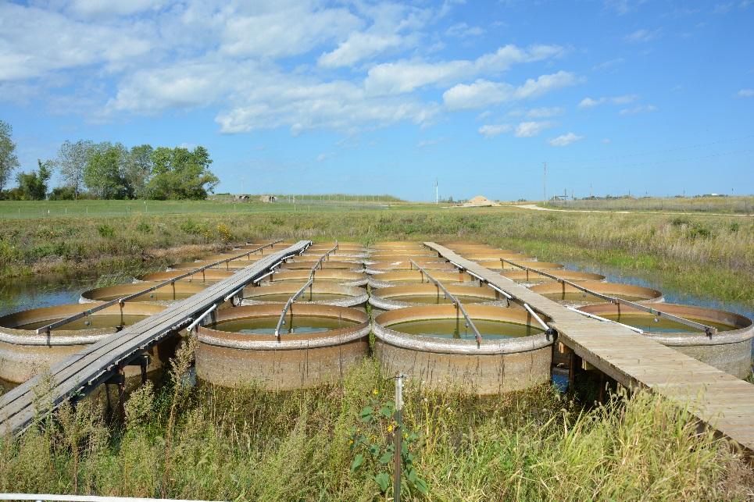
Figure S1: Experimental mesocosm tank set up. The trees in the distance are over 100 m away.

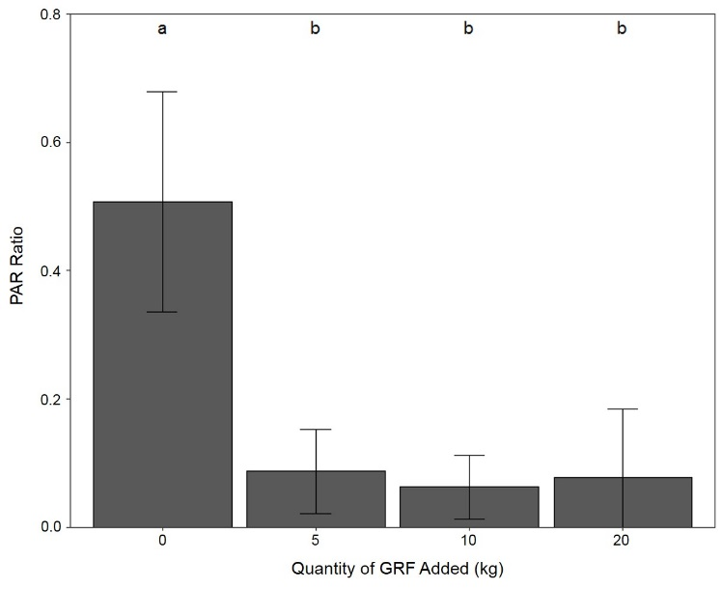
Figure S2: Comparison of the light environment in tanks that received varying amounts of glacial rock flour (GRF). PAR ratio (0.5 m water/air reading) measured in mesocosm tanks that received 0, 5, 10, and 20 kg of GRF. The light ratio was determined by dividing photosynthetically active radiation (PAR) measurements made at 0.5 m depth by PAR measurements from above the water’s surface in the air. Bars with the same letter indicate that no significant difference exists between experimental groups while bars with different letters indicate that there is a significant difference in PAR between groups. We found no significant difference in PAR among tanks that received 5, 10, and 20 kg of GRF (Kruskal-Wallis p>0.05). In this dosing experiment, each experimental group consisted of 2 tanks that were not used in the larger, 9-day experiment.
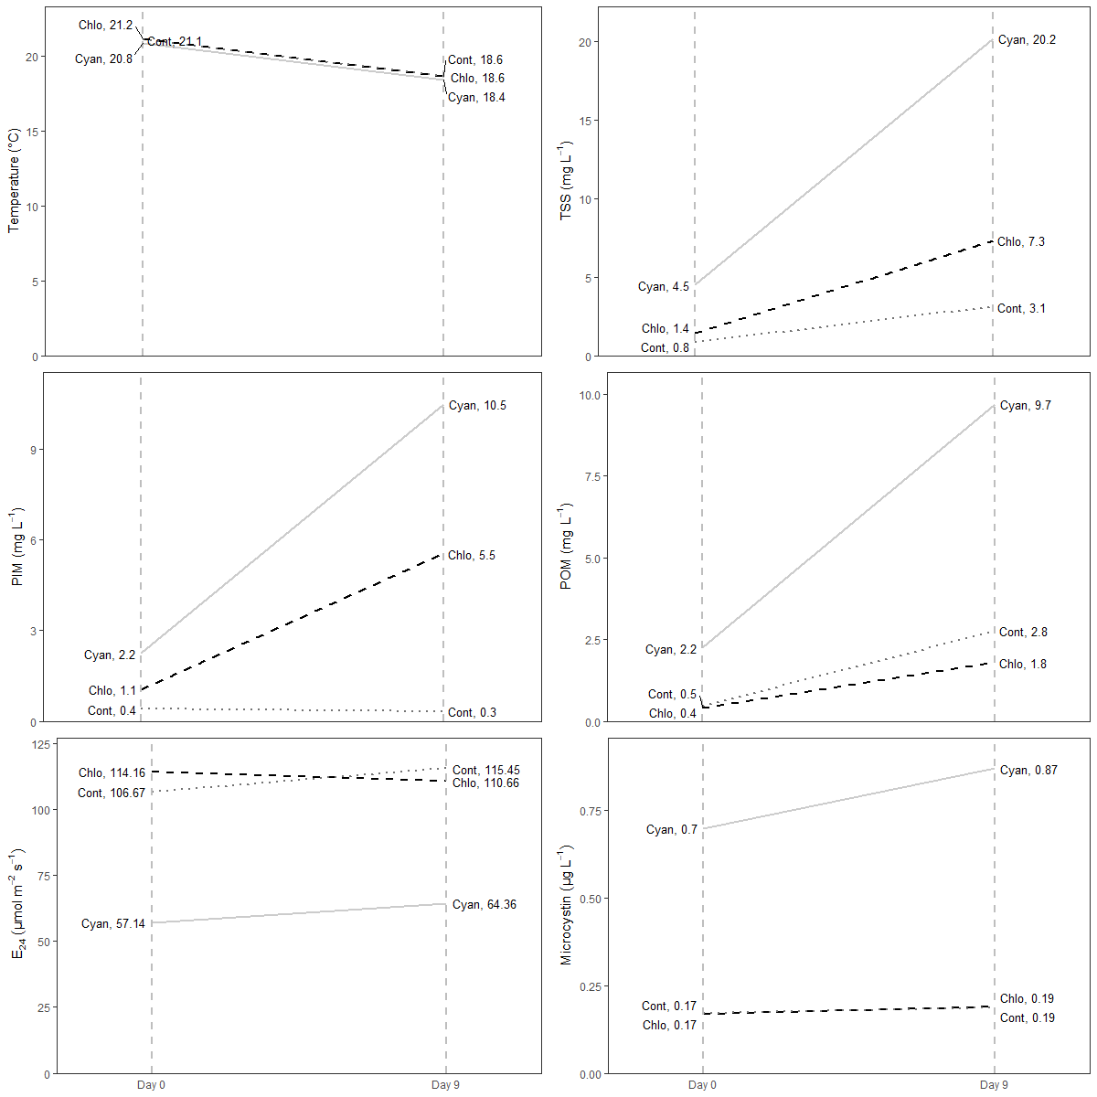
Figure S3: Slope plots for parameters in experimental mesocosm tanks. Temperature, total suspended solids (TSS), particulate inorganic matter (PIM), particulate organic matter (POM), mean mixed layer irradiance (Ē₂₄), and microcystin are presented. Vertical, dashed lines represent measurements taken on day 0 and day 9. Sloped lines represent the change in each parameter for chlorophyte dominated (Chlo, black, dashed line, n= 6), cyanophyte-dominated (Cyan, light gray solid, line, n= 8), and control (Cont, dark gray, dotted line, n= 3) mesocosm tanks. Values to the right of each label are the mean of all tanks within that group.

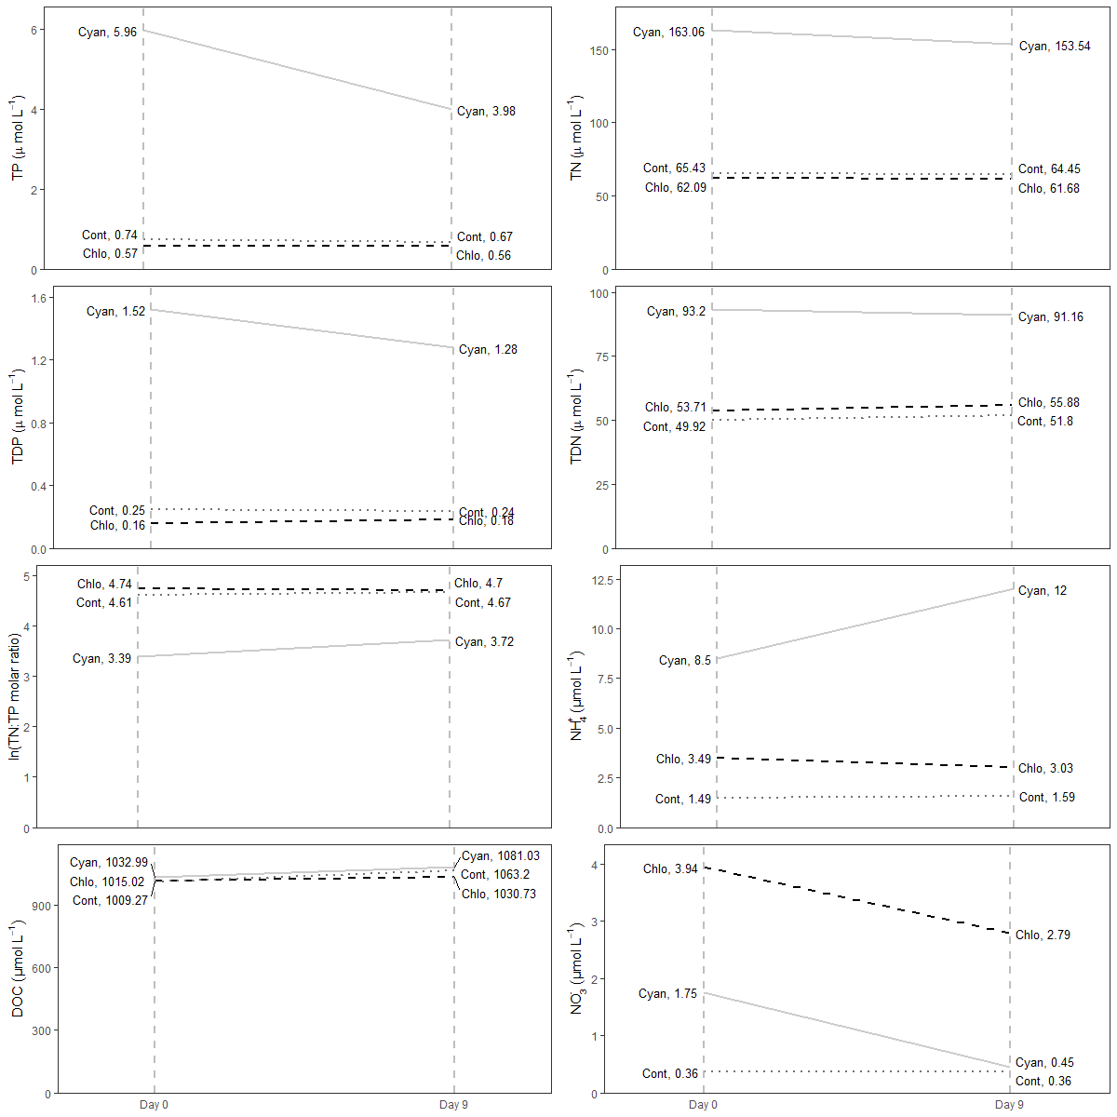
Figure S4: Slope plots for chemical parameters in experimental mesocosm tanks. Total phosphorus (TP), total nitrogen (TN), total dissolved phosphorus (TDP), total dissolved nitrogen (TDN), the natural log ratio of TN to TP (TN:TP), ammonium (NH₄⁺), dissolved organic carbon (DOC), and nitrate (NO₃⁻) are presented. Vertical, dashed lines represent measurements taken on day 0 and day 9. Sloped lines represent the change in each parameter for chlorophyte dominated (Chlo, black, dashed line, n= 6), cyanophyte-dominated (Cyan, light gray, solid line, n= 8), and control (Cont, dark gray, dotted line, n= 3) mesocosm tanks. Values to the right of each label are the mean of all tanks within that group.
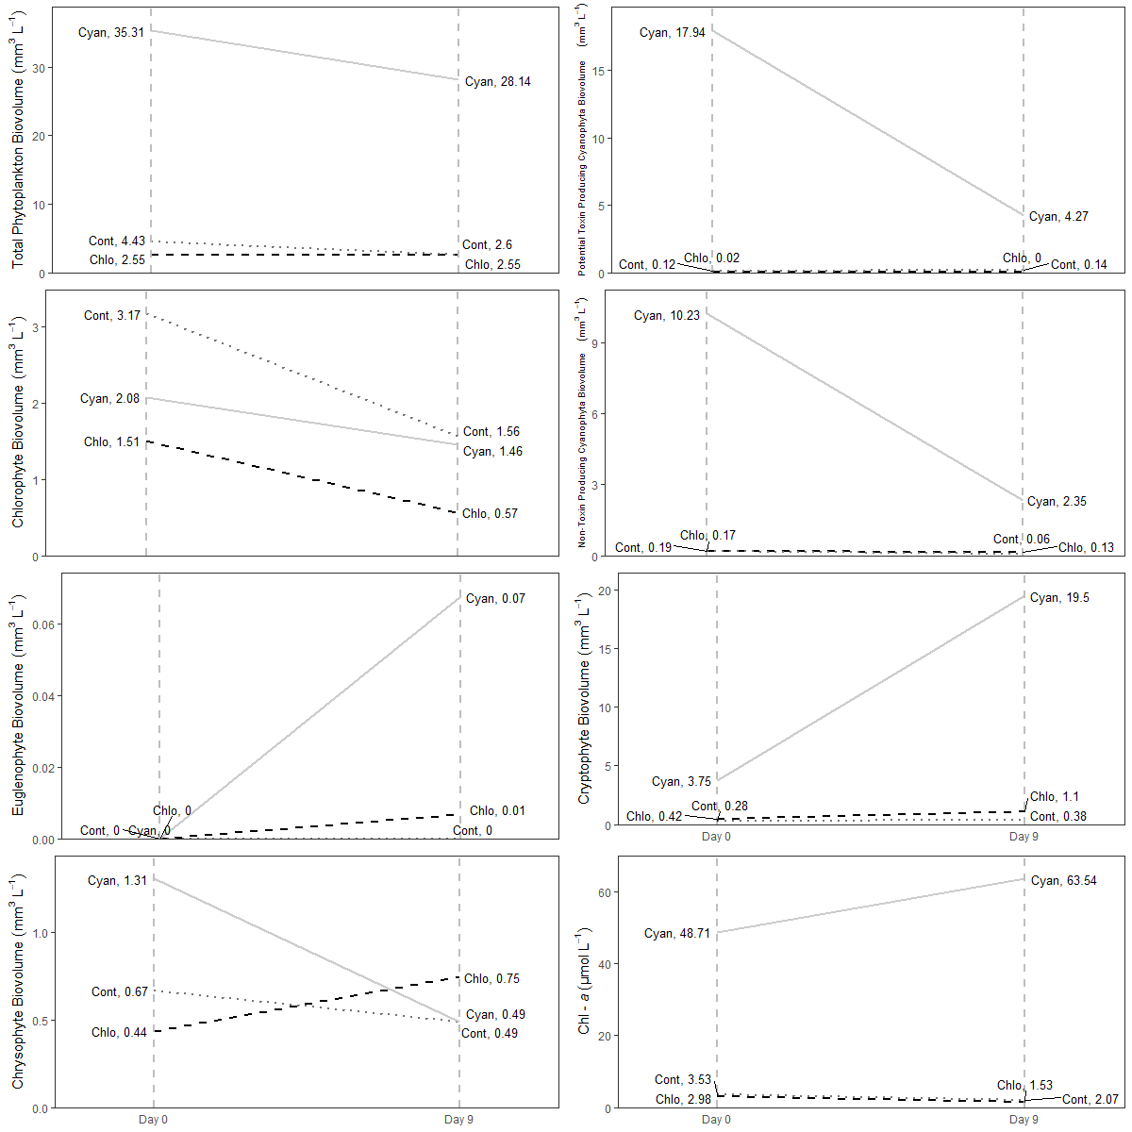
Figure S5: Slope plots for phytoplankton and chlorophyll-a concentrations (Chl-a) in experimental mesocosm tanks. Vertical, dashed lines represent measurements taken on day 0 and day 9. Sloped lines represent the change in each parameter for chlorophyte dominated (Chlo, black, dashed line, n= 6), cyanophyte-dominated (Cyan, light gray, solid line, n= 8), and control (Cont, dark gray, dotted line, n= 3) mesocosm tanks. Values to the right of each label are the mean of all tanks within that group.

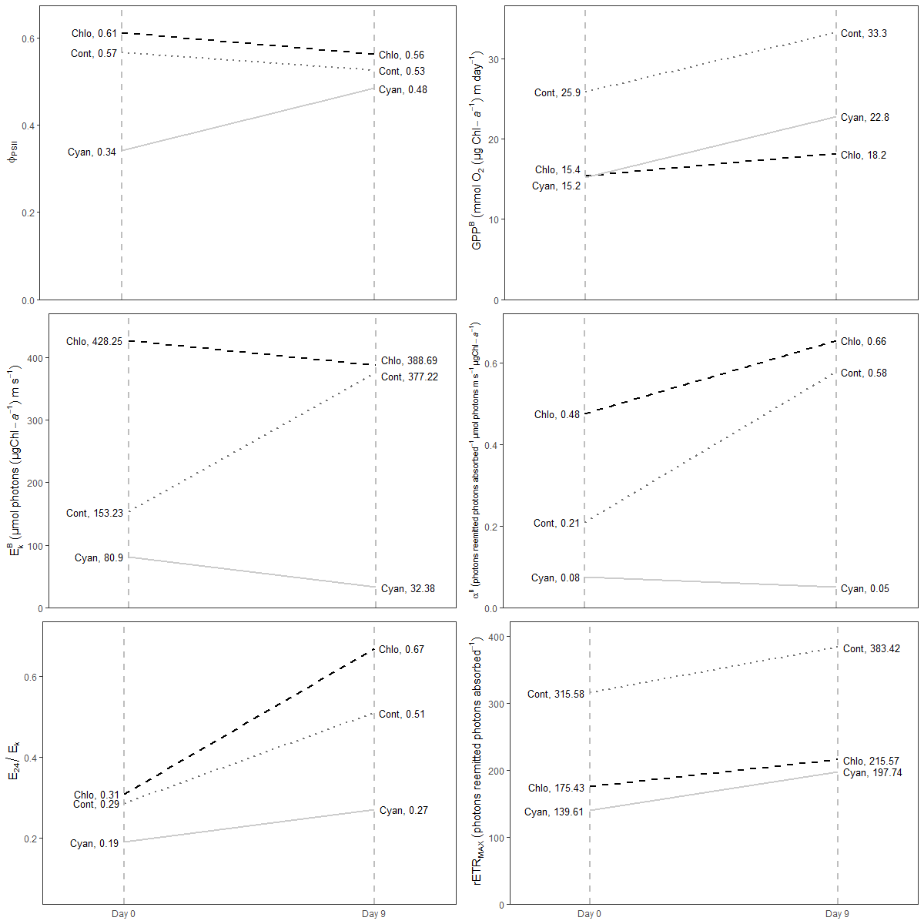
Figure S6: Slope plots for phytoplankton physiology parameters in experimental mesocosm tanks. Maximum quantum yield of photosystem II (φ_{PSII}), gross primary productivity normalized to chlorophyll-a (GPP^{B}), light saturation threshold normalized to chlorophyll-a (E_{k}^{B}), alpha normalized to chlorophyll-a (α^{B}), light deficiency parameter (Ē₂₄/E_{k}), and maximum relative electron transport rate (rETR_{MAX}) are presented. Vertical, dashed lines represent measurements taken on day 0 and day 9. Sloped lines represent the change in each parameter for chlorophyte dominated (Chlo, black, dashed line, n= 6), cyanophyte-dominated (Cyan, light gray, solid line, n= 8), and control (Cont, dark gray, dotted line, n= 3) mesocosm tanks. Values to the right of each label are the mean of all tanks within that group.

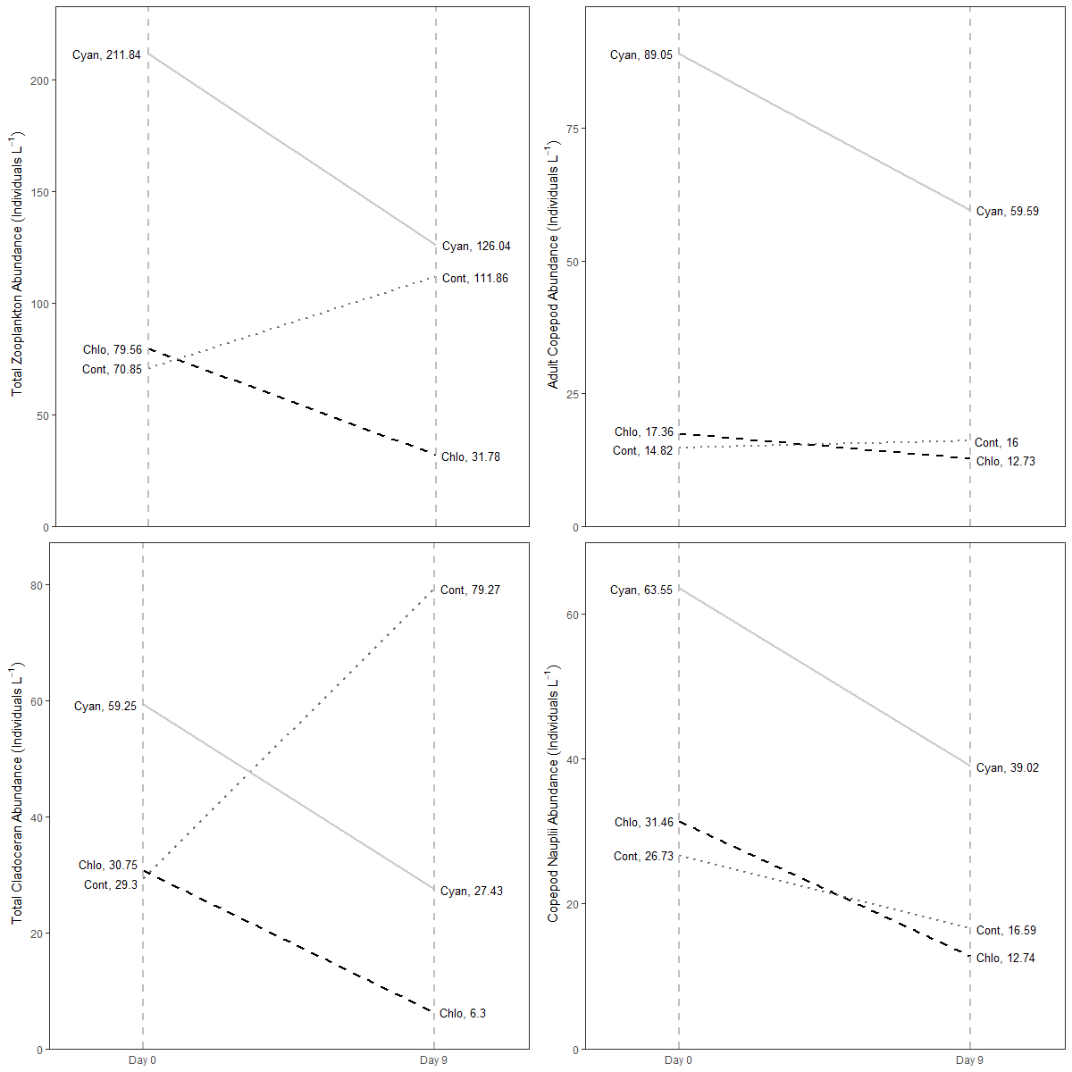
Figure S7: Slope plots for zooplankton in experimental mesocosm tanks. Vertical, dashed lines represent measurements taken on day 0 and day 9. Sloped lines represent the change in each parameter for chlorophyte dominated (Chlo, black, dashed line, n= 6), cyanophyte-dominated (Cyan, light gray, solid line, n= 8), and control (Cont, dark gray, dotted line, n= 3) mesocosm tanks. Values to the right of each label are the mean of all tanks within that group.

2 Reference
Chapman, A., and Foss, A. (2019). Potentially Toxigenic (PTOX) Cyanobacteria List. GreenWater Laboratories Technical Report.
Guiry, M.D., and Guiry, G.M. (2020). AlgaeBase. World-wide electronic publication, National University of Ireland, Galway. https://www.algaebase.org
Thorp, J.H, and Covich, A.P. (2001). Ecology and Classification of North American Freshwater Invertebrates. San Diego: Academic Press.

