Supplementary Information

Plasma proteome responses in salmonid fish following immunization

Bakke F.K., Monte M.M., Stead D.A., Cornulier T., Causey D.R., Douglas A., Macqueen D.J., Dooley H.

Includes Fig. S1 – S6

Attached in .xlsx format: Supplementary Tables
Table S1: Raw proteomic data; Label-free quantification (LFQ) values for 605 proteins identified by the MaxQuant Andromeda peptide search engine. Contaminants and reverse sequence counterparts are not shown.
Table S2: Filtered proteomic data; All proteins with LFQ values for at least 7 out of 10 time points across the post-immunization time course.
Table S3: Statistical analysis of filtered dataset; using one-way ANOVA for the filtered dataset of 278 proteins
Table S4: STRING enrichment analysis; for the filtered dataset of 278 proteins
Table S5: Analysis of duplicated proteins, scenario i ; Duplicated proteins present in the same majority protein group
Table S6: Analysis of duplicated proteins scenario ii; Duplicated proteins present in unique majority protein groups
Table S7: Uncharacterized protein analysis; Results of BLAST queries against two proteins in the filtered dataset which were annotated as uncharacterized in rainbow trout

Attached in .txt format: Supplementary Data
Supplementary Data 1: Sequencing alignments used in study

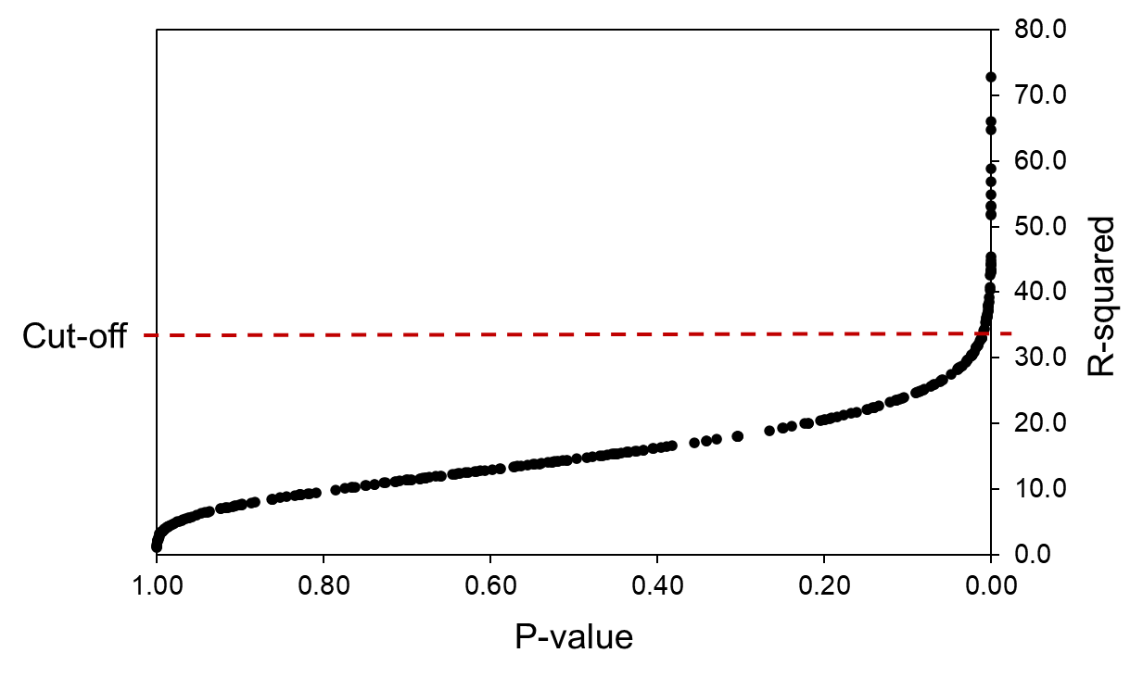
Fig. S1. Scatterplot showing relationship between R² and P-value following one-way ANOVA (time as fixed factor) of 278 plasma proteins, highlighting the cut-off used (P<0.05 after Bonferroni-Holm correction based on 278 separate analyses) for further investigation of proteins.

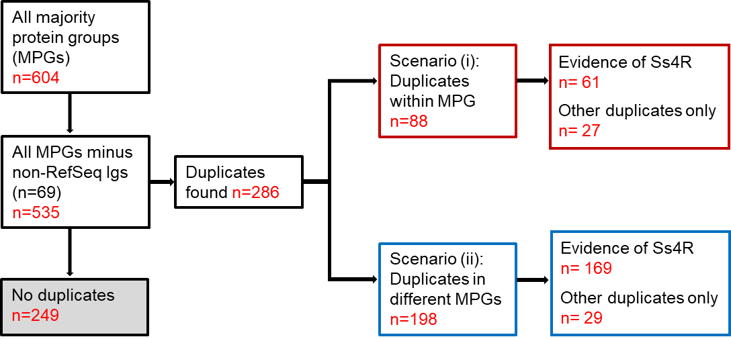

Fig. S2. Visualization of approach used to determine how MaxQuant groups duplicated proteins into common or different protein groups.

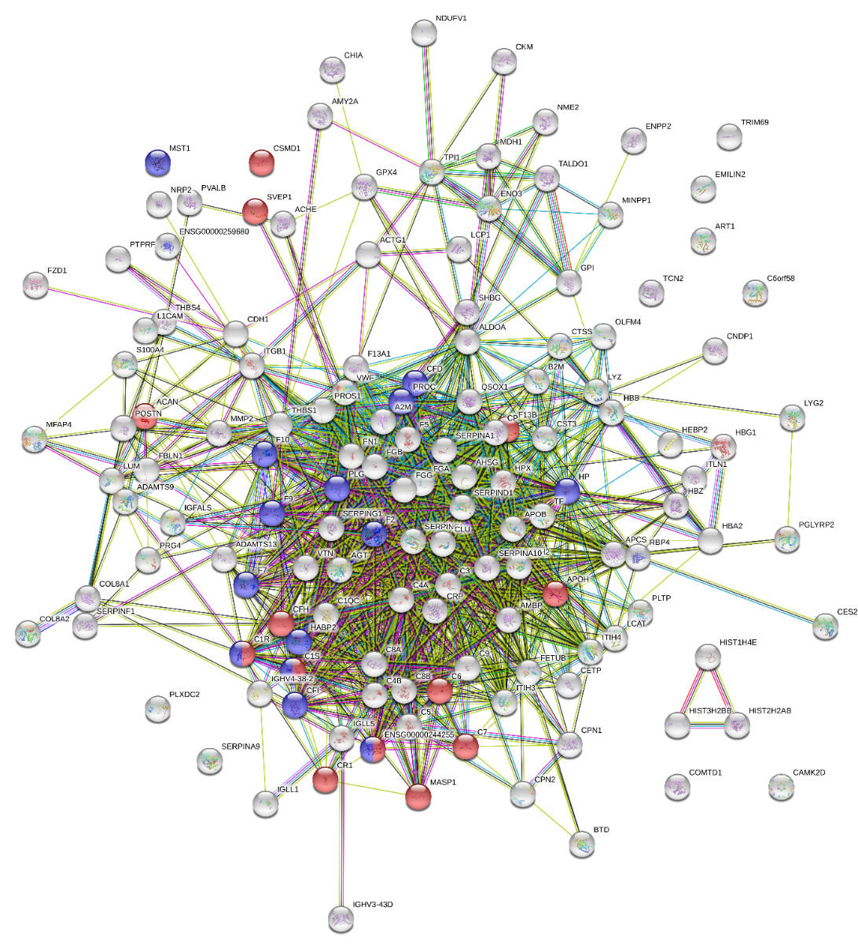
Fig. S3. STRING protein-protein interaction (PPI) network for putative human orthologues of the filtered trout plasma protein dataset. PPI enrichment = P < 1.0e-16.

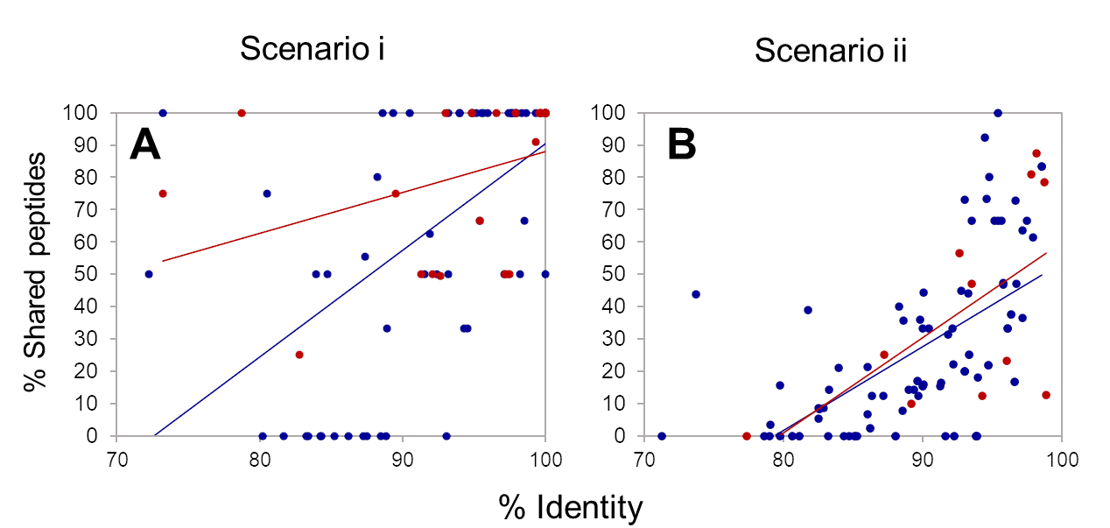

Fig. S4. Relationship between protein sequence identity and proportion of shared peptides among duplicated proteins classified into (A) scenario i, the same MPG and (B) scenario ii, unique MPGs. Colours show duplication category (red = Ss4R; blue = other duplications).

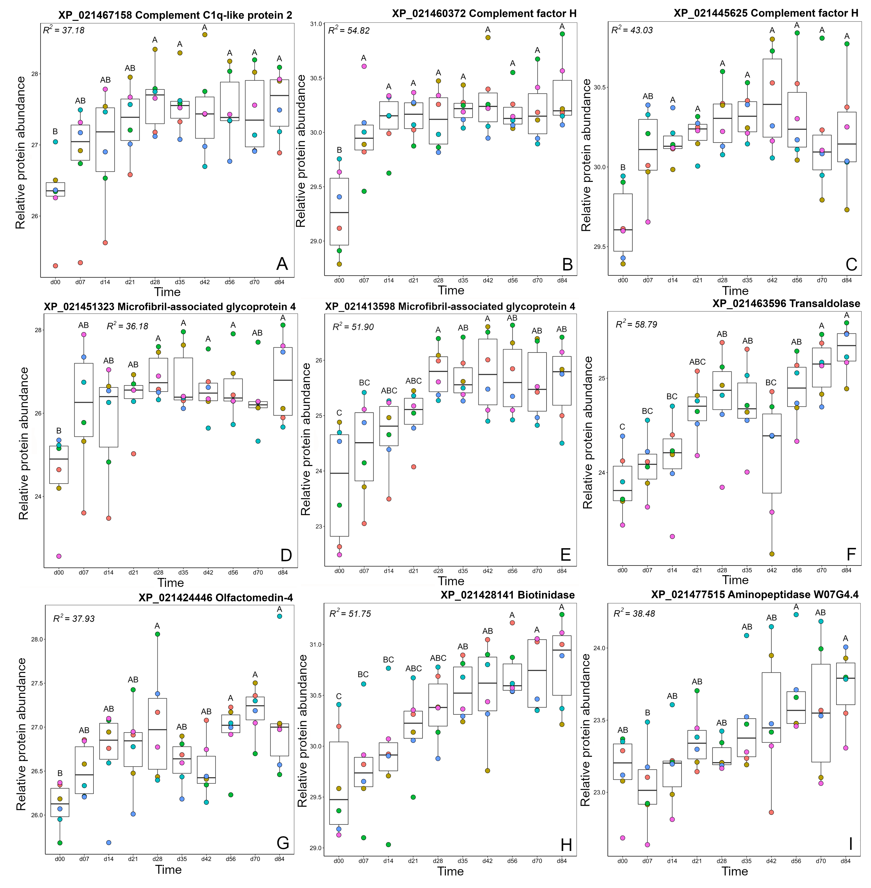
Fig S5. Additional proteins represented in cluster A2 (see Fig. 5, main text)

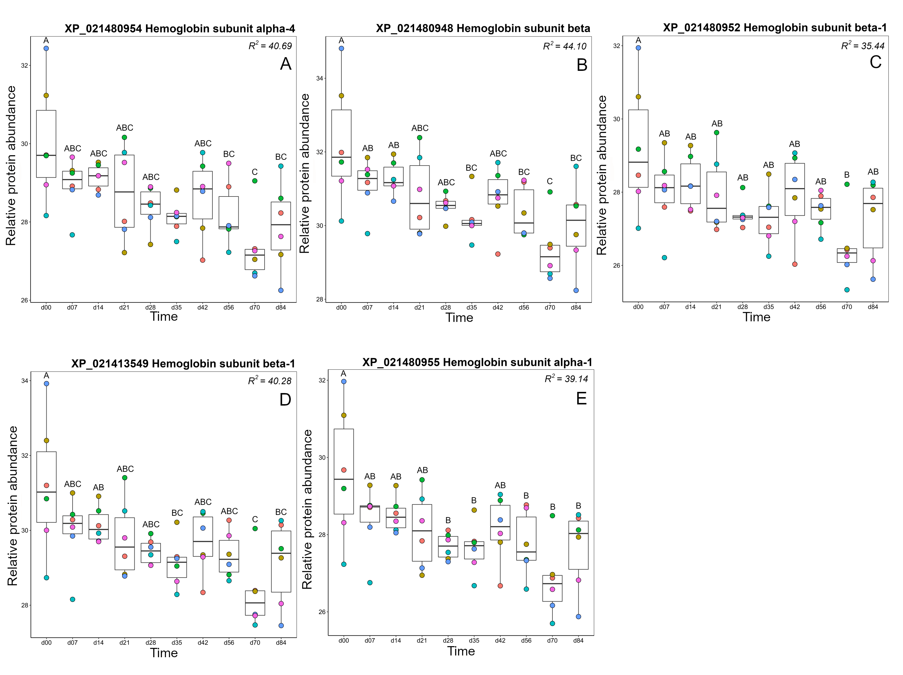
Fig S6. Additional proteins represented in cluster B3 (see Fig. 10, main text)

