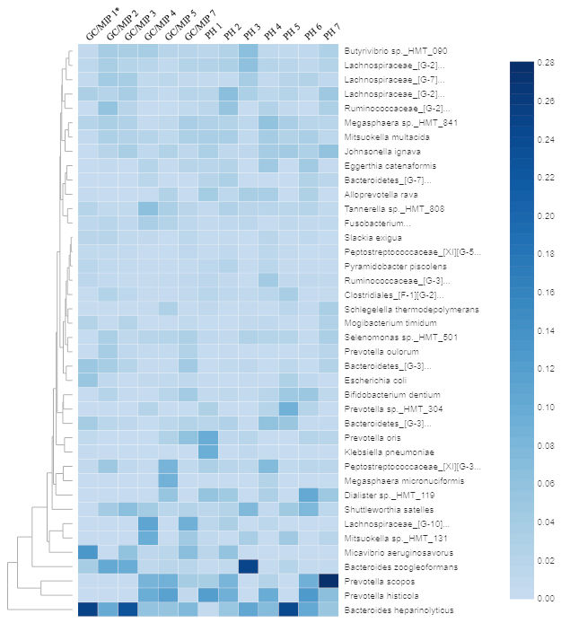
Supplementary Figure 2. Heat map based on the relative abundance of the 40 most abundant species in fecal samples of individuals with GC/MIP and Control. *, patient Aa JP2-like+ clone.

