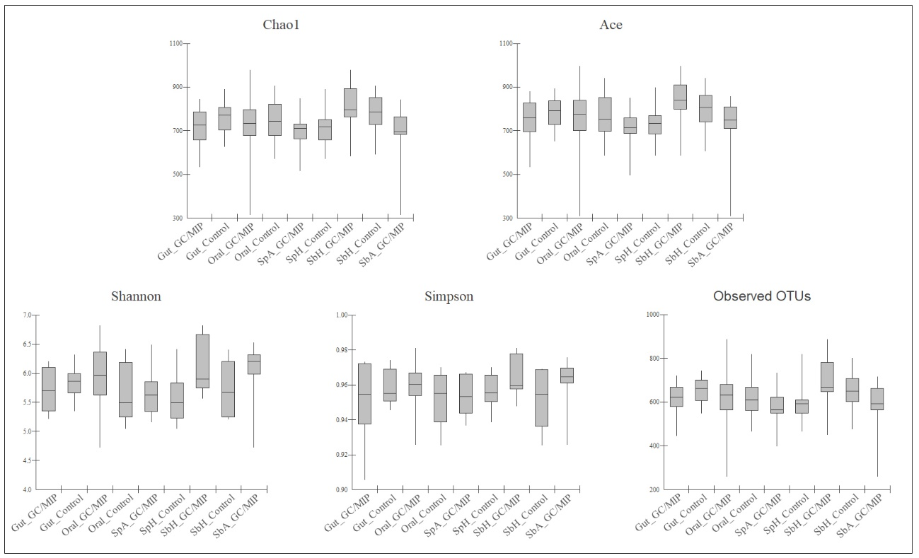
Supplementary Figure 1. Box-plots of alpha diversity indexes calculated for each site. Alpha diversity was determined by the indexes Chao 1 (estimates richness), ACE (Abundance-based Coverage Estimator), Shannon (estimates diversity and evenness), Simpson (estimates evenness) and the amount of unique OTUs found in each sample was estimated (observed species). Boxes contain 50% of all values and whiskers represent the 25th and 75th percentiles. No statistically significant difference was observed (P > 0.05, Student t test).

