Supplemental Material. Simulate Result III
The full results of CDRs for different conditions were presented in this supplemental material. The boxplots of AFIs for different conditions were presented in Figures S1 – S20. For convenient, let M1 = the SH-DINA model. M2 = the SH-DINO model, M3 = the SH-ACDM, and M4 = the SH-GDINA model.

Table S1. CDRs of RFIs for different models with non-hierarchical attribute structures.
GM | CM | Low item quality |  |  |  |  | High item quality
 |  | AIC | BIC | aBIC | CAIC | AICc | AIC | BIC | aBIC | CAIC | AICc
 |  |  |  |  |  | N = 1,000
M1 | M1 | 1 | 1 | 1 | 1 | 1 | 1 | 1 | 1 | 1 | 1
 | M2 | 0 | 0 | 0 | 0 | 0 | 0 | 0 | 0 | 0 | 0
 | M3 | 0 | 0 | 0 | 0 | 0 | 0 | 0 | 0 | 0 | 0
 | M4 | 0 | 0 | 0 | 0 | 0 | 0 | 0 | 0 | 0 | 0
M2 | M1 | 0 | 0 | 0 | 0 | 0 | 0 | 0 | 0 | 0 | 0
 | M2 | 1 | 1 | 1 | 1 | 1 | 1 | 1 | 1 | 1 | 1
 | M3 | 0 | 0 | 0 | 0 | 0 | 0 | 0 | 0 | 0 | 0
 | M4 | 0 | 0 | 0 | 0 | 0 | 0 | 0 | 0 | 0 | 0
M3 | M1 | 0 | 0 | 0 | 0 | 0 | 0 | 0 | 0 | 0 | 0
 | M2 | 0 | 0 | 0 | 0 | 0 | 0 | 0 | 0 | 0 | 0
 | M3 | 1 | 1 | 1 | 1 | 1 | 1 | 1 | 1 | 1 | 1
 | M4 | 0 | 0 | 0 | 0 | 0 | 0 | 0 | 0 | 0 | 0
M4 | M1 | 0 | 0 | 0 | 0 | 0 | 0 | 0 | 0 | 0 | 0
 | M2 | 0 | 0 | 0 | 0 | 0 | 0 | 0 | 0 | 0 | 0
 | M3 | 0 | 1 | .502 | 1 | .134 | 0 | 0 | 0 | 0 | 0
 | M4 | 1 | 0 | .498 | 0 | .866 | 1 | 1 | 1 | 1 | 1
 |  |  |  |  |  | N = 3,000
M1 | M1 | 1 | 1 | 1 | 1 | 1 | 1 | 1 | 1 | 1 | 1
 | M2 | 0 | 0 | 0 | 0 | 0 | 0 | 0 | 0 | 0 | 0
 | M3 | 0 | 0 | 0 | 0 | 0 | 0 | 0 | 0 | 0 | 0
 | M4 | 0 | 0 | 0 | 0 | 0 | 0 | 0 | 0 | 0 | 0
M2 | M1 | 0 | 0 | 0 | 0 | 0 | 0 | 0 | 0 | 0 | 0
 | M2 | 1 | 1 | 1 | 1 | 1 | 1 | 1 | 1 | 1 | 1
 | M3 | 0 | 0 | 0 | 0 | 0 | 0 | 0 | 0 | 0 | 0
 | M4 | 0 | 0 | 0 | 0 | 0 | 0 | 0 | 0 | 0 | 0
M3 | M1 | 0 | 0 | 0 | 0 | 0 | 0 | 0 | 0 | 0 | 0
 | M2 | 0 | 0 | 0 | 0 | 0 | 0 | 0 | 0 | 0 | 0
 | M3 | 1 | 1 | 1 | 1 | 1 | 1 | 1 | 1 | 1 | 1
 | M4 | 0 | 0 | 0 | 0 | 0 | 0 | 0 | 0 | 0 | 0
M4 | M1 | 0 | 0 | 0 | 0 | 0 | 0 | 0 | 0 | 0 | 0
 | M2 | 0 | 0 | 0 | 0 | 0 | 0 | 0 | 0 | 0 | 0
 | M3 | 0 | .76 | 0 | .978 | 0 | 0 | 0 | 0 | 0 | 0
 | M4 | 1 | .24 | 1 | .022 | 1 | 1 | 1 | 1 | 1 | 1
Note. GM = data generation model; CM = calibration model.

Table S2. CDRs of RFIs for different models with linear attribute structures.
GM | CM | Low item quality |  |  |  |  | High item quality
 |  | AIC | BIC | aBIC | CAIC | AICc | AIC | BIC | aBIC | CAIC | AICc
 |  |  |  |  |  | N = 1,000
M1 | M1 | 1 | 1 | 1 | 1 | 1 | 1 | 1 | 1 | 1 | 1
 | M2 | 0 | 0 | 0 | 0 | 0 | 0 | 0 | 0 | 0 | 0
 | M3 | 0 | 0 | 0 | 0 | 0 | 0 | 0 | 0 | 0 | 0
 | M4 | 0 | 0 | 0 | 0 | 0 | 0 | 0 | 0 | 0 | 0
M2 | M1 | 0 | 0 | 0 | 0 | 0 | 0 | 0 | 0 | 0 | 0
 | M2 | 1 | 1 | 1 | 1 | 1 | .998 | 1 | 1 | 1 | 1
 | M3 | 0 | 0 | 0 | 0 | 0 | 0 | 0 | 0 | 0 | 0
 | M4 | 0 | 0 | 0 | 0 | 0 | .002 | 0 | 0 | 0 | 0
M3 | M1 | 0 | 0 | 0 | 0 | 0 | 0 | 0 | 0 | 0 | 0
 | M2 | 0 | 0 | 0 | 0 | 0 | 0 | 0 | 0 | 0 | 0
 | M3 | .088 | .088 | .088 | .088 | .088 | .01 | .01 | .01 | .01 | .01
 | M4 | .912 | .912 | .912 | .912 | .912 | .99 | .99 | .99 | .99 | .99
M4 | M1 | 0 | 0 | 0 | 0 | 0 | 0 | 0 | 0 | 0 | 0
 | M2 | 0 | 0 | 0 | 0 | 0 | 0 | 0 | 0 | 0 | 0
 | M3 | .126 | .126 | .126 | .126 | .126 | .01 | .01 | .01 | .01 | .01
 | M4 | .874 | .874 | .874 | .874 | .874 | .99 | .99 | .99 | .99 | .99
 |  |  |  |  |  | N = 3,000
M1 | M1 | 1 | 1 | 1 | 1 | 1 | 1 | 1 | 1 | 1 | 1
 | M2 | 0 | 0 | 0 | 0 | 0 | 0 | 0 | 0 | 0 | 0
 | M3 | 0 | 0 | 0 | 0 | 0 | 0 | 0 | 0 | 0 | 0
 | M4 | 0 | 0 | 0 | 0 | 0 | 0 | 0 | 0 | 0 | 0
M2 | M1 | 0 | 0 | 0 | 0 | 0 | 0 | 0 | 0 | 0 | 0
 | M2 | 1 | 1 | 1 | 1 | 1 | 1 | 1 | 1 | 1 | 1
 | M3 | 0 | 0 | 0 | 0 | 0 | 0 | 0 | 0 | 0 | 0
 | M4 | 0 | 0 | 0 | 0 | 0 | 0 | 0 | 0 | 0 | 0
M3 | M1 | 0 | 0 | 0 | 0 | 0 | 0 | 0 | 0 | 0 | 0
 | M2 | 0 | 0 | 0 | 0 | 0 | 0 | 0 | 0 | 0 | 0
 | M3 | .01 | .01 | .01 | .01 | .01 | .016 | .016 | .016 | .016 | .016
 | M4 | .99 | .99 | .99 | .99 | .99 | .984 | .984 | .984 | .984 | .984
M4 | M1 | 0 | 0 | 0 | 0 | 0 | 0 | 0 | 0 | 0 | 0
 | M2 | 0 | 0 | 0 | 0 | 0 | 0 | 0 | 0 | 0 | 0
 | M3 | .168 | .168 | .168 | .168 | .168 | .006 | .006 | .006 | .006 | .006
 | M4 | .832 | .832 | .832 | .832 | .832 | .994 | .994 | .994 | .994 | .994
Note. GM = data generation model; CM = calibration model.

Table S3. CDRs of RFIs for different models with convergent attribute structures.
GM | CM | Low item quality |  |  |  |  | High item quality
 |  | AIC | BIC | aBIC | CAIC | AICc | AIC | BIC | aBIC | CAIC | AICc
 |  |  |  |  |  | N = 1,000
M1 | M1 | 1 | 1 | 1 | 1 | 1 | 1 | 1 | 1 | 1 | 1
 | M2 | 0 | 0 | 0 | 0 | 0 | 0 | 0 | 0 | 0 | 0
 | M3 | 0 | 0 | 0 | 0 | 0 | 0 | 0 | 0 | 0 | 0
 | M4 | 0 | 0 | 0 | 0 | 0 | 0 | 0 | 0 | 0 | 0
M2 | M1 | 0 | 0 | 0 | 0 | 0 | 0 | 0 | 0 | 0 | 0
 | M2 | 1 | 1 | 1 | 1 | 1 | .998 | 1 | 1 | 1 | 1
 | M3 | 0 | 0 | 0 | 0 | 0 | 0 | 0 | 0 | 0 | 0
 | M4 | 0 | 0 | 0 | 0 | 0 | .002 | 0 | 0 | 0 | 0
M3 | M1 | 0 | 0 | 0 | 0 | 0 | 0 | 0 | 0 | 0 | 0
 | M2 | 0 | 0 | 0 | 0 | 0 | 0 | 0 | 0 | 0 | 0
 | M3 | .97 | 1 | 1 | 1 | 1 | .938 | 1 | .998 | 1 | .998
 | M4 | .03 | 0 | 0 | 0 | 0 | .062 | 0 | .002 | 0 | .002
M4 | M1 | 0 | 0 | 0 | 0 | 0 | 0 | 0 | 0 | 0 | 0
 | M2 | 0 | 0 | 0 | 0 | 0 | 0 | 0 | 0 | 0 | 0
 | M3 | 0 | .642 | .05 | .822 | .014 | 0 | .046 | 0 | .126 | 0
 | M4 | 1 | .358 | .95 | .178 | .986 | 1 | .954 | 1 | .874 | 1
 |  |  |  |  |  | N = 3,000
M1 | M1 | 1 | 1 | 1 | 1 | 1 | 1 | 1 | 1 | 1 | 1
 | M2 | 0 | 0 | 0 | 0 | 0 | 0 | 0 | 0 | 0 | 0
 | M3 | 0 | 0 | 0 | 0 | 0 | 0 | 0 | 0 | 0 | 0
 | M4 | 0 | 0 | 0 | 0 | 0 | 0 | 0 | 0 | 0 | 0
M2 | M1 | 0 | 0 | 0 | 0 | 0 | 0 | 0 | 0 | 0 | 0
 | M2 | 1 | 1 | 1 | 1 | 1 | 1 | 1 | 1 | 1 | 1
 | M3 | 0 | 0 | 0 | 0 | 0 | 0 | 0 | 0 | 0 | 0
 | M4 | 0 | 0 | 0 | 0 | 0 | 0 | 0 | 0 | 0 | 0
M3 | M1 | 0 | 0 | 0 | 0 | 0 | 0 | 0 | 0 | 0 | 0
 | M2 | 0 | 0 | 0 | 0 | 0 | 0 | 0 | 0 | 0 | 0
 | M3 | .966 | 1 | 1 | 1 | .988 | .954 | 1 | 1 | 1 | .97
 | M4 | .034 | 0 | 0 | 0 | .012 | .046 | 0 | 0 | 0 | .03
M4 | M1 | 0 | 0 | 0 | 0 | 0 | 0 | 0 | 0 | 0 | 0
 | M2 | 0 | 0 | 0 | 0 | 0 | 0 | 0 | 0 | 0 | 0
 | M3 | 0 | .006 | 0 | .032 | 0 | 0 | 0 | 0 | 0 | 0
 | M4 | 1 | .994 | 1 | .968 | 1 | 1 | 1 | 1 | 1 | 1
Note. GM = data generation model; CM = calibration model.

Table S4. CDRs of RFIs for different models with divergent attribute structures.
GM | CM | Low item quality |  |  |  |  | High item quality
 |  | AIC | BIC | aBIC | CAIC | AICc | AIC | BIC | aBIC | CAIC | AICc
 |  |  |  |  |  | N = 1,000
M1 | M1 | 1 | 1 | 1 | 1 | 1 | 1 | 1 | 1 | 1 | 1
 | M2 | 0 | 0 | 0 | 0 | 0 | 0 | 0 | 0 | 0 | 0
 | M3 | 0 | 0 | 0 | 0 | 0 | 0 | 0 | 0 | 0 | 0
 | M4 | 0 | 0 | 0 | 0 | 0 | 0 | 0 | 0 | 0 | 0
M2 | M1 | 0 | 0 | 0 | 0 | 0 | 0 | 0 | 0 | 0 | 0
 | M2 | 1 | 1 | 1 | 1 | 1 | 1 | 1 | 1 | 1 | 1
 | M3 | 0 | 0 | 0 | 0 | 0 | 0 | 0 | 0 | 0 | 0
 | M4 | 0 | 0 | 0 | 0 | 0 | 0 | 0 | 0 | 0 | 0
M3 | M1 | 0 | 0 | 0 | 0 | 0 | 0 | 0 | 0 | 0 | 0
 | M2 | 0 | 0 | 0 | 0 | 0 | 0 | 0 | 0 | 0 | 0
 | M3 | .996 | 1 | 1 | 1 | 1 | .994 | 1 | 1 | 1 | 1
 | M4 | .004 | 0 | 0 | 0 | 0 | .006 | 0 | 0 | 0 | 0
M4 | M1 | 0 | 0 | 0 | 0 | 0 | 0 | 0 | 0 | 0 | 0
 | M2 | 0 | 0 | 0 | 0 | 0 | 0 | 0 | 0 | 0 | 0
 | M3 | 0 | .888 | .02 | .988 | 0 | 0 | .062 | 0 | .236 | 0
 | M4 | 1 | .112 | .98 | .012 | 1 | 1 | .938 | 1 | .764 | 1
 |  |  |  |  |  | N = 3,000
M1 | M1 | 1 | 1 | 1 | 1 | 1 | 1 | 1 | 1 | 1 | 1
 | M2 | 0 | 0 | 0 | 0 | 0 | 0 | 0 | 0 | 0 | 0
 | M3 | 0 | 0 | 0 | 0 | 0 | 0 | 0 | 0 | 0 | 0
 | M4 | 0 | 0 | 0 | 0 | 0 | 0 | 0 | 0 | 0 | 0
M2 | M1 | 0 | 0 | 0 | 0 | 0 | 0 | 0 | 0 | 0 | 0
 | M2 | 1 | 1 | 1 | 1 | 1 | 1 | 1 | 1 | 1 | 1
 | M3 | 0 | 0 | 0 | 0 | 0 | 0 | 0 | 0 | 0 | 0
 | M4 | 0 | 0 | 0 | 0 | 0 | 0 | 0 | 0 | 0 | 0
M3 | M1 | 0 | 0 | 0 | 0 | 0 | 0 | 0 | 0 | 0 | 0
 | M2 | 0 | 0 | 0 | 0 | 0 | 0 | 0 | 0 | 0 | 0
 | M3 | .992 | 1 | 1 | 1 | 1 | .992 | 1 | 1 | 1 | .998
 | M4 | .008 | 0 | 0 | 0 | 0 | .008 | 0 | 0 | 0 | .002
M4 | M1 | 0 | 0 | 0 | 0 | 0 | 0 | 0 | 0 | 0 | 0
 | M2 | 0 | 0 | 0 | 0 | 0 | 0 | 0 | 0 | 0 | 0
 | M3 | 0 | 0 | 0 | .056 | 0 | 0 | 0 | 0 | 0 | 0
 | M4 | 1 | 1 | 1 | .944 | 1 | 1 | 1 | 1 | 1 | 1
Note. GM = data generation model; CM = calibration model.

Table S5. CDRs of RFIs for different models with unstructured attribute structures.
GM | CM | Low item quality |  |  |  |  | High item quality
 |  | AIC | BIC | aBIC | CAIC | AICc | AIC | BIC | aBIC | CAIC | AICc
 |  |  |  |  |  | N = 1,000
M1 | M1 | 1 | 1 | 1 | 1 | 1 | 1 | 1 | 1 | 1 | 1
 | M2 | 0 | 0 | 0 | 0 | 0 | 0 | 0 | 0 | 0 | 0
 | M3 | 0 | 0 | 0 | 0 | 0 | 0 | 0 | 0 | 0 | 0
 | M4 | 0 | 0 | 0 | 0 | 0 | 0 | 0 | 0 | 0 | 0
M2 | M1 | 0 | 0 | 0 | 0 | 0 | 0 | 0 | 0 | 0 | 0
 | M2 | 1 | 1 | 1 | 1 | 1 | 1 | 1 | 1 | 1 | 1
 | M3 | 0 | 0 | 0 | 0 | 0 | 0 | 0 | 0 | 0 | 0
 | M4 | 0 | 0 | 0 | 0 | 0 | 0 | 0 | 0 | 0 | 0
M3 | M1 | 0 | 0 | 0 | 0 | 0 | 0 | 0 | 0 | 0 | 0
 | M2 | 0 | 0 | 0 | 0 | 0 | 0 | 0 | 0 | 0 | 0
 | M3 | 1 | 1 | 1 | 1 | 1 | .996 | 1 | 1 | 1 | 1
 | M4 | 0 | 0 | 0 | 0 | 0 | .004 | 0 | 0 | 0 | 0
M4 | M1 | 0 | 0 | 0 | 0 | 0 | 0 | 0 | 0 | 0 | 0
 | M2 | 0 | 0 | 0 | 0 | 0 | 0 | 0 | 0 | 0 | 0
 | M3 | 0 | .894 | .002 | .998 | 0 | 0 | 0 | 0 | .018 | 0
 | M4 | 1 | .106 | .998 | .002 | 1 | 1 | 1 | 1 | .982 | 1
 |  |  |  |  |  | N = 3,000
M1 | M1 | 1 | 1 | 1 | 1 | 1 | 1 | 1 | 1 | 1 | 1
 | M2 | 0 | 0 | 0 | 0 | 0 | 0 | 0 | 0 | 0 | 0
 | M3 | 0 | 0 | 0 | 0 | 0 | 0 | 0 | 0 | 0 | 0
 | M4 | 0 | 0 | 0 | 0 | 0 | 0 | 0 | 0 | 0 | 0
M2 | M1 | 0 | 0 | 0 | 0 | 0 | 0 | 0 | 0 | 0 | 0
 | M2 | 1 | 1 | 1 | 1 | 1 | 1 | 1 | 1 | 1 | 1
 | M3 | 0 | 0 | 0 | 0 | 0 | 0 | 0 | 0 | 0 | 0
 | M4 | 0 | 0 | 0 | 0 | 0 | 0 | 0 | 0 | 0 | 0
M3 | M1 | 0 | 0 | 0 | 0 | 0 | 0 | 0 | 0 | 0 | 0
 | M2 | 0 | 0 | 0 | 0 | 0 | 0 | 0 | 0 | 0 | 0
 | M3 | 1 | 1 | 1 | 1 | 1 | 1 | 1 | 1 | 1 | 1
 | M4 | 0 | 0 | 0 | 0 | 0 | 0 | 0 | 0 | 0 | 0
M4 | M1 | 0 | 0 | 0 | 0 | 0 | 0 | 0 | 0 | 0 | 0
 | M2 | 0 | 0 | 0 | 0 | 0 | 0 | 0 | 0 | 0 | 0
 | M3 | 0 | .652 | .002 | .938 | 0 | 0 | 0 | 0 | 0 | 0
 | M4 | 1 | .348 | .998 | .062 | 1 | 1 | 1 | 1 | 1 | 1
Note. GM = data generation model; CM = calibration model.

Table S6. CDRs of AFIs for different models with non-hierarchical attribute structures.
GM | CM | Low item quality |  |  | High item quality
 |  | MADcor | 100MAD  RESIDCOV | SRMSR | MADcor | 100MAD  RESIDCOV | SRMSR
 |  |  |  | N = 1,000
M1 | M1 | .064 | .088 | .048 | .056 | .078 | .046
 | M2 | 0 | 0 | 0 | 0 | 0 | 0
 | M3 | 0 | 0 | 0 | 0 | 0 | 0
 | M4 | .936 | .912 | .952 | .944 | .922 | .954
M2 | M1 | 0 | 0 | 0 | 0 | 0 | 0
 | M2 | .044 | .052 | .03 | .036 | .044 | .028
 | M3 | .032 | .01 | .01 | 0 | 0 | 0
 | M4 | .924 | .938 | .96 | .964 | .956 | .972
M3 | M1 | 0 | 0 | 0 | 0 | 0 | 0
 | M2 | 0 | 0 | 0 | 0 | 0 | 0
 | M3 | .482 | .458 | .476 | .292 | .254 | .274
 | M4 | .518 | .542 | .524 | .708 | .746 | .726
M4 | M1 | 0 | 0 | 0 | 0 | 0 | 0
 | M2 | 0 | 0 | 0 | 0 | 0 | 0
 | M3 | .21 | .186 | .2 | .008 | 0 | .006
 | M4 | .79 | .814 | .8 | .992 | 1 | .994
 |  |  |  | N = 3,000
M1 | M1 | .044 | .076 | .038 | .058 | .064 | .036
 | M2 | 0 | 0 | 0 | 0 | 0 | 0
 | M3 | 0 | 0 | 0 | 0 | 0 | 0
 | M4 | 0.956 | .924 | .962 | .942 | .936 | .964
M2 | M1 | 0 | 0 | 0 | 0 | 0 | 0
 | M2 | .03 | .044 | .012 | .03 | .042 | .024
 | M3 | 0 | 0 | 0 | 0 | 0 | 0
 | M4 | .97 | .956 | .988 | .97 | .958 | .976
M3 | M1 | 0 | 0 | 0 | 0 | 0 | 0
 | M2 | 0 | 0 | 0 | 0 | 0 | 0
 | M3 | .426 | .394 | .386 | .244 | .2 | .24
 | M4 | .574 | .606 | .614 | .756 | .8 | .76
M4 | M1 | 0 | 0 | 0 | 0 | 0 | 0
 | M2 | 0 | 0 | 0 | 0 | 0 | 0
 | M3 | .156 | .102 | .12 | 0 | 0 | 0
 | M4 | .844 | .898 | .88 | 1 | 1 | 1
Note. GM = data generation model; CM = calibration model.

Table S7. CDRs of AFIs for different models with linear attribute structures.
GM | CM | Low item quality |  |  | High item quality
 |  | MADcor | 100MAD  RESIDCOV | SRMSR | MADcor | 100MAD  RESIDCOV | SRMSR
 |  |  |  | N = 1,000
M1 | M1 | .158 | .142 | .114 | .176 | .144 | .126
 | M2 | 0 | 0 | 0 | 0 | 0 | 0
 | M3 | .53 | .526 | .528 | .42 | .472 | .454
 | M4 | .312 | .332 | .358 | .404 | .384 | .42
M2 | M1 | 0 | 0 | 0 | 0 | 0 | 0
 | M2 | .082 | .082 | .056 | .042 | .044 | .036
 | M3 | .444 | .438 | .454 | .536 | .522 | .514
 | M4 | .474 | .48 | .49 | .422 | .434 | .45
M3 | M1 | 0 | 0 | 0 | 0 | 0 | 0
 | M2 | 0 | 0 | 0 | 0 | 0 | 0
 | M3 | .554 | .548 | .558 | .554 | .592 | .54
 | M4 | .446 | .452 | .442 | .446 | .408 | .46
M4 | M1 | 0 | 0 | 0 | 0 | 0 | 0
 | M2 | 0 | 0 | 0 | 0 | 0 | 0
 | M3 | .46 | .492 | .492 | .562 | .568 | .556
 | M4 | .54 | .508 | .508 | .438 | .432 | .444
 |  |  |  | N = 3,000
M1 | M1 | .146 | .158 | .114 | .154 | .162 | .128
 | M2 | 0 | 0 | 0 | 0 | 0 | 0
 | M3 | .438 | .44 | .488 | .464 | .44 | .508
 | M4 | .416 | .402 | .398 | .382 | .398 | .364
M2 | M1 | 0 | 0 | 0 | 0 | 0 | 0
 | M2 | .078 | .072 | .048 | .078 | .072 | .048
 | M3 | .422 | .438 | .46 | .422 | .438 | .46
 | M4 | .5 | .49 | .492 | .5 | .49 | .492
M3 | M1 | 0 | 0 | 0 | 0 | 0 | 0
 | M2 | 0 | 0 | 0 | 0 | 0 | 0
 | M3 | .492 | .462 | .48 | .502 | .498 | .53
 | M4 | .508 | .538 | .52 | .498 | .502 | .47
M4 | M1 | 0 | 0 | 0 | 0 | 0 | 0
 | M2 | 0 | 0 | 0 | 0 | 0 | 0
 | M3 | .558 | .49 | .554 | .562 | .542 | .544
 | M4 | .442 | .51 | .446 | .438 | .458 | .456
Note. GM = data generation model; CM = calibration model.

Table S8. CDRs of AFIs for different models with convergent attribute structures.
GM | CM | Low item quality |  |  | High item quality
 |  | MADcor | 100MAD  RESIDCOV | SRMSR | MADcor | 100MAD  RESIDCOV | SRMSR
 |  |  |  | N = 1,000
M1 | M1 | .120 | .130 | .104 | .112 | .126 | .1
 | M2 | 0 | 0 | 0 | 0 | 0 | 0
 | M3 | .006 | .002 | .004 | 0 | 0 | 0
 | M4 | .874 | .868 | .892 | .888 | .874 | .9
M2 | M1 | 0 | 0 | 0 | 0 | 0 | 0
 | M2 | .088 | .088 | .056 | .074 | .074 | .056
 | M3 | .058 | .038 | .050 | 0 | 0 | 0
 | M4 | .854 | .874 | .894 | .926 | .926 | .944
M3 | M1 | 0 | 0 | 0 | 0 | 0 | 0
 | M2 | 0 | 0 | 0 | 0 | 0 | 0
 | M3 | .436 | .44 | .434 | .39 | .342 | .368
 | M4 | .564 | .56 | .566 | .61 | .658 | .632
M4 | M1 | 0 | 0 | 0 | 0 | 0 | 0
 | M2 | 0 | 0 | 0 | 0 | 0 | 0
 | M3 | .144 | .12 | .11 | .13 | .098 | .114
 | M4 | .856 | .88 | .89 | .87 | .902 | .886
 |  |  |  | N = 3,000
M1 | M1 | .168 | .178 | .12 | .146 | .164 | .116
 | M2 | 0 | 0 | 0 | 0 | 0 | 0
 | M3 | 0 | 0 | 0 | 0 | 0 | 0
 | M4 | .832 | .822 | .88 | .854 | .836 | .884
M2 | M1 | 0 | 0 | 0 | 0 | 0 | 0
 | M2 | .076 | .076 | .04 | .04 | .044 | .024
 | M3 | 0 | 0 | 0 | 0 | 0 | 0
 | M4 | .924 | .924 | .96 | .96 | .956 | .976
M3 | M1 | 0 | 0 | 0 | 0 | 0 | 0
 | M2 | 0 | 0 | 0 | 0 | 0 | 0
 | M3 | .436 | .41 | .426 | .382 | .352 | .378
 | M4 | .564 | .59 | .574 | .618 | .648 | .622
M4 | M1 | 0 | 0 | 0 | 0 | 0 | 0
 | M2 | 0 | 0 | 0 | 0 | 0 | 0
 | M3 | .144 | .104 | .122 | .112 | .088 | .094
 | M4 | .856 | .896 | .878 | .888 | .912 | .906
Note. GM = data generation model; CM = calibration model.

Table S9. CDRs of AFIs for different models with divergent attribute structures.
GM | CM | Low item quality |  |  | High item quality
 |  | MADcor | 100MAD  RESIDCOV | SRMSR | MADcor | 100MAD  RESIDCOV | SRMSR
 |  |  |  | N = 1,000
M1 | M1 | .146 | .138 | .094 | .084 | .082 | .066
 | M2 | 0 | 0 | 0 | 0 | 0 | 0
 | M3 | 0 | 0 | 0 | 0 | 0 | 0
 | M4 | .854 | .862 | .906 | .916 | .918 | .934
M2 | M1 | 0 | 0 | 0 | 0 | 0 | 0
 | M2 | .082 | .086 | .058 | .04 | .038 | .024
 | M3 | 0 | 0 | 0 | 0 | 0 | 0
 | M4 | .918 | .914 | .942 | .96 | .962 | .976
M3 | M1 | 0 | 0 | 0 | 0 | 0 | 0
 | M2 | 0 | 0 | 0 | 0 | 0 | 0
 | M3 | .446 | .42 | .414 | .35 | .306 | .314
 | M4 | .554 | .58 | .586 | .65 | .694 | .686
M4 | M1 | 0 | 0 | 0 | 0 | 0 | 0
 | M2 | 0 | 0 | 0 | 0 | 0 | 0
 | M3 | .198 | .082 | .178 | .146 | .102 | .112
 | M4 | .802 | .918 | .822 | .854 | .898 | .888
 |  |  |  | N = 3,000
M1 | M1 | .092 | .084 | .058 | .08 | .092 | .064
 | M2 | 0 | 0 | 0 | 0 | 0 | 0
 | M3 | 0 | 0 | 0 | 0 | 0 | 0
 | M4 | .908 | .916 | .942 | .92 | .908 | .936
M2 | M1 | 0 | 0 | 0 | 0 | 0 | 0
 | M2 | .056 | .06 | .028 | .034 | .038 | .02
 | M3 | 0 | 0 | 0 | 0 | 0 | 0
 | M4 | .944 | .94 | .972 | .966 | .962 | .98
M3 | M1 | 0 | 0 | 0 | 0 | 0 | 0
 | M2 | 0 | 0 | 0 | 0 | 0 | 0
 | M3 | .334 | .318 | .338 | .342 | .292 | .304
 | M4 | .666 | .682 | .662 | .658 | .708 | .696
M4 | M1 | 0 | 0 | 0 | 0 | 0 | 0
 | M2 | 0 | 0 | 0 | 0 | 0 | 0
 | M3 | .04 | .03 | .014 | 0 | 0 | 0
 | M4 | .96 | .97 | .986 | 1 | 1 | 1
Note. GM = data generation model; CM = calibration model.

Table S10. CDRs of AFIs for different models with unstructured attribute structures.
GM | CM | Low item quality |  |  | High item quality
 |  | MADcor | 100MAD  RESIDCOV | SRMSR | MADcor | 100MAD  RESIDCOV | SRMSR
 |  |  |  | N = 1,000
M1 | M1 | .122 | .136 | .096 | .056 | .078 | .048
 | M2 | 0 | 0 | 0 | 0 | 0 | 0
 | M3 | 0 | 0 | 0 | 0 | 0 | 0
 | M4 | .878 | .864 | .904 | .944 | .922 | .952
M2 | M1 | 0 | 0 | 0 | 0 | 0 | 0
 | M2 | .068 | .078 | .052 | .046 | .046 | .03
 | M3 | .01 | .004 | .002 | 0 | 0 | 0
 | M4 | .922 | .918 | .946 | .954 | .954 | .97
M3 | M1 | 0 | 0 | 0 | 0 | 0 | 0
 | M2 | 0 | 0 | 0 | 0 | 0 | 0
 | M3 | .444 | .37 | .454 | .32 | .274 | .278
 | M4 | .556 | .63 | .546 | .68 | .726 | .722
M4 | M1 | 0 | 0 | 0 | 0 | 0 | 0
 | M2 | 0 | 0 | 0 | 0 | 0 | 0
 | M3 | .154 | .08 | .096 | .012 | .006 | .004
 | M4 | .846 | .92 | .904 | .988 | .994 | .996
 |  |  |  | N = 3,000
M1 | M1 | .058 | .08 | .054 | .064 | .086 | .054
 | M2 | 0 | 0 | 0 | 0 | 0 | 0
 | M3 | 0 | 0 | 0 | 0 | 0 | 0
 | M4 | .942 | .92 | .946 | .936 | .914 | .946
M2 | M1 | .058 | .08 | .054 | 0 | 0 | 0
 | M2 | 0 | 0 | 0 | .05 | .052 | .046
 | M3 | 0 | 0 | 0 | 0 | 0 | 0
 | M4 | .942 | .92 | .946 | .95 | .948 | .954
M3 | M1 | 0 | 0 | 0 | 0 | 0 | 0
 | M2 | 0 | 0 | 0 | 0 | 0 | 0
 | M3 | .398 | .352 | .376 | .29 | .274 | .264
 | M4 | .602 | .648 | .624 | .71 | .726 | .736
M4 | M1 | 0 | 0 | 0 | 0 | 0 | 0
 | M2 | 0 | 0 | 0 | 0 | 0 | 0
 | M3 | .174 | .084 | .112 | 0 | 0 | 0
 | M4 | .826 | .916 | .888 | 1 | 1 | 1
Note. GM = data generation model; CM = calibration model.

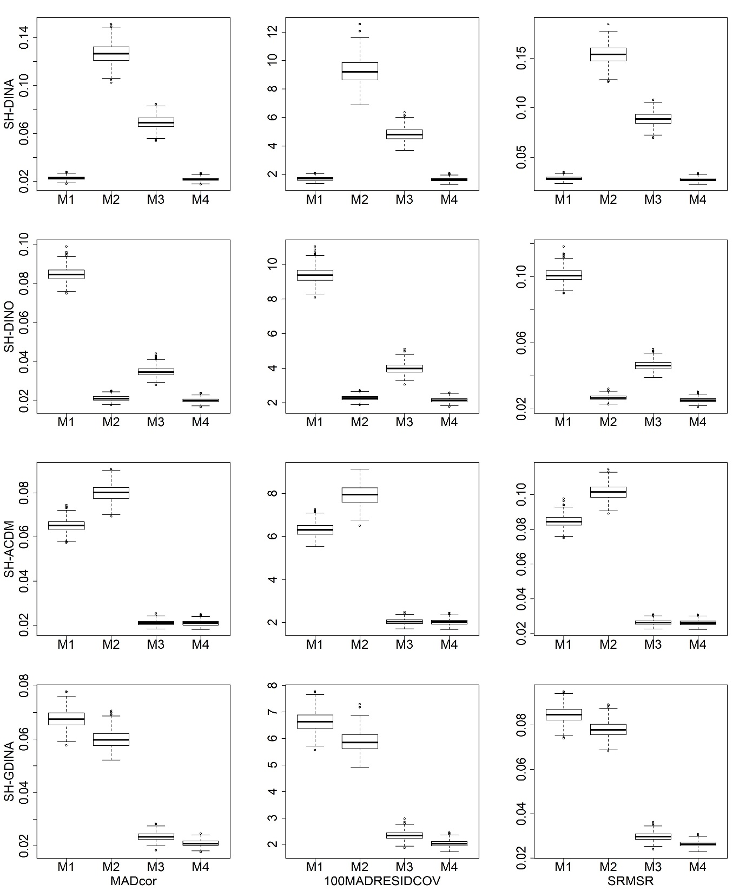
Figure S1. Boxplots of AFIs for non-hierarchical attribute structures
with small sample size in high item quality cases

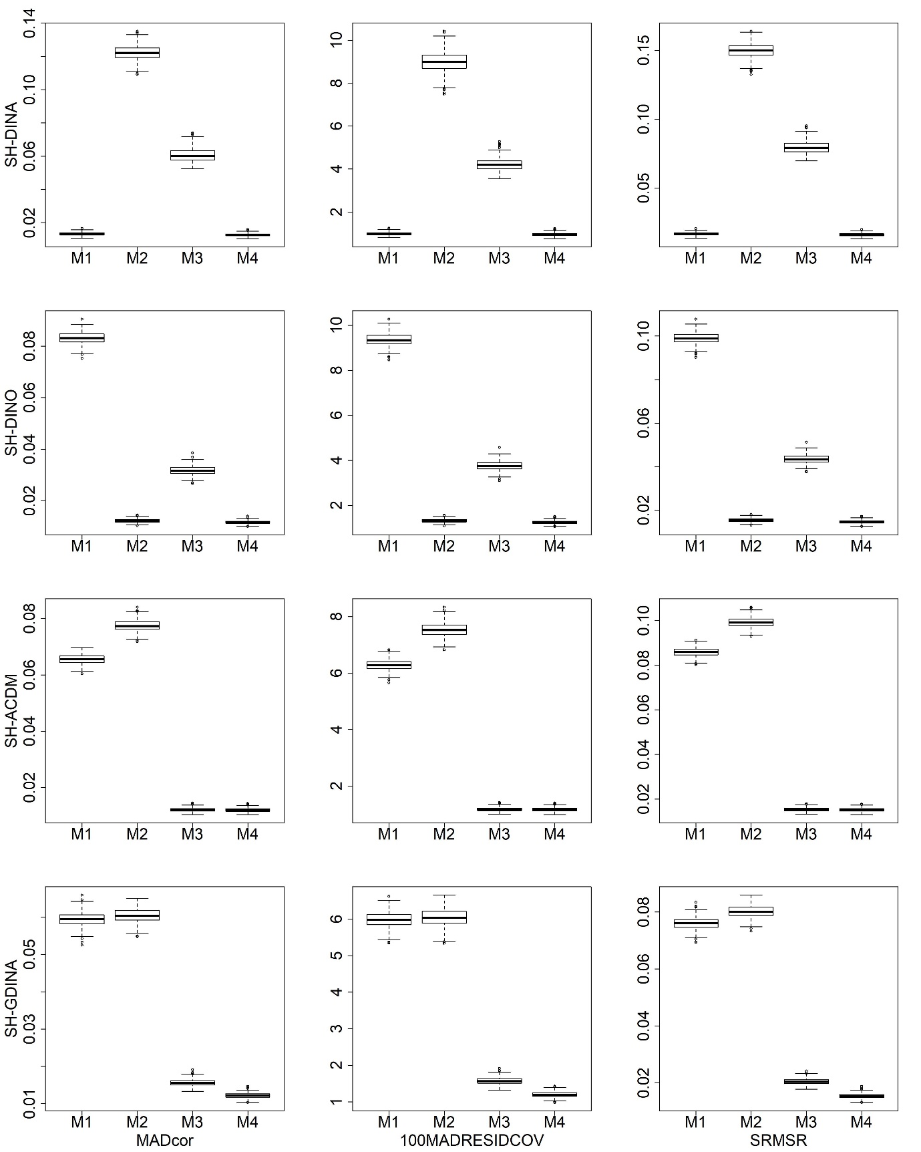
Figure S2. Boxplots of AFIs for non-hierarchical attribute structures
with large sample size in high item quality cases

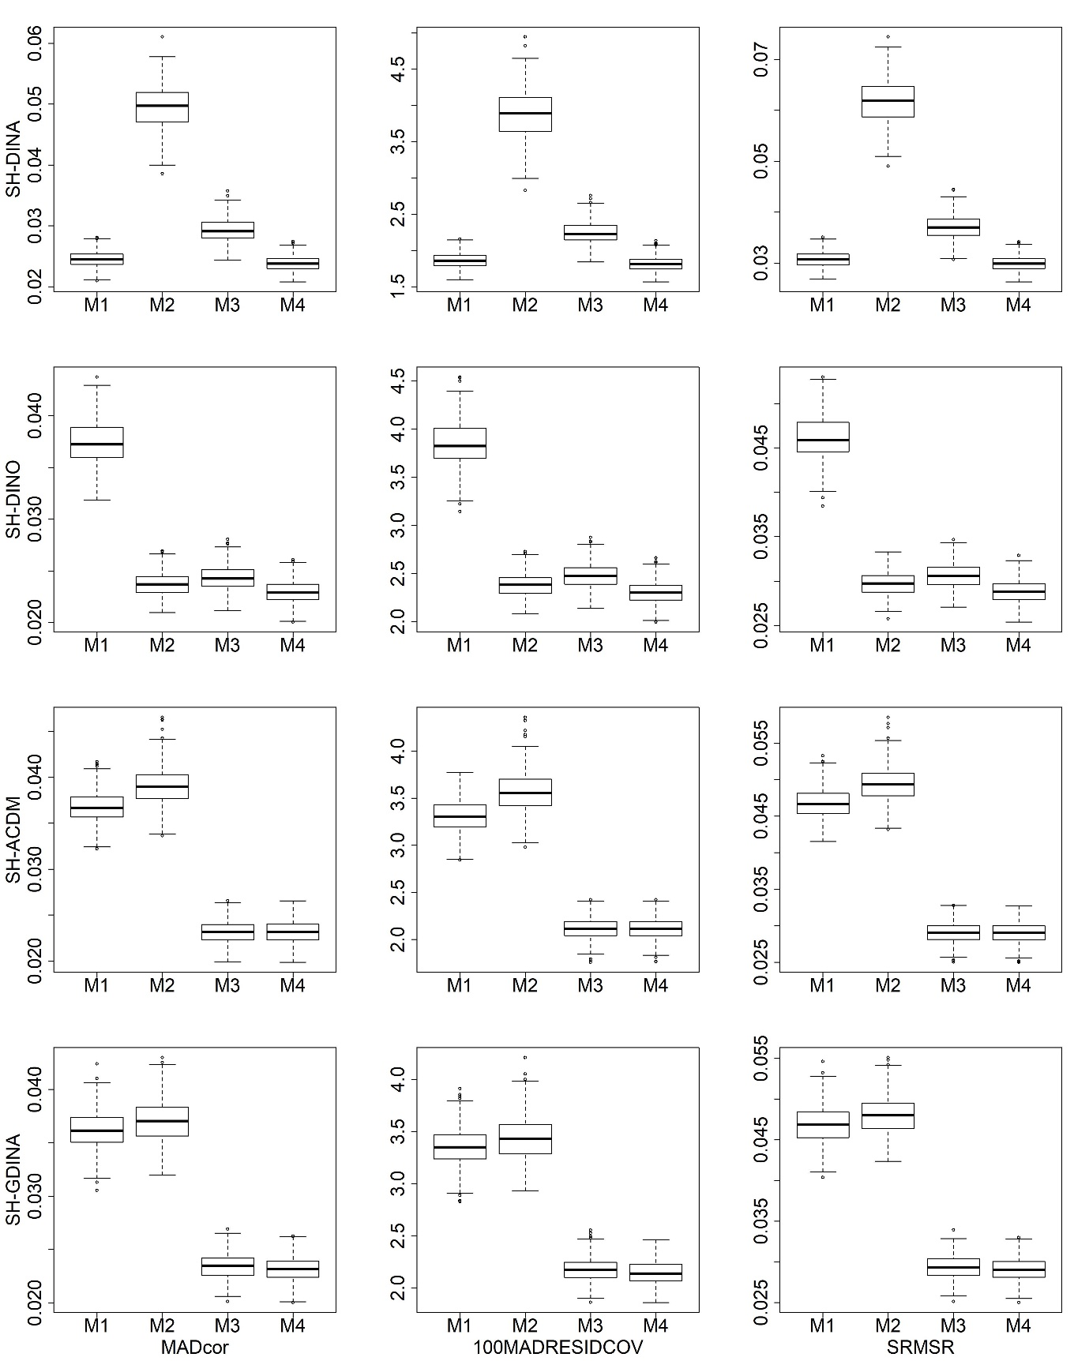
Figure S3. Boxplots of AFIs for non-hierarchical attribute structures
with small sample size in low item quality cases

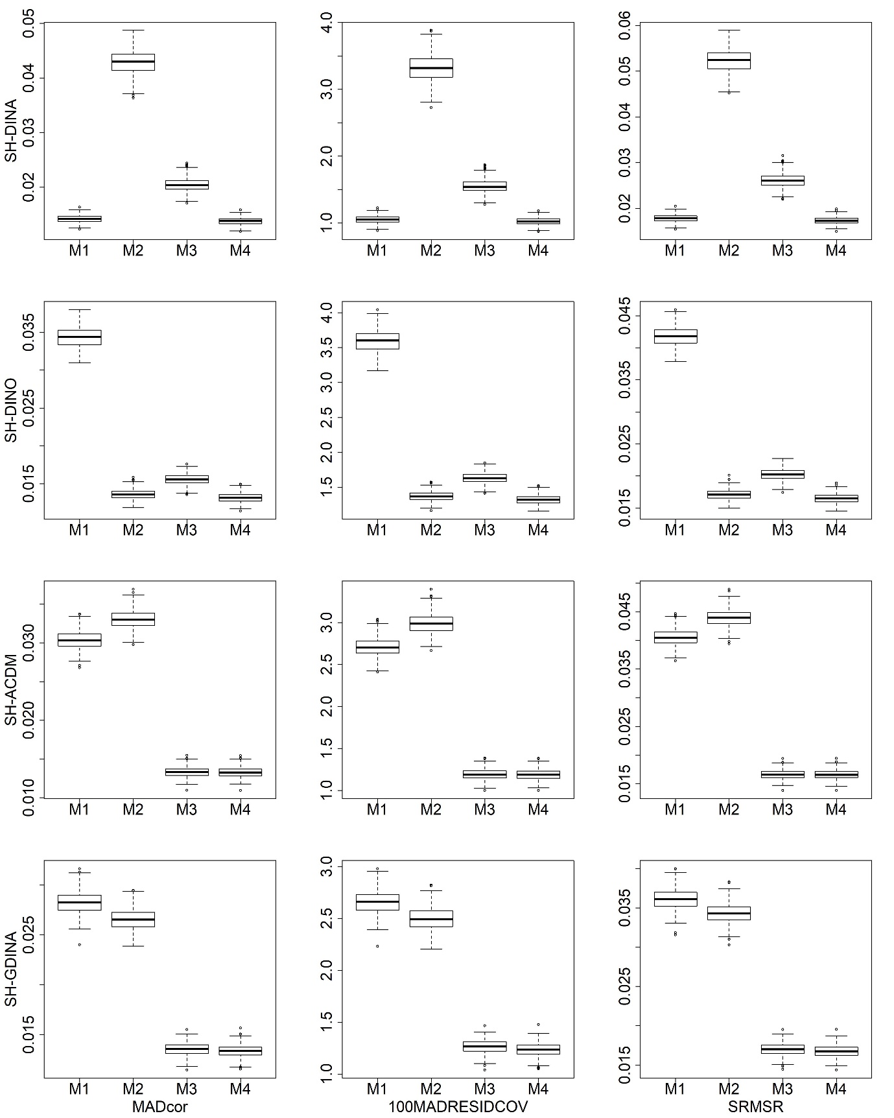
Figure S4. Boxplots of AFIs for non-hierarchical attribute structures
with large sample size in low item quality cases

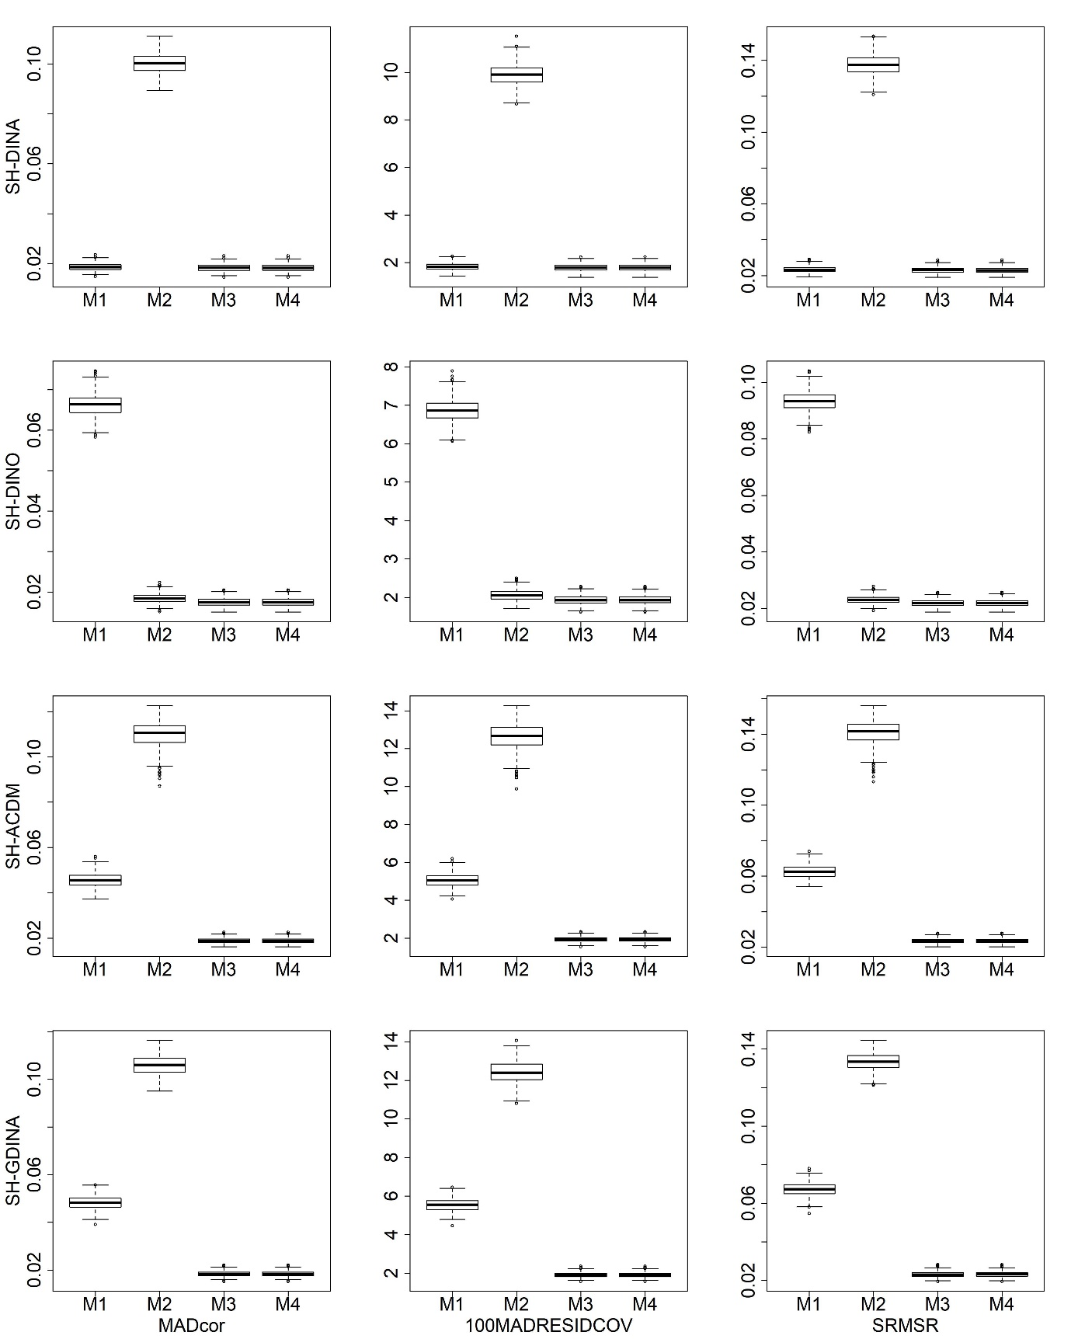
Figure S5. Boxplots of AFIs for linear attribute structures with
small sample size in high item quality cases

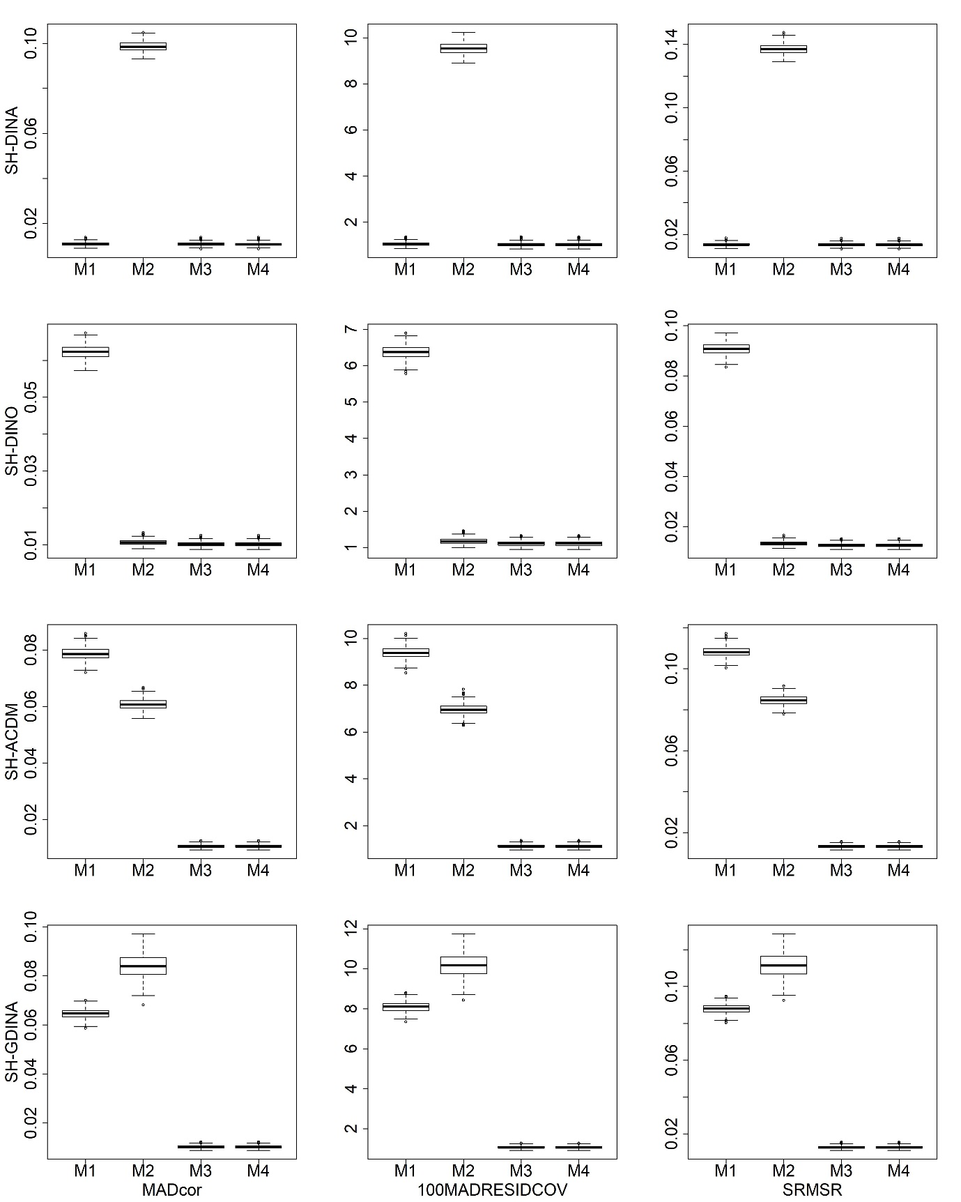
Figure S6. Boxplots of AFIs for linear attribute structures with
large sample size in high item quality cases

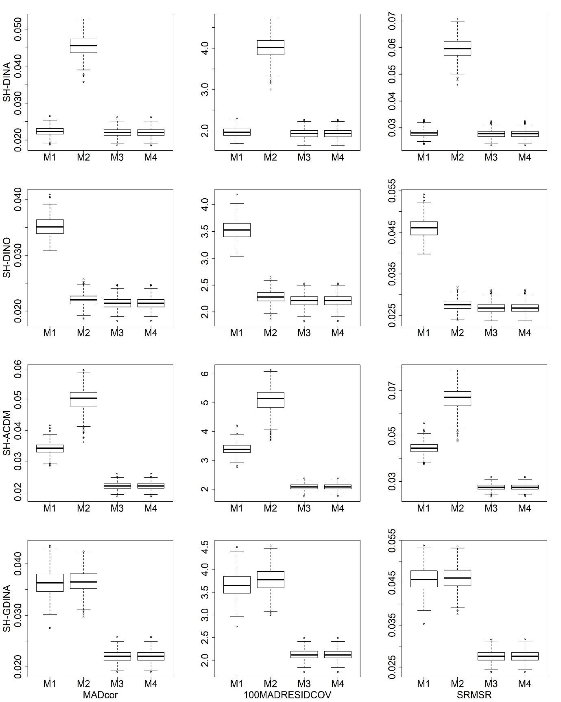
Figure S7. Boxplots of AFIs for linear attribute structures with
small sample size in low item quality cases

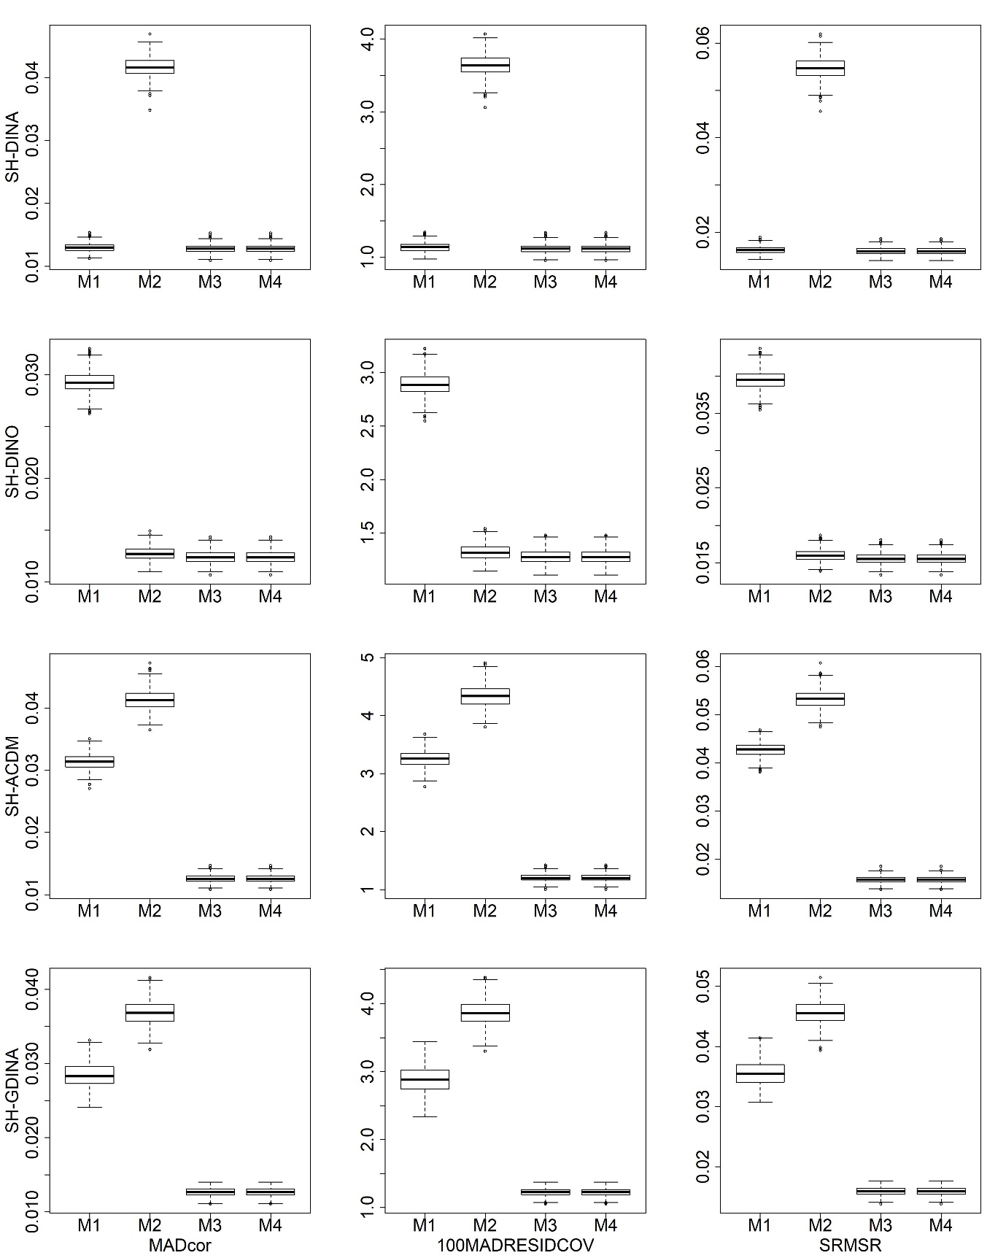
Figure S8. Boxplots of AFIs for linear attribute structures with
large sample size in low item quality cases

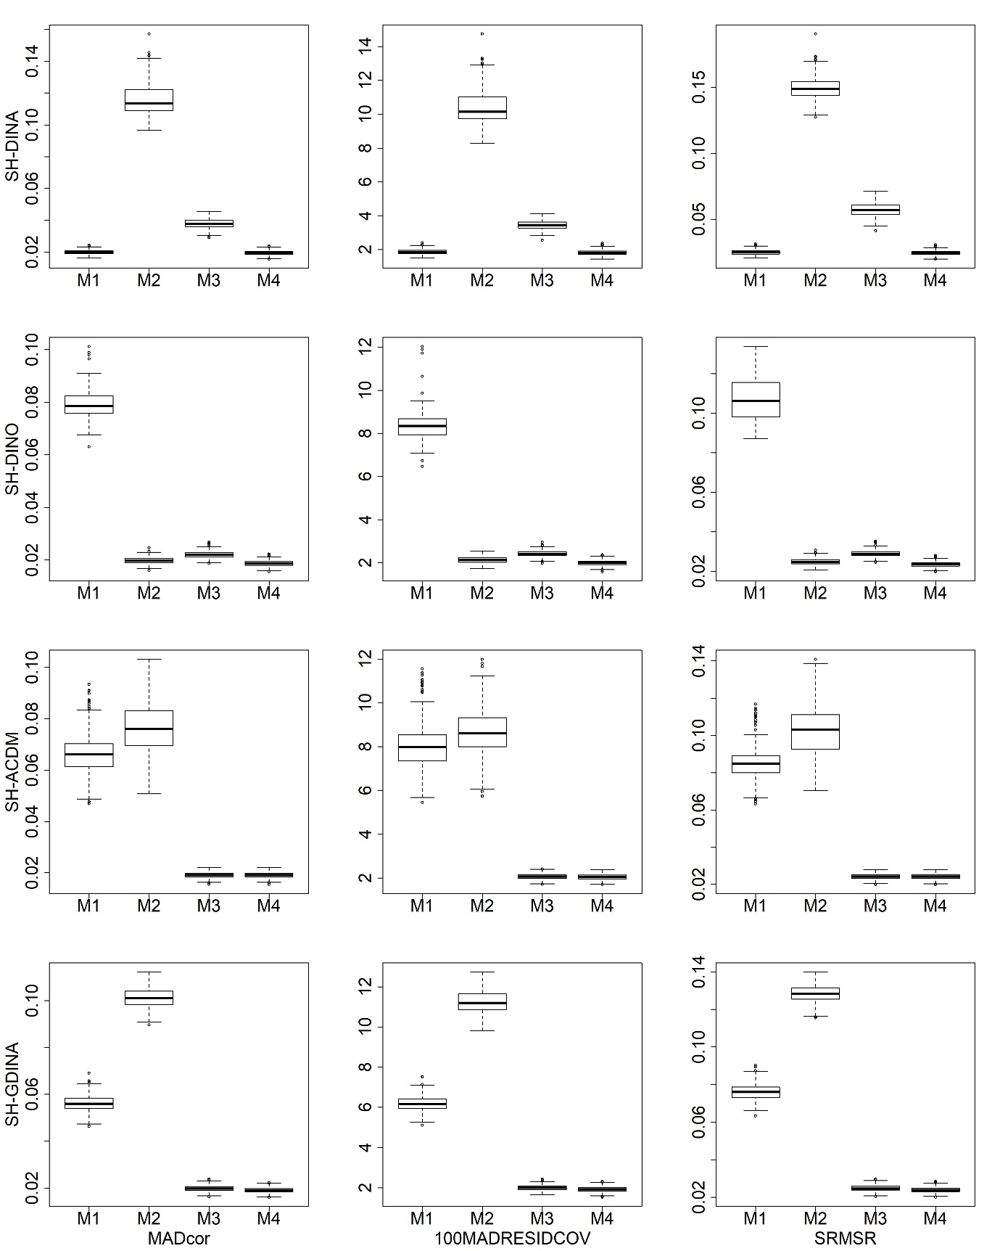
Figure S9. Boxplots of AFIs for convergent attribute structures
with small sample size in high item quality cases

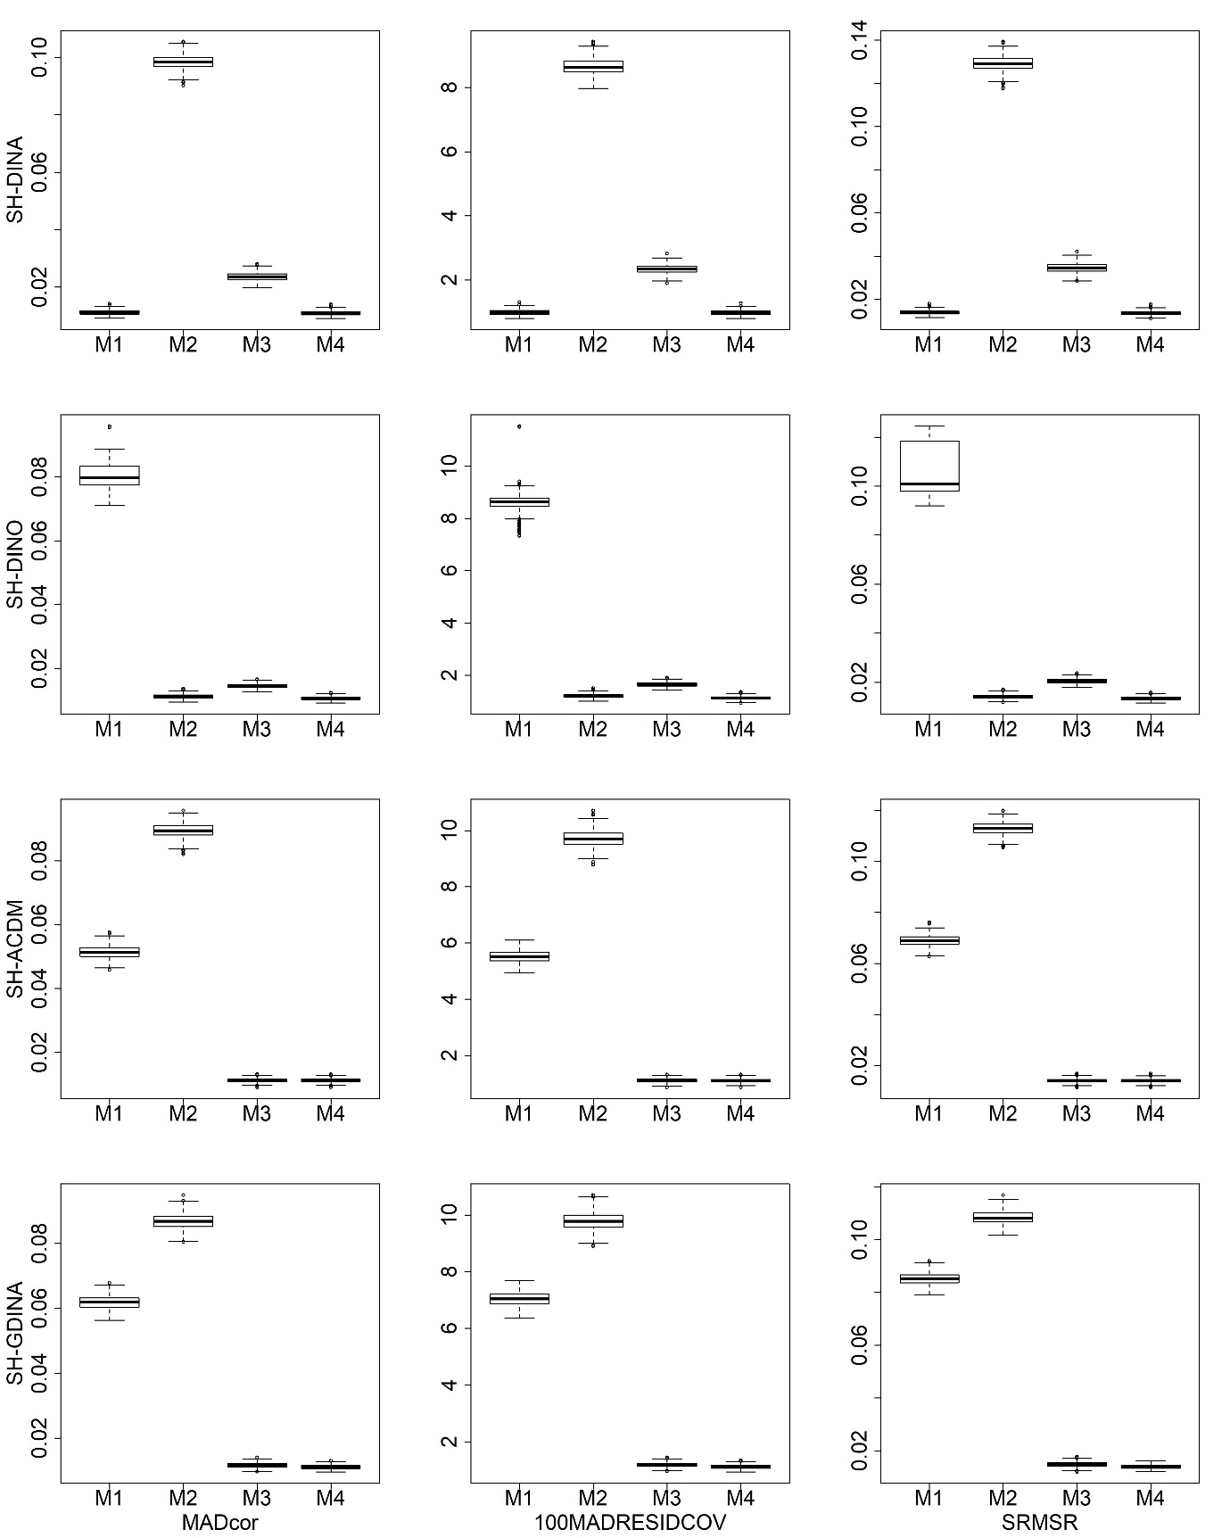
Figure S10. Boxplots of AFIs for convergent attribute structures
with large sample size in high item quality cases

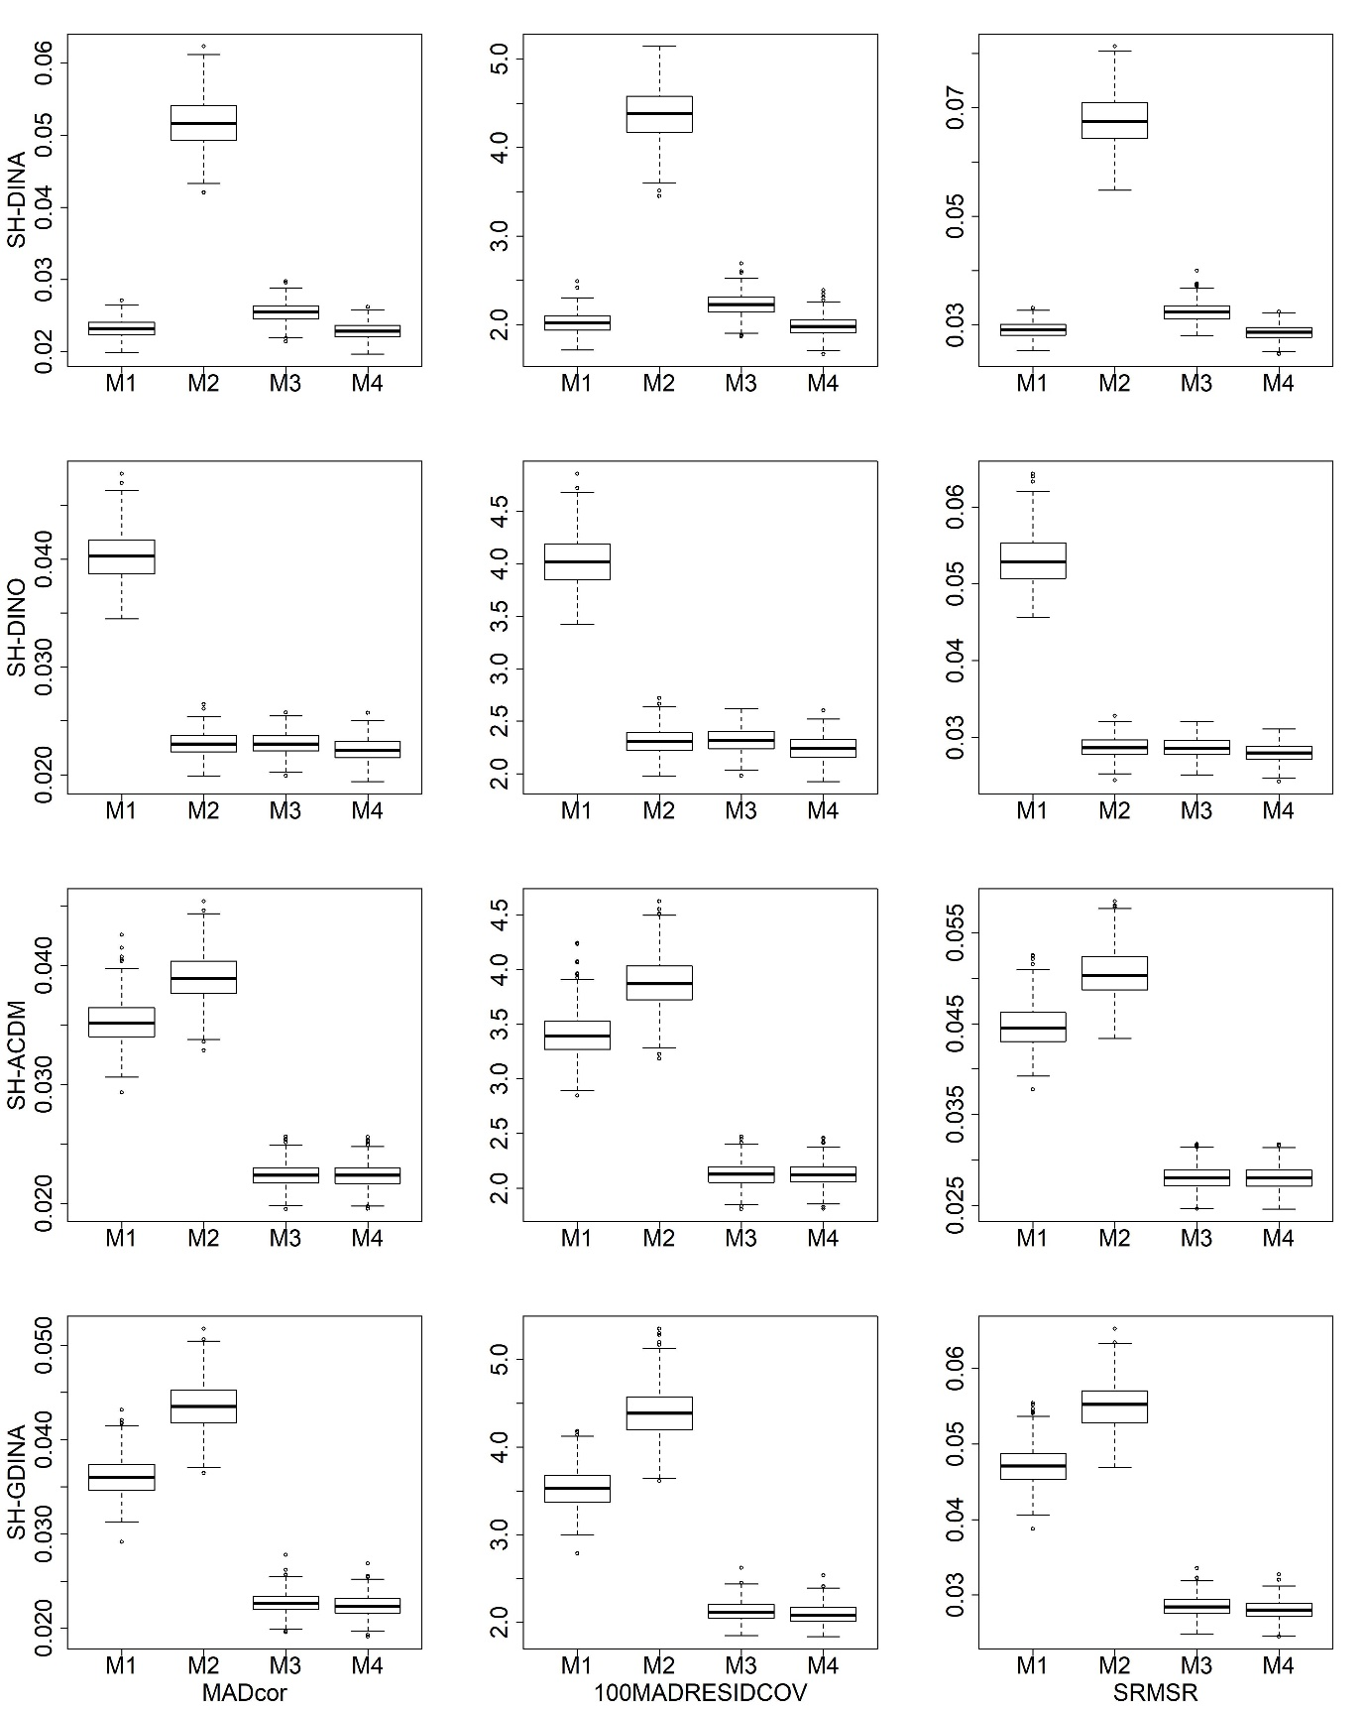
Figure S11. Boxplots of AFIs for convergent attribute structures
with small sample size in low item quality cases

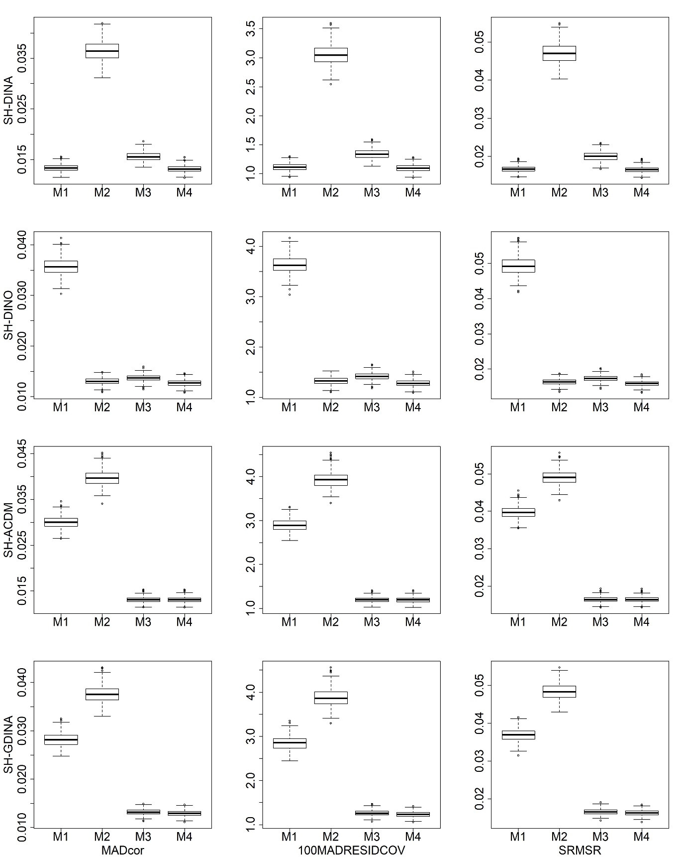
Figure S12. Boxplots of AFIs for convergent attribute structures
with large sample size in low item quality cases

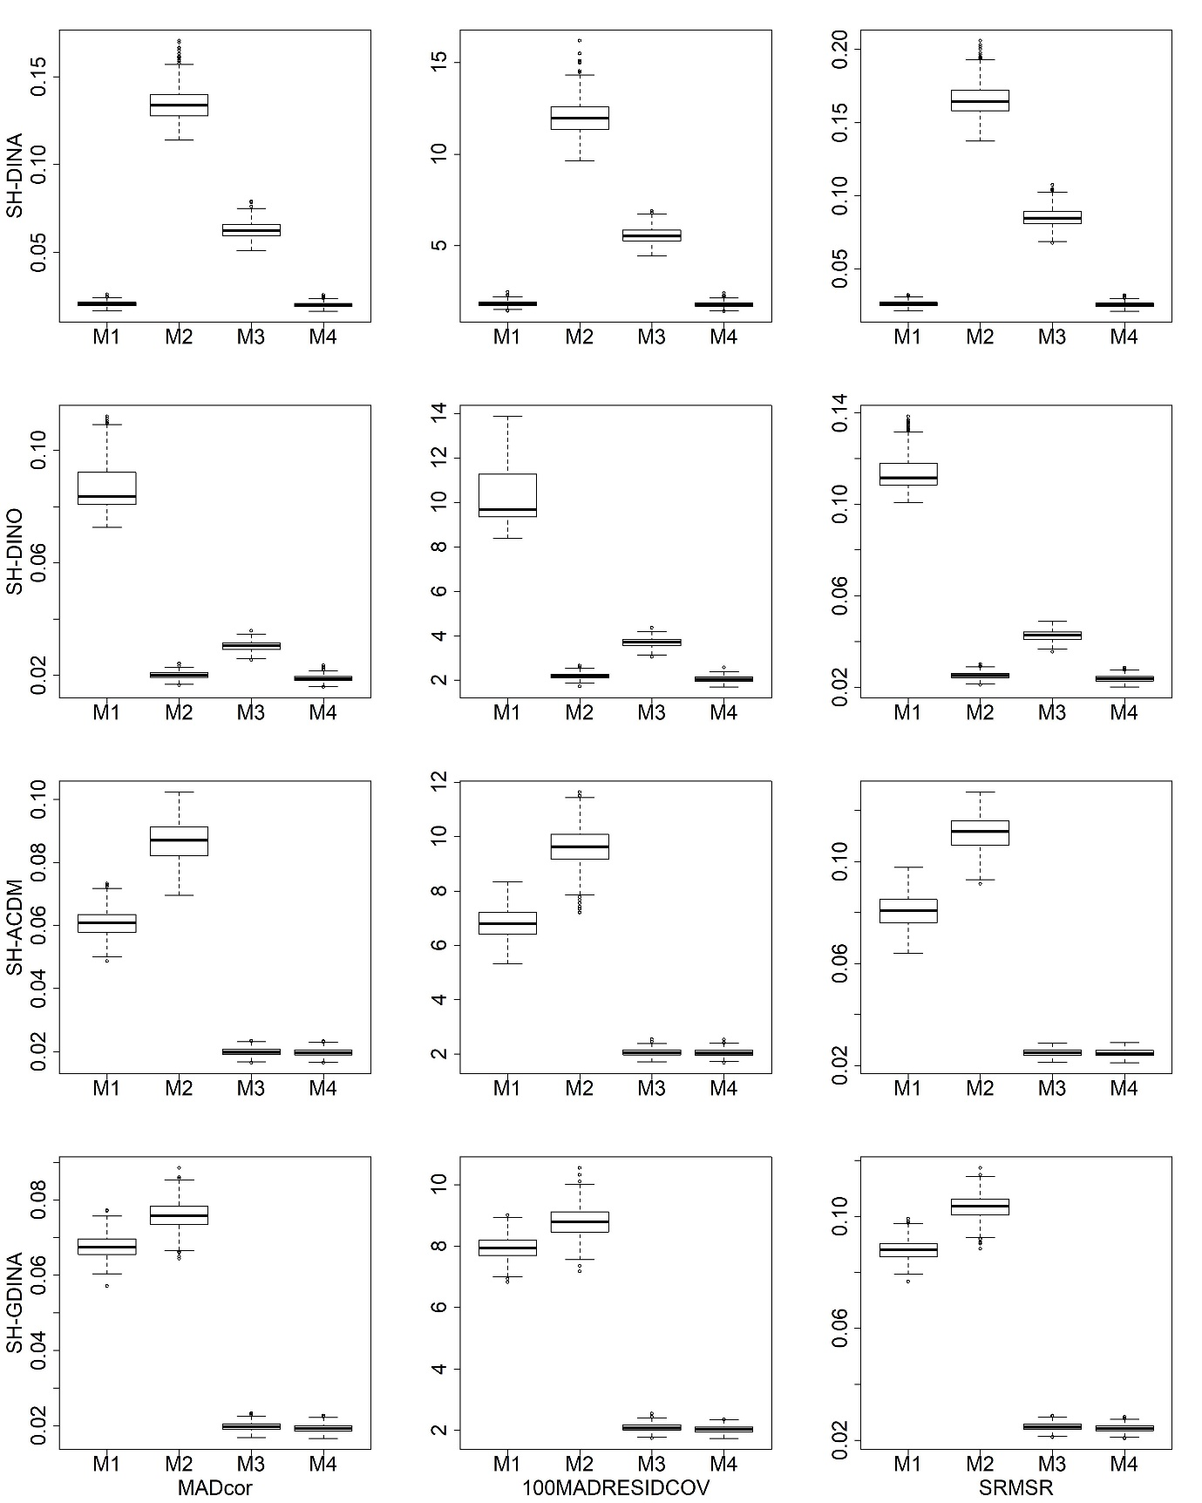
Figure S13. Boxplots of AFIs for divergent attribute structures
with small sample size in high item quality cases

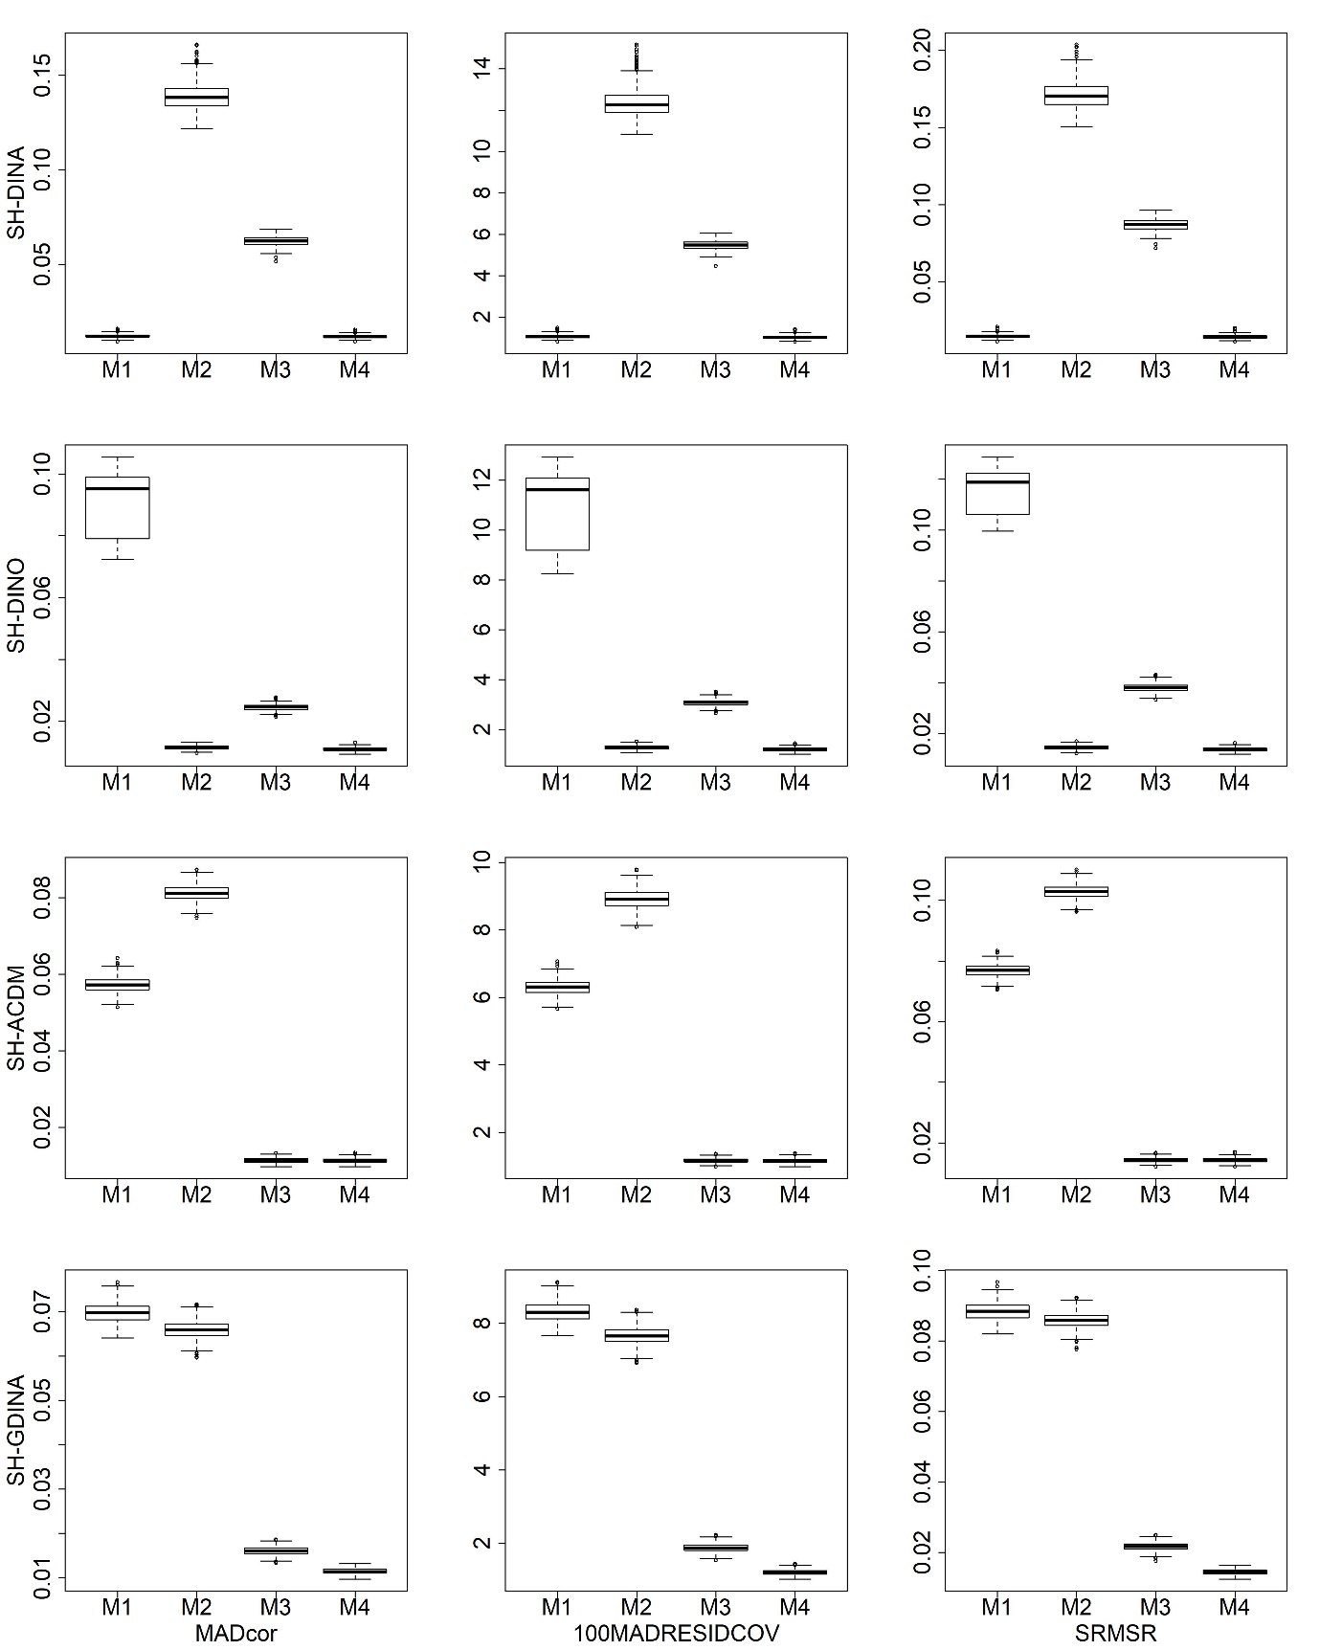
Figure S14. Boxplots of AFIs for divergent attribute structures
with large sample size in high item quality cases

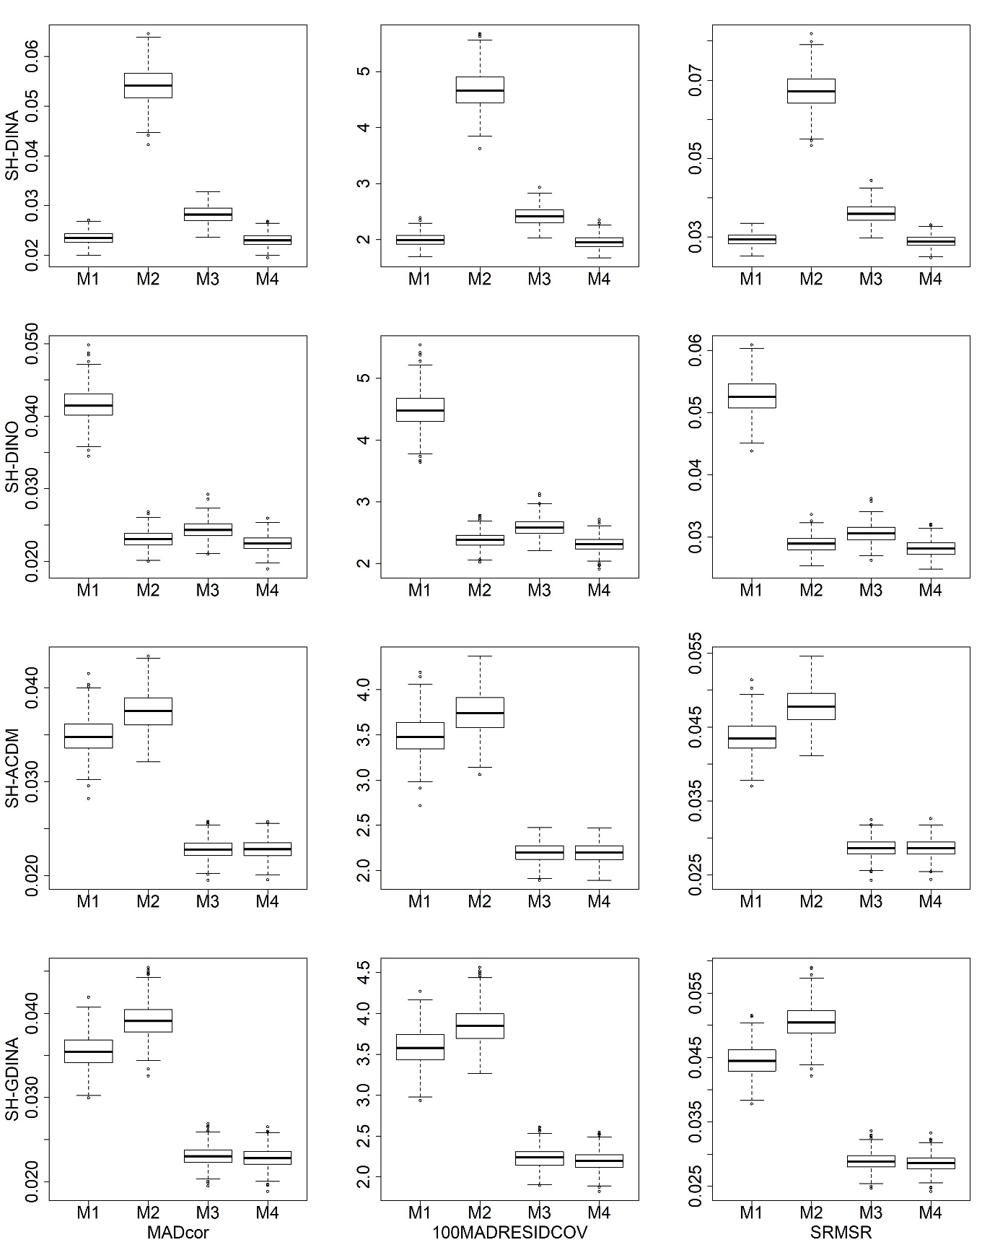
Figure S15. Boxplots of AFIs for divergent attribute structures
with small sample size in low item quality cases

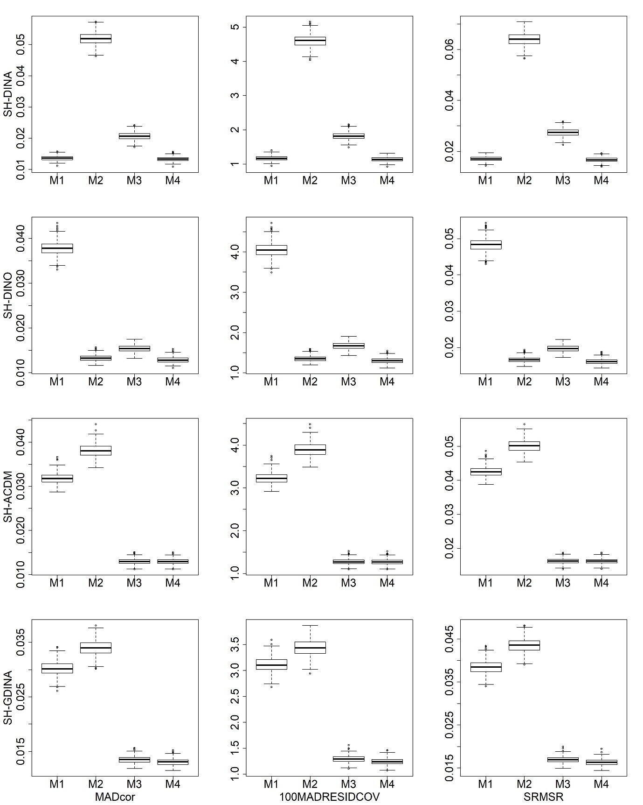
Figure S16. Boxplots of AFIs for divergent attribute structures
with large sample size in low item quality cases

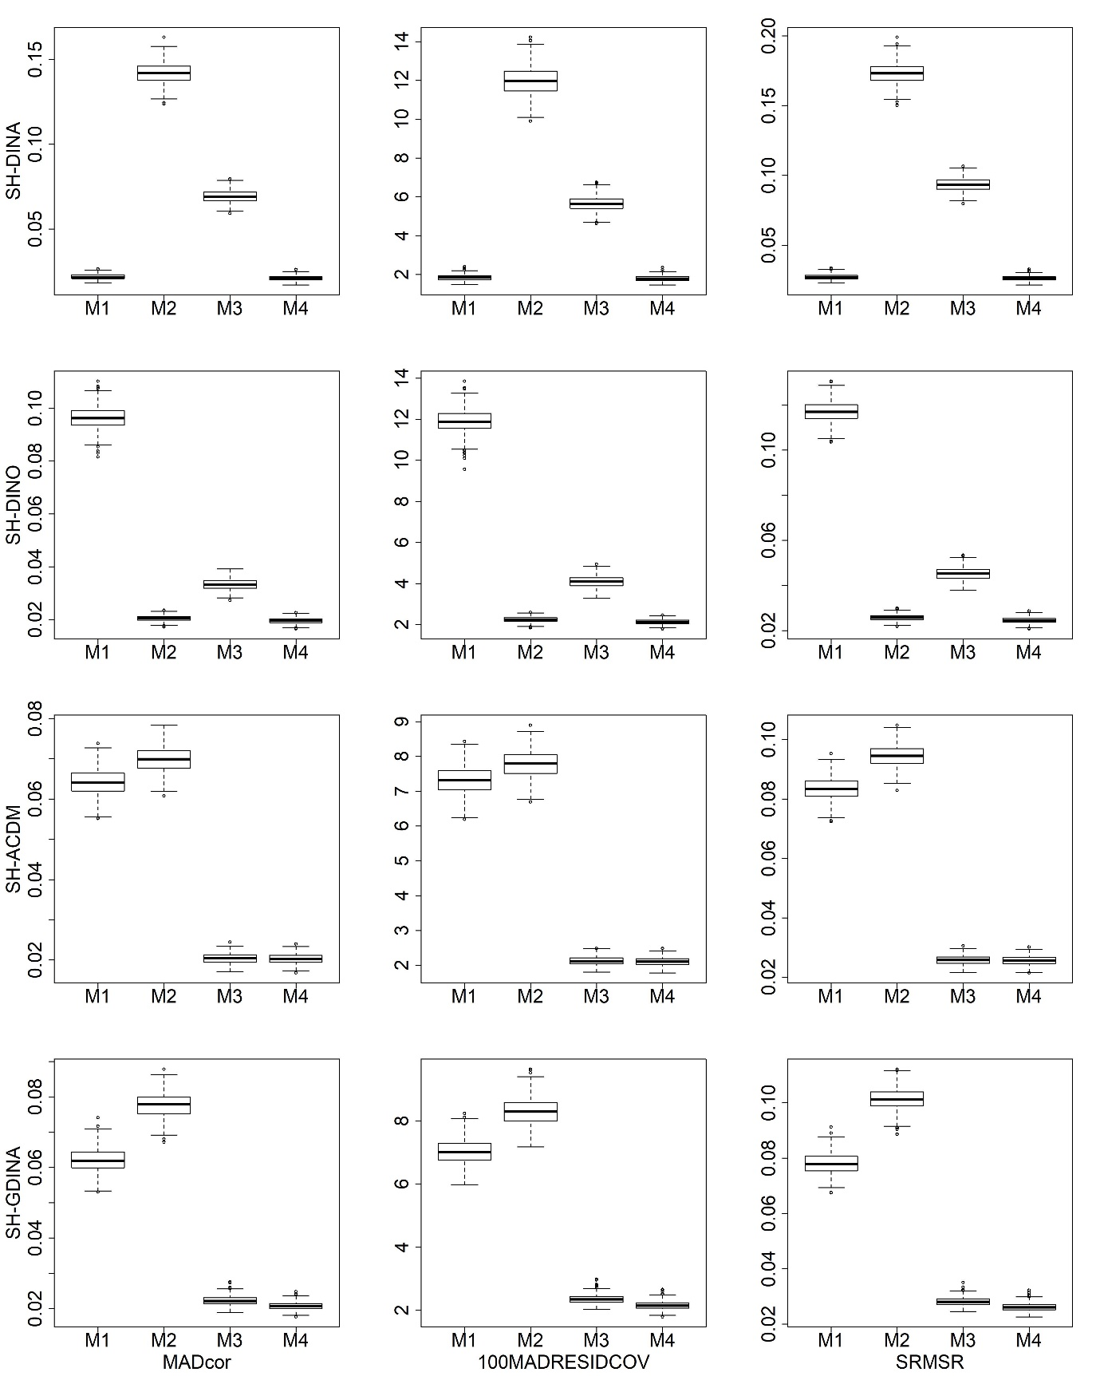
Figure S17. Boxplots of AFIs for unstructured attribute structures
with small sample size in high item quality cases

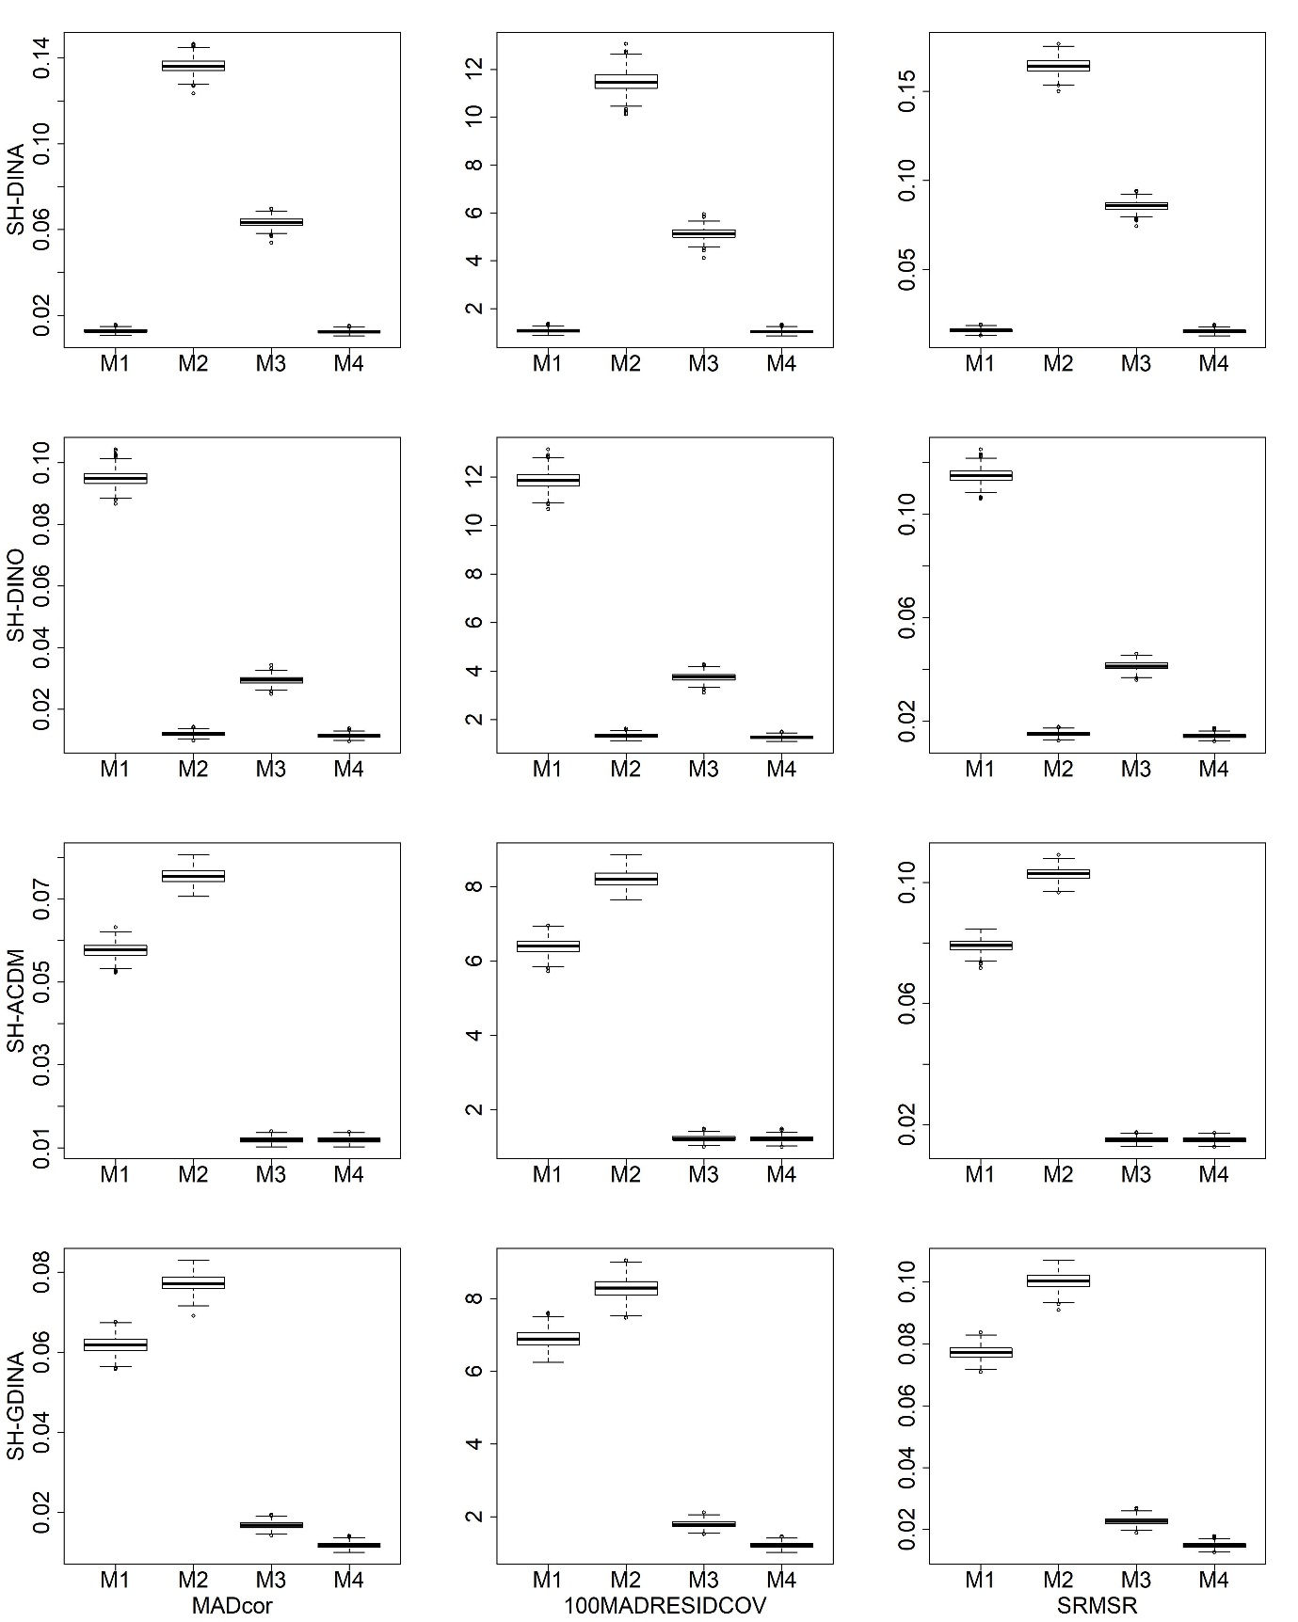
Figure S18. Boxplots of AFIs for unstructured attribute structures
with large sample size in high item quality cases

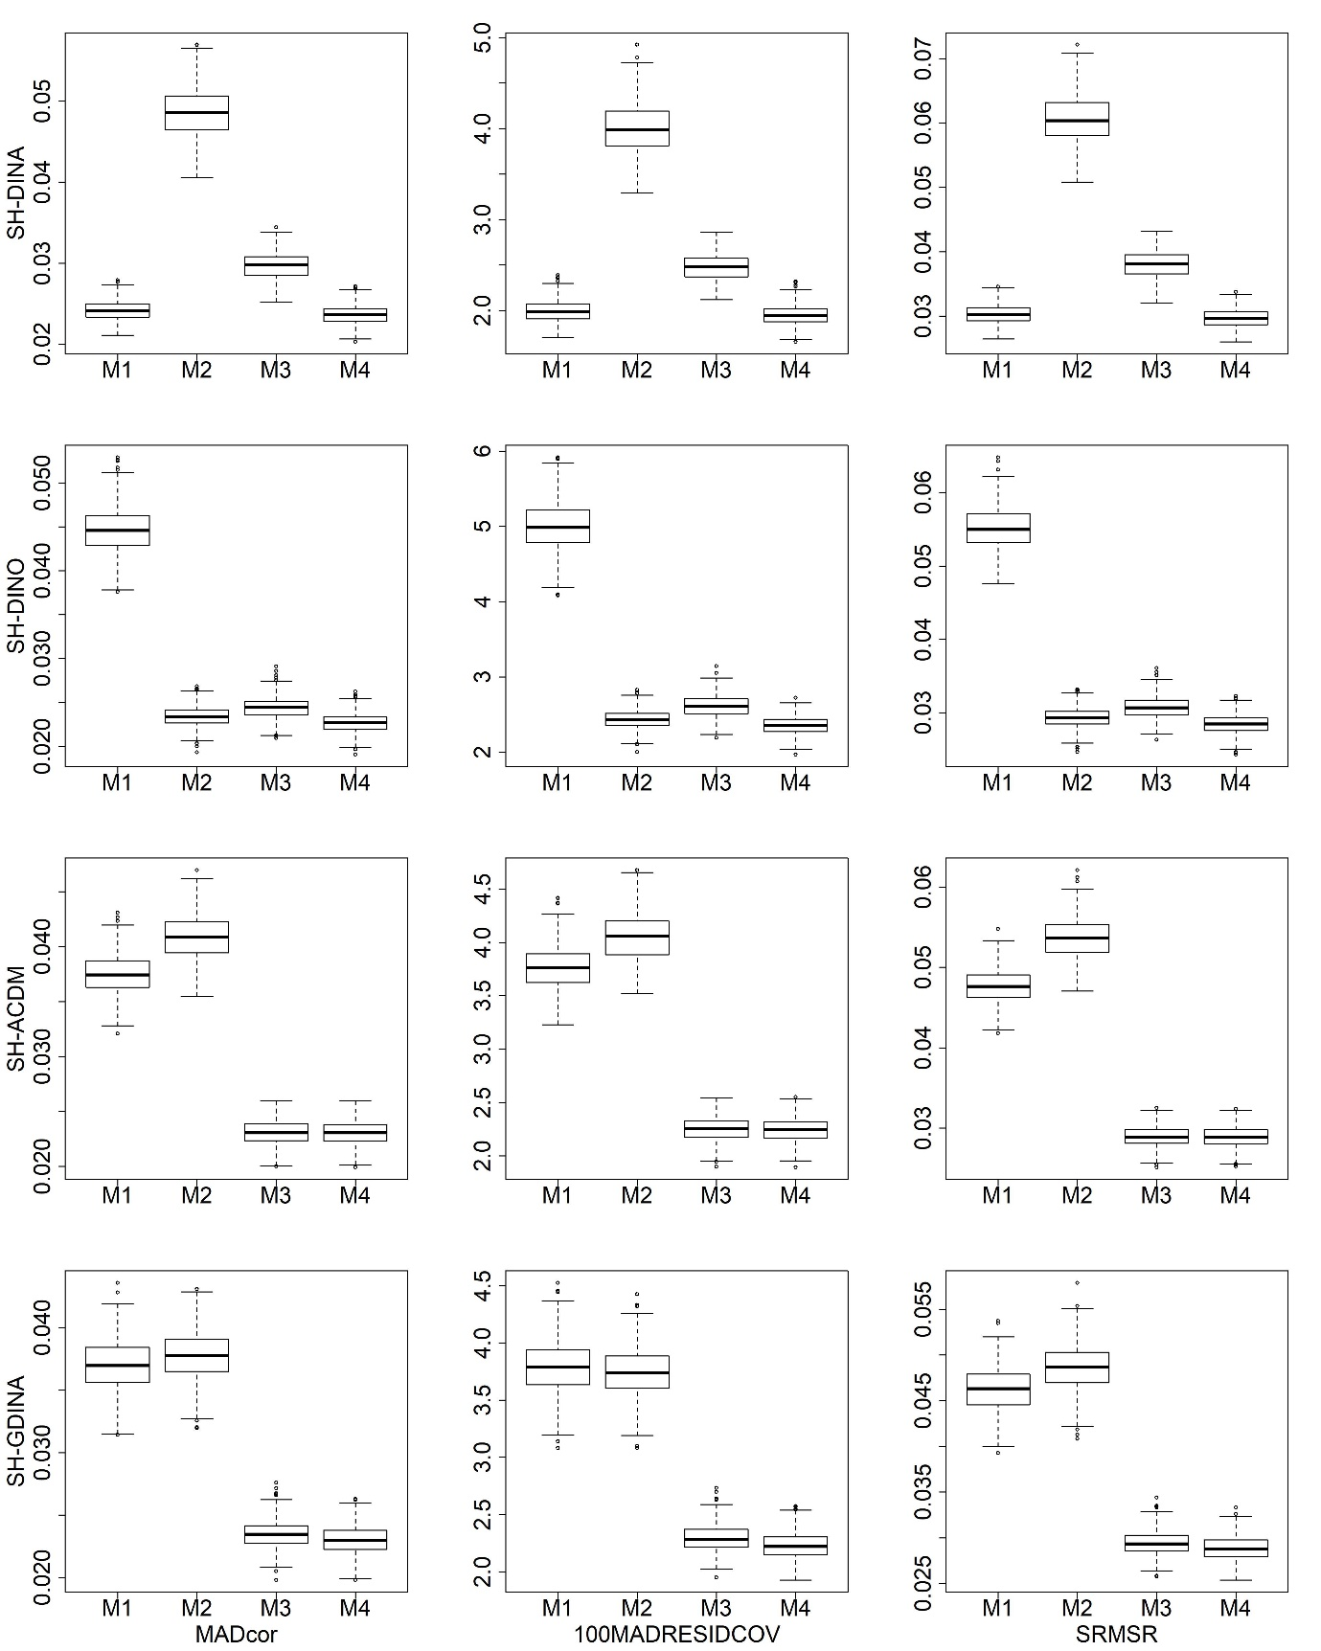
Figure S19. Boxplots of AFIs for unstructured attribute structures
with small sample size in low item quality cases

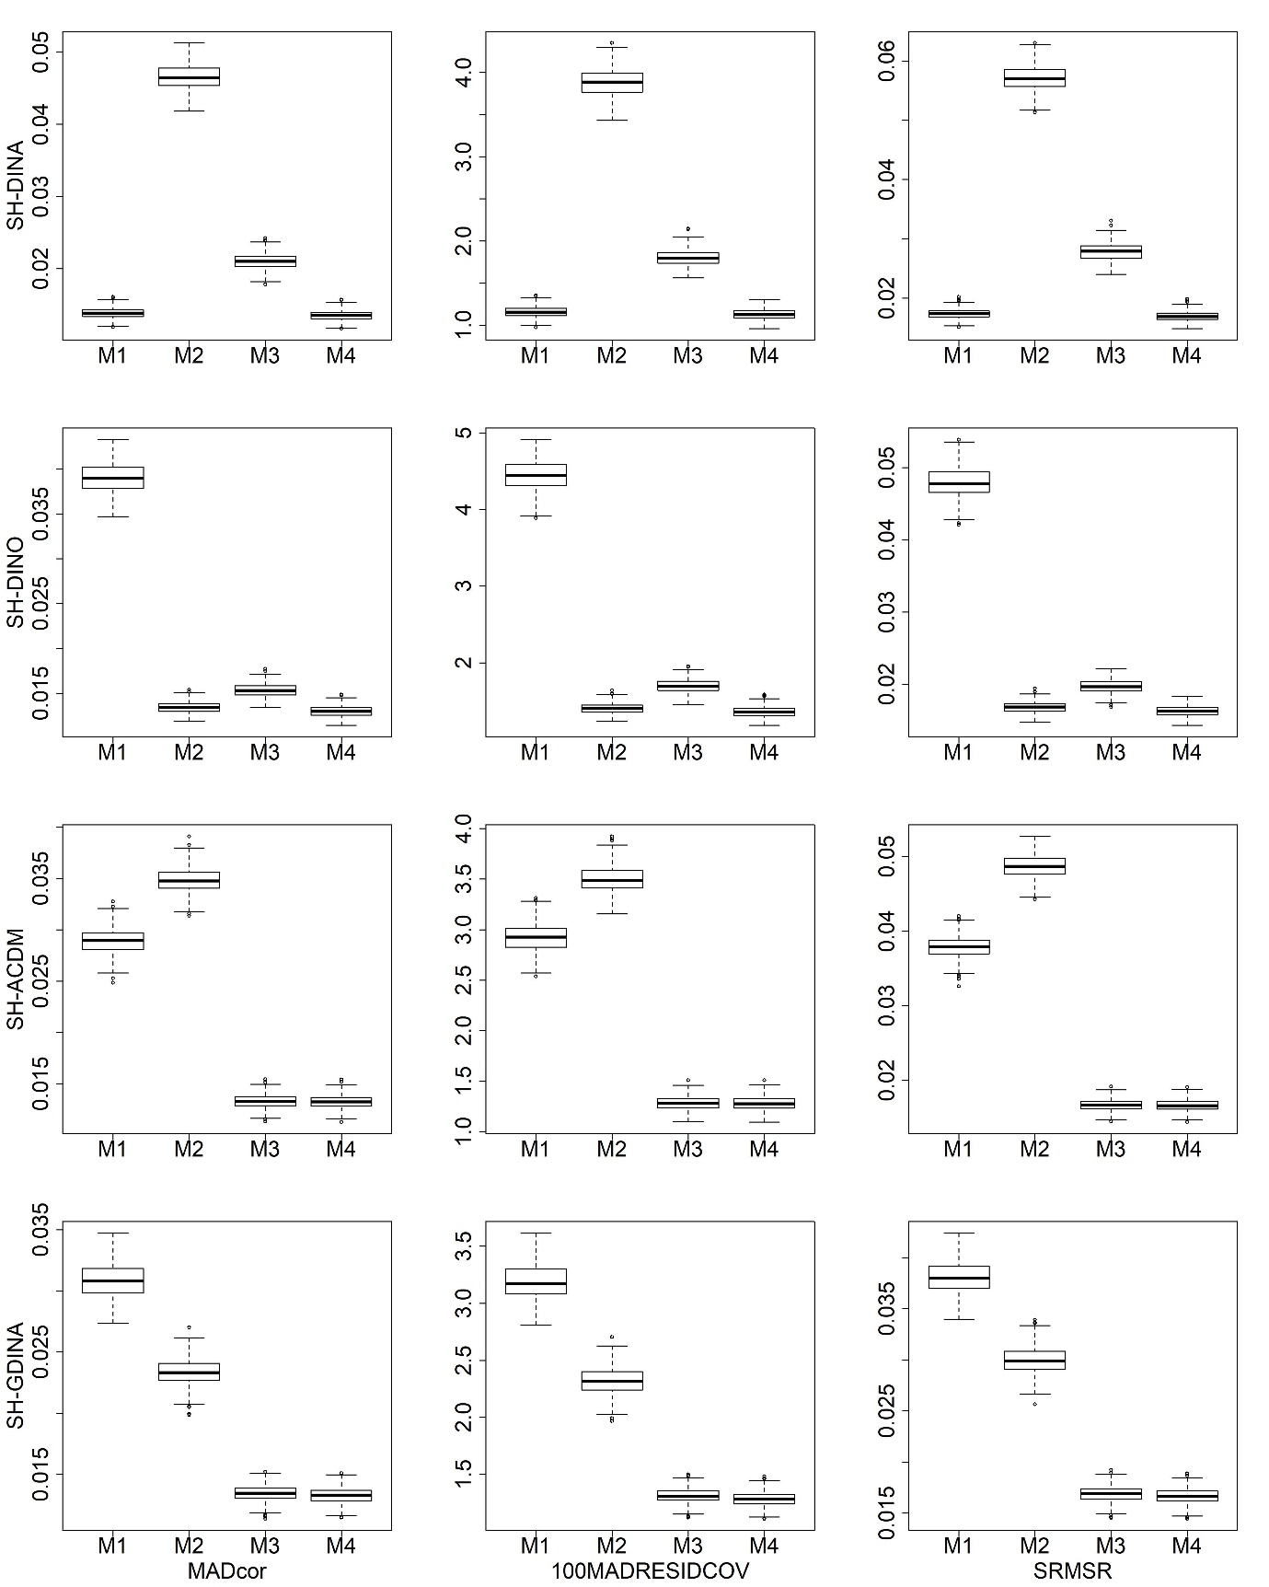
Figure S20. Boxplots of AFIs for unstructured attribute structures
with large sample size in low item quality cases

