Supplement Table S1. Determination of LD₅₀ of 12 P. mirabilis isolates
Strain No. | Bacterial concentration (CFU/mL) | Total number of mice | Dead mice number | LD₅₀
 | 3.5×10⁹ | 8 | 6
CC15042 | 3.5×10⁸ | 8 | 3 | 1.78×10⁸
 | 3.5×10⁷ | 8 | 0
 | 2.17×10⁹ | 8 | 6
CC16101 | 2.17×10⁸ | 8 | 7 | 1.54×10⁹
 | 2.17×10⁷ | 8 | 3
 | 2.94×10⁹ | 8 | 8
CC16012 | 2.94×10⁸ | 8 | 3 | 0.76×10⁸
 | 2.94×10⁷ | 8 | 0
 | 2.72×10⁹ | 8 | 7
CC16071 | 2.72×10⁸ | 8 | 2 | 1.30×10⁸
 | 2.72×10⁷ | 8 | 0
 | 2.74×10⁹ | 8 | 8
CC16091 | 2.74×10⁸ | 8 | 5 | 0.48×10⁸
 | 2.74×10⁷ | 8 | 0
 | 2.67×10⁹ | 8 | 7
CC17011 | 2.67×10⁸ | 8 | 2 | 1.28×10⁸
 | 2.67×10⁷ | 8 | 0
 | 1.94×10⁹ | 8 | 5
CC16082 | 1.94×10⁹ | 8 | 5 | 4.65×10⁸
 | 1.94×10⁹ | 8 | 1
 | 2.24×10⁹ | 8 | 6
CC15071 | 2.24×10⁸ | 8 | 6 | 0.51×10⁸
 | 2.24×10⁷ | 8 | 0
 | 2.78×10⁹ | 8 | 7
CC15091 | 2.78×10⁸ | 8 | 4 | 0.8×10⁸
 | 2.78×10⁷ | 8 | 0
 | 2.84×10⁹ | 8 | 8
CC16092 | 2.84×10⁸ | 8 | 4 | 2.84×10⁸
 | 2.84×10⁷ | 8 | 0
 | 2.18×10⁹ | 8 | 8
CC15031 | 2.18×10⁸ | 8 | 5 | 0.57×10⁶
 | 2.18×10⁷ | 8 | 2
 | 2.52×10⁹ | 8 | 8
CC16051 | 2.52×10⁸ | 8 | 3 | 0.50×10⁸
 | 2.52×10⁷ | 8 | 0

Supplement Table S2. MICs (μg/mL) of different agents against twelve P. mirabilis isolates
Strain No. | ENR | CLI | SUL | FOR | CEF | DOX | CIP | GEN | ERY | CHL
CC16101 | 32 | <0.06 | <0.06 | 512 | >512 | 128 | 32 | 256 | >512 | <0.06
CC15071 | 4 | >512 | >512 | 32 | >512 | 64 | 4 | 256 | >512 | 32
CC16091 | 16 | >512 | >512 | 512 | >512 | 128 | 32 | 32 | >512 | 256
CC16082 | 8 | 32 | >512 | 128 | >512 | 128 | 16 | >512 | >512 | 32
CC15042 | 8 | >512 | >512 | 128 | >512 | 128 | 16 | >512 | >512 | 32
CC15031 | 16 | >512 | >512 | 32 | >512 | 128 | 16 | 256 | >512 | 256
CC15091 | 16 | >512 | >512 | 32 | >512 | 64 | 4 | 256 | >512 | 16
CC16092 | 32 | >512 | >512 | 512 | >512 | 256 | 32 | 256 | >512 | 128
CC16071 | <0.06 | <0.06 | 64 | 2 | <0.06 | 16 | 0.125 | 0.5 | 128 | 16
CC16051 | 128 | >512 | 512 | >512 | >512 | 256 | 64 | >512 | >512 | >512
CC17011 | 16 | >512 | >512 | 128 | <0.06 | 128 | 16 | 0.125 | >512 | 32
CC16012 | 0.5 | 32 | 128 | 4 | <0.06 | 2 | 0.125 | 0.125 | 128 | 256
ENR, Enrofloxacin; CLI, Clindamycin; SUL, Sulfamethoxazole; FOR, Florfenicol; CEF, Ceftriaxone; DOX, Doxycycline; CIP, Ciprofloxacin; GEN, Gentamicin; ERY, Erythromycin; CHL, Chloramphenicol677

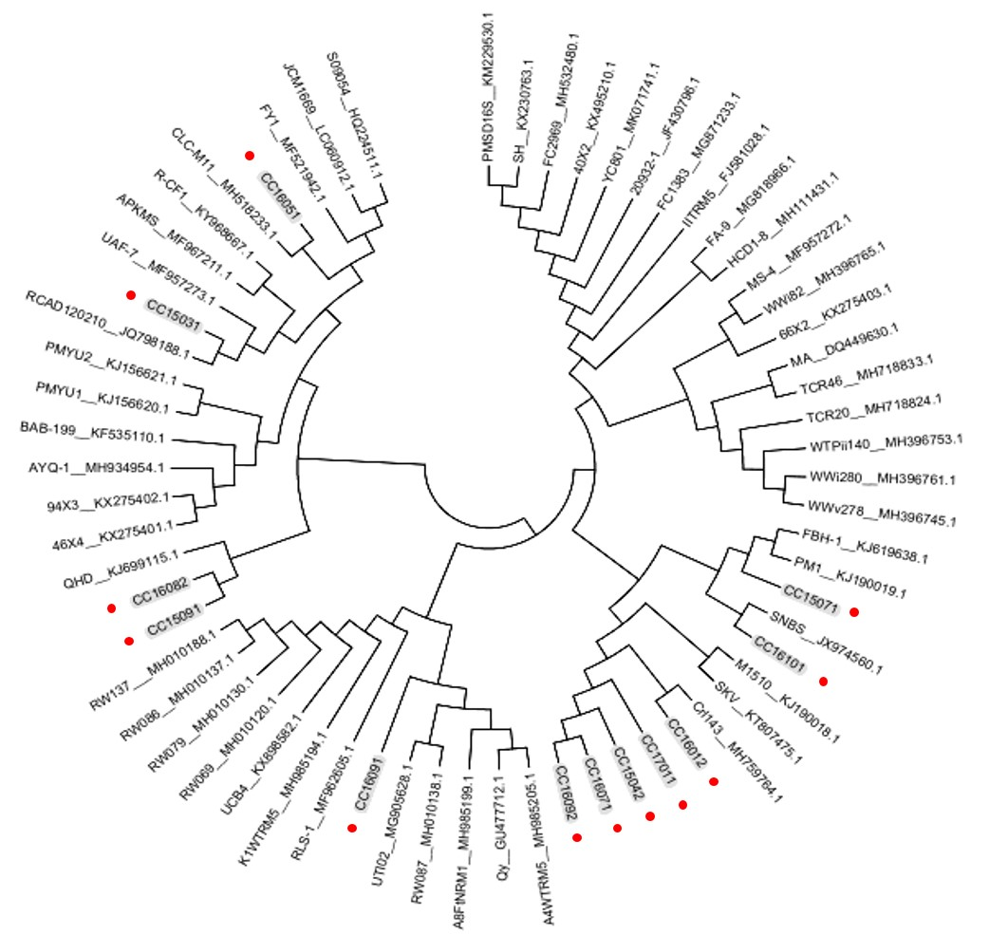

Supplement Figure S1. The phylogenetic tree based on 16S rRNA gene sequences of P. mirabilis.
Red represents 12 strains isolated from the diarrhea samples of dogs. Black represents 52 strains of P. mirabilis, and the sequence is included in GenBank.

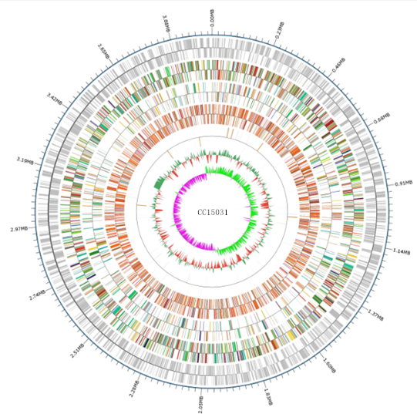
Supplement Figure S2. Relevant genomic features of CC15031 chromosome
Moving inward from the outermost circle, each ring of the circle contains information of a genome: rRNA/tRNA (red for tRNA and blue for rRNAs), reverse CDSs (colored according to the COGs categories), CDSs (colored according to the COGs categories), GC skew (yellow and blue for positive and negative values, respectively) and GC ratio (red and green for positive and negative values, respectively).

Supplement Table S3. Annotation of CC15031 based on VFDB
Gene_id | Identity |  | E_value | VFDB_internal_  id | VF_id | VF_name
GM000027 | 42.7 | 4.40E-34 |  | VFG000320 | VF0056 | LPS
GM000028 | 49.4 | 2.50E-63 |  | VFG013315 | CVF494 | LOS
GM000029 | 51.9 | 5.70E-121 |  | VFG013157 | CVF494 | LOS
GM000034 | 58 | 4.40E-94 |  | VFG013152 | CVF494 | LOS
GM000035 | 60.9 | 6.50E-115 |  | VFG013400 | CVF494 | LOS
GM000036 | 78.1 | 3.60E-141 |  | VFG013409 | CVF494 | LOS
GM000049 | 66 | 6.00E-154 |  | VFG007656 | CVF282 | Capsular polysaccharide
GM000050 | 63.1 | 6.30E-117 |  | VFG019018 | CVF043 | O-antigen
GM000051 | 49.2 | 2.10E-70 |  | VFG038088 | CVF775 | Capsule
GM000058 | 40.6 | 5.20E-36 |  | VFG009866 | CVF333 | MprA/B
GM000120 | 82.4 | 1.20E-194 |  | VFG046459 | CVF827 | EF-Tu
GM000162 | 40.8 | 3.80E-29 |  | VFG045340 | VF0414 | RicA
GM000186 | 57.5 | 1.10E-106 |  | VFG013510 | CVF494 | LOS
GM000187 | 65.6 | 9.40E-130 |  | VFG023778 | CVF043 | O-antigen
GM000189 | 71.2 | 6.50E-153 |  | VFG007640 | CVF282 | Capsular polysaccharide
GM000190 | 68.9 | 1.80E-164 |  | VFG007635 | CVF282 | Capsular polysaccharide
GM000191 | 80.1 | 2.70E-169 |  | VFG007659 | CVF282 | Capsular polysaccharide
GM000192 | 74.4 | 4.00E-126 |  | VFG037938 | CVF775 | Capsule
GM000201 | 40.4 | 1.40E-60 |  | VFG013634 | CVF506 | Heme biosynthesis
GM000202 | 44.7 | 3.30E-49 |  | VFG013199 | CVF506 | Heme biosynthesis
GM000203 | 64.4 | 5.80E-107 |  | VFG013198 | CVF506 | Heme biosynthesis
GM000252 | 43 | 1.20E-39 |  | VFG010532 | CVF349 | Mip
GM000256 | 60.3 | 1.10E-149 |  | VFG038900 | CVF792 | Hemolysin, HlyA
GM000282 | 74.3 | 4.20E-191 |  | VFG013514 | CVF495 | Exopolysaccharide
GM000284 | 47.6 | 1.90E-31 |  | VFG039487 | CVF803 | T4SS effectors
GM000291 | 76.4 | 5.30E-126 |  | VFG043545 | AI331 | NlpI
GM000306 | 56.1 | 3.90E-50 |  | VFG043619 | AI075 | type 1 fimbriae
GM000307 | 56.6 | 2.60E-69 |  | VFG033257 | CVF426 | Type I fimbriae
GM000308 | 53.4 | 3.90E-278 |  | VFG033294 | CVF426 | Type I fimbriae
GM000309 | 52.1 | 1.20E-43 |  | VFG012305 | CVF426 | Type I fimbriae
GM000310 | 52.1 | 1.40E-46 |  | VFG012313 | CVF426 | Type I fimbriae
GM000311 | 49 | 2.40E-76 |  | VFG042718 | AI090 | F9 fimbriae
GM000326 | 43.4 | 2.00E-59 |  | VFG047700 | CVF845 | Pyrimidine biosynthesis
GM000327 | 43.7 | 5.70E-68 |  | VFG015903 | CVF546 | Phytotoxin phaseolotoxin
GM000392 | 49.4 | 1.40E-46 |  | VFG013201 | CVF506 | Heme biosynthesis
GM000407 | 49.3 | 0.00E+00 |  | VFG009597 | CVF318 | Nitrate reductase
GM000408 | 56.7 | 3.10E-166 |  | VFG024081 | CVF318 | Nitrate reductase
GM000416 | 44.5 | 4.80E-77 |  | VFG019760 | CVF518 | Type IV pili biosynthesis
GM000435 | 40.5 | 4.80E-63 |  | VFG036990 | CVF759 | MtrCDE
GM000436 | 43.3 | 4.40E-244 |  | VFG037008 | CVF759 | MtrCDE
GM000451 | 46.9 | 2.20E-89 |  | VFG030679 | CVF651 | Trehalose-recycling ABC transporter
GM000454 | 49.5 | 5.10E-117 |  | VFG043534 | AI309 | SP41/UgpB
GM000484 | 55.6 | 9.30E-152 |  | VFG042736 | AI097 | type IV pili
GM000489 | 46.1 | 3.50E-70 |  | VFG011729 | CVF393 | Capsule biosynthesis and transport
GM000499 | 40.5 | 1.30E-70 |  | VFG014988 | CVF523 | Alginate regulation
GM000500 | 40 | 3.70E-73 |  | VFG015769 | CVF523 | Alginate regulation
GM000519 | 61 | 6.60E-28 |  | VFG006471 | CVF221 | Urease
GM000520 | 47.2 | 2.10E-24 |  | VFG000269 | VF0050 | Urease
GM000521 | 62.6 | 2.70E-211 |  | VFG006476 | CVF221 | Urease
GM000524 | 68.1 | 1.20E-58 |  | VFG006495 | CVF221 | Urease
GM000526 | 40 | 1.50E-31 |  | VFG011801 | CVF396 | LOS
GM000560 | 45.9 | 2.40E-71 |  | VFG010515 | SS047 | Dot/Icm
GM000562 | 56.3 | 4.10E-200 |  | VFG043573 | AI392 | MOMP
GM000574 | 47.6 | 2.00E-96 |  | VFG047721 | CVF845 | Pyrimidine biosynthesis
GM000575 | 57.5 | 0.00E+00 |  | VFG047710 | CVF845 | Pyrimidine biosynthesis
GM000606 | 40.3 | 2.80E-42 |  | VFG009865 | CVF333 | MprA/B
GM000622 | 49.9 | 1.10E-143 |  | VFG047605 | CVF840 | Cysteine acquisition
GM000623 | 41.1 | 7.70E-28 |  | VFG022828 | CVF322 | AhpC
GM000666 | 64.4 | 4.20E-69 |  | VFG000077 | VF0074 | ClpP
GM000682 | 47 | 5.90E-273 |  | VFG036998 | CVF759 | MtrCDE
GM000683 | 42.6 | 5.90E-80 |  | VFG036980 | CVF759 | MtrCDE
GM000733 | 45.6 | 4.30E-08 |  | VFG042629 | AI072 | Proteus-like (MR/P) fimbriae, mannose resistant (biofilm formation)
GM000738 | 44.3 | 3.10E-61 |  | VFG030684 | CVF651 | Trehalose-recycling ABC transporter
GM000744 | 53.1 | 8.80E-30 |  | VFG008117 | CVF305 | Pantothenate synthesis
GM000745 | 48.1 | 1.20E-55 |  | VFG009302 | CVF305 | Pantothenate synthesis
GM000754 | 70.1 | 9.90E-182 |  | VFG013203 | CVF506 | Heme biosynthesis
GM000760 | 43 | 1.50E-180 |  | VFG001887 | VF0260 | RelA
GM000764 | 59.9 | 7.20E-140 |  | VFG005579 | CVF153 | Streptococcal enolase
GM000767 | 44.3 | 3.40E-52 |  | VFG041913 | SS003 | T3SS
GM000777 | 98.8 | 1.20E-176 |  | VFG044280 | IA034 | Proteobactin
GM000778 | 98.9 | 1.60E-142 |  | VFG044281 | IA034 | Proteobactin
GM000779 | 99.6 | 1.40E-157 |  | VFG044282 | IA034 | Proteobactin
GM000780 | 98.9 | 0.00E+00 |  | VFG044283 | IA034 | Proteobactin
GM000781 | 99.1 | 0.00E+00 |  | VFG044284 | IA034 | Proteobactin
GM000782 | 98.9 | 1.30E-275 |  | VFG044285 | IA034 | Proteobactin
GM000783 | 99.4 | 1.50E-193 |  | VFG044286 | IA034 | Proteobactin
GM000784 | 98.4 | 2.00E-226 |  | VFG044287 | IA034 | Proteobactin
GM000785 | 99.8 | 6.60E-228 |  | VFG044288 | IA034 | Proteobactin
GM000786 | 100 | 9.10E-213 |  | VFG044289 | IA034 | Proteobactin
GM000787 | 100 | 1.60E-83 |  | VFG044290 | IA034 | Proteobactin
GM000802 | 78.9 | 4.80E-74 |  | VFG042621 | AI072 | Proteus-like (MR/P) fimbriae, mannose resistant (biofilm formation)
GM000803 | 66.1 | 0.00E+00 |  | VFG042623 | AI072 | Proteus-like (MR/P) fimbriae, mannose resistant (biofilm formation)
GM000804 | 74.2 | 2.70E-110 |  | VFG042624 | AI072 | Proteus-like (MR/P) fimbriae, mannose resistant (biofilm formation)
GM000805 | 47.3 | 1.60E-43 |  | VFG042625 | AI072 | Proteus-like (MR/P) fimbriae, mannose resistant (biofilm formation)
GM000806 | 62.1 | 7.90E-49 |  | VFG042626 | AI072 | Proteus-like (MR/P) fimbriae, mannose resistant (biofilm formation)
GM000807 | 55.5 | 7.80E-48 |  | VFG042627 | AI072 | Proteus-like (MR/P) fimbriae, mannose resistant (biofilm formation)
GM000808 | 47.7 | 1.70E-65 |  | VFG042628 | AI072 | Proteus-like (MR/P) fimbriae, mannose resistant (biofilm formation)
GM000809 | 64.2 | 1.10E-33 |  | VFG042629 | AI072 | Proteus-like (MR/P) fimbriae, mannose resistant (biofilm formation)
GM000810 | 100 | 1.60E-108 |  | VFG042620 | AI072 | Proteus-like (MR/P) fimbriae, mannose resistant (biofilm formation)
GM000811 | 100 | 9.20E-94 |  | VFG042621 | AI072 | Proteus-like (MR/P) fimbriae, mannose resistant (biofilm formation)
GM000812 | 99.5 | 5.20E-103 |  | VFG042622 | AI072 | Proteus-like (MR/P) fimbriae, mannose resistant (biofilm formation)
GM000813 | 100 | 0.00E+00 |  | VFG042623 | AI072 | Proteus-like (MR/P) fimbriae, mannose resistant (biofilm formation)
GM000814 | 100 | 6.90E-143 |  | VFG042624 | AI072 | Proteus-like (MR/P) fimbriae, mannose resistant (biofilm formation)
GM000815 | 100 | 8.10E-101 |  | VFG042625 | AI072 | Proteus-like (MR/P) fimbriae, mannose resistant (biofilm formation)
GM000816 | 100 | 6.30E-89 |  | VFG042626 | AI072 | Proteus-like (MR/P) fimbriae, mannose resistant (biofilm formation)
GM000817 | 100 | 5.20E-100 |  | VFG042627 | AI072 | Proteus-like (MR/P) fimbriae, mannose resistant (biofilm formation)
GM000818 | 100 | 7.50E-159 |  | VFG042628 | AI072 | Proteus-like (MR/P) fimbriae, mannose resistant (biofilm formation)
GM000819 | 100 | 8.50E-58 |  | VFG042629 | AI072 | Proteus-like (MR/P) fimbriae, mannose resistant (biofilm formation)
GM000825 | 41.3 | 3.80E-88 |  | VFG044152 | IA042 | HasA-type hemophore-mediated heme uptake system
GM000826 | 52.8 | 2.50E-164 |  | VFG044153 | IA042 | HasA-type hemophore-mediated heme uptake system
GM000827 | 92.5 | 8.70E-278 |  | VFG043807 | TX178 | ZapA
GM000840 | 43.1 | 1.90E-08 |  | VFG042629 | AI072 | Proteus-like (MR/P) fimbriae, mannose resistant (biofilm formation)
GM000843 | 43.4 | 4.60E-191 |  | VFG042585 | AI046 | Sfp fimbriae
GM000844 | 54.6 | 6.50E-68 |  | VFG042654 | AI078 | Pix pilus
GM000864 | 42.6 | 2.70E-27 |  | VFG002308 | VF0401 | Type IV pili
GM000878 | 68.7 | 1.40E-155 |  | VFG013626 | CVF506 | Heme biosynthesis
GM000879 | 55.4 | 2.70E-57 |  | VFG013268 | CVF494 | LOS
GM000883 | 44.2 | 1.10E-74 |  | VFG042917 | AI117 | type IV pili
GM000887 | 49.6 | 7.10E-60 |  | VFG045607 | VF0156 | Dot/Icm
GM000895 | 78.1 | 8.60E-85 |  | VFG013418 | CVF494 | LOS
GM000909 | 49.4 | 3.90E-204 |  | VFG044365 | IA012 | Chrysobactin
GM000923 | 83.6 | 3.70E-21 |  | VFG010906 | CVF362 | Carbon storage regulator A
GM000926 | 77.8 | 2.70E-74 |  | VFG018243 | CVF628 | Autoinducer-2
GM000936 | 46 | 2.10E-79 |  | VFG044185 | IA023 | Vulnibactin
GM000945 | 43.8 | 3.60E-183 |  | VFG000079 | VF0072 | ClpC
GM000954 | 58.2 | 4.30E-176 |  | VFG036965 | CVF758 | FarAB
GM000955 | 46.5 | 2.80E-90 |  | VFG036944 | CVF758 | FarAB
GM000961 | 45.6 | 1.30E-192 |  | VFG013643 | CVF506 | Heme biosynthesis
GM000964 | 40.6 | 9.00E-44 |  | VFG030684 | CVF651 | Trehalose-recycling ABC transporter
GM001002 | 41.5 | 2.50E-40 |  | VFG030314 | CVF649 | MymA operon
GM001155 | 94.1 | 2.70E-48 |  | VFG042615 | AI071 | uroepithelial cell adhesin (UCA)
GM001156 | 99.2 | 2.60E-207 |  | VFG042616 | AI071 | uroepithelial cell adhesin (UCA)
GM001157 | 99.1 | 0.00E+00 |  | VFG042617 | AI071 | uroepithelial cell adhesin (UCA)
GM001158 | 98.2 | 2.40E-126 |  | VFG042618 | AI071 | uroepithelial cell adhesin (UCA)
GM001159 | 95 | 2.30E-92 |  | VFG042619 | AI071 | uroepithelial cell adhesin (UCA)
GM001165 | 86.4 | 9.00E-74 |  | VFG000478 | VF0113 | Fur
GM001207 | 40.4 | 1.90E-14 |  | VFG039074 | CVF799 | OmpA
GM001212 | 51.8 | 2.00E-87 |  | VFG044185 | IA023 | Vulnibactin
GM001226 | 51 | 1.60E-89 |  | VFG047511 | CVF838 | Biotin metabolism
GM001259 | 41.6 | 3.00E-45 |  | VFG044378 | IA009 | thioquinolobactin
GM001312 | 40.4 | 7.40E-71 |  | VFG000079 | VF0072 | ClpC
GM001339 | 67.8 | 3.40E-225 |  | VFG013149 | CVF494 | LOS
GM001340 | 51.9 | 1.00E-93 |  | VFG013246 | CVF494 | LOS
GM001343 | 70.9 | 3.20E-95 |  | VFG038845 | VF0473 | Polar flagella
GM001354 | 52.3 | 9.60E-42 |  | VFG035450 | CVF736 | ACE T6SS
GM001357 | 49.5 | 0.00E+00 |  | VFG035495 | CVF736 | ACE T6SS
GM001358 | 44.3 | 1.30E-105 |  | VFG035513 | CVF736 | ACE T6SS
GM001359 | 47.2 | 5.70E-41 |  | VFG035543 | CVF736 | ACE T6SS
GM001361 | 64.3 | 0.00E+00 |  | VFG035582 | CVF736 | ACE T6SS
GM001362 | 55.6 | 1.10E-74 |  | VFG035601 | CVF736 | ACE T6SS
GM001363 | 46.4 | 2.50E-122 |  | VFG038391 | SS194 | T6SS
GM001364 | 50 | 4.40E-46 |  | VFG038389 | SS194 | T6SS
GM001365 | 41.8 | 1.90E-84 |  | VFG038387 | SS194 | T6SS
GM001366 | 48.1 | 2.70E-89 |  | VFG038385 | SS194 | T6SS
GM001367 | 40.8 | 1.90E-127 |  | VFG038384 | CVF782 | T6SS
GM001368 | 43.4 | 5.00E-29 |  | VFG038381 | SS194 | T6SS
GM001369 | 76.6 | 4.20E-229 |  | VFG038380 | SS194 | T6SS
GM001370 | 65.6 | 2.50E-56 |  | VFG038379 | CVF782 | T6SS
GM001372 | 90.1 | 5.00E-92 |  | VFG038370 | VF0480 | T6SS
GM001401 | 54.1 | 9.90E-109 |  | VFG043568 | AI384 | Hek
GM001420 | 69.1 | 1.00E-142 |  | VFG043544 | AI330 | OmpA
GM001444 | 42.7 | 1.10E-65 |  | VFG013174 | CVF494 | LOS
GM001481 | 44.2 | 3.50E-157 |  | VFG007263 | CVF277 | Enterobactin receptors
GM001499 | 77.5 | 3.10E-103 |  | VFG038840 | VF0473 | Polar flagella
GM001500 | 63.2 | 1.00E-20 |  | VFG011430 | CVF383 | LPS
GM001501 | 41.4 | 5.60E-78 |  | VFG009135 | CVF300 | FAS-II
GM001522 | 54 | 2.50E-149 |  | VFG018397 | CVF010 | PhoPQ
GM001523 | 69.5 | 2.50E-91 |  | VFG004061 | CVF010 | PhoPQ
GM001574 | 61.2 | 6.00E-19 |  | VFG042615 | AI071 | uroepithelial cell adhesin (UCA)
GM001591 | 61.5 | 3.70E-18 |  | VFG042615 | AI071 | uroepithelial cell adhesin (UCA)
GM001635 | 50.7 | 1.80E-75 |  | VFG012586 | CVF459 | Iron/managanease transport
GM001636 | 66.8 | 2.10E-106 |  | VFG012585 | CVF459 | Iron/managanease transport
GM001637 | 62 | 1.60E-90 |  | VFG034214 | CVF459 | Iron/managanease transport
GM001638 | 61.9 | 4.30E-107 |  | VFG012575 | CVF459 | Iron/managanease transport
GM001644 | 50.5 | 4.40E-83 |  | VFG042718 | AI090 | F9 fimbriae
GM001652 | 40.4 | 2.10E-57 |  | VFG044237 | IA059 | direct heme uptake system
GM001654 | 41.2 | 1.00E-81 |  | VFG011156 | CVF380 | LPS
GM001664 | 47 | 1.10E-105 |  | VFG012874 | CVF465 | Mxi-Spa TTSS effectors controlled by MxiE
GM001675 | 48.6 | 3.70E-55 |  | VFG042564 | AI042 | F18 fimbriae
GM001688 | 51.4 | 1.20E-115 |  | VFG013196 | CVF506 | Heme biosynthesis
GM001692 | 80.6 | 2.50E-133 |  | VFG013466 | CVF494 | LOS
GM001717 | 60.5 | 2.30E-82 |  | VFG039536 | CVF803 | T4SS effectors
GM001721 | 90.1 | 5.00E-92 |  | VFG038370 | VF0480 | T6SS
GM001723 | 41.5 | 1.10E-72 |  | VFG035856 | CVF736 | ACE T6SS
GM001736 | 58.6 | 3.20E-108 |  | VFG013087 | CVF484 | MsbB2
GM001762 | 41.5 | 6.50E-79 |  | VFG025879 | CVF643 | Flagella
GM001810 | 42 | 2.90E-39 |  | VFG009864 | CVF333 | MprA/B
GM001877 | 47.1 | 1.20E-31 |  | VFG035450 | CVF736 | ACE T6SS
GM001914 | 54.2 | 6.00E-76 |  | VFG045346 | VF0513 | IlpA
GM001928 | 60.5 | 6.60E-60 |  | VFG000463 | VF0109 | SodCI
GM001938 | 40.9 | 8.10E-61 |  | VFG026700 | CVF315 | Mycobactin
GM001954 | 45.5 | 7.80E-40 |  | VFG003498 | CVF037 | Ail
GM001965 | 42 | 2.30E-60 |  | VFG043148 | AI142 | lateral flagella
GM001973 | 40.4 | 1.00E-56 |  | VFG001214 | VF0082 | Type IV pili
GM001995 | 66.5 | 2.30E-77 |  | VFG001867 | VF0169 | SodB
GM002020 | 55 | 2.30E-96 |  | VFG044185 | IA023 | vulnibactin
GM002021 | 47.5 | 2.50E-08 |  | VFG044241 | IA059 | direct heme uptake system
GM002023 | 100 | 0.00E+00 |  | VFG044291 | IA060 | direct heme uptake system
GM002024 | 100 | 1.60E-209 |  | VFG044292 | IA060 | direct heme uptake system
GM002025 | 100 | 1.50E-140 |  | VFG044293 | IA060 | direct heme uptake system
GM002026 | 100 | 1.50E-185 |  | VFG044294 | IA060 | direct heme uptake system
GM002027 | 100 | 3.60E-150 |  | VFG044295 | IA060 | direct heme uptake system
GM002052 | 42.8 | 1.20E-62 |  | VFG013197 | CVF506 | Heme biosynthesis
GM002064 | 44 | 1.10E-219 |  | VFG012302 | CVF426 | Type I fimbriae
GM002065 | 50.2 | 3.80E-63 |  | VFG042681 | AI083 | type 1 fimbriae
GM002067 | 48.1 | 4.60E-43 |  | VFG021131 | CVF003 | Fim
GM002069 | 47.3 | 1.90E-34 |  | VFG016532 | CVF591 | Capsule
GM002086 | 49.1 | 8.70E-233 |  | VFG006717 | VF0444 | Lap
GM002089 | 49.9 | 6.70E-93 |  | VFG016390 | CVF567 | Polysaccharide capsule
GM002090 | 70 | 7.80E-117 |  | VFG013348 | CVF494 | LOS
GM002107 | 49.7 | 1.90E-87 |  | VFG005359 | CVF123 | Streptococcal plasmin receptor/GAPDH
GM002125 | 41.6 | 6.10E-27 |  | VFG019944 | CVF529 | GacS/GacA two-component system
GM002141 | 44.9 | 2.70E-36 |  | VFG013192 | CVF501 | Haemophilus iron transport locus
GM002155 | 42.3 | 3.40E-53 |  | VFG044099 | IA049 | direct heme uptake system
GM002179 | 44.3 | 1.10E-71 |  | VFG047558 | CVF839 | Purine
GM002199 | 45.7 | 1.80E-35 |  | VFG011225 | CVF381 | LPS-modifying enzyme
GM002226 | 67.3 | 3.60E-61 |  | VFG002318 | VF0394 | Flagella
GM002227 | 83.1 | 2.40E-108 |  | VFG002319 | VF0394 | Flagella
GM002228 | 57.2 | 8.60E-102 |  | VFG011232 | CVF382 | Flagella
GM002229 | 60.1 | 5.20E-107 |  | VFG011232 | CVF382 | Flagella
GM002230 | 48.1 | 1.70E-113 |  | VFG002324 | VF0394 | Flagella
GM002231 | 59.2 | 5.10E-36 |  | VFG043053 | AI139 | peritrichous flagella
GM002232 | 43 | 1.50E-20 |  | VFG002326 | VF0394 | Flagella
GM002238 | 58.3 | 1.50E-28 |  | VFG003147 | CVF039 | Flagella (cluster I)
GM002239 | 59.4 | 1.80E-191 |  | VFG023635 | CVF039 | Flagella (cluster I)
GM002240 | 81.7 | 2.00E-150 |  | VFG002329 | VF0394 | Flagella
GM002241 | 42.9 | 2.40E-52 |  | VFG002330 | VF0394 | Flagella
GM002242 | 79.6 | 7.50E-204 |  | VFG023641 | CVF039 | Flagella (cluster I)
GM002243 | 62.1 | 1.90E-47 |  | VFG002332 | VF0394 | Flagella
GM002245 | 57.1 | 6.80E-43 |  | VFG023647 | CVF039 | Flagella (cluster I)
GM002246 | 79 | 2.20E-155 |  | VFG002335 | VF0394 | Flagella
GM002247 | 67.9 | 9.50E-46 |  | VFG043064 | AI139 | peritrichous flagella
GM002248 | 51.9 | 7.20E-23 |  | VFG043065 | AI139 | peritrichous flagella
GM002249 | 78.3 | 2.90E-104 |  | VFG023655 | CVF039 | Flagella (cluster I)
GM002250 | 77.5 | 1.40E-34 |  | VFG002339 | VF0394 | Flagella
GM002251 | 61.5 | 2.70E-89 |  | VFG002669 | CVF039 | Flagella (cluster I)
GM002253 | 46.4 | 6.30E-71 |  | VFG002670 | CVF039 | Flagella (cluster I)
GM002254 | 50.9 | 1.90E-161 |  | VFG002671 | CVF039 | Flagella (cluster I)
GM002255 | 54.8 | 4.40E-89 |  | VFG002343 | VF0394 | Flagella
GM002256 | 76.5 | 1.70E-153 |  | VFG043029 | AI139 | peritrichous flagella
GM002257 | 78.1 | 2.10E-96 |  | VFG002345 | VF0394 | Flagella
GM002258 | 83.5 | 1.10E-122 |  | VFG003433 | CVF039 | Flagella (cluster I)
GM002259 | 62.9 | 1.20E-86 |  | VFG023672 | CVF039 | Flagella (cluster I)
GM002260 | 53 | 1.20E-123 |  | VFG002677 | CVF039 | Flagella (cluster I)
GM002261 | 47.6 | 2.90E-19 |  | VFG011281 | CVF382 | Flagella
GM002262 | 77.6 | 3.80E-55 |  | VFG002679 | CVF039 | Flagella (cluster I)
GM002263 | 65 | 1.90E-46 |  | VFG002351 | VF0394 | Flagella
GM002265 | 51.5 | 5.90E-21 |  | VFG023684 | CVF039 | Flagella (cluster I)
GM002266 | 43.4 | 7.30E-28 |  | VFG002683 | CVF039 | Flagella (cluster I)
GM002270 | 78 | 4.4e-312 |  | VFG023690 | CVF039 | Flagella (cluster I)
GM002271 | 63.8 | 1.90E-139 |  | VFG017341 | CVF039 | Flagella (cluster I)
GM002273 | 74.1 | 1.60E-82 |  | VFG043205 | AI145 | peritrichous flagella
GM002274 | 83.7 | 2.50E-56 |  | VFG043206 | AI145 | peritrichous flagella
GM002275 | 76.6 | 1.90E-151 |  | VFG043038 | AI139 | peritrichous flagella
GM002276 | 63.8 | 9.40E-99 |  | VFG043208 | AI145 | peritrichous flagella
GM002277 | 45.7 | 3.10E-116 |  | VFG043209 | AI145 | peritrichous flagella
GM002278 | 55.6 | 2.00E-158 |  | VFG043209 | AI145 | peritrichous flagella
GM002279 | 81 | 2.90E-65 |  | VFG043210 | AI145 | peritrichous flagella
GM002280 | 65.3 | 7.50E-246 |  | VFG043211 | AI145 | peritrichous flagella
GM002281 | 57.5 | 9.10E-101 |  | VFG043212 | AI145 | peritrichous flagella
GM002282 | 71 | 4.40E-120 |  | VFG043213 | AI145 | peritrichous flagella
GM002283 | 82.8 | 6.00E-86 |  | VFG002687 | CVF039 | Flagella (cluster I)
GM002284 | 81 | 1.60E-46 |  | VFG002359 | VF0394 | Flagella
GM002286 | 62.4 | 2.40E-73 |  | VFG004044 | CVF005 | Mg2+ transport
GM002298 | 56.3 | 1.80E-95 |  | VFG013438 | CVF494 | LOS
GM002354 | 68.8 | 4.80E-196 |  | VFG037041 | CVF760 | Catalase
GM002429 | 52.4 | 3.60E-10 |  | VFG042629 | AI072 | Proteus-like (MR/P) fimbriae, mannose resistant (biofilm formation)
GM002445 | 45.1 | 6.00E-55 |  | VFG013192 | CVF501 | Haemophilus iron transport locus
GM002463 | 46.6 | 3.50E-27 |  | VFG031464 | CVF660 | Nucleoside diphosphate kinase
GM002487 | 44.7 | 2.50E-95 |  | VFG043345 | AI149 | polar flagella
GM002492 | 100 | 1.10E-97 |  | VFG042610 | AI070 | PMF pili
GM002493 | 99.6 | 0.00E+00 |  | VFG042611 | AI070 | PMF pili
GM002494 | 99.6 | 6.30E-144 |  | VFG042612 | AI070 | PMF pili
GM002495 | 99.7 | 1.10E-210 |  | VFG042613 | AI070 | PMF pili
GM002496 | 99.5 | 7.60E-99 |  | VFG042614 | AI070 | PMF pili
GM002510 | 65.6 | 1.90E-68 |  | VFG000121 | VF0091 | Alginate
GM002572 | 56.8 | 4.80E-231 |  | VFG012633 | CVF461 | Iron-regulated element
GM002578 | 60.3 | 4.40E-110 |  | VFG013287 | CVF494 | LOS
GM002589 | 51.2 | 1.20E-71 |  | VFG038332 | VF0479 | T3SS
GM002616 | 48.7 | 1.10E-187 |  | VFG007023 | CVF263 | RTX toxin
GM002617 | 46.5 | 4.80E-110 |  | VFG007030 | CVF263 | RTX toxin
GM002618 | 49.3 | 1.20E-189 |  | VFG038918 | CVF795 | The repeat in toxin (RTX)
GM002632 | 53.9 | 0.00E+00 |  | VFG007017 | CVF263 | RTX toxin
GM002639 | 47.8 | 9.30E-31 |  | VFG045955 | CVF825 | Hemorrhagic E.coli pilus (HCP)
GM002640 | 48.9 | 6.90E-91 |  | VFG042799 | AI102 | Hemorrhagic Coli pili (HCP)
GM002646 | 99.3 | 0.00E+00 |  | VFG042330 | SS132 | HpmA-HpmB
GM002647 | 99.6 | 0.00E+00 |  | VFG042331 | SS132 | HpmA-HpmB
GM002651 | 73.7 | 6.50E-135 |  | VFG013417 | CVF494 | LOS
GM002673 | 48.5 | 7.70E-44 |  | VFG009376 | CVF309 | Leucine synthesis
GM002706 | 98.8 | 1.30E-138 |  | VFG042332 | SS172 | AipA
GM002774 | 50.2 | 1.00E-63 |  | VFG013326 | CVF494 | LOS
GM002787 | 41.2 | 1.30E-133 |  | VFG031407 | CVF658 | Copper exporter
GM002796 | 41.7 | 6.80E-70 |  | VFG002689 | CVF043 | O-antigen
GM002797 | 49.4 | 4.00E-87 |  | VFG013617 | CVF506 | Heme biosynthesis
GM002822 | 43.8 | 1.30E-08 |  | VFG042629 | AI072 | Proteus-like (MR/P) fimbriae, mannose resistant (biofilm formation)
GM002826 | 48.2 | 2.50E-128 |  | VFG021660 | CVF027 | Sti
GM002827 | 42.8 | 3.90E-41 |  | VFG012335 | VF0222 | S fimbriae
GM002832 | 40.7 | 1.10E-28 |  | VFG033094 | CVF425 | P fimbriae
GM002835 | 63.6 | 1.60E-88 |  | VFG042586 | AI046 | Sfp fimbriae
GM002836 | 58.3 | 4.00E-304 |  | VFG042585 | AI046 | Sfp fimbriae
GM002838 | 52 | 6.10E-40 |  | VFG042651 | AI078 | Pix pilus
GM002845 | 79.9 | 1.50E-145 |  | VFG000477 | VF0112 | RpoS
GM002853 | 49.7 | 1.20E-47 |  | VFG015885 | CVF546 | Phytotoxin phaseolotoxin
GM002869 | 49 | 3.10E-39 |  | VFG002552 | VF0436 | Capsule I
GM002872 | 63.5 | 6.00E-100 |  | VFG045346 | VF0513 | IlpA
GM002883 | 63 | 3.20E-131 |  | VFG013386 | CVF494 | LOS
GM002884 | 68.2 | 1.70E-102 |  | VFG013167 | CVF494 | LOS
GM002885 | 47.2 | 1.70E-32 |  | VFG011402 | CVF383 | LPS
GM002886 | 68.6 | 3.40E-132 |  | VFG013165 | CVF494 | LOS
GM002889 | 43.9 | 6.20E-102 |  | VFG015009 | CVF523 | Alginate regulation
GM002891 | 44.6 | 3.60E-53 |  | VFG045688 | CVF618 | Capsule
GM002934 | 40 | 1.10E-33 |  | VFG030679 | CVF651 | Trehalose-recycling ABC transporter
GM002950 | 99.4 | 0.00E+00 |  | VFG042333 | SS112 | Proteus toxic agglutinin (Pta)
GM002958 | 65.5 | 1.20E-164 |  | VFG044140 | IA044 | HasA-type hemophore-mediated heme uptake system
GM002968 | 70.4 | 2.70E-191 |  | VFG013435 | CVF494 | LOS
GM002978 | 40.5 | 4.70E-36 |  | VFG015510 | CVF536 | Phenazines biosynthesis
GM002982 | 53.2 | 3.70E-81 |  | VFG009718 | CVF325 | Sigma A
GM002991 | 42.3 | 6.40E-71 |  | VFG043040 | AI139 | peritrichous flagella
GM002992 | 40.4 | 1.70E-63 |  | VFG043040 | AI139 | peritrichous flagella
GM003096 | 98.6 | 4.50E-78 |  | VFG038025 | CVF775 | Capsule
GM003097 | 100 | 7.40E-90 |  | VFG038010 | CVF775 | Capsule
GM003245 | 74.9 | 5.20E-228 |  | VFG010484 | CVF347 | Hsp60
GM003270 | 44.5 | 1.30E-46 |  | VFG043577 | AI396 | M. catarrhalis adherence protein (McaP)
GM003284 | 40.8 | 1.00E-56 |  | VFG012628 | CVF460 | Hemin uptake
GM003292 | 50 | 1.70E-44 |  | VFG041856 | SS016 | Cpi-1a + Cpi-1 (SPI-1 like)
GM003293 | 43.2 | 1.70E-83 |  | VFG041463 | SS005 | PAI-2 encoded
GM003294 | 42 | 8.30E-51 |  | VFG003517 | SS018 | Ysa T3SS
GM003295 | 63 | 2.00E-25 |  | VFG002454 | VF0428 | Bsa T3SS
GM003296 | 59.6 | 3.60E-71 |  | VFG002455 | VF0428 | Bsa T3SS
GM003300 | 52.8 | 3.40E-126 |  | VFG003523 | SS018 | Ysa T3SS
GM003302 | 53.4 | 2.80E-202 |  | VFG003525 | SS018 | Ysa T3SS
GM003304 | 40.9 | 4.90E-104 |  | VFG020107 | CVF462 | Mxi-Spa TTSA (type III secretion apparatus)
GM003308 | 47.9 | 1.20E-11 |  | VFG012643 | CVF462 | Mxi-Spa TTSA (type III secretion apparatus)
GM003309 | 41.3 | 1.20E-07 |  | VFG025179 | CVF641 | Bsa T3SS
GM003310 | 41.5 | 2.40E-39 |  | VFG018554 | CVF031 | TTSS (SPI-1 encode)
GM003326 | 42.4 | 2.00E-77 |  | VFG006720 | CVF228 | Listeria adhesion protein
GM003328 | 41.5 | 1.30E-101 |  | VFG031960 | CVF228 | Listeria adhesion protein
GM003337 | 41.6 | 4.10E-31 |  | VFG018389 | CVF003 | Fim
GM003338 | 44.1 | 1.80E-49 |  | VFG042681 | AI083 | type 1 fimbriae
GM003339 | 47 | 2.20E-225 |  | VFG033271 | CVF426 | Type I fimbriae
GM003340 | 40.7 | 3.10E-25 |  | VFG043615 | AI075 | type 1 fimbriae
GM003346 | 46.2 | 9.50E-64 |  | VFG030696 | CVF651 | Trehalose-recycling ABC transporter
GM003364 | 77.6 | 7.00E-257 |  | VFG013531 | CVF495 | Exopolysaccharide
GM003373 | 61.3 | 1.40E-146 |  | VFG001381 | VF0253 | Isocitrate lyase
GM003384 | 42.7 | 8.80E-16 |  | VFG043551 | AI354 | histone-like protein (Hlp)/laminin-binding protein (LBP)
GM003387 | 78 | 2.50E-162 |  | VFG013200 | CVF506 | Heme biosynthesis
GM003392 | 41.7 | 1.20E-46 |  | VFG044378 | IA009 | thioquinolobactin
GM003405 | 82.2 | 3.60E-194 |  | VFG046459 | CVF827 | EF-Tu
GM003421 | 48.9 | 1.40E-82 |  | VFG025884 | CVF643 | Flagella
GM003422 | 40 | 1.90E-92 |  | VFG043209 | AI145 | peritrichous flagella
GM003425 | 49.1 | 8.20E-41 |  | VFG035450 | CVF736 | ACE T6SS
GM003426 | 45.2 | 2.90E-63 |  | VFG043209 | AI145 | peritrichous flagella
GM003434 | 65.8 | 1.10E-74 |  | VFG042734 | AI097 | type IV pili
GM003457 | 41.2 | 1.20E-28 |  | VFG016532 | CVF591 | Capsule
GM003458 | 41.9 | 4.90E-24 |  | VFG016532 | CVF591 | Capsule
GM003478 | 40.3 | 1.50E-142 |  | VFG009926 | CVF335 | (p)ppGpp synthesis and hydrolysis
GM003491 | 49.5 | 1.00E-131 |  | VFG009407 | CVF311 | Glutamine synthesis
GM003493 | 42.5 | 7.50E-82 |  | VFG042915 | AI117 | type IV pili
GM003494 | 68.5 | 2.90E-187 |  | VFG013205 | CVF506 | Heme biosynthesis
GM003500 | 40.9 | 1.60E-43 |  | VFG038219 | VF0463 | BfmRS
GM003529 | 55.8 | 5.00E-07 |  | VFG045722 | CVF359 | Ferrous iron transport
GM003530 | 46.9 | 1.80E-202 |  | VFG047394 | CVF836 | Ferrous iron-transport system
GM003567 | 45.8 | 2.20E-79 |  | VFG044221 | IA028 | petrobactin
GM003569 | 56.4 | 4.70E-75 |  | VFG044219 | IA028 | petrobactin
GM003601 | 42.7 | 3.10E-49 |  | VFG034435 | CVF625 | E. coli common pilus (ECP)
GM003602 | 52.6 | 4.20E-45 |  | VFG034418 | CVF625 | E. coli common pilus (ECP)
GM003621 | 45.9 | 3.90E-67 |  | VFG045346 | VF0513 | IlpA
GM003627 | 41.5 | 2.90E-57 |  | VFG013118 | CVF486 | Type IV pili
GM003632 | 65.8 | 2.00E-77 |  | VFG046612 | CVF833 | Capsule
GM003638 | 45.9 | 1.20E-45 |  | VFG001867 | VF0169 | SodB
GM003670 | 52 | 7.20E-130 |  | VFG047249 | CVF834 | LPS
GM003688 | 44.5 | 9.10E-56 |  | VFG013192 | CVF501 | Haemophilus iron transport locus
GM003718 | 61.5 | 8.90E-103 |  | VFG013348 | CVF494 | LOS

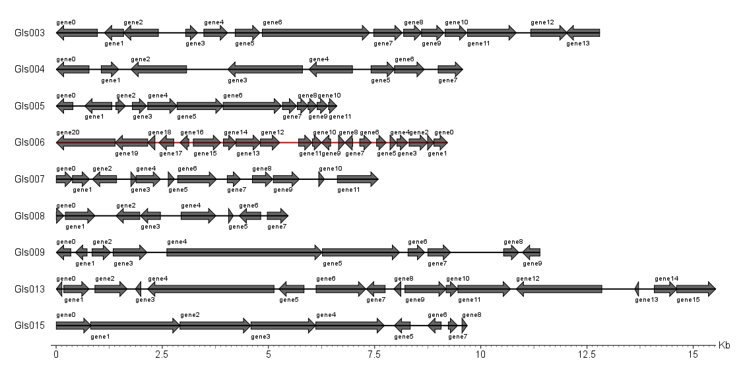Supplement Figure S3. Statistical Map of Gene Distribution in Gene Island.

