Shared Medical Appointments
Education Sessions – Diabetes NSW & ACT
Time per session: 30 minutes
Scope of the education session
- Delivered by a credentialled diabetes educator
- Where possible the education session is linked to the topics discussed during the Shared Medical Appointment (SMA) or is the chosen of by the participants.
- Provide information and education to assist with self-management.
- Each topic will have learning objectives, suit different learning styles; visual (use of props) and kinaesthetic (touch/handle props), as well as auditory (delivery of the session without the use of a PowerPoint presentation).
- Provide details of where to go for further support such as NDSS services such as the Helpline and local programs.
- Encourage regular visits or reconnecting with their doctor and/or primary health care team.
- The program will be developed to encompass the choice theory; focusing on what the person wants to change based on their individual needs, delivered using positive health literacy language and tone, providing content that is user-centred.
What support is available and will be promoted?
- Information book - After registering with the National Diabetes Services Scheme (NDSS), the person will receive a registration card and an information book within 10 business days. The book is designed to give general information about diabetes, NDSS services and products.
- National NDSS information sheets on a large variety of topics are available. These can be downloaded or ordered through the diabetes organisations or the NDSS website.
- NDSS Multicultural Portal: provides a broad range of translated diabetes resources, including factsheets and brochures, about managing diabetes in a wide variety of languages.
- National NDSS Diabetes Helpline: a phone service staffed by a variety of health professionals, such as diabetes educators and dietitians, who can answer questions and provide practical, up-to-date information. The Helpline operates during 8:30am to 5:00pm Monday to Friday and from 9:00am to 12:00pm on Saturdays and national public holidays.

NDSS Education programs: held locally and free to attend if registered with the NDSS, include for example:
  - Carb Smart: covering healthy eating, how carbohydrates impact blood glucose levels and how to choose good quality carbohydrates.
  - Foot Smart: covering daily foot care and how to avoid foot complications
  - Med Smart: covering what kind of medications the person uses, what they do and what the side effects could be.
  - Shop Smart: covering healthy eating and how to read food labels.
  - Ready Set Go, Let’s Move: which assist the person in taking the first steps to making physical activity a part of their lifestyle.
  - Beat it Gym program: 8 week (2 one-hour sessions per week) physical activity and lifestyle program, tailored exercises by accredited exercise physiologist in a group setting.
  - Living with insulin: workshop for people changing or have changed insulin injections, to learn more about how insulin works, blood glucose monitoring and hypo/hyperglycaemia.

Sessions and learning objectives
- Each session will close where to go for more support, and promotion of other local education options
TOPIC | LEARNING OBJECTIVES | VISUAL AIDS & activities | RESOURCES
What makes your blood glucose level go up or come down | - To understand the action of insulin  - To understand the effect of food, exercise, stress, illness and medication including steroids on the blood glucose level  - To identify their target BGL range.  - To recall the action to take if the blood glucose level is not in the target range. | Activity: using the diagram below look at the reasons why BGLs vary, the causes of diabetes and what effects the blood glucose level.  Group discussion and problem solving  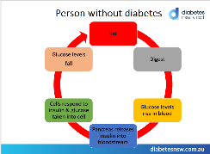  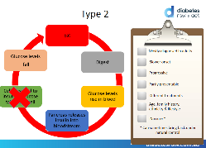 | NDSS Fact sheets:  - Type 2 diabetes
Practical tip for monitoring your blood glucose levels | - To understand when to check their blood glucose level  - To recall how to check blood glucose level  - To understand how to access testing strips, lancets and sharps  - To understand the services provided by the NDSS | Activity: People will bring their meters  Discussion on how to use the equipment, check the strips are in-date, lancet usage (frequency before changing).  Everyone will check their meter with control solution.  People who are not checking their BGL will be provided with a meter and instruction. Meters will be replaced if an older model. | NDSS Fact sheets:  - Blood glucose monitoring  Supplies  - Spare meters to give away  - Sharps containers to give away  - Control solution
Annual Cycle of Care | - To understand the role of the Annual Cycle of Care in self-managing their diabetes  - To identify the tests and checks | Activity: Cards matching game to discuss the test and checks and who to see.  See attached cards | Record Card – see attached appendix 2  NDSS Fact sheets:  - Annual Cycle of Care  - Diabetes related complications  - Sexual health and diabetes
Simple steps to healthier feet | - To understand the importance of a regular home foot inspection.  - To demonstrate a foot inspection.  - To recall the action to take if there is a change identified. | Activity: take off shoes and socks and inspect feet  Activity: rub oil/cream into one hand and compare to other  Aides: files, clippers, creams, mirrors  Each person: sample of Plunket’s products | NDSS Fact sheets:  - Looking after your feet
Simples steps to healthier meals | - To recall the role of healthier eating in self-managing their diabetes  - To identify the simple steps to eating healthier  - To demonstrate food selection for a healthy meal  - To recall to find more information about food and diabetes | Activity: assemble a healthy plate meal using food models  Demonstrate: Sugar per serve – soft drinks, juice and compare to common food items (food model and packet foods)  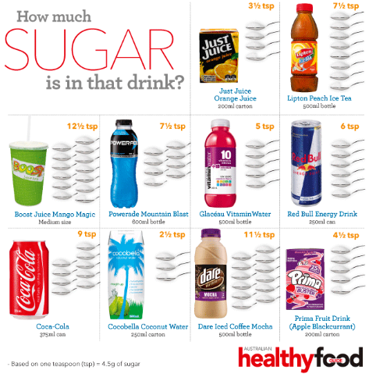 | NDSS Fact sheets:  - Healthy food choice  - Healthy Meal Tips information sheet – see attached
Simple steps to moving more | - To recall the role of physical activity in self-managing their diabetes  - To identify the simple steps to moving more  - To identify one thing to start being more physically active  - To recall where to find more information about physical activity | Activity: using the current exercise guidelines (Department of Health) – using attached activity outline (1) | NDSS Fact sheets:  - Physical Activity  Possible programs (NDSS free to attend if registered:  - Ready Set Go let’s Move  - Beat it Gym
Medications to insulin | - To recall the role of medications in managing diabetes  - To identify how their medication works, and possible side-effects  - To recall where to find more information about medications | Activity: whiteboard: everyone identifies the medications they are taking. Compare the way each medication works, when to take and possible side-effects. | NDSS Fact sheets:  - Medications for type 2  - Insulin  - Steroid Medication
Sick days | - To recall their role in managing sick days, hospital admissions | Activity: each person to develop a sick day plan using template provided following group discussion on what is needed in the plan.  Equipment: Whiteboard, pens  Key discussion points:  - Effect on BGL  - What equipment is needed  - Action to take | NDSS Fact sheets:  - Sick days and type 2 diabetes

