Appendix C
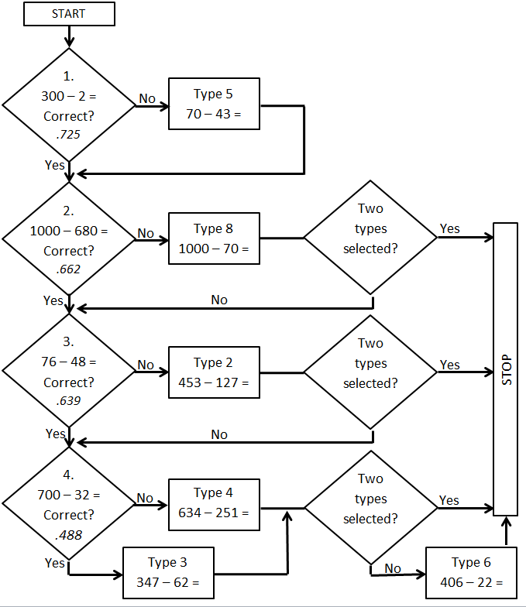
Flowchart that was used to assembly the DI tailored to students’ error pattern on the LOVS M3 test. The items on the left, which are numbered 1 through 4, correspond with the subtraction items in the paper version of the LOVS M3 test that require borrowing. The items are ordered based on the proportion correct (p-value), which is the italicised in the diamond shapes on the left. These p-values are based on a cohort study with five cohorts, N = 16,375 third grade students. Note that, item types 1, 7, and 9 are missing in this flowchart because those item types were included in every version of the DI.

