Supplementary Material

Supplementary Tables

Table S1. Gene Panel
Gene | Seq Ref Panel | Gene | Seq Ref Panel
ATM | NM_000051.3 | PALB2 | NM_024675.3
BARD1 | NM_000465.3 | RAD50 | NM_005732.3
BRIP1 | NM_032043.2 | RAD51C | NM_058216.2
CHEK2 | NM_001005735.1 | TP53 | NM_000546.5
MRE11A | NM_005591.3 | CDH1 | NM_004360.3
MUTYH | NM_001128425.1 | PTEN | NM_000314.4
NBN | NM_002485.4 | STK11 | NM_000455.4

Table S2. Sociodemographic data of the 52 women included in the study
Sociodemographic data | N | %
Self-declared color
White | 44 | 86.3
Brown | 6 | 11.8
Black | 1 | 2
Ignored | 1 | -
Scholarity
Illiterate/incomplete elementary school | 8 | 15.7
Complete primary education | 9 | 17.6
Complete high school | 18 | 35.3
Complete higher education | 16 | 31.4
Ignored | 1 | -
Marital Status
Not married | 11 | 21.6
Married/stable union | 34 | 66.7
Widower | 2 | 3.9
Divorced | 4 | 7.8
Ignored | 1 | -
Profession
Does not work | 11 | 22
Works without a formal contract | 34 | 68
Works with a formal contract | 2 | 4
Housewife | 3 | 6
Ignored | 2 | -
Origin
DF | 1 | 1.9
ES | 1 | 1.9
GO | 2 | 3.8
MG | 7 | 13.2
PE | 1 | 1.9
PR | 3 | 5.7
RO | 1 | 1.9
RR | 1 | 1.9
SP | 34 | 64.2
TO | 1 | 1.9
Place of birth (state)
BA | 2 | 3.8
DF | 1 | 1.9
GO | 2 | 3.8
MG | 8 | 15.4
MS | 1 | 1.9
MT | 1 | 1.9
PR | 4 | 7.7
SP | 32 | 61.5
Ignored | 1 | -
DF: Distrito Federal; GO: Goias; MG: Minas Gerais; MS: Mato Grosso do Sul; PE: Pernambuco; PR: Paraná; RO: Rondônia; RR: Roraima; SP: São Paulo; TO: Tocantins; BA: Bahia; MT: Mato Grosso.

Table S3. Variables related to risk of developing breast and / or ovarian cancer (n = 52)
Risk variables for CMOH | N | %
Smoking
No | 38 | 79.2
Yes | 10 | 20.8
Ignored | 4 | -
Menopausal status:
Pré | 33 | 76.7
Peri | 1 | 2.3
Pós | 9 | 20.9
Ignored | 9 | -
HRT
No | 9 | 100
Yes | 0 | 0
Ignored | 43 | -
First degree relative with breast CA
No | 22 | 43.1
Yes | 29 | 56.9
Ignored | 1 | -
HRT: Hormone replacement therapy; CA: cancer

Table S4. Details of the proband´s family history (n=51)
Family History |  | N (%)
Mother with breast cancer | No | 30 (58.8%)
 | Yes | 21 (41.2%)
Presence of ovarian cancer at any age | No | 37 (72.5%)
 | Yes | 14 (27.5%)
Presence of Mother and Daughter / Pairs of Sisters with Breast Cancer <50 years | No | 25 (49.0%)
 | Yes | 26 (50.9%)
Presence of Mother and Daughter / Pairs of Sisters with Ovarian Cancer | No | 48 (94.1%)
 | Yes | 3 (5.8%)
Presence of Mother and Daughter / Pairs of Sisters with Breast and / or Ovarian Cancer | No | 45 (88.2%)
 | Yes | 6 (11.8%)
Presence of prostate cancer | No | 35 (68.6%)
 | Yes | 16 (31.4%)
Presence of pancreatic cancer | No | 49 (96.1%)
 | Yes | 2 (3.9%)
Presence of colorectal cancer | No | 33 (64.7%)
 | Yes | 18 (35.3%)
Presence of thyroid cancer | No | 47 (92.1%)
 | Yes | 4 (7.8%)
Presence of gastric cancer | No | 44 (86.3%)
 | Yes | 7 (13.7%)
Presence of endometrial cancer | No | 49 (96.0%)
 | Yes | 2 (3.9%)
Presence of sarcoma | No | 46 (90.2%)
 | Yes | 5 (9.8%)
Presence of adrenocortical cancer | No | 50 (98.0%)
 | Yes | 1 (2.0%)
Presence of CNS Cancer | No | 50 (98.0%)
 | Yes | 1 (2.0%)
Presence of individuals with multiple tumors | No | 39 (76,5%)
 | Yes | 12 (23,5%)
CNS: central nervous system.

Supplementary Figures
Supplementary Figure 1. Flowchart illustrating the criteria and variants submitted to co-segregation and/or LOH analysis. (CS=co-segregation; LOH=loss of heterozygosity)

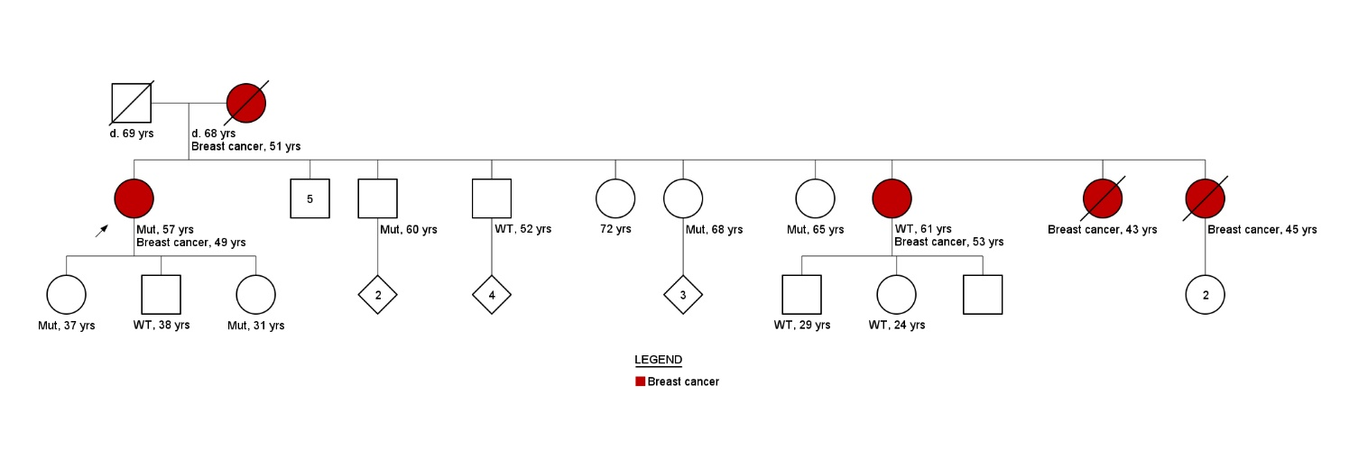
Supplementary Figure 2: Family history. Pedigree family ID640. Variant c.1009G>T in the RAD51C.

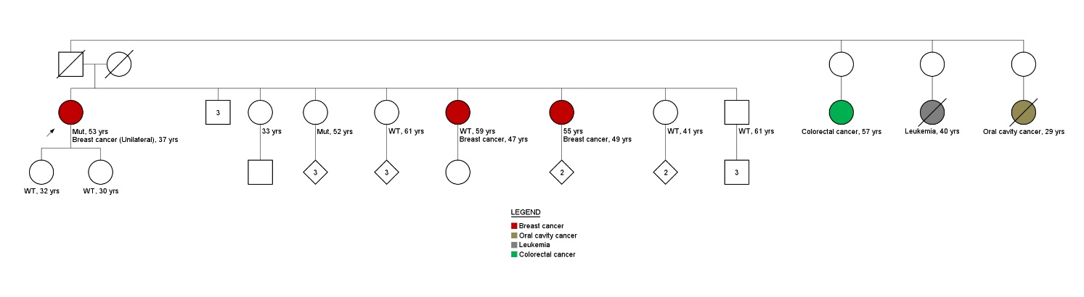
Supplementary Figure 3: Family history. Pedigree family ID1046. Variant c.9086G>A in the ATM.
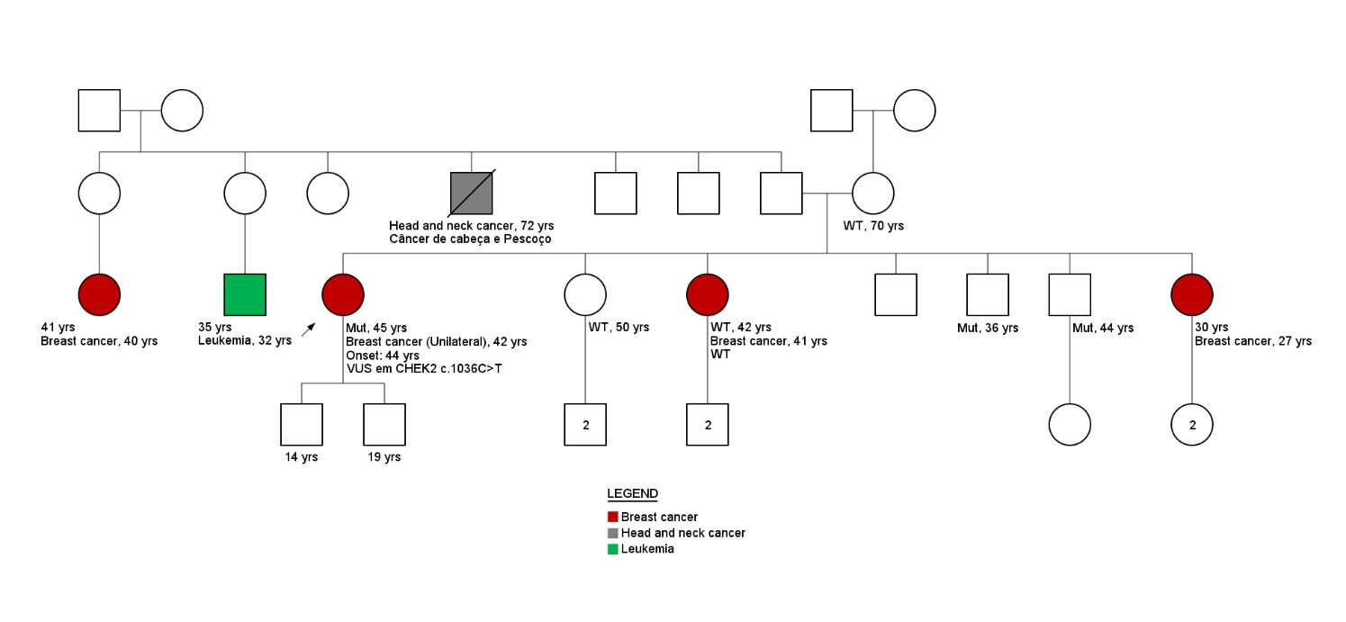
Supplementary Figure 4: Family history. Pedigree family ID1095. Variant c.1036C>T in the CHEK2.

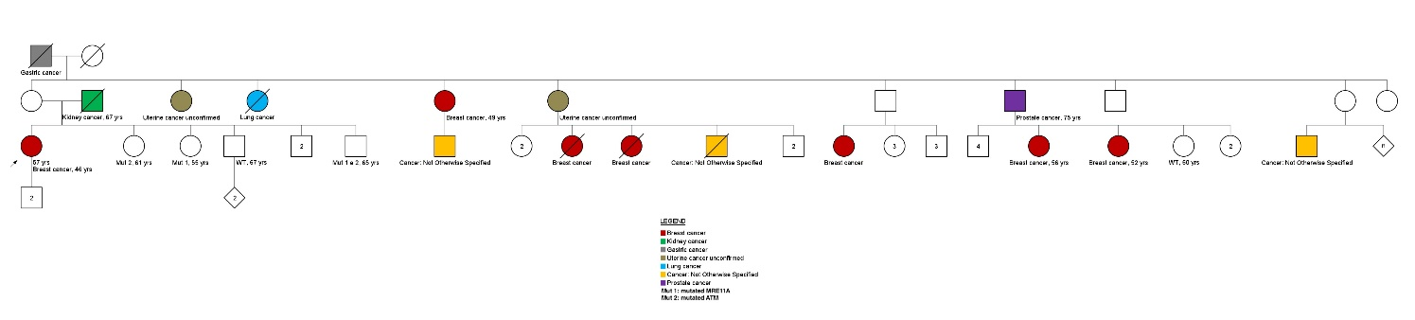

Supplementary Figure 5: Family history. Pedigree family ID133. Variant c.482A>G in the MRE11A and c.4709T>C in the ATM.

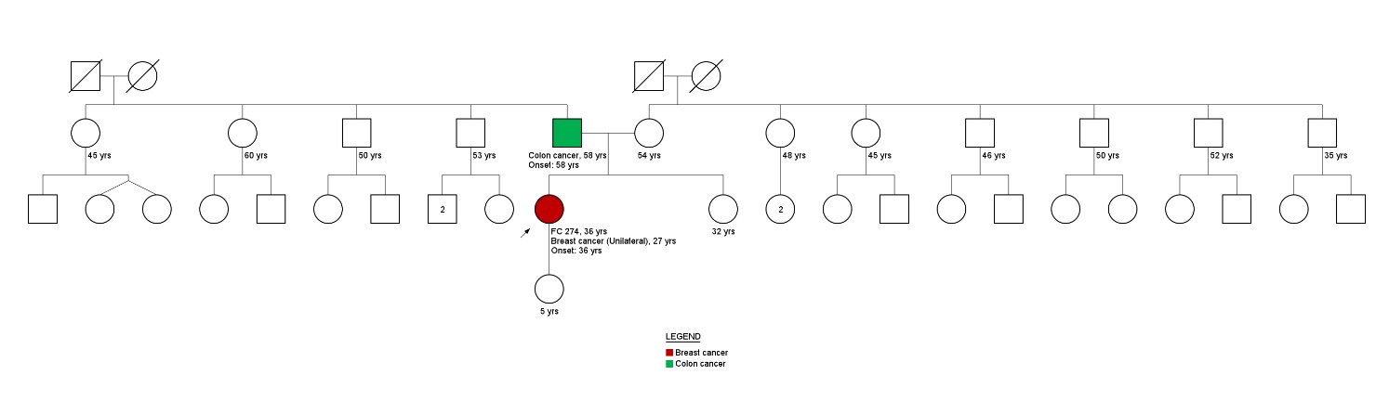
Supplementary Figure 6: Family history. Pedigree family ID274. Variant c.281T>C in the RAD50.

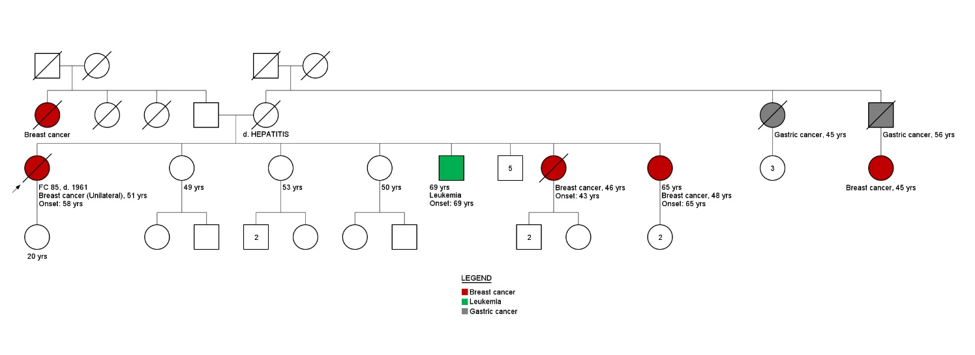
Supplementary Figure 7: Family history. Pedigree family ID85. Variant c.1810C>T in the ATM and c.1001A>G in PALB2 gene.

