Supplementary Material
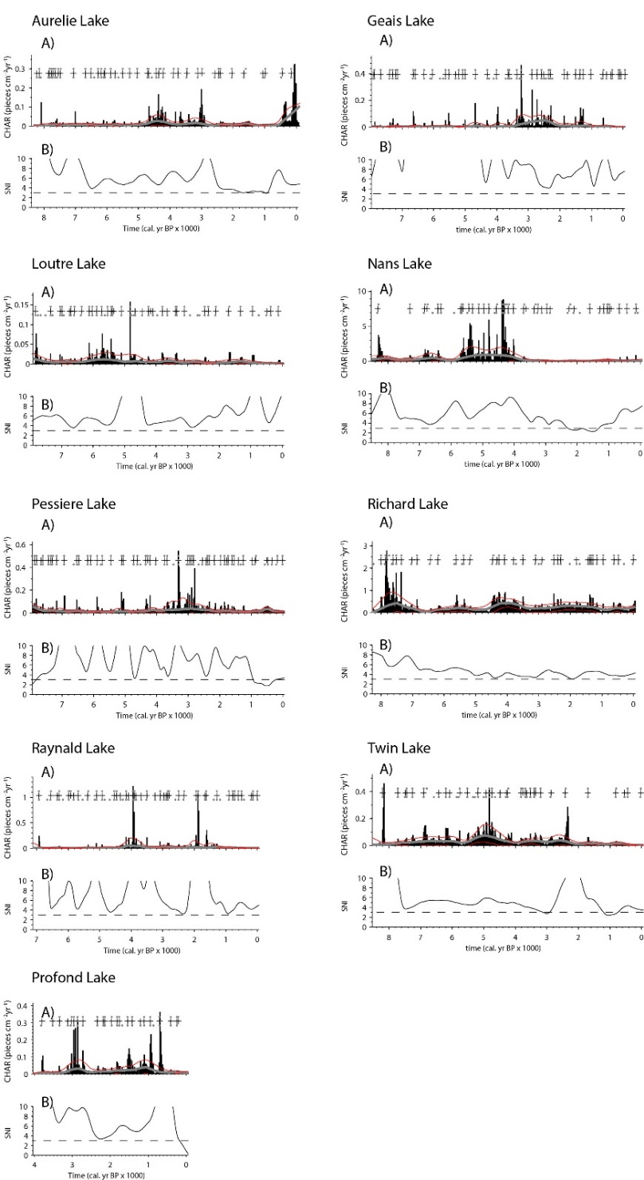

Supplementary Figure 1. CharAnalysis output checks for all charcoal extracted from lakes located in the coniferous boreal forest. For each lake, panel A presents the charcoal influx, with associated charcoal background (mean noise in grey) and its confidence intervals (in red) from which significant charcoal peaks (crosses) were retrieved over time. Similarly, panel B reports the Signal-to-Noise Index (SNI) with its changes over time, to check when SNI values fall below the threshold value of 3 (dashed line), as suggested by Kelly et al. (2011), which would indicate that a fire frequency reconstruction had been overestimated as a result of false fire events. Over the last 1000 years, SNI values lower than 3 only occurred temporarily for three of the nine lake records (Pessière, Twin, and Profond Lakes, respectively).
Kelly, R., Higuera, P., Barrett, C. M., and Hu, F. S. (2011). A signal-to-noise index to quantify the potential for peak detection in sediment–charcoal records. Quaternary Research 75, 11–17.

