Table S1. Accession numbers for reference strains and isolates of Trichoderma species used for phylogenetic analysis.
Trichoderma species | TEF1-α |  | ITS
 | Isolate/Strain | Accession number¹ | Isolate/Strain | Accession number¹
T. afarasin | DIS 314F | FJ463400 | GJS 06-98 | FJ442630
T. afroharzianum | Tri1 | MT793729 | Tri1 | MT793748
T. afroharzianum | Tri2 | MT793728 | Tri2 | MT793747
T. afroharzianum | Tri3 | MT793727 | Tri3 | MT793746
T. afroharzianum | Tri5 | MT793726 | Tri5 | MT793745
T. afroharzianum | CBS124620 | FJ463301 | T1K1 | MN518417
T. atrobrunneum | SZMC:24206 | MN520085 | ALG07 | MT000972
T. atroviride | IPP0316 | MT793743 | IPP0316 | MT793762
T. atroviride | SZMC:24276 | MN520050 | SZMC:24276 | MN516465
T. camerunense | GJS 99-230 | AF348107 | GJS 99-231 | AY027783
T. endophyticum | TR 22 | KT619074 | 23F18C-AC | MK713502
T. guizhouense | SZMC:24281 | MN520084 | PARC1022 | MT448968
T. harzianum | Tri6 | MT793732 | Tri6 | MT793751
T. harzianum | Tri7 | MT793731 | Tri7 | MT793750
T. harzianum | Tri8 | MT793730 | Tri8 | MT793749
T. harzianum | Tri9 | MT793733 | Tri9 | MT793752
T. harzianum | Tri10 | MT793737 | Tri10 | MT793756
T. harzianum | Tri11 | MT793736 | Tri11 | MT793755
T. harzianum | Tri12 | MT793735 | Tri12 | MT793754
T. harzianum | Tri14 | MT793734 | Tri14 | MT793753
T. harzianum | IPP318 | MT793742 | IPP318 | MT793761
T. harzianum | IPP319 | MT793741 | IPP319 | MT793760
T. harzianum | IPP320 | MT793740 | IPP320 | MT793759
T. harzianum | T12 | MT793739 | T12 | MT793758
T. harzianum | T39 | MT793738 | T39 | MT793757
T. harzianum | CBS226.95 | AY605833 | CBS 316.31 | MH855226
T. inhamatum | TR 32 | KT619076 | CBS 274.78 | MH861135
T. lentiforme | CEN1428 | MK696667 | CEN1428 | MK714909
T. lixii | DAOM 229978 | FJ716620 | DA3B 10-2 | MH729889
T. neotropicale | LA11 | HQ022771 | CBS 130633 | MH865818
T. pyramidale | Tpyle24 | MT081438 | Tpyle24 | MT102399
T. rifaii | DIS 355B | FJ463324 | DIS 337F | FJ442621
T. simmonsii | SZMC:26773 | MN520083 | E32 | MT706637
T. tomentosum | Tri4 | MT793725 | Tri4 | MT793744
T. tomentosum | MIAE00031 | HM176579 | CEN252 | KC561062
T. virens | KSSO1_6_9 | MN555264 | CBS 249.59 | MH857855
¹Nucleotide sequences were obtained from NCBI genbank.
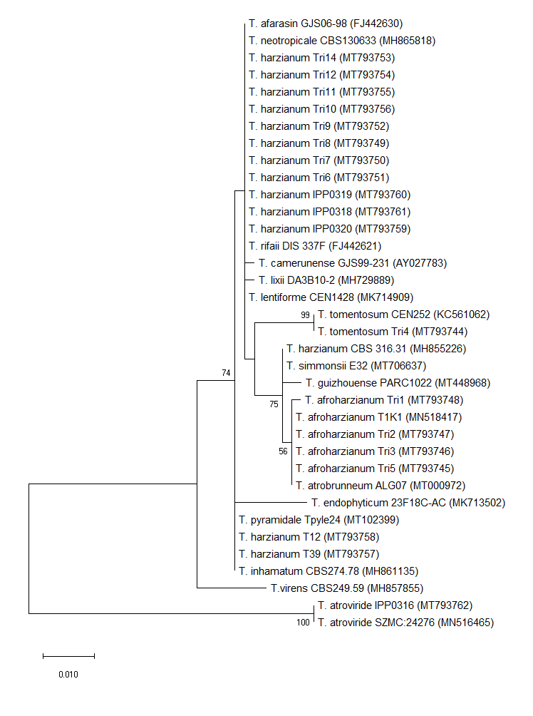
Figure S1. Molecular phylogenetic analysis of internal transcribed spacers (ITS) by maximum likelihood method (1000 bootstrap replicates) (Tamura & Nei, 1993). The analysis was performed with MEGA version 7.0.26 (Kumar et al., 2016) with partial ITS sequences. The strains are listed in Table 1; GenBank accession numbers of the sequences are shown in brackets. The tree is drawn to scale, with branch lengths measured in the number of substitutions per site. Bootstrap values are presented next to the nodes. Individual accession numbers are presented in Table S1. Sequence alignment is available at TreeBASE (http://purl.org/phylo/treebase/phylows/ study/TB2:S26786).

