Supplementary Material
Supplementary Discussion 1: Extended review of friction models
Here we expand upon on the literature review of friction models, including their theoretical background and application to earthquake processes, in particular nucleation.
The sliding regime organization, described in in the main text introduction, helps in understanding the different phenomena and associated models by highlighting the models’ different independent variables. Those designed for the pre-sliding regime are inherently displacement dependent because there is no gross slip-rate, but one can define a bulk displacement or strain. While in the gross-sliding regime, steady-state velocity curves naturally lead to friction laws with slip-rate dependence [Al-Bender et al., 2004]. Yet to capture the observed frictional lag in these regimes, a further history or memory dependence is needed. Given the multivalued nature of experimental datasets, where friction takes on different values for the same velocity [Sone & Shimamoto 2009; Rubino et al., 2017; Liao et al., 2014], only singular experiments with limited conditions can be parameterized with a single variable dependency (for an example, slip weakening friction (SWF) is described in section 1.1). Any model that hopes to cover a range of phenomena and regimes must evolve with more than one variable; for example, Sone & Shimamoto [2009] use both slip and slip-rate, as described in section 2, or an internal state variable to track history in addition to rate dependence (see section 1.2 for common rate-state friction (RSF) models).
There is a growing effort to design physics-based friction laws for fault settings, which are briefly reviewed in supplement section 1.3. We readily acknowledge that it is critical to explore the underlying granular physics, contact mechanics, plasticity, poroelasticity, and other expected processes to understand the limits of the various frictional parameterizations applicability in real geologic settings. Nevertheless, given the numerical complexity of these physics-based models and challenges in estimating their relevant parameters, there remains a need for simpler constitutive relations to represent friction. Yet these parameterizations must be sufficiently complex to capture the phenomenon of interest. For example, to simulate the effect of temporal friction evolution on 2D/3D field-scale finite faults over numerous earthquake cycles and/or with complex forcing.
1.1 Displacement dependent friction laws
Slip-weakening friction (SWF) type constitutive relations are dependent on slip, or displacement. Called weakening, these models tend to focus on parameterizing the drop from static to kinetic friction over a critical slip weakening distance (often referred to as d_{c}), generally with a linear or exponential dependence on slip, but have recently been formulated with the additional initial strengthening and healing stages [Liao & Reches 2019]. The History, Acceleration, Rate, Displacement (HARD) friction law, discussed further in section 1.5, linearly parameterizes each of these stages, giving friction as a step-wise function of displacement:
$μ(d)=μ_{i-1}+W_{i}(d-d_{i-1})$, (1.1)
where i defines the friction evolution stages (i = 1 is initial strengthening, i = 2 is dynamic weakening, and i = 3 is healing); μ is the current friction coefficient (the ratio of frictional shear stress to normal stress); d is the displacement in meters; d_{i-1} is the displacement that defines the beginning of each stage i, d_{c} as commonly defined in SWF is d₂, the displacement which defines the transition from weakening to healing; μ_{i-1} is the friction coefficient at the end of the last stage, μ₀ is the initial friction at the start of rupture (d=0); and $W_{i} = \frac{μ_{i}-μ_{i-1}}{d_{i}-d_{i-1}}$ defines the linear weakening or strengthening rate during each stage. Although a straightforward way to parameterize the expected frictional evolution or experimental results, a purely slip dependent model is limited in its application to different slip-histories, even on a single interface [Rubino et al., 2017].
The physical origin of SWF comes from descriptions of cohesion across crack tips [Barenblatt 1959, Ida 1972, Palmer & Rice 1973]. Ohnaka [1989] developed a version of SWF that incorporates a cohesive or ‘breakdown’ zone to fit initial slip-strengthening in experiments, claiming that it is needed for rupture models to retain bounded slip acceleration (possibly due to the absence of healing). He also argued that a slip-dependent model is needed to capture the physics of both frictional slip failures on pre-existing faults and shear fracture in intact rocks, both processes of which contribute to earthquake nucleation [Ohnaka 2003]. Rate-state friction (RSF) models capture slip-dependent weakening through state evolution following a jump in velocity, and have been shown to exhibit slip-weakening behavior with a distinct characteristic distance (d_{C}) than that prescribed for the state evolution (D) [Cocco & Bizzarri 2002; Bizzarri & Cocco 2003].
1.2 State dependent friction laws
The other common fault friction model is rate-state friction (RSF), which is dependent on slip-rate and one or more internal state variables (commonly interpreted in bare rock surfaces as representing the age of contacts, with units of time, or in granular gouge as porosity or dilation [Segall & Rice 1995]). First derived empirically, dimensional [Hatano 2015] and thermodynamic [Baumberger et al., 1999] considerations support direct logarithmic velocity dependence, giving the most common form [Dieterich 1979; Ruina 1983]:
$μ=μ_{0}+a\ln\left(\frac{v}{v_{0}}\right)+b ln⁡(\frac{v_{0}θ}{D})$, (1.2)
where μ is the current friction coefficient; v is the slip velocity; μ₀ is the reference friction coefficient (steady-state friction when v = v₀); v₀ is a characteristic velocity, discussed more in the main text section 4.1; D is the critical slip distance, related to d_{c} in SWF and L in BSF; θ is the state variable; a is the parameter constant that determines the amplitude of the direct effect; and b determines the amount friction changes due to state evolution. Further state variables can be incorporated, as shown in equation 4.1 below. These constants are assumed to be material properties, but have been shown to vary with conditions such as slip velocity [Leeman et al., 2018], temperature [Chester 1994; Nakatani 2001], and fluid pressure [Cappa et al., 2019].
There are two primary choices for the evolution of the state variable, for mathematical simplicity we focus in this study on the aging (Dieterich) law, which evolves in time even without slip (when v=0):
$\frac{dθ}{dt}=1- \frac{θv}{D}$. (1.3)
The other common way to describe state evolution is with the slip (Ruina) law which requires slip (v≠0) for state evolution:
$\frac{dθ}{dt}=-\frac{θv}{D} ln⁡(\frac{θv}{D})$. (1.4)
It is commonly found that both of these evolution laws are capable of capturing increasing velocity-step experiments, but their fit to decreasing steps and slide-hold-slide experiments require different physical arguments. The aging law clearly shows the observed logarithmic healing, but the slip law can also exhibit this behavior by continuing to slip while the machine or surrounding rock relaxes during hold times [Bhattacharya et al., 2017]. Forms of RSF have been developed to combine these evolution laws [Kato & Tullis 2001] and discussion is ongoing to reconcile their interpretations [Li 2019].
There have been various attempts to update RSF to include further physical processes, especially those present at high slip-rates. One example with theoretical and experimental support is flash-heating, which predicts 1/v dependence above a characteristic weakening velocity, v_{w} [Rice 1999]. This model has been combined with RSF to give the following form [Rubino et al., 2017]:
$μ=μ_{w}+\left(\frac{\left[μ_{0}+aln\left(\frac{v}{v_{0}}\right)+bln\left(\frac{v_{0}θ}{D}\right)\right]-μ_{w}}{1+\frac{D}{v_{w}θ}}\right)$, (1.5)
where the evolution laws and parameters are the same as in equation 1.2 above, with two additional parameters, v_{w} and $μ$_{w}, the residual friction coefficient.
Another issue with RSF comes from the logarithmic velocity dependence, ln(v/v₀), of the direct effect, which is undefined at stuck conditions (v=0) [Daub & Carlson 2010]. The inherent assumption is that the interface is always slipping above a reference velocity (v₀), or seismicity is due to ‘slide-slip’ or ‘creep-slip’ behavior. It is assumed that the reference velocity can be scaled down to velocities so low that they represent the fully coupled or locked fault zones we expect are responsible for major earthquakes, but physically there should be an added static friction effect when at truly stuck, static conditions (v=0). The logarithmic functional form comes from fitting experimental results (slide-hold-slides and velocity steps), but was later understood to come from an Arrhenius activated rate process when only forward jumps are considered [Baumberger et al., 1999]. Several studies have treated this problem by regularizing around v=0, such as allowing backward jumps by using an inverse hyperbolic sine function instead of the exponential dependence that produces the ln(v) term in the direct effect [Rice et al., 2001], giving the following form:
$μ=a\sinh^{-1}\left(\frac{v}{{2v}_{0}}exp⁡[\frac{μ_{0}+bln\left(\frac{v_{0}θ}{D}\right)}{a}]\right)$, (1.6)
These regularized forms are numerically stable and allow calculation around v=0 (they are not biased towards one direction of slip), but they do not capture the stiction phase, as there is no explicit difference when at static conditions.
1.3 Physics-based friction laws
The clear shortcomings of these friction model has motivated increasing effort towards more physics-based friction laws in fault settings. Studies using Discrete Element Method (DEM) models of fault gouges containing hard elastic spherical grains with simple Hertz contacts under Coulomb friction have been shown to exhibit stick-slip behavior, differing static and dynamic friction coefficients [Aharonov & Sparks 2004], and even behave equivalent in velocity step and slide-hold-slide experiments to RSF models [Ferdowsi & Rubin 2020], without the need for contact plasticity. Other friction laws have been derived based on granular physics, such as STZ theory, which uses statistical mechanics to describe the evolution of grain arrangements during strain localization and slip [Daub & Carlson 2010]. These models rely on the multi-body dynamics of granular packs to produce the observed complex frictional responses, yet Atomic Force Microscopy (AFM) experiments show that even single contacts exhibit rate-dependent behavior not captured by these models’ simple grain contacts, found to be due to chemical bond formation on contacts [Tian et al., 2018]. New models whose only inputs are material property measurements can explain steady-state experimental friction results over a large range of sliding velocities and temperatures, appealing to contact plasticity and frictional melt at high slip velocities [Aharonov & Scholz 2018; Aharonov & Scholz 2019] or comminution to weaker grains [Rattez & Veveakis 2019], but so far do not address transient evolution in friction away from steady-state. Microphysical models have been developed to include the effect of changes in porosity, fluid pressure, pressure solution, and other granular flow processes [van den Ende et al., 2018]. Although their mathematical complexity limits use in field-scale earthquake modelling, these models are important for understanding underlying physical processes and testing the applicability of more commonly used frictional parameterizations. To the authors’ knowledge, none of these models has been tested against the full transient frictional evolution found in realistic earthquake rupture experiments.
1.4 Other bristle-state friction laws
In the main text, we describe the development of bristle-state friction (BSF) models and show an example, modified Dahl. This is one of simplest forms of BSF, but is not the most common in engineering literature. The same group of researchers, from Lund and Grenoble universities, later developed a more commonly used integrated friction model of this type, terming it LuGre, combining the names of their affiliations [De-Witt et al., 1995]. The form is similar, but includes an additional direct dependence on state evolution, responsible for micro damping:
$μ=a_{3}v+a_{4}θ+a_{5}\frac{dθ}{dt}$ (1.5)
$\frac{dθ}{dt}=v-\frac{a_{4}∣v∣θ}{g\left(v\right)}=v-\frac{a_{4}∣v∣θ}{μ_{c}+\left({μ_{s}-μ}_{c}\right)exp⁡[-{\left(\frac{v}{v_{s}}\right)}^{2}]}$, (1.6)
where the variables are related to those described in the main text. This form is useful in control systems and frictional compensation applications, but represents an unnecessary complexity and addition of free variables for our current purposes. As described in the main text, we plan to continue to explore further mathematical forms, making use of this integrated modeling approach, to find which best capture the important behaviors of realistic rupture experiments and geophysical observations.
1.5 Modeling transient friction evolution
As most of these fault friction models focus on capturing the steady-state velocity dependence, little work has tried to quantitatively fit measurements of transient frictional evolution. To the authors’ knowledge, all three stages of friction evolution during rupture have only been fit by two parameterizations.
Sone & Shimamoto [2009] propose a mathematical relationship (see section 2 below) where friction is dependent on slip and slip-rate, with six free parameters fit to their constant velocity and velocity-varying experiments on recovered fault gouge samples, but the parameters are specific to the conditions of the experiment (such as a simplified slip-rate history and low normal stress of limited applicability) [Lapusta 2009].
Liao & Reches [2019] show the importance of all kinematic components (History, Acceleration, Rate, and Displacement), but their ‘HARD’ friction law (equation 1.1 above) is only directly dependent on slip, utilizing their experiments to capture other kinematic dependencies through power law relationships between their free parameters and the product of the experimental maximum velocity and rise-time. The HARD friction law reproduces realistic slip-pulse ruptures given a simple shear stress forcing, but cannot be used for arbitrary histories or driving stresses. Frictional weakening has been shown to depend on slip-rate history, so pure slip-dependence is unable to explain the range of experimental results from a single interface [Rubino et al., 2017]. Without state variable dependence, these laws also cannot simulate the response to complex forcing such as dynamic triggering, earthquake interaction, or multiple seismic cycles.
Other models have focused on just one transient friction stage. One such example, Proctor et al., [2014] captures the transient weakening in bare-rock and gouge high-velocity measurements with a flash heating model [Rice 1999], but does not fit the healing or initial strengthening stages.

Supplementary Discussion 2: Comparison to Sone & Shimamoto [2009] constant velocity experiments and friction relation based on slip and slip-rate
Sone & Shimamoto [2009] also present constant velocity measurements (see their Figures 2.1 and 2.2) on the Chelungpu fault gouge samples, where the velocity is rapidly accelerated (assumed instantaneous) from static to a set velocity where it is held. They find that the friction coefficient quickly reaches a peak value ($μ_{p}$) and then decays exponentially towards a steady-state value ($μ_{ss}$) over a distance ($d_{c}$), fitting the post-peak evolution with the following exponential SWF law [Mizoguchi et al., 2007]:
$μ(d)=μ_{ss}+(μ_{p}-μ_{ss})exp[ln(b)\frac{d}{d_{c}}]$, (2.1)
where d is displacement in meters, and $d_{c}=9.6±2.0 m$ is the slip weakening distance (defined to give the distance where friction decreases to a factor b = 0.05 of the total weakening). They found that the steady-state friction ($μ_{ss}$) is exponentially dependent on velocity:
$μ_{ss}(v)=μ_{ss0}e^{-\frac{v}{v_{c}}}$, (2.2)
where $μ_{ss0}=0.55 ± 0.09$ is the steady state zero velocity friction coefficient, and $v_{c}=0.99 ± 0.23 m/s$ is the characteristic velocity for velocity weakening.
We can also solve for the BSF steady-state friction by solving the constant velocity form of our analytic solution (appendix equation A14) at infinite displacement:
$$μ_{ss}\left(v\right)=μ\left(d→∞\right)=a_{3}v+a_{1}(1-e^{-\frac{d}{L}})-a_{2}{(e}^{-\frac{v^{2}}{v_{s}^{2}}}+e^{-\frac{d}{L}-\frac{v^{2}}{v_{s}^{2}}})+ce^{-\frac{d}{L}}$$
$μ_{ss}\left(v\right)=a_{3}v+a_{1}-a_{2}e^{-\frac{v^{2}}{v_{s}^{2}}} \sim a_{3}v+a_{1}$, when $v≫v_{s}$. (2.3)
This steady-state friction relation does not fit the data with the best fit parameters from the inversions, since $a_{3}=-a_{1}$ it gives $μ_{ss}<0$ for $v$ > 1 m/s. For this reason, these parameters do not work to model the constant velocity data very well overall (Figure 2.1), suggesting issues with this form of BSF for steady-state velocity dependence. Although we can adjust the value of $a_{1}$ to about 0.5 to better fit the Sone & Shimamoto [2009] steady-state constant velocity data (Figure 2.2) with equation 2.3, this linear relation will never be able to fit steady-state friction over a wide range of velocities, making clear this form of BSF’s shortcomings at steady-state conditions, with alternative forms to be explored in future work. Using this new value of $a_{1}$=0.5 does not drastically change the model result for the velocity-varying experiment (Figure 2.3). Following this strategy, similar to that employed by Sone & Shimamoto [2009] (see below), for finding best fitting parameters, the model does not quite reach the full weakening, but still follows the trends, suggesting the current form of BSF could work for constant velocity as well as velocity-varying situations within a limited range of velocities (~0.3-2 m/s).
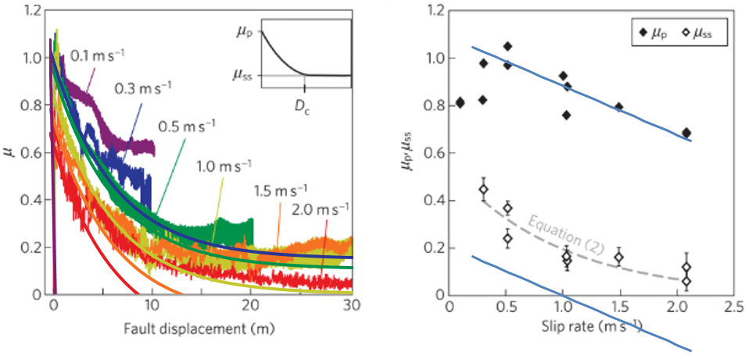
Figure 2.1: Reproduction of Sone & Shimamoto [2009] Figure 2. a) Constant velocity friction evolution with constant velocity version of BSF analytical form (appendix equation A14) plotted on top, using best-fit parameters from inversion. b) Peak and steady-state friction measurements as a function of constant applied slip-rate. Plotted in blue on top is the constant velocity relations obtained from the BSF analytical form (equations 2.3 and 2.4). The fit for peak friction, equation 2.4, has the right slope with the best-fit parameter $a_{3}$ from the inversion of the velocity-varying data, but the steady-state relation, equation B3, is less accurate requiring a different $a_{1}$ from the inversion.
Although the steady-state relation, the value at the end of the constant velocity curves, using the analytical BSF model does not fit the data very well, we are able to find a useful relation for the peak friction. Sone & Shimamoto [2009] use a strengthening function to replace the peak friction coefficient ($μ_{p}$), which is shown below, but it does not match the measured peak friction values, especially above 0.5 m/s, see their supplement Figure 2b. They give this as further motivation to better understand and model the initial strengthening process. As in equation (2.3), we find a relation between peak friction coefficient and velocity by solving appendix equation A14 for when d = 0:
$μ_{p}\left(v\right)=μ\left(d=0,v\right)=a_{3}v+a_{1}-{a_{1}e}^{-\frac{d}{D}}-a_{2}e^{-\frac{v^{2}}{v_{s}^{2}}}+{a_{2}e}^{-\frac{d}{D}-\frac{v^{2}}{v_{s}^{2}}}+ce^{-\frac{d}{D}}=a_{3}v+c$. (2.4)
This gives a simple linear relation between peak friction coefficient and velocity that roughly fits their measurements at velocities greater than 0.5 m/s (their Figure 2b is reproduced with this relation in Figures 2.1 and 2.2). The value of c in this case is different from that in our inversion of the velocity-varying data, because the model is now being used only to fit the evolution after the peak-friction. In this way, it is not surprising that for the velocities lower than ~0.5 m/s the relation does not work, in low-velocity (<15$μ$m/s) experiments the gouge was measured to have friction coefficients of 0.63-0.74 [Sone et al., 2005]. But the fact that the inverted best fit parameters for a different set of experiments is able to demonstrate a useful relationship between peak friction and velocity, supports that the BSF model and the best-fit parameters are capturing the frictional dynamics and material properties, especially of the initial strengthening process at these high velocities. More work needs to be done to understand or adapt the model to improve its behavior at steady-state, as it was mostly designed to capture the stiction or initial strengthening transition from pre-sliding to gross-sliding.
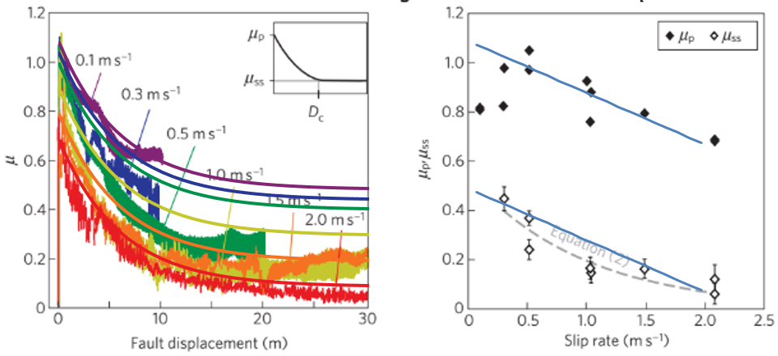
Figure 2.2: Reproduction of Sone & Shimamoto [2009] Figure 2, as above, but now using a different $a_{1}$ (0.5) to better match the steady-state values. Although the changed $a_{1}$ value does not significantly change the behavior of the model to the varying driving velocity, see Figure 2.3 below, the BSF model’s linear velocity dependence at high velocities is of limited utility since it will always give an unphysical negative friction coefficient at sufficiently high velocities. For this reason, new forms of BSF’s direct effect need to be explored as discussed in section 3.1.2.
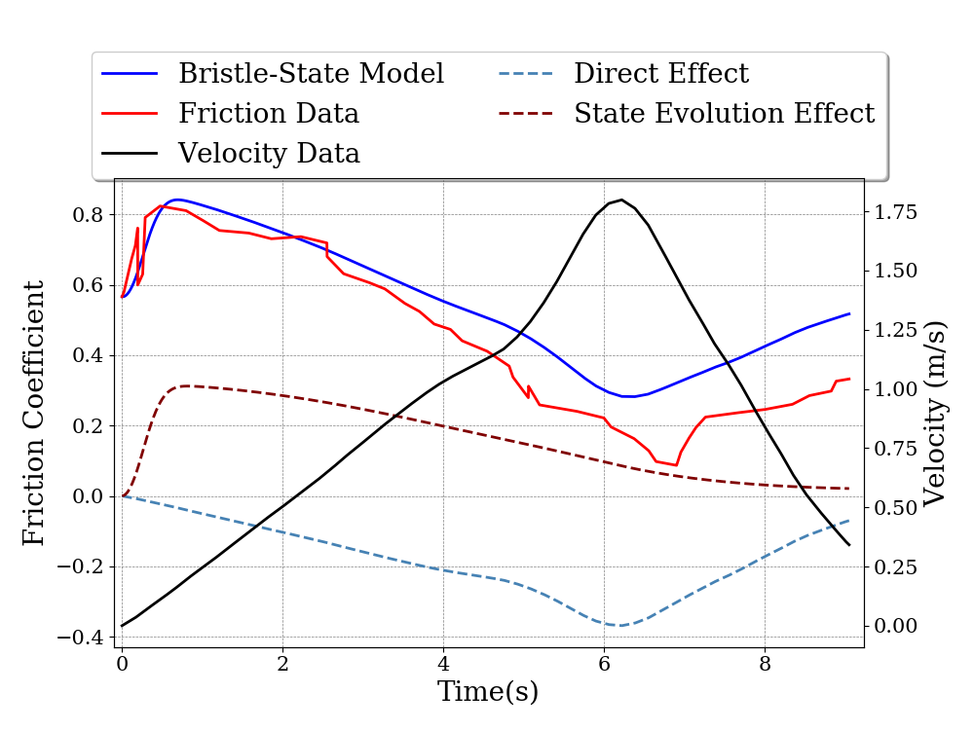
Figure 2.3: Forward model of velocity-varying data with best-fit parameters from inversion, except the value of $a_{1}$ was set to 0.5 to improve the fit to steady-state values of constant velocity experiments from Sone & Shimamoto [2009], this follows their strategy of using the constant velocity measurements to constrain the parameters prior to inversion.
Sone & Shimamoto [2009] show that the standard formulation of RSF with the aging law was not able to capture their velocity-varying data with a single set of realistic parameters (their Figure 4), instead they provide a frictional constitutive relation which they say “quantitatively replicates” the RSF description. The form of this law comes from equations 2.1 and 2.2, combined with an exponential initial strengthening [Ohnaka & Yamashita 1989; Matsu’ura et al., 1992]:
$μ(d,v)=μ_{ss0}e^{-\frac{v}{v_{c}}}+\{α+(1-α){exp[ln(b)\frac{d}{d_{a}}]μ}_{i}-μ_{ss0}e^{-\frac{v}{v_{c}}}\}exp[ln(b)\frac{d}{d_{c}}]$. (2.5)
$μ_{ss0}$, $v_{c}$, and $D_{c}$ are each fit to the constant velocity measurements with values given above, while the other parameters are fit to the velocity-varying data: $α=1.26–1.54$ and $d_{a}=23–160 mm$ are the characteristic strengthening factor and distance, respectively (again defined in the same way as $d_{c}$ but now a factor of b = 0.05 from the total strengthening); and $μ_{i}=0.6$ is the initial (or static) friction coefficient (measured by manually increasing shear stress until slip starts). Thus having six free parameters to fit to the two types of data sets. The model is able to fit the trends in the data fairly well, but as it was designed based on these specific experimental conditions, it would be problematic to apply directly to alternative expected field conditions (such as higher normal stresses) or driven by a pulsed slip-rate history [Lapusta 2009].

Supplementary Discussion 3: Pulsed-slip velocity used in Liao & Reches [2019]
To explore each model’s ability to capture pulsed-slip experiments on bare rock surfaces, we ran the same inversion for datasets used in Liao & Reches [2019]. In their study, they present the HARD friction law (equation 1.1) as a way to parameterize the frictional evolution of high velocity experiments with non-trivial slip-rate histories. They used ROtary Gouge Apparatus (ROGA) [Reches & Lockner 2010] Radiant Red granite datasets from two previously published papers: fly-wheel experiments, where a fast-acting clutch applies a large stored angular momentum to the ring-shaped fault interface, reaching velocities up to 1 m/s very rapidly and then decelerating due to frictional energy dissipation [Chang et al., 2012]; and controlled slip velocity experiments using regularized Yoffe functions [Liao et al., 2014]. Their study focuses on these most pulsed velocity functions which exhibit all three frictional evolution stages.
We agree with their approach of capturing the frictional evolution with a simple friction law, but see shortcomings with its purely slip dependence, as discussed in supplementary discussion 1.2. This dataset presents difficulties for our inversion, as it does not provide a steady-state velocity relation to constrain $μ_{0}$, as discussed in more detail in Appendix B. Consequently, we left μ₀ as a free parameter, finding a strong trade-off between v₀ and μ₀ in the MCMC inversion (Figure 3.2a, 3.3a, and 3.4a). Furthermore, as is common in these types of experiments, the shear stress is increased from un-strained conditions, so the initial increase in friction coefficient (as normal stress is held constant and only shear stress is measured) is convoluted with elastic loading. The examples given in the main text avoid this problem - Sone & Shimamoto [2009] carefully increased shear stress to the point that slip first initiates under quasi-static loads in order to separate the static friction coefficient from the peak friction, while Rubino et al., [2017] load the entire fault near to failure before inducing rupture at a specific location. Since in this case the static friction in which sliding begins is unknown, elastic loading is included in and exaggerates the initial strengthening. We find these examples useful for exploring the frictional evolution in the last two stages during realistic rupture experiments, but since it is problematic to interpret the initial strengthening stage, the main focus of this study, we decided to relegate these examples to the supplement.
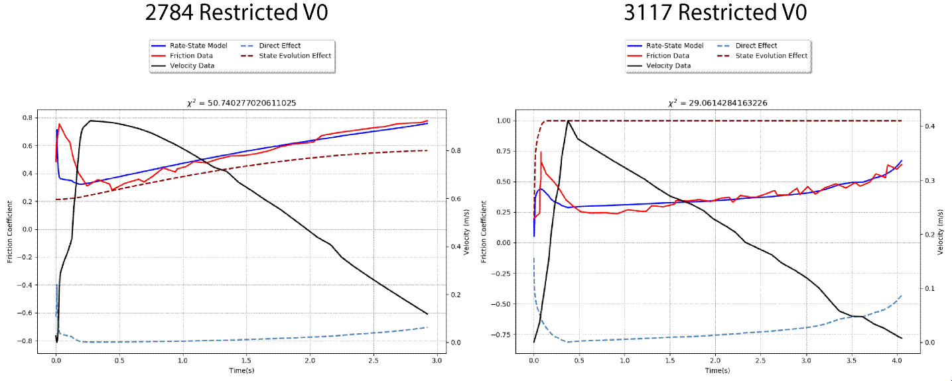
Figure 3.1 Best-fitting models for Liao et al., [2014] Yoffe function datasets, using RSF with restricted v₀ [<10⁻⁴]. Both runs a) 2784 and b) 3117 show the difficulty in fitting the initial strengthening peak, without the added flexibility of allowing higher v₀.
We performed the inversion for four different pulsed experiments with similar results. We show that RSF with low v₀ values cannot reach the friction peak (Figure 3.1). While Figures 3.2, 3.3, and 3.4 show the best fit models for unrestricted RSF (a) and BSF (b). In Figure 3.2a RSF is able to fit the initial strengthening but not the rest of the evolution, while Figure 3.3a cannot fit the initial peak, but does a better job with the healing. The Chang et al., [2012] flywheel data has much higher initial accelerations, so it is difficult to see the fit on a linear time scale (Figure 1 in the text shows the general measured friction evolution of this experiment on a logarithmic time scale), but the χ² shows that the RSF fit is not ideal (Figure 3.4a) The BSF model consistently does a better job fitting the entire dataset in all three cases, seen in lower χ² values (Figures 3.2b, 3.3b, and 3.4b).
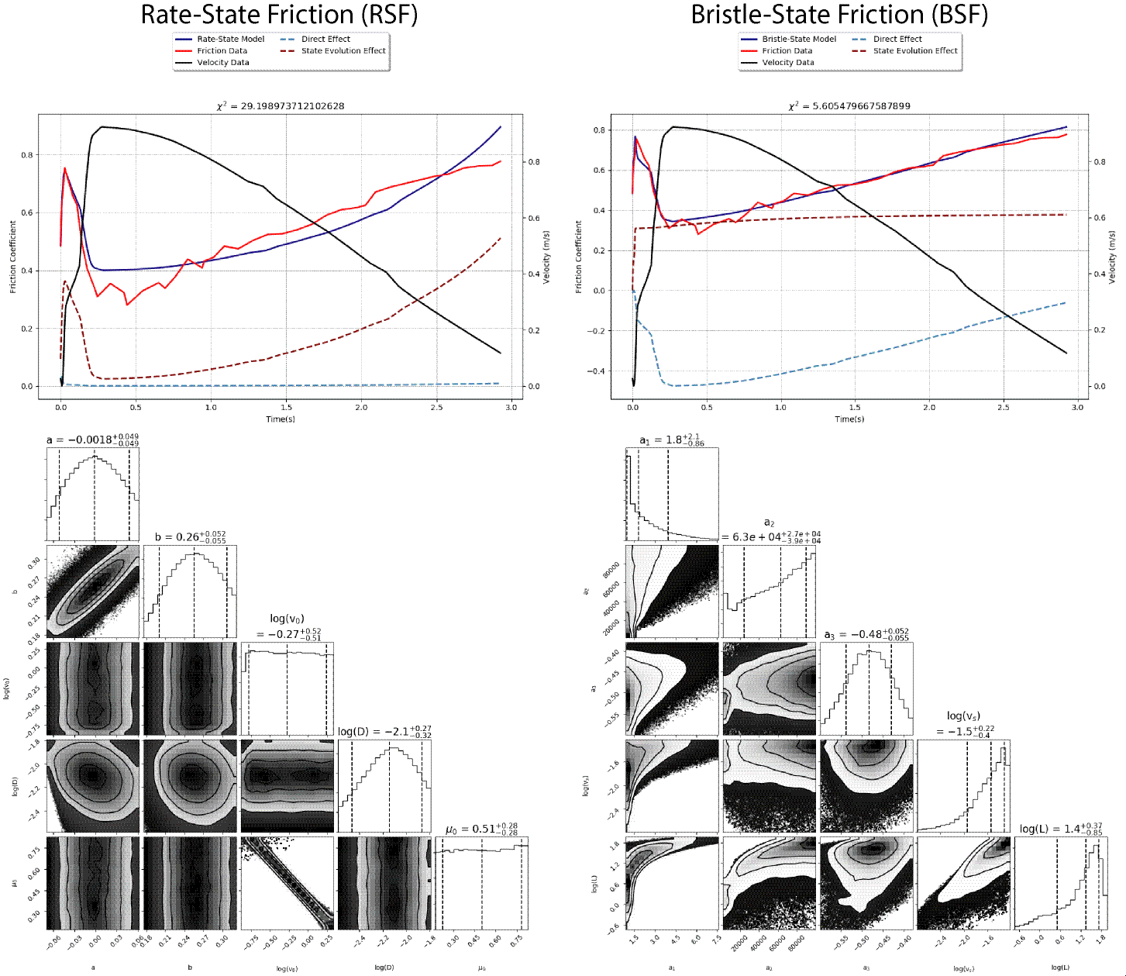
Figure 3.2: Best-fits of (a) RSF and (b) BSF models to regularized Yoffe function experiment, run 2784, from Liao et al., [2014], details are the same as for Figure 3 in the main text.

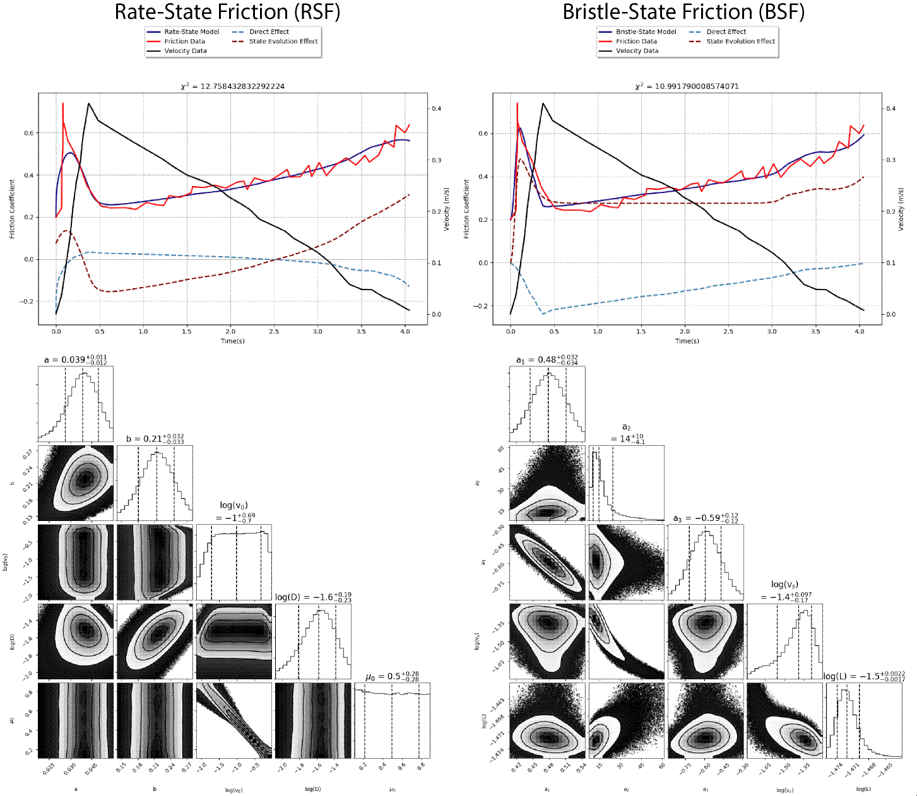
Figure 3.3: Best-fits of (a) RSF and (b) BSF models to regularized Yoffe function experiment, run 3117, from Liao et al., [2014], details are the same as for Figure 3 in the main text.
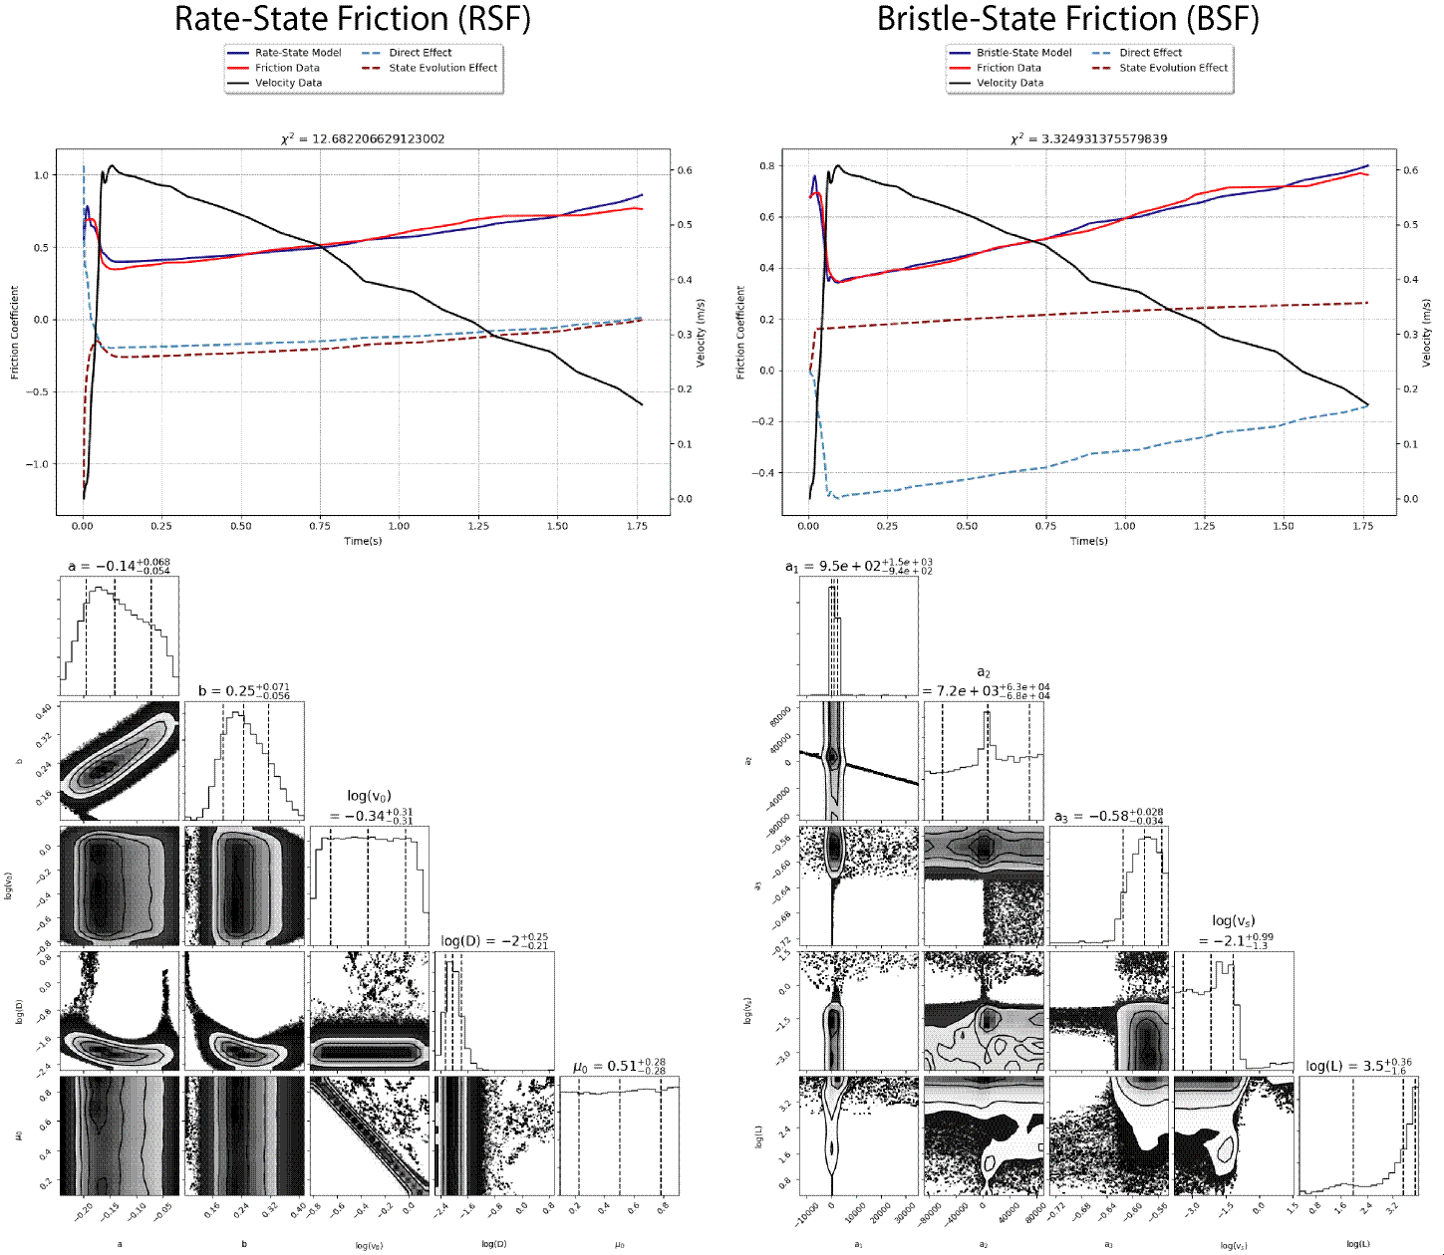
Figure 3.4: Best-fits of a) RSF and b) BSF models to a flywheel experiment, sample 733, from Chang et al., [2012]. The dataset which motivated Figure 1, but now using a linear time scale. The details are the same as for Figure 3 in the main text.

Supplementary Discussion 4: Flash-heating and two-state RSF inversion results
Although not included in the text, we performed inversions using the combined RSF with flash-heating (equation 1.5) and two-state variable version of RSF on each data set presented in the text and supplement. Here we show some of those results and the form of RSF with two-state variables.
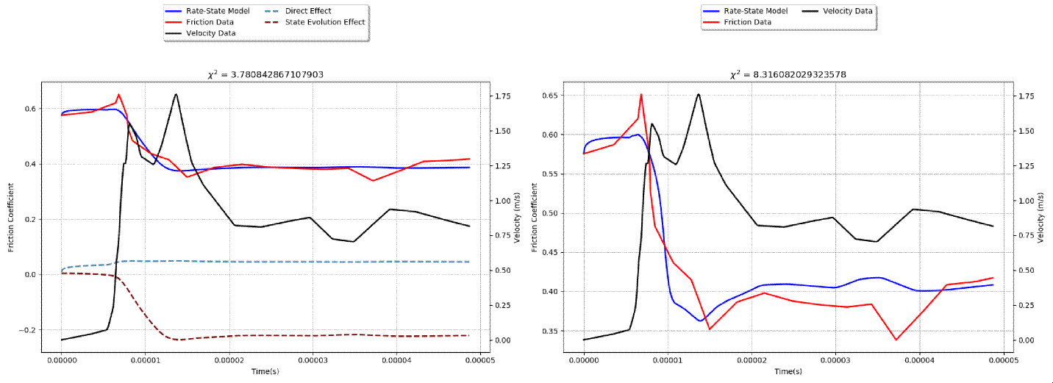 Figure 4.1: Best-fitting models for Rubino et al., [2017] spontaneously developing slip data, a) RSF with restricted v₀ [<10⁻⁴ m/s], in this case the restriction has no affect. b) Inversion of frictional data with RSF/flash-heating combined model, using parameter (a-b, v₀, $μ$_{w}, v_{w}) values from their fit to steady-state form and leaving the rest as free parameters, is not consistent with the measured transient friction peak, performing worse than the standard RSF formulation in a). The direct and state evolution effects are not able to be separated for the combined model because of the more complex mathematical form of equation 1.5.
The direct effect for RSF with two state variables has the following form:
$μ=μ_{0}+a\ln\left(\frac{v}{v_{0}}\right)+b_{1 }ln⁡(\frac{v_{0}θ_{1}}{D_{1}})+b_{2 }ln⁡(\frac{v_{0}θ_{2}}{D_{2}})$, (4.1)
with two additional parameters, $b_{2}$ and $D_{2}$, to go along with the additional state variable $θ_{2}$. This also requires an additional state evolution equation, such as:
$\frac{dθ_{2}}{dt}=1- \frac{θ_{2}v}{D_{2}}$, (4.2)
in the form of the aging law, or in the form of the slip law, such as equation 1.4 above. As expected, the inversion, given these additional free parameters with a wide range of potential values, especially two critical slip distances ($D_{1}$ and $D_{2}$), is able to fit well all of the datasets. With two separate distances over which state can evolve, the model can devote a different state evolution term to the separate frictional stages, giving it more than enough flexibility to capture the three stages. The MCMC results for each of the models on all the data sets are available with the code at DOI: 10.6084/m9.figshare.11473530.

References
Aharonov E. & Sparks D. (2004). Stick-slip motion in simulated granular layers. Journal of Geophysical Research: Solid Earth, 109, B9, doi:10.1029/2003JB002597.
Aharonov E. & Scholz C.H. (2018). A physics-based rock friction constitutive law: Steady state friction. Journal of Geophysical Research: Solid Earth, 123, 1591-1614. doi:10.1002/2016JB013829.
Aharonov E. & Scholz C.H. (2019). The brittle-ductile transition predicted by a physics-based friction law. Journal of Geophysical Research: Solid Earth, doi:10.1029/2018JB016878.
Barenblatt, G. I. (1959). The formation of equilibrium cracks during brittle fracture. General ideas and hypotheses. Axially-symmetric cracks. Journal of applied mathematics and mechanics, 23(3), 622-636.
Baumberger, T., Berthoud, P., & Caroli, C. (1999). Physical analysis of the state-and rate-dependent friction law. II. Dynamic friction. Physical Review B, 60(6), 3928.
Bhattacharya P., Rubin, A.M., & Beeler N.M. (2017). Does fault strengthening in laboratory rock friction experiments really depend primarily upon time and not slip?. Journal of Geophysical Research: Solid Earth, 122, 6389–6430, doi:10.1002/2017JB013936.
Bizzarri, A., & Cocco, M. (2003). Slip‐weakening behavior during the propagation of dynamic ruptures obeying rate‐and state‐dependent friction laws. Journal of Geophysical Research: Solid Earth, 108(B8).
Cappa, F., Scuderi, M. M., Collettini, C., Guglielmi, Y., & Avouac, J. P. (2019). Stabilization of fault slip by fluid injection in the laboratory and in situ. Science Advances, 5(3), eaau4065.
Chang, J. C., Lockner, D. A., & Reches, Z. (2012). Rapid acceleration leads to rapid weakening in earthquake-like laboratory experiments. Science, 338(6103), 101-105.
Chester, F. M. (1994). Effects of temperature on friction: Constitutive equations and experiments with quartz gouge. Journal of Geophysical Research: Solid Earth, 99(B4), 7247-7261.
Cocco, M. & Bizzarri, A. (2002) On the slip‐weakening behavior of rate‐ and state dependent constitutive laws. Geophysical Research Letters, 29, 11, 1-4. doi:10.1029/2001GL013999.
Daub, E. G., & Carlson, J. M. (2010). Friction, fracture, and earthquakes. Annu. Rev. Condens. Matter Phys., 1(1), 397-418.
Ferdowsi, B., & Rubin A. M. (2020) A granular-physics-based view of fault friction experiments. Journal of Geophysical Research - Solid Earth
Hatano T. (2015). Friction laws from dimensional-analysis point of view. Geophysical Journal International, 202, 3, 2159-2162. doi: 10.1093/gji/ggv280Ida, Y. (1972). Cohesive force across the tip of a longitudinal‐shear crack and Griffith's specific surface energy. Journal of Geophysical Research, 77(20), 3796-3805.
Kato, N. & Tullis, T.E. (2001). A composite rate- and state-dependent law for rock friction. Geophysical Research Letters, 28, 6, 1103-1106.
Kitajima, H., Chester, F. M., & Chester, J. S. (2011). Dynamic weakening of gouge layers in high‐speed shear experiments: Assessment of temperature‐dependent friction, thermal pressurization, and flash heating. Journal of Geophysical Research: Solid Earth, 116(B8).
Lapusta, N. (2009). Seismology: The roller coaster of fault friction. Nature Geoscience, 2(10), 676.
Leeman, J. R., Marone, C., & Saffer, D. M. (2018). Frictional mechanics of slow earthquakes. Journal of Geophysical Research: Solid Earth, 123(9), 7931-7949.
Li, T. (2019). An effort to reconcile time- and slip-dependent friction evolution. Journal of Geophysical Research: Solid Earth, 124. doi:10.1029/2018JB016922
Liao, Z., Chang, J. C., & Reches, Z. E. (2014). Fault strength evolution during high velocity friction experiments with slip-pulse and constant-velocity loading. Earth and Planetary Science Letters, 406, 93-101.
Liao, Z., & Reches, Z. E. (2019). An experimentally-based friction law for high-velocity, long-displacement slip-pulse events during earthquakes. Earth and Planetary Science Letters, 515, 209-220.
Madariaga, R. (1976). Dynamics of an expanding circular fault. Bulletin of Seismological Society of America, 66(3): 639-666.
Marone, C. (1998). Laboratory-derived friction laws and their application to seismic faulting. Annual Review of Earth and Planetary Sciences, 26(1), 643-696.
Matsu'ura, M., Kataoka, H., & Shibazaki, B. (1992). Slip-dependent friction law and nucleation processes in earthquake rupture. Tectonophysics, 211(1-4), 135-148.
Mizoguchi, K., Hirose, T., Shimamoto, T., & Fukuyama, E., (2007). Reconstruction of seismic faulting by high-velocity friction experiments: an example of the 1995 Kobe earthquake. Geophys. Res. Lett., 34, L01308. doi:10.1029/2006GL027931.
Nagata, K., Nakatani, M., & Yoshida, S. (2012). A revised rate‐and state‐dependent friction law obtained by constraining constitutive and evolution laws separately with laboratory data. Journal of Geophysical Research: Solid Earth, 117(B2).
Nakatani, M. (2001). Conceptual and physical clarification of rate and state friction: Frictional sliding as a thermally activated rheology. Journal of Geophysical Research: Solid Earth, 106(B7), 13347-13380.
Noda, H., Dunham, E.M., & Rice, J.R. (2009). Earthquake ruptures with thermal weakening and the operation of major faults at low overall stress levels. J. Geophys. Res., 114, B7, doi:10.1029/2008JB006143.
Ohnaka, M. (2003). A constitutive scaling law and a unified comprehension for frictional slip failure, shear fracture of intact rock, and earthquake rupture. Journal of Geophysical Research: Solid Earth, 108(B2).
Ohnaka, M. & Yamashita, T. (1989). A cohesive zone model for dynamic shear faulting based on experimentally inferred constitutive relation and strong motion source parameters. J. Geophys. Res., 94, 4089–4104.
Proctor, B.P., Mitchell, T.M., Hirth, G., Goldsby, D., Zorzi, F., Platt, J.D., & G. Di Toro (2014). Dynamic weakening of serpentinite gouges and bare surfaces at seismic slip rates. J. Geophys. Res., 119, 11, p. 8107-8131. doi: 10.1002/2014JB011057
Rattez, H., & Veveakis, E. (2019). Weak phases production and heat generation controls fault friction during seismic slip. https://doi.org/10.31223/osf.io/xupr8
Rice, J. R. (1999), Flash heating at asperity contacts and rate-dependent friction, Eos Trans. AGU, 80(46), Fall Meet. Suppl., F681
Rice, J. R., Lapusta, N., & K. Ranjith (2001), Rate and state dependent friction and the stability of sliding between elastically deformable solids, Journal of the Mechanics and Physics of Solids, 49, 1865-1898.
Ruina, A. (1983), Slip instability and state variable friction laws, J. Geophys. Res., 88, B12, 10, 359-10, 370.
Scholz, C.H. (2019), The mechanics of earthquakes and faulting 3rd edition: Cambridge University Press.
Segall, P. and Rice, J. R. (1995). Dilatancy, compaction, and slip instability of a fluid-infiltrated fault. Journal of Geophysical Research, 100(B11):22155–22171. doi: 10.1029/95JB02403.
Sone, H., Shimamoto, T., Yeh, E. C. & Nakaya, T. (2005). Structural observations on fault zone cores from Taiwan Chelungpu Fault deep drilling and its frictional properties. [Japanese abstract]. Annu. Meet. Geol. Soc. Jpn O-165
Sone, H., & Shimamoto, T. (2009). Frictional resistance of faults during accelerating and decelerating earthquake slip. Nature Geoscience, 2(10), 705.
Svetlizky, I., Bayart, E., & Fineberg, J. (2018). Brittle Fracture Theory Describes the Onset of Frictional Motion. Annual Review of Condensed Matter Physics.
Tian, K., Goldsby, D. L., & Carpick, R. W. (2018). Rate and state friction relation for nanoscale contacts: thermally activated prandtl-tomlinson model with chemical aging. Physical review letters, 120(18), 186101.
Van den Ende, M. P. A., Chen, J., Ampuero, J. P., & Niemeijer, A. R. (2018). A comparison between rate-and-state friction and microphysical models, based on numerical simulations of fault slip. Tectonophysics, 733, 273-295.

