Supplementary Material
Supplementary Tables and Figures
Supplementary Table 1
Supplementary Table 1. Comparison of an exponential equation and linear equation model for key-enzyme activities and photosynthesis rates.
Model
Key-enzymes | Exp. Eq. |  | Linear Eq. |  | Exp. Eq. |  | Linear Eq.
 | AIC | R² | AIC | R² | AIC | R² | AIC | R²
 | Triticum aestivum |  |  |  | Oryza sativa
NADP-G3PDH | 134.94 | 0.857 | 146.72 | 0.816 | 27.66 | 0.921 | 42.82 | 0.932
PGA Kinase | 30.70 | 0.981 | 49.83 | 0.981 | 20.77 | 0.968 | 51.46 | 0.929
cpFBPase | 39.04 | 0.984 | 80.31 | 0.966 | 23.36 | 0.929 | 41.40 | 0.922
 | Zea mays
NADP-ME | 29.05 | 0.828 | 142.67 | 0.24
PCK | 42.25 | 0.839 | 144.57 | 0.321
Rubisco | 33.83 | 0.851 | 146.31 | 0.346
 | Sorghum bicolor
Rubisco | 42.63 | 0.87 | 78.97 | 0.597
PEPC | 27.84 | 0.953 | 74.02 | 0.79
Note: Akaike’s information criterion (AIC) and best R² were used.

Supplementary Figure 1
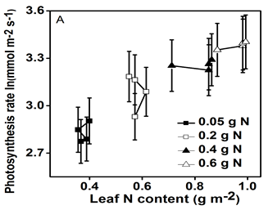

Supplementary Figure 1. Relationships in Sorghum bicolor between the photosynthesis rates and leaf N contents (0.05, 0.2, 0.4, or 0.6 g N). Photosynthesis rate increased with increased amount of leaf N content in sorghum, respectively. The error bars indicate the standard errors. Data taken from (Makino and Ueno 2018).

Supplementary Figure 2

Supplementary Figure 2. Response of the leaf photosynthesis rates on the intercellular CO₂ concentrations (C_{i}), due to the nitrogen deficiencies in the Sorghum bicolor. Three types of Hoagland nutrient solution (0, 20, and 100 %) were tested, and after 46 to 50 days measurements were taken of the fully expanded leaves. The nitrogen deficiency in the leaves is seen to cause a decrease in the C_{i}. While, the 0 and 20 % N reduced the leaf photosynthesis rates, they also reduced the intercellular CO₂ concentrations, compared with the 100 % N. The error bars indicate the standard errors of three measurements. Data are taken from (Zhao et al, 2005).

