Species composition and functional traits of macrofauna in different mangrove habitats in the Persian Gulf

Table S1. The geographical coordinates of the sampled areas.
Area | Latitude | Longitude
Tabl - beach | 26° 46’24. 42” | 55° 43’39.23”
Tabl - creek | 26° 49’29.48” | 55° 42’57.92”
Gavarzin - beach | 26° 49’ 08.72” | 55° 47’30.49”
Gavarzin - creek | 26° 48’44.12” | 55° 47’25.92”
Laft - beach | 26° 53’08.36” | 55° 46’17.08”
Laft - creek | 26° 51’21.30” | 55° 45’50.13”
Khamir1 - beach | 26° 59’03.38” | 55° 39’24.48”
Khamir1- creek | 26° 59’01.60” | 55° 39’24.84”
Khamir2 - beach | 26° 58’37.06” | 55° 38’02.12”
Khamir2- creek | 26° 58’20.29” | 55° 37’57.89”

Table S2. Analysis of variance (two-way ANOVA) of salinity and temperature data exploring differences between habitats and seasons in the mangrove forest. PERMANOVA was used to analyse differences in sediment total organic matter (TOM), as the data did not fulfil requirements of ANOVA (i.e. normality assumptions).
Environmental variable | Factor | df | SS | MS | F | p
Salinity | Habitat | 5 | 181.2 | 36.24 | 6.849 | <0.001
 | Season | 3 | 348.3 | 116.09 | 25.1 | <0.001
 | Habitat*Season | 15 | 297 | 19.8 | 6.34 | <0.001
Temperature | Habitat | 5 | 66 | 13.24 | 0.76 | 0.58
 | Season | 3 | 4022 | 1340.8 | 539.7 | <0.001
 | Habitat*Season | 15 | 95.42 | 6.36 | 3.02 | 0.0002
PERMANOVA | Factor | df | SS | MS | pseudo-F | p(perm)
TOM | Habitat | 5 | 211.88 | 42.377 | 3.957 | 0.002
 | Season | 3 | 67.189 | 22.396 | 2.091 | >0.05
 | Habitat*Season | 15 | 69.674 | 4.6449 | 0.433 | 0.964

Table S3. The number of species collected in the six habitats during winter and summer, B = beach, C = creek.
Faunal group | Order | Habitat/Winter |  |  |  |  |  | Habitat/Summer
 |  | B1 | B2 | B3 | C1 | C2 | C3 | B1 | B2 | B3 | C1 | C2 | C3
Crustacea | Decapoda | 5 | 9 | 6 | 7 | 11 | 8 | 4 | 4 | 4 | 8 | 8 | 9
 | Isopoda | - | - | - | 1 | - | - | - | - | - | - | - | -
 | Stomatopoda | - | - | - | 1 | - | 1 | - | - | - | - | - | -
 | Sessilia | - | - | 1 | 1 | 1 | 1 | 1 | 1 | 1 | 1 | 1 | 1
Annelida | Polychaeta | 4 | 6 | 6 | 11 | 8 | 12 | 1 | 5 | 7 | 9 | 9 | 8
 | Sipuncula | - | - | - | 1 | - | - | - | - | - | 1 | - | -
Mollusca | Gastropoda | 4 | 10 | 6 | 9 | 7 | 8 | 5 | 10 | 10 | 20 | 23 | 9
 | Bivalvia | - | 1 | 1 | 2 | 2 | 3 | 3 | 8 | 6 | 16 | 13 | 4
Total species richness |  | 13 | 26 | 20 | 33 | 29 | 33 | 14 | 28 | 28 | 55 | 54 | 31

Table S4. List of all species found in the different seasons.
Faunal group | Species | Winter | Spring | Summer | Fall
Crustacea | Alpheus euphrosyne | * |  | * | *
 | Alpheus lutosus | * | * | * | *
 | Amphibalanus amphitrite | * | * | * | *
 | Austruca iranica | * | *
 | Austruca sindensis | *
 | Eurycarcinus orientalis | * | * | * | *
 | Ilyograpsus rhizophorae | * | * | * | *
 | Ilyoplax frater | * | * | * | *
 | Ilyoplax stevensi | * | * | * | *
 | Manningis arabicum | * | * | * | *
 | Nasima dotilliformis | * | * | * | *
 | Olibrinus antennatus | * |  |  | *
 | Opusia indica | * | * | * | *
 | Parasesarma persicum | * | * | * | *
 | Stomatopoda sp. | *
 | Synalpheus sp. | * | * | * | *
 | Venitus dentipes |  | *
Annelida | Amphinomidae sp. |  |  | *
 | Capitellidae sp. A | * | * | * | *
 | Capitellidae sp. B | * | * | * | *
 | Cirratulidae sp. | *
 | Echiuridae sp. | *
 | Eunicidae sp. A | * | * | * | *
 | Eunicidae sp. B | * |  |  | *
 | Glyceridae sp. | * |  | * | *
 | Goniadidae sp. A | * | * | * | *
 | Goniadidae sp. B |  | * | * | *
 | Lumbrineridae sp. | * | * | * | *
 | Nereididae sp. A | * | * | * | *
 | Nereididae sp. B | * | * | * | *
 | Nereididae sp. C |  | * | * | *
 | Nereis persica | * |  | * | *
 | Perinereis horsti | * |  | * | *
 | Perinereis sp. | * | * | * | *
 | Phyllodocidae sp. | *
 | Pilargidae sp. |  |  | *
 | Poecilochaetidae sp. | *
 | Raricirrus sp. |  |  |  | *
 | Simplisetia erythraeensis | *
 | Simplisetia qeshmensis | *
 | Simplisetia sp. | * |  | * | *
 | Sipuncula sp. | * | * | * | *
Mollusca | Acar plicata |  | * |  | *
 | Acrilla acuminata |  | * | * | *
 | Acteocina sp. |  |  |  | *
 | Acteocina inconspicua |  | * | * | *
 | Aliculastrum cylindricum |  |  |  | *
 | Amphilepida sp. |  |  | * | *
 | Anadara ehrenbergi |  |  | * | *
 | Ancilla farsiana |  | * | * | *
 | Arcuatula senhousia | * | * | * | *
 | Assiminea sp. | * | * | * | *
 | Brachidontes variabilis |  | * | * | *
 | Calyptraea pellucida |  |  |  | *
 | Carditopsis majeeda |  |  |  | *
 | Cerithidium cerithinum |  |  |  | *
 | Cerithidium sp. |  |  | *
 | Chicoreus ramosus |  |  |  | *
 | Chrysallida sp. |  | * |  | *
 | Clanculus scabrosus | *
 | Clypeomorus bifasciata | * | * | *
 | Congetia chesneyi |  | * | * | *
 | Coralliophaga coralliophaga |  | * | * | *
 | Corbula taitensis |  | * | * | *
 | Crassispira sp. | * | * |  | *
 | Cyclostrema ocrinium |  | * | * | *
 | Didimacar tenebrica | * | * | * | *
 | Diodora funiculata | * | *
 | Diodora singaporensis |  | *
 | Diplodonta sp. |  | * |  | *
 | Discopsis sp. |  | * |  | *
 | Dosinia sp. |  | * | * | *
 | Ellobium sp. |  | *
 | Epitonium sp. | * | * | * | *
 | Euchelus asper | * | * | *
 | Eulimella sp. |  |  |  | *
 | Eulimastoma eutropia |  | * | * | *
 | Eurytellina nitens |  | * | *
 | Exolaternula erythraea |  | * | * | *
 | Gibberula mazagonica |  | * | * | *
 | Granulina oodes |  |  | * | *
 | Haminoea vitrea | * | * | * | *
 | Indothais lacera | * | * |  | *
 | Iravadia quadrasi | * | * | * | *
 | Irus irus |  | * | * | *
 | Laemodonta monilifera |  |  |  | *
 | Littoraria intermedia | * | * | * | *
 | Mitrella blanda | * | * | * | *
 | Notomyrtea fabula |  |  | *
 | Nassarius castus |  | * | * | *
 | Natica sp. |  | *
 | Naticarius sp. |  |  |  | *
 | Neotrapezium sublaevigatum | * | * | * | *
 | Nerita albicilla |  | * |  | *
 | Oscilla evanida |  | * | * | *
 | Pirenella cingulata | * | * | * | *
 | Pitar pellucidus |  |  | * | *
 | Platevindex tigrinus | * |  | * | *
 | Pseudominolia biangulosa |  |  |  | *
 | Pseudonoba sp. |  |  | * | *
 | Ptychobela opisthochetos |  | *
 | Pyramidellidae sp. |  |  |  | *
 | Salinator fragilis | * | * | * | *
 | Septifer cumingii | *
 | Serratina capsoides |  |  | *
 | Serratina serrata |  |  | *
 | Stenothyra sp. |  | * | * | *
 | Stosicia annulata |  |  |  | *
 | Tellina sp. |  | * | * | *
 | Terebra sp. |  | * |  | *
 | Theora mesopotamica |  | * | * | *
 | Timoclea arakana |  | * |  | *
 | Tornatina persiana |  |  |  | *
 | Tornus sp. |  | * | * | *
 | Trochus fultoni |  | * | * | *
 | Trochus sp. |  | * | *
 | Turbonilla icela |  |  | * | *
 | Turbonilla linjaica |  |  |  | *
 | Turritella sp. A |  | * | * | *
 | Turritella sp. B |  | *
 | Umbonium vestiarium | * | * | * | *
 | Zafra sp. |  |  | * | *

Table S5. The number of species, average total abundance (ind. m⁻²) and biomass (g wwt m⁻²) in the six habitats during the four seasons.
Season | Habitat | Species richness | Abundance | Biomass
Winter | B1 | 13 | 719 | 134
 | B2 | 26 | 1414 | 240
 | B3 | 20 | 1625 | 466
 | C1 | 33 | 434 | 69
 | C2 | 29 | 255 | 16
 | C3 | 33 | 434 | 71
Spring | B1 | 24 | 603 | 92
 | B2 | 26 | 1914 | 277
 | B3 | 58 | 2082 | 404
 | C1 | 40 | 885 | 108
 | C2 | 43 | 1271 | 177
 | C3 | 41 | 1086 | 129
Summer | B1 | 14 | 535 | 71
 | B2 | 28 | 3168 | 511
 | B3 | 28 | 482 | 85
 | C1 | 55 | 2077 | 241
 | C2 | 54 | 1231 | 179
 | C3 | 31 | 423 | 61
Fall | B1 | 22 | 824 | 157
 | B2 | 29 | 1298 | 125
 | B3 | 47 | 1235 | 177
 | C1 | 76 | 2231 | 362
 | C2 | 39 | 775 | 123
 | C3 | 44 | 396 | 103

Table S6. Pairwise comparisons of abundance, biomass and traits between habitats and seasons. The analyses were performed with two-way PERMANOVA, if the main test was significant (p<0.05; Table 3). Habitats: B=beach, C=creek. Seasons: W=winter, Sp=spring, Su=summer, F=fall.
 | Abundance |  | Biomass |  | Traits
Habitats | t | P(perm) | t | P(perm) | t | P(perm)
B1-B2 | 2.125 | 0.003 | 2.292 | 0.002 | 2.159 | 0.005
B1-B3 | 2.262 | 0.001 | 2.567 | 0.000 | 2.475 | 0.002
B1-C1 | 2.268 | 0.000 | 2.345 | 0.000 | 2.593 | 0.000
B1-C2 | 2.469 | 0.000 | 2.728 | 0.000 | 2.850 | 0.000
B1-C3 | 2.165 | 0.001 | 2.407 | 0.000 | 2.551 | 0.000
B2-B3 | 1.095 | 0.268 | 1.143 | 0.202 | 1.156 | 0.242
B2-C1 | 2.404 | 0.000 | 2.268 | 0.000 | 2.005 | 0.010
B2-C2 | 2.467 | 0.000 | 2.405 | 0.000 | 2.318 | 0.001
B2-C3 | 2.288 | 0.000 | 2.171 | 0.000 | 2.528 | 0.002
B3-C1 | 2.159 | 0.000 | 2.265 | 0.000 | 1.376 | 0.116
B3-C2 | 1.951 | 0.000 | 2.025 | 0.000 | 1.448 | 0.093
B3-C3 | 1.666 | 0.013 | 1.609 | 0.013 | 1.757 | 0.039
C1-C2 | 1.133 | 0.201 | 1.291 | 0.070 | 0.647 | 0.822
C1-C3 | 1.670 | 0.001 | 1.788 | 0.000 | 1.232 | 0.176
C2-C3 | 1.386 | 0.026 | 1.437 | 0.017 | 1.270 | 0.151
Seasons
W-Sp | 1.481 | 0.021 | 2.056 | 0.000
W-Su | 1.705 | 0.003 | 2.165 | 0.000
W-F | 1.398 | 0.028 | 1.788 | 0.000
Sp-Su | 0.791 | 0.835 | 1.010 | 0.405
Sp-F | 1.295 | 0.069 | 1.524 | 0.014
Su-F | 1.139 | 0.183 | 1.122 | 0.219

bjjj

Figure S1. Salinity (ppt) and temperature (℃, avg. ± SD) in the six different habitats during the four seasons.

Figure S2. Percentage of the grain size fractions in the six habitats. The values are averaged across all seasons and sampling areas.

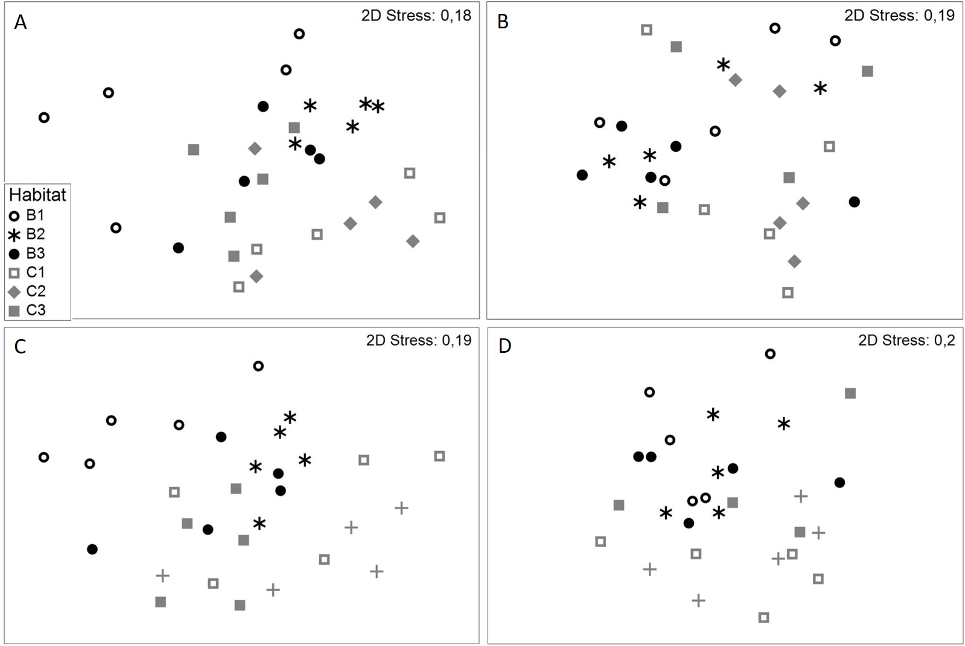
Figure S3. nMDS ordinations illustrating the differences in macrofauna community abundance and biomass between the six habitats in summer and winter, A) abundance in summer and B) in winter, C) biomass in summer and D) in winter.

