**Supplementary materials**

**Coating Persistent Luminescence Nanoparticles with Hydrophilic Polymers for *In Vivo* Imaging**

Jianhua Liu,1 Lenka Kotrchová,2 Thomas Lécuyer,1 Yohann Corvis,1 Johanne Seguin,1 Nathalie Mignet,1 Tomáš Etrych,2 Daniel Scherman,1 Eva Randarová2* and Cyrille Richard1*

Unité de Technologies Chimiques et Biologiques pour la Santé (UTCBS), CNRS UMR8258, Inserm U1267, Université de Paris, 75006 Paris, France

Institute of Macromolecular Chemistry, Czech Academy of Sciences, Heyrovského nám. 2, 162 06 Prague, Czech Republic

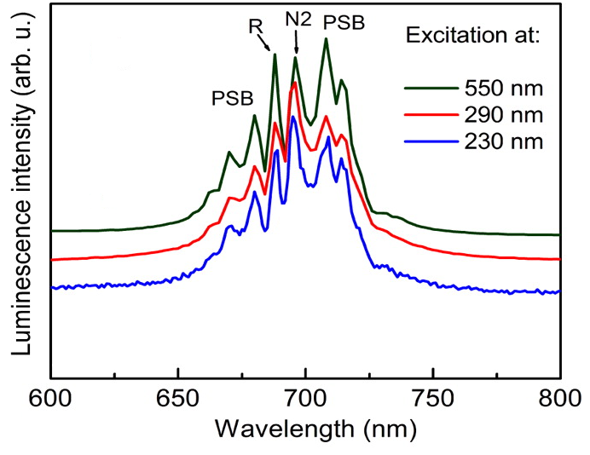

Fig S1. Emission spectrum of ZGO at different excitation wavelength.

Adapted from Chem Mater 2014, 26, 1365-1373.



Fig S2. *In vivo* imaging using non-coated ZGO-OH nanoparticles



Fig S3. Thermogravimetric analyses of functionalized ZGO-NH2 (blue), ZGO-PEG (green), and ZGO-HPMA (red). The weight loss percentages, i.e. 1.2%, 4.3%, and 5.2% have been determined between 220 and 550 °C due to -NH2, -PEG, and -HPMA thermal degradation, respectively.



Fig S4. Colloidal stability of functionalized ZGO in DI water