Supplementary Materials

Supplementary Figures
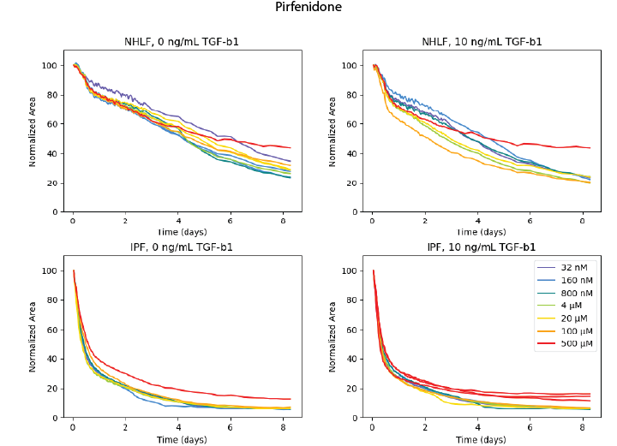
Supplementary Figure 1. Contraction of primary human fibroblasts with addition of pirfenidone. Areas are normalized to the initial area of each microgel. N=1-2 per condition.

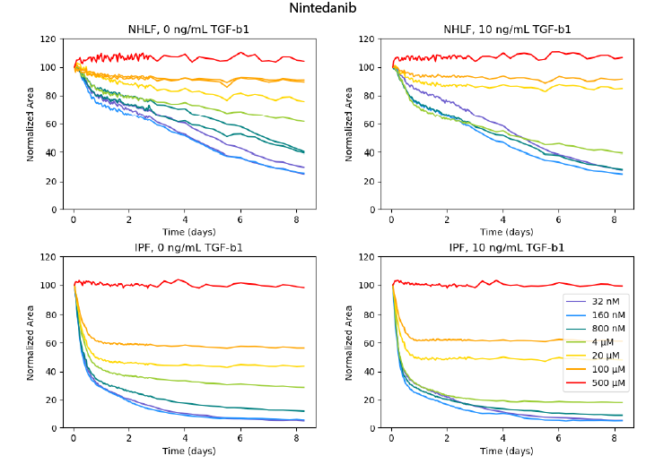

Supplementary Figure 2. Contraction of collagen microgels by primary human lung fibroblasts with addition of nintedanib. Areas of collagen microgels were normalized to their initial area. N=1-2 per condition.
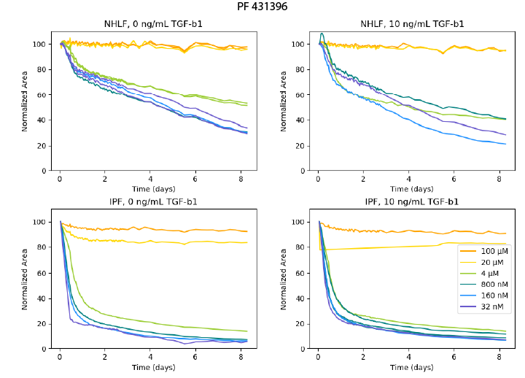
Supplementary Figure 3. Contraction of collagen microgels with primary human lung fibroblasts and the FAK inhibitor, PF 431396. Areas are normalized to the initial area of each microgel. N=1-2 per condition.
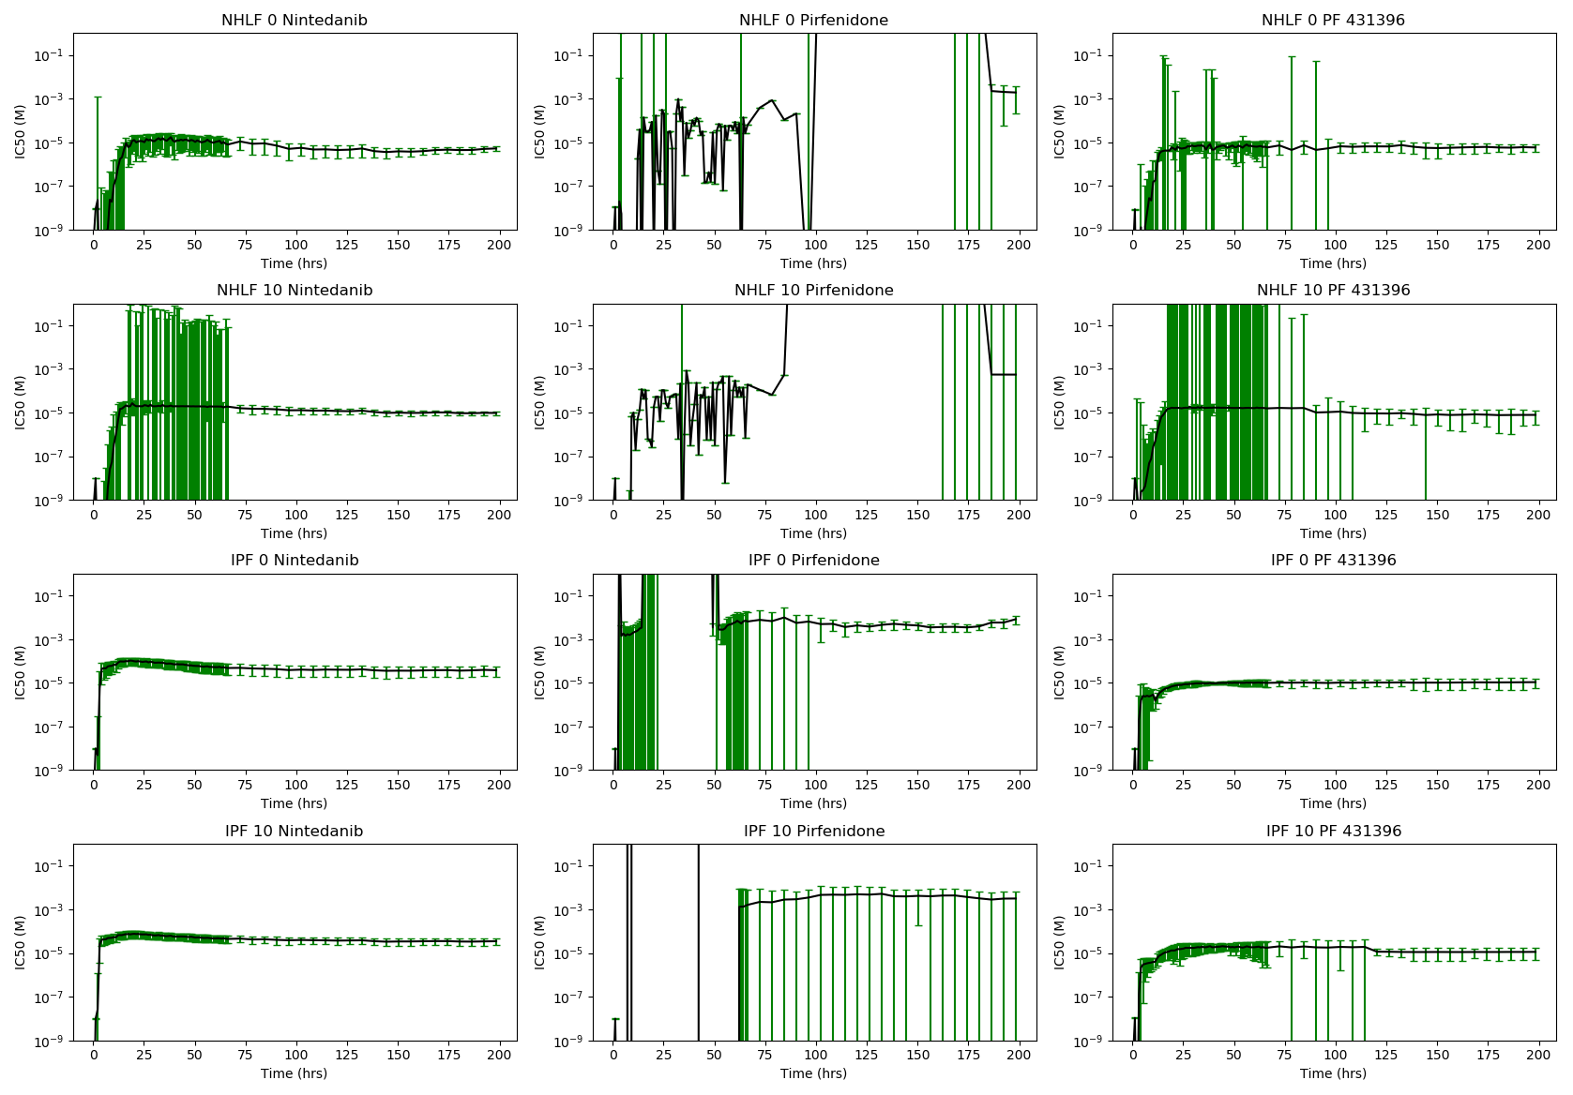Supplementary Figure 4. Fitted values for IC50 for each cell and TGF-β1 combination, graphed over individual time points. Error bars are standard deviation, calculated from the model fit covariance.

Supplementary Table 1. Fitted IC50 values for cell, stimulant, and drug combinations.
 | NHLF IC50 (μM) |  |  | IPF IC50 (μM)
Drug | -TGF-β1 | +TGF-β1 |  | -TGF-β1 | +TGF-β1
PF 431396 | 6.3$±$2.5 | 10.2$±$10.7 |  | 9.8$±$ 3.6 | 11.5$±$4.3
Nintedanib | 5.9$±$3.0 | 12.9$±$ 4.1 |  | 47.1$±$23.9 | 43.1$±$15.2
Pirfenidone | >500.0 | >500.0 |  | >500.0 | >500.0

