Title: Nodule and Root Zone Microbiota of Salt-tolerant Wild Soybean in Coastal Sand and Saline-alkali Soil
Yingjie Yangª, Lei Liu^{b}, Raghvendra Pratap Singh^{c}*, Chen Mengª, Siqi Maª, Changliang Jingª, Yiqiang Liª and Chengsheng Zhangª*
Affiliations:
ªMarine Agriculture Research Center, Tobacco Research Institute, Chinese Academy of Agricultural Sciences, Qingdao, Shandong 266101, China. YJY: yingjieyoung@sina.com; CM: mengchen01@caas.cn; CLJ: jingchangliang@caas.cn; CSZ: zhangchengsheng@caas.cn; YQL: liyiqiang@caas.cn.
^{b}Bureau of Agriculture and Rural Affairs of Laoshan District, Qingdao, Shandong 266061, China. LL: liulei72288@163.com
^{c}Department of Research & Development, Biotechnology, Uttaranchal University, Dehradun 248007, India. RPS: rpsingh@uttaranchaluniversity.ac.in

*corresponding authors: Raghvendra Pratap Singh and Chengsheng Zhang
Corresponding E-mail: rpsingh@uttaranchaluniversity.ac.in (R.P. Singh); zhangchengsheng@caas.cn (C.S. Zhang)

Legends of supplementary materials
Fig. S1. the Venn map of 16S Illumina sequencing of six root zones samples and six nodules under saline fields
Fig. S2. the relative abundance of 16S Illumina sequencing of six root zones samples and six nodules under saline fields at order level (2A) and family level (2B)
Fig. S3. Principal Component Analysis (PCA analysis) based on 16S OTU (A) and based on 16S diff-OTU (B).
Fig. S4. Tags distribution of 16Sr RNA V5-V7 regions and nifH gene fragments
Fig. S5. the Venn map of nifH gene fragments Illumina sequencing of six root zones samples and six nodules under saline fields
Fig. S6 the relative abundance of nifH gene fragments Illumina sequencing of six root zones samples and six nodules under saline fields at order level (6A), family level (6B), species level(6C)
Fig. S7 G.soja obtained from the Yellow River Delta (Dongying city) (7A) and Shilaoren coastal region in Qingdao (7B)

Table S1 Sequencing data of 16S V5-V7 region by Illumina sequencing platform
Table S2 the alpha diversity index of 16S V5-V7 region replicon sequencing of two root zone and two nodules of wild soybean grown in saline-alkali soil.
Table S3 The relative abundance of 16S rRNA in root zone of wild soybean
Table S4 The relative abundance of 16S rRNA in the nodules of wild soybean at phylum level
Table S5 The relative abundance of 16S rRNA in the nodules of wild soybean at genus level
Table S6 Sequencing data of nifH gene fragments by Illumina sequencing platform
Table S7 the alpha diversity index of nifH replicon sequencing of two root zone and two nodules of wild soybean grown in saline-alkali soil.
Table S8 the relative abundance of nifH in nodules at phylum level
Table S9 the relative abundance of nifH in root zones at phylum level
Table S10 the relative abundance of nifH in root zones at genus level

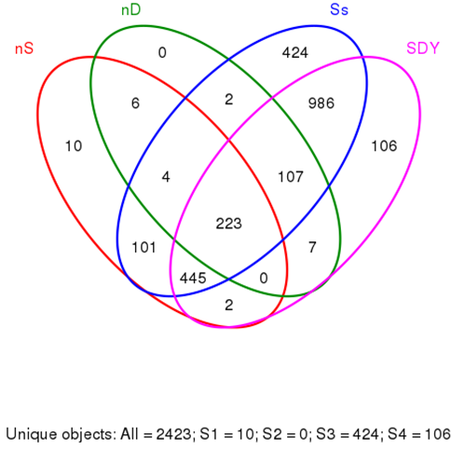
Fig. S1 the Venn map of 16S Illumina sequencing of six root zones samples and six nodules under saline fields

2A
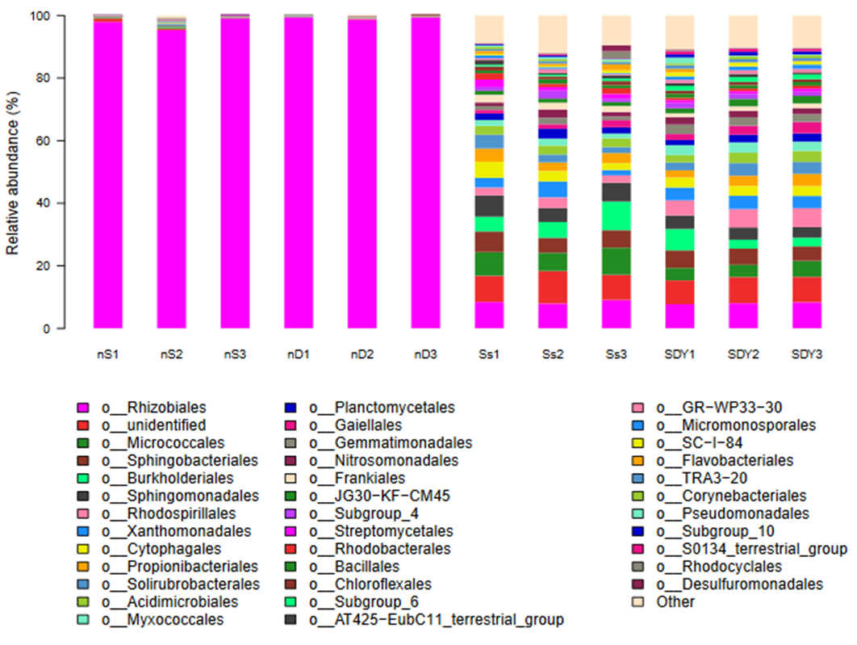
2B
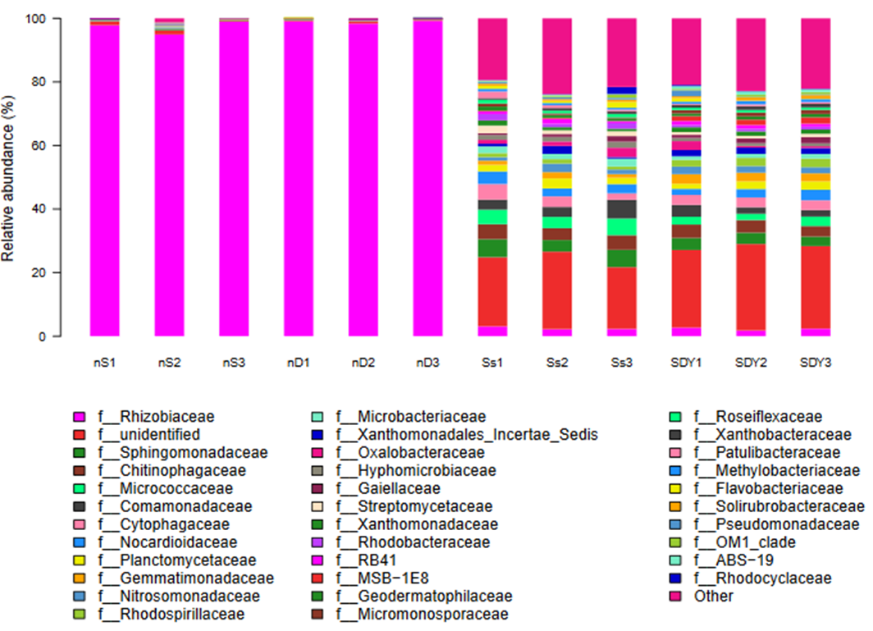
Fig. S2 the relative abundance of 16S Illumina sequencing of six root zones samples and six nodules under saline fields in the order level (2A) and family level (2B).

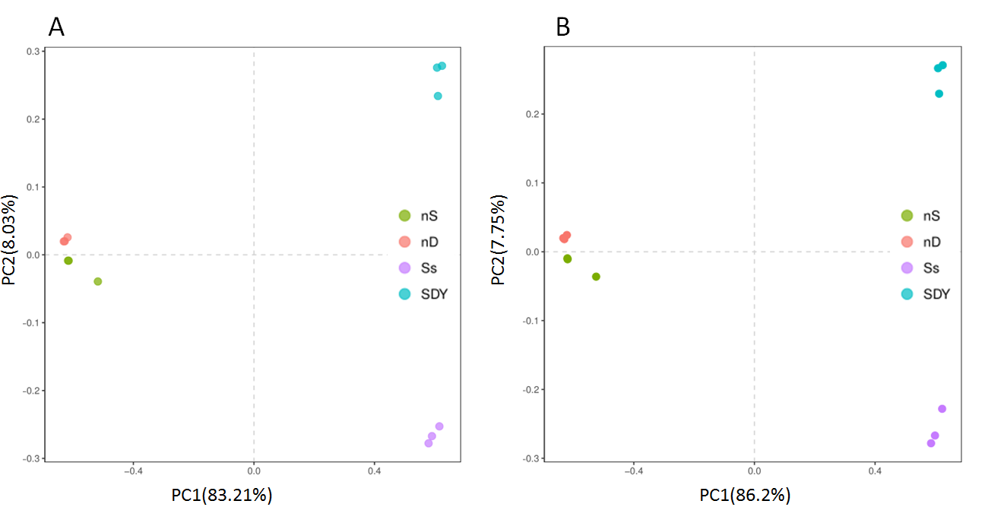
Fig. S3 Principal Component Analysis (PCA analysis) based on 16S OTU (A) and based on 16S diff-OTU (B).
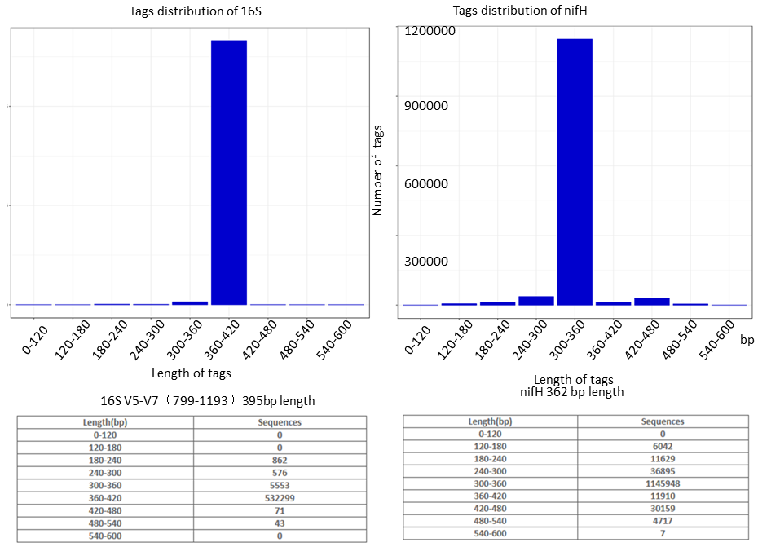
Fig. S4 Tags distribution of 16Sr RNA V5-V7 regions and nifH gene fragments.

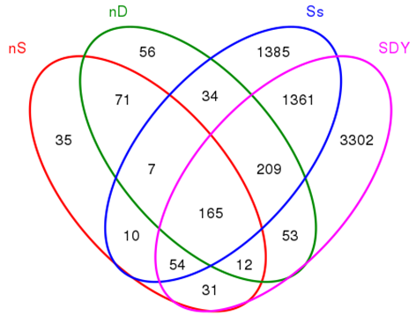
Fig. S5 the Venn map of nifH gene fragments Illumina sequencing of six root zones samples and six nodules under saline fields

Fig. S6A
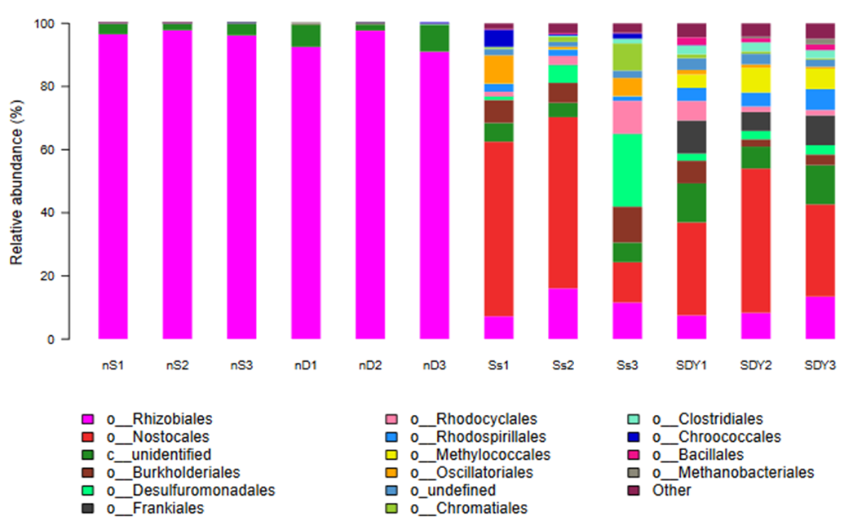

Fig. S6B

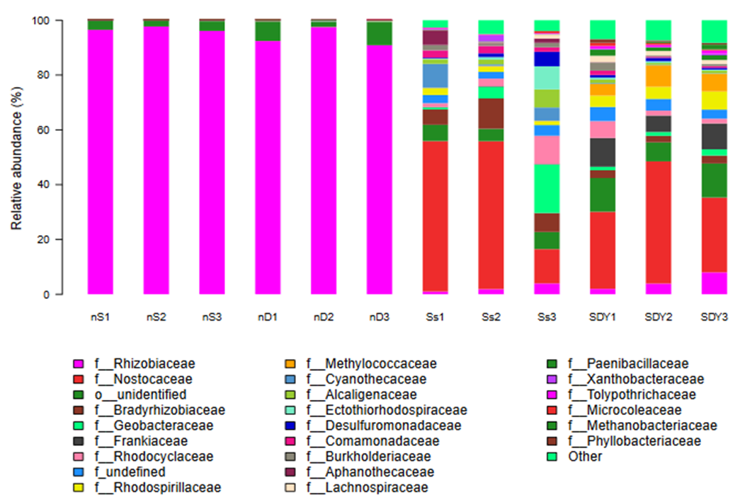
Fig. S6C
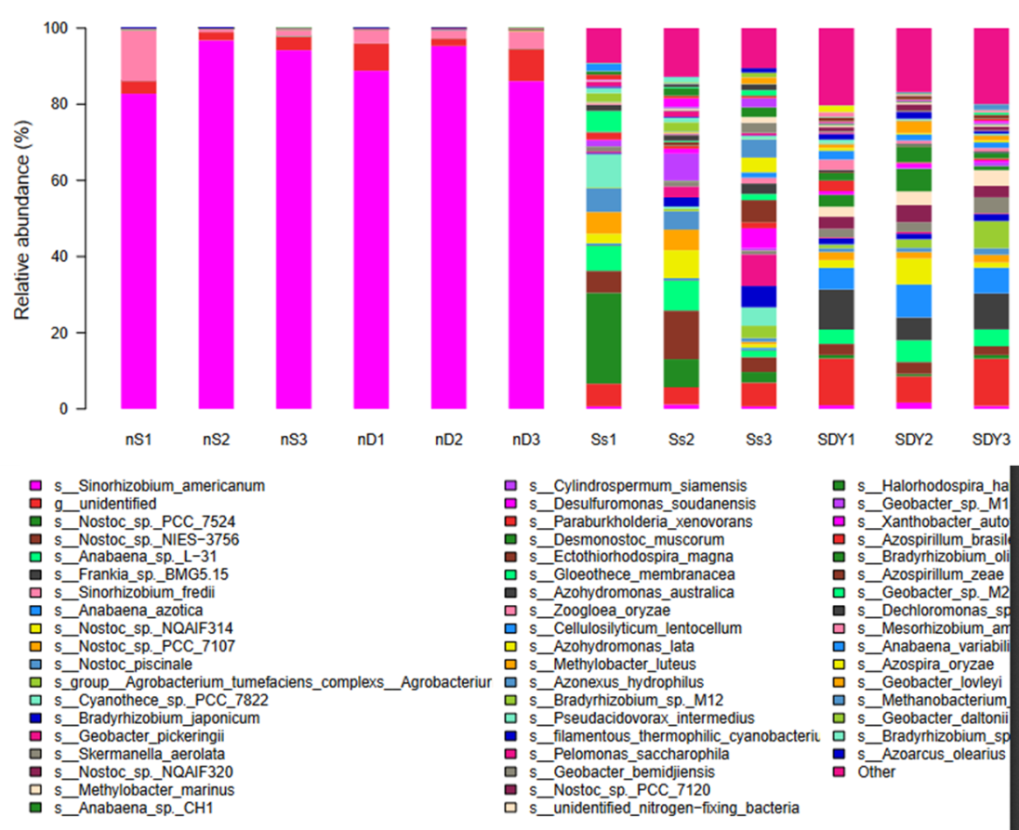
Fig. S6 the relative abundance of nifH gene fragments Illumina sequencing of six root zones samples and six nodules under saline fields in the order level (6A), family level (6B), and species level (6C).

Fig. S7A
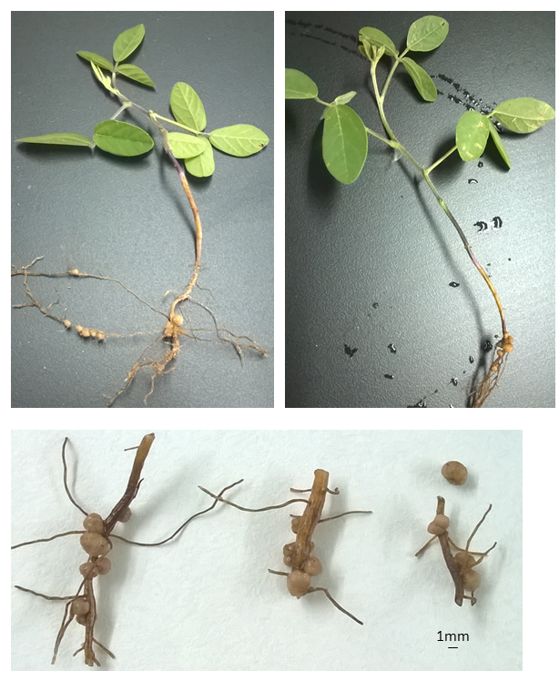
Fig. S7B
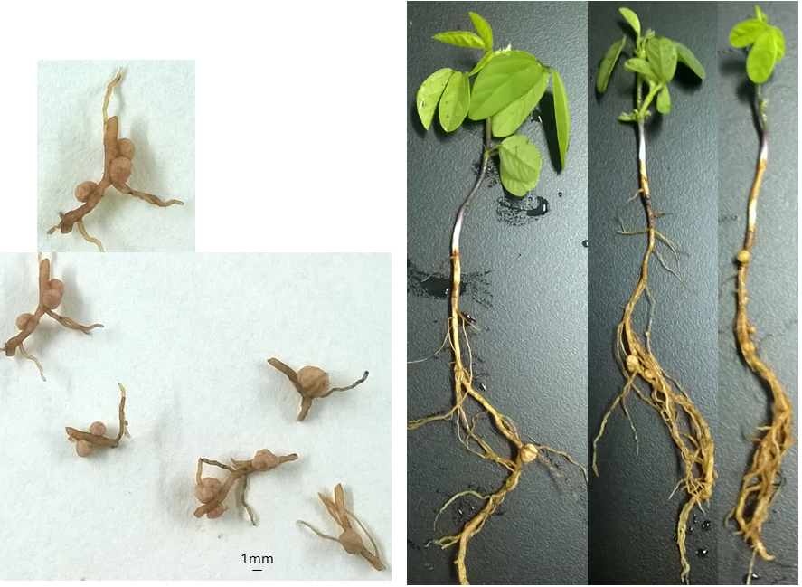
Fig. S7 G.soja obtained from the Yellow River Delta (Dongying city) (7A) and Shilaoren coastal region in Qingdao (7B)

Table S1 Sequencing data of 16S V5-V7 region by Illumina sequencing platform
Samples | Raw_Tags | Clean_Tags | Final_tags | OTUs
nD | 34471±4134 | 33702±4157 | 31481±3907 | 164±10
nS | 39970±1548 | 38181±2064 | 34922±2538 | 358±209
SDY | 46272±5104 | 37475±4260 | 20591±1818 | 1528±39
Ss | 83145±44123 | 70442±40229 | 43727±23594 | 1797±246

Table S2 the alpha diversity index of 16S V5-V7 region replicon sequencing of two root zone and two nodules of wild soybean grown in saline-alkali soil.
Samples | chao1 | goods_coverage | observed_species | PD_whole_tree | shannon
nD | 356.94±10.90 | 0.9952±0.0005 | 104±15.8 | 30.8±10.5 | 0.15±0.04
nS | 548.26±293.77 | 0.9910±0.0053 | 233.2±152.5 | 65.5±33.1 | 0.39±0.25
SDY | 1737.90±14.38 | 0.9794±0.0005 | 1466.3±12.6 | 118.4±2.7 | 9.00±0.04
Ss | 1867.28±99.50 | 0.9764±0.0006 | 1540.8±101.1 | 157.7±18.7 | 8.95±0.19

Table S3 The relative abundance of 16S rRNA in root zone of wild soybean
Phylum | Relative abundance in root zone in coastal region（%） | Relative abundance in root zone in the Yellow river delta（%）
Proteobacteria | 39.67±2.87 | 39.67±3.09
Actinobacteria | 26.00±2.94 | 24.00±3.74
Bacteroidetes | 10.67±1.70 | 9.00±0.82
Chloroflexi | 6.00±0.05 | 6.67±0.47
Acidobacteria | 3.67±0.90 | 6.00±0.02
Gemmatimonadetes | 2.67±0.47 | 4.67±0.47
Planctomycetes | 3.00±0.83 | 3.67±0.47
Saccharibacteria | 1.33±0.47 | 0.20±0.00
Firmicutes | 1.30±0.50 | 1.00±0.01
Armatimonadetes | 0.67±0.05 | 0.73±0.09
TM6 | 0.31±0.20 | 0.06±0.02
Chlamydiae | 0.40±0.22 | 0.16±0.06
Nitrospira | 0.67±0.21 | 0.67±0.12
Verrucomicrobia | 0.90±0.14 | 2.00±0.00
Parcubacteria | 0.50±0.37 | 0.04±0.01
Cyanobacteria | 0.09±0.02 | 0.04±0.02

Table S4 The relative abundance in the nodules of wild soybean at phylum level
Phylum name | nodule in coastal sand (nS) | nodule in the Yellow River delta soil (nD)
Proteobacteria | 98.458±0.045 | 99.703±0.002
γ-proteobacteria | 0.225±0.081 | 0.178±0.062
β-proteobacteria | 0.187±0.052 | 0.053±0.010
δ-proteobacteria | 0.134±0.061 | 0.046±0.010
Actinobacteria | 0.533±0.340 | 0.167±0.047
Bacteroidetes | 0.177±0.158 | 0.037±0.017
Chloroflexs | 0.123±0.122 | 0.047±0.009
Acidobacteria | 0.113±0.092 | 0.043±0.012
Gemmatimonadetes | 0.117±0.095 | 0.043±0.009
Planctomycetes | 0.077±0.057 | 0.014±0.008
Saccharibacteria | 0.026±0.023 | 0.001±0.001
Firmicutes | 0.036±0.031 | 0.010±0.007
Armatimonadetes | 0.014±0.012 | 0.005±0.002
TM6 | 0.010±0.009 | ND
Chlamydiae | 0.009±0.007 | ND
Nitrospira | 0.013±0.010 | ND
Verrucomicrobia | 0.022±0.016 | 0.004±0.001
ND: not detected

Table S5 The relative abundance of 16S rRNA in the nodules at genus level
Genus | nS (%) | nD (%)
Actinobacteria
Microbacterium | 0.066±0.009 | 0.006±0.002
Arthrobacter | 0.060±0.010 | 0.008±0.004
Nocardiodes | 0.059±0.011 | 0.009±0.002
Streptomyces | 0.037±0.012 | 0.006±0.003
Blastococcus | 0.012±0.003 | 0.017±0.005
Patulibacter | 0.013±0.007 | 0.008±0.001
Bacteroidetes
Flavobacterium | 0.042±0.010 | 0.001±0.001
Flavisolibacter | 0.028±0.008 | 0.009±0.002
Proteobacteria
Sinorhizobium/Ensifer (α-) | 97.330±1.701 | 98.661±0.471
Sphingomonas (α-) | 0.086±0.009 | 0.016±0.004
Varribacter (α-) | 0.015±0.006 | 0.013±0.004
Devosia (α-) | 0.008±0.001 | 0.002±0.001
Pedomicrobium (α-) | 0.008±0.001 | 0.014±0.005
Microvirga (α-) | 0.006±0.001 | 0.008±0.002
Enterobacteriaceae (γ-) | 0.086±0.005 | 0.056±0.009
Pseudomonas (γ-) | 0.032±0.008 | 0.027±0.007
Acinetobacter (γ-) | 0.012±0.003 | 0.002±0.000
Pseudoxanthomonas (γ-) | 0.010±0.003 | 0.014±0.004
Candidatus- Entotheonella (δ-) | 0.015±0.002 | 0.009±0.002
GR-WP33-30 (δ-) | 0.016±0.005 | 0.008±0.003
Methylibium (β-) | 0.015±0.004 | 0.001±0.000
Ramlibacter (β-) | 0.004±0.003 | 0.007±0.003
Nitrosomonadaceae (β-) | 0.025±0.009 | 0.010±0.006
Firmicutes
Bacillus | 0.022±0.005 | 0.010±0.007
Paenibacillus | 0.008±0.003 | ND
Halobacillus | 0.004±0.002 | ND
Lysinibacillus | 0.004±0.001 | ND

Table S6 Sequencing data of nifH gene fragments by Illumina platform
Samples | Raw_Tags | Clean_Tags | Final_tags | OTUs
nS | 67618±4707 | 67017±4505 | 66460±4358 | 194±36
nD | 69471±6228 | 68701±6364 | 68083±6225 | 303±16
Ss | 134675±28132 | 131744±27556 | 123471±26427 | 1689±21
SDY | 150932±23230 | 148306±22497 | 136043±20027 | 2795±415

Table S7 the alpha diversity index of nifH replicon sequencing of two root zone and two nodules of wild soybean grown in saline-alkali soil.
Samples | chao1 | goods_coverage | observed_species | PD_whole_tree | shannon
nD | 546.78±72.07 | 0.9973±0.0003 | 269.1±17.5 | 141.9±11.8 | 0.75±0.20
nS | 341.96±39.64 | 0.9983±0.0002 | 174.1±29.3 | 107.3±17.4 | 0.61±0.32
SDY | 2783.83±364.99 | 0.9887±0.0019 | 1334.7±303.4 | 953.3±191.5 | 7.61±0.28
Ss | 1796.96±101.75 | 0.9922±0.0007 | 1327.0±114.1 | 561.6±98.7 | 6.54±0.45

Table S8 the relative abundance of nifH in nodules at phylum level
type | Relative abundance in nS | Relative abundance in nD
Sinorhizobium/Ensifer | 96.657±0.943 | 93.342±2.645
Proteobacteria | 97.010±0.816 | 94.001±2.944
Unidentified | 3.029±0.735 | 5.675±2.625
Viridiplantae | ND | 0.005±0.003
Euryarchaeota | ND | 0.004±0.003

Table S9 the relative abundance of nifH in root zones at phylum level
type | SS | SDY
Cyanobacteria | 49.000±20.607 | 37.667±8.055
Proteobacteria | 32.323±9.843 | 31.333±3.091
Unidentified | 5.672±0.473 | 10.333±2.357
Delta/epsilon | 10.000±7.204 | 3.667±0.471
Firmicutes | 0.668±0.231 | 4.104±0.393
Actinobacteria | 0.238±0.047 | 9.000±2.160
Euryarchaeota | 0.100±0.007 | 1.733±1.159
Viridiplantae | 0.003±0.002 | 0.003±0.000
Metazoa | 0.003±0.001 | 0.011±0.010
Dickarya | 0.005±0.003 | 0.007±0.001

Table S10 the relative abundance of nifH in root zones at genus level
Genus name | Relative abundance of niH gene in each phylum at samples Ss (%) | Relative abundance of niH gene in each phylum at samples SDY (%)
Cyanobacteria | 100 | 100
Nostoc | 58.7±9.9 | 40.3±0.5
Anabaena | 13.7±1.7 | 40.0±1.6
Cylindrospermum | 6.0±3.9 | 1.8±1.6
Gloeothece | 5.5±3.5 | ND
Cyanothece | 12.0±8.5 | ND
Proteobacteria | 100 | 100
Bradyrhizobium | 32.7±4.7 | 8.3±0.5
Agrobacterium_ | 1.7±0.5 | 10.3±7.9
Sinorhizobium | 4.0±0.0 | 3.7±1.7
Azohydromonas | 6.0±1.4 | 3.3±0.5
Paraburkholderia | 5.0±2.8 | 4.0±3.5
Azospirillum | 4.3±1.9 | 5.7±0.5
Azotobacter | 1.7±0.5 | 1.0±0.5
Skermanella | 4.3±0.5 | 9.7±2.0
Agrobacterium | 1.7±0.5 | 10.3±4.8
Ectothiorhodospira | 2.3±1.0 | 0.7±0.3
Methylobacter | 0.4±0.1 | 17.7±6.2
Actinobacteria | 100 | 100
Frankia | 80.0±11.2 | 98.7±0.5
Firmicutes | 100 | 100
Cellulosilyticum | 35.3±33.0 | 38.3±4.5
Paenibacillus | 24.0±12.3 | 37.3±6.0
Clostridium | 13.3±7.8 | 14.3±6.2
Bacillus | 12.7±7.0 | 1.4±0.8

