Supplementary information
Figure captions

Supplementary Figure S1. A. Methane concentration vs. salinity in the OT, ESC. Blue points represent the sampling sites in the shelf, green points represent the sampling sites on the upper slope, red points represent the sites on the lower slope.
Supplementary Figure S2. Gridded methane concentrations at 5 m, 100 m, 200 m, 600 m and 900 m water depth. Methane concentrations decrease towards the sea-surface.
Supplementary Figure S3. Horizontal distributions of CH₄ saturations (%) in the surface waters of the OT.

Supplementary Figure S1.

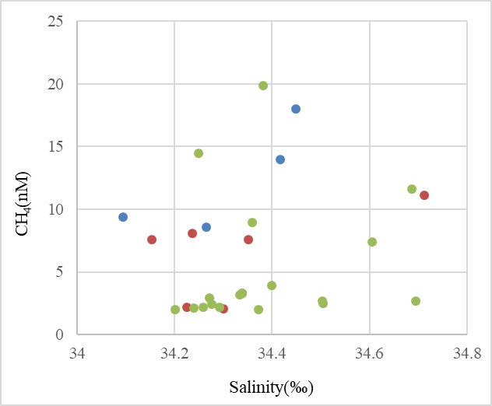

Supplementary Figure S2.
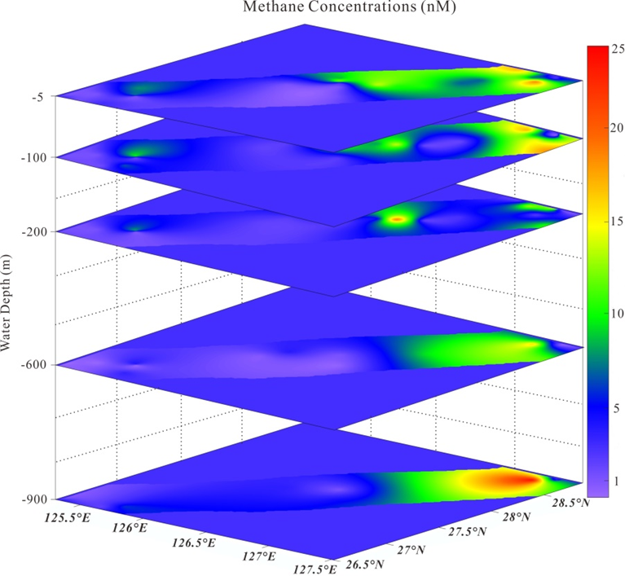

Supplementary Figure S3

