What we do in the shallows:

Natural and anthropogenic seafloor geomorphologies in a drowned river valley, New Zealand

Watson Sally J. ¹, Neil, Helen ¹, Ribó, Marta ², Lamarche, Geoffroy ^{1,2,3}, Strachan Lorna J. ², MacKay, Kevin ¹, Wilcox, Steve ¹, Kane, Tim ¹ Orpin, Alan ¹, Nodder, Scott¹, Pallentin, Arne ¹ & Steinmetz, Tilmann ¹

¹ National Institute of Water and Atmospheric Research (NIWA), Private Bag 14-901, Wellington, New Zealand.
² School of Environment, University of Auckland, Private Bag 92019, Auckland, New Zealand.
³ Now: Office of the Parliamentary Commissioner for the Environment, Wellington, New Zealand.

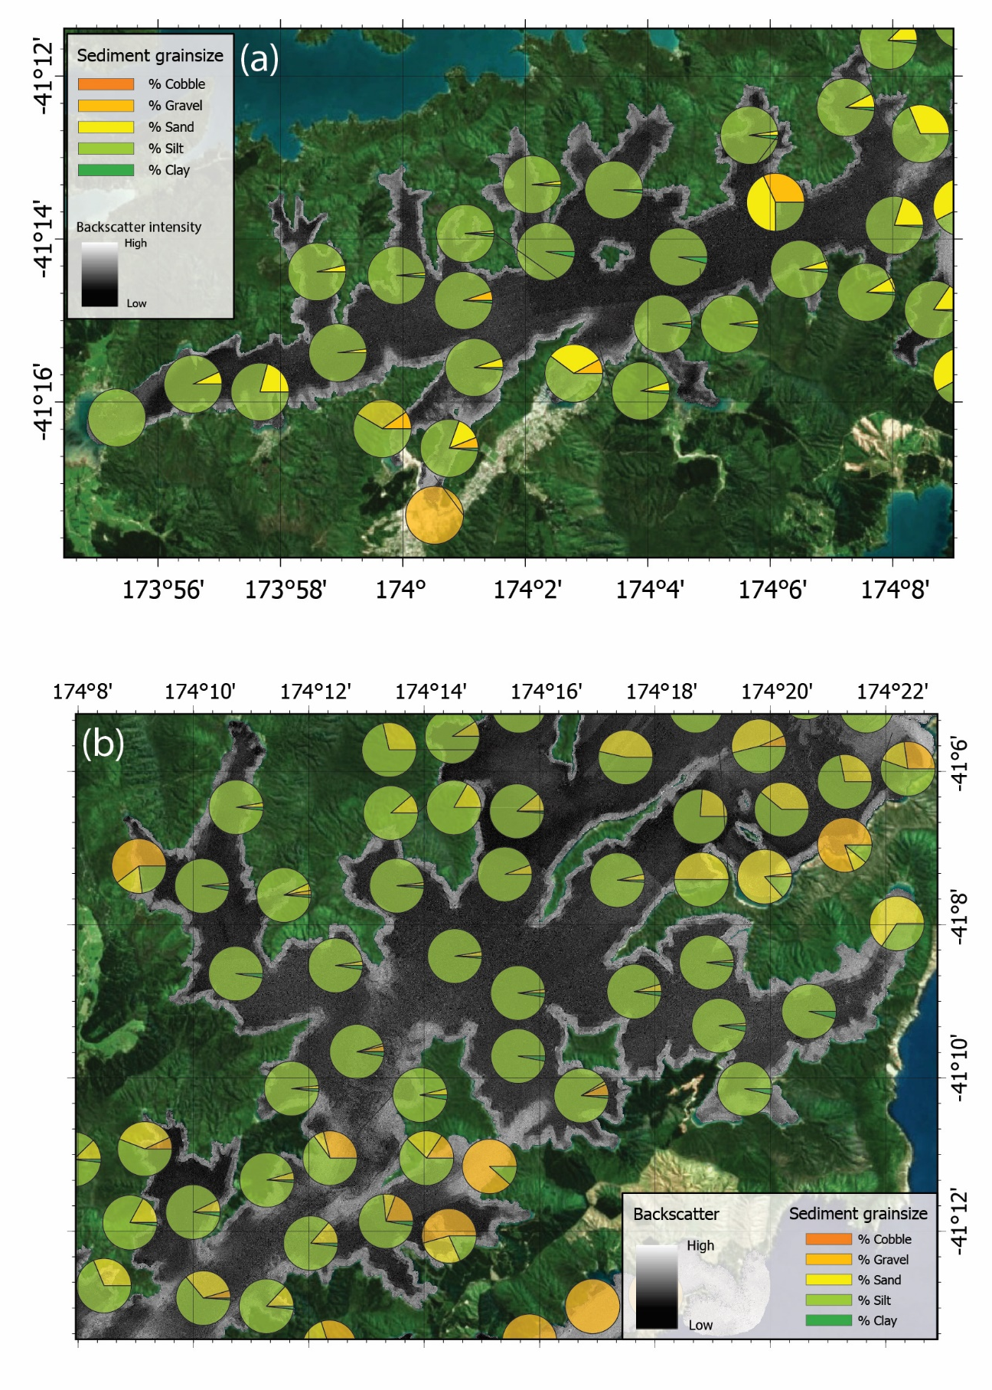
Supplementary material figure 1 – 0.5 m resolution seafloor backscatter mosaic and pie charts showing grainsize distribution for all geologic samples collected in the inner QCS (a), central QCS (b), outer QCS (c), and Tory Channel (d). For locations of each inset, refer to Fig. 1b.

