Supplementary Material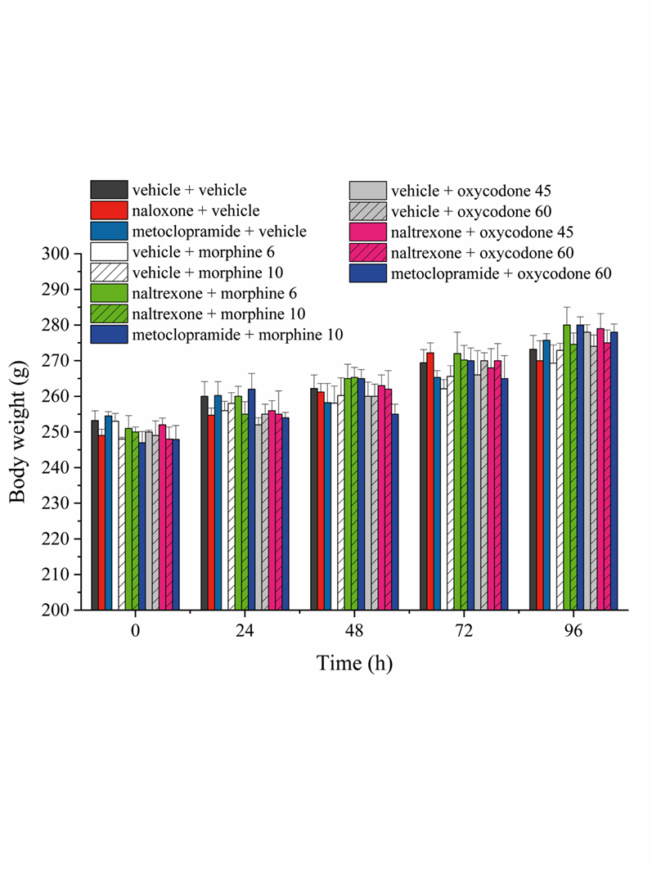
Supplementary Figure 1. Effect of intranasal administration of naltrexone on body weight of morphine and oxycodone treated rats. Animal’s body weight was measured up to 96 h after morphine (6 - 10 mg kg⁻¹) or oxycodone (45 - 60 mg kg⁻¹) administration. Metoclopramide (5 mg kg⁻¹) or naltrexone (1 μg) were administered 30 min before the opioids. Control animals were treated with vehicles. Each value represents the mean of 10 rats per group, performed in two different experimental set.

