**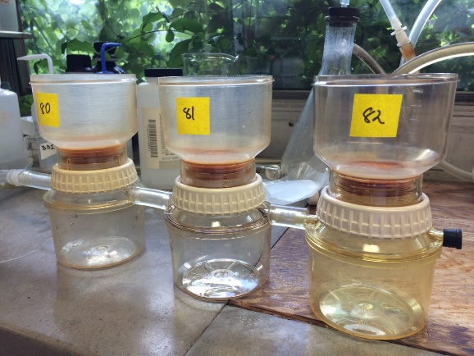**

**Supplementary Figure 1.** The filtering unit used in the P leaching studies. All experiments were conducted in triplicates.

**/Volumes/PATRIOT/XRD biochars/first chapter/Maple-biochar-final.pdf**

**Supplementary Figure 2.** X-ray diffraction pattern of a maple biochar sample. Calcite= CaCO3; Quartz= SiO2

/Volumes/PATRIOT/XRD biochars/first chapter/HWB-final.pdf

**Supplementary Figure 3.**  X-ray diffraction pattern of a hardwood biochar sample. Sylvite = KCl

**/Volumes/PATRIOT/XRD biochars/first chapter/Pine_Biochar-final (1).pdf**

**Supplementary Figure 4** X-ray diffraction pattern of a pine biochar sample.