Personality Traits Modulate the Impact of Emotional Stimuli During a Working Memory Task: A Near-infrared Spectroscopy Study

Supplementary Figures and Tables

Supplementary Figures

Supplementary Tables
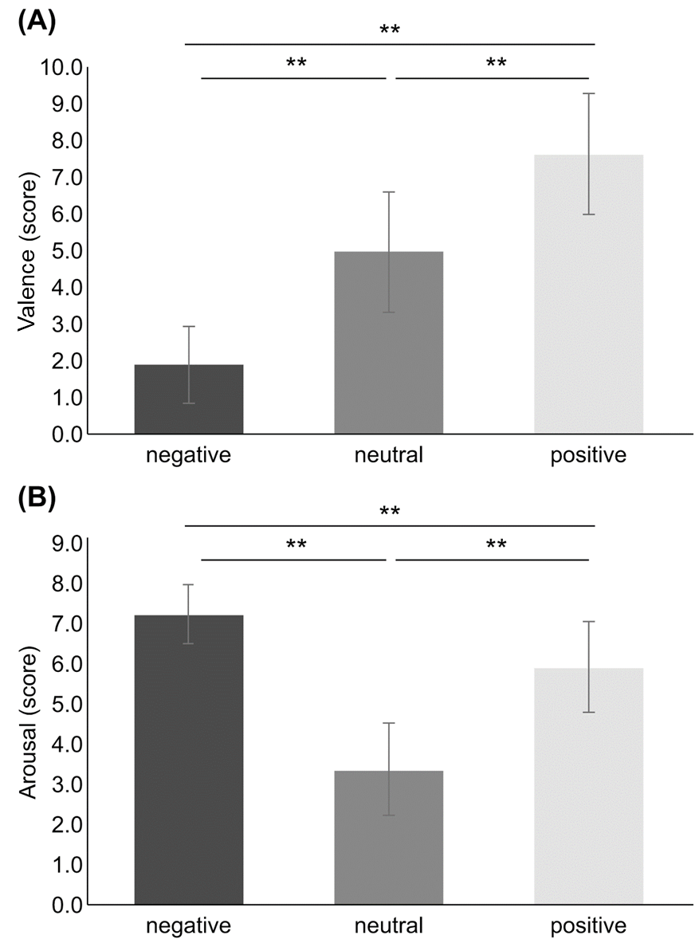
Supplementary Figure 1. Comparison of emotional valence rating and arousal rating among the three emotional valences. (A) Comparison of emotional valence rating among the three emotional valences. (B) Comparison of arousal rating among the three emotional valences. *p < 0.01; **p < 0.001. Error bars indicate standard error.
Supplementary Figure 2. 25 participants were included in SCR analysis because 5 participants were excluded by missing data due to device malfunction. The averaged SCR during picture presentation periods was significantly higher than those during rest periods in every emotional valence (p＜0.01). *p < 0.01. Error bars indicate standard error.
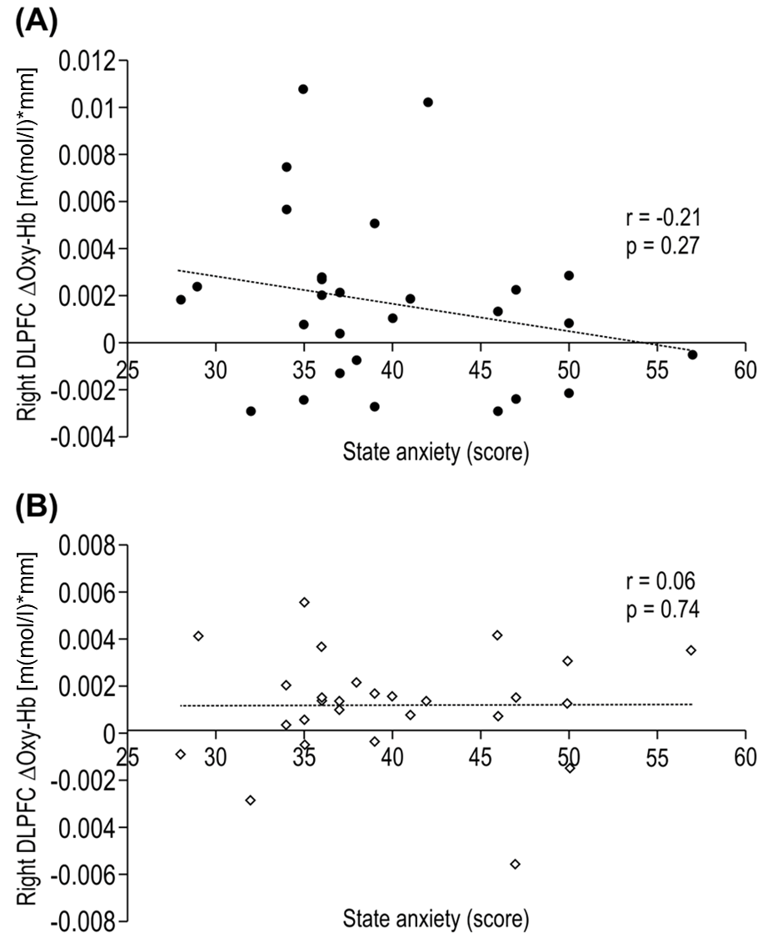
Supplementary Figure 3. Correlation between state anxiety score and Right DLPFC ΔOxy-Hb. No significant correlations were shown in negative valence (A) and positive valence (B).
Supplementary Table
Supplementary Table 1. Emotional images of IAPS selected in the preliminary experiment
Image | Number | Valence | Arousal
Controls for the scaling criteria
Burn Victim (as negative) | 3100 | 1.60 | 6.49
Basket (as neutral) | 7010 | 4.94 | 1.76
Family (as positive) | 2154 | 8.03 | 4.48
Negative images
Burn Victim* | 3053 | 1.31 | 6.91
Headless Body | 3001 | 1.62 | 6.64
Mutilation* | 3069 | 1.70 | 7.03
Vomit | 9325 | 1.89 | 6.01
Cat | 9571 | 1.96 | 5.64
Neutral images
Mug | 7009 | 4.93 | 3.01
Girl* | 2411 | 5.07 | 2.86
Outlet | 6150 | 5.08 | 3.22
Shadow | 2880 | 5.18 | 2.96
Bridge* | 7547 | 5.21 | 3.18
Positive images
Couple | 2530 | 7.80 | 3.99
Children* | 2347 | 7.83 | 5.56
Family* | 2340 | 8.03 | 4.90
Sea | 5825 | 8.03 | 5.46
Puppies | 1710 | 8.34 | 5.41
*Images selected in the preliminary experiment and used in the main experiment.
IAPS: International Affective Picture System

Supplementary Table 2. Montreal Neurological Institute coordinate data in all channels
Channel number | x | y | z
1 | -44.96 | 47.54 | 22.18
2 | -27.54 | 49.79 | 39.18
3 | -51.75 | 36.89 | 20.46
4 | -38.71 | 38.71 | 40.86
5 | -17.21 | 41.00 | 53.43
6 | -46.50 | 28.86 | 40.79
7 | -28.75 | 29.68 | 55.57
8 | -54.54 | 16.18 | 36.11
9 | -41.21 | 18.29 | 56.93
10 | -19.07 | 20.29 | 66.79
11 | -49.29 | 6.36 | 52.50
12 | -31.39 | 8.79 | 66.14
13 | -60.07 | -8.71 | 44.68
14 | -42.36 | -5.57 | 62.96
15 | -19.89 | -3.61 | 74.39
16 | -54.25 | -19.36 | 57.64
17 | -33.50 | -16.71 | 73.00
18 | -63.61 | -33.86 | 46.11
19 | -45.93 | -29.29 | 66.54
20 | -22.11 | -26.68 | 76.04
21 | -55.00 | -44.71 | 54.75
22 | -34.89 | -41.04 | 71.18
23 | 32.71 | 48.75 | 38.86
24 | 47.86 | 46.64 | 24.29
25 | 23.25 | 40.54 | 52.89
26 | 42.25 | 37.96 | 41.29
27 | 54.43 | 35.96 | 23.89
28 | 33.29 | 29.25 | 54.61
29 | 49.11 | 28.82 | 41.75
30 | 23.86 | 20.71 | 65.29
31 | 43.29 | 19.46 | 55.71
32 | 56.32 | 14.86 | 38.64
33 | 33.64 | 10.11 | 64.82
34 | 50.68 | 7.11 | 53.25
35 | 22.21 | -1.89 | 73.57
36 | 43.86 | -4.04 | 63.32
37 | 60.43 | -7.68 | 47.79
38 | 34.61 | -15.36 | 72.68
39 | 53.68 | -17.61 | 59.79
40 | 23.46 | -26.07 | 76.43
41 | 45.50 | -26.54 | 67.43
42 | 63.54 | -31.54 | 50.32
43 | 34.04 | -38.43 | 72.39
44 | 54.46 | -41.14 | 57.25

Supplementary Table 3. Correlation analysis between the BIS/BAS scores and behavioral data and DLPFC activity
 |  | BIS score |  |  | BAS score |  |  | ER |  |  | RT
 |  | r | p |  | r | p |  | r | p |  | r | p
Dual 2-back task | (n = 30)
ER | Negative | -0.042 | 0.828 |  | -0.001 | 0.995
 | Neutral | -0.002 | 0.994 |  | 0.199 | 0.292
 | Positive | 0.026 | 0.891 |  | -0.059 | 0.758
RT | Negative | 0.053 | 0.783 |  | 0.066 | 0.729
 | Neutral | -0.027 | 0.887 |  | 0.111 | 0.560
 | Positive | -0.104 | 0.585 |  | -0.027 | 0.885
DLPFC activity | (n = 28)
Left | negative | -0.045 | 0.820 |  | -0.180 | 0.359 |  | 0.161 | 0.414 |  | 0.107 | 0.588
 | neutral | -0.101 | 0.610 |  | 0.167 | 0.395 |  | 0.301 | 0.119 |  | 0.232 | 0.235
 | positive | 0.031 | 0.876 |  | -0.019 | 0.925 |  | 0.048 | 0.810 |  | 0.105 | 0.593
Right | negative | 0.173 | 0.379 |  | -0.068 | 0.733 |  | 0.095 | 0.631 |  | 0.043 | 0.828
 | neutral | -0.004 | 0.983 |  | 0.131 | 0.506 |  | -0.273 | 0.160 |  | -0.245 | 0.209
 | positive | 0.192 | 0.328 |  | -0.192 | 0.328 |  | -0.052 | 0.794 |  | 0.037 | 0.851
BIS: behavioral inhibition system, BAS: behavioral activation system, DLPFC: dorsolateral prefrontal cortex, ER: error rate, RT: reaction time

