Supplementary Material

Microscale Self-assembly of Upconversion Nanoparticles Driven by Block Copolymer
Qianqian Su^{1,2,#,}*, Meng-Tao Zhou^{1,#}, Ming-Zhu Zhou¹, Qiang Sun³, Taotao Ai⁴, Yan Su^{5,}*

¹Institute of Nanochemistry and Nanobiology, Shanghai University, Shanghai 200444, China
²Department of Chemistry, National University of Singapore, Singapore 117543, Singapore
³Center for Functional Materials, NUS (Suzhou) Research Institute, Suzhou, Jiangsu 215123, China
⁴National and Local Joint Engineering Laboratory for Slag Comprehensive Utilization and Environmental Technology, School of Materials Science and Engineering, Shaanxi University of Technology, Hanzhong, Shaanxi 723000, China
⁵Genome Institute of Singapore, Agency of Science Technology and Research, 138672, Singapore

*Correspondence: Corresponding Authors: chmsqq@shu.edu.cn (Q. Su) and suy1@gis.a-star.edu.sg (Y. Su)
#These authors contributed equally.

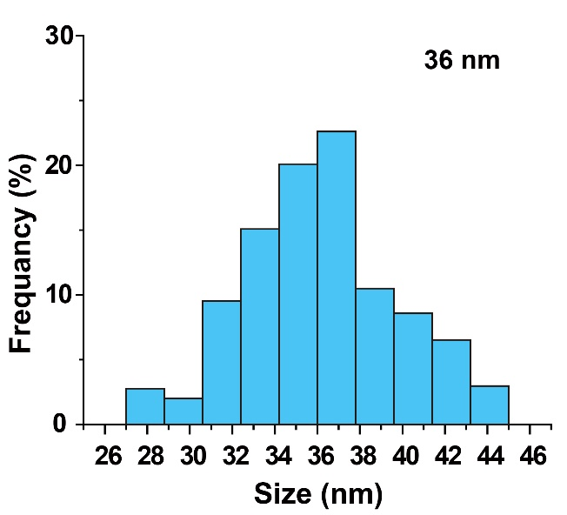
Figure S1. Size distribution of NaYF₄:Yb,Tm@NaYF₄ nanoparticles.

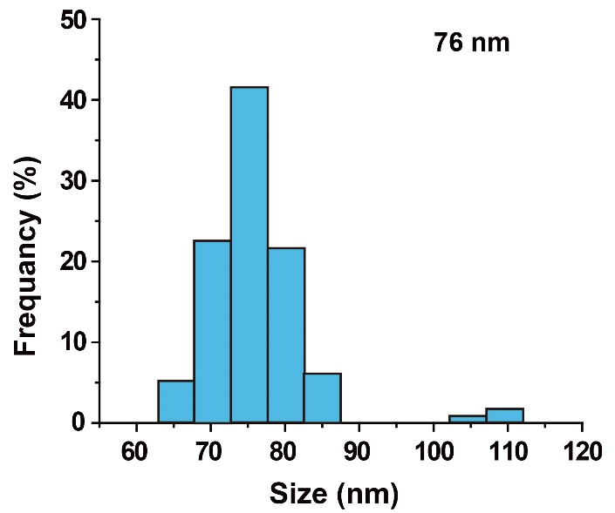
Figure S2. Size distribution of NaYF₄:Yb,Tm@NaYF₄@SiO₂ (UCNP_{Tm}@SiO₂) nanoparticles.

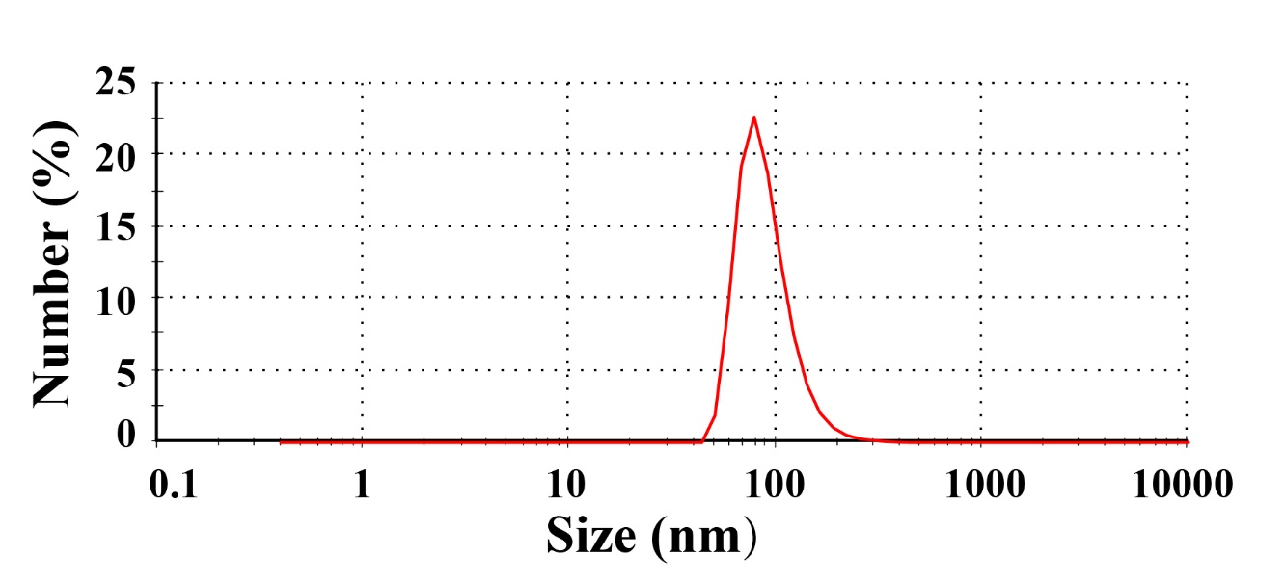
Figure S3. Dynamic light scattering (DLS) of UCNP_{Tm}@SiO₂ nanoparticles in water.

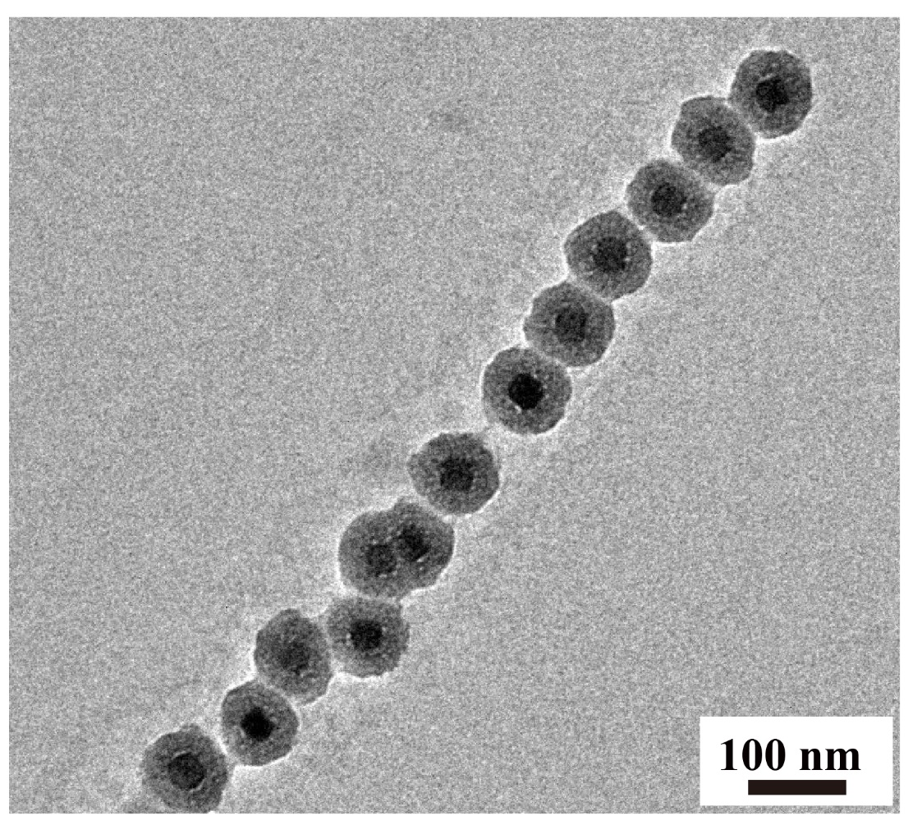
Figure S4. TEM images of the as-prepared UCNP_{Tm}@SiO₂ nanoparticle chain mediated by F127 for 12 hours.
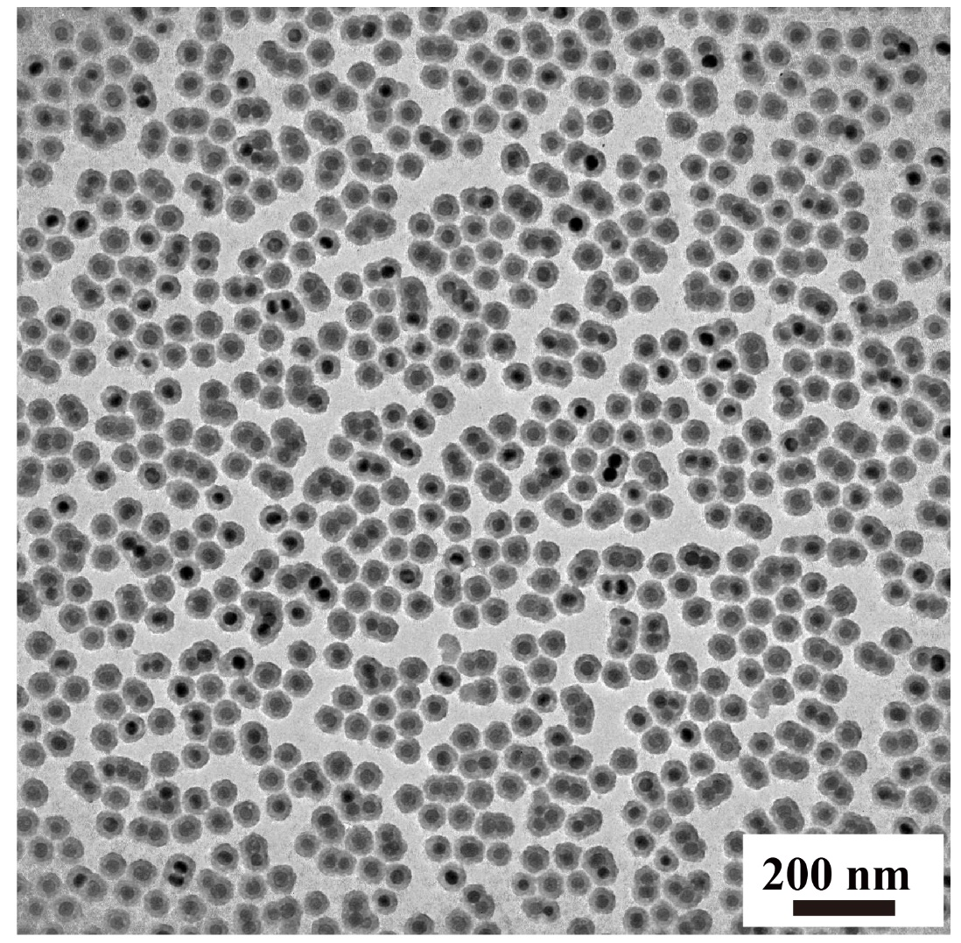
Figure S5. TEM images of the as-prepared UCNP_{Tm}@SiO₂ nanoparticles incubated in water without F127.

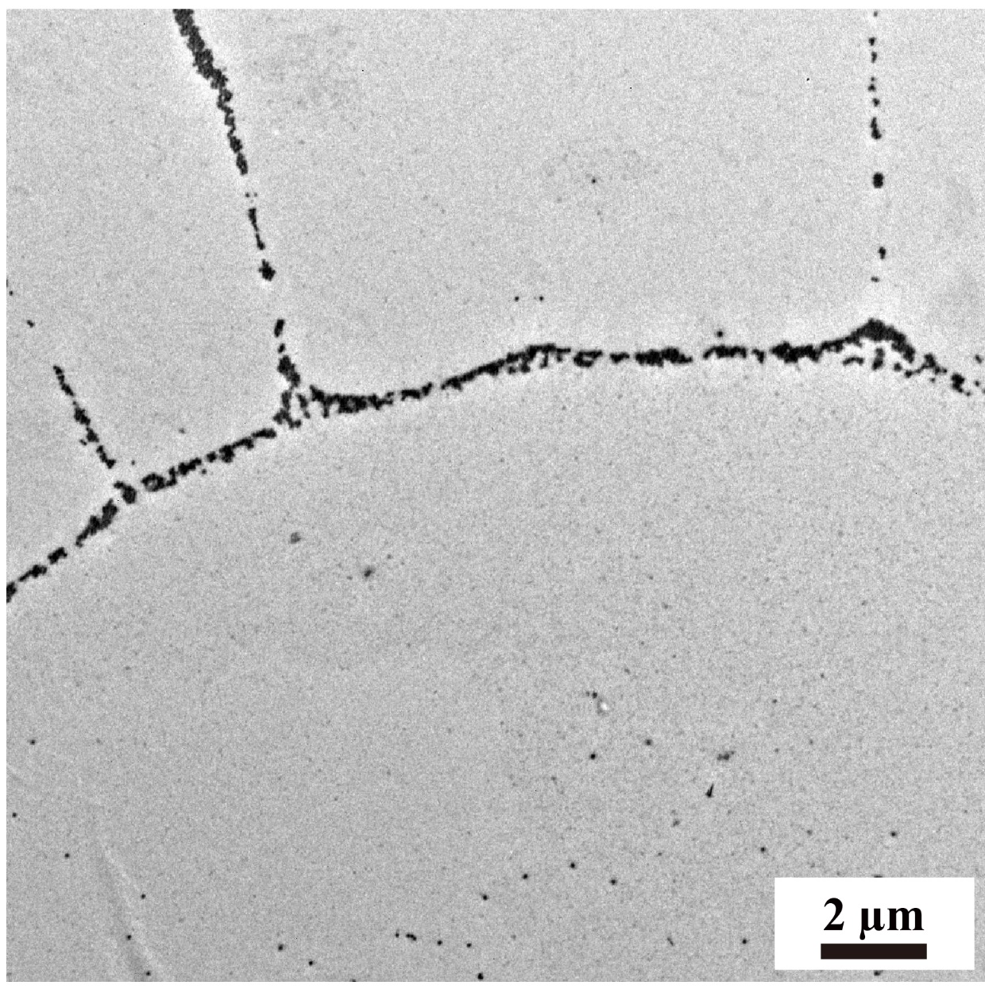
Figure S6. TEM demonstrated the existence of Y-junctions of UCNP_{Tm}@SiO₂ assemblies incubated with F127 mediation for 24 hours.

