Supplementary data
Table 1
MRSA strains: Two-way ANOVA on CFU counts
Strains | Source | DF | SS | MS | F | P value
ATCC 33591 | Reincubation | 3 | 40.79 | 13.6 | F (3, 24) = 52.64 | P<0.001
 | Pulsed-Lavage | 1 | 84.16 | 84.16 | F (1, 24) = 325.8 | P<0.001
 | Interaction | 3 | 38.59 | 12.86 | F (3, 24) = 49.81 | P<0.001
 | Residuals | 24 | 6.199 | 0.2583
 | Total | 31 | 169.7
676 | Reincubation | 3 | 25.13 | 8.378 | F (3, 24) = 54.87 | P<0.001
 | Pulsed-Lavage | 1 | 79.84 | 79.84 | F (1, 24) = 522.9 | P<0.001
 | Interaction | 3 | 31.14 | 10.38 | F (3, 24) = 67.98 | P<0.001
 | Residuals | 24 | 3.664 | 0.1527
 | Total | 31 | 139.8
749 | Reincubation | 3 | 28.56 | 9.522 | F (3, 24) = 43.72 | P<0.001
 | Pulsed-Lavage | 1 | 74.2 | 74.2 | F (1, 24) = 340.7 | P<0.001
 | Interaction | 3 | 25.43 | 8.478 | F (3, 24) = 38.92 | P<0.001
 | Residuals | 24 | 5.227 | 0.2178
 | Total | 31 | 133.4
DF : degrees of freedom ; SS : sum of squares ; MS : mean square

Table 2
MSSA strains: Two-way ANOVA on CFU counts
Strains | Source | DF |  | SS |  | MS |  | F |  | P value
ATCC 25923 | Reincubation | 3 | 104.7 |  | 34.91 |  | F (3, 24) = 60.24 |  | P<0.001
 | Pulsed-Lavage | 1 | 48.77 |  | 48.77 |  | F (1, 24) = 84.15 |  | P<0.001
 | Interaction | 3 | 24.46 |  | 8.155 |  | F (3, 24) = 14.07 |  | P<0.001
 | Residuals | 24 | 13.91 |  | 0.5796
 | Total | 31 | 191.9
578 | Reincubation | 3 | 49.93 |  | 16.64 |  | F (3, 24) = 42.52 |  | P<0.001
 | Pulsed-Lavage | 1 | 81.59 |  | 81.59 |  | F (1, 24) = 208.5 |  | P<0.001
 | Interaction | 3 | 28.24 |  | 9.413 |  | F (3, 24) = 24.05 |  | P<0.001
 | Residuals | 24 | 9.394 |  | 0.3914
 | Total | 31 | 169.2
611 | Reincubation | 3 | 73.75 |  | 24.58 |  | F (3, 24) = 79.85 |  | P<0.001
 | Pulsed-Lavage | 1 | 81.52 |  | 81.52 |  | F (1, 24) = 264.8 |  | P<0.001
 | Interaction | 3 | 26.47 |  | 8.825 |  | F (3, 24) = 28.67 |  | P<0.001
 | Residuals | 24 | 7.388 |  | 0.3079
 | Total | 31 | 189.1
DF : degrees of freedom ; SS : sum of squares ; MS : mean square

Table 3
MRSA strains: Two-way ANOVA on biomass
Strains | Source | DF | SS | MS | F | P value
ATCC 33591 | Reincubation | 3 | 38282 | 12761 | F (3, 24) = 14.85 | P<0.001
 | Pulsed-Lavage | 1 | 33695 | 33695 | F (1, 24) = 39.21 | P<0.001
 | Interaction | 3 | 16838 | 5613 | F (3, 24) = 6.532 | P=0.002
 | Residuals | 24 | 20622 | 859.2
 | Total | 31 | 109437
676 | Reincubation | 3 | 21349 | 7116 | F (3, 24) = 51.32 | P<0.001
 | Pulsed-Lavage | 1 | 38133 | 38133 | F (1, 24) = 275 | P<0.001
 | Interaction | 3 | 9099 | 3033 | F (3, 24) = 21.87 | P<0.001
 | Residuals | 24 | 3328 | 138.7
 | Total | 31 | 71909
749 | Reincubation | 3 | 22114 | 7371 | F (3, 24) = 41.31 | P<0.001
 | Pulsed-Lavage | 1 | 37638 | 37638 | F (1, 24) = 210.9 | P<0.001
 | Interaction | 3 | 12613 | 4204 | F (3, 24) = 23.56 | P<0.001
 | Residuals | 24 | 4283 | 178.4
 | Total | 31 | 76649
DF : degrees of freedom ; SS : sum of squares ; MS : mean square

Table 4
MSSA strains: Two-way ANOVA on biomass
Strains | Source | DF | SS | MS | F | P value
ATCC 25923 | Reincubation | 3 | 128267 | 42756 | F (3, 24) = 44.43 | P<0.001
 | Pulsed-Lavage | 1 | 14610 | 14610 | F (1, 24) = 15.18 | P<0.001
 | Interaction | 3 | 15854 | 5285 | F (3, 24) = 5.492 | P=0.005
 | Residuals | 24 | 23093 | 962.2
 | Total | 31 | 181825
578 | Reincubation | 3 | 22625 | 7542 | F (3, 24) = 138.1 | P<0.001
 | Pulsed-Lavage | 1 | 50168 | 50168 | F (1, 24) = 918.5 | P<0.001
 | Interaction | 3 | 6500 | 2167 | F (3, 24) = 39.67 | P<0.001
 | Residuals | 24 | 1311 | 54.62
 | Total | 31 | 80603
611 | Reincubation | 3 | 20168 | 6723 | F (3, 24) = 60.51 | P<0.001
 | Pulsed-Lavage | 1 | 32823 | 32823 | F (1, 24) = 295.4 | P<0.001
 | Interaction | 3 | 10358 | 3453 | F (3, 24) = 31.08 | P<0.001
 | Residuals | 24 | 2667 | 111.1
 | Total | 31 | 66016
DF : degrees of freedom ; SS : sum of squares ; MS : mean square

Figure 1
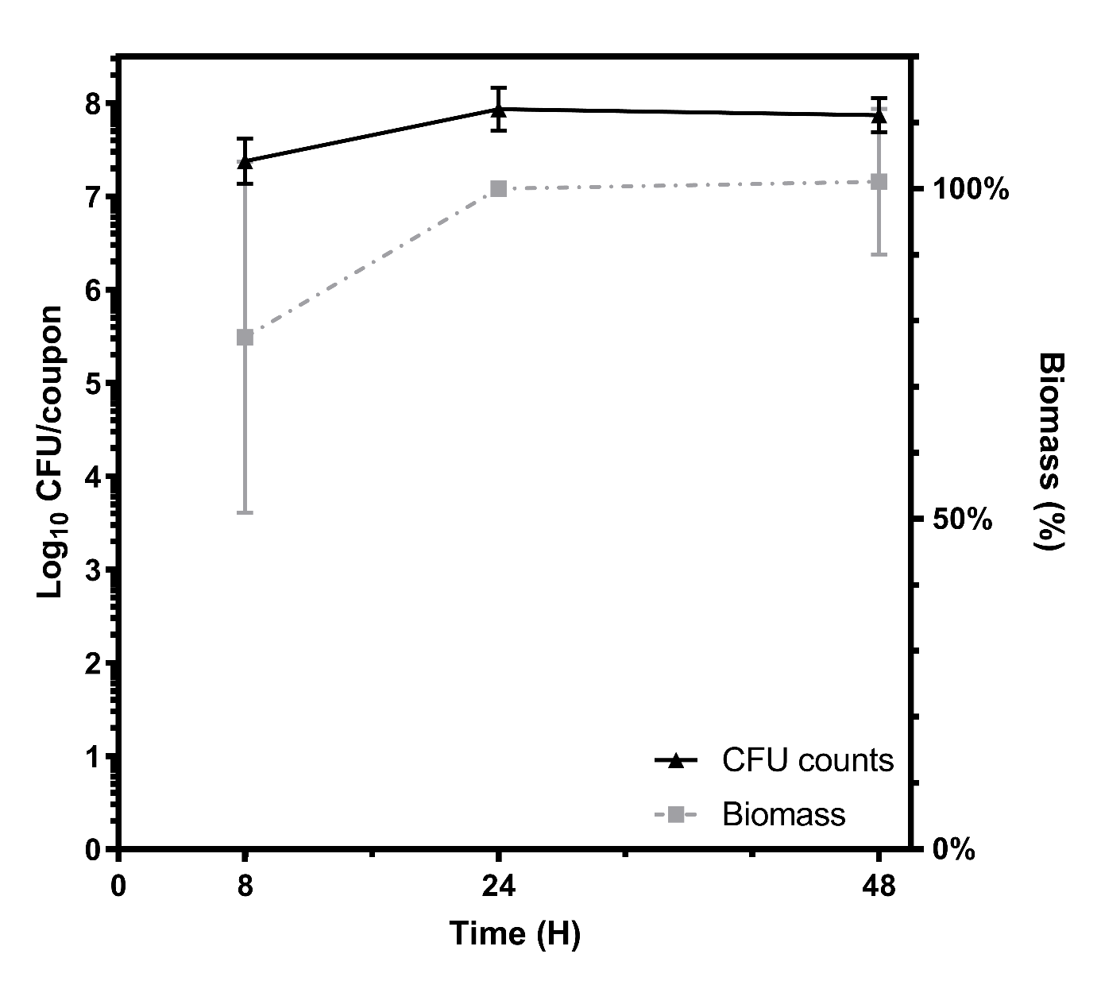
Growth of ATCC 33591 biofilms on Ti6Al4V coupons over time. CFU counts (triangles, black) expressed in logarithm (left axis), biomass (squares, grey), expressed in percentage of 24h biofilms biomass (right axis). Data expressed as means of 3 experiments and SEM.

