Supporting Information for:

Bumble bees (Hymenoptera: Apidae) respond to moth (Lepidoptera: Noctuidae) pheromone components, leading to bee bycatch in monitoring traps targeting moth pests
Nicholas L. Grocock^{1*}, Ronald E. Batallas¹, Emily A. McNamara¹, Ashton B. Sturm¹, Jessamyn S. Manson^{1,2}, Maya L. Evenden¹
¹ Department of Biological Sciences, CW405 Biological Sciences Building, University of Alberta, Edmonton, AB, Canada
² Department of Biology, 229 Gilmer Hall, University of Virginia, Charlottesville, VA, USA

*Correspondence author.
Nicholas L. Grocock
Email: grocock@ualberta.ca

Supplementary Methods:
Morphometric measurements:
After bee identification, morphometric measurements were taken for each female Bombus rufocinctus to distinguish between worker and queen females in the bycatch. Intertegular length is a robust estimate of body size (Cane, 1987; Greenleaf et al., 2007) and was measured as the distance between the wing bases using a stereomicroscope equipped with an ocular micrometer at 12x magnification (Wild Heerbrugg, Switzerland). Wing measurements were completed by processing scanned images with ImageJ (Rasband, 2017) to measure forewing length, forewing area, and the radial cell length on the forewing. All wing measurements were performed on the right forewing; the left forewing was used if the right was missing or damaged.

Table S1. Site locations for seven study sites in central Alberta, Canada.
County | Site | Field | Coordinates | 2014 | 2015 | 2016
Leduc | 1 | A | 53.23790 N 113.34226 W | Canola | Wheat | Canola
 |  | B | 53.24722 N 113.34219 W | Wheat | Canola | Wheat
 | 2 | A | 53.28640 N 113.87867 W | Canola | Wheat | Canola
 |  | B | 53.27595 N 113.85422 W | Wheat | Canola | Wheat
Parkland | 3 | A | 53.44492 N 113.71344 W | Canola | Wheat | Canola
 |  | B | 53.43946 N 113.71339 W | Wheat | Canola | Wheat
Barrhead | 4 | A | 54.07452 N 114.37685 W | Canola | Wheat | Canola
 |  | B | 54.05627 N 114.34988 W | Wheat | Canola | Wheat
 | 5 | A | 54.30392 N 114.47681 W | Canola | Wheat | Canola
 |  | B | 54.34530 N 114.47697 W | Wheat | Canola | Wheat
Wainwright | 6 | A | 52.95971 N 111.43202 W | Canola | Wheat | Canola
 |  | B | 52.95963 N 111.43922 W | Wheat | Canola | Wheat
 | 7 | A | 52.90159 N 110.56340 W | Canola | Wheat | Canola
 |  | B | 52.88453 N 110.60859 W | Wheat | Canola | Wheat

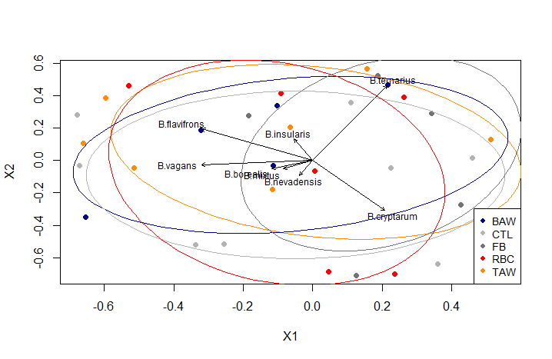
Figure S1. Non-metric multidimensional scaling (NMDS) ordination for bumble bee (Bombus spp.) species, excluding B. rufocinctus, captured as bycatch in non-saturating green-coloured Unitraps during the 2014 field season. Only Bombus spp. with ≥1 individual captured were included. Differences were assessed across five lure types: food bait (FB; acetic acid + 3-methyl-1-butanol), redbacked cutworm (RBC; Euxoa ochrogaster [Guenée]), bertha armyworm (BAW; Mamestra configurata Walker), true armyworm (TAW; Mythimna unipuncta [Haworth]), and an unbaited control (CTL).

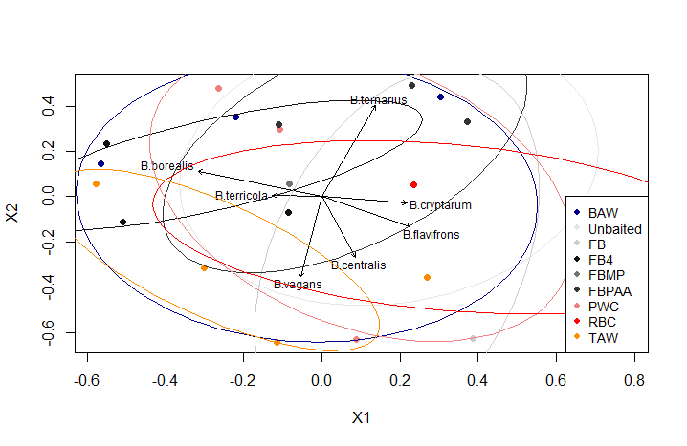
Figure S2. Non-metric multidimensional scaling (NMDS) ordination for bumble bee (Bombus spp.) species, excluding B. rufocinctus, captured as bycatch in non-saturating green-coloured Unitraps during the 2015 field season. Only Bombus spp. with ≥1 individual captured were included. Differences were assessed across nine lure types: FB (acetic acid + 3-methyl-1-butanol), FBMP (acetic acid + 3-methyl-1-butanol + 2-methyl-1-propanol), FMPAA (acetic acid + 3-methyl-1-butanol + phenylacetaldehyde), FB4 (acetic acid + 3-methyl-1-butanol + 2-methyl-1-propanol + phenylacetaldehyde), redbacked cutworm (RBC; Euxoa ochrogaster [Guenée]), bertha armyworm (BAW; Mamestra configurata Walker), true armyworm (TAW; Mythimna unipuncta [Haworth]), pale western cutworm (PWC; Agrotis orthogonia [Morrison]),and an unbaited control.

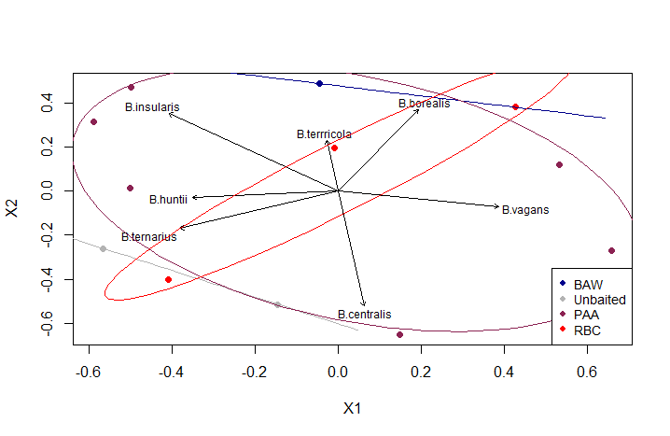
Figure S3. Non-metric multidimensional scaling (NMDS) ordination for bumble bee (Bombus spp.) species, excluding B. rufocinctus, captured as bycatch in non-saturating green-coloured Unitraps during the 2016 field season. Only Bombus spp. with ≥1 individual captured were included. Differences were assessed across four lure types: phenylacetaldehyde, redbacked cutworm (RBC; Euxoa ochrogaster [Guenée]), bertha armyworm (BAW; Mamestra configurata Walker), and an unbaited control.

Figure S4. Non-metric multidimensional scaling (NMDS) ordination for bumble bee (Bombus spp.) species, excluding B. rufocinctus, captured as bycatch in non-saturating green-coloured Unitraps during the 2014 field season. Only Bombus spp. with ≥1 individual captured were included. Differences were assessed across two crop types: canola and wheat.
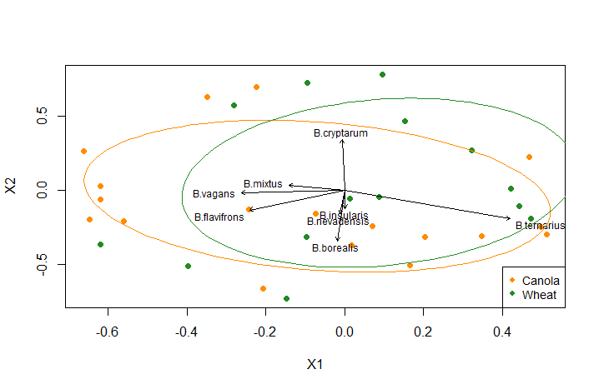

Figure S5. Non-metric multidimensional scaling (NMDS) ordination for bumble bee (Bombus spp.) species, excluding B. rufocinctus, captured as bycatch in non-saturating green-coloured Unitraps during the 2015 field season. Only Bombus spp. with ≥1 individual captured were included. Differences were assessed across two crop types: canola and wheat.

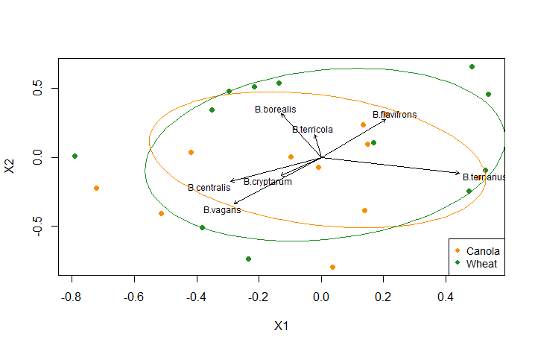
Figure S6. Non-metric multidimensional scaling (NMDS) ordination for bumble bee (Bombus spp.) species, excluding B. rufocinctus, captured as bycatch in non-saturating green-coloured Unitraps during the 2016 field season. Only Bombus spp. with ≥1 individual captured were included. Differences were assessed across two crop types: canola and wheat.
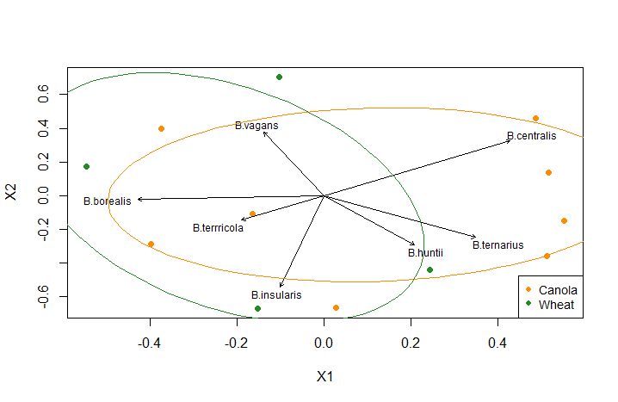

Literature cited
Cane, J.H. (1987). Estimation of bee size using intertegular span (Apoidea). Journal of the Kansas Entomological Society, 145-147.
Greenleaf, S.S., Williams, N. M., Winfree, R., & Kremen, C. (2007). Bee foraging ranges and their relationship to body size. Oecologia, 153(3), 589-596.
Rasband, W.S. (2017). Image Processing and Analysis in Java (Image J), US National Institutes of Health, Bethesda, Maryland USA.

