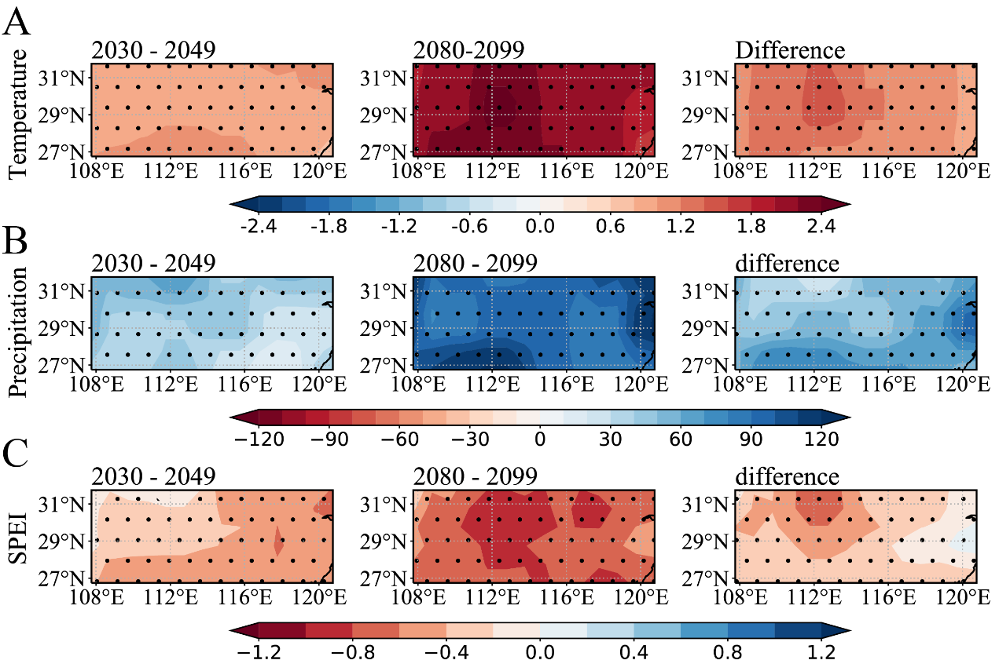
Figure S1. (A) Surface air temperature, (B) precipitation, (C) SPEI changes across the Yangtze River Basin based on MME during the periods 2030‒2049 (the left column) and 2080‒2099 (the middle column), in comparison with the historical mean (1999–2018), and the differences between the two periods (the right column). The dotted regions represent that there are more than three models showing the same sign.

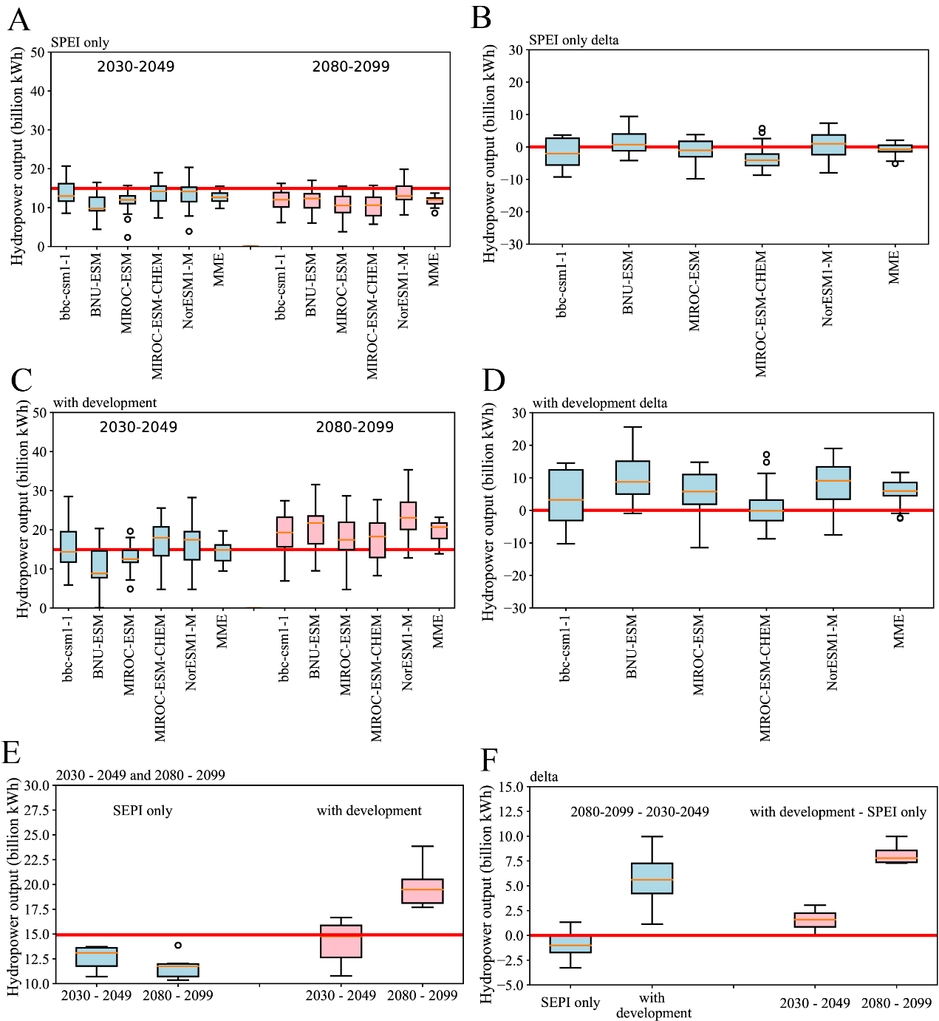
Figure S2. The projection of hydropower capacity of each chosen model over the Yangtze River Basin during the periods 2030‒2049 and 2080‒2099 when (A) only the meteorological conditions are considered and (B) the differences between the two periods. (C) and (D) are the same as (A) and (B), but take the joint effect of meteorological conditions and the development of hydropower stations into account (E) The prediction of mean hydropower capacity in Zhejiang Province during the periods 2030‒2049 and 2080‒2099 when only the meteorological conditions are considered (blue) and considering the joint effect of meteorological condition and the development of the hydropower stations (pink). (F) The differences between the periods 2080‒2099 and 2030‒2049 (blue) and the effects of considering the development of hydropower stations (pink). The red lines indicate the historical mean (1999‒2018) of hydropower capacity in Zhejiang Province in (A, C, E) and indicate the zero lines in (B, D, F).

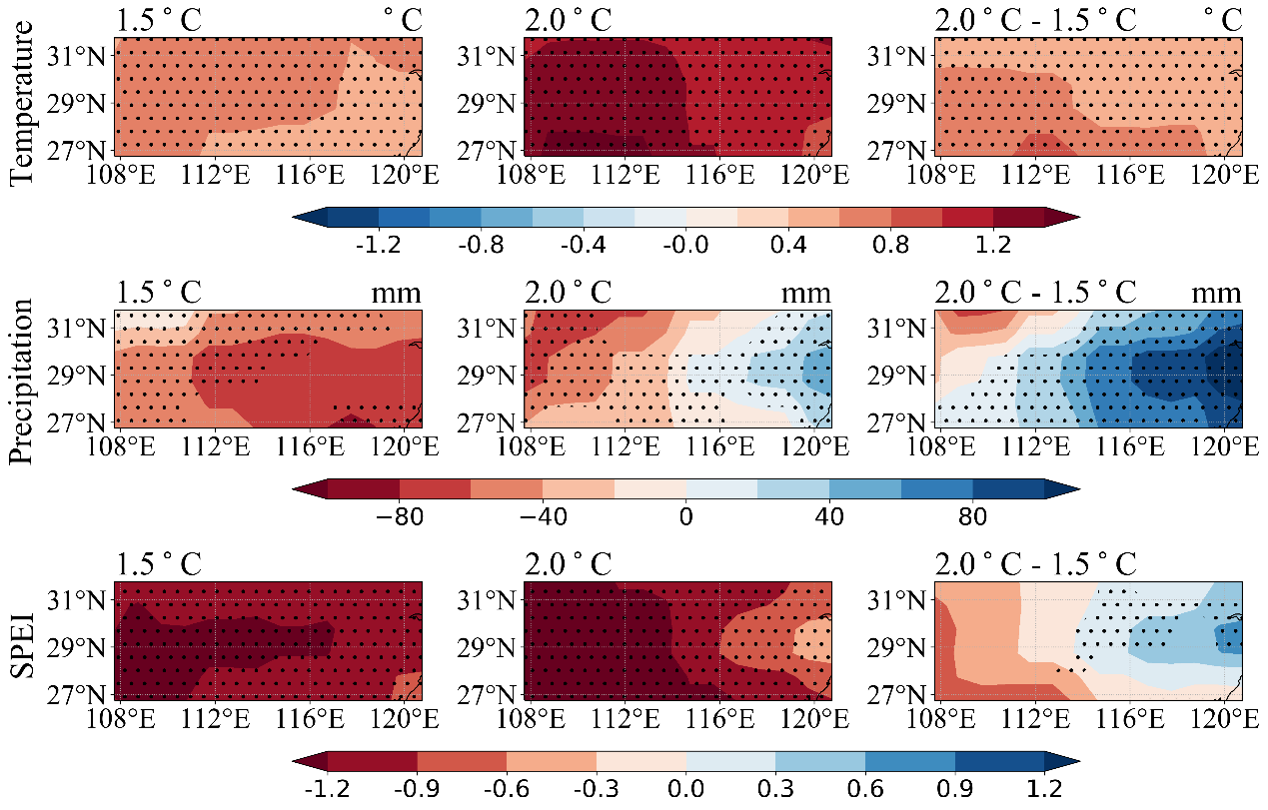
Figure S3. Same as FIGURE S1, but for RCP8.5
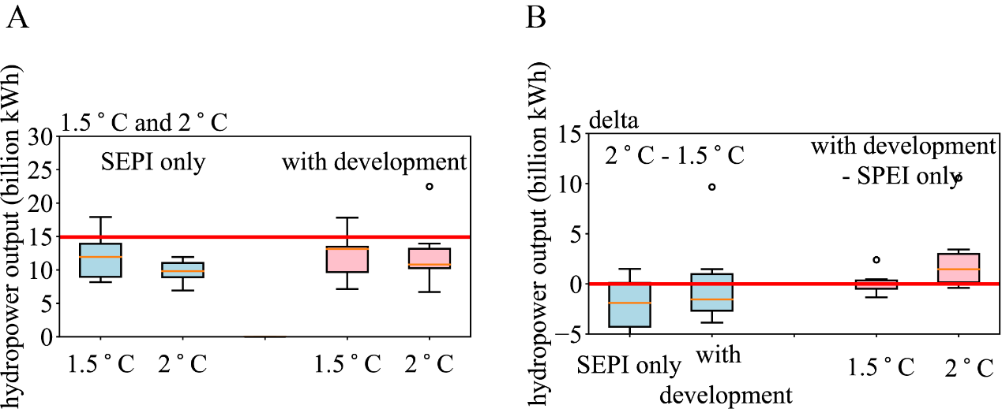
Figure S4. Same as Figure S2 (E and F), but for RCP8.5

Table S1. The projection of hydropower capacity over 1.5°C and 2°C warming targets when only the meteorological conditions are considered and considering the joint effect of meteorological conditions and the development of hydropower stations , and their differences. Asterisks stand for the joint effect, and “MME-14.92” represents the anomaly).
 | 1.5℃ | 2.0℃ | Diff | 1.5℃* | 2.0℃* | Diff*
bcc-csm1-1 | 17.80 | 12.96 | -4.85 | 17.91 | 15.42 | -2.49
BNU-ESM | 13.49 | 13.43 | -0.06 | 13.49 | 13.67 | 0.18
MIROC-ESM | 13.06 | 12.71 | -0.35 | 14.41 | 13.70 | -0.71
MIROC-ESM-CHEM | 12.49 | 14.74 | 2.25 | 13.82 | 18.79 | 4.97
NorESM1-M | 15.72 | 13.72 | -2.00 | 19.83 | 21.49 | 1.66
MME | 14.58 | 13.69 | -0.90 | 14.64 | 16.03 | 1.40
MME-14.92 | -0.34 | -1.23 |  | -0.28 | 1.11

Table S2. The intensity of SPEI over 1.5°C and 2°C warming targets and their differences.
 | 1.5℃ | 2.0℃ | Diff
bcc-csm1-1 | 0.01 | -0.35 | -0.36
BNU-ESM | -0.44 | -0.27 | 0.18
MIROC-ESM | -0.33 | -0.39 | -0.06
MIROC-ESM-CHEM | -0.79 | -0.03 | 0.76
NorESM1-M | 0.14 | -0.22 | -0.36
MME | -0.35 | -0.43 | -0.09

Table S3. Same as Table S1, but during the periods 2030‒2049 and 2080‒2099. “MME-14.92” represents the anomaly. Asterisks stand for the joint effect。
 | 2030‒2049 | 2080‒2099 | Diff | 2030‒2049* | 2080‒2099* | Diff*
bcc-csm1-1 | 13.72 | 11.79 | -1.93 | 15.34 | 19.12 | 3.77
BNU-ESM | 10.71 | 12.04 | 1.33 | 10.78 | 20.74 | 9.96
MIROC-ESM | 11.49 | 10.41 | -1.08 | 12.12 | 17.70 | 5.58
MIROC-ESM-CHEM | 13.61 | 10.35 | -3.26 | 16.65 | 17.78 | 1.13
NorESM1-M | 13.59 | 13.87 | 0.28 | 16.05 | 23.85 | 7.80
MME | 12.63 | 11.69 | -0.93 | 14.19 | 19.84 | 5.65
MME-14.92 | -2.29 | -3.23 |  | -0.73 | 4.92

Table S4. The frequency of drought events during the periods 2030‒2049 and 2080‒2099.
 | 2030-2049 | 2080-299 | Once every () year
 |  |  | 2030-2049 | 2080-2099
SPEI<-0.5 | 13 | 19 | 1.54 | 1.05
SPEI<-1.0 | 6 | 12 | 3.33 | 1.67
SPEI<-1.5 | 2 | 3 | 10 | 6.67

