Supplementary Material

Carbonyl index method
Carbonyl and hydroxyl species are formed during degradation of polymers. To quantify the degree of change in PE, polyester and PS microplastics (MPs) the carbonyl index (COI), the ratio of absorbance of carbonyl group to a reference peak, was calculated.
PE
For PE the ratio of the integrated area of carbonyl absorbance at 1737 cm⁻¹ (range 1775-1715 cm⁻¹) to the methylene peak at 1469 cm⁻¹ (range 1507-1407 cm⁻¹) (Canopoli et al., 2020), was calculated (COI =A₁₇₃₇/A₁₄₆₉).
Polyester
For polyester the COI was established from the ratio of the carbonyl absorbance at 1713 cm⁻¹ (1775-1633 range cm⁻¹) and the C-H aromatic ring at 724 cm⁻¹ (range 755-640 cm⁻¹) (Ueland et al., 2017) (COI =A₁₇₁₃/A₇₂₄).
PS
For PS the COI was established from the ratio of the carbonyl at 1745 cm⁻¹ (range 1780-1475 cm⁻¹) and the symmetric CH₂ stretching band at 2851 cm⁻¹ (range 2868-2777cm⁻¹) (Mylläri et al., 2015) (COI =A₁₇₄₅/A₂₈₅₁).
Rayon
For rayon, the absorbances at 1420 cm⁻¹ and 1346 cm⁻¹ (1544-1210 cm⁻¹) and 893 cm⁻¹ (range 917-868 cm⁻¹) broaden as a result of degradation (i.e. from oxidation (Fan et al., 2012; Khiari et al., 2017) and are used to determine the crystallinity index (CI) (CI =A₈₉₃/A₁₄₂₀₊₁₃₄₆) (Comnea-Stancu et al., 2016).
Data analysis
CI and COI’s of the non-treated virgin MPs and MPs exposed to EtOH were compared using Mann-Whitney U tests (two tailed, P<0.05) (GraphPad Prism 8.4.3).

Supplementary Figures
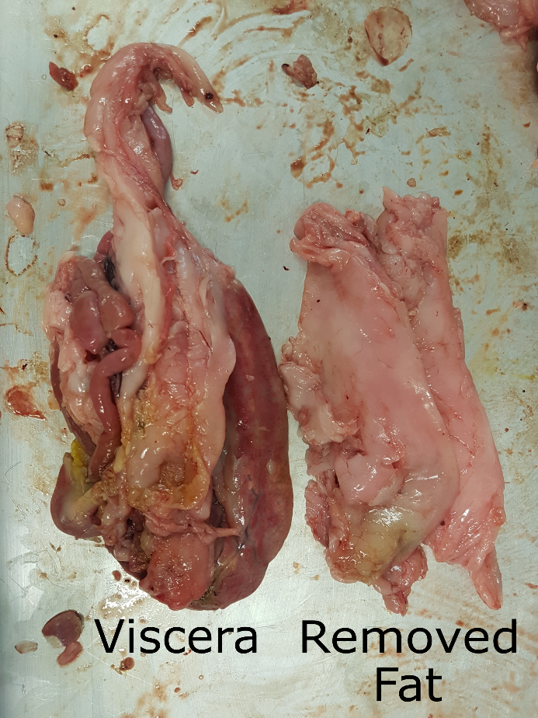
Supplementary Figure 1. Viscera from farmed barramundi, Lates calcarifer. Excess solid lipid (fat) deposits removed from Experiment C viscera, note a substantial amount of solid lipid (fat) remains attached to the viscera

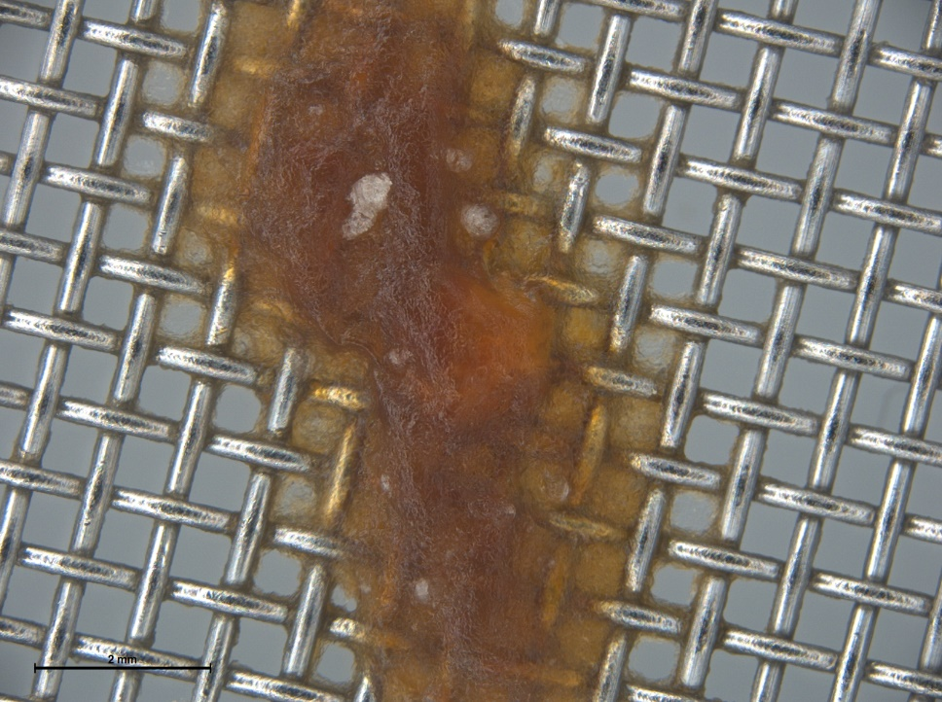
Supplementary Figure 2. A droplet of KOH saponified gel, resulting from 10% KOH digestion of viscera from farmed barramundi (Lates calcarifer). Despite vacuum filtration being applied, the droplet did not pass through the filter (547 µm).

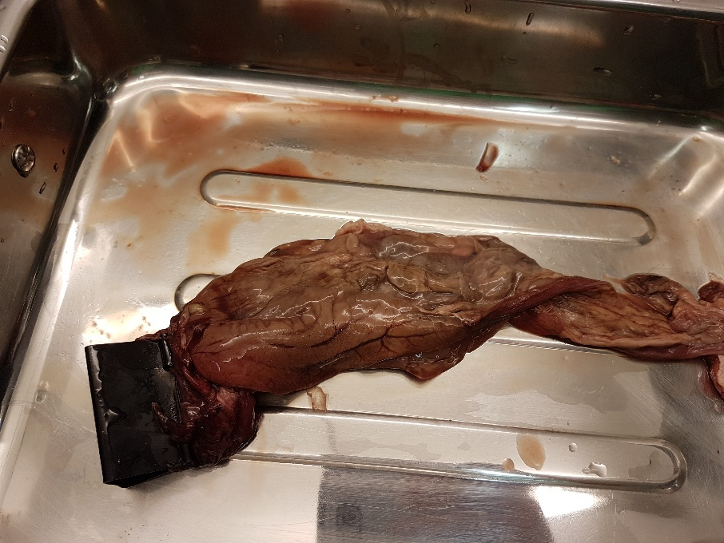
Supplementary Figure 3. Viscera of wild Barramundi with limited fat deposits.

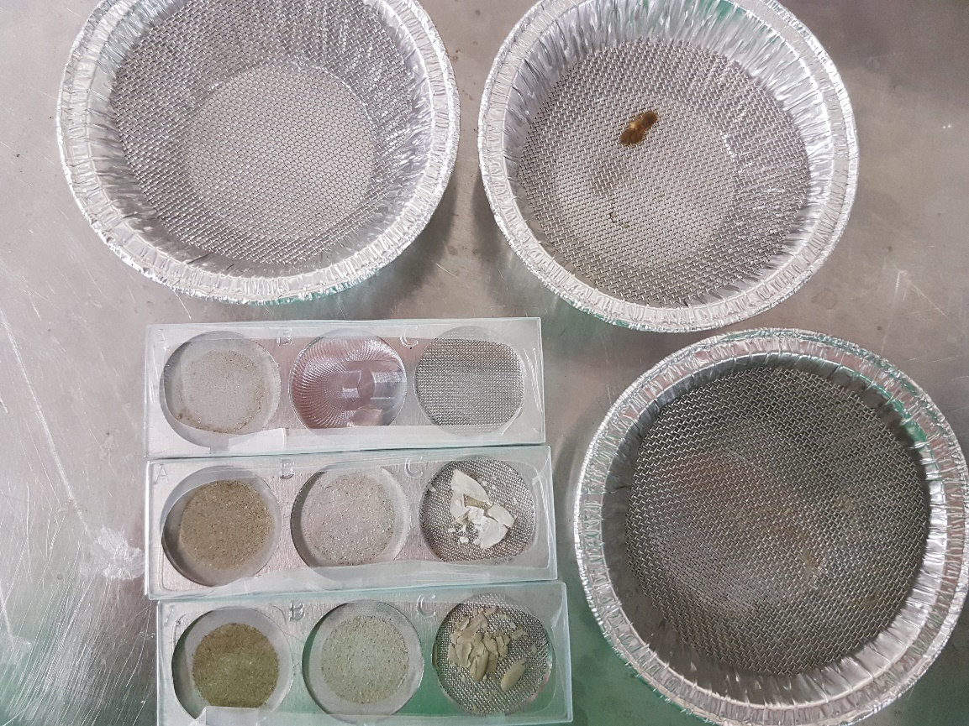
Supplementary Figure 4. Digestate residue of farmed barramundi (Lates calcarifer), containing very little prey and sediment, following a 10% KOH digestion conducted at 40°C for 3 days and subsequent EtOH treatment (Experiment C).
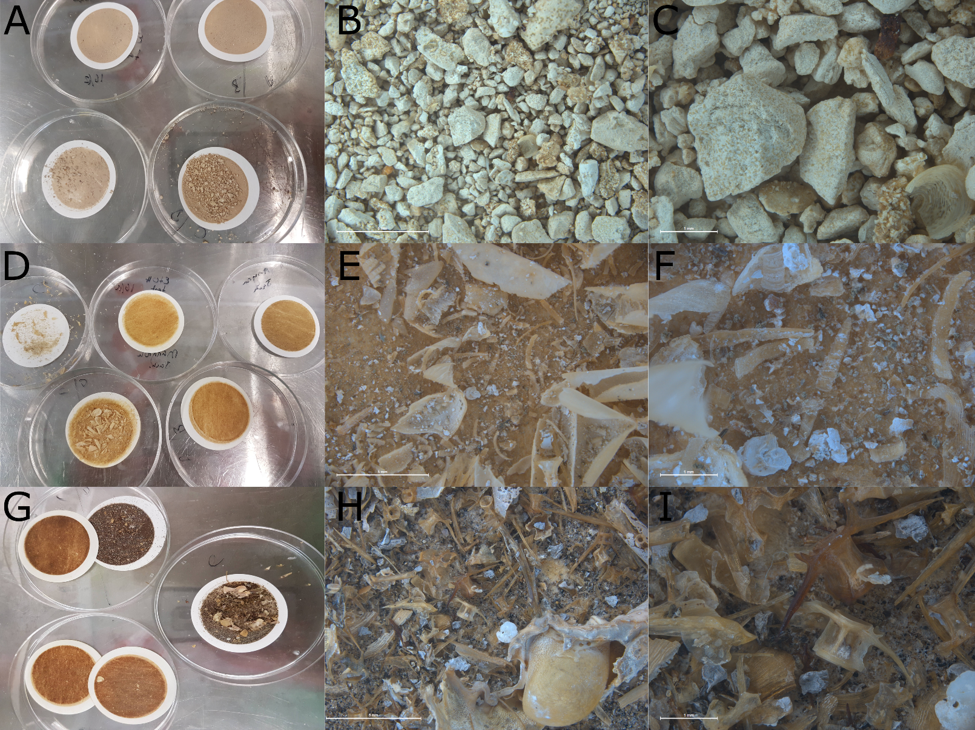
Supplementary Figure 5. Digestate residue of wild fish present on the filters after a 10% KOH digestion conducted at 40°C for 3 days and subsequent EtOH treatment where required (Experiment D). (A) coral trout (Plectropomus leopardus); (B) coral trout 10x magnification; (C) coral trout 30x magnification; (D) mangrove jack (Lutjanus argentimaculatus); (E) mangrove jack 10x magnification; (F) mangrove jack 30x magnification; (G) barramundi (Lates calcarifer); (H) barramundi 10x magnification; and (I) barramundi 30x magnification.

Supplementary Tables
Supplementary Table 1 Weights (g) of each tissue sample from farmed and wild-caught fish and KOH volume (mL) used in the four digestions experiments.
Experiment | Sample | Tissue | Weight (g) | KOH volume (mL)
A | 1 | Viscera | 86.01 | 344
 | 2 | Viscera | 115.01 | 460
 | 3 | Viscera | 147.09 | 588
B | 1 | Stomach | 22.13 | 89
 | 1 | Intestine | 15.28 | 61
 | 2 | Stomach | 26.15 | 105
 | 2 | Intestine | 18.23 | 73
 | 3 | Stomach | 22.07 | 88
 | 3 | Intestine | 15.64 | 63
C | 1 | Viscera | 179.00 | 1790
 | 2 | Viscera | 234.00 | 2340
 | 3 | Viscera | 224.87 | 2249
D | 1 | Viscera | 29.78 | 298
 | 2 | Viscera | 48.12 | 481
 | 3 | Viscera | 156.64 | 1566

Supplementary Table 2 Spectral matches of the spiked polymers using COMPARE analysis in the PerkinElmer Spectrum IR software. Digestion Method I - Foekema et al. (2013) and II - Karami et al. (2017), PS = polystyrene particles (1-2mm), PES = polyester fibers (1-5mm), PE = polyethylene particles (nominal 1mm); KOH = potassium hydroxide, EtOH = ethanol.
Polymer |  | Spectral Match %
 | Digestion Method | Mean | Min | Max
Rayon | I | 94.9 | 86.0 | 98.4
 | II | 97.9 | 95.9 | 99.2
 | KOH + EtOH | 97.1 | 96.5 | 98.2
PS | I | 98.7 | 95.5 | 99.8
 | II | 99.6 | 99.3 | 99.8
 | KOH + EtOH | 99.3 | 98.2 | 99.8
PES | I | - | - | -
 | II | 97.7 | 95.7 | 98.9
 | KOH + EtOH | 98.0 | 96.8 | 99.0
PE | I | 99.0 | 98.2 | 99.5
 | II | 98.5 | 97.7 | 99.0
 | KOH + EtOH | 98.6 | 97.8 | 99.2

Supplementary Table 3 Carbonyl indices (CI and COI) determined by comparing the infrared spectra of untreated virgin polymers polyethylene (PE), polystyrene (PS) polyester (PES), and rayon with those treated with potassium hydroxide (KOH) and ethanol (EtOH). ns = non-significant (p>0.05) (Experiment B and C).

Polymer | Digestion Method | Carbonyl indices  CI / COI |  | Sig. Diff.
 |  | Mean | Std. Dev.
Rayon | Virgin | 0.175 | 0.145 | -
 | KOH + EtOH | 0.026 | 0.053 | ns
PS | Virgin | 0.170 | 0.021 | -
 | KOH + EtOH | 0.155 | 0.047 | ns
PES | Virgin | 0.011 | 0.001 | -
 | KOH + EtOH | 0.022 | 0.016 | ns
PE | Virgin | 0.175 | 0.145 | -
 | KOH + EtOH | 0.026 | 0.053 | ns

Supplementary References
Canopoli, L., Coulon, F., and Wagland, S.T. (2020). Degradation of excavated polyethylene and polypropylene waste from landfill. Science of The Total Environment 698, 134125. doi: https://doi.org/10.1016/j.scitotenv.2019.134125.
Comnea-Stancu, I.R., Wieland, K., Ramer, G., Schwaighofer, A., and Lendl, B. (2016). On the Identification of Rayon/Viscose as a Major Fraction of Microplastics in the Marine Environment: Discrimination between Natural and Manmade Cellulosic Fibers Using Fourier Transform Infrared Spectroscopy. Applied Spectroscopy 71(5), 939-950. doi: 10.1177/0003702816660725.
Fan, M., Dai, D., and Huang, B. (2012). Fourier transform infrared spectroscopy for natural fibres. Fourier transform-materials analysis 3, 45-68.
Foekema, E.M., De Gruijter, C., Mergia, M.T., van Franeker, J.A., Murk, A.J., and Koelmans, A.A. (2013). Plastic in North Sea Fish. Environmental Science & Technology 47(15), 8818-8824. doi: 10.1021/es400931b.
Karami, A., Golieskardi, A., Choo, C.K., Romano, N., Ho, Y.B., and Salamatinia, B. (2017). A high-performance protocol for extraction of microplastics in fish. Science of The Total Environment 578, 485-494. doi: https://doi.org/10.1016/j.scitotenv.2016.10.213.
Khiari, R., Salon, M.-C.B., Mhenni, M.F., Mauret, E., and Belgacem, M.N. (2017). Synthesis and characterization of cellulose carbonate using greenchemistry: Surface modification of Avicel. Carbohydrate Polymers 163, 254-260. doi: https://doi.org/10.1016/j.carbpol.2017.01.037.
Mylläri, V., Ruoko, T.-P., and Syrjälä, S. (2015). A comparison of rheology and FTIR in the study of polypropylene and polystyrene photodegradation. Journal of Applied Polymer Science 132(28). doi: 10.1002/app.42246.
Ueland, M., Howes, J.M., Forbes, S.L., and Stuart, B.H. (2017). Degradation patterns of natural and synthetic textiles on a soil surface during summer and winter seasons studied using ATR-FTIR spectroscopy. Spectrochimica Acta Part A: Molecular and Biomolecular Spectroscopy 185, 69-76. doi: https://doi.org/10.1016/j.saa.2017.05.044.

