Supplementary Material

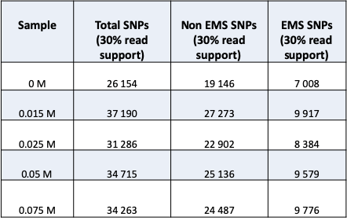
TABLE S2⎟ Pgt UK-01 wildtype assembly statistics.

Parameters | Nanopore assembly | Polished assembly
No. of contigs | 4,902 | 4,902
Contigs ≥ 10,000 bp | 3,956 | 3964
Total length (Mb) | 163.4 | 164.3
Total length ≥ 10,000 bp | 158.2 | 159.1
N50 (kb) | 56.2 | 53.6
Min (kb) | 1.01 | 1.01
Max (kb) | 570.8 | 572.4
L50 | 812 | 812
GC (%) | 43.45 | 43.45
% complete BUSCOs | 76.7 | 93.9
% single-copy BUSCOs | 50.6 | 47.3
% duplicated BUSCOs | 26.1 | 46.6
% fragmented BUSCOs | 16.4 | 3.6
% missing BUSCOs | 6.9 | 2.5

