Supplementary Material
Figure S1. Calibration curve of blank-corrected absorbance intensity against various concentrations of CGF diluted in water or 1x PBS. Blank absorbance values were obtained when the solvent, either deionized water or PBS, was examined. The mean (n = 3) ± SD are shown. The linear equations are Y = [(1.785 × X) - 0.01677] and Y = [(1.99 × X) + 0.01468] when CGF is diluted in water and PBS respectively. Y refers to the absorbance intensity at 260 nm (OD₂₆₀) while X refers to the concentration of CGF in g/L. Weighted R² values are 0.9928 and 0.999 for PBS and water respectively. Unknown concentration of CGF, diluted in PBS, can be calculated from the formula: [CGF]g/L = [(abs₂₆₀ - 0.01468)/1.99].

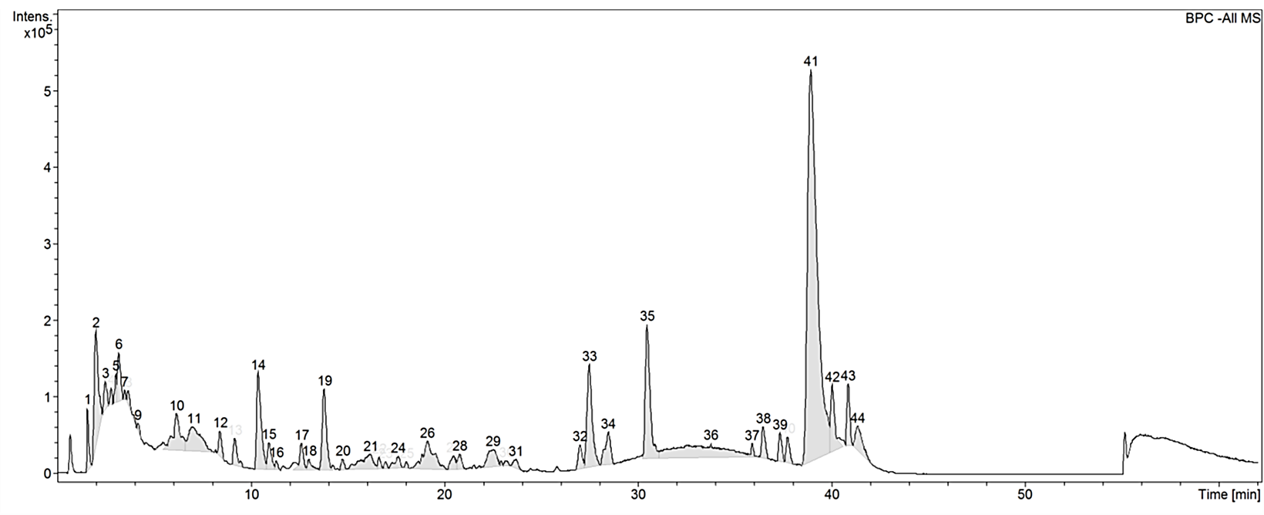
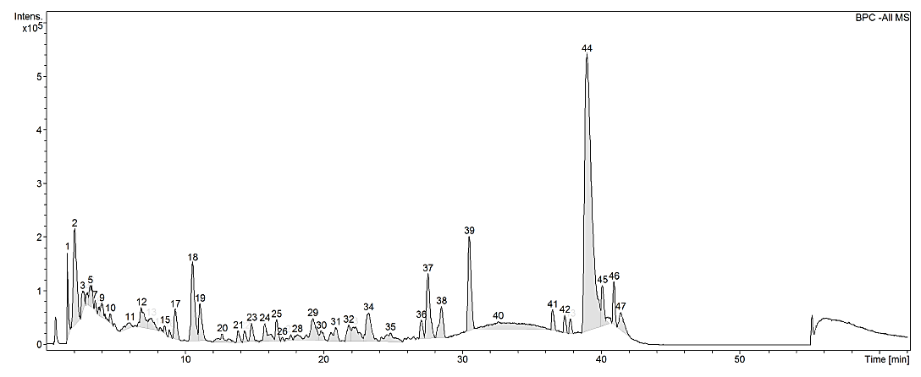
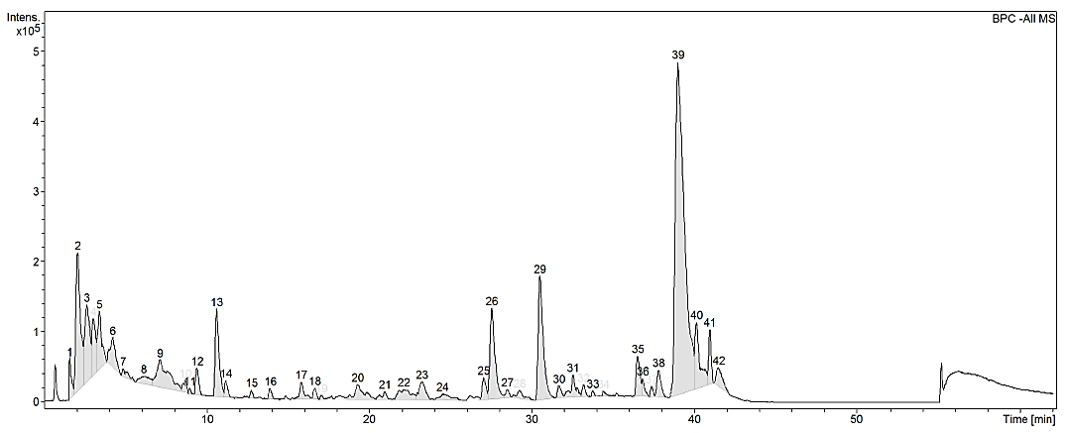
Figure S2. Base peak chromatograms (BPC) of three batches of CGF analyzed with HPLC on Agilent 1200 series LC. Mobile phase consists of 1% (v/v) aqueous formic acid (A) and acetonitrile (ACN) (B) and, they were used with a discontinuous gradient. Flow rate was 0.2 mL/min. UV detection was set at the wavelength of 260 nm and, 20 μL of 10% (w/v) CGF was injected each run. The ordinate and abscissa are UV absorbance intensity (mAU) and retention time (t_{R}) respectively. Peak patterns appear to be similar between the three BPCs.
Batch 1
Batch 2
Batch 3

Figure S3. Calibration curve of blank-corrected absorbance intensity against various concentrations of GFP standards. Blank absorbance values were obtained when the kit’s diluent was examined. The mean (n = 3) ± SD are shown. The linear equation is Y = [(0.9632 × X) – 2.538]. Y refers to the absorbance intensity at 450 nm (OD₄₅₀) while X refers to the concentration of GFP in pg/mL. R² value is 0.9946. Unknown concentration of GFP can be calculated from the formula: [GFP]pg/mL = [(abs₄₅₀ + 2.538)/0.9632].

Hydrogel matrix porosity via scanning electron microscopy (SEM)
The microstructure and porosity of the hydrogel matrix were analysed using SEM. In brief, lyophilized hydrogel samples (Alpha 1-2 LD+, Christ Martin, Germany) were first frozen in liquid nitrogen before being separated at their cross-sections. Then, the dissected hydrogels were quickly mounted onto pin stubs with their cross sections facing the electron emission source. The samples were subsequently sputter coated with gold using the JEOL JFC-1100 ion sputter (Tokyo, Japan) and examined with JEOL JSM-6510 scanning electron microscope. Pore size was calculated with reference to an in-built scale bar.
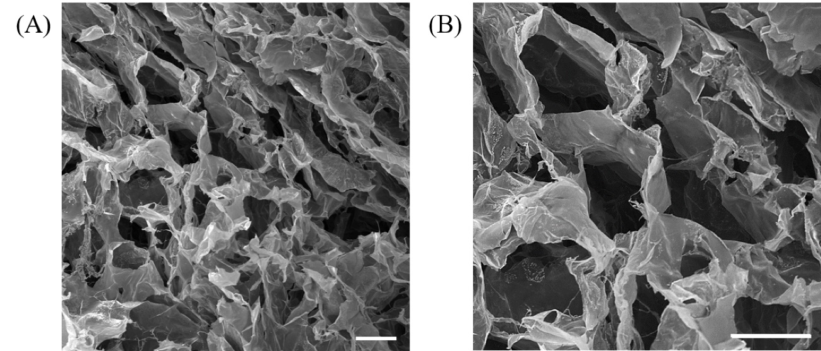
Figure S4. Scanning electron microscopy (SEM) images of the cross-section of hydrogel scaffold used for 3D cell culture at (A) 150× and (B) 250× zoom. Hydrogel samples were lyophilized to preserve their microstructure. Under the SEM, regularly shaped pores are clearly visible throughout the field of view. The longest diameter of the pores is defined as the further perpendicular distance between 2 points of the pores’ circumference, and was estimated to be ~ 150 µm. Scale bar = 100 µm.

Franz diffusion cell assay
Vertical Franz diffusion cells with an effective area of 1 cm² were used to determine the diffusion of CGF across the hydrogel matrix (Franz, 1975). The device is divided into the donor and receptor compartments, which were separated by two sheets of Whatman® 0.45 µm nylon membrane filters. 240 µL of cell-free hydrogel was formed in the donor compartment of Franz diffusion cells (n = 3), each donor compartments were then topped up with 800 µL of 1 g/L of CGF diluted in 1x PBS. The receptor compartment contained 5 mL of 1x PBS and a small magnetic stirrer. The Franz cells were sealed with parafilm to minimize the effect of evaporation and clamped to secure the overall setup. The assembled Franz cells were then placed inside a hot air chamber (Franz cell incubator) with the temperature maintained at 37 °C. Magnetic stirrers in the receptor cells stirred at a constant speed of 180 rpm. CGF solution in the donor compartments was replaced every 2 – 3 days (Mon, Wed and Fri).

For quantification, samples were removed from the receptor compartment via the sampling port at different time-points after 1, 3, and 7 days of incubation. Fresh 1 mL 1x PBS was immediately refilled after the sampling was completed. The concentration of CGF (g/L) released at each time-point (C_{a}) was determined by UV spectroscopy at OD₂₆₀. The total weight of CGF (g) within the receptor compartment was then quantified. The amount of CGF (g) removed from the previous time points (W_{o}) was added to determine the total amount of CGF collected at each referred time point. The resultant value was then expressed against the total amount of CGF (g) added to the donor compartment (W_{t}). Cumulative percentage release was then determined based on equation (1):
$$Cumulative \% release of CGF =\left(\frac{\left\{\left[\frac{Ca}{1000} ×5\right]+Wo\right\}}{Wt}\right)× 100\%-\left(1\right)$$
Figure S5. Cumulative percentage release of CGF across hydrogel scaffold examined with Franz diffusion cells. 800 µL of 1 g/L of CGF was incubated on top of 240 µL of hydrogel scaffold in the donor compartment. The donor and receptor compartments were separated by 2 sheets of 0.45 µm Whatman® filter papers. Samples of 1 mL were collected after 1, 3 and 7 d of incubation. The amount of CGF was determined based on UV-Vis spectroscopy. CGF in the donor compartment was replaced every 2 – 3 days (Mon, Wed, Fri). The mean (n = 3) ± SD are shown.

Table S1. Identification of phenolic compounds in CGF and their negative mode ESI-Q-TOF MS data.
No. | t_{R} [min] | Area under curve (AUC) | Molecular formula | Calculated exact mass
1 | 1.6 | 547201 | Unidentified | 238.8918
2 | 2.0 | 2161837 | C₁₄H₁₀N₄O₇ | 346.0556
3 | 2.5 | 412131 | C₁₁H₂₁O₂₁ | 489.0583
4 | 2.8 | 162878 | C₃₄H₇₂N₂ | 508.5684
5 | 3.0 | 241069 | C₁₁H₂₄N₅O₂₆ | 642.0717
6 | 3.2 | 728555 | C₃₄H₁₈O₁₄ | 650.0702
7 | 3.5 | 72264 | C₃₉H₇₇N₂O₅ | 653.5838
8 | 2.7 | 260400 | Unidentified | 484.5511
9 | 4.2 | 96054 | C₃₃H₁₇N₆O₁₁ | 673.0967
10 | 6.2 | 1312185 | Unidentified | 403.5568
11 | 7.0 | 1478331 | C₂₀H₂₂N₅O₂₀ | 652.0860
12 | 8.4 | 370695 | C₁₄H₂₅N₃O₁₀ | 395.1552
13 | 9.2 | 521467 | Unidentified | 491.6462
14 | 10.4 | 2075603 | C₃₆H₃₂O₂₀ | 784.1493
15 | 10.9 | 500205 | C₂₁H₁₇N₃O₉ | 455.0971
16 | 11.3 | 116637 | C₁₇H₂₉O₁₁ | 409.1712
17 | 12.6 | 499196 | C₂₄H₄₁O₁₆ | 585.2404
18 | 13.0 | 210858 | C₁₈H₃₁O₁₁ | 423.1873
19 | 13.8 | 1630126 | C₁₈H₃₁O₁₁ | 423.1874
20 | 14.8 | 160296 | C₁₉H₁₉N₂O₈ | 403.1149
21 | 16.2 | 921071 | C₂₆H₃₉N₄O₈ | 535.2771
22 | 16.6 | 162573 | Unidentified | 685.8480
23 | 17.0 | 95147 | C₁₁H₁₇O₄ | 213.1135
24 | 17.6 | 325275 | C₂₅H₄₅O₁₂ | 537.2921
25 | 18.1 | 84804 | C₃₀H₄₆N₇O₁₁ | 680.3262
26 | 19.1 | 1512591 | C₃₁H₃₅NO₁₀ | 581.2271
27 | 20.5 | 316501 | C₂₇H₄₉O₁₂ | 565.3226
28 | 20.8 | 295379 | C₃₁H₃₇NO₁₀ | 583.2428
29 | 22.5 | 834749 | C₃₃H₃₉NO₁₀ | 609.2584
30 | 23.2 | 97231 | C₁₈H₃₃O₅ | 329.2330
31 | 23.7 | 222649 | C₃₃H₄₁NO₁₀ | 611.2744
32 | 27.0 | 454546 | C₁₇H₂₅O₄ | 293.1761
33 | 27.5 | 2524827 | C₁₇H₂₅O₅ | 309.1709
34 | 28.5 | 863702 | C₁₆H₂₅O₃ | 265.1813
35 | 30.5 | 3071706 | C₁₇H₂₅O₃ | 277.1810
36 | 33.8 | 3244893 | C₁₆H₂₉O₃ | 269.2124
37 | 35.9 | 150481 | C₁₈H₂₉O₂ | 277.2176
38 | 36.5 | 543737 | C₁₄H₂₇O₂ | 227.2018
39 | 37.3 | 441208 | C₁₈H₃₁O₂ | 279.2331
40 | 37.7 | 439026 | C₁₅H₂₉O₂ | 241.2178
41 | 38.9 | 17801890 | C₁₆H₃₁O₂ | 255.2331
42 | 40.0 | 1351697 | C₁₇H₃₃O₂ | 269.2492
43 | 40.9 | 842536 | C₁₈H₃₅O₂ | 283.2648
44 | 41.3 | 836042 | C₁₈H₃₅O₂ | 283.2648

Table S2. E_{max} & CC₅₀ values of CGF (2D cell culture)
 | Concentration of CGF (g/L)
 | HDF | HaCaT | CHO | hMSC | ADSC
E_{max} | 0.001 | 0.001 | 0.001 | 0.001 | 0.001
CC₅₀  (95% CI) | 0.597  (0.508  –  0.710) | 1.026  (0.957  –  1.139) | 0.755  (0.694  –  0.828) | 1.919  (1.486  –  2.881) | 4.645  (2.932  –  7.172)

Hydrodynamic size analysis of CGF via dynamic light scattering (DLS)
Hydrodynamic size of the solubilized particles in CGF were first determined via DLS using Anton Paar Litesizer™ 500 (Graz, Austria), equipped with a red (658 nm) laser. The measuring range is between 0.3 nm – 10 µm in diameter, with a sensitivity of 0.1 mg/mL minimum macromolecule concentration. Briefly, 100 µL of CGF samples (n = 3) were examined in a low-volume quartz cuvette (163391, Anton Paar). Particle sizing was conducted in a series measurement mode at 25 °C. For each sample, 3 DLS measurements were conducted with 1 min of equilibration time in-between. The average hydrodynamic size of different populations of particles as well as their polydispersity index were analyzed with the software, Kalliope™ (Anton Paar).
Table S3. Hydrodynamic size and polydispersity index of CGF.
Population | Average Hydrodynamic Size† (nm) | Polydispersity Index (PDI)‡ (%)
1 | 920.4 ± 42.6 | 17.7
2 | 463.8 ± 15.3 | 30.9
†Hydrodynamic size was determined via DLS using Litesizer™ 500. The mean (n = 3) ± SD are shown.
‡PDI was determined via DLS using Litesizer™ 500. Both hydrodynamic size and PDI were examined at 25 °C.

