Supporting Information

Article title: Differential transcription and alternative splicing in cotton underly specialized defense responses against pests

Authors: Dian-Yang Chen; Qiu-Yi Chen; Dan-Dan Wang; Yu-Pei Mu; Mu-Yang Wang; Ji-Rong Huang; Ying-Bo Mao

The following Supporting Information is available for this article:

FIGURES
Figure S1: Images of the untreated (A) and A.lucorum infested cotton plants (B-D).
Figure S2: Transcriptomes analysis of the untreated (CK), H. armigera (HA) and A. lucorum (AL) infested cotton cotyledons.
Figure S3: The expression of the PR genes with higher induction by A.lucorum from the RNA-Seq results.
Figure S4: The effects of protein inhibitor on cotton bollworm growth.
Figgure S5: The amount and distribution of the different types of alternative splicing events in cotton.

TABLES
Table S1: Primers used in this investigation.
Table S2: The rules for well-expressed AS genes selection.
Table S3: General information of the differentially expressed genes (DEGs) by insect infestations.
Table S4: Gene Ontology (GO) enrichment of insect down-regulated genes.
Table S5: Gene Ontology (GO) enrichment of the up-regulated DEGs from HA and AL.
Table S6: The DEGs with higher inductions by H. armigera (HA) and by A.lucorum (AL) were subject to GO enrichment assay respectively.
Table S7: The detailed information of the JA and SA related genes in Figure 2B.
Table S8: The detailed information of the PR genes in Figure 3.
Table S9: General information of the differential AS (DAS) events caused by the H. armigera and A. lucorum infestations in cotton.
Table S10: Gene Ontology (GO) enrichment of differential AS genes from HA samples and AL samples.
Table S11: PSI (Percent spliced in) value of U1 and SR proteins from CK samples, HA samples and AL samples.

Table S 3 to 11: See separate Excel file.

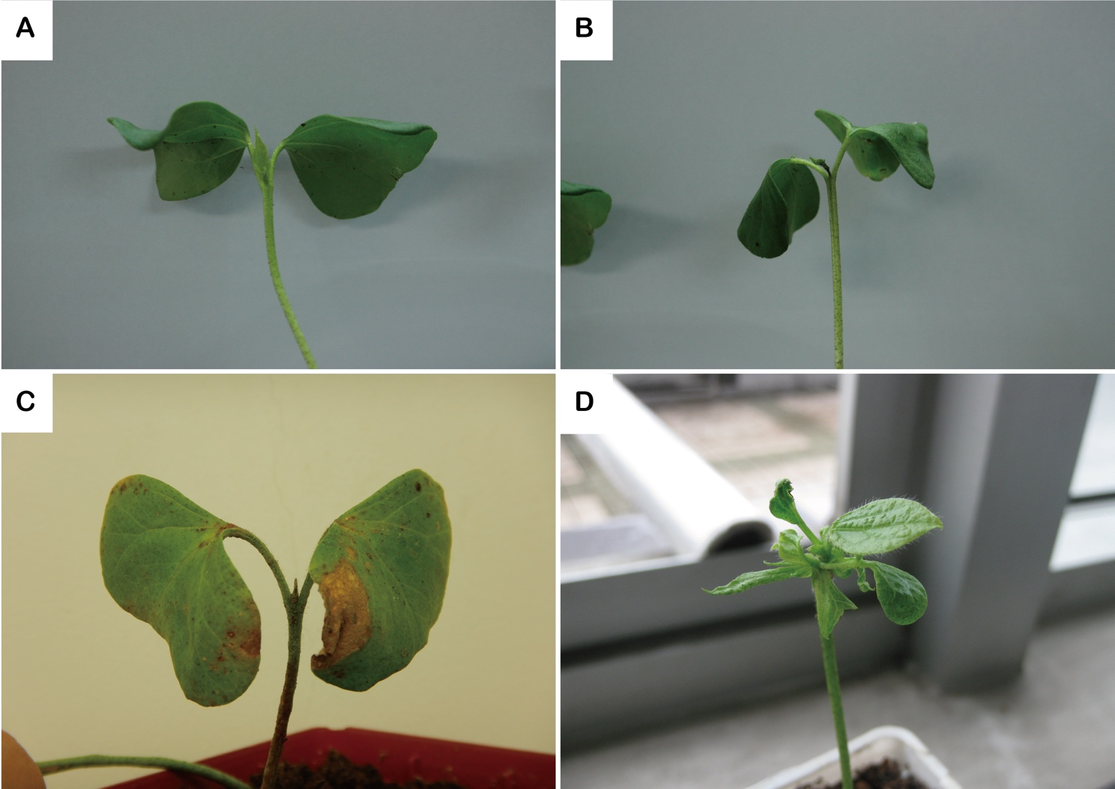
Figure S1. Images of the untreated (A) and A.lucorum infested cotton plants (B-D). The A.lucorum infested cotton seedlings exhibited symptoms of leaf wilting (B), necrotic plaques (C) and abnormal leaf development (D)
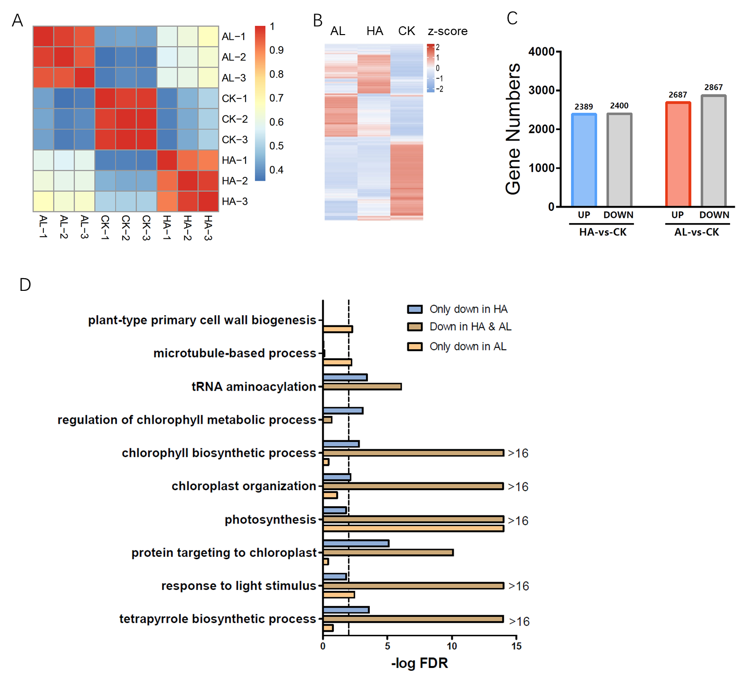
Figure S2. Transcriptomes analysis of the untreated (CK), H. armigera (HA) and A. lucorum (AL) infested cotton cotyledons. A. Corelationship analyze of transcriptome row data of CK, HA and AL sample groups. It suggested that H. armigera and A. lucorum contributed to differential transcription of cotton. B. Heat map analysis of the bulk RNA-seq data. The 3 biological replicates (-1,-2,-3) of CK, HA and AL sample groups were analyzed. High uniformity within the 3 biological replicates of the same sample group and quite different among the CK, HA and AL were observed. C. The amount of up and down-regulated genes by the H. armigera and A. lucorum infestations. D. The GO enrichment assay of insect down-regulated genes. The down-regulated genes only in HA, in AL and in both HA & AL were separately subject to GO enrichment assay.
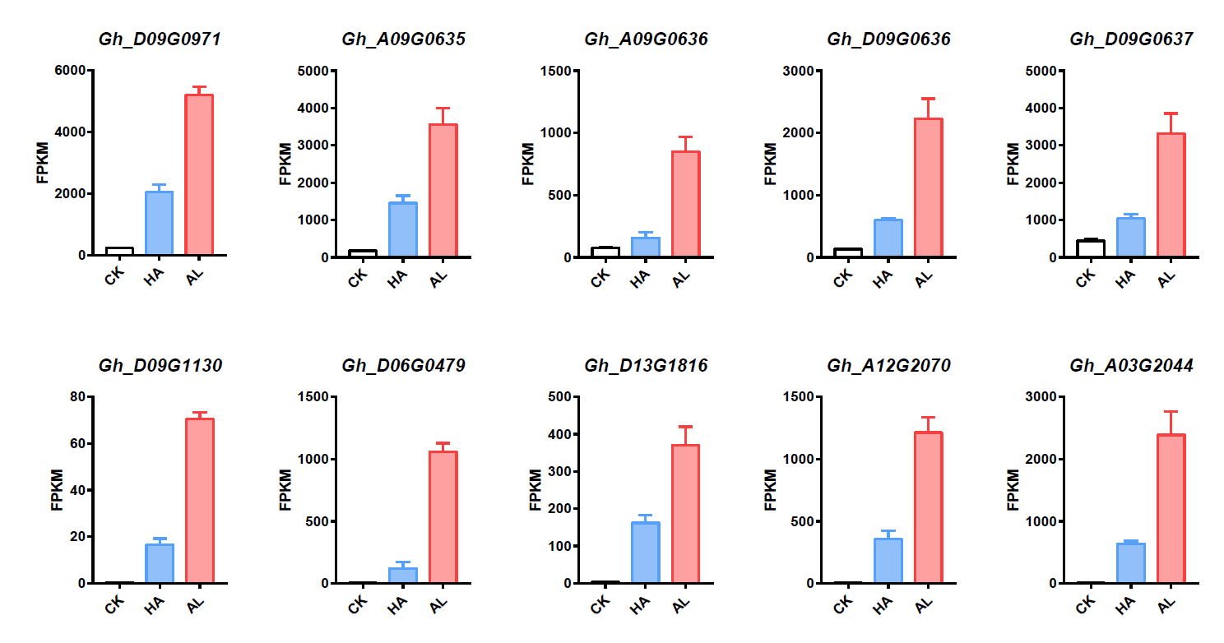
Figure S3. The expression of the PR genes with higher induction by A.lucorum from the RNA-Seq results. HA and AL indicated cotton seedlings treated by H. armigera and A. lucorum respectively. Error bar means ± SEM (n=3 biological replicates).

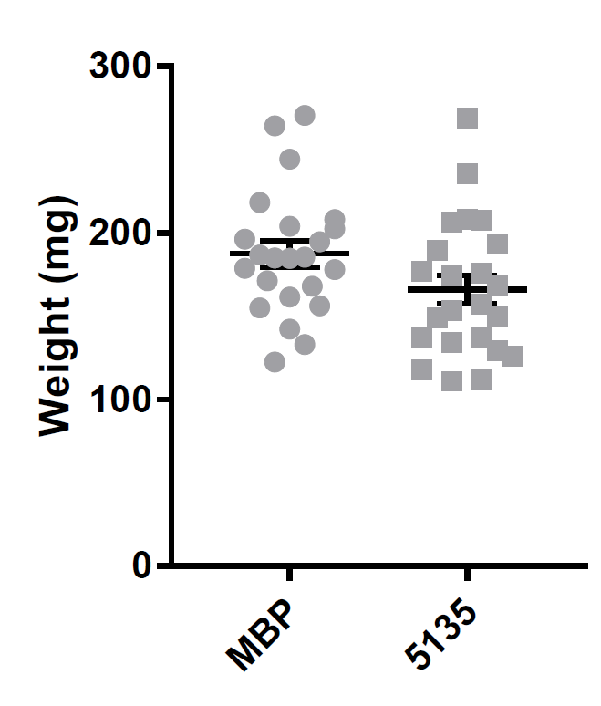
Figure S4. The effects of protein inhibitor (Gh_Sca005135G01) on cotton bollworm growth. The 2nd instar larvae were fed with basal artificial diet mixed with MBP and Gh_Sca005135G01 expressing E. coli cells for4days and the weight of each individual was detected. Error bar means ± SEM (n=30-35).

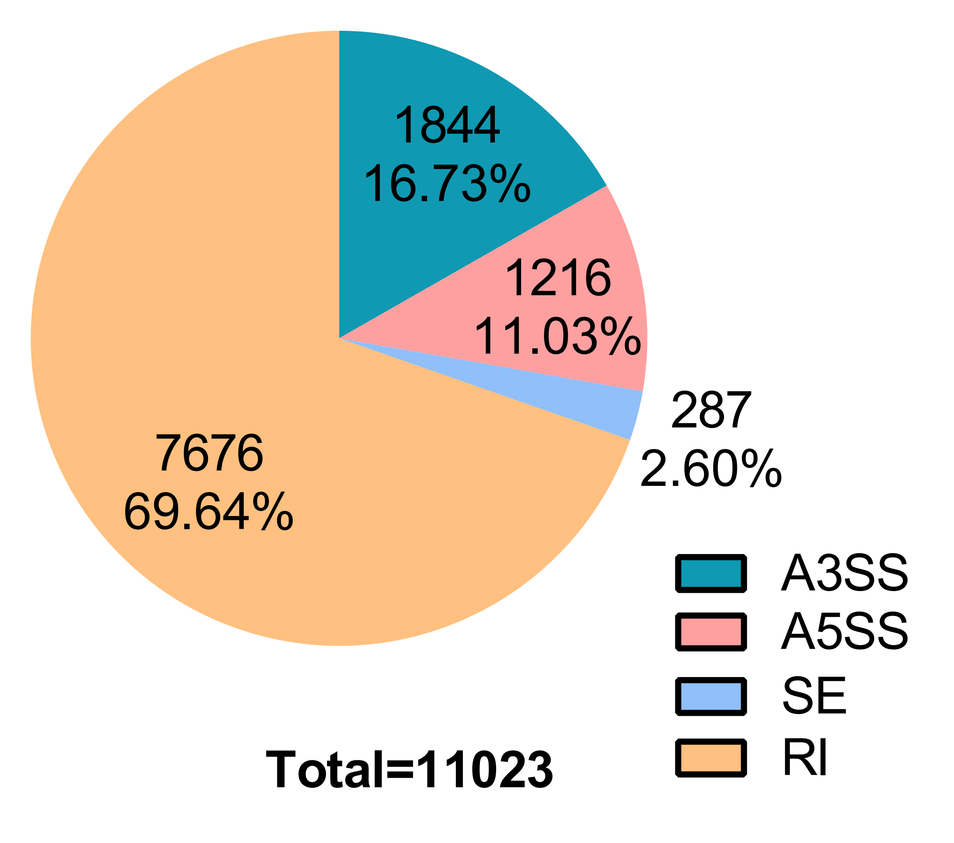
Figure S5. The amount and distribution of the different types of alternative splicing events in cotton. A3SS, alternative 3' splice site; A5SS, alternative 5' splice site; SE, skipping exon; RI, retained intron.

Table S1 Primers used in this investigation.
primer for qPCR
 | primer F (5'-3') | primer R (5'-3')
GhHIS3 | CGGTGGTGTGAAGAAGCCCTAT | AATTTCACGAACAAGCCTCTGGAA
Gh_D01G1683 | TAGCCCAAACTTCCCATGAA | CCCGTAGTTGTAGTTCCAA
Gh_A05G1019 | AACACAACCATCTTCCTCCTTCTC | TTTGCCGAAGTCTGGAGTC
GH_A10G2244 | GCGGACAAGGTGAAGG | CGTCGGGTTTAGGTGG
GH_A06G0705 | CTCCTCCTCGGAAACT | TCCACTGAAGAACCCA
Gh_D12G2247 | AAATCTCCTCCCTCCT | GTCCACCACAATCACC
Gh_D10G2219 | ACATTGATGGCAACGAGG | AGTTTGGGTCTGAGGGGA
Gh_D09G1520 | AAGTGCTTTCCTACCC | AGATTTTGCCCCATAA
Gh_D06G1912 | CGACTTCTGCTTGTTATC | TGTCTTGAATGGGTGTTA
Gh_D03G1462 | TTGACATCTCCAACATC | ACCTCTCCTTGAAAAAC
Gh_D10G1757 | AGCACCAGATAGGAGG | TAGCCAAGAGGTAAGC
Gh_A13G2341 | AACCTGCCAGCACATTA | AGTCCTTGAAAACCCGA
Gh_A10G2355 | CGTTGTTCGCCTATCC | TCACCCACCATTTTCC
Gh_D09G0971 | TGACTTTTCAGGCACT | CACCTCACCTTAGCAC
Sca005135G01 | CCATCGTCCTTTTCGT | ACCGTTGTTGTTTCGC
primer for protein expression in E.coli cells
 | primer F (5'-3') | primer R (5'-3')
5135-Pmal-c5x | GGGATCGAGGGAAGGATGAAAACCACAACAG | GGACATATGTGAAATCTAATTATGAACAACTTGT
1177-Pmal-c5x | GGGATCGAGGGAAGGATGACAGATTGCATCG | GGACATATGTGAAATCTAGCCAATGTGAGGCGTG

Table S2 The rules for well-expressed AS genes selection.
IJC-CK | SJC-CK | IJC-HA | SJC-HA | IJC-AL | SJC-AL
Χ | Χ | Χ | Χ | Χ | Χ
Χ | Χ | Χ | Χ | Χ | Ο
Χ | Χ | Χ | Χ | Ο | Χ
Χ | Χ | Χ | Ο | Χ | Χ
Χ | Χ | Ο | Χ | Χ | Χ
Χ | Χ | Ο | Χ | Ο | Χ
Χ | Χ | Χ | Ο | Χ | Ο
Χ | Ο | Χ | Χ | Χ | Χ
Χ | Ο | Χ | Χ | Χ | Ο
Χ | Ο | Χ | Ο | Χ | Χ
Χ | Ο | Χ | Ο | Χ | Ο
Ο | Χ | Χ | Χ | Χ | Χ
Ο | Χ | Χ | Χ | Ο | Χ
Ο | Χ | Ο | Χ | Χ | Χ
Ο | Χ | Ο | Χ | Ο | Χ
If the IJC values > 5 in all the three replicates, marked the IJC “Ο”, otherwise “Χ”. If the SJC values > 5 in all the three replicates, marked the SJC “Ο”, otherwise “Χ”. Remove the AS events with the combinations listed in the table below and the rested AS events were subject to further analysis.

