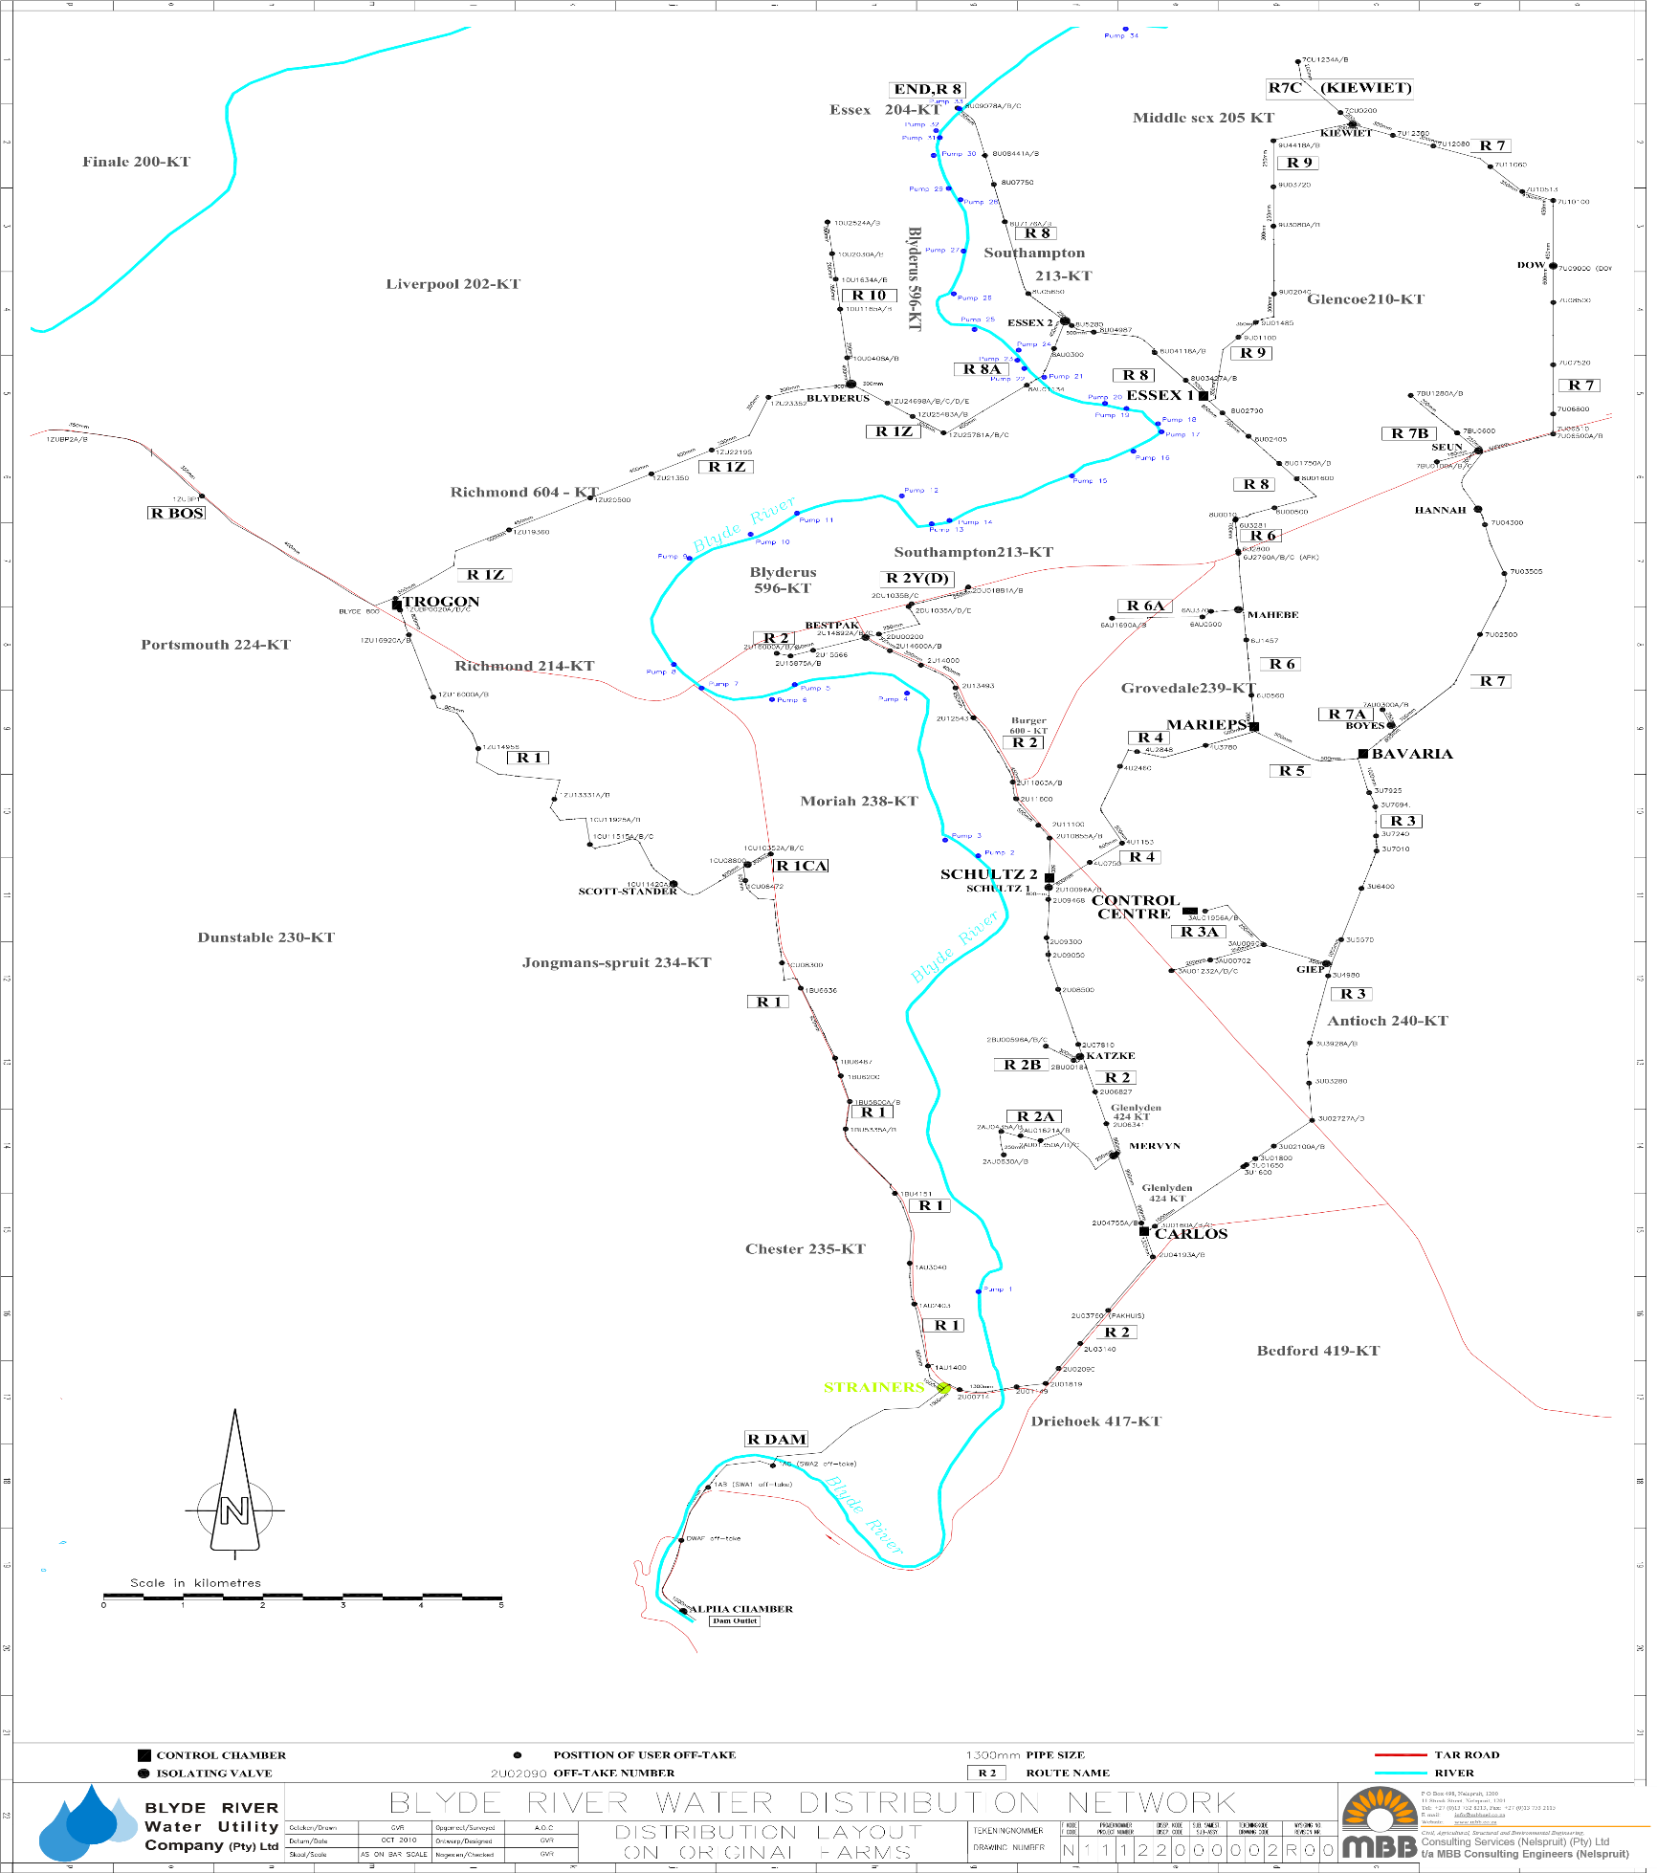
Supplement A - Schematic layout of the LBIS located downstream from the Blyderiver dam in Mpumalanga and Limpopo provinces, SA. LBIS 1 – LBIS 10 indicate sampling sites (Courtesy of Mr Org van Rensburg, MBB Consulting Engineers).
LBIS 5

Blyderiver Dam
LBIS 3

LBIS 10

LBIS 9

LBIS 8

LBIS 7

LBIS 6

LBIS 4

LBIS 2

LBIS 1

