Supplementary data
Table S1. Primers used in this study.
Location | Primer | Nucleotide sequence (5’-3’) | Product length (bp) | Reference
tnsA | tnsA-fw | TGGCTAACAGTACAAGAAGT | 713 | This study
tnsA | tnsA-rv | CGCAACTCCTCCATATTCA
tnsB | tnsB-fw | GGCTGAGTTGTTGCTAATG | 845 | This study
tnsB | tnsB-rv | CCACCACATAAGACGGATT
tnsC | tnsC-fw | TCGCATAATGGTTCGCTAA | 893 | This study
tnsC | tnsC-rv | CTTGTCATCGTTGGATTCTG
16s | 16s-fw | AGAGTTTGATCMTGGCTCAG | 1466 | (Suzuki et al., 2000)
16s | 16s-rv | TACGGYTACCTTGTTACGACTT
intI2 | intI2-fw | CACGGATATGCGACAAAAAGGT | 788 | (Mazel et al., 2000)
intI2 | intI2-rv | GTAGCAAACGAGTGACGAAATG

References

Mazel, D., Dychinco, B., Webb, V. A., & Davies, J. (2000). Antibiotic resistance in the ECOR collection: integrons and identification of a novel aad gene. Antimicrob Agents Chemother, 44(6), 1568-1574. doi: 10.1128/aac.44.6.1568-1574.2000
Suzuki, M. T., Taylor, L. T., & DeLong, E. F. (2000). Quantitative analysis of small-subunit rRNA genes in mixed microbial populations via 5'-nuclease assays. Appl Environ Microbiol, 66(11), 4605-4614. doi: 10.1128/aem.66.11.4605-4614.2000

Table S2. Antibiotic resistance rates of Tn7-like transposons positive strains isolated from different sources

Antimicrobial  Agent | % resistant isolates from different sources |  | P value
 | Pigs  (n=303) | Chicken  (n=74)
GEN (10μg) | 25.7 | 18.9 | 0.2205
STR (10μg) | 88.8 | 83.8 | 0.2392
FLR (30μg) | 60.7 | 59.5 | 0.7606
CAZ (30μg) | 5.6 | 6.8 | 0.7061
IPM (10μg) | 0.7 | 0.0 | 0.4835
FOX (30μg) | 5.9 | 5.4 | 0.8602
SXT(1.25/23.75μg) | 74.6 | 71.6 | 0.6020
ATM (30μg) | 4.0 | 5.4 | 0.5804
CIP (5μg) | 21.8 | 23.0 | 0.8246
AMK (30μg) | 6.3 | 5.4 | 0.7804
MDR | 55.4 | 52.7 | 0.6708
Chi-square test was used to analyze the data.

Table S3. Resistance Phenotype of EC600 with Plasmid p1.1.2

Antibiotics | Inhibitory zone diameter（mm） |  |  | Antimicrobial resistance phenotype
 | SCBX1.1 | EC600 | EC600+P1.1.2 | SCBX1.1 | EC600 | EC600+P1.1.2
GEN(10μg) | 9 | 24 | 8 | R | S | R
STR (10μg) | 0 | 27 | 0 | R | S | R
FLR(30μg) | 0 | 24 | 0 | R | S | R
CAZ(30μg) | 13 | 30 | 11 | R | S | R
FOX(30μg) | 13 | 30 | 0 | R | S | R
SXT(1.25/23.75μg) | 0 | 31 | 0 | R | S | R
CIP(5μg) | 11 | 27 | 0 | R | S | R
AMK(30μg) | 0 | 23 | 0 | R | S | R
R, resistant; I, intermediate; S, susceptible.

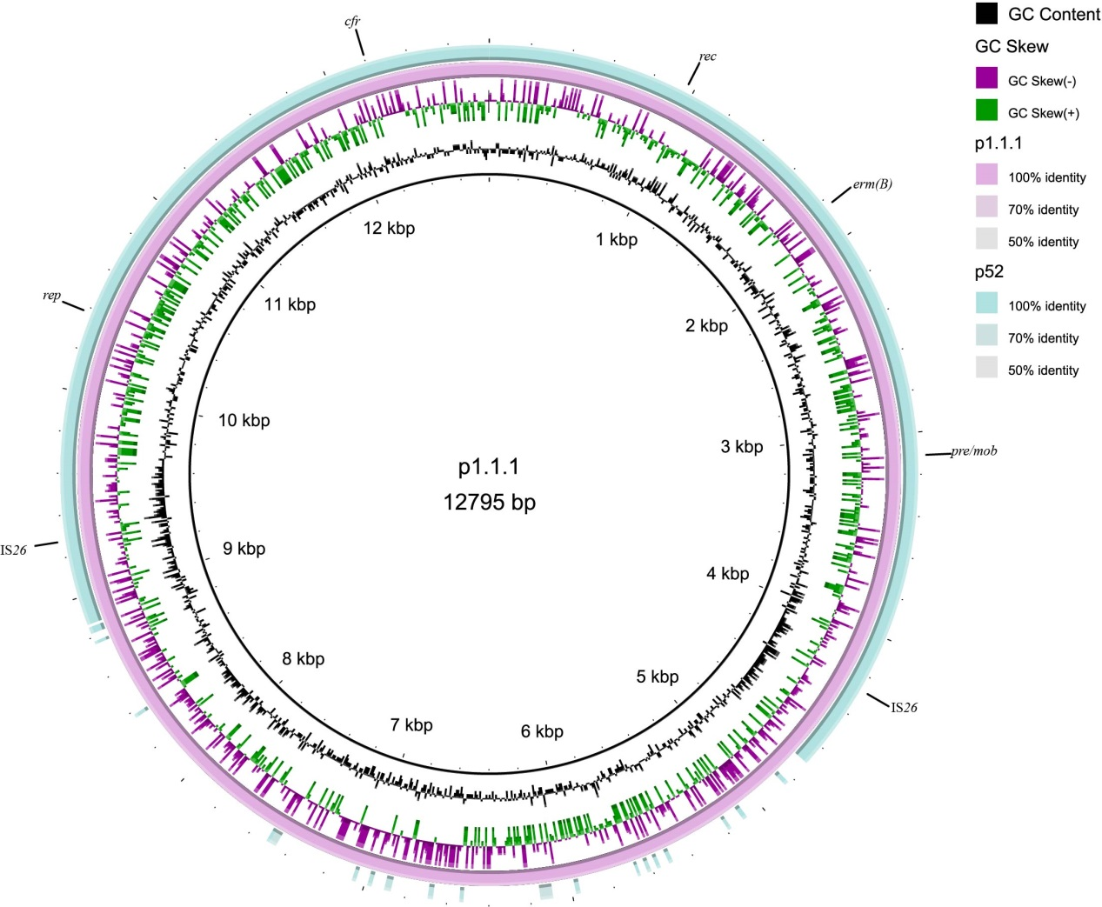

Fig. S1. Circular representation of plasmid p1.1.1. The physical map of p1.1.1 was generated using BRIG v0.95.

