Supplementary Material

Novel Expedient Synthesis of 5-Azaisocoumarins by Transition Metal-Catalyzed Cycloisomerization

Jeong A Yoon ¹, Changjin Lim ^{2, *} and Young Taek Han ^{1,*}

¹ College of Pharmacy, Dankook University, Cheonan 31116, Korea
² School of Pharmacy, Jeonbuk National University, Jeonju 54896, Korea

* Correspondence:
Changjin Lim
limcj@jbnu.ac.kr
Young Taek Han
hanyt@dankook.ac.kr

Table of Contents

1. General Information ·························································································· S2
2. Preparation of Known Compounds ········································································· S3
3. ¹H- and ¹³C-NMR Spectra ··················································································· S5
4. References ····································································································S19

General Information
Unless noted otherwise, all starting materials and reagents were obtained commercially and were used without further purification. All solvents utilized for routine product isolation and chromatography were of reagent grade and glass-distilled, and reaction flasks were dried at 100 °C before use. Flash column chromatography was performed using silica gel 60 (230-400 mesh, Merck, Kenilworth, NJ, USA) with the indicated solvents. Thin-layer chromatography (TLC) was performed using 0.25-mm silica gel plates (Merck, Kenilworth, NJ, USA). Mass spectra were obtained using an Agilent 6530 Q-TOF (Santa Clara, CA, USA) instrument. Infrared spectra were recorded on a JASCO FT-IR-4200 spectrometer (Tokyo, Japan). ¹H and ¹³C spectra were recorded on a Brucker Analytik ADVANCE digital 500 (500 MHz) (Billerica, MA, USA) and BRUKER AVANCE-800 (Billerica, MA, USA). Chemical shifts are expressed in parts per million (ppm, δ) downfield from tetramethylsilane and are referenced to the deuterated solvent. ¹HNMR data are reported in the order of chemical shift, multiplicity (s, singlet; d, doublet; t, triplet; q, quartet; m, multiplet; bs, broad singlet; and/or multiple resonances), number of protons, and coupling constant in hertz (Hz).

Preparation of Known Compounds
4-Hydroxy-6-phenyl-2H-pyran-2-one (1). 1 was prepared according to the literature procedure and the ¹H-NMR spectra was consistent with the previous data (Prasad et al., 1995). Yellow solid of 1 (1.18 g, 82%) was obtained from 1 g of malonyl chloride. m.p.: 283–284 ˚C; R_{f} = 0.23, (MeOH/CH₂Cl₂ = 1 : 10); ¹H-NMR (400 MHz, DMSO-d₆) δ 11.89 (s, 1H, OH) 7.87–7.83 (m, 2H, Ar-H) 7.53–7.50 (m, 3H, Ar-H) 6.77 (d, 1H, J = 2.5 Hz, cyclic-CH) 5.40 (d, 1H, J = 2.5 Hz, cyclic-CH); ¹³C-NMR (125 MHz, DMSO-d₆) δ 170.5, 163.0, 160.0, 131.0, 130.9, 129.1, 125.4, 98.4, 89.6 ; IR (thin film, neat) ν_{max} 1734, 1604, 1546, 1421, 1224, 1173, 1070, 804, 772 cm⁻¹; LR-MS (ESI+) m/z 189 (M + H⁺); HR-MS (ESI+) calcd for C₁₁H₉O₃ (M + H⁺) 189.0546; found 189.0544.
Structures of the synthesized propargylamine 3b’ (Nishizawa et al., 2010), 3c’ (Uredi et al., 2018), 3d’ (Sakthivel et al., 2017), 3e’ (Sakthivel et al., 2017), 3f’ (Uredi et al., 2019), 3g’ (Balducci et al., 2009), 3h’ (Cui et al., 2018), 3i’ (Valverde et al., 2009), 3j’ (Mons et al., 2019), and 3k’ (Sakthivel et al., 2017) were confirmed via comparison of their spectral data with those of the corresponding known propargylamine reported in the precedent literature.
Table S1. ¹H NMR and ¹³C NMR assignments of 7-phenyl-5H-pyrano[4,3-b]pyridin-5-one 4a
Position | ¹H-NMR |  | ¹³C-NMR
 | Reported | Synthesized | Reported | Synthesized
1 |  |  | 156.6 | 156.3
3 |  |  | 153.3 | 155.1
4 | 7.20 (s, 1H) | 7.23 (s, 1H) | 104.0 | 103.6
4a |  |  | 162.2 | 162.1
5 | 8.91 (dd, 1H, J = 1.3, 4.7 Hz) | 8.94 (dd, 1H, J = 1.8, 4.6 Hz) | 157.4 | 157.6
6 | 7.40  (dd, 1H, J = 4.7, 8.1 Hz), | 7.43  (dd, 1H, J = 4.6, 7.9 Hz) | 123.2 | 123.0
7 | 8.52 (dd, 1H, J = 1.3, 8.1 Hz) | 8.55  (dd, 1H, J = 1.4, 7.8 Hz) | 137.8 | 137.9
7a |  |  | 117.2 | 117.2
3’ |  |  | 131.6 | 131.5
4’, 8’ | 7.50-7.45 (m, 3H) | 7.51-7.47 (m, 3H) | 129.3 | 129.2
6’
 |  |  | 125.9 | 125.9
5’, 7’ | 7.93-7.86 (m, 2H) | 7.93-7.91 (m, 2H) | 131.1 | 131.0

¹H- and ¹³C-NMR Spectra
¹H-NMR Spectra of 1 (400 MHz, DMSO-d₆)
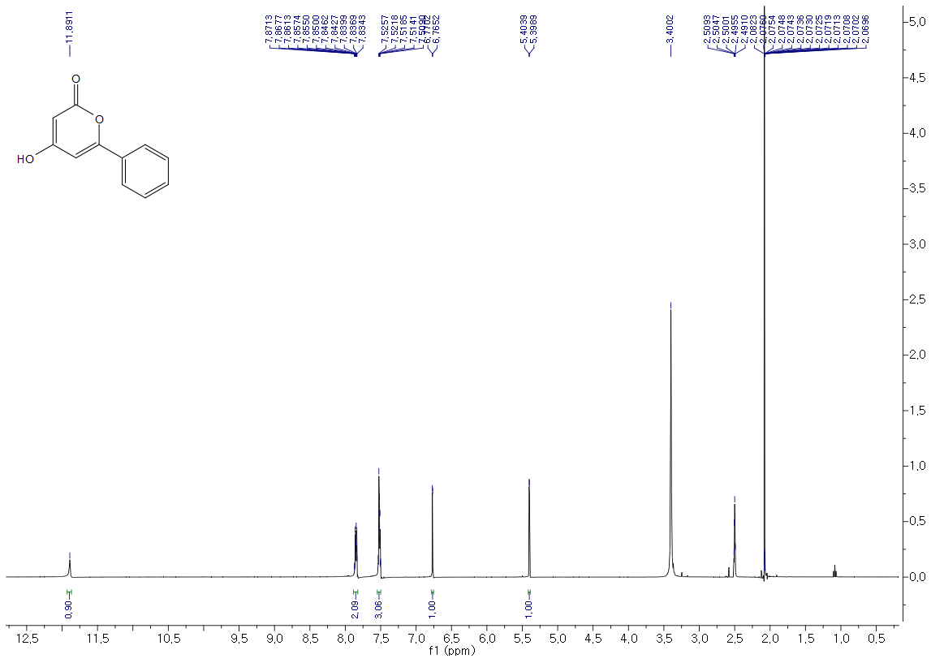
¹³C-NMR Spectra of 1 (125 MHz, DMSO-d₆)
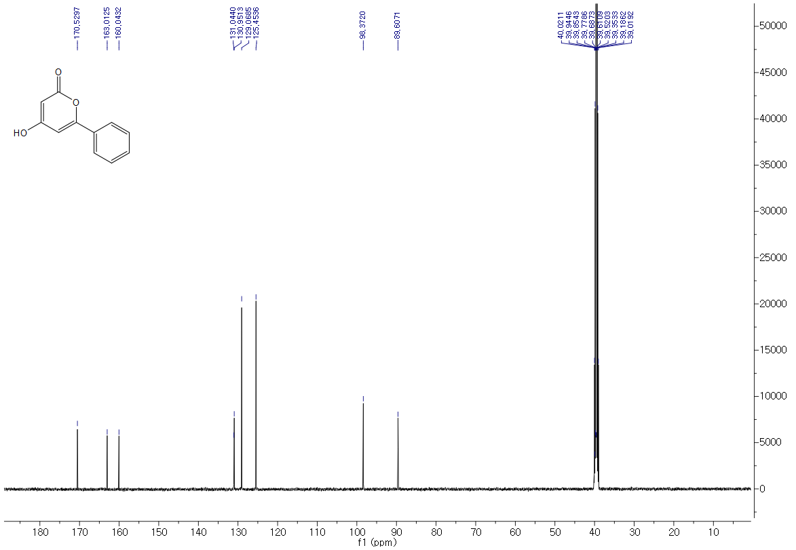
¹H-NMR Spectra of 2 (500 MHz, CDCl₃)
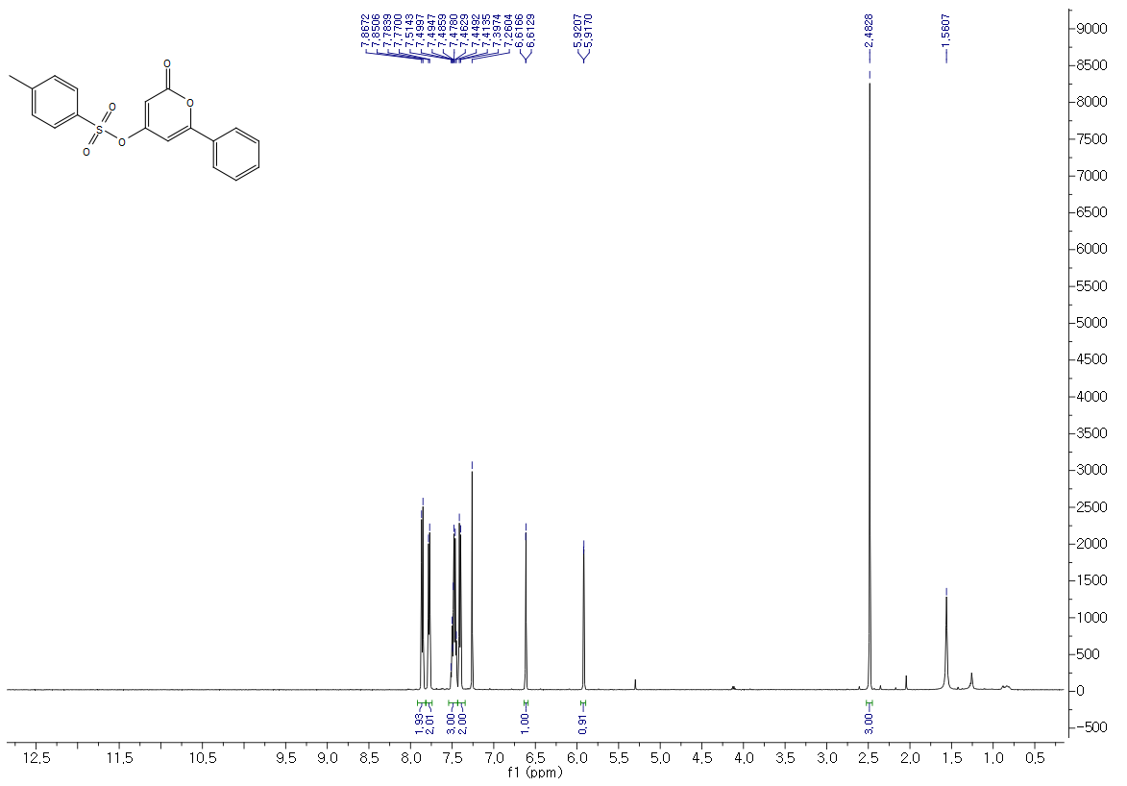
¹³C-NMR Spectra of 2 (125 MHz, CDCl₃)
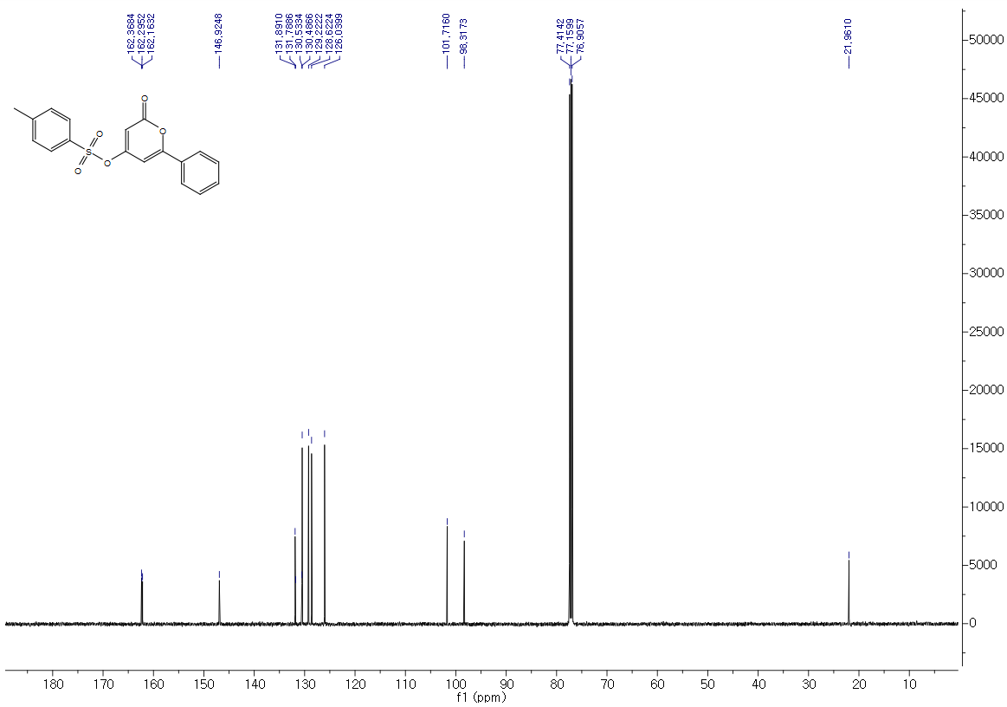
¹H-NMR Spectra of 3a (500 MHz, DMSO-d₆)
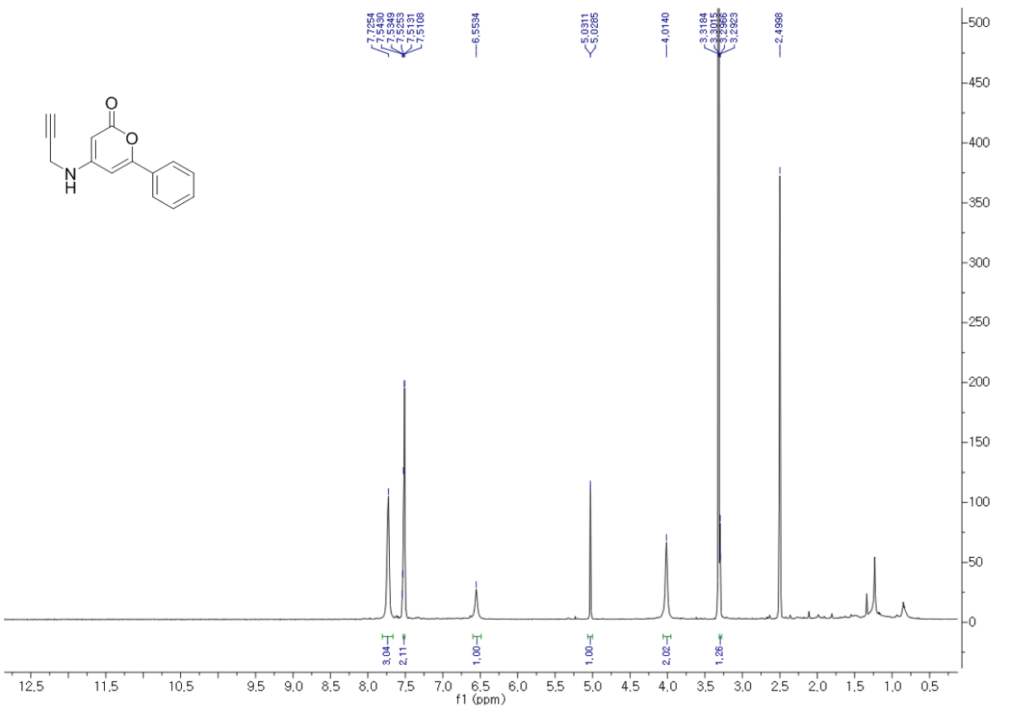
¹³C-NMR Spectra of 3a (125 MHz, DMSO-d₆)
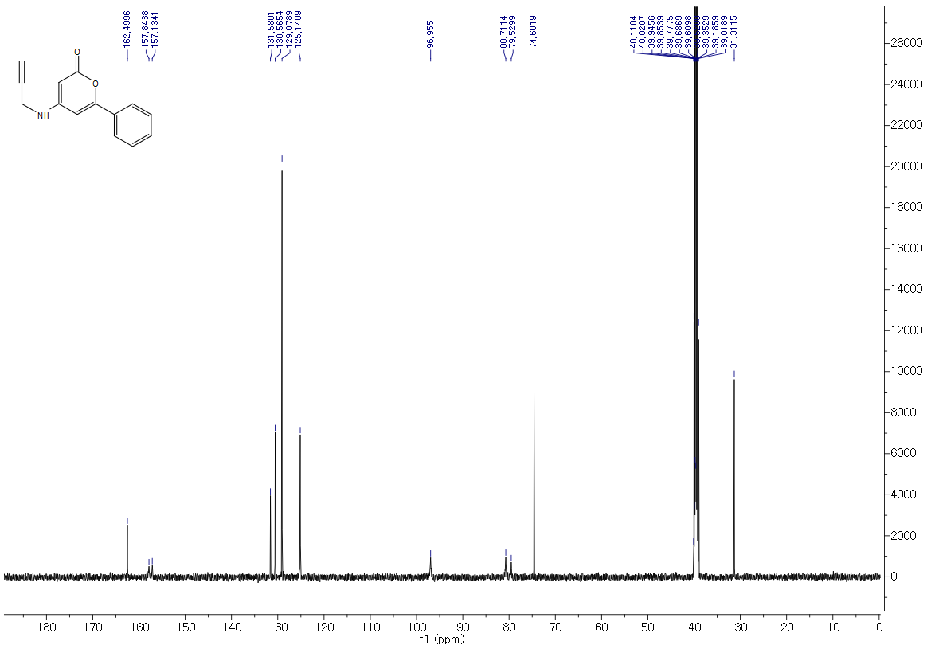
¹H-NMR Spectra of 3b (500 MHz, DMSO-d₆)
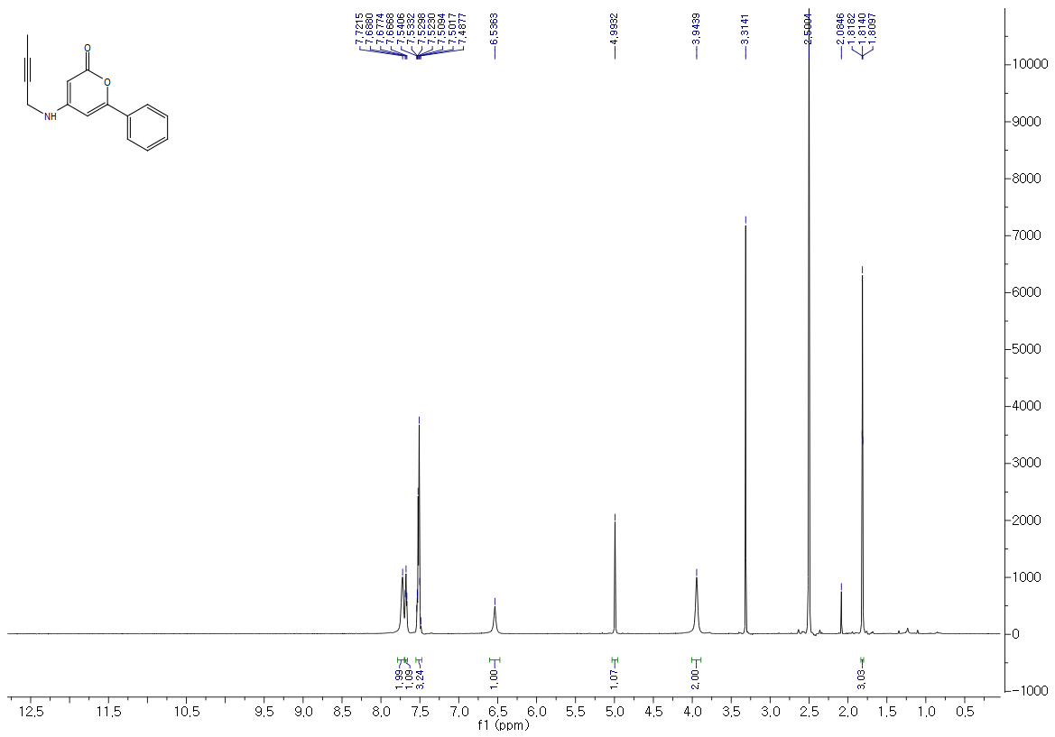
¹³C-NMR Spectra of 3b (125 MHz, DMSO-d₆)
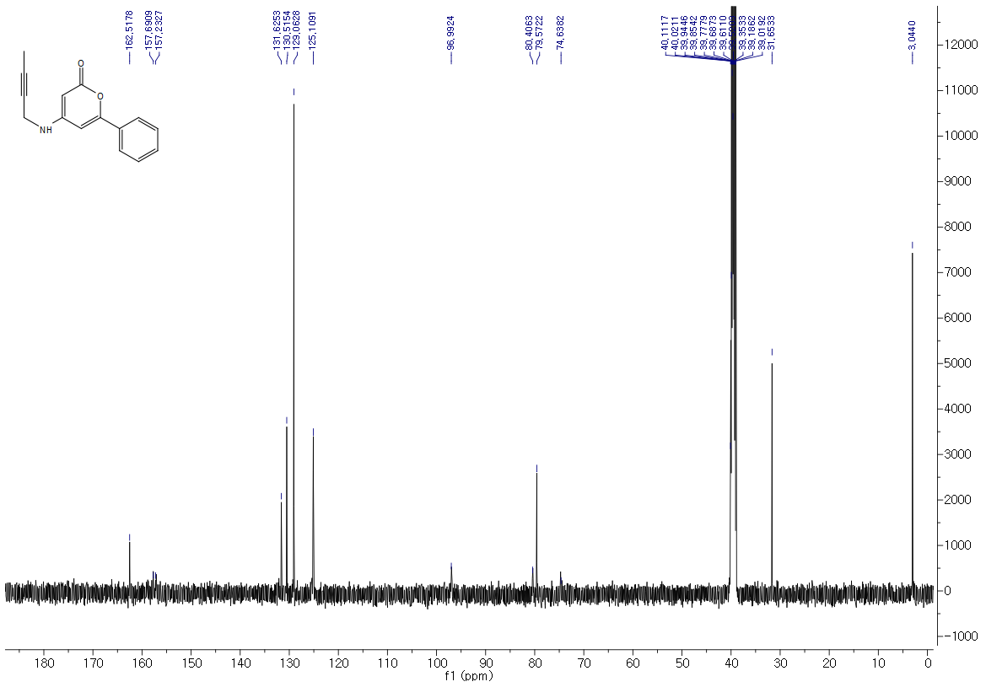
¹H-NMR Spectra of 3c (500 MHz, DMSO-d₆)
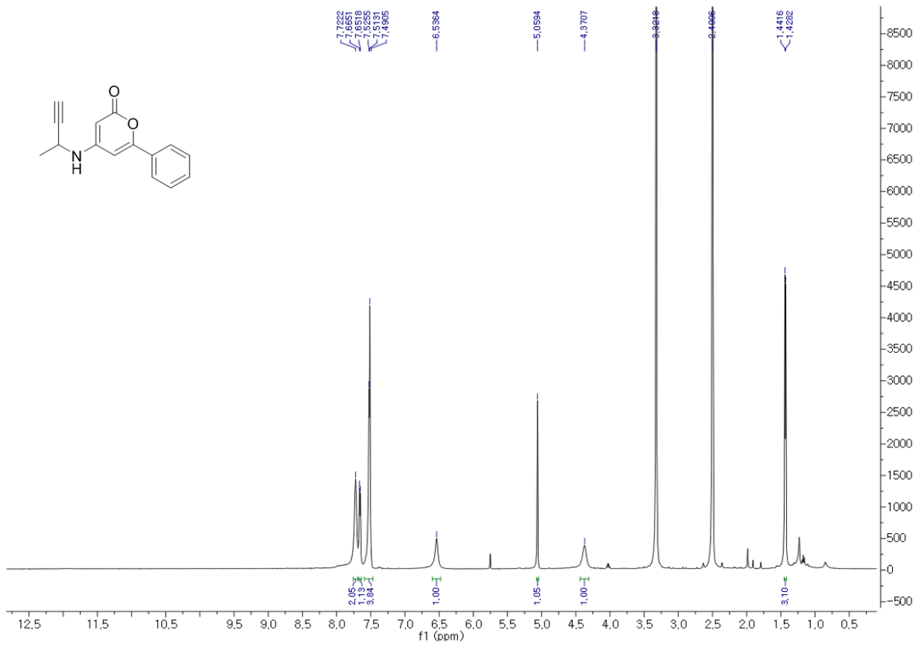
¹³C-NMR Spectra of 3c (125 MHz, DMSO-d₆)
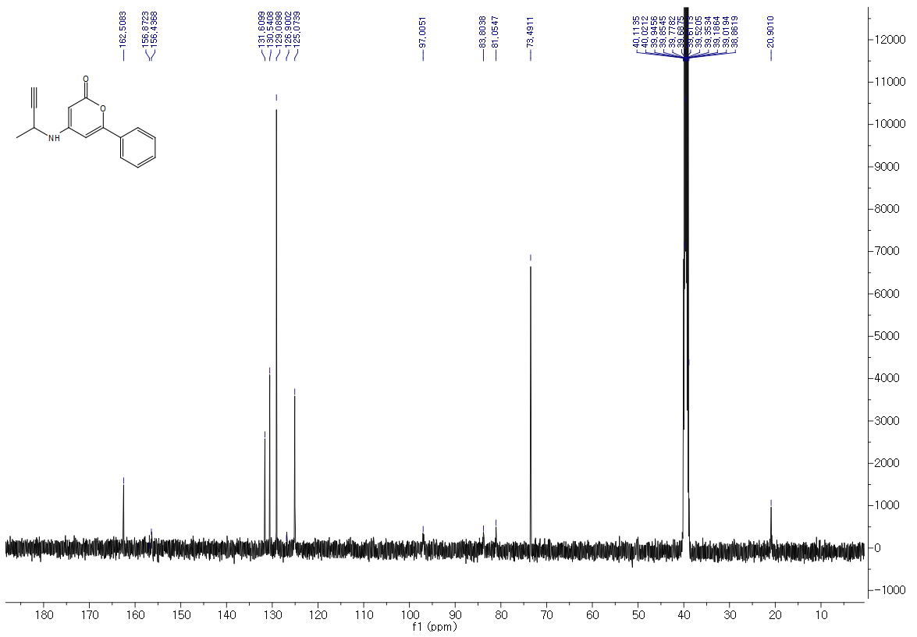
¹H-NMR Spectra of 3d (500 MHz, DMSO-d₆)
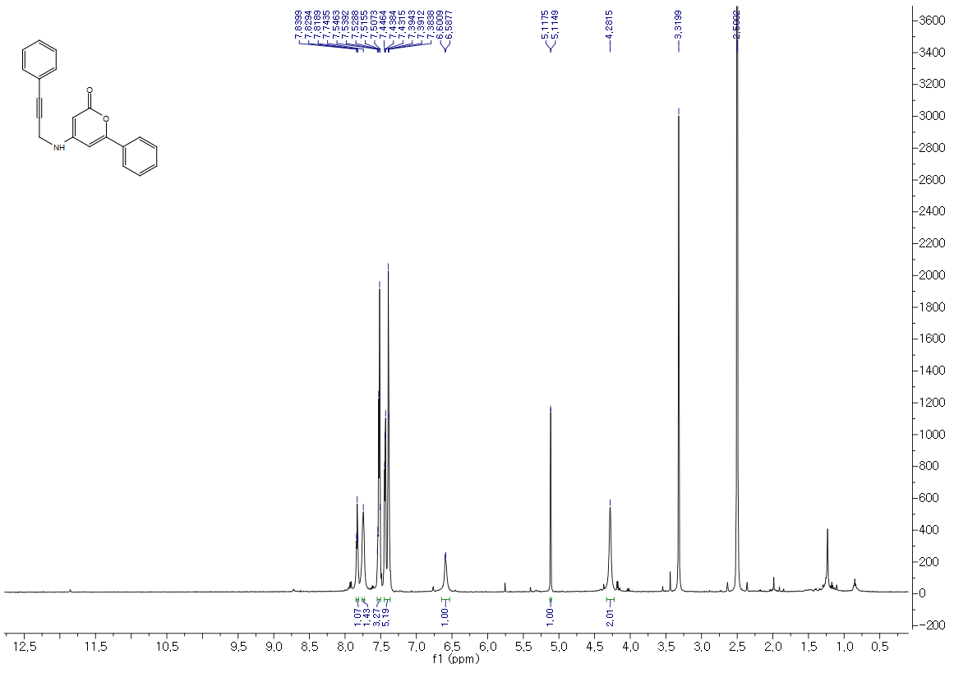
¹³C-NMR Spectra of 3d (125 MHz, DMSO-d₆)
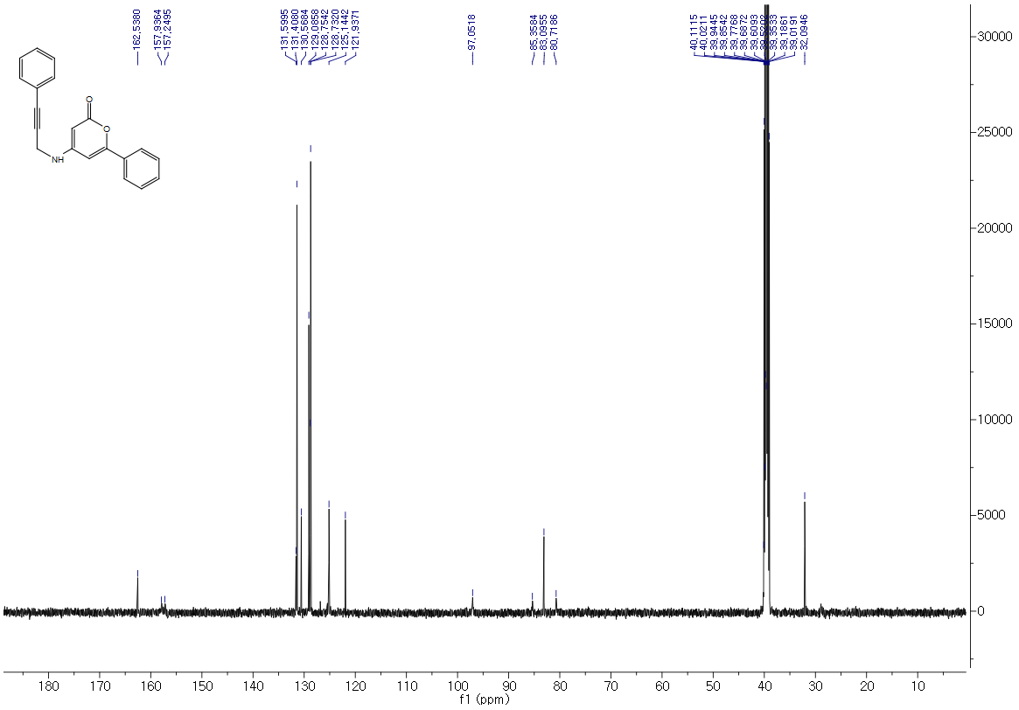
¹H-NMR Spectra of 3e (800 MHz, DMSO-d₆)
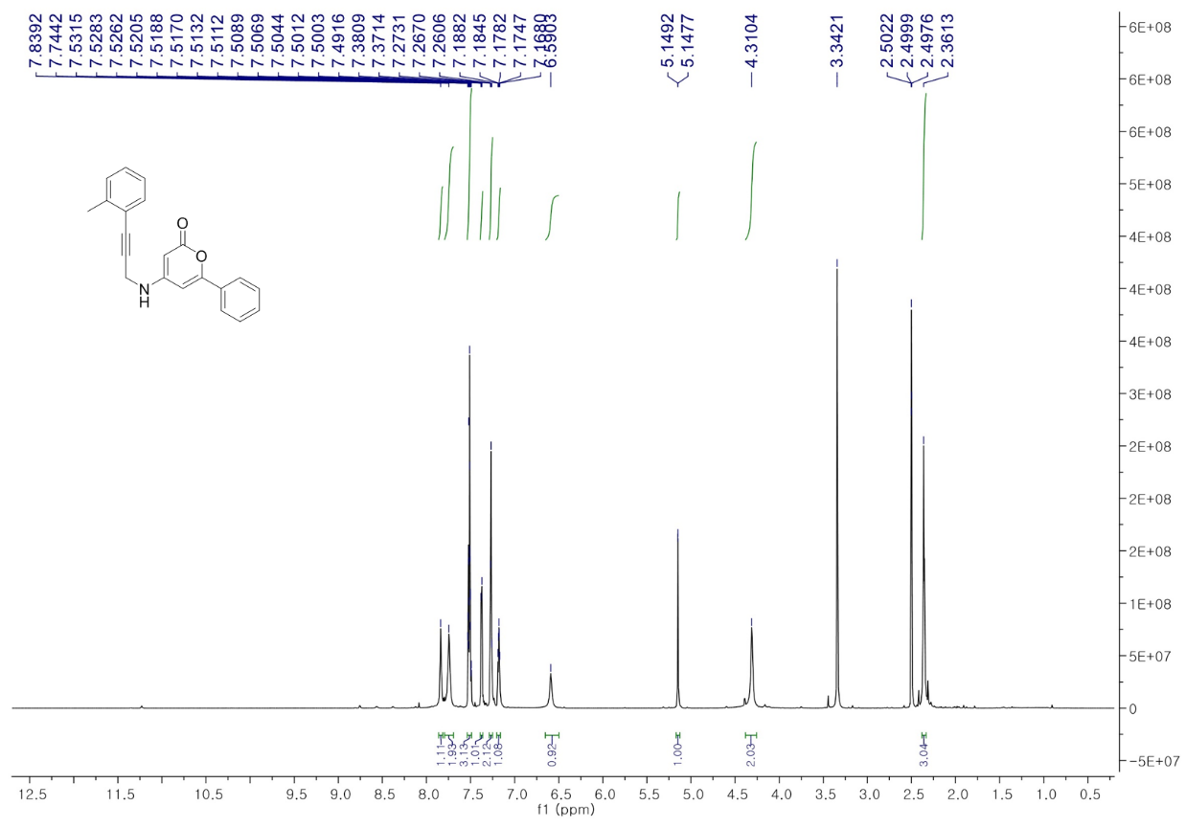
¹³C-NMR Spectra of 3e (200 MHz, DMSO-d₆)
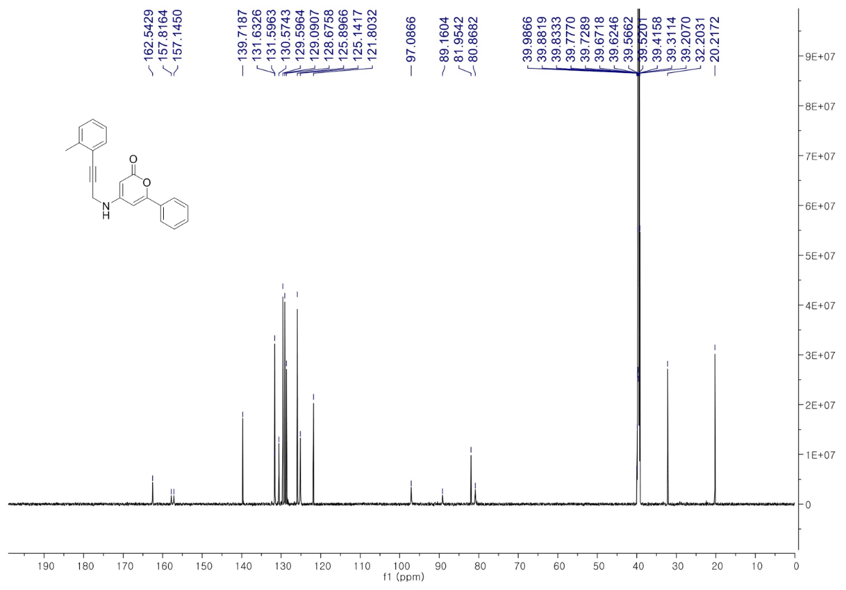
¹H-NMR Spectra of 3g (800 MHz, DMSO-d₆)
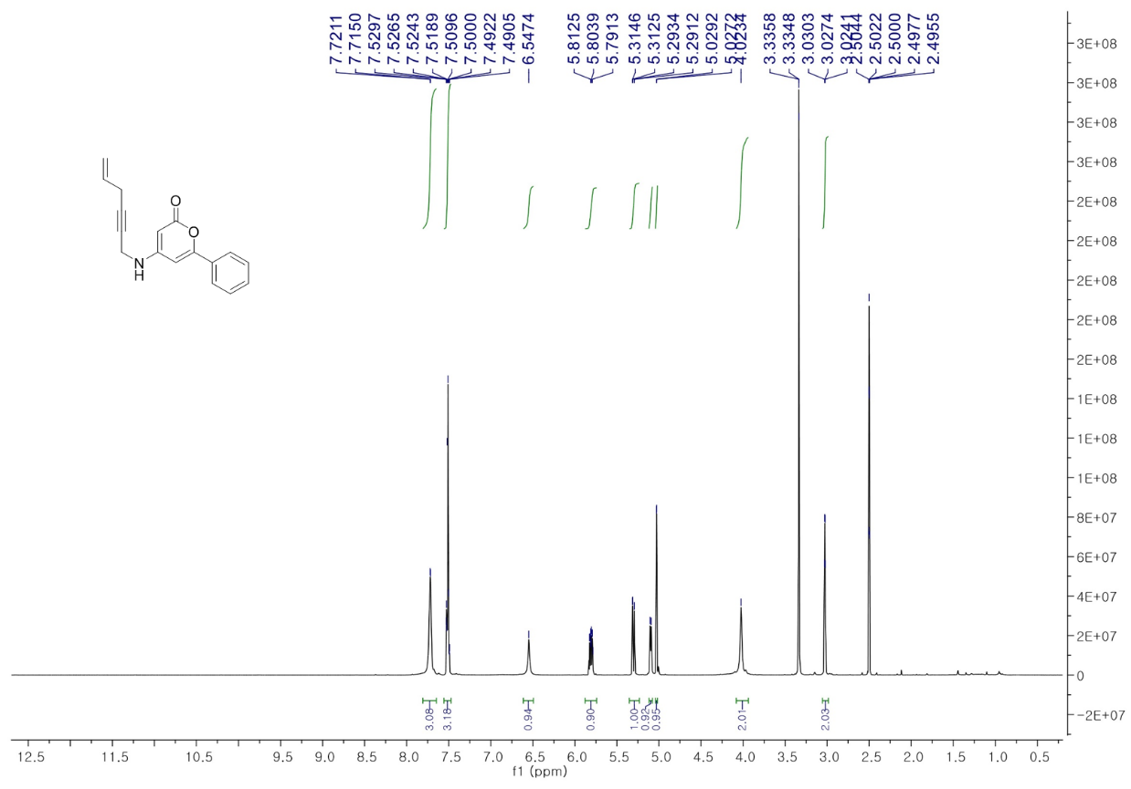
¹³C-NMR Spectra of 3g (200 MHz, DMSO-d₆)
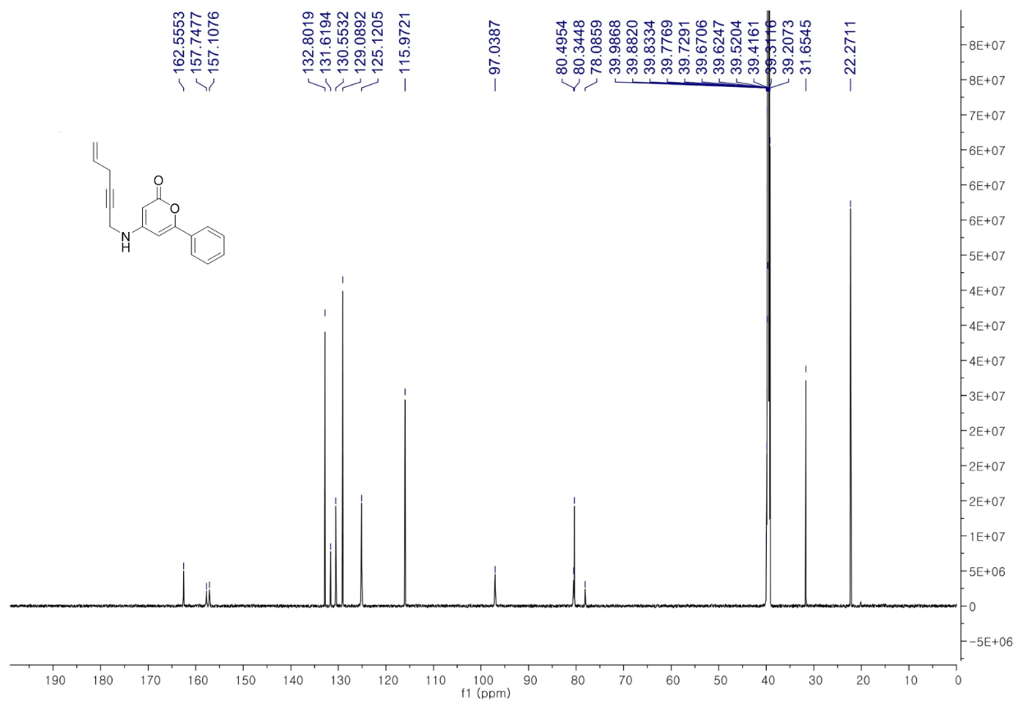
¹H-NMR Spectra of 3h (800 MHz, DMSO-d₆)
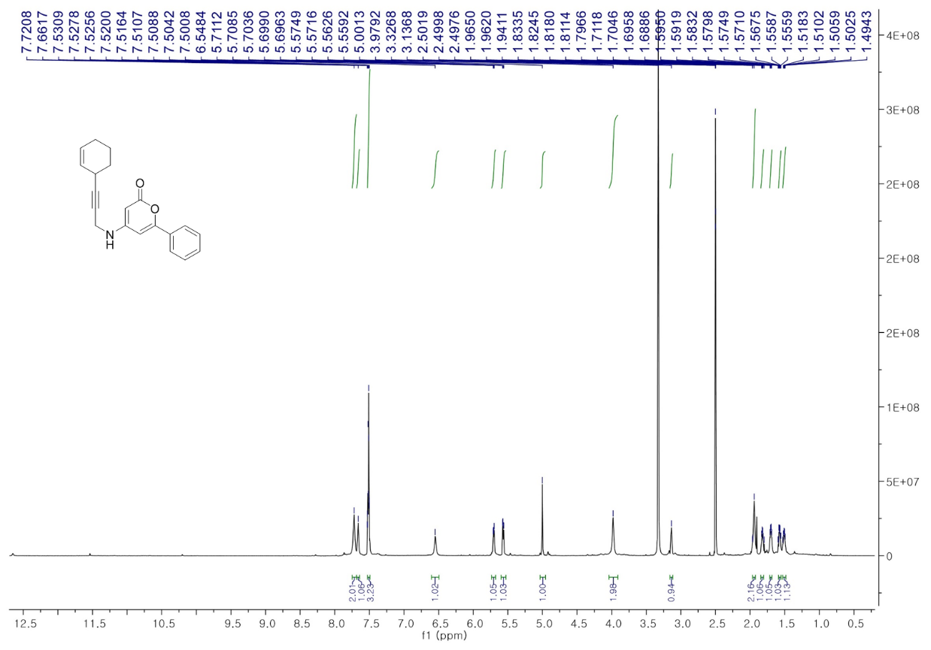
¹³C-NMR Spectra of 3h (200 MHz, DMSO-d₆)
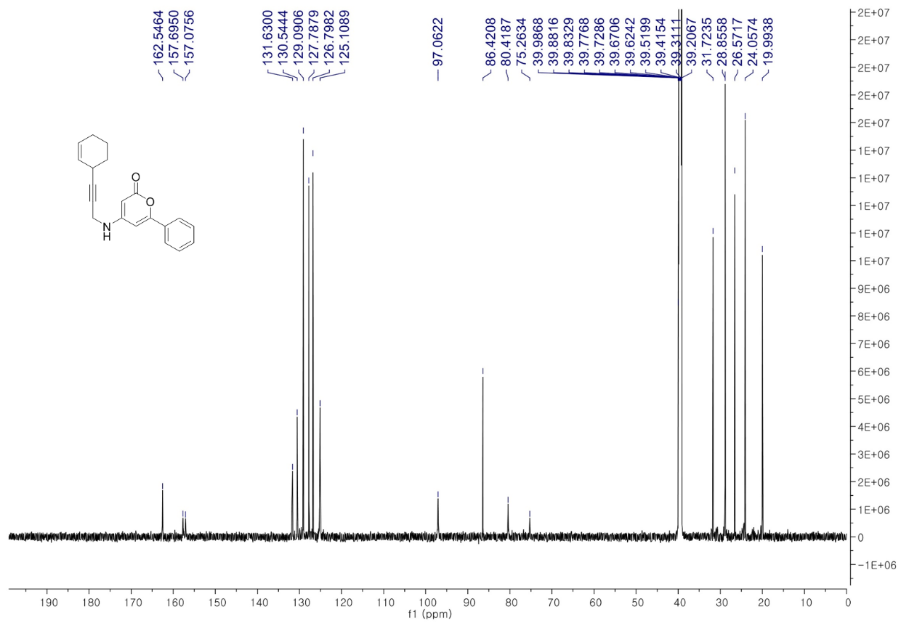
¹H-NMR Spectra of 3i (800 MHz, DMSO-d₆)
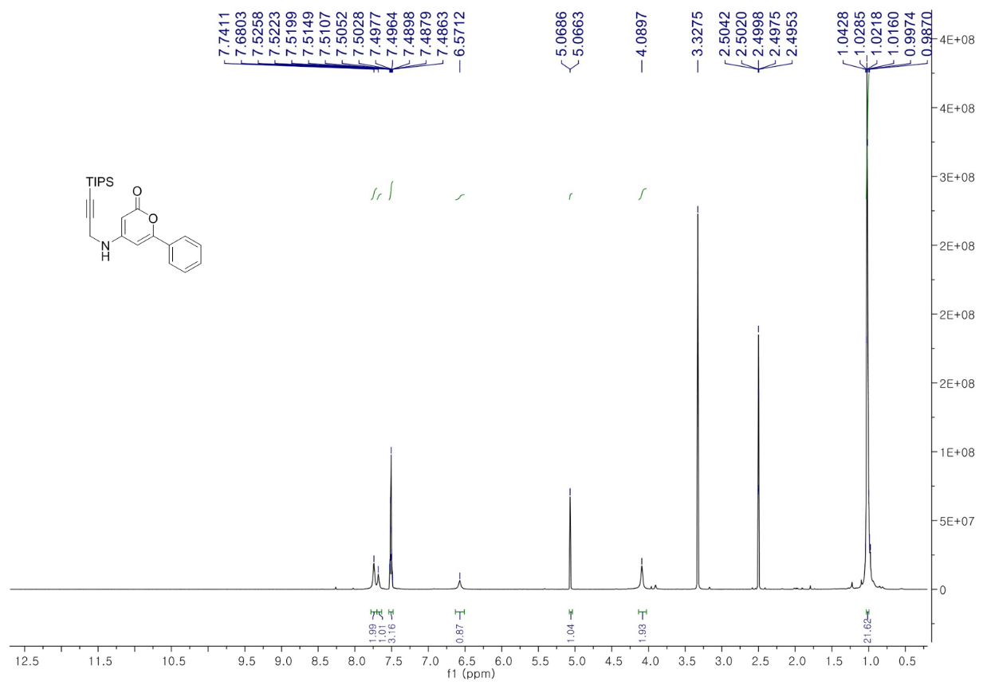
¹³C-NMR Spectra of 3i (200 MHz, DMSO-d₆)
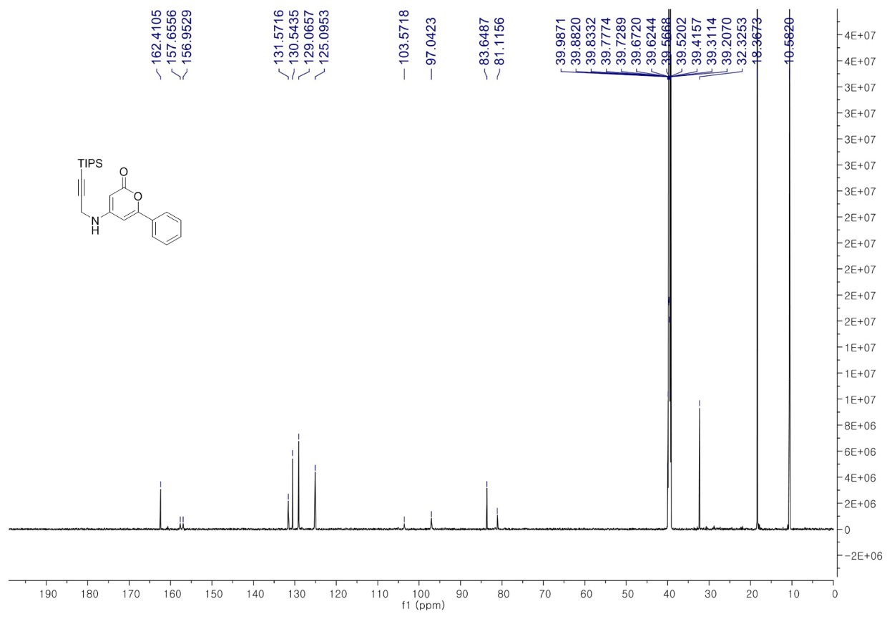
¹H-NMR Spectra of 4a (800 MHz, CDCl₃)
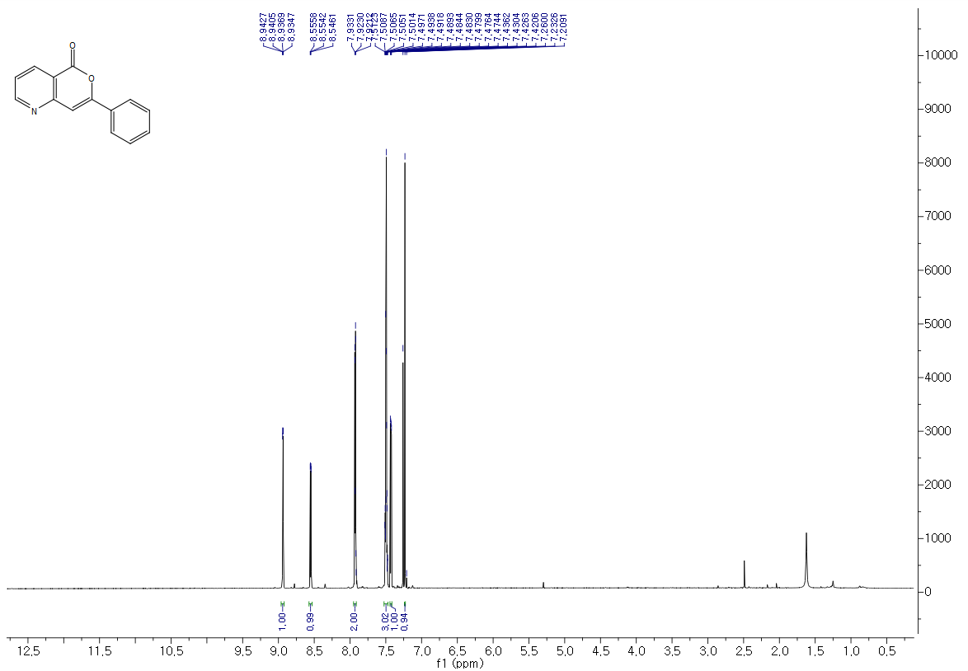
¹³C-NMR Spectra of 4a (125 MHz, CDCl₃)
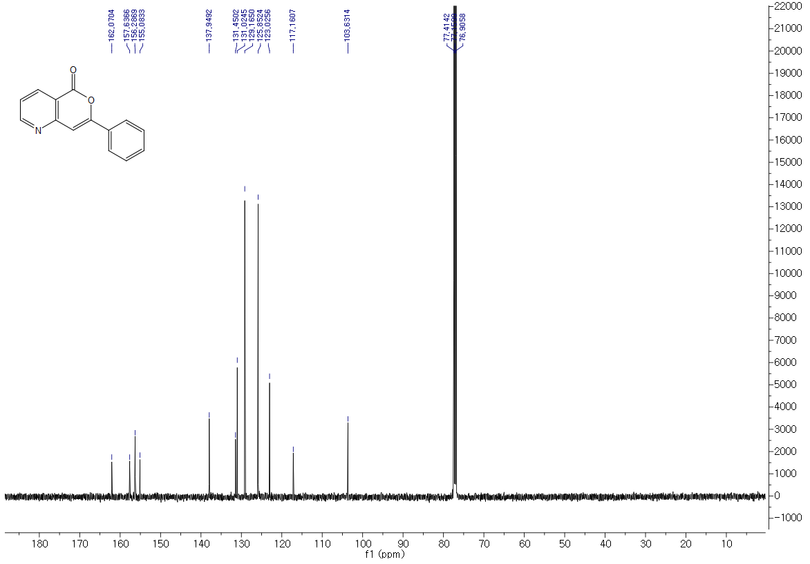
¹H-NMR Spectra of 4b (500 MHz, CDCl₃)
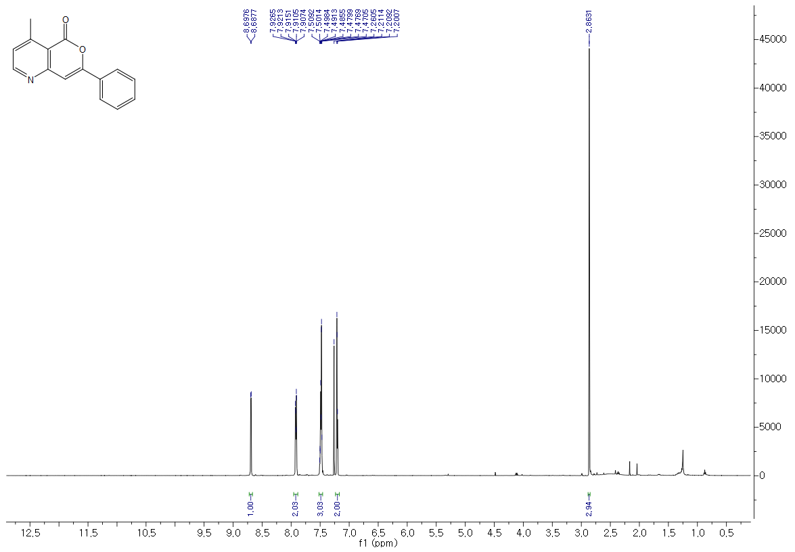
¹³C-NMR Spectra of 4b (125 MHz, CDCl₃)
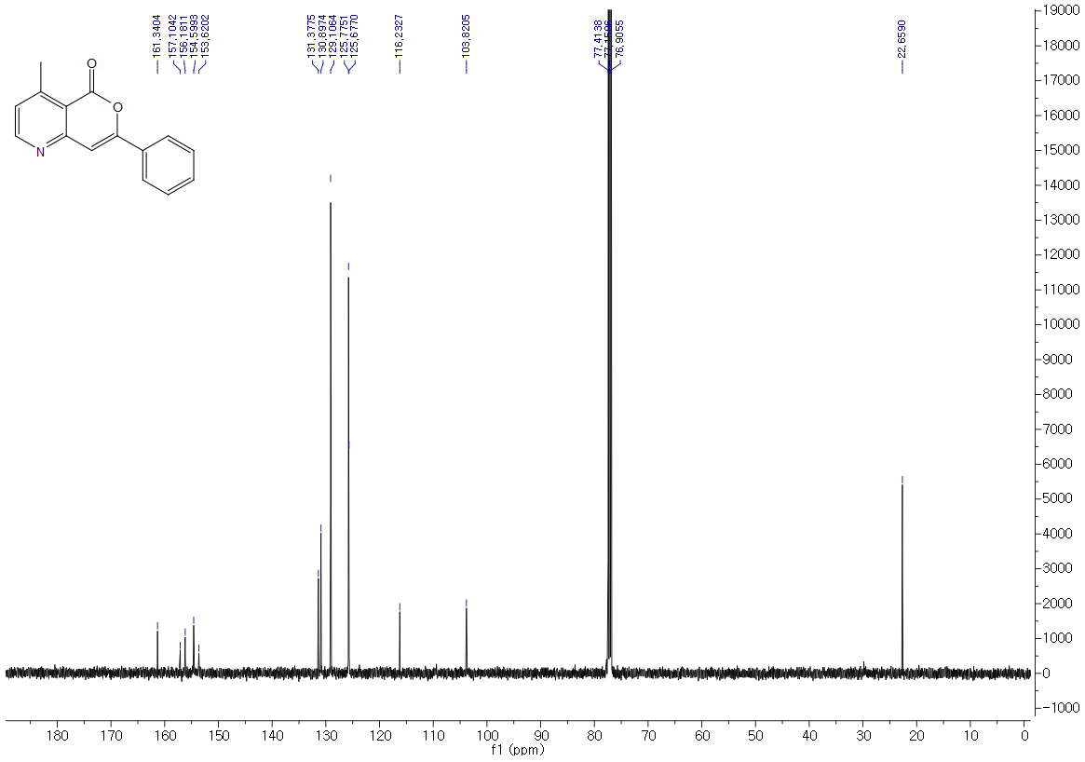
¹H-NMR Spectra of 4c (500 MHz, CDCl₃)
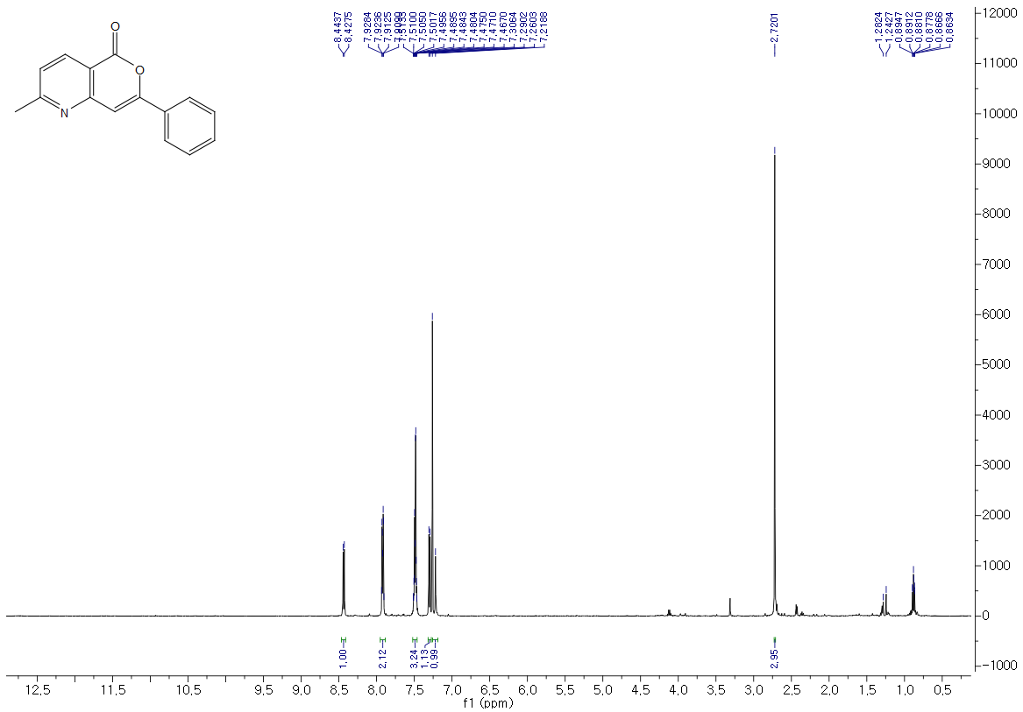
¹³C-NMR Spectra of 4c (125 MHz, CDCl₃)
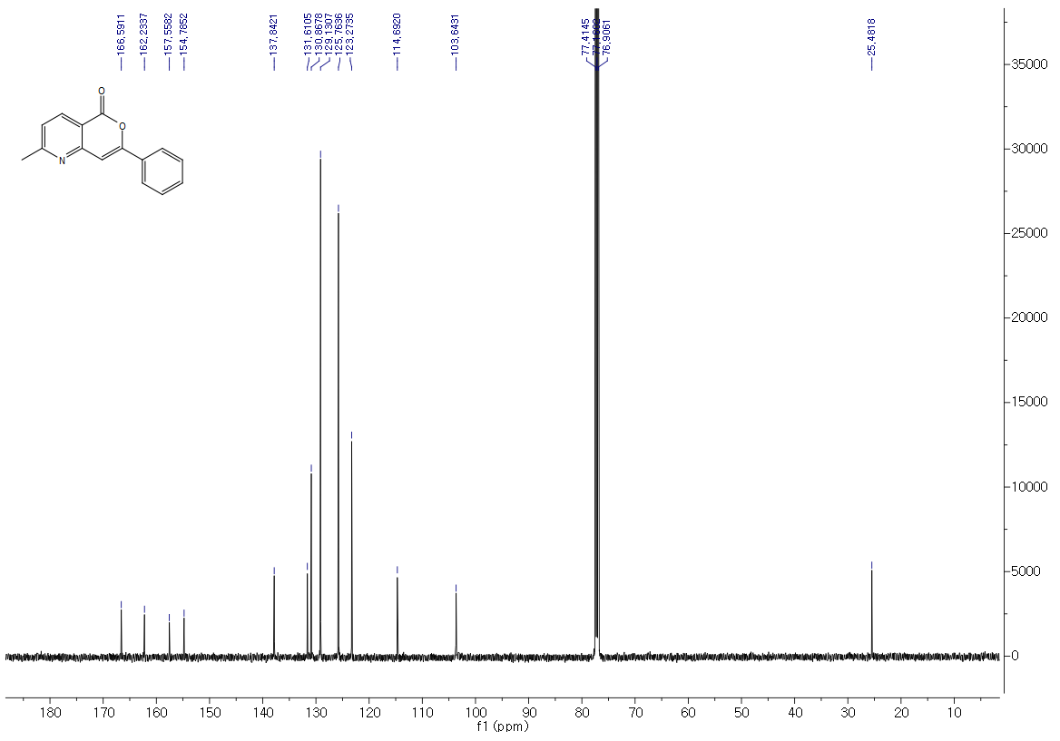
¹H-NMR Spectra of 4d (500 MHz, CDCl₃)
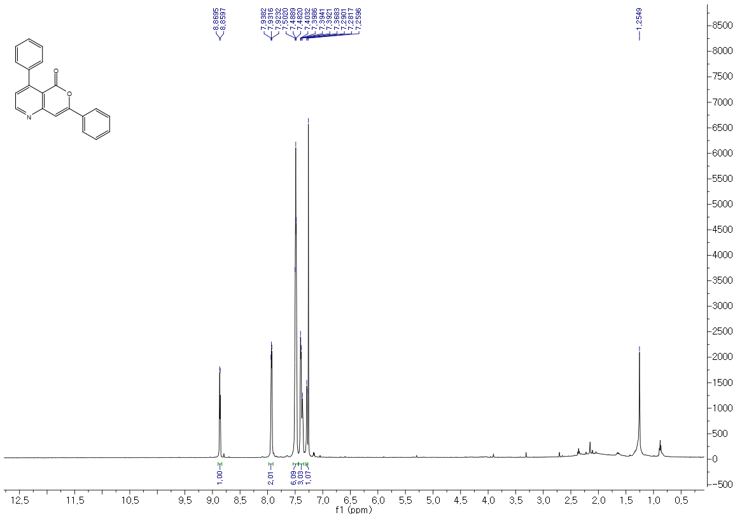
¹³C-NMR Spectra of 4d (125 MHz, CDCl₃)
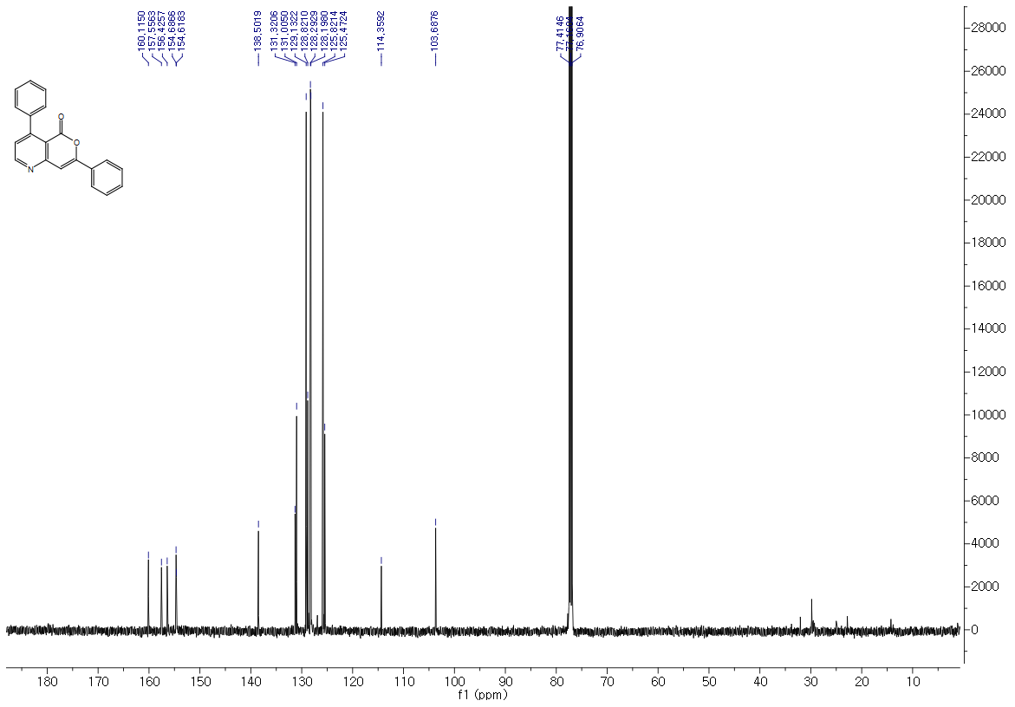
¹H-NMR Spectra of 4e (800 MHz, CDCl₃)
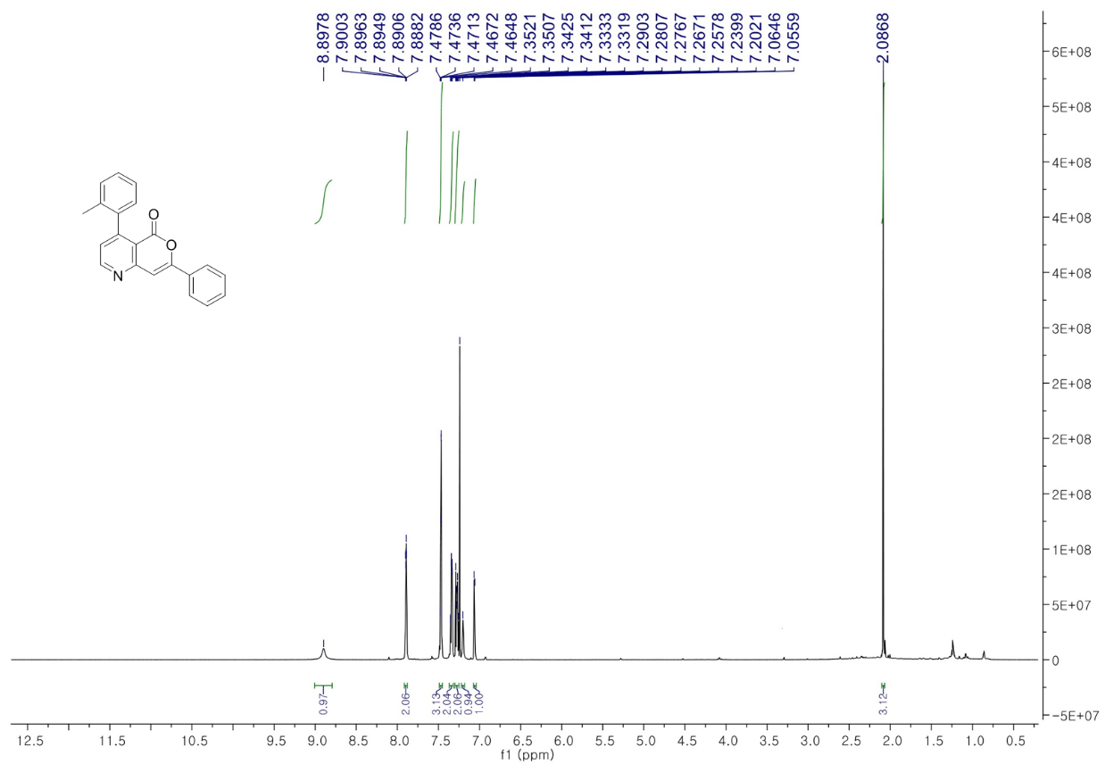
¹³C-NMR Spectra of 4e (200 MHz, CDCl₃)
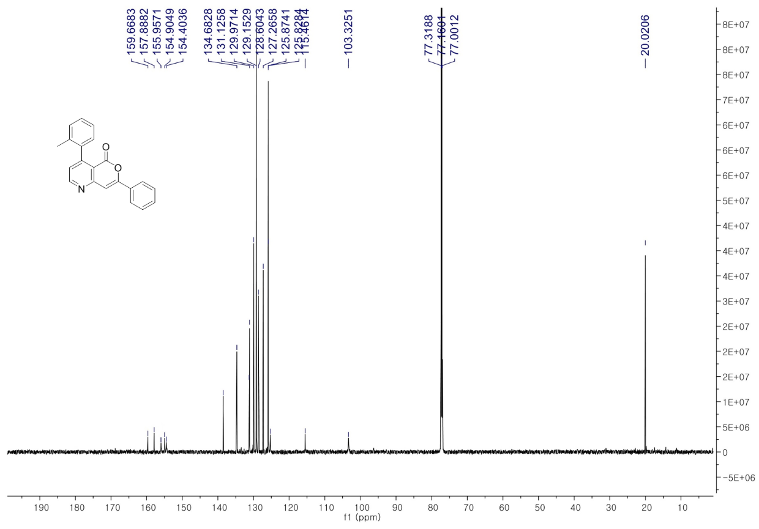
¹H-NMR Spectra of 4f (800 MHz, DMSO-d₆)
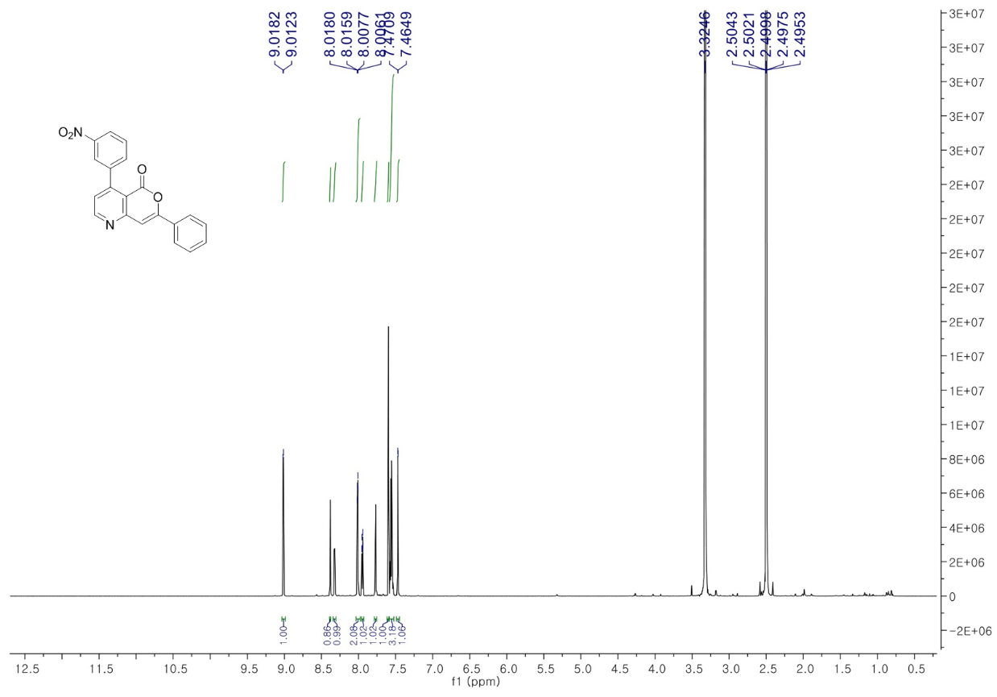
¹³C-NMR Spectra of 4f (200 MHz, DMSO-d₆)
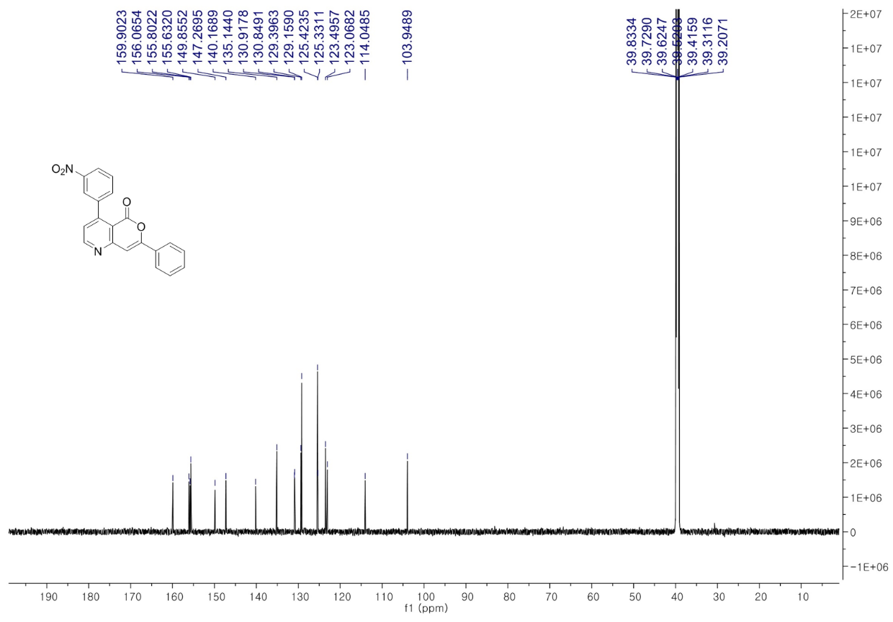

References
Balducci, E., Bellucci, L., Petricci, E., Taddei, M., and Tafi, A. (2009). Microwave-assisted intramolecular Huisgen cycloaddition of azido alkynes derived from α-amino acids. J. Org. Chem. 74, 1314-1321. doi: 10.1021/jo802463r
Cui, X.-Y., Ge, Y., Tan, S. M., Jiang, H., Tan, D., Lu, Y., et al. (2018). (Guanidine)copper complex-catalyzed enantioselective dynamic kinetic allylic alkynylation under biphasic condition. J. Am. Chem. Soc. 140, 8448-8455. doi: 10.1021/jacs.7b12806
Mons, E., Jansen, I. D., Loboda, J., van Doodewaerd, B. R., Hermans, J., Verdoes, M., et al. (2019). The alkyne moiety as a latent electrophile in irreversible covalent small molecule inhibitors of cathepsin K. J. Am. Chem. Soc. 141, 3507-3514. doi: 10.1021/jacs.8b11027
Nishizawa, R., Nishiyama, T., Hisaichi, K., Hirai, K., Habashita, H., Takaoka, Y., et al. (2010). Discovery of orally available spirodiketopiperazine-based CCR5 antagonist. Bioorg. Med. Chem. 18, 5208-5223. doi: 10.1016/j.bmc.2010.05.057
Sakthivel, S., Sharma, A., and Balamurugan, R. (2017). Silver‐catalyzed synthesis of substituted pyridine derivatives from N‐propargylic α‐enamino esters. Eur. J. Org. Chem. 3941–3946. doi: 10.1002/ejoc.201700559
Prasad, J. V., Para, K. S., Tummino, P. J., Ferguson, D., McQuade, T. J., Lumney, E. A., et al. (1995). Nonpeptidic potent HIV-1 protease inhibitors:(4-hydroxy-6-phenyl-2-oxo-2H-pyran-3-yl) thiomethanes that span P₁-P₂' subsites in a unique mode of binding. J. Med. Chem. 38, 898–905. doi: 10.1021/jm00006a007
Uredi, D., Motati, D.R., and Watkins, E.B. (2019). A simple, tandem approach to the construction of pyridine derivatives under metal-free conditions: A one-step synthesis of the monoterpene natural product, (−)-actinidine. Chem. Commun. 55, 3270-3273. doi: 10.1039/c9cc01097a
Uredi, D., Motati, D.R., and Watkins, E.B. (2018). A unified strategy for the synthesis of β-carbolines, γ-carbolines, and other fused azaheteroaromatics under mild, metal-free conditions. Org. Lett. 20, 6336-6339. doi: 10.1021/acs.orglett.8b02441
Valverde, I. E., Delmas, A. F., and Aucagne, V. (2009). Click à la carte: Robust semi-orthogonal alkyne protecting groups for multiple successive azide/alkyne cycloadditions. Tetrahedron 65, 7597-7602. doi: 10.1016/j.tet.2009.06.093

