VOPO₄·2H₂O: Large-Scale Synthesis and Zinc-Ion Storage Application
Supplementary Material
Xianghua Zhang¹, Dan Yang¹, Weiling Liu², Xianhong Rui^{1*}
¹School of Materials and Energy, Guangdong University of Technology, Guangzhou 510006
²School of Materials Science and Engineering, Nanyang Technological University, Singapore, 639798
* Correspondence:
Corresponding Author
xhrui@gdut.edu.cn (X. Rui)
Supplementary Figure 1. The high-resolution XPS spectra of P2p and O1s in the VOPO₄·2H₂O sample.
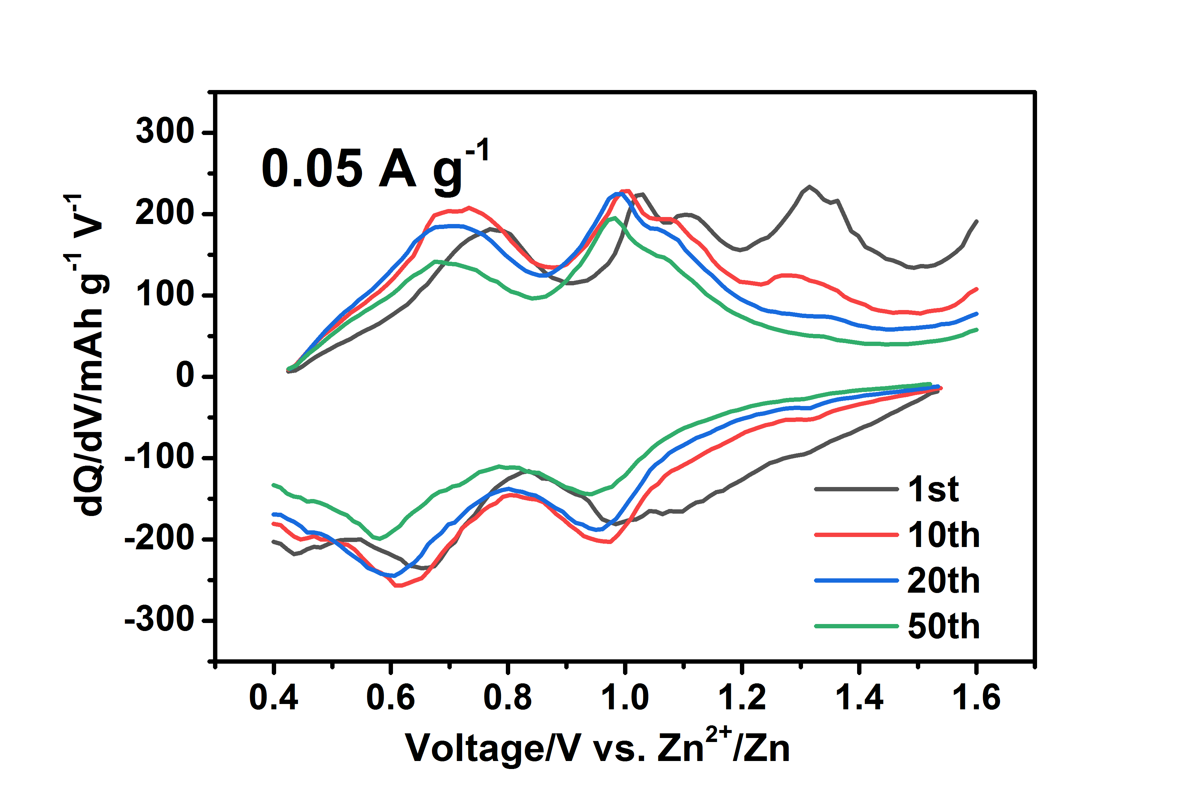
Supplementary Figure 2. The associated differential capacity curves of the VOPO₄·2H₂O sample at low current density of 0.05 A g⁻¹.

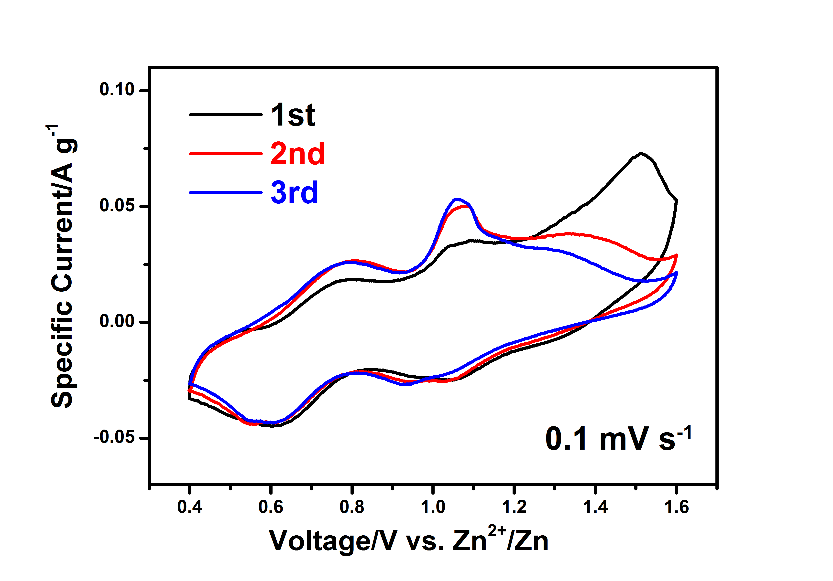
Supplementary Figure 3. The CV curves of the VOPO₄·2H₂O sample at a scan rate of 0.1 mV s⁻¹.

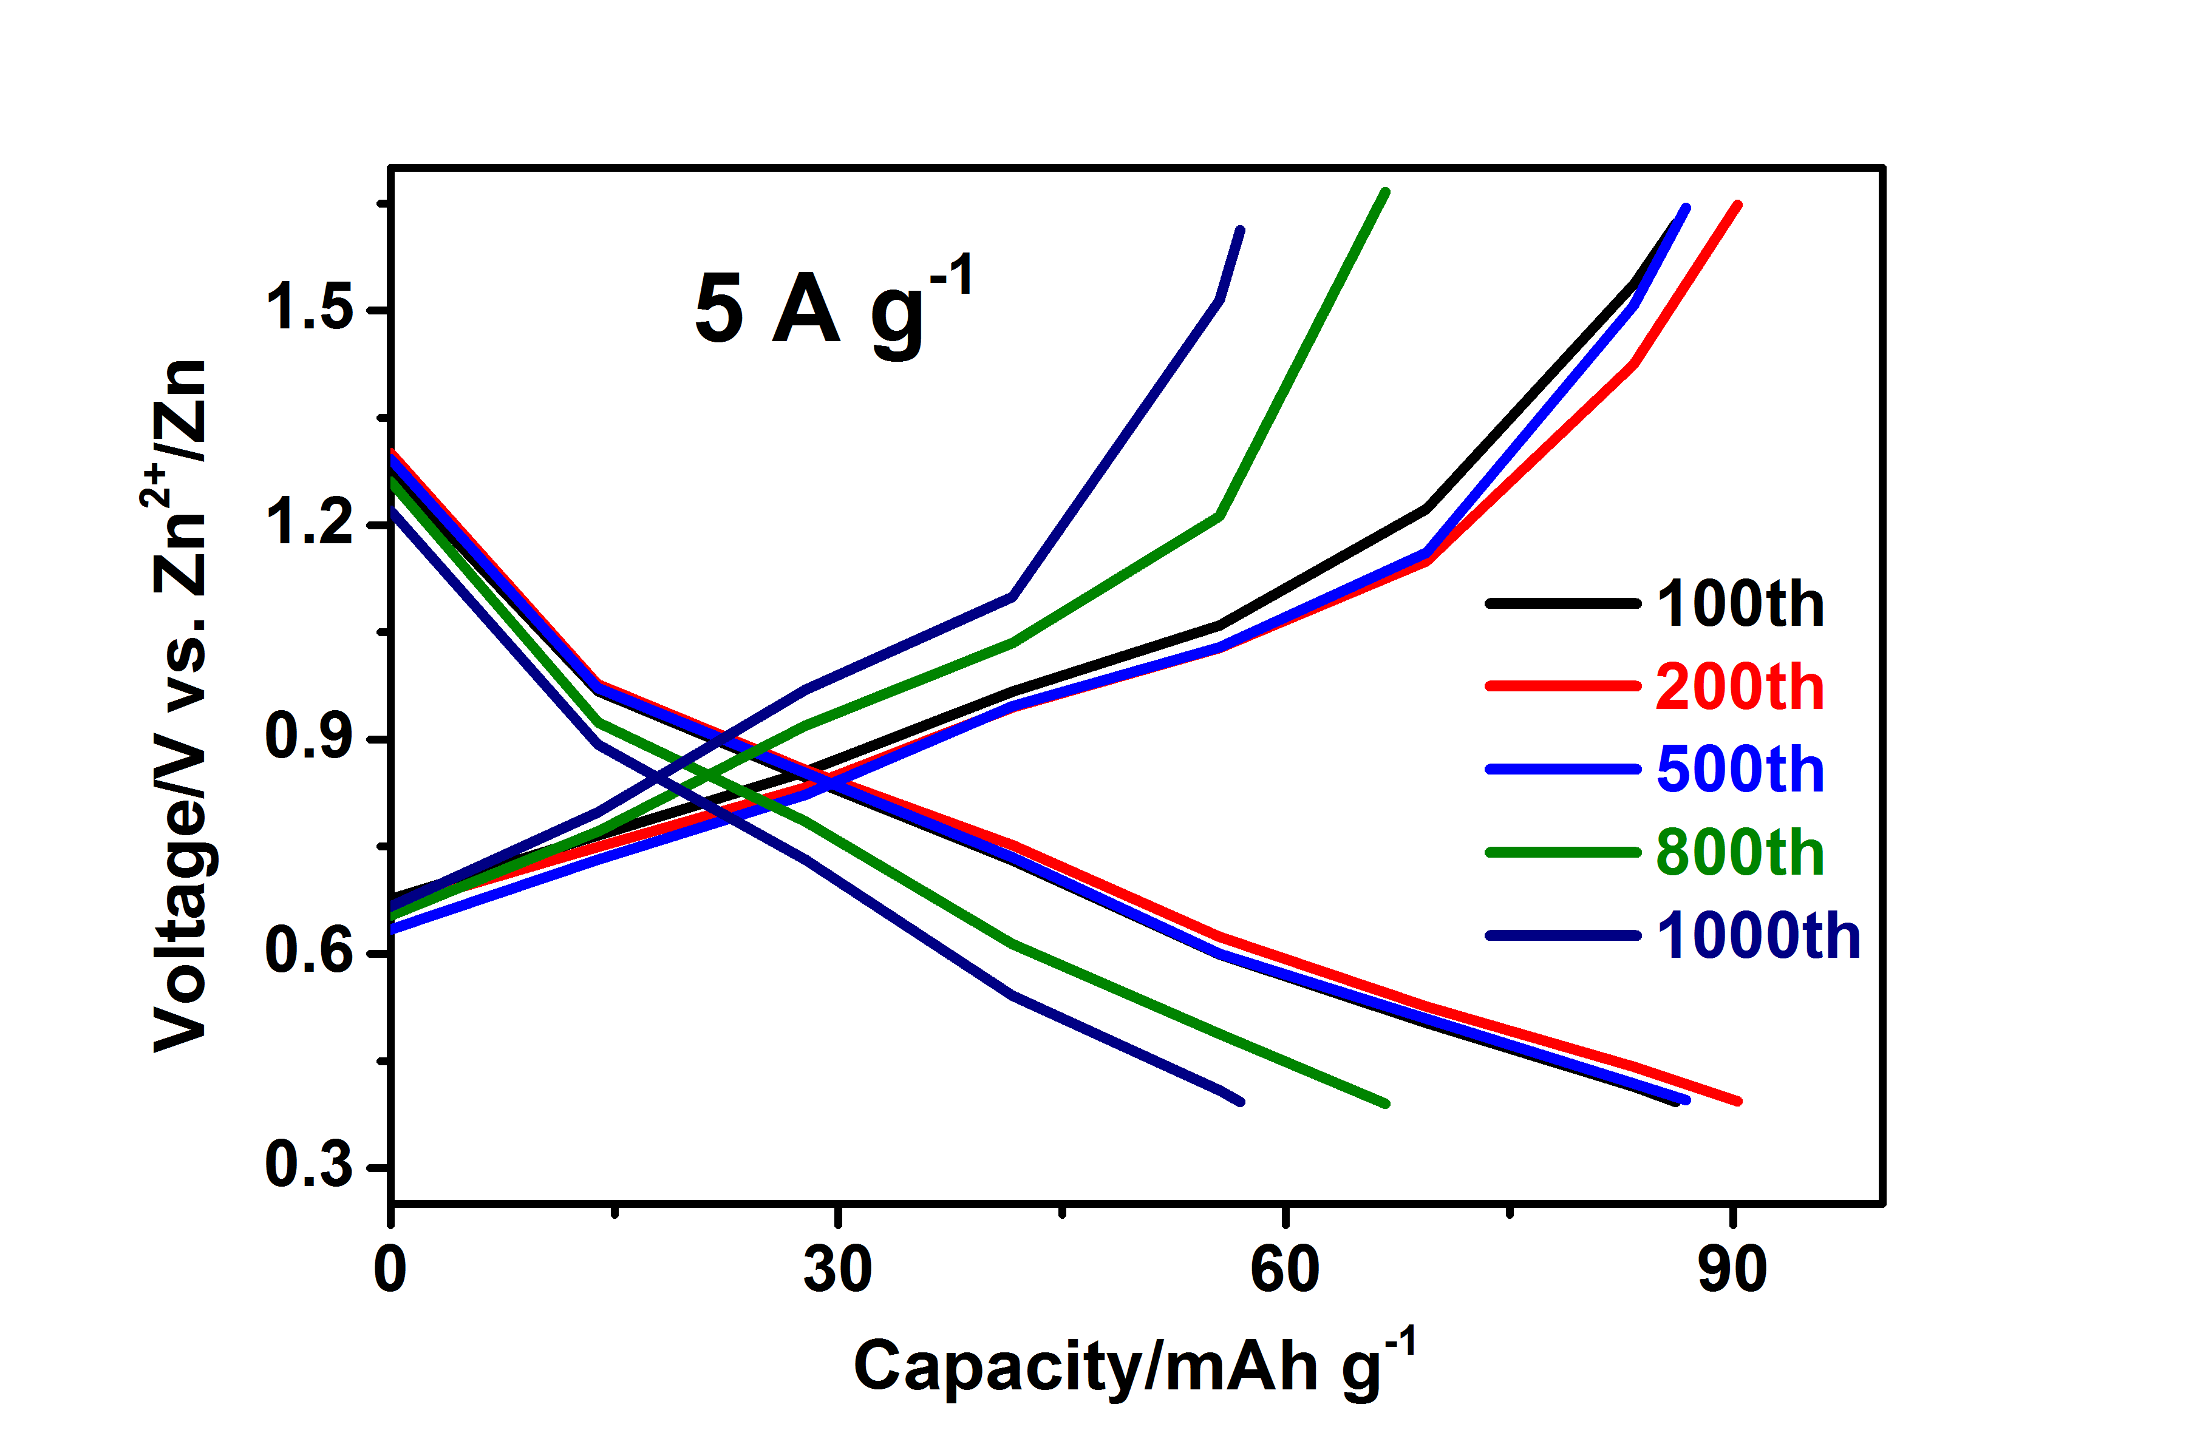
Supplementary Figure 4. The galvanostatic charge-discharge curves of the VOPO₄·2H₂O sample at high current density of 5 A g⁻¹.

