Genetic Dissection of Growth Traits in a Unique Chicken Advanced Intercross Line
Yuzhe Wang^{1,2†}, Lina Bu^{2†}, Xuemin Cao², Hao Qu³, Chunyuan Zhang², Jiangli Ren², Zhuolin Huang², Yiqiang Zhao², Chenglong Luo^{3*}, Xiaoxiang Hu^{2*}, Dingming Shu³, Ning Li²
1. College of Animal Science and Technology, China Agricultural University, Beijing 100193, China
2. State Key Laboratory of Agrobiotechnology, College of Biological Sciences, China Agricultural University, Beijing 100193, China
3. State Key Laboratory of Livestock and Poultry Breeding, Guangdong Key Laboratory of Animal Breeding and Nutrition, Institute of Animal Science, Guangdong Academy of Agricultural Sciences, Guangzhou 510640, China
† These authors have contributed equally to this work.
* Corresponding author:
Xiaoxiang Hu, Email: huxx@cau.edu.cn.
Chenglong Luo, Email: chenglongluo1981@163.com

Supplementary Figure

Supplementary Figure 1 Chromosome-wise SNP density in the GBS panel in physical distance

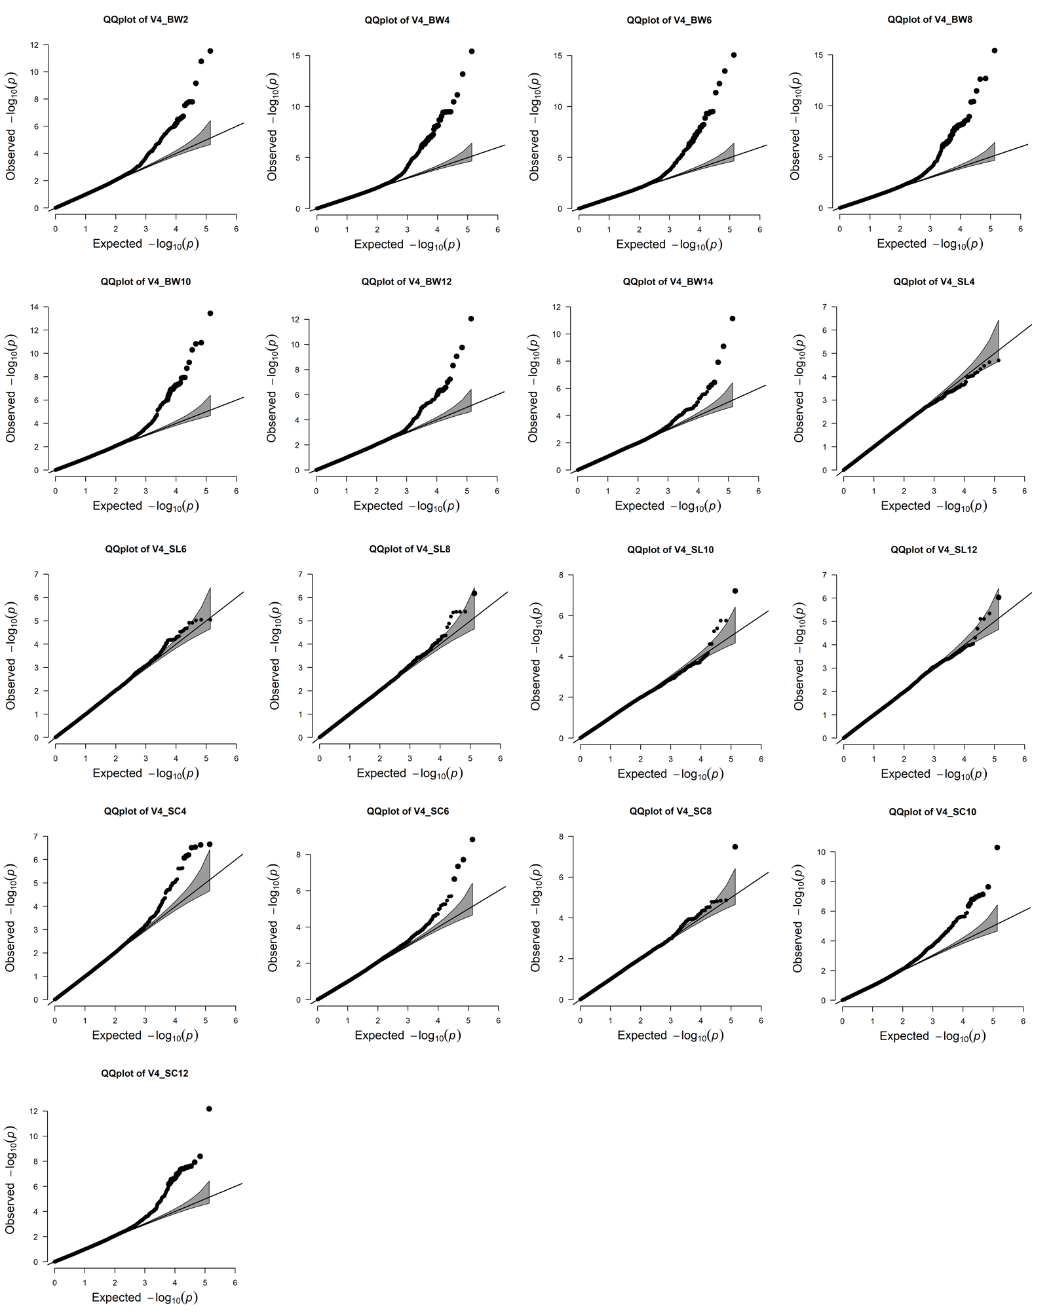
Supplementary Figure 2 Quantile-quantile (Q-Q) plot of all 17 traits

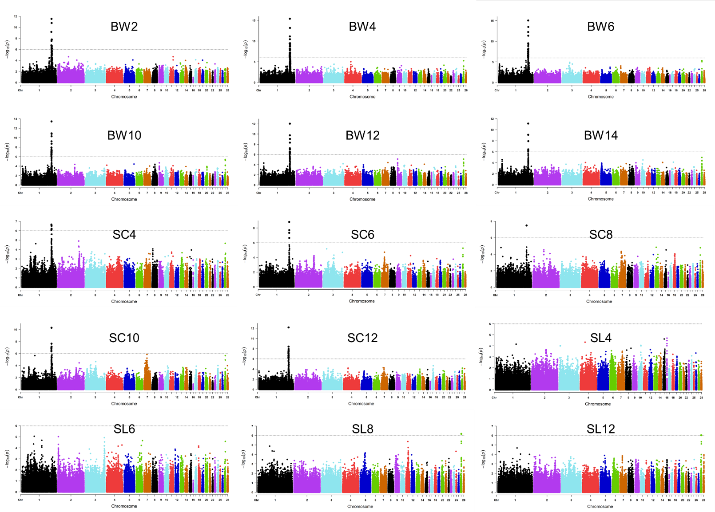
Supplementary Figure 3 The Manhattan plots for 15 traits. Phenotypes including BW2 to BW6, BW10 to BW14, SC4 to SC12, SL4 to SL8 and SL12. The genome-wide 5% significance threshold -log₁₀P was 5.99.

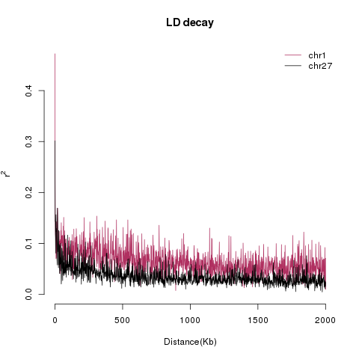
Supplementary Figure 4 LD decay near two QTL interval. The red line represents the LD pattern of GGA1: 168-171 Mb (543 SNPs) and the black line represents the LD pattern of GGA27: 2.16-5.16 Mb (391 SNPs).

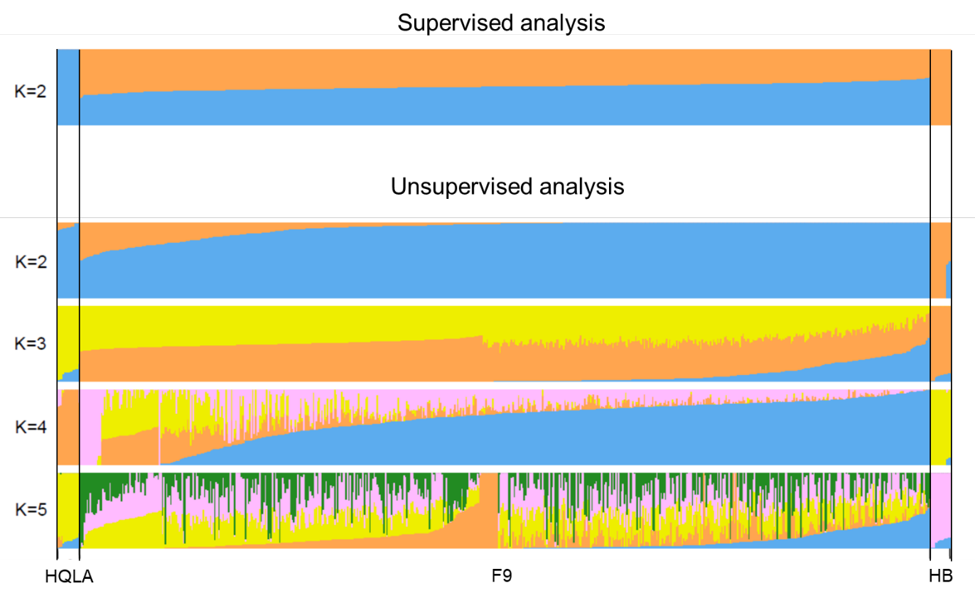

Supplementary Figure 5 Analysis of population structure of F₀ and F₉. Supervised analysis showed that all F₉ individuals were clustered in the middle of the two founders. Unsupervised analysis showed K=3 is the best model that consistent with the breeding process of HQLA and F₉ cross.

