Supplementary Material

Appendix A

Practice Session of the experiment
The Practice Session included two sub-sessions: (1) a key learning session to ensure the participant was able to correctly associate a given response with a specific emotional state; (2) the facial emotion recognition session. The “D”, “F”, “H”, “J” and “K” keys of an AZERTY keyboard were re-labeled with stickers as follows: “C” (for “Colère”= anger in French); “P” (for “Peur” = fear); “N” (for “Neutre” = neutrality), “T” (for “Tristesse” = sadness), and “J” (for “Joie” = happiness). The key learning session consisted of a minimum of 30 trials with one emotional state word displayed randomly in the center of a screen to which participants responded by pressing the corresponding key. After each five-trial block, the average response accuracy was displayed (in %). This key learning session ended when participants reached 100% accuracy over five successive blocks, after, which the facial emotion recognition practice session began. There were two blocks, i) inverted and upright sketched faces; ii) inverted and upright photographed faces. Block order was randomized. After each block of five trials, the average response accuracy (in %) was displayed. The practice trials consisted of 40 images for the sketched and photographed face blocks: 2 Expressors x 2 Orientation (inverted vs. upright) x 2 Stimulus type (photographs vs. sketches) x 5 Facial expression. The stimuli used in the practice sessions were excluded from the experimental session. The participants obtaining less than 75% accuracy during the practice session did not take part in the experimental session.

Appendix B

Analysis of the individual Diffusion Decision Model fits
Predicted and empirical cumulative density functions (CDFs) of reaction times were computed for each participant separately, using Fast-dm (see Supplementary Figure 1A). In addition to the p values of model fitting provided by Fast-dm, we assessed statistically the overall quality of individual DDM model fits. Therefore, we computed the linear regression adjusted to the predicted CDFs values as a function of the empirical CDFs values for correct response RTs (see Supplementary Figure 1B). Table 1 summarizes the regression statistics that proved to be satisfactory with R² values greater than 0.98.
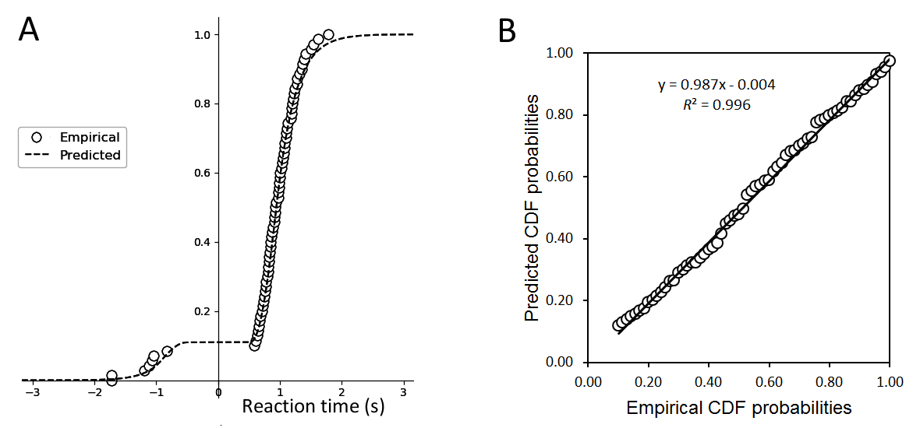
Supplementary Figure 1. Example of the data for one participant, in the inverted photographed faces condition. (A) Fast-dm plot of predicted and empirical CDFs as a function of RTs with negative signs assigned to error responses (Voss, Nagler, et al., 2013; Voss & Voss, 2007). (B) Linear fit adjusted to the predicted CDFs values plotted against the empirical CDFs values for correct response RTs.

Predicted vs empirical CDFs regressions | Photographed faces |  | Sketched faces
 | Upright | Inverted | Upright | Inverted
Mean individual R² | 0.9916 | 0.9910 | 0.9920 | 0.9873
95% CI | [0.9888; 0.9944] | [0.9886; 0.9934] | [0.9899; 0.9941] | [0.9849; 0.9898]
Mean slope | 0.9873 | 0.9872 | 0.9816 | 0.9687
95% CI | [0.9798; 0.9949] | [0.9770; 0.9973] | [0.9720; 0.9912] | [0.9566; 0.9808]
p values, slope vs 1 | 0.002 | 0.016 | 0.001 | 0.000
Mean intercept | 0.0011 | -0.0007 | 0.0021 | 0.0100
95% CI | [-0.0054; 0.0076] | [-0.0059; 0.0046] | [-0.0044; 0.0087] | [0.0014; 0.0186]
ps, intercept vs 0 | 0.729 | 0.800 | 0.512 | 0.024
Supplementary Table 1. Summary of the linear regression statistics on the CDF values for correct response RTs.

Some predicted values were slightly underestimated with respect to the empirical values. This is evidenced by the mean slope values (of the predicted vs. empirical CDFs regressions) ranging between 0.95 and 1 (see 95% CI values in Table 1), and by a graphical analysis of model fit. Supplementary Figure 2 and 3 show the mean predicted values (y-axis) of the CDF of the RT distributions plotted against mean empirical values (x-axis), along the same lines as (Voss, Rothermund, et al., 2013, Appendix B). Most of the data points fell on the unity line, suggesting that there was no systematic bias in the DDM fits.
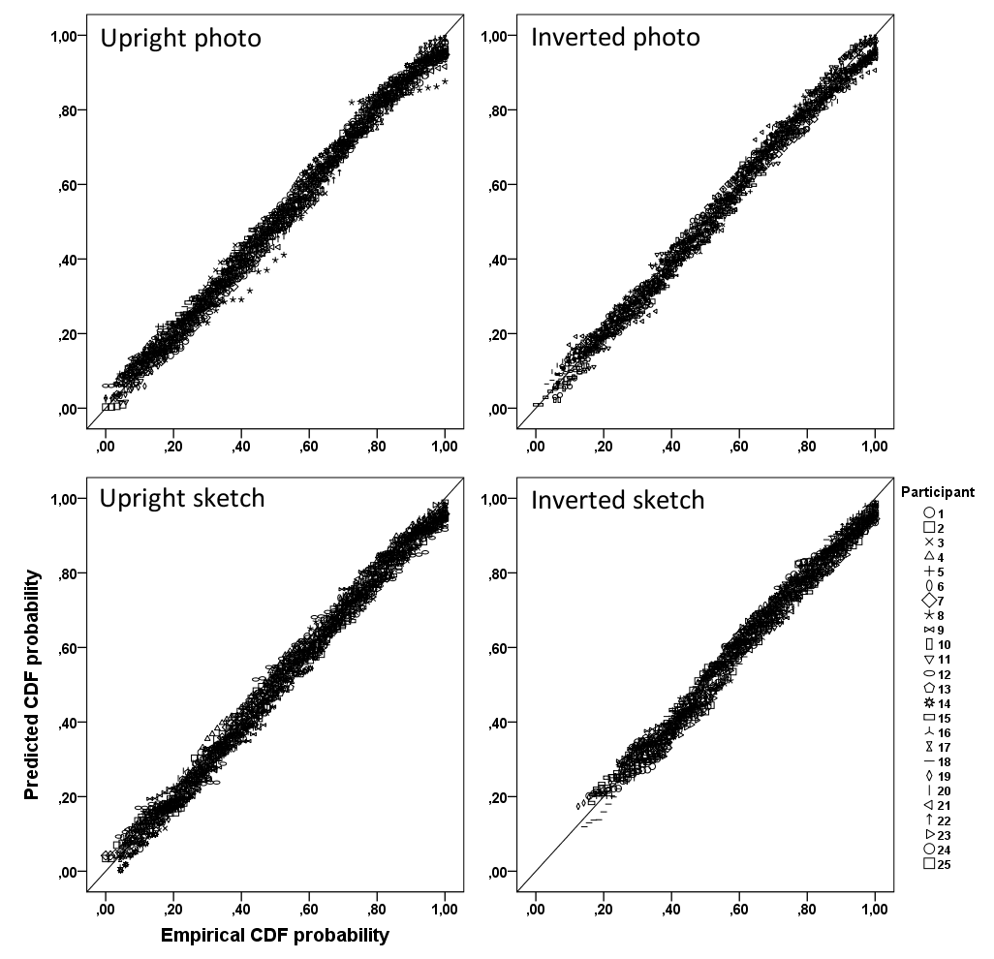
Supplementary Figure 2. Relation of the empirical vs predicted statistics (cumulative distribution function probability) of correct response RTs for each trial and experimental condition, across each participant. Each data point represents one trial.
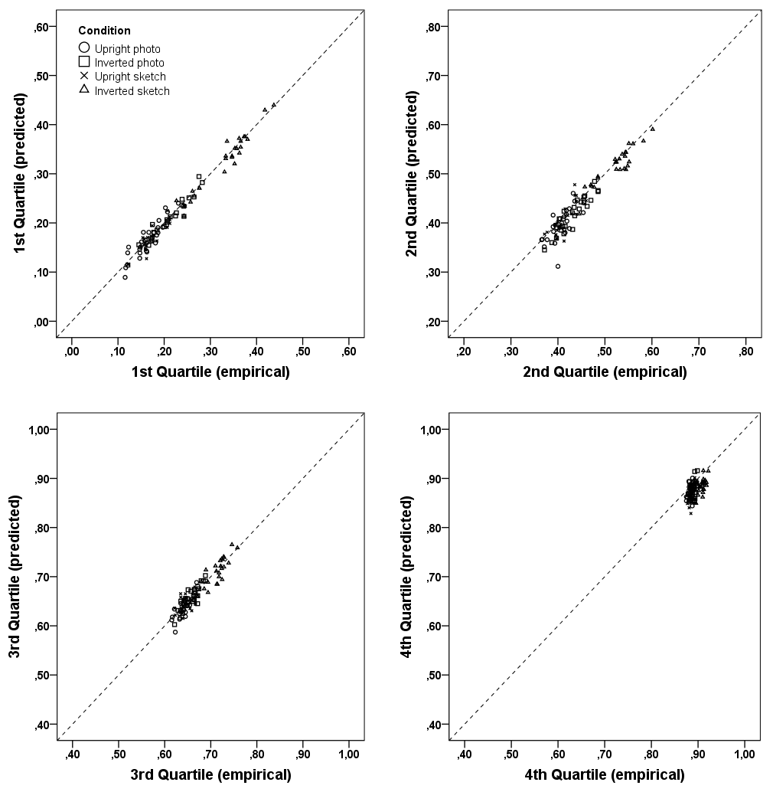
Supplementary Figure 3. Relation of the empirical vs predicted statistics (CDF probability) for each RT quartile of correct responses, across each experimental condition. Each data point represents the mean CDF probability of one participant in a given condition. Note that the more clustered data points for the 4th Quartile reflect the characteristics of the CDFs (see Supplementary Figure 1A) where greater RT values keep increasing while probability values are capped close to 1.

Appendix C

 |  |  |  | Pearson |  |  |  |  |  | Spearman
 |  |  |  | r | p | VS-MPR† | Lower 95% CI | Upper 95% CI |  | rho | p | VS-MPR† | Lower 95% CI | Upper 95% CI
v | - | t₀ |  | -0.242 | 0.091 | 1.691 | -0.487 | 0.039 |  | -0.287* | 0.044 | 2.688 | -0.523 | -0.009
v | - | P100_amp |  | 0.242 | 0.090 | 1.694 | -0.039 | 0.488 |  | 0.235 | 0.101 | 1.592 | -0.047 | 0.482
v | - | N170_amp |  | -0.221 | 0.124 | 1.424 | -0.470 | 0.061 |  | -0.270 | 0.058 | 2.216 | -0.510 | 0.009
v | - | P250_amp |  | 0.082 | 0.569 | 1.000 | -0.200 | 0.353 |  | 0.044 | 0.760 | 1.000 | -0.237 | 0.319
t₀ | - | P100_amp |  | -0.017 | 0.904 | 1.000 | -0.294 | 0.262 |  | -0.052 | 0.717 | 1.000 | -0.326 | 0.229
t₀ | - | N170_amp |  | 0.332* | 0.018 | 5.020 | 0.060 | 0.559 |  | 0.368** | 0.009 | 8.757 | 0.100 | 0.586
t₀ | - | P250_amp |  | -0.159 | 0.269 | 1.041 | -0.419 | 0.125 |  | -0.150 | 0.298 | 1.020 | -0.411 | 0.134
P100_amp | - | N170_amp |  | -0.048 | 0.740 | 1.000 | -0.322 | 0.233 |  | -0.127 | 0.379 | 1.000 | -0.391 | 0.157
P100_amp | - | P250_amp |  | 0.370** | 0.008 | 9.349 | 0.102 | 0.588 |  | 0.338* | 0.017 | 5.332 | 0.065 | 0.563
N170_amp | - | P250_amp |  | 0.043 | 0.766 | 1.000 | -0.238 | 0.318 |  | -0.049 | 0.736 | 1.000 | -0.323 | 0.233
Supplementary Table 2. Correlation matrices on the inversion effect for DDM parameters and ERPs peak amplitude. †Vovk-Sellke Maximum p-Ratio based on the p -value, the maximum possible odds in favor of H₁ over H₀ equals 1/(-e p log( p )) for p ≤ 0.37 (Sellke, Bayarri, & Berger, 2001). *p< 0.05, ** p < 0.01, *** p < 0.001

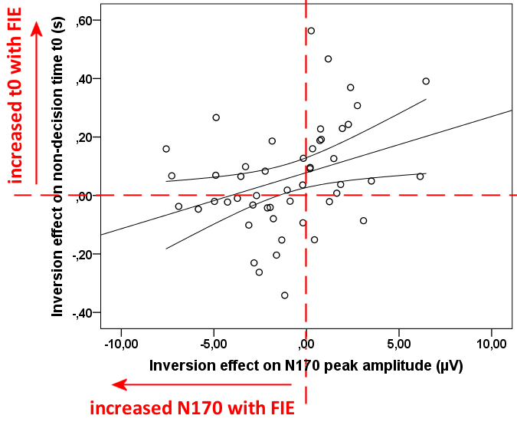
Supplementary Figure 4. Illustration of the positive link between FIE on t₀ and on N170 peak amplitude. FIE on t₀ decreases with increasing N170 deflection (in response to FIE).

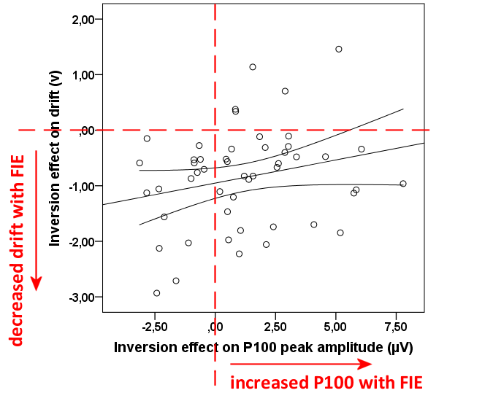Supplementary Figure 5. Illustration of the positive link between FIE on v and on P100 peak amplitude.

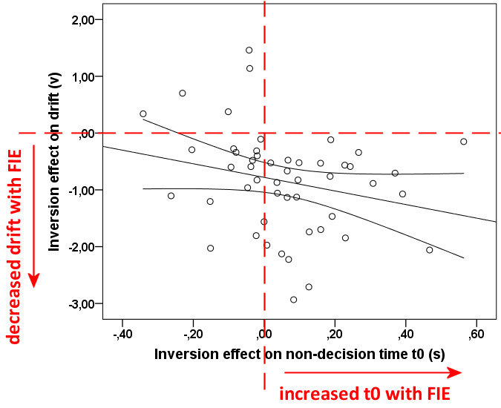
Supplementary Figure 6. Illustration of the negative link between FIE on t₀ and on drift. FIE on drift decreases with increasing FIE on t₀.

 |  |  |  | Pearson |  |  |  |  |  | Spearman
 |  |  |  | r | p | VS-MPR | Lower 95% CI | Upper 95% CI |  | rho | p | VS-MPR | Lower 95% CI | Upper 95% CI
v | - | t₀ |  | -0.242 | 0.091 | 1.691 | -0.487 | 0.039 |  | -0.287* | 0.044 | 2.688 | -0.523 | -0.009
v | - | P100_lat |  | -0.027 | 0.854 | 1.000 | -0.303 | 0.254 |  | 0.043 | 0.766 | 1.000 | -0.238 | 0.318
v | - | N170_lat |  | 0.099 | 0.495 | 1.000 | -0.185 | 0.367 |  | 0.119 | 0.412 | 1.000 | -0.165 | 0.384
v | - | P250_lat |  | -0.038 | 0.792 | 1.000 | -0.313 | 0.243 |  | -0.034 | 0.817 | 1.000 | -0.309 | 0.247
t₀ | - | P100_lat |  | 0.106 | 0.462 | 1.000 | -0.177 | 0.374 |  | 0.152 | 0.293 | 1.023 | -0.132 | 0.413
t₀ | - | N170_lat |  | -0.023 | 0.874 | 1.000 | -0.299 | 0.257 |  | -0.036 | 0.802 | 1.000 | -0.312 | 0.244
t₀ | - | P250_lat |  | -0.010 | 0.943 | 1.000 | -0.288 | 0.269 |  | -0.001 | 0.993 | 1.000 | -0.280 | 0.277
P100_lat | - | N170_lat |  | 0.016 | 0.912 | 1.000 | -0.263 | 0.293 |  | 0.001 | 0.994 | 1.000 | -0.277 | 0.279
P100_lat | - | P250_lat |  | 0.184 | 0.201 | 1.140 | -0.100 | 0.440 |  | 0.211 | 0.142 | 1.327 | -0.072 | 0.462
N170_lat | - | P250_lat |  | 0.298* | 0.036 | 3.092 | 0.021 | 0.532 |  | 0.290* | 0.041 | 2.816 | 0.013 | 0.526
Supplementary Table 3. Correlation matrices on the inversion effect for DDM parameters and ERPs peak latency. *p< 0.05, ** p < 0.01, *** p < 0.001

 |  |  |  | Pearson |  |  |  |  |  | Spearman
 |  |  |  | r | p | VS-MPR | Lower 95% CI | Upper 95% CI |  | rho | p | VS-MPR | Lower 95% CI | Upper 95% CI
v | - | t₀ |  | -0.267 | 0.061 | 2.164 | -0.508 | 0.012 |  | -0.348* | 0.014 | 6.307 | -0.571 | -0.078
v | - | P100_amp |  | 0.171 | 0.234 | 1.082 | -0.112 | 0.429 |  | 0.038 | 0.795 | 1.000 | -0.243 | 0.313
v | - | N170_amp |  | -0.268 | 0.060 | 2.185 | -0.509 | 0.011 |  | -0.278 | 0.050 | 2.444 | -0.517 | 0.000
v | - | P250_amp |  | -0.158 | 0.272 | 1.039 | -0.418 | 0.126 |  | -0.155 | 0.280 | 1.032 | -0.416 | 0.129
t₀ | - | P100_amp |  | -0.029 | 0.844 | 1.000 | -0.304 | 0.252 |  | -0.047 | 0.743 | 1.000 | -0.322 | 0.234
t₀ | - | N170_amp |  | 0.189 | 0.188 | 1.171 | -0.094 | 0.444 |  | 0.183 | 0.204 | 1.134 | -0.101 | 0.439
t₀ | - | P250_amp |  | 0.120 | 0.405 | 1.000 | -0.163 | 0.386 |  | 0.125 | 0.387 | 1.000 | -0.159 | 0.389
P100_amp | - | N170_amp |  | -0.102 | 0.481 | 1.000 | -0.370 | 0.182 |  | -0.119 | 0.411 | 1.000 | -0.384 | 0.165
P100_amp | - | P250_amp |  | 0.343* | 0.015 | 5.949 | 0.072 | 0.567 |  | 0.462*** | < 0.001 | 62.383 | 0.211 | 0.656
N170_amp | - | P250_amp |  | 0.155 | 0.282 | 1.031 | -0.129 | 0.416 |  | 0.066 | 0.650 | 1.000 | -0.217 | 0.338
Supplementary Table 4. Correlation matrices on the stimulus type effect for DDM parameters and ERPs peak amplitude. *p< 0.05, ** p < 0.01, *** p < 0.001

 |  |  |  | Pearson |  |  |  |  |  | Spearman
 |  |  |  | r | p | VS-MPR | Lower 95% CI | Upper 95% CI |  | rho | p | VS-MPR | Lower 95% CI | Upper 95% CI
v | - | t₀ |  | -0.267 | 0.061 | 2.164 | -0.508 | 0.012 |  | -0.348* | 0.014 | 6.307 | -0.571 | -0.078
v | - | P100_lat |  | 0.165 | 0.252 | 1.059 | -0.119 | 0.424 |  | 0.135 | 0.351 | 1.001 | -0.149 | 0.398
v | - | N170_lat |  | 0.010 | 0.944 | 1.000 | -0.269 | 0.288 |  | -0.023 | 0.875 | 1.000 | -0.299 | 0.257
v | - | P250_lat |  | 0.146 | 0.310 | 1.013 | -0.138 | 0.408 |  | 0.164 | 0.255 | 1.055 | -0.120 | 0.423
t₀ | - | P100_lat |  | -0.048 | 0.740 | 1.000 | -0.322 | 0.233 |  | -0.096 | 0.507 | 1.000 | -0.365 | 0.187
t₀ | - | N170_lat |  | -0.036 | 0.805 | 1.000 | -0.311 | 0.245 |  | -0.064 | 0.658 | 1.000 | -0.336 | 0.218
t₀ | - | P250_lat |  | -0.217 | 0.130 | 1.386 | -0.467 | 0.065 |  | -0.241 | 0.091 | 1.683 | -0.487 | 0.040
P100_lat | - | N170_lat |  | 0.028 | 0.846 | 1.000 | -0.252 | 0.304 |  | 0.039 | 0.789 | 1.000 | -0.242 | 0.314
P100_lat | - | P250_lat |  | 0.120 | 0.406 | 1.000 | -0.164 | 0.386 |  | 0.129 | 0.373 | 1.000 | -0.155 | 0.393
N170_lat | - | P250_lat |  | 0.572*** | < 0.001 | 2288.679 | 0.349 | 0.733 |  | 0.487*** | < 0.001 | 138.340 | 0.242 | 0.674
Supplementary Table 5. Correlation matrices on the stimulus type effect for DDM parameters and ERPs peak latency. *p< 0.05, ** p < 0.01, *** p < 0.001

Appendix D

Response accuracy (Hu) as a function of emotion
For the sake of simplicity, the analyses reported here will examine to what extent the Stimulus type x Orientation interaction varied with Emotion. We first performed an ANOVA on Hu (arcsined values) while introducing Emotion (sadness, fear, happiness, neutral, and anger) as an additional within-subject factor. The Stimulus type x Orientation x Emotion interaction that turned out to be significant (F(4, 96) = 4.31, p = 0.003, η_{p}² = 0.152), reflecting the fact that Emotion modulated the Stimulus type x Orientation interaction on Hu, as illustrated in Supplementary Figure 7. The emotions contributing mainly to the Stimulus type x Orientation interaction on Hu (see Figure 3 in the main text) were anger and neutral, and to a lesser extent sadness, as illustrated by the similarity of their graphical patterns. However, the higher-order interaction accounted for 3 times less variance (η_{p}² = 0.152) than the Stimulus type x Orientation interaction (η_{p}² = 0.524), suggesting that the variance in Hu introduced by Emotion was relatively less important than for the first-order interaction.

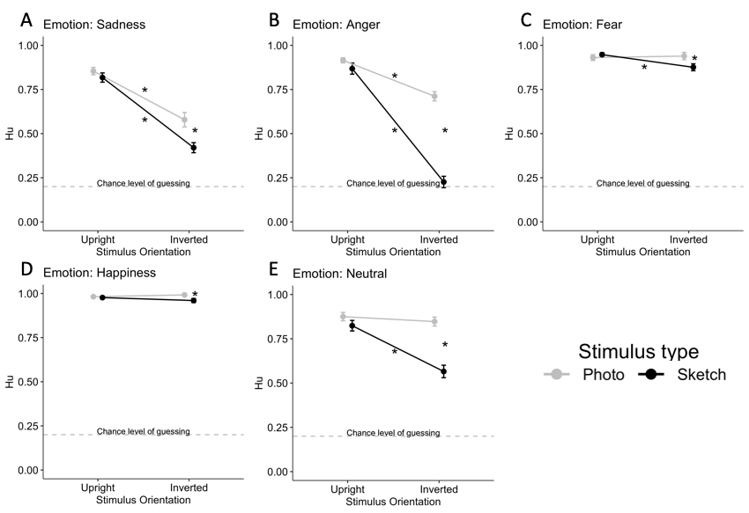
Supplementary Figure 7. Illustration of the Stimulus type x Orientation x Emotion interaction on response accuracy (Hu). Note that this figure displays the Hu values before they were arcsined to run the ANOVAs. Stars indicate significant Bonferroni post-hoc pairwise comparisons, p < 0.05.

Emotion | Source of variance | F (1, 24) | p value | η_{p}²
Sadness | Stimulus type | 11.73 | 0.002 | 0.33
 | Orientation | 64.81 | <0.0001 | 0.73
 | Stimulus type x Orientation | 3.62 | 0.069, n.s. | 0.13
Fear | Stimulus type | 2.94 | 0.10, n.s. | 0.11
 | Orientation | 2.66 | 0.12, n.s. | 0.10
 | Stimulus type x Orientation | 4.74 | 0.04 | 0.17
Happiness | Stimulus type | 8.02 | 0.009 | 0.25
 | Orientation | < 1 | 0.95, n.s. | 0.00
 | Stimulus type x Orientation | 2.01 | 0.17, n.s. | 0.08
Neutral | Stimulus type | 42.08 | < 0.0001 | 0.64
 | Orientation | 14.41 | 0.001 | 0.38
 | Stimulus type x Orientation | 16.33 | < 0.001 | 0.41
Anger | Stimulus type | 45.33 | < 0.0001 | 0.65
 | Orientation | 153.88 | < 0.0001 | 0.87
 | Stimulus type x Orientation | 31.43 | < 0.0001 | 0.57
Supplementary Table 6. Results of separate ANOVAs per Emotion, on Hu (arcsined values).

Correct answer RTs as a function of emotion
We also performed an ANOVA on RTs for correct responses, with Emotion as an additional within-subject factor. The Stimulus type x Orientation x Emotion interaction turned out to be significant (F(4, 96) = 3.51, p = 0.01, η_{p}² = 0.13), reflecting the fact that Emotion modulated the Stimulus type x Orientation interaction on correct answer RTs, as illustrated in Supplementary Figure 8. However, the higher-order interaction accounted for 2 times less variance (η_{p}² = 0.128) than the Stimulus type x Orientation interaction (η_{p}² = 0.248), suggesting that the variance in RT introduced by Emotion was relatively less important than for the first-order interaction. Noteworthy, the RT data show that there was no speed-accuracy tradeoff as illustrated by the data of inverted sketch angry and neutral expressions that show low Hu, in spite of high RT values.

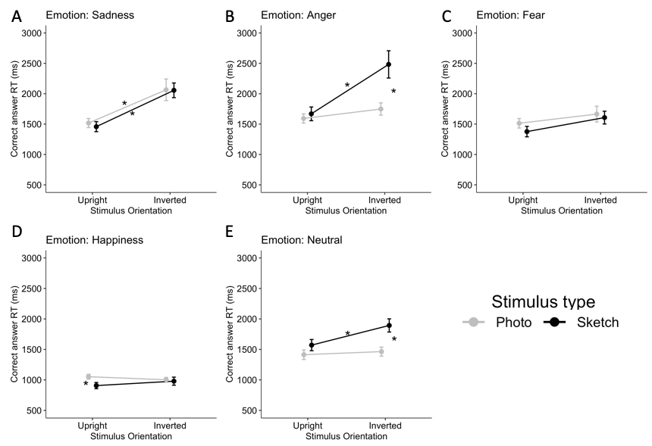
Supplementary Figure 8. Illustration of the Stimulus type x Orientation x Emotion interaction on correct answer RTs. Stars indicate significant Bonferroni post-hoc pairwise comparisons, p < 0.05.

Emotion | Source of variance | F (1, 24) | p value | η_{p}²
Sadness | Stimulus type | 0.12 | 0.74, n.s. | 0.01
 | Orientation | 45.95 | < 0.0001 | 0.66
 | Stimulus type x Orientation | 0.06 | 0.80, n.s. | 0.00
Fear | Stimulus type | 2.07 | 0.16, n.s. | 0.08
 | Orientation | 6.63 | 0.02 | 0.22
 | Stimulus type x Orientation | 0.77 | 0.39, n.s. | 0.03
Happiness | Stimulus type | 5.11 | 0.03 | 0.18
 | Orientation | 0.09 | 0.76, n.s. | 0.00
 | Stimulus type x Orientation | 4.08 | 0.06, n.s. | 0.15
Neutral | Stimulus type | 15.64 | < 0.001 | 0.40
 | Orientation | 10.93 | 0.003 | 0.31
 | Stimulus type x Orientation | 8.93 | 0.006 | 0.27
Anger | Stimulus type | 11.87 | 0.002 | 0.33
 | Orientation | 21.29 | 0.0001 | 0.47
 | Stimulus type x Orientation | 8.72 | 0.007 | 0.27
Supplementary Table 7. Results of separate ANOVAs per Emotion, on correct answer RTs.

References
Voss, A., Nagler, M., & Lerche, V. (2013). Diffusion models in experimental psychology. Experimental Psychology, 60(6), 385-402.
Voss, A., Rothermund, K., Gast, A., & Wentura, D. (2013). Cognitive processes in associative and categorical priming: A diffusion model analysis. Journal of Experimental Psychology: General, 142(2), 536-559.
Voss, A., & Voss, J. (2007). Fast-dm: A free program for efficient diffusion model analysis. Behavior Research Methods, 39(4), 767-775.

