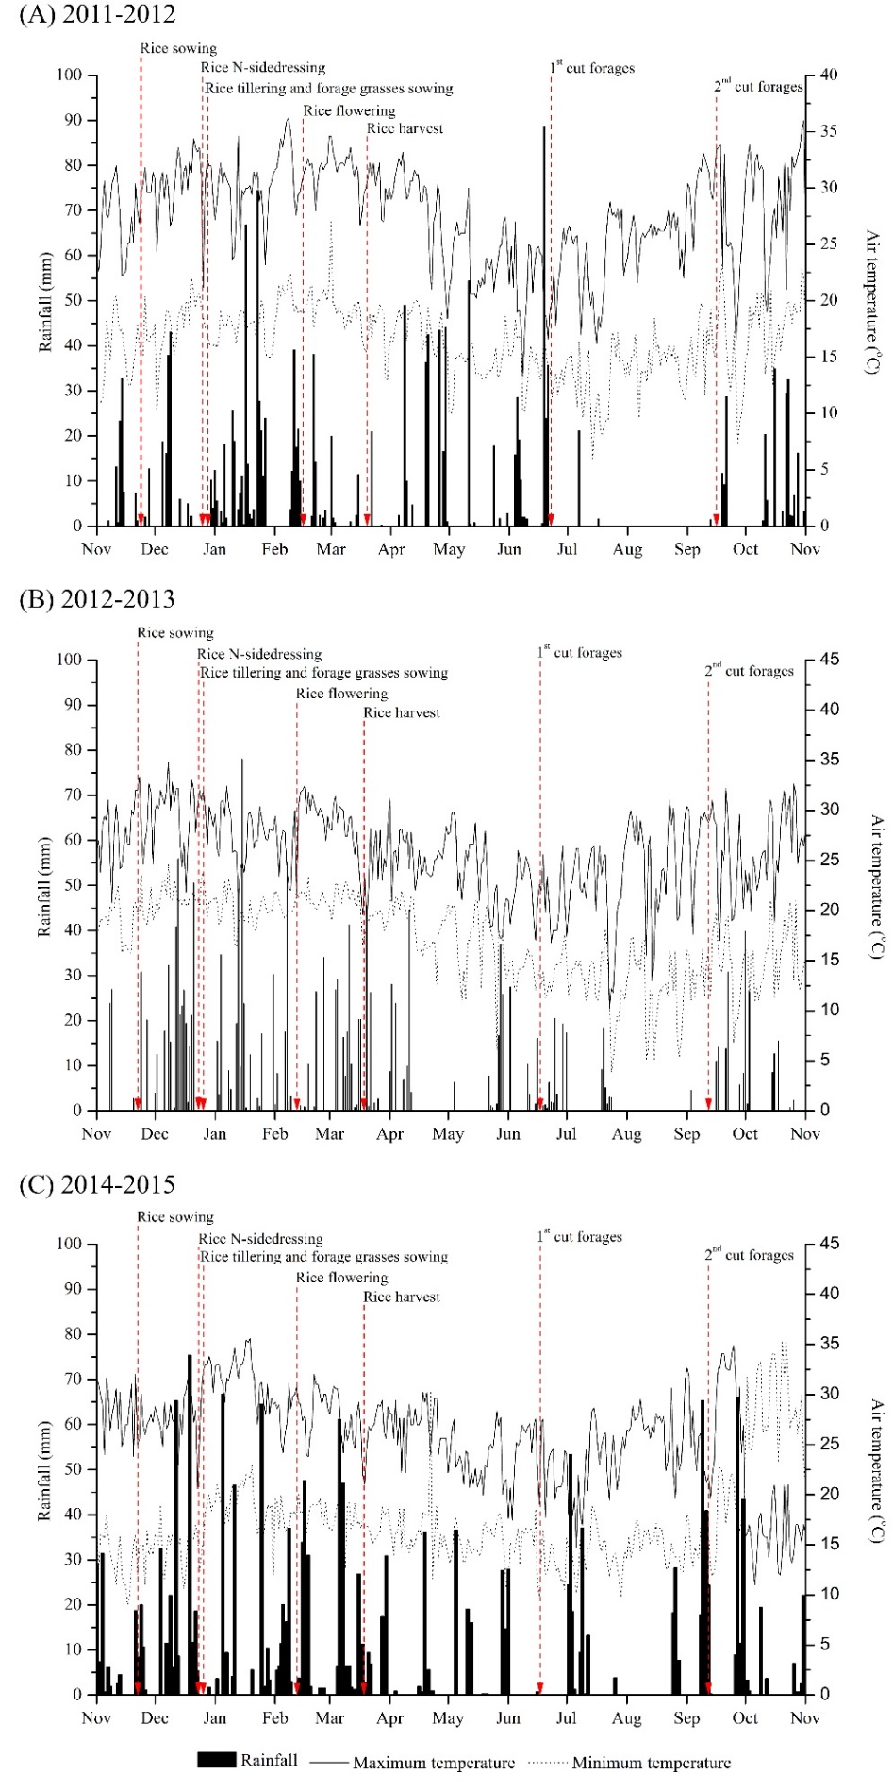

Supplementary Fig. 1. Daily rainfall (bars) and maximum and minimum temperatures (lines) at Botucatu, São Paulo State, Brazil, during the study periods in 2011-2012 (A), 2012-2013 (B) and 2014-2015 (C) growing seasons, and times of main events in the experiments.
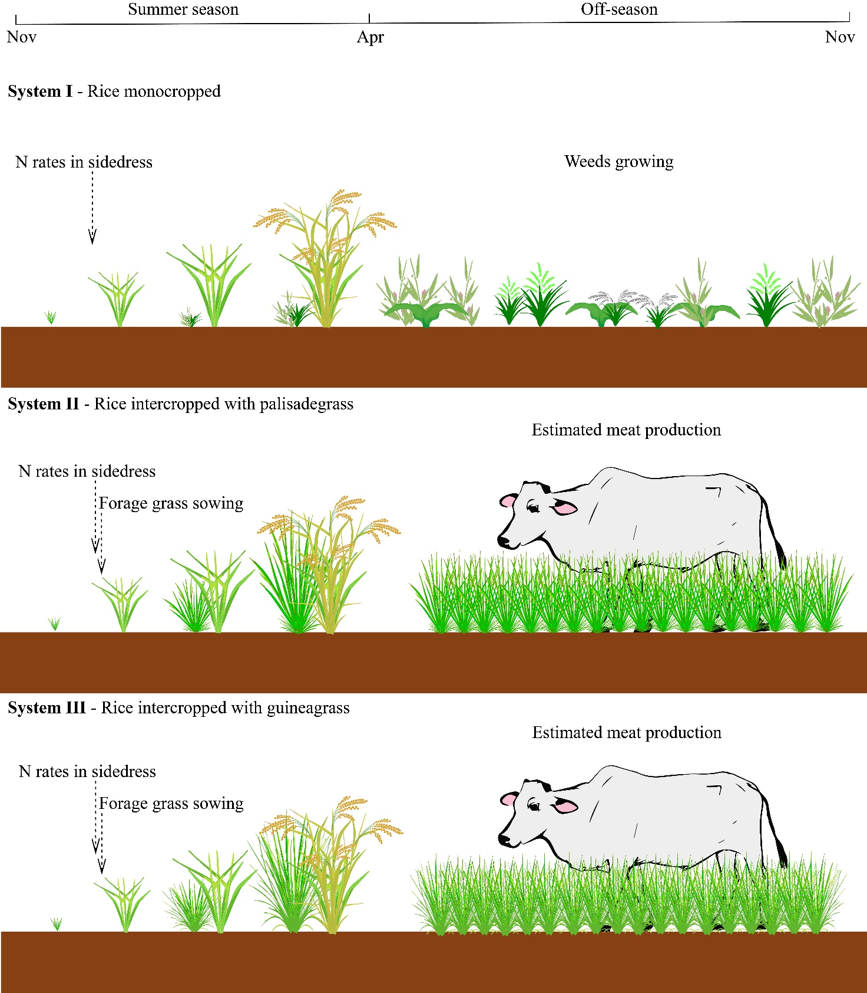

Supplementary Fig. 2. Schematic diagram of N management on three cropping systems during the study periods in 2011-2012, 2012-2013 and 2014-2015 growing seasons.

