SUPLEMMENTARY MATERIAL

Alantolactone enhance the phagocytic properties of human macrophages and modulate their proinflammatory functions

Barbara Gierlikowska^{1*}, Wojciech Gierlikowski² , Urszula Demkow¹

¹Department of Laboratory Diagnostics and Clinical Immunology of Developmental Age, Medical University of Warsaw, Banacha 1, 02-097 Warsaw, Poland,
²Department of Internal Medicine and Endocrinology, Medical University of Warsaw, Banacha 1a, 02-097 Warsaw, Poland

Figure S1. All experiments were performed on the single cells as gated below.

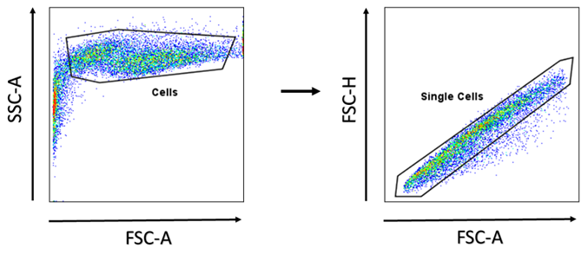

Figure S2. The uptake of S. aureus by THP-1-derived macrophages. The data show % of positive-infected macrophages (cells which phagocytosed one or more bacteria).

