Supplementary Material

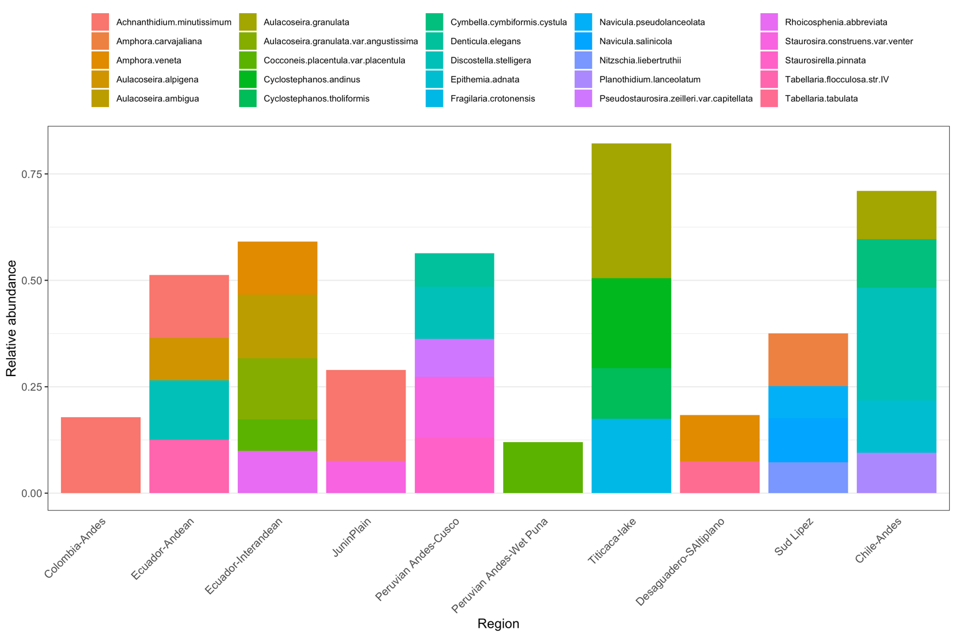
Supplementary Figure 1. Relative abundance of the most abundant species in sediment surface samples (i.e. those with a relative abundance >3% in at least one sample) for each lake region. Area of each bar represents the fraction of a given species averaged across all samples for that lake region.

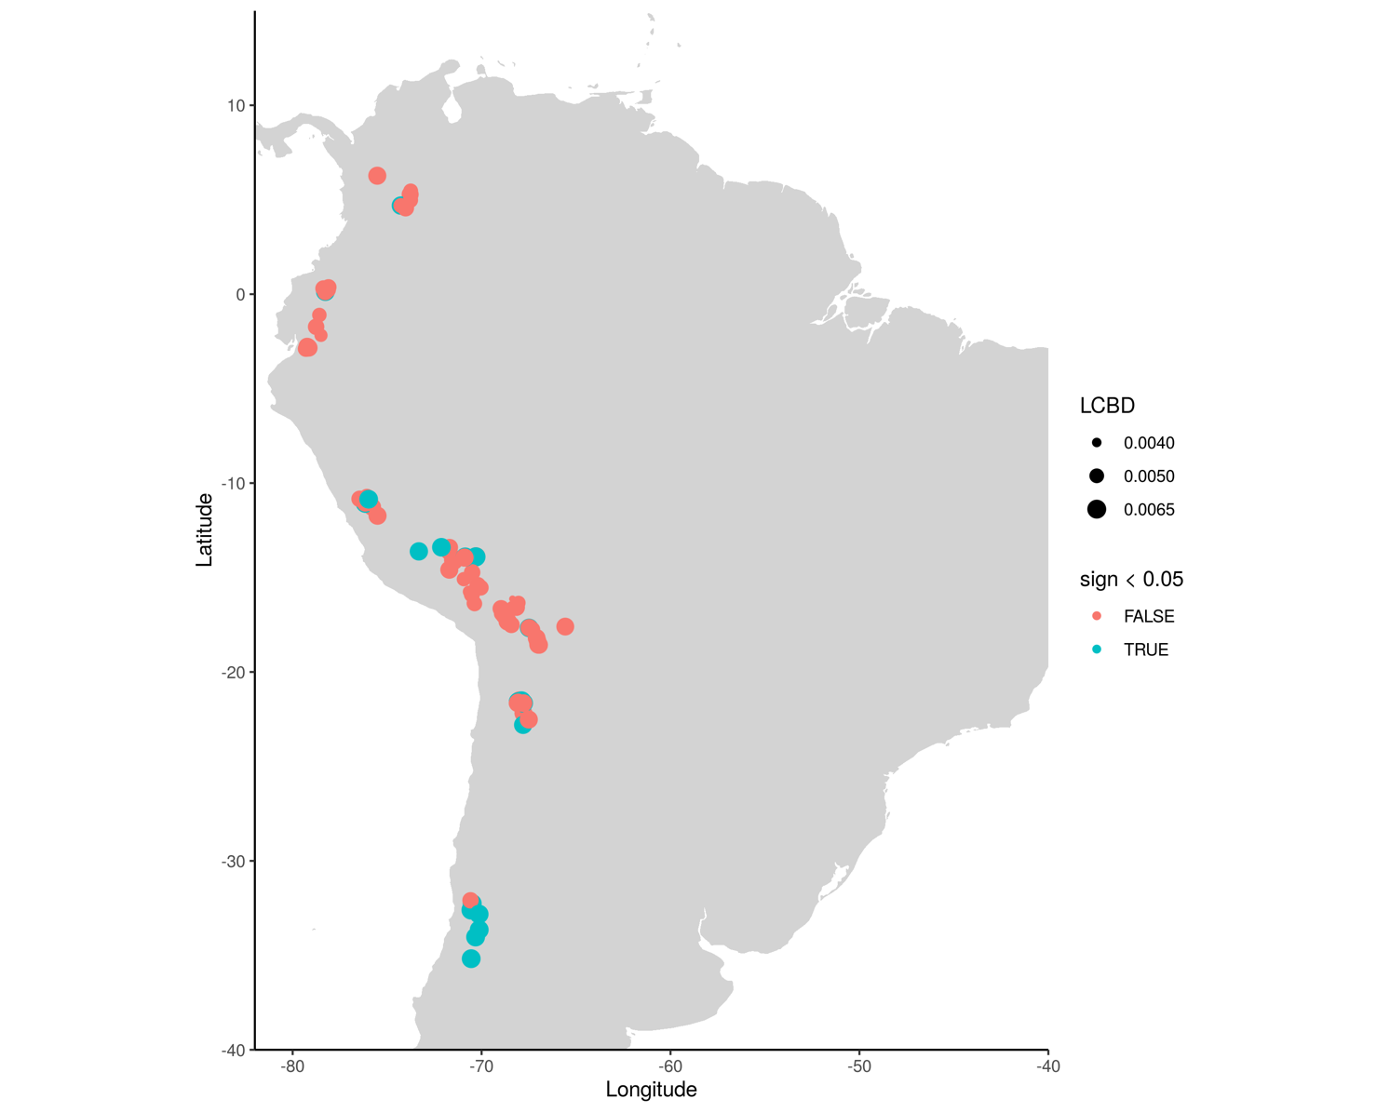
Supplementary Figure 2. Lakes with LCBD (local contribution to beta diversity) significant values (without correcting for multiple testing).
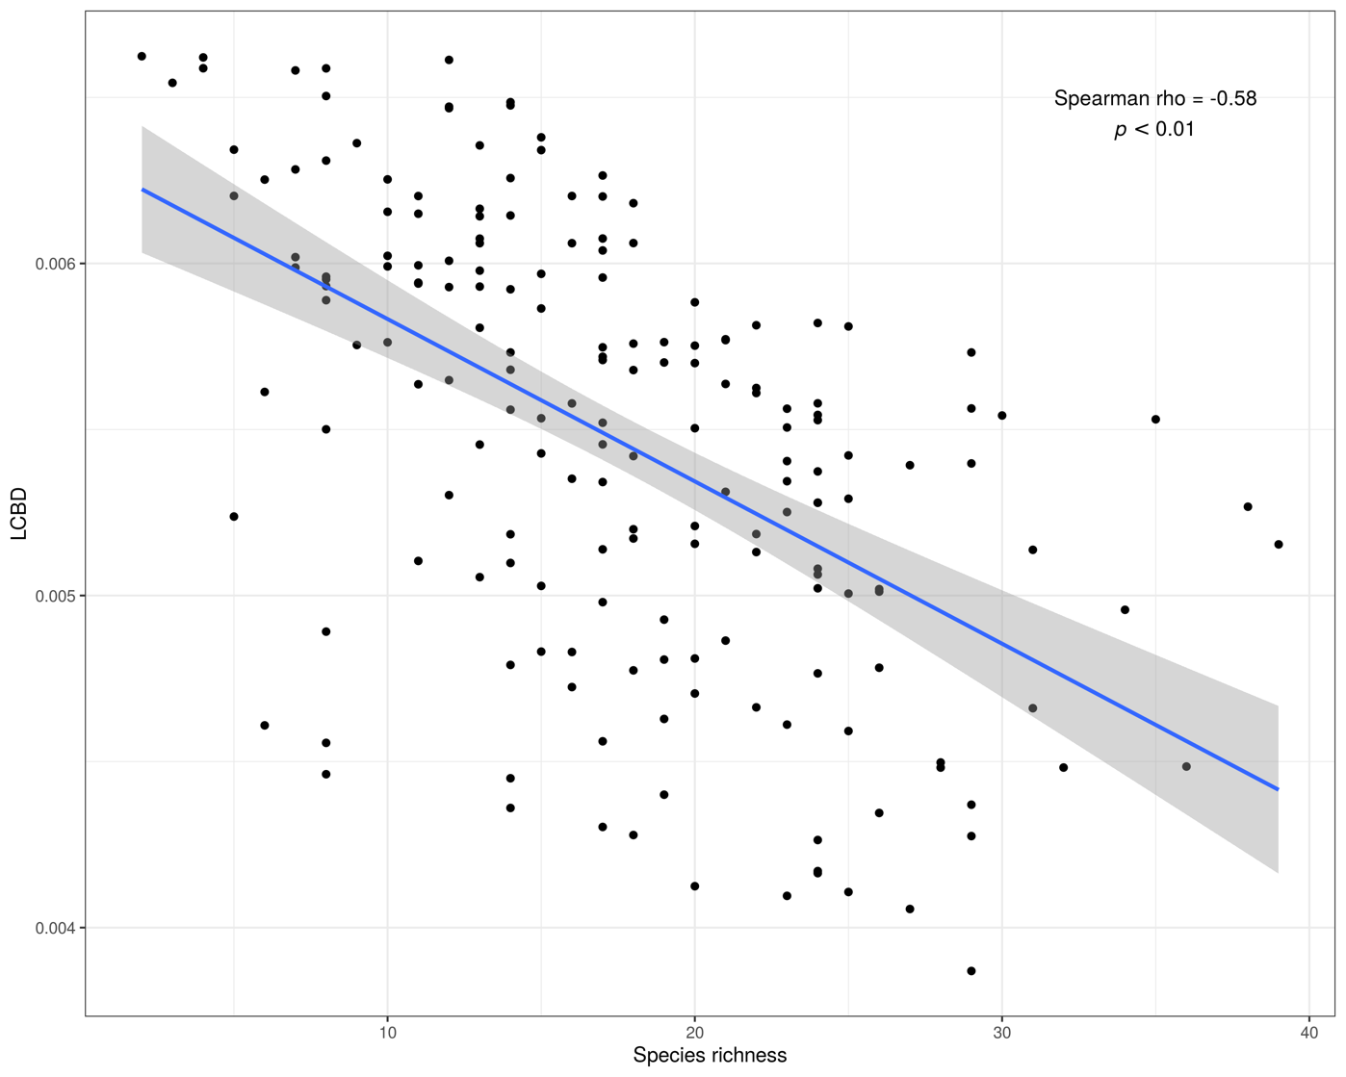
Supplementary Figure 3. The relationship between local contribution to beta diversity (LCBD) with local species richness across the study lakes (n=144).
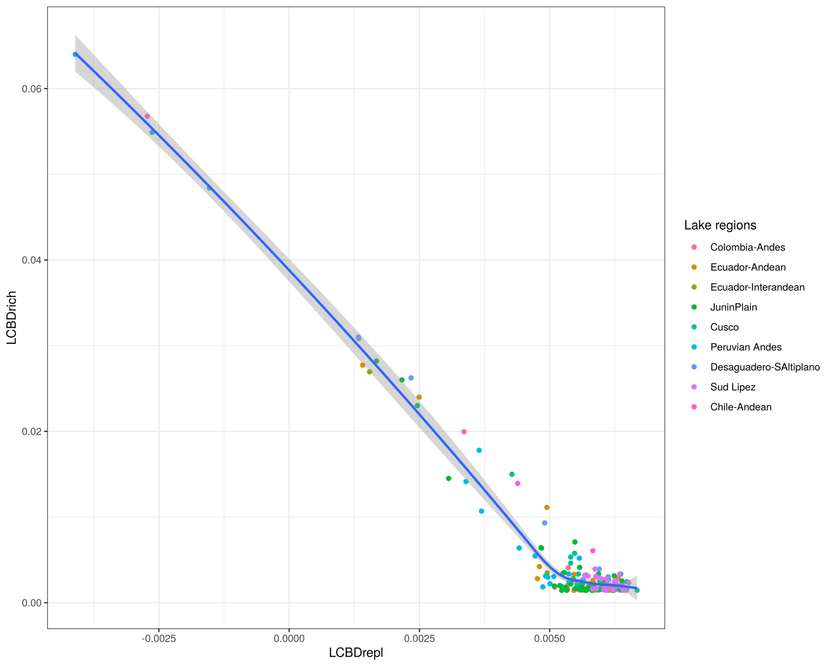
Supplementary Figure 4. The relationship between the replacement (LCBDrepl) and richness (LCBDrich) components of the local contribution to beta diversity (LCBD) colored by lake regions.

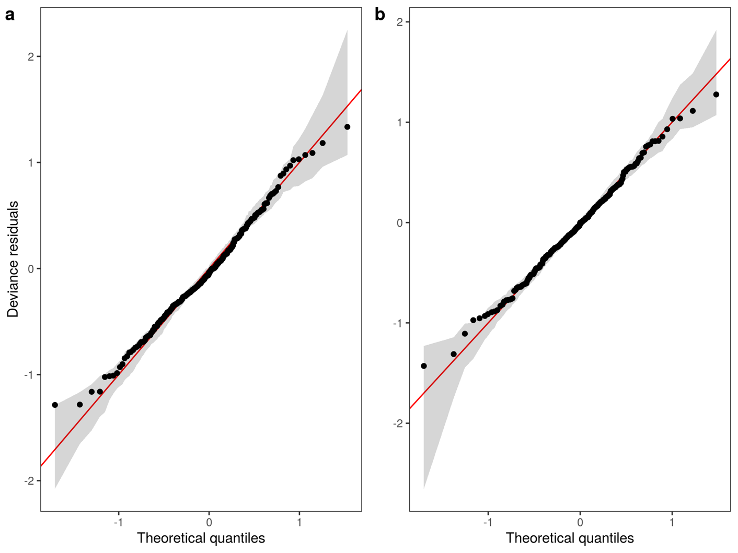
Supplementary Figure 5. QQ-plots for Hierarchical Generalized Additive Models GS (a) and GI (b) fitted to beta replacement across the six lakes investigated.

Supplementary Table 1. List of lakes, arranged by latitude, included in the modern spatial beta diversity analysis. Regions as in Figure 1 and year of sampling are also shown.
Lake | Longitude | Latitude | Region | Year
Belmira | -75.64 | 6.62 | Colombia-Andes | 2013
Belmira | -75.64 | 6.62 | Colombia-Andes | 2013
Belmira | -75.64 | 6.62 | Colombia-Andes | 2013
Guarne | -75.52 | 6.27 | Colombia-Andes | 2001
Guarne | -75.52 | 6.27 | Colombia-Andes | 2001
Fuquene | -73.75 | 5.47 | Colombia-Andes | 2001
Fuquene | -73.75 | 5.47 | Colombia-Andes | 2001
Fuquene | -73.75 | 5.47 | Colombia-Andes | 2001
Fuquene | -73.75 | 5.47 | Colombia-Andes | 2001
Cucunoba | -73.78 | 5.28 | Colombia-Andes | 2001
Cucunoba | -73.78 | 5.28 | Colombia-Andes | 2001
Suesca | -73.78 | 5.18 | Colombia-Andes | 2001
Suesca | -73.78 | 5.18 | Colombia-Andes | 2001
Guatavita | -73.78 | 4.98 | Colombia-Andes | 2001
Guatavita | -73.78 | 4.98 | Colombia-Andes | 2001
Herrera | -74.27 | 4.69 | Colombia-Andes | 2001
Herrera | -74.27 | 4.69 | Colombia-Andes | 2001
Verjon | -74.02 | 4.56 | Colombia-Andes | 2001
Verjon | -74.02 | 4.56 | Colombia-Andes | 2001
Verjon | -74.02 | 4.56 | Colombia-Andes | 2001
Ubaque | -73.93 | 4.50 | Colombia-Andes | 2014
Ubaque | -73.93 | 4.50 | Colombia-Andes | 2014
Ubaque | -73.93 | 4.50 | Colombia-Andes | 2014
Ubaque | -73.93 | 4.50 | Colombia-Andes | 2014
Ubaque | -73.93 | 4.50 | Colombia-Andes | 2014
Ubaque | -73.93 | 4.50 | Colombia-Andes | 2014
Ubaque | -73.93 | 4.50 | Colombia-Andes | 2014
Ubaque | -73.93 | 4.50 | Colombia-Andes | 2014
Ubaque | -73.93 | 4.50 | Colombia-Andes | 2014
Ubaque | -73.93 | 4.50 | Colombia-Andes | 2014
Ubaque | -73.93 | 4.50 | Colombia-Andes | 2014
Ubaque | -73.93 | 4.50 | Colombia-Andes | 2014
Yahuarcocha | -78.10 | 0.37 | Ecuador-Interandean | 2017
Cuicocha | -78.37 | 0.30 | Ecuador-Andean | 2017
Cunrro | -78.09 | 0.24 | Ecuador-Interandean | 2017
Cubilche | -78.13 | 0.23 | Ecuador-Andean | 2017
San Pablo | -78.23 | 0.22 | Ecuador-Interandean | 2017
Caricocha | -78.27 | 0.14 | Ecuador-Andean | 2017
Huarmicocha | -78.25 | 0.13 | Ecuador-Andean | 2017
Yanacocha | -78.25 | 0.12 | Ecuador-Andean | 2017
Chiriacu | -78.27 | 0.11 | Ecuador-Andean | 2017
Yambo | -78.59 | -1.10 | Ecuador-Interandean | 2017
Colta-2 | -78.76 | -1.73 | Ecuador-Interandean | 2017
Kuyuk | -78.50 | -2.18 | Ecuador-Andean | 2017
Fondococha | -79.24 | -2.76 | Ecuador-Andean | 2017
Dos Chorreras | -79.16 | -2.77 | Ecuador-Andean | 2015
Toreadora | -79.22 | -2.78 | Ecuador-Andean | 2014
Marmolcocha | -79.22 | -2.78 | Ecuador-Andean | 2017
Patoquinuas | -79.21 | -2.78 | Ecuador-Andean | 2014
Llaviucu | -79.15 | -2.84 | Ecuador-Andean | 2017
Lagunas de Napalé | -79.30 | -2.89 | Ecuador-Andean | 2014
Jigeno | -79.29 | -2.91 | Ecuador-Andean | 2017
Estrellascocha | -79.25 | -2.91 | Ecuador-Andean | 2017
L. Tauli, shore | -76.07 | -10.72 | JuninPlain | 1999
L. Ccochachuycho, shore | -76.07 | -10.76 | JuninPlain | 1999
L. Lulicocha, shore | -76.10 | -10.78 | JuninPlain | 1999
L. Lulicocha, shore | -76.10 | -10.78 | JuninPlain | 1999
Junin 10, Tambo del Sol | -76.13 | -10.81 | JuninPlain | 1999
Junin 10, Tambo del Sol | -76.13 | -10.81 | JuninPlain | 1999
Junin 9, ditch before Shelby | -76.23 | -10.81 | JuninPlain | 1999
Junin 9, ditch before Shelby | -76.23 | -10.81 | JuninPlain | 1999
L. Yanacocha, shore | -76.04 | -10.83 | JuninPlain | 1999
L. Yanacocha, shore | -76.04 | -10.83 | JuninPlain | 1999
L. Purun, center | -76.46 | -10.84 | JuninPlain | 1999
L. Purun, shore | -76.45 | -10.84 | JuninPlain | 1999
L. Purun, shore | -76.45 | -10.84 | JuninPlain | 1999
Yanacocha 3, spring | -75.97 | -10.86 | JuninPlain | 1999
Yanacocha 3, spring | -75.97 | -10.86 | JuninPlain | 1999
Yanacocha 1, wetland | -75.99 | -10.86 | JuninPlain | 1999
Yanacocha 2, inflow stream | -75.98 | -10.86 | JuninPlain | 1999
Yanacocha 4, outlet channel | -76.00 | -10.87 | JuninPlain | 1999
Junin 14, Palcamayo R. | -76.05 | -10.91 | JuninPlain | 1999
Junin 8, Upamayo Bridge | -76.26 | -10.92 | JuninPlain | 1999
Junin 8, Upamayo Bridge | -76.26 | -10.92 | JuninPlain | 1999
Junin 11, Gunoc Km 255 | -76.05 | -10.94 | JuninPlain | 1999
Junin 11, Gunoc Km 255 | -76.05 | -10.94 | JuninPlain | 1999
Junin 11, Gunoc Km 255 | -76.05 | -10.94 | JuninPlain | 1999
Junin 7, San Pedro de Pari | -76.23 | -10.96 | JuninPlain | 1999
Junin 13, Qda. Anascanchi | -76.04 | -10.98 | JuninPlain | 1999
L. Junin, center | -76.06 | -11.00 | JuninPlain | 1999
L. Junin, center | -76.06 | -11.00 | JuninPlain | 1999
Junin 12, Chacpas | -76.01 | -11.00 | JuninPlain | 1999
Junin 6, Chuchucancha R. | -76.19 | -11.04 | JuninPlain | 1999
Junin 6, Chuchucancha R. | -76.19 | -11.04 | JuninPlain | 1999
Junin 5, Conoc spring | -76.16 | -11.06 | JuninPlain | 1999
Junin 5, Conoc spring | -76.16 | -11.06 | JuninPlain | 1999
L. Junin, shore | -76.16 | -11.06 | JuninPlain | 1999
L. Junin, shore | -76.16 | -11.06 | JuninPlain | 1999
Junin 4, Ondores spring | -76.15 | -11.08 | JuninPlain | 1999
Junin 4, Ondores spring | -76.15 | -11.08 | JuninPlain | 1999
L. Alcacocha, shore | -75.94 | -11.08 | JuninPlain | 1999
Junin 2, Warmipuquio spring | -76.09 | -11.11 | JuninPlain | 1999
Junin 2, Warmipuquio spring | -76.09 | -11.11 | JuninPlain | 1999
Junin 2, Warmipuquio spring | -76.09 | -11.11 | JuninPlain | 1999
Junin 3, spring 2 | -76.09 | -11.12 | JuninPlain | 1999
Junin 1, Chacachimpa R. | -76.02 | -11.17 | JuninPlain | 1999
Huagapo Cave, inside | -75.79 | -11.27 | JuninPlain | 1999
Huagapo Cave, outside | -75.79 | -11.27 | JuninPlain | 1999
L. Paca, inflow stream | -75.51 | -11.72 | JuninPlain | 1999
L. Paca, inflow stream | -75.51 | -11.72 | JuninPlain | 1999
L. Paca, 12m deep | -75.51 | -11.73 | JuninPlain | 1999
Huamanmarca | -72.37 | -13.03 | Peruvian Andes | 2009
Miski | -72.37 | -13.03 | Peruvian Andes | 2009
Cusco-PLS-2 | -72.13 | -13.40 | Cusco | 2011
Cusco-PLS-13 | -71.69 | -13.40 | Cusco | 2011
Cusco-PLS-1 | -72.05 | -13.42 | Cusco | 2011
Pacucha | -73.32 | -13.62 | Peruvian Andes | 2009
Cusco-PLS-11 | -71.72 | -13.62 | Cusco | 2011
Cusco-PLS-5 | -70.25 | -13.86 | Cusco | 2011
Cusco-PLS-7 | -70.31 | -13.86 | Cusco | 2011
Cusco-PLS-8 | -70.30 | -13.91 | Cusco | 2011
Cusco-CH1 | -70.87 | -13.92 | Cusco | 2011
Cusco-PLS-6 | -70.31 | -13.93 | Cusco | 2011
Cusco-DP1 | -70.90 | -13.94 | Cusco | 2011
Cusco-YC1 | -70.87 | -13.95 | Cusco | 2011
Cusco-IA1 | -70.90 | -13.95 | Cusco | 2011
Acopia | -71.52 | -14.08 | Peruvian Andes | 2009
Cusco-PLS-12 | -71.46 | -14.13 | Cusco | 2011
Cusco-PLS-3 | -71.72 | -14.58 | Cusco | 2011
Cusco-PLS-4 | -71.71 | -14.59 | Cusco | 2011
Cusco-PLS-9 | -70.50 | -14.73 | Cusco | 2011
Cusco-PLS-10 | -70.94 | -15.09 | Cusco | 2011
Titicaca-lake | -69.21 | -15.26 | Titicaca-lake | 1996
Titicaca-lake | -69.21 | -15.26 | Titicaca-lake | 1996
Titicaca-lake | -69.07 | -15.37 | Titicaca-lake | 1996
Titicaca-lake | -69.07 | -15.37 | Titicaca-lake | 1996
Chacas | -70.20 | -15.41 | Peruvian Andes | 2003
Titicaca-lake | -69.62 | -15.53 | Titicaca-lake | 1996
Umapata | -70.05 | -15.54 | Peruvian Andes | 2003
Pacuna | -70.21 | -15.58 | Peruvian Andes | 2003
Lake 6 | -70.20 | -15.66 | Peruvian Andes | 2003
Lagunillas | -70.68 | -15.75 | Peruvian Andes | 2003
Sara Cocha | -70.61 | -15.78 | Peruvian Andes | 2003
Ululumasa | -70.60 | -15.78 | Peruvian Andes | 2003
Titicaca-lake | -69.70 | -15.81 | Titicaca-lake | 1998
Titicaca-lake | -69.75 | -15.83 | Titicaca-lake | 1996
Maquera | -70.56 | -15.88 | Peruvian Andes | 2003
Calzada | -70.51 | -15.90 | Peruvian Andes | 2003
Titicaca-lake | -69.44 | -15.96 | Titicaca-lake | 1998
Titicaca-lake | -69.32 | -16.04 | Titicaca-lake | 1996
Titicaca-lake | -69.32 | -16.04 | Titicaca-lake | 1996
Khara Kkota (north) | -68.36 | -16.13 | Peruvian Andes | 2003
Titicaca-lake | -69.15 | -16.22 | Titicaca-lake | 1996
Estrellani | -68.04 | -16.34 | Peruvian Andes | 2003
Jacumarini | -70.39 | -16.36 | Peruvian Andes | 2003
Asiruni | -70.37 | -16.39 | Peruvian Andes | 2003
Laja | -68.39 | -16.53 | Peruvian Andes | 2003
Jachcha Kkota | -68.17 | -16.58 | Peruvian Andes | 2003
Chara Nkkota | -68.16 | -16.58 | Peruvian Andes | 2003
Lake 27 | -68.27 | -16.62 | Peruvian Andes | 2003
Rio Desaguadero: downstream from Desaguadero | -68.97 | -16.64 | Desaguadero-SAltiplano | 2001
Lake 23 | -68.32 | -16.68 | Peruvian Andes | 2003
Rio Desaguadero: Nazacara N. | -68.80 | -16.88 | Desaguadero-SAltiplano | 2001
Lake 34 | -68.95 | -16.91 | Peruvian Andes | 2003
Laguna Desaguadero | -68.79 | -16.98 | Desaguadero-SAltiplano | 2001
Rio Desaguadero at Parco Khota | -68.68 | -17.21 | Desaguadero-SAltiplano | 2001
Rio Mauri | -68.63 | -17.29 | Desaguadero-SAltiplano | 2001
Rio Desaguadero Bridge (pipeline) | -68.62 | -17.31 | Desaguadero-SAltiplano | 2001
Flood Plain Pond near Pipeline | -68.62 | -17.33 | Desaguadero-SAltiplano | 2001
Laguna Blanca S. Rio Jalsuri Uma | -68.55 | -17.47 | Desaguadero-SAltiplano | 2001
Salcro Tarquiamaya | -68.59 | -17.48 | Desaguadero-SAltiplano | 2001
Rio Quebrada Huajra Uma | -68.42 | -17.50 | Desaguadero-SAltiplano | 2001
Laguna Challacaba | -65.57 | -17.60 | Desaguadero-SAltiplano | 2007
Huancaroma Dairy | -67.48 | -17.66 | Desaguadero-SAltiplano | 2001
Huancaroma Dairy | -67.48 | -17.67 | Desaguadero-SAltiplano | 2001
Laguna Soledad (Uru Uru) | -67.31 | -17.75 | Desaguadero-SAltiplano | 2001
Rio Desaguadero Balsa Crossing | -67.09 | -18.20 | Desaguadero-SAltiplano | 2001
Rio Desaguadero | -67.04 | -18.35 | Desaguadero-SAltiplano | 2001
Rio Desaguadero: Poopo (town) | -67.05 | -18.37 | Desaguadero-SAltiplano | 2001
Rio Poopo drainage | -67.02 | -18.38 | Desaguadero-SAltiplano | 2001
Road tracks & N Lago Poopo plain | -67.00 | -18.55 | Desaguadero-SAltiplano | 2001
N Lago Poopo plain | -66.95 | -18.57 | Desaguadero-SAltiplano | 2001
Salar de Uyuni | -67.66 | -20.14 | Sud Lipez | 1991
Laguna Canapa | -68.01 | -21.51 | Sud Lipez | 2002
Chulluncani | -67.88 | -21.53 | Sud Lipez | 2002
Chulluncani | -67.88 | -21.53 | Sud Lipez | 2002
Laguna Hedionda | -68.07 | -21.57 | Sud Lipez | 2002
Chiar Kkota | -68.07 | -21.58 | Sud Lipez | 2002
Honda | -68.07 | -21.62 | Sud Lipez | 2002
Pujio | -68.07 | -21.62 | Sud Lipez | 2002
Ballivian | -68.08 | -21.63 | Sud Lipez | 2002
Laguna Ramaditas | -68.08 | -21.64 | Sud Lipez | 2002
Pastos Grandes | -67.78 | -21.65 | Sud Lipez | 2002
Pastos Grandes | -67.78 | -21.65 | Sud Lipez | 2002
Pastos Grandes | -67.78 | -21.65 | Sud Lipez | 2002
Pastos Grandes | -67.78 | -21.65 | Sud Lipez | 2002
Pastos Grandes | -67.78 | -21.65 | Sud Lipez | 2002
Pastos Grandes | -67.78 | -21.65 | Sud Lipez | 2002
Pastos Grandes | -67.78 | -21.65 | Sud Lipez | 2002
Pastos Grandes | -67.78 | -21.65 | Sud Lipez | 2002
Pastos Grandes | -67.78 | -21.65 | Sud Lipez | 2002
Pastos Grandes | -67.78 | -21.65 | Sud Lipez | 2002
Pastos Grandes | -67.78 | -21.65 | Sud Lipez | 2002
Pastos Grandes | -67.78 | -21.65 | Sud Lipez | 2002
Pastos Grandes | -67.78 | -21.65 | Sud Lipez | 2002
Pastos Grandes | -67.78 | -21.65 | Sud Lipez | 2002
Pastos Grandes | -67.78 | -21.65 | Sud Lipez | 2002
Pastos Grandes | -67.78 | -21.65 | Sud Lipez | 2002
Cachi | -67.95 | -21.72 | Sud Lipez | 2002
Laguna Cachi | -67.95 | -21.73 | Sud Lipez | 1991
Laguna Colorada | -67.78 | -22.18 | Sud Lipez | 2002
Laguna Colorada | -67.78 | -22.18 | Sud Lipez | 2002
Puripica | -67.50 | -22.52 | Sud Lipez | 2002
Laguna Chairiri | -67.65 | -22.53 | Desaguadero-SAltiplano | 2001
Laguna Verde | -67.80 | -22.80 | Sud Lipez | 2002
Laguna Canchuca | -70.59 | -32.09 | Chile-Andean | 2013
Chepical | -70.50 | -32.26 | Chile-Andean | 2013
Laguna Copín | -70.56 | -32.60 | Chile-Andean | 2013
Laguna del Inca | -70.13 | -32.82 | Chile-Andean | 2013
Laguna Negra-Chile | -70.13 | -33.65 | Chile-Andean | 2013
Laguna Ocho | -70.32 | -34.03 | Chile-Andean | 2013
Laguna de Teno | -70.55 | -35.18 | Chile-Andean | 2013

Supplementary Table 2. Predictive ability (total deviance of out-of-sample) for Hierarchical Generalized Additive Models GS and GI applied to the beta replacement component.
Lake | Intercept only | Model GS | Model GI
Fondococha | 30 | 25 | 23
Llaviucu | 11 | 8.7 | 7.4
Piñan | 8.6 | 6.4 | 5.7
Titicaca | 23 | 17 | 14
Umayo | 6.9 | 6.2 | 5.2
Yahuarcocha | 9.2 | 7.9 | 7.9

Sediment chronologies. Age-depth models of the investigated lakes in the Andes of Ecuador: Piñan, Yahuarcocha, Fondococha and Llaviucu. The ²¹⁰Pb chronologies were calculated using the constant-rate-of-supply model (Appleby and Oldfield, 1978). In all cores, the entire inventory of unsupported ²¹⁰Pb was contained within the top 20 cm. ¹⁴C ages were calibrated with the IntCal13 calibration curve (Reimer et al., 2013). For each core, a Bayesian age-depth model was generated using the R package rbacon (Blaauw and Christen 2018).

Supplementary Table 3. Summary of the radiocarbon data of lakes Piñan (PIN), Yahuarcocha (YAH), Fondococha (FON) and Llaviucu (LLA), including sample depth, sample type, 14C ages, and the calibrated ages. Dates reported for Lakes Fondococha and Llaviucu were taken from Arcusa et al. (2020).
Lake | Depth | LAB ID | Type | ¹⁴C age (yr BP) | Cal. age (cal. yr BP)
PIN | 24 | OS-139509 | Macrophyte | 510 ± 15 | 528 ± 13
PIN | 49 | OS-139676 | Macrophyte | 950 ± 15 | 834 ± 37
PIN | 73 | OS-139677 | Macrophyte | 1590 ± 15 | 1502 ± 30
YAH | 31.5 | OS-141027 | Sediment organic carbon | 1790 ± 15 | 1608 ± 365
YAH | 56.5 | OS-139544 | Sediment organic carbon | 1830 ± 15 | 1840 ± 416
FON** | 26.55 | BE-3530.1.1 | Bulk sediment | 940 ± 26 | 853 ± 39
FON | 30 | BE-3520.1.1 | Seed; Carex tricuspid | 301 ± 62 | 377 ± 92
FON | 39.3 | BE-4783.1.1 | Loricaria leaf fragment | 726 ± 38 | 675 ± 34
FON | 42.5 | BE-10950.1.1 | Periderm and grass fragment | 989 ± 67 | 890 ± 75
FON** | 53.5 | BE-10953.1.1 | Charred twig fragments | 1943 ± 99 | 1893 ± 126
FON** | 64.7 | BE-4782.1.1 | Loricaria leaf fragment | 1080 ± 51 | 996 ± 56
FON | 75.5 | BE-10952.1.1 | Charred twig fragments | 2104 ± 50 | 2079 ± 82
FON | 92 | BE-10951.1.1 | Bark fragment | 2540 ± 41 | 2620 ± 85
LLA** | 21.15 | BE-3518.1.1 | Isolepsis and Loricaria fragments | 157 ± 78 | 163 ± 101
LLA** | 21.15 | BE-3527.1.1 | Bulk sediment | 682 ± 34 | 650 ± 41
LLA | 55.45 | BE-3519.1.1 | Loricaria leaf fragments | 317 ± 22 | 387 ± 43
LLA** | 55.45 | BE-3528.1.1 | Bulk sediment | 891 ± 22 | 804 ± 52
LLA | 59.5 | BE-4778.1.1 | Wood and Loricaria fragments | 332 ± 44 | 392 ± 55
LLA** | 61.6 | BE-4779.1.1 | Seed husk | 2378 ± 235 | 2438 ± 284
LLA** | 70 | BE-10954.1.1 | Unidentified | -24 ± 63 | 100 ± 78
LLA | 71.5 | BE-4780.1.1 | Loricaria leaf fragment | 1274 ± 171 | 1184 ± 170
LLA** | 90 | BE-10956.1.1 | Grass and twig fragments | 2239 ± 85 | 2233 ± 110
LLA | 107.5 | BE-10955.1.1 | Bark and grass fragments | 1781 ± 68 | 1704 ± 83
LLA** | 108.5 | BE-3529.1.1 | Bulk sediment | 2248 ± 23 | 2227 ± 55
LLA** | 180.5 | BE-4781.1.1 | Seed fragments | 2923 ± 356 | 3109 ± 445
** dates are outliers, details in Arcusa et al., (2020)

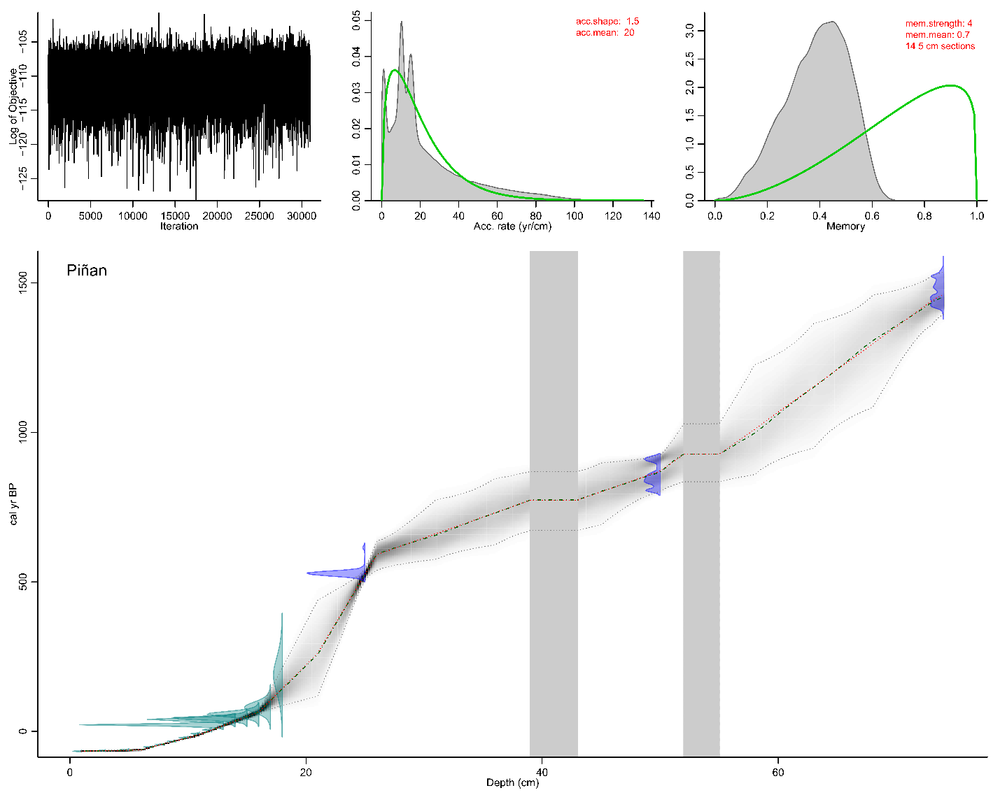
Supplementary Figure 6. Age-depth model of lake Piñan. The red line indicates the mean age-depth model, the green line represents the median age-depth model. The turqoise distribution curves represent the ²¹⁰Pb-samples, the blue distribution curves represent the ¹⁴C samples. Grey shades represent the 95% confidence interval and the grey vertical bars indicate masked layers.

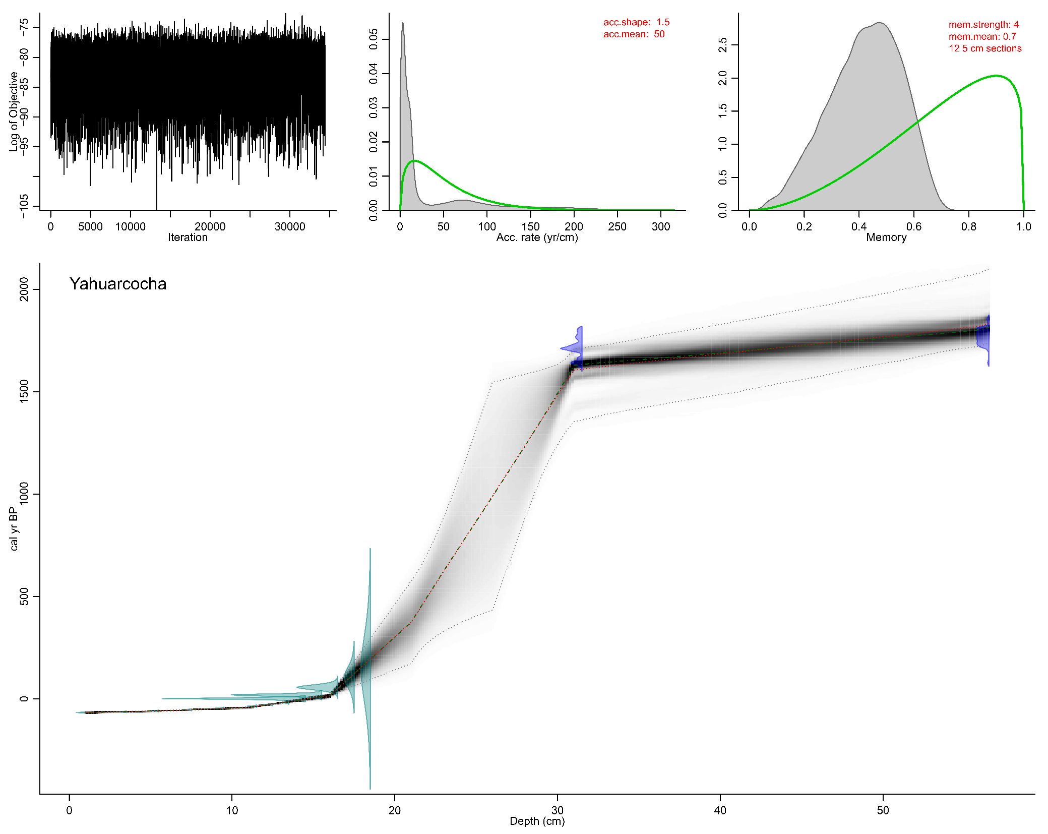
Supplementary Figure 7. Age-depth model of lake Yahuarcocha. The red line indicates the mean age-depth model, the green line represents the median age-depth model. The turqoise distribution curves represent the ²¹⁰Pb-samples, the blue distribution curves represent the ¹⁴C samples. Grey shades represent the 95% confidence interval and the grey vertical bars indicate masked layers.

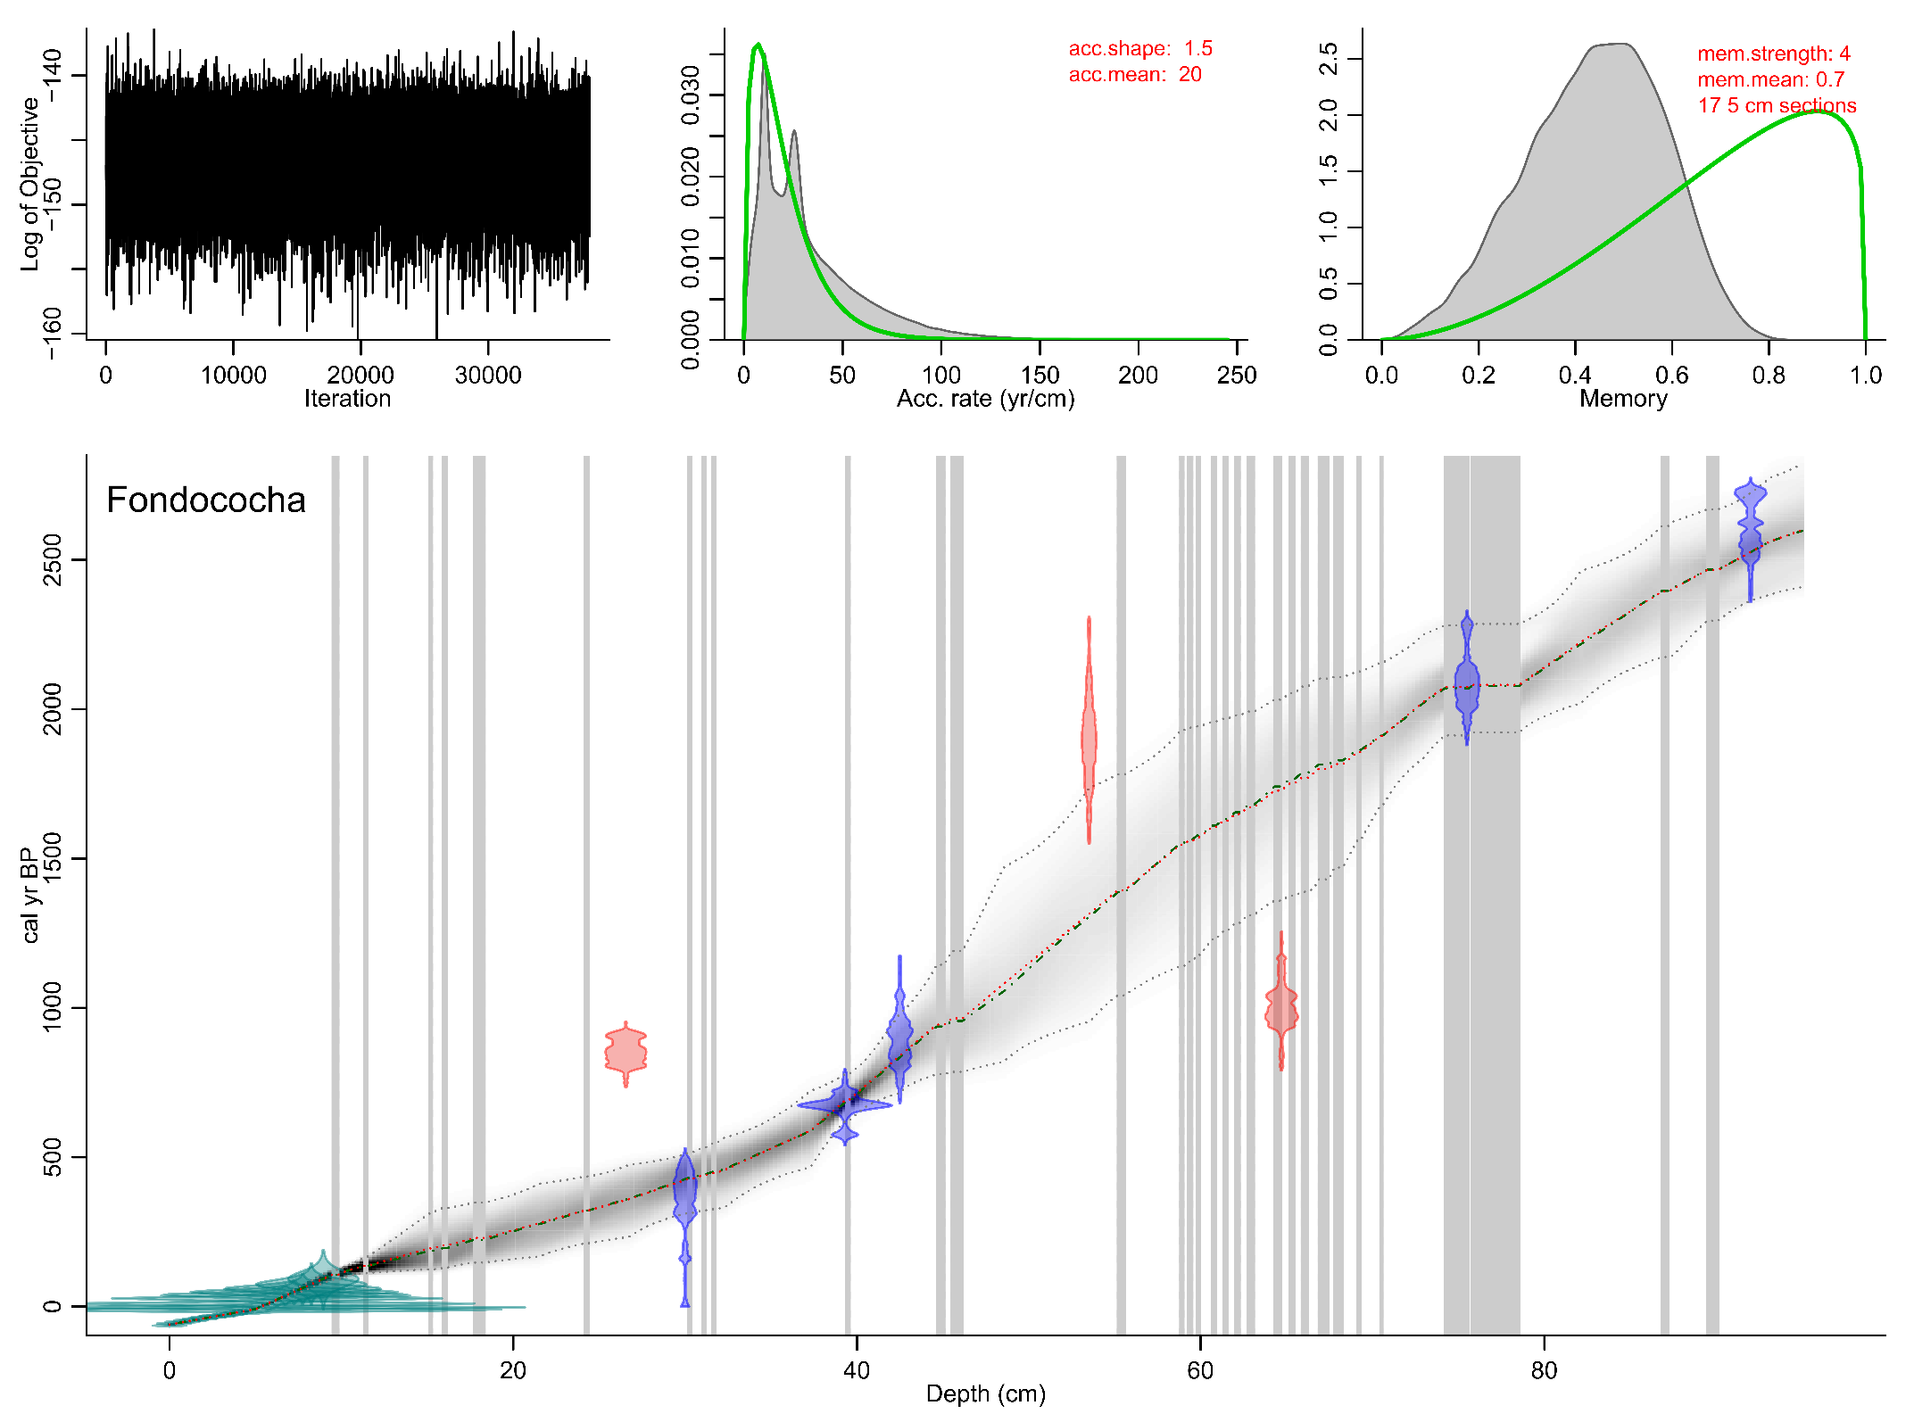
Supplementary Figure 8. Age-depth model of lake Fondococha. The red line indicates the mean age-depth model, the green line represents the median age-depth model. The turqoise distribution curves represent the ²¹⁰Pb-samples, the blue distribution curves represent the ¹⁴C samples, the red distribution curves show outliers that were not included in the final age-model (details can be found in Arcusa et al., 2020). Grey shades represent the 95% confidence interval and the grey vertical bars indicate masked layers.

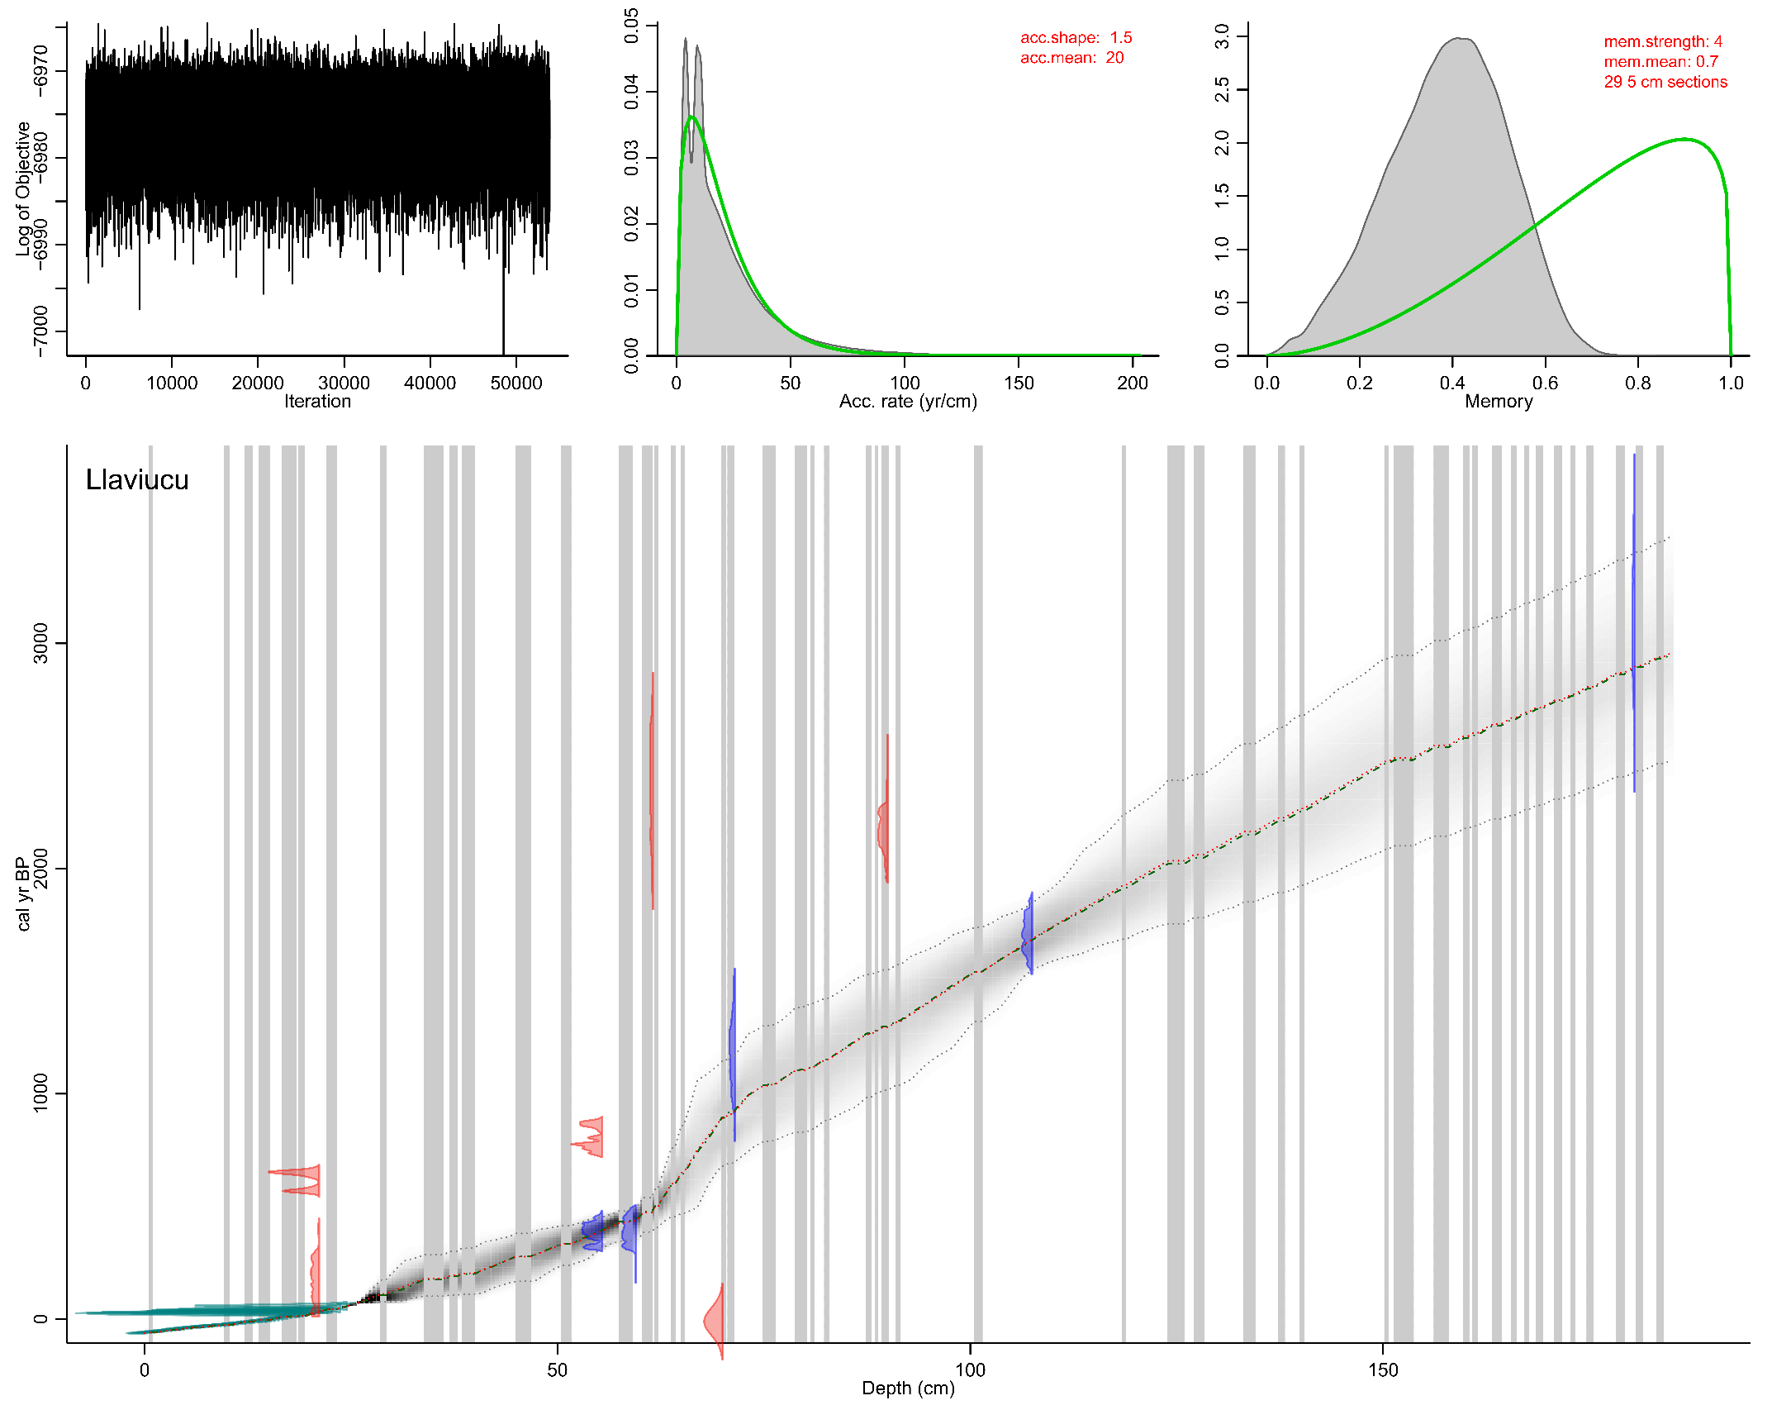
Supplementary Figure 9. Age-depth model of lake Llaviucu. The red line indicates the mean age-depth model, the green line represents the median age-depth model. The turqoise distribution curves represent the ²¹⁰Pb-samples, the blue distribution curves represent the ¹⁴C samples, the red distribution curves show outliers that were not included in the final age-model (details can be found in Arcusa et al., 2020). Grey shades represent the 95% confidence interval and the grey vertical bars indicate masked layers.

Diatom stratigraphies
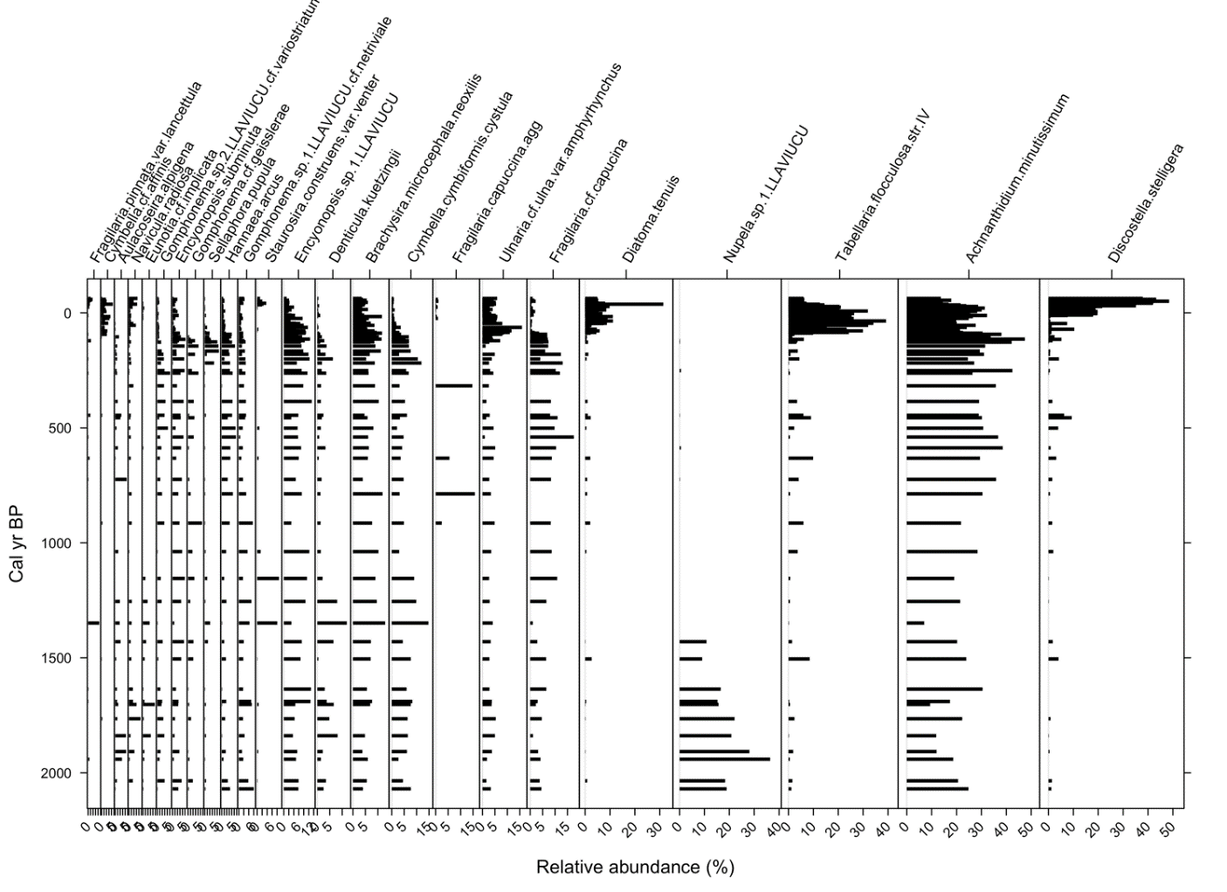
Supplementary Figure 10. Lake Llaviucu’s diatom stratigraphy. Diatom species are those with a relative abundance >3% in at least one sample.
Lake Llaviucu’s diatom record was dominated by benthic taxa, including Achnanthidium minutissimum, and followed by the less abundant Nupela sp.1, Brachysira microcephala, Cymbella cymbiformis, Encyonopsis sp., Denticula kuetzingii, and Gomphonema spp. Planktic taxa fluctuated over the core (up to 25% relative abundance), with a clear shift towards the top of the core to planktic dominated assemblage of Discostella stelligera and Tabellaria flocculosa and benthic Diatoma tenuis.

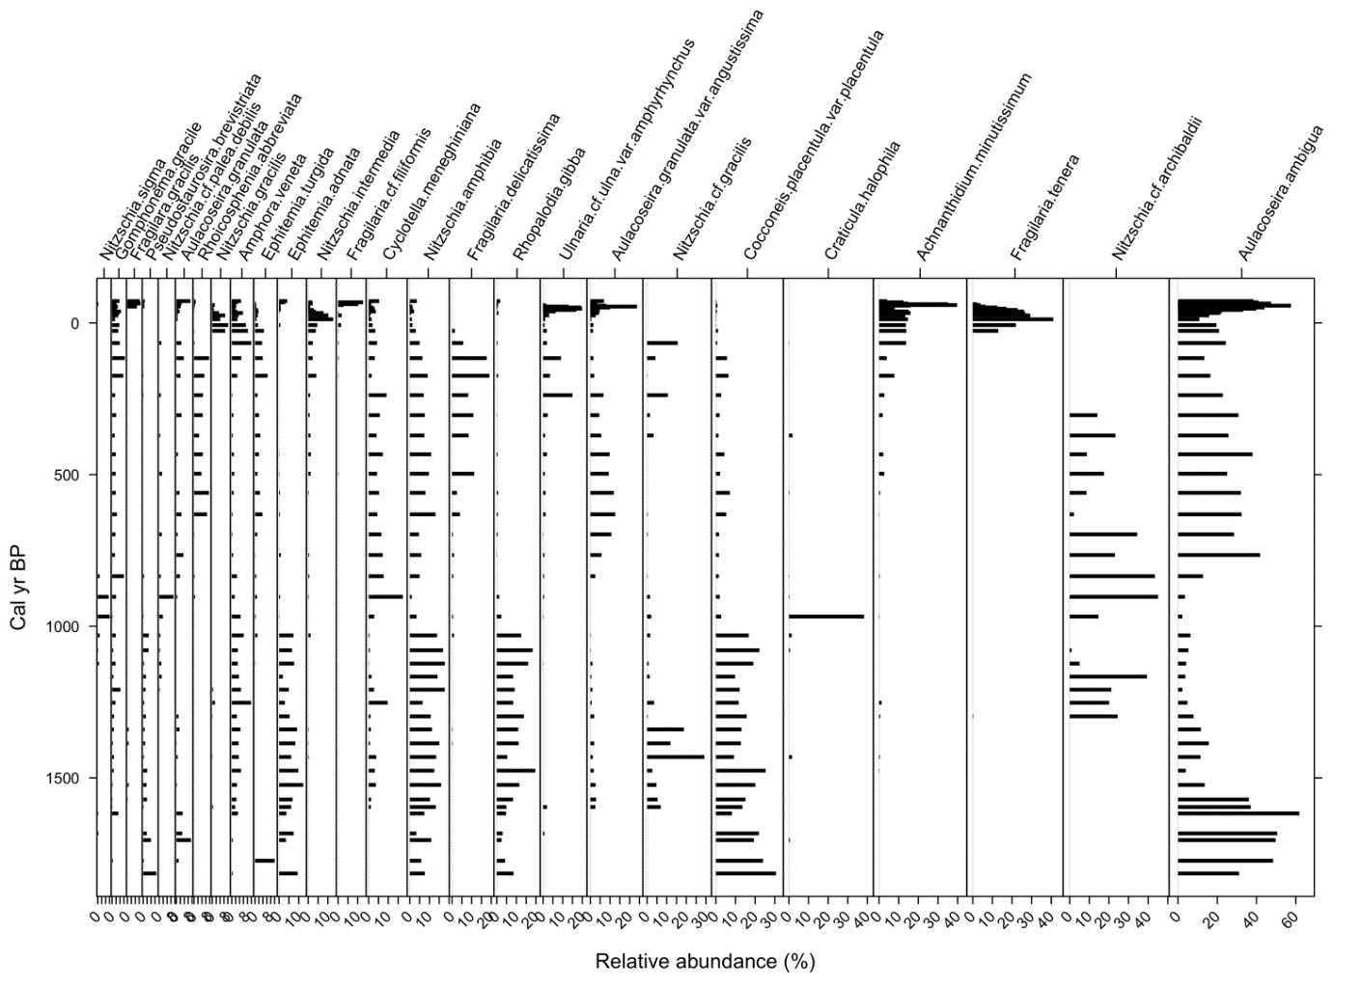
Supplementary Figure 11. Figure Lake Yahuarcocha’s diatom stratigraphy. Diatom species are those with a relative abundance >3% in at least one sample.
Yahuarcocha was dominated by a mixture of planktic (Aulacoseira ambigua, ~20-40% relative abundance), benthic (Nitzschia cf archibaldii, Achnanthidium minutissimum; Nitzschia amphibia, Cocconeis placentula; ~20%), and tychoplanktic (Fragilaria tenera, Ulnaria cf ulna; ~10-20%) taxa. The decrease of saline diatoms (Craticula halophila) at ca 1000 cal yr BP was concomitant with the increase in planktic and tychoplanktic taxa towards the top of the core.
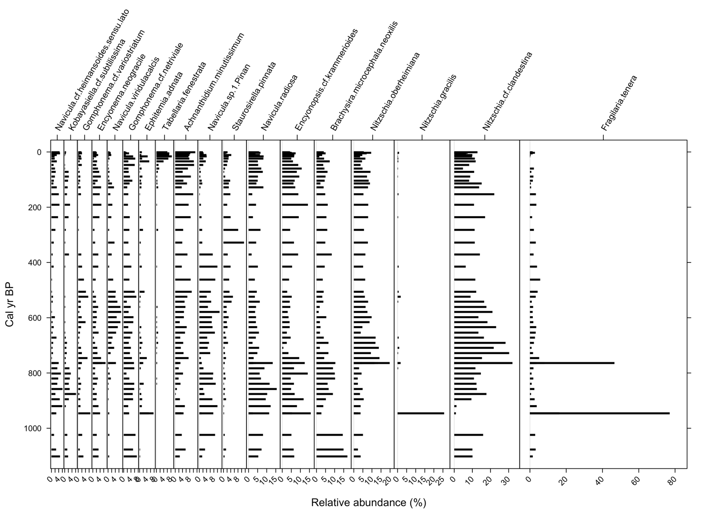
Supplementary Figure 12. Figure Lake Piñan’s diatom stratigraphy. Diatom species are those with a relative abundance >3% in at least one sample.
The dominant taxa in Lake Piñan were benthic Nitzschia species (~20-30% relative abundance), namely Nitzschia cf clandestina, and Nitzschia oberheimiana, followed by smaller proportions of the benthic species Brachysira microcephala, Encyonopsis cf krammerioides, Navicula radiosa, and Achnanthidium minutissimum. The planktic Tabellaria fenestrata showed an increase, albeit minor (~8% relative abundance), towards the top of the core, as well as other tychoplanktic species (Staurosirella pinnata).

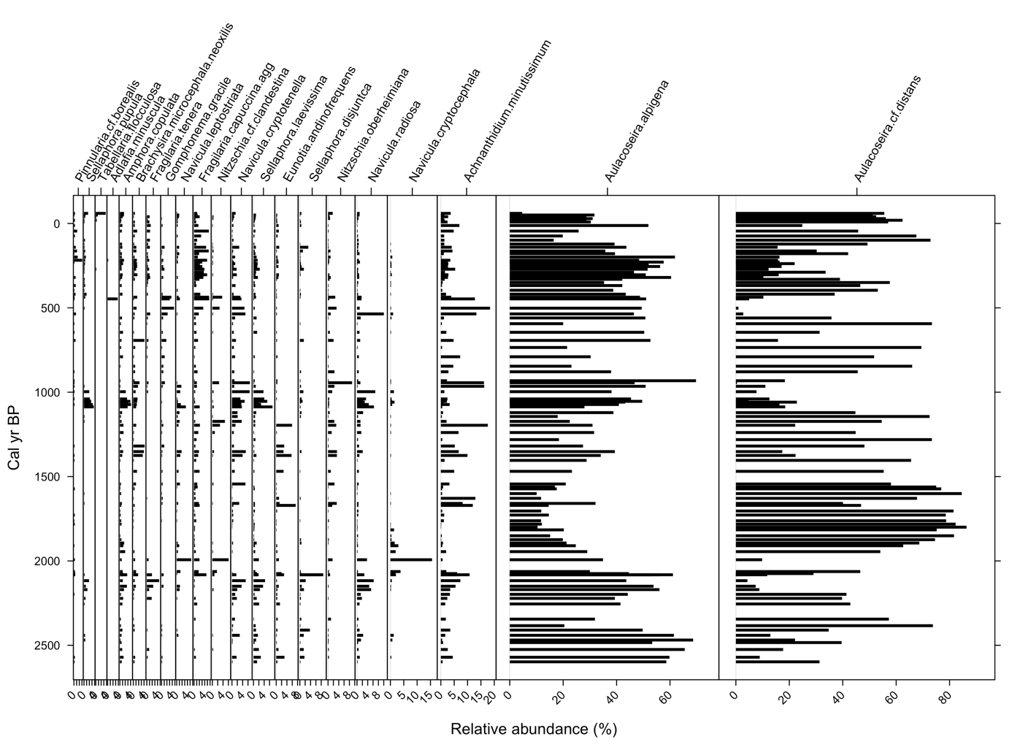
Supplementary Figure 13. Figure Lake Fondococha’s diatom stratigraphy. Diatom species are those with a relative abundance >3% in at least one sample.
Through the record, planktic Aulacoseira taxa (A. cf distans and A. alpigena) dominated the diatom assemblage (~40-80% relative abundance), followed by benthic Achnanthidium minutissimum, Navicula spp., and Nitzschia oberheimiana. The tychoplanktic Fragilaria capucina increased in relative abundance towards the top of the core but remained as a common component of the assemblage throughout the core.

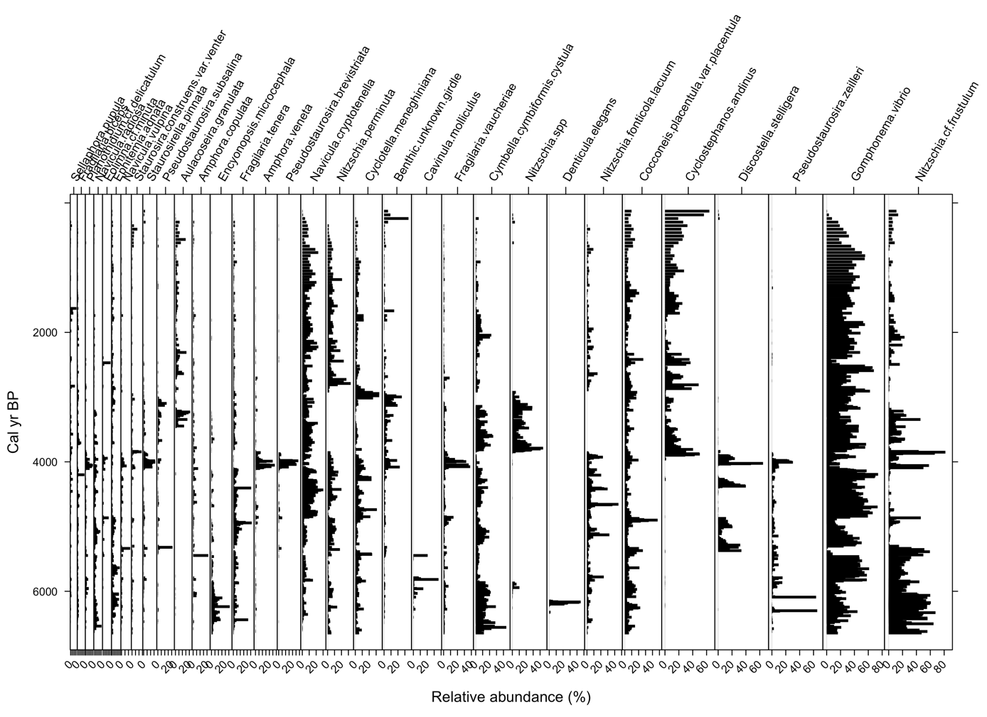
Supplementary Figure 14. Figure Lake Umayo’s diatom stratigraphy. Diatom species are those with a relative abundance >5% in at least one sample. Adapted from Ekdahl et al. (2008)
Throughout the core, eight species dominate the diatom assemblages: Nitzschia spp., Denticula elegans, Cocconeis placentula, Nitzschia fonticola/ lacuum, Cyclostephanos andinus, Discostella stelligera, Pseudostaurosira zeilleri, Gomphonema vibrio, and Nitzschia cf frustulum. In general, there is a decrease of benthic and saline diatom abundance from the mid Holocene to the present. Freshwater planktic diatoms began to be a significant component from the mid Holocene.
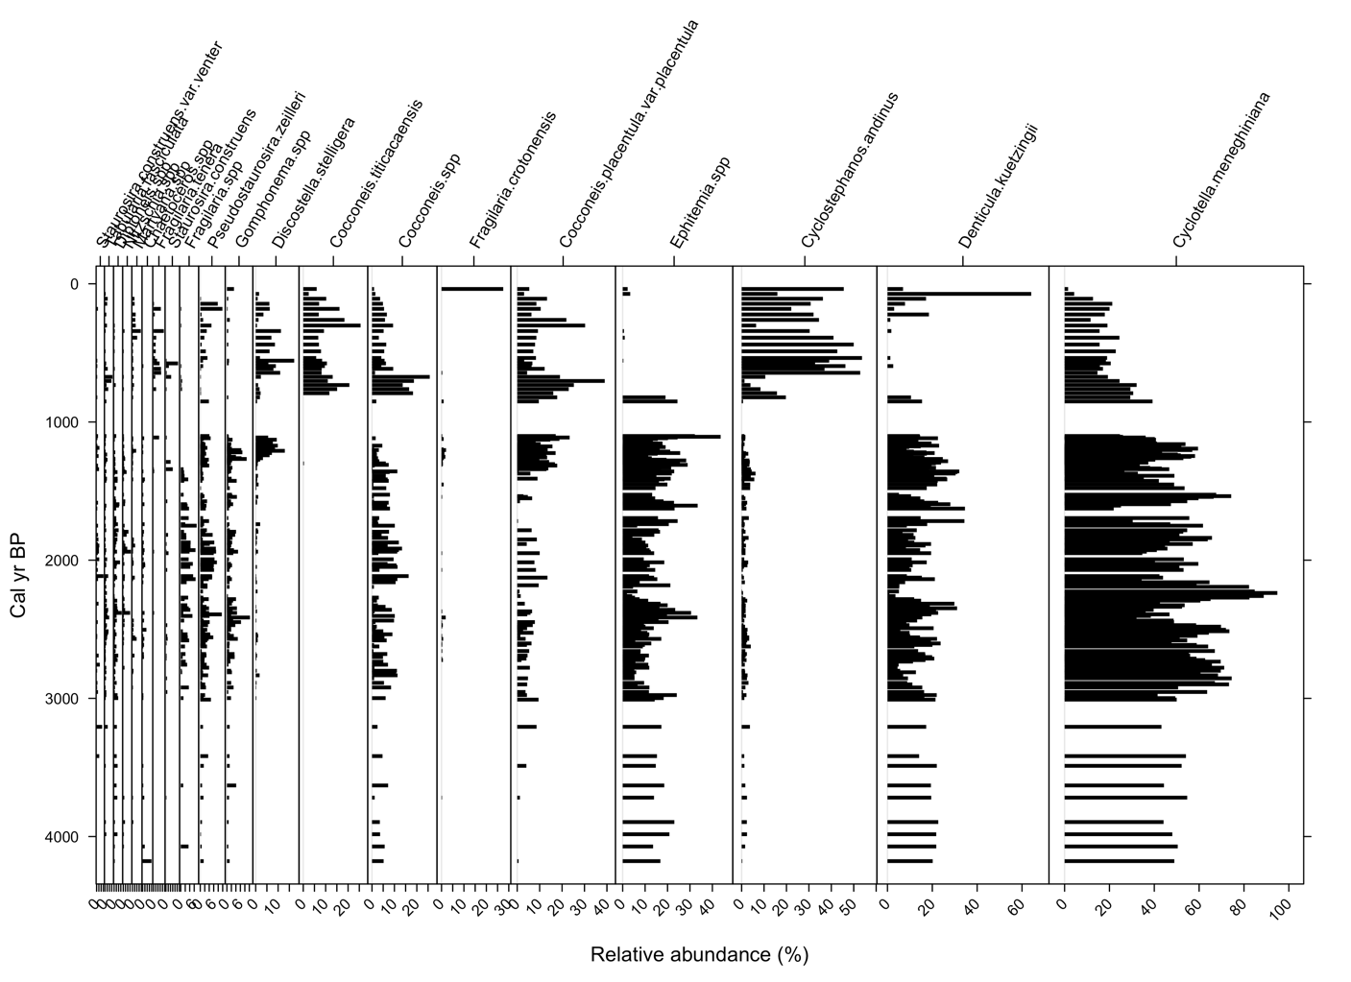
Supplementary Figure 15. Figure Lake Titicaca’s diatom stratigraphy. Diatom species are those with a relative abundance >3% in at least one sample. Adapted from Weide et al. (2017)
Eight dominant species make up the majority of the flora: Cocconeis titicaensis, Cocconeis spp. (mostly C. placentula), Fragilaria crotonesis, Ephitemia spp., Cyclostephanos andinus, Denticula kuetzingii, and Cyclotella meneghiniana. There is a general decrease of the mesoeutrophic planktic species C. meneghiniana from the mid Holocene to the present, accompanied with increase of the epiphytic C. placentula, and C. andinus, indicating a freshening trend throughout the reminder of the record.

References cited in the supplementary material
Appleby, P. G., and Oldfield, F. (1978). The calculation of lead-210 dates assuming a constant rate of supply of unsupported 210Pb to the 10/3/13 2:51:00 PMsediment. Catena 5, 1–8.
Arcusa, S. H., Schneider, T., Mosquera, P. V., Vogel, H., Kaufman, D., Szidat, S., et al. (2020). Late Holocene tephrostratigraphy from Cajas National Park, southern Ecuador. Andean Geology 47. doi:http://dx.doi.org/10.5027/andgeoV47n3-3301.
Blaauw, M., and Christen, J. A. (2018). rbacon: Age-depth modelling using bayesian statistics. R package version 2.3 2.
Ekdahl, E. J., Fritz, S. C., Baker, P. A., Rigsby, C. A., and Coley, K. (2008). Holocene multidecadal-to millennial-scale hydrologic variability on the South American Altiplano. The Holocene 18, 867–876
Reimer, P. J., Bard, E., Bayliss, A., Beck, J. W., Blackwell, P. G., Ramsey, C. B., et al. (2013). IntCal13 and Marine13 radiocarbon age calibration curves 0–50,000 years cal BP. Radiocarbon 55, 1869–1887.
Weide, D. M., Fritz, S. C., Hastorf, C. A., Bruno, M. C., Baker, P. A., Guedron, S., et al. (2017). A∼ 6000 yr diatom record of mid-to late Holocene fluctuations in the level of Lago Wiñaymarca, Lake Titicaca (Peru/Bolivia). Quaternary Research 88, 179–192.

