Table S1:Predicted disease targets of SNT (related to the Ulcerative Colitis) based on the TTD.
Term description | Adjusted p-value | -LOG₁₀ | Targets* | ClusterNum | cluster1(p-value|benjamini-value|coverage|EnrichRatio|gene names)
Inflammation | 0.262 | 0.581698709 | 18 | 1 | 1.02e-001|2.62e-001|18|1.4|ADAM8;ADK;ADORA1;ADORA2A;ADRB2;AOC3;CSF2;DHFR;F2R;F2RL1;<br>IKBKB;KIT;MIF;NOS3;PLA2G1B;PPARD;PPARG;PTGS2;|
Inflammatory Diseases | 0.262 | 0.581698709 | 10 | 1 | 1.79e-001|2.62e-001|10|1.4|ADAM17;ALB;HRH3;IKBKB;IL10;ITGAL;PIK3CD;PTGFR;PTGS2;SYK;<br>|
Inflammatory Bowel Disease | 0.207 | 0.684029655 | 6 | 1 | 4.06e-002|2.07e-001|6|2.2|ADAM17;ADK;ADORA1;CNR1;P2RX3;PPARG;|
Ulcerative Colitis | 0.0421 | 1.375717904 | 5 | 1 | 3.01e-003|4.21e-002|5|3.9|HMOX1;MIF;NPR2;PPARG;PTGER4;|
Nausea And Vomiting | 0.111 | 0.954677021 | 4 | 1 | 1.20e-002|1.11e-001|4|3.7|DRD2;HRH1;HTR3A;HTR6;|
Chronic Inflammatory Diseases | 0.262 | 0.581698709 | 4 | 1 | 6.39e-002|2.62e-001|4|2.4|MC3R;PPARG;PTGS1;TNF;|
Colorectal Cancer | 0.262 | 0.581698709 | 3 | 1 | 1.19e-001|2.62e-001|3|2.3|AURKA;FNTA;TLR9;|
Immune Disease | 0.262 | 0.581698709 | 3 | 1 | 1.19e-001|2.62e-001|3|2.3|MSTN;NT5E;OPRK1;|
Multiple Sclerosis | 0.412 | 0.385102784 | 5 | 1 | 3.34e-001|4.12e-001|5|1.3|ADRB2;CRH;IFNG;LEP;PPARG;|

Table S2: Prediction of potential target pathways related to SNT

KEGG pathway ID | KEGG pathway name | Adjusted p-value | Targets* | gene symbol
hsa04970 | Salivary Secretion | 0.0923 | 17 | ADRA1A;ADRA1B;ADRA1D;ADRB1;ADRB2;ADRB3;ATP1A1;ATP1A2;ATP2B4;CHRM3;  GUCY1B3;ITPR1;ITPR2;ITPR3;KCNMA1;NOS1;RYR3;
hsa04971 | Gastric Acid Secretion | 0.0481 | 16 | ATP1A1;ATP1A2;CAMK2D;CAMK2G;CFTR;CHRM3;HRH2;ITPR1;ITPR2;ITPR3;  KCNE2;KCNJ1;KCNJ10;KCNJ15;KCNK2;KCNQ1;
hsa04972 | Pancreatic Secretion | 0.314 | 15 | AMY2A;ATP1A1;ATP1A2;ATP2A1;ATP2B4;CFTR;CHRM3;ITPR1;ITPR2;ITPR3;  KCNMA1;KCNQ1;PLA2G1B;RHOA;RYR2;
hsa04973 | Carbohydrate Digestion And Absorption | 0.222 | 9 | AMY2A;ATP1A1;ATP1A2;CACNA1D;GNAT3;MGAM;SI;TAS1R2;TAS1R3;
hsa04974 | Protein Digestion And Absorption | 1 | 5 | ATP1A1;ATP1A2;KCNQ1;SLC7A7;SLC8A1;
hsa04975 | Fat Digestion And Absorption | 1 | 4 | APOA1;CD36;MTTP;PLA2G1B;
hsa04976 | Bile Secretion | 0.0668 | 15 | ABCB1;ABCB4;ABCC4;AQP1;AQP8;ATP1A1;ATP1A2;CFTR;CYP3A4;HMGCR;  NR1H4;RXRA;SLC22A1;SLCO1B1;SLCO1B3;
hsa04977 | Vitamin Digestion And Absorption | 1 | 2 | APOA1;LRAT;
hsa04978 | Mineral Absorption | 0.751 | 7 | ATP1A1;ATP1A2;HMOX1;S100G;SLC26A6;SLC8A1;VDR;

Table S4: KEGG pathway analysis of differentially regulated proteins related to SNT.

Item name | Item description | Number of differential protein targets | Total number of protein targets | Adjusted p-value
has 04512 | ECM-receptor interaction | 6 | 81 | 0.0000353
has 05146 | Amoebiasis | 4 | 94 | 0.0134
has 04510 | Focal adhesion | 5 | 197 | 0.0155
has 05165 | Human papillomavirus infection | 6 | 317 | 0.0155
has 04151 | PI3K-Akt signaling pathway | 6 | 348 | 0.0187
has 03320 | PPAR signaling pathway | 3 | 72 | 0.0286

Figure S1: The chemical structures of the pharmacoactive compounds of SNT.

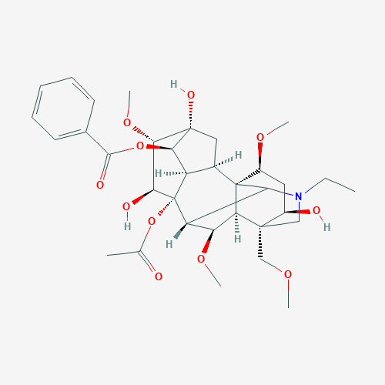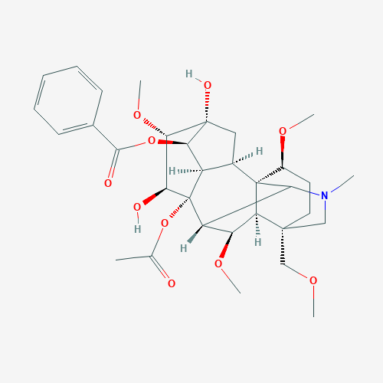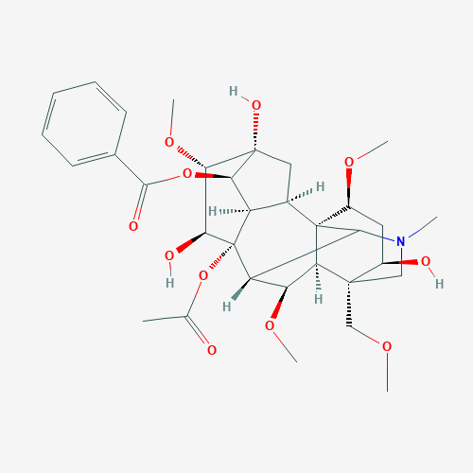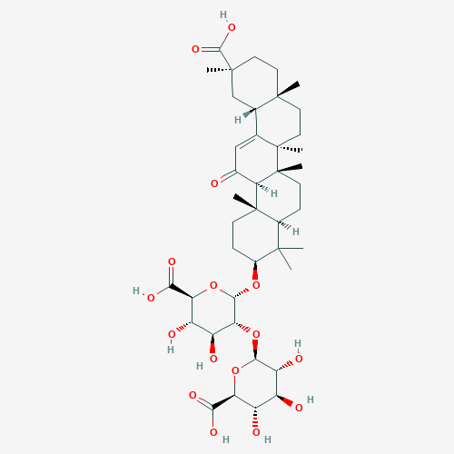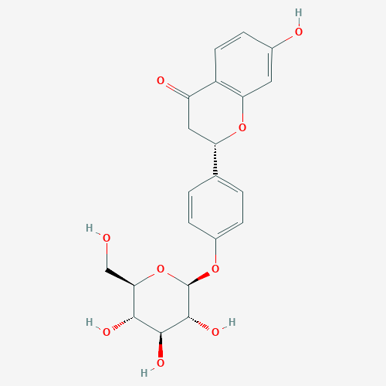
Aconitine Hypaconitine Mesaconitine Glycyrrhizic_acid Liquiritin
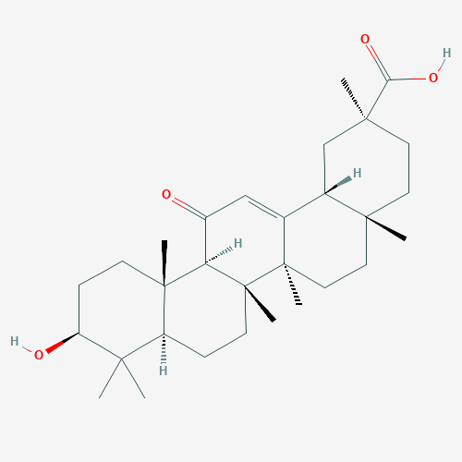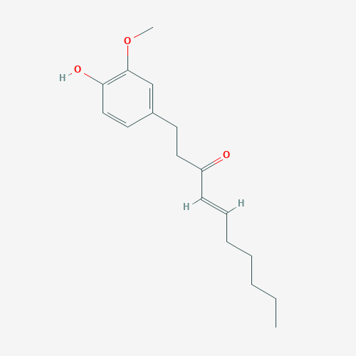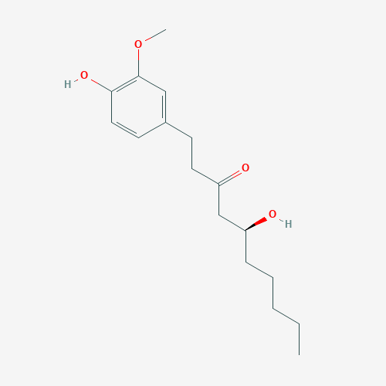
Enoxolone 6-Shogaol 6-Gingerol
Figure S2: SNT drug components–targets analysis.

