Supplementary Material

Mesh independence study
3 mesh sizes have been explored in order to select the most adapted domain discretization. The 270 mm dual tube configuration was considered. The mesh size for the insulation (1 cm) and for the cavity (1 mm) was not modified as the physics is simpler than in the tubular reaction zone. In the tubular reaction zone, 3 mesh sizes were tested: 1 mm (total of 9,189 cells), 0.5 mm (total of 26,084 cells) and 0.25 mm (total of 90,310 cells). The results are reported in Table S1 for the methane conversion and in Figure S1 and Figure S2 for the temperature and methane mole fraction along the reactor axis, respectively. As can be seen in Table S1, the methane conversion is in close agreement for the 0.5 mm and 0.25 mm mesh. Also, the temperature is not very sensitive to mesh size (Figure S1). Conversely, the influence on the mesh size is more pronounced for the methane mole fraction. A 0.5 mm mesh size is found to be a good compromise between the computational time and the calculation precision. Table S2 summarizes the convergence conditions.
Supplementary Table S1: Influence of the mesh size on methane conversion in the tubular reaction zone
Position | Methane conversion vs. mesh size
 | 1 mm | 0.5 mm | 0.25 mm
X1 | 0.15 | 0.13 | 0.12
X2 | 0.16 | 0.18 | 0.18
X3 | 0.18 | 0.20 | 0.20
Outlet | 0.20 | 0.22 | 0.22

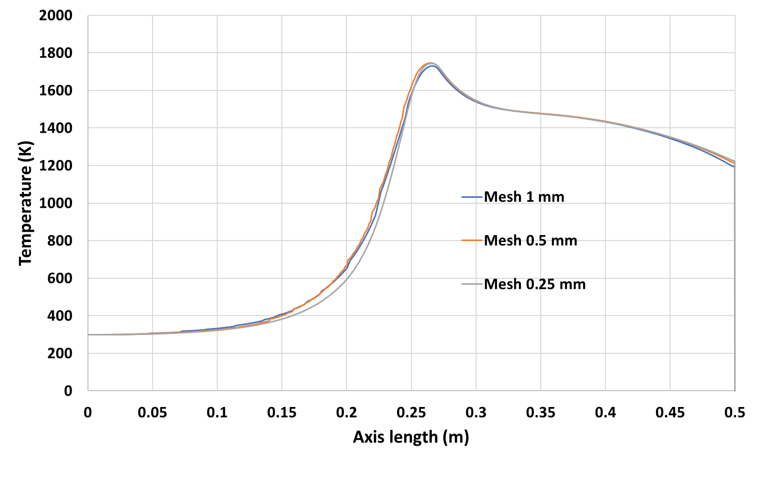
Supplementary Figure S1: Influence of the mesh size on the temperature on the reactor axis
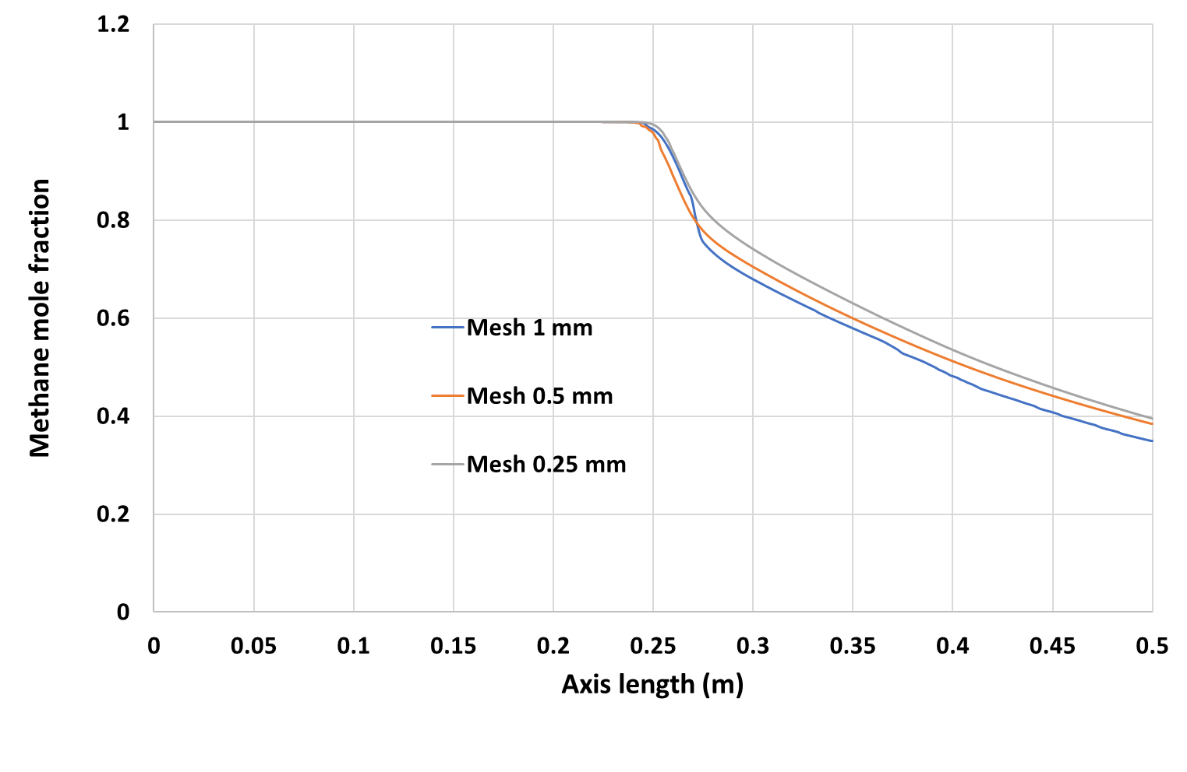
Supplementary Figure S2: Influence of the mesh size on the methane mole fraction on the reactor axis

Typical computational time is a few hours on a personal computer (Intel® Core™ i7-8665U CPU @ 1.90 GHz 2.11 GHz RAM 16 Go) for the convergence conditions of Table S2. The solution method was as follows. A coupled scheme was chosen for the pressure-velocity coupling. As far as spatial discretization was concerned, the least squares cell based method was selected for gradient, the body force weighted for pressure, and first order upwind for momentum, species, energy and radiation models.

Supplementary Table S2: Convergence conditions

Residual |  | Absolute criteria
continuity |  | 0.001
x-velocity |  | 0.001
y-velocity |  | 0.001
energy |  | 0.0000001
do-intensity |  | 0.000001
CH4 |  | 0.001
H2 |  | 0.001
C(s) |  | 0.001
Heat balance |  | 0.01

On axis mole fractions (dual tube configuration 270 mm)
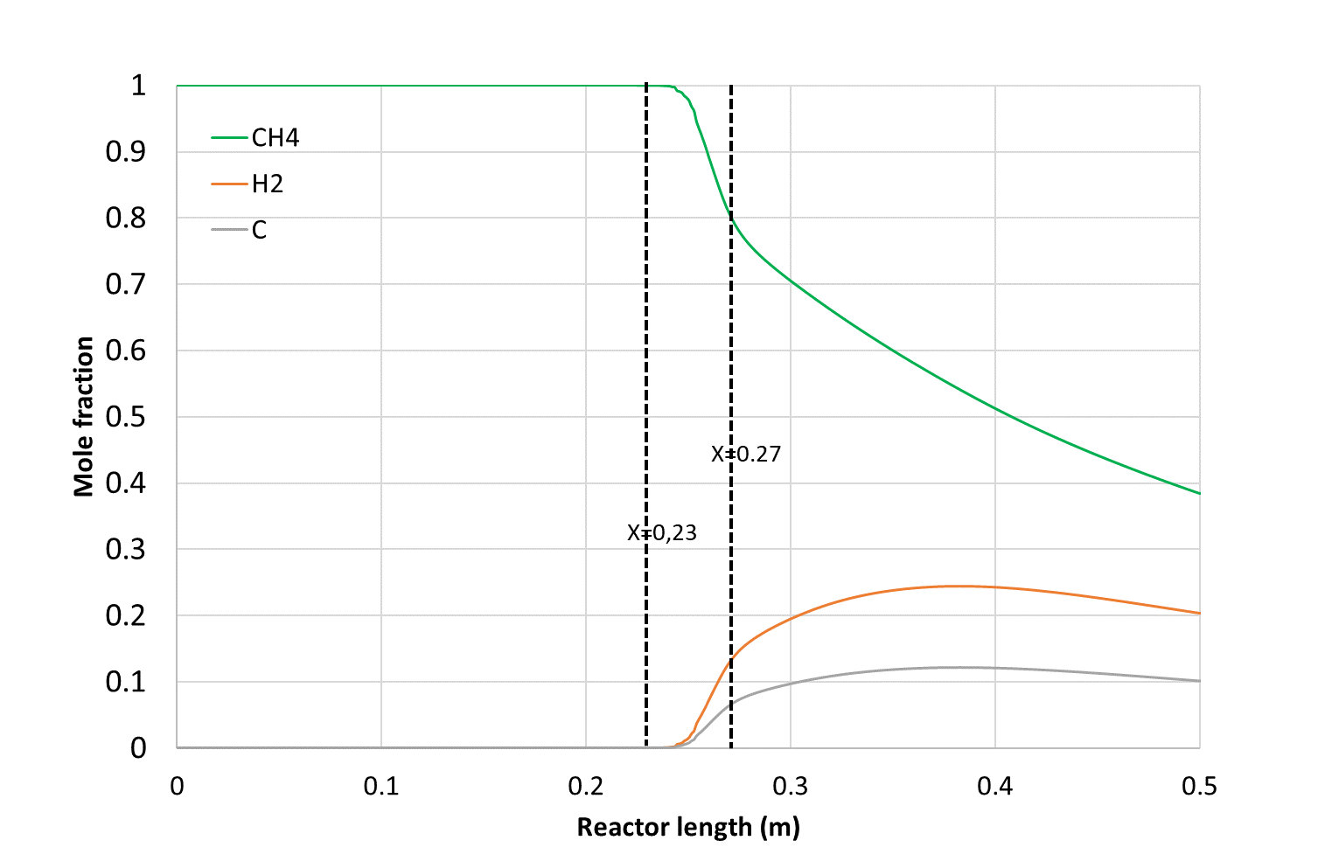
Supplementary Figure S3: On-axis CH₄, H₂ and C mole fractions along the reactor length (dual tube configuration 270 mm)

Velocity contour (dual tube configuration 270 mm)

Supplementary Figure S4: Velocity contour for the 270 mm dual tube configuration

