Supplementary Material

Supplementary Figures
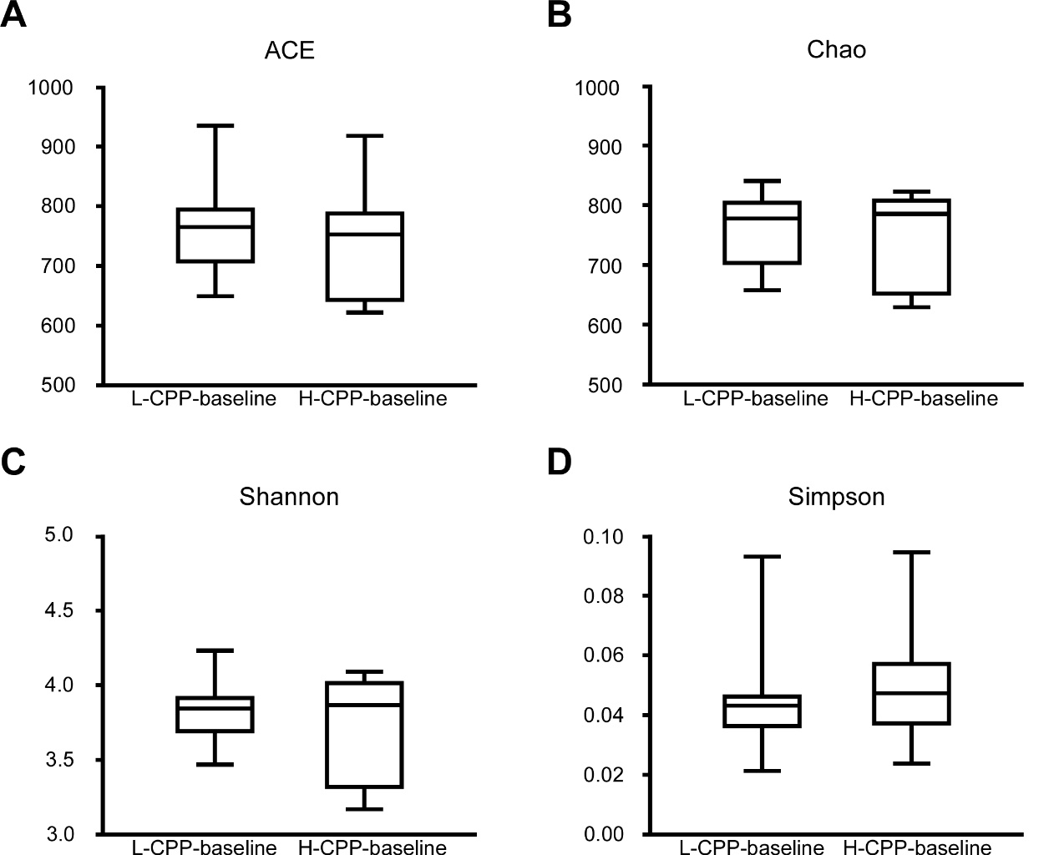
Figure S1: Comparison of the community alpha diversity between L-CPP-baseline and H-CPP-baseline. Alpha diversity was measured by ACE (A), Chao (B), Shannon (C) and Simpson (D). A Mann-Whitney test was used to analyze the data. A student’s t test was used for the data with Gaussian distribution. The central line shown in each box plot indicates the median of data. Whiskers extend to cover the whole range of values. Statistical significance was accepted at p<0.05.

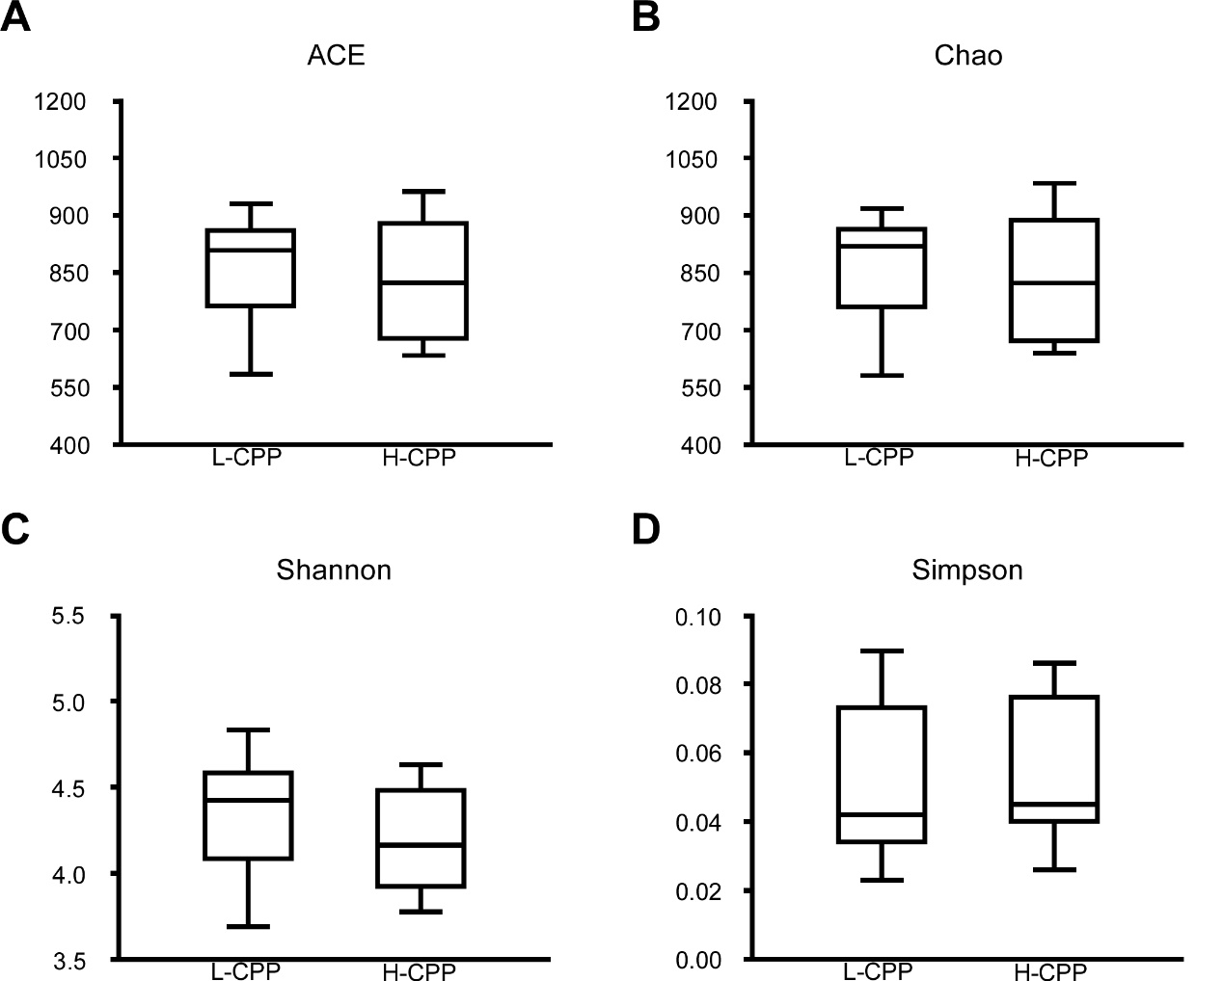
Figure S2: Comparison of the community alpha diversity between L-CPP and H-CPP. Alpha diversity was measured by ACE (A), Chao (B), Shannon (C) and Simpson (D). A Mann-Whitney test was used to analyze the data. A student’s t test was used for the data with Gaussian distribution. The central line shown in each box plot indicates the median of data. Whiskers extend to cover the whole range of values. Statistical significance was accepted at p<0.05.

- Supplementary Tables
Table S1: Gut microbiota analyzed at family and genus levels
Family Acidaminococcaceae | Family Corynebacteriaceae | Family Paenibacillaceae_1
Family Actinomycetaceae | Family Deferribacteraceae | Family Pasteurellaceae
Family Aerococcaceae | Family Dermabacteraceae | Family Peptococcaceae_1
Family Alcaligenaceae | Family Desulfovibrionaceae | Family Peptostreptococcaceae
Family Anaeroplasmataceae | Family Dietziaceae | Family Phyllobacteriaceae
Family Bacillaceae_1 | Family Elusimicrobiaceae | Family Piscirickettsiaceae
Family Bacillaceae_2 | Family Enterobacteriaceae | Family Planococcaceae
Family Bacillales_Incertae_Sedis_XI | Family Enterococcaceae | Family Porphyromonadaceae
Family Bacteriovoracaceae | Family Erysipelotrichaceae | Family Prevotellaceae
Family Bacteroidaceae | Family Erythrobacteraceae | Family Promicromonosporaceae
Family Bdellovibrionaceae | Family Eubacteriaceae | Family Pseudomonadaceae
Family Bifidobacteriaceae | Family Flavobacteriaceae | Family Puniceicoccaceae
Family Bradymonadaceae | Family Helicobacteraceae | Family Rhodobacteraceae
Family Bradyrhizobiaceae | Family Hyphomicrobiaceae | Family Rhodospirillaceae
Family Brevibacteriaceae | Family Idiomarinaceae | Family Rikenellaceae
Family Brucellaceae | Family Lachnospiraceae | Family Ruminococcaceae
Family Burkholderiaceae | Family Lactobacillaceae | Family Sphingobacteriaceae
Family Carnobacteriaceae | Family Methanobacteriaceae | Family Spirochaetaceae
Family Catabacteriaceae | Family Methanomassiliicoccaceae | Family Staphylococcaceae
Family Caulobacteraceae | Family Microbacteriaceae | Family Streptococcaceae
Family Chloroplast | Family Micrococcaceae | Family Sutterellaceae
Family Christensenellaceae | Family Moraxellaceae | Family Unassigned
Family Clostridiaceae_1 | Family Mycoplasmataceae | Family Veillonellaceae
Family Clostridiales_Incertae_Sedis_XIII | Family Nitrosomonadaceae | Family Verrucomicrobiaceae
Family Comamonadaceae | Family No_Rank | Family Victivallaceae
Family Coriobacteriaceae | Family Nocardiaceae | Family Xanthomonadaceae
Genus Acetanaerobacterium | Genus Coraliomargarita | Genus Ochrobactrum
Genus Acetatifactor | Genus Corynebacterium | Genus Odoribacter
Genus Acinetobacter | Genus Desulfovibrio | Genus Okibacterium
Genus Adlercreutzia | Genus Devosia | Genus Oligella
Genus Aerococcus | Genus Dietzia | Genus Olsenella
Genus Aestuariispira | Genus Dorea | Genus Oscillibacter
Genus Akkermansia | Genus Eisenbergiella | Genus Paenalcaligenes
Genus Alcaligenes | Genus Elusimicrobium | Genus Paenibacillus
Genus Aliidiomarina | Genus Enteractinococcus | Genus Paenochrobactrum
Genus Alistipes | Genus Enterobacter | Genus Papillibacter
Genus Allobaculum | Genus Enterococcus | Genus Parabacteroides
Genus Alloprevotella | Genus Enterorhabdus | Genus Paracoccus
Genus Anaerobacterium | Genus Erysipelotrichaceae_incertae_sedis | Genus Paraprevotella
Genus Anaerofilum | Genus Escherichia/Shigella | Genus Parasutterella
Genus Anaerofustis | Genus Eubacterium | Genus Peredibacter
Genus Anaeroplasma | Genus Facklamia | Genus Phascolarctobacterium
Genus Anaerorhabdus | Genus Flaviflexus | Genus Prevotella
Genus Anaerostipes | Genus Flavobacterium | Genus Proteus
Genus Anaerotruncus | Genus Flavonifractor | Genus Pseudoflavonifractor
Genus Anaerovorax | Genus Gemella | Genus Pseudomonas
Genus Aquamicrobium | Genus Gemmobacter | Genus Pseudosphingobacterium
Genus Arthrobacter | Genus Globicatella | Genus Psychrobacter
Genus Atopostipes | Genus Gracilibacillus | Genus Pusillimonas
Genus Bacillus | Genus Helicobacter | Genus Ralstonia
Genus Bacteroides | Genus Holdemania | Genus Rhodococcus
Genus Barnesiella | Genus Intestinimonas | Genus Rikenella
Genus Bifidobacterium | Genus Jeotgalicoccus | Genus Romboutsia
Genus Bilophila | Genus Kurthia | Genus Roseburia
Genus Blautia | Genus Lachnospiracea_incertae_sedis | Genus Rothia
Genus Bosea | Genus Lactobacillus | Genus Ruminococcus
Genus Brachybacterium | Genus Lactococcus | Genus Ruminococcus2
Genus Bradymonas | Genus Leucobacter | Genus Saccharibacteria_genera_incertae_sedis
Genus Brevibacterium | Genus Luteimonas | Genus Schwartzia
Genus Brevundimonas | Genus Lysinibacillus | Genus Solibacillus
Genus Butyricicoccus | Genus Marvinbryantia | Genus Sphingobacterium
Genus Butyricimonas | Genus Methanomassiliicoccus | Genus Sporobacter
Genus Butyrivibrio | Genus Methanosphaera | Genus Sporosarcina
Genus Catabacter | Genus Methylophaga | Genus Staphylococcus
Genus Cellulosimicrobium | Genus Microbacterium | Genus Stenotrophomonas
Genus Cellvibrio | Genus Moheibacter | Genus Streptococcus
Genus Christensenella | Genus Morganella | Genus Streptophyta
Genus Clostridium_IV | Genus Mucispirillum | Genus Subdoligranulum
Genus Clostridium_XlVa | Genus Murimonas | Genus Thiopseudomonas
Genus Clostridium_XlVb | Genus Mycoplasma | Genus Turicibacter
Genus Clostridium_XVIII | Genus Myroides | Genus Unassigned
Genus Collinsella | Genus Nitrosomonas | Genus Vagococcus
Genus Comamonas | Genus No_Rank | Genus Vampirovibrio
Genus Coprobacillus | Genus Nosocomiicoccus | Genus Victivallis
Genus Coprococcus | Genus Oceanobacillus

Table S2: Comparison of the gut microbial composition among the baseline and post-treatment for the morphine and saline group at the genus level
Genus-taxon | Saline-baseline VS Saline | Morphine-baseline VS Morphine | Saline VS Morphine
Acetatifactor |  | 0.0281
Adlercreutzia | 0.0004 | <0.0001
Alistipes | 0.0032 | <0.0001
Allobaculum |  | 0.0002
Alloprevotella |  | 0.0002
Anaerofustis |  | <0.0001
Anaerorhabdus | 0.0313 | 0.0002
Anaerovorax | 0.0084 | 0.0009
Bacteroides |  | 0.002
Barnesiella |  | <0.0001
Bilophila | 0.0288 | 0.0031 | 0.0287
Blautia |  | 0.0002
Butyricicoccus |  | 0.034
Butyricimonas | 0.0156 | 0.0012
Butyrivibrio |  | 0.0094
Catabacter | 0.0141 | <0.0001
Clostridium_XlVa | 0.0125 |  | 0.0117
Clostridium_XVIII | 0.0313 | 0.0004
Collinsella |  | <0.0001 | 0.0045
Coprobacillus | 0.0156 | 0.0019
Corynebacterium | 0.0156 |  | <0.0001
Desulfovibrio | 0.0156 | <0.0001
Enterorhabdus |  | 0.0057
Eisenbergiella |  | 0.0116
Escherichia/Shigella |  | 0.0005 | 0.0351
Flavonifractor |  |  | 0.0402
Helicobacter |  | 0.011
Intestinimonas | 0.0312
Jeotgalicoccus | 0.0156 | 0.0402 | <0.0001
Lactococcus |  |  | 0.0454
Marvinbryantia | 0.0313 |  | 0.034
Mucispirillum | 0.0156 | 0.0022
Oscillibacter | 0.0313
Parasutterella | 0.0313 | 0.0061
Rikenella |  | 0.0176
Romboutsia |  | 0.0014
Roseburia |  |  | 0.0104
Rothia | 0.0156 |  | 0.021
Sporobacter |  | 0.0025
Staphylococcus |  |  | 0.0401
Streptococcus | 0.0156 |  | 0.0448
Streptophyta |  |  | 0.0067
A Mann-Whitney test and Wilcoxon signed rank test were used to analyzed the data. Student’s t test was used for data with Gaussian distribution. Values were expressed as p values. Statistical significance was accepted at p<0.05.
Table S3: Comparison of the gut microbiome composition among the baseline and post-treatment for the morphine and saline group at the family level
Family-taxon | Saline-baseline VS Saline | Morphine-baseline VS Morphine | Saline VS Morphine
Bacteroidaceae |  | 0.0024
Catabacteriaceae | 0.0141 | <0.0001
Chloroplast |  |  | 0.0067
Clostridiales_Incertae_Sedis_XIII | 0.0084 | 0.0008
Coriobacteriaceae | 0.0181 | 0.0004
Corynebacteriaceae | 0.0156 |  | <0.0001
Deferribacteraceae | 0.0156 | 0.0022
Desulfovibrionaceae | 0.0093 | 0.0008
Enterobacteriaceae |  | 0.0005 | 0.0309
Enterococcaceae |  |  | 0.0325
Erysipelotrichaceae | 0.0156 | 0.0281
Helicobacteraceae |  | 0.011
Lachnospiraceae |  | 0.001
Microbacteriaceae | 0.0243 |  | 0.0025
Micrococcaceae | 0.0085 |  | 0.0001
No_Rank |  | 0.0402
Pasteurellaceae |  | <0.0001 | 0.002
Peptococcaceae_1 | 0.0156 | 0.0034
Peptostreptococcaceae |  | 0.0014
Puniceicoccaceae |  | 0.0002
Rikenellaceae | 0.0156 | <0.0001
Spirochaetaceae | 0.0156 | 0.0006
Staphylococcaceae |  |  | 0.0035
Streptococcaceae | 0.0156 |  | 0.0201
Sutterellaceae | 0.0313 | 0.0061
Mann-Whitney test and Wilcoxon signed rank test were used to analyzed the data. Student’s t test was used for data with Gaussian distribution. Values were expressed as p values. Statistical significance was accepted at p<0.05.

Table S4: Comparison of the gut microbial H-CPP and L-CPP group after the morphine-induced CPP training both at the genus and the family levels
Taxon | L-CPP VS H-CPP
Family Lachnospiraceae | 0.008
Family Ruminococcaceae | 0.0066
Family Porphyromonadaceae | 0.0023
Family Peptostreptococcaceae | 0.01
Family Spirochaetaceae | 0.0252
Family Veillonellaceae | 0.0236
Family Catabacteriaceae | 0.0087
Family Elusimicrobiaceae | 0.0196
Family Christensenellaceae | 0.0474
Genus Alloprevotella | 0.0384
Genus Romboutsia | 0.01
Genus Clostridium_IV | 0.0387
Genus Roseburia | 0.0036
Genus Schwartzia | 0.0236
Genus Catabacter | 0.0087
Genus Elusimicrobium | 0.0196
Genus Dorea | 0.0423
Genus Christensenella | 0.0471
Genus Anaerofilum | 0.0185
A Mann-Whitney test was used to analyze the data. A student’s t test was used for the data with Gaussian distribution. Values were expressed as p values. Statistical significance was accepted at p<0.05.

Table S5: Comparison of the within-group differences in the gut microbiome composition for L-CPP and H-CPP groups between the pre- and post-conditioning at the genus level
Genus-taxon | L-CPP-baseline VS L-CPP | H-CPP-baseline VS H-CPP
Butyricicoccus | 0.0244
Rikenella | 0.0093
Clostridium_XVIII | 0.002
Sporobacter | 0.0264
Coprobacillus | 0.0112
Anaerorhabdus | 0.0015
Enterococcus | 0.0469
Romboutsia |  | 0.0049
Parasutterella |  | 0.0425
Bilophila |  | 0.0254
Mucispirillum |  | 0.0039
Enterorhabdus |  | 0.0244
Rothia |  | 0.0189
Bacteroides |  | 0.0269
Anaerovorax |  | 0.0396
Saccharibacteria_genera_incertae_sedis |  | 0.0204
Alloprevotella | 0.0032 | 0.0486
Barnesiella | 0.0006 | 0.0122
Blautia | 0.0342 | 0.0015
Escherichia/Shigella | 0.0186 | 0.0068
Desulfovibrio | 0.002 | 0.002
Catabacter | 0.0195 | 0.0041
Collinsella | 0.0439 | 0.002
Alistipes | 0.0039 | 0.024
Adlercreutzia | 0.0149 | 0.0024
A Wilcoxon signed rank test was used to analyzed the data. A student’s t test was used for data with Gaussian distribution. Values were expressed as p values. Statistical significance was accepted at p<0.05.

Table S6: Comparison of the within-group differences in the gut microbiome composition for L-CPP and H-CPP groups between the pre- and post-conditioning at the family level.
Family-taxon | L-CPP-baseline VS L-CPP | H-CPP-baseline VS H-CPP
Peptococcaceae_1 | 0.0075
Lachnospiraceae | 0.0042
Ruminococcaceae | 0.0342
Porphyromonadaceae | 0.0093
Puniceicoccaceae | 0.0039
Erysipelotrichaceae |  | 0.0425
Peptostreptococcaceae |  | 0.0049
Sutterellaceae |  | 0.0425
Desulfovibrionaceae |  | 0.0034
Staphylococcaceae |  | 0.0425
Deferribacteraceae |  | 0.0039
Bacteroidaceae |  | 0.0269
Spirochaetaceae |  | 0.001
Clostridiales_Incertae_Sedis_XIII |  | 0.0358
Catabacteriaceae | 0.0195 | 0.0041
Enterobacteriaceae | 0.0137 | 0.0068
Pasteurellaceae | 0.001 | 0.0059
Coriobacteriaceae | 0.0034 | 0.042
Rikenellaceae | 0.0025 | 0.0196
A Wilcoxon signed rank test was used to analyzed the data. A student’s t test was used for data with Gaussian distribution. Values were expressed as p values. Statistical significance was accepted at p<0.05.

