Supplementary Figures

Title | Content
Supplementary Figure 1 | Details of Proteome Discoverer® Parameters & Outcomes
Supplementary Figure 2 | Alterations of the Cytoskeletal regulators upon treatment of Meningioma Primaries with Cpd22 (2.5uM)
Supplementary Figure 3 | Alterations of the PI3K-Akt components upon treatment of Meningioma Primaries with Cpd22 (2.5uM)
Supplementary Figure 4 | Cell Images: Treated vs Untreated cell lines
Supplementary Figure 5 | SRM Analysis outcomes in various grades of meningioma and non tumor controls
Supplementary Figure 6 | Perturbations in Integrin components in meningiomas

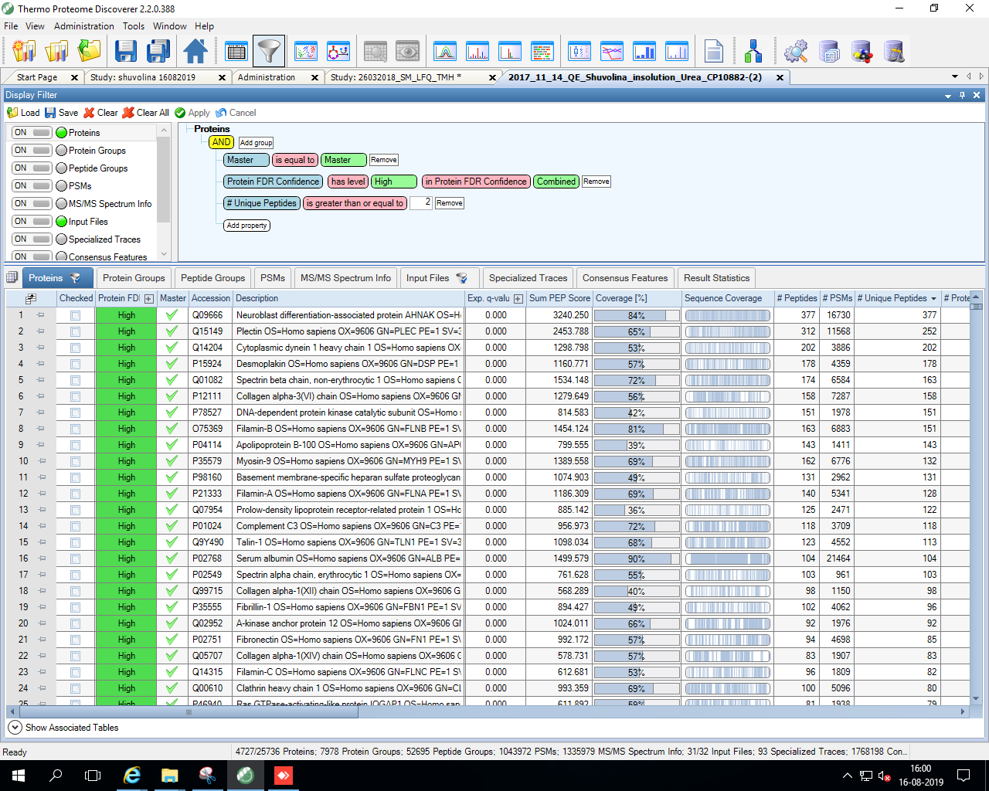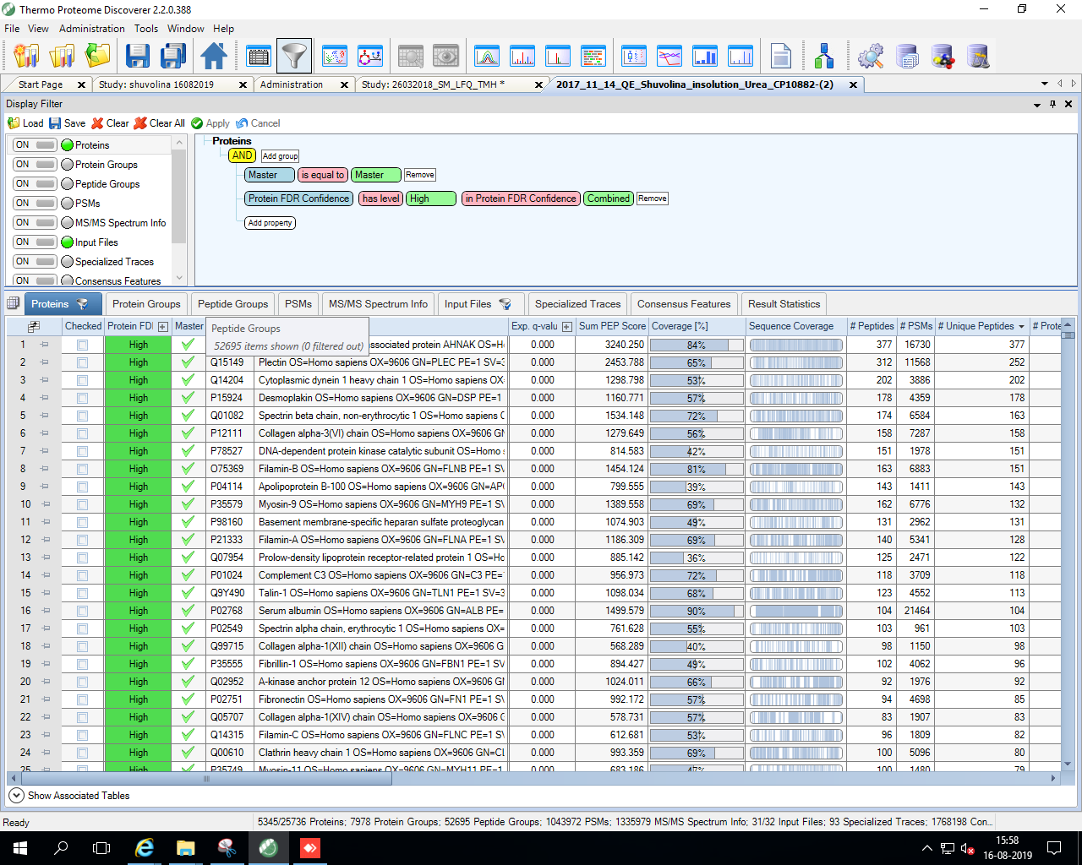
Supplementary Figure 1: Details of Proteome Discoverer® Parameters & Outcomes

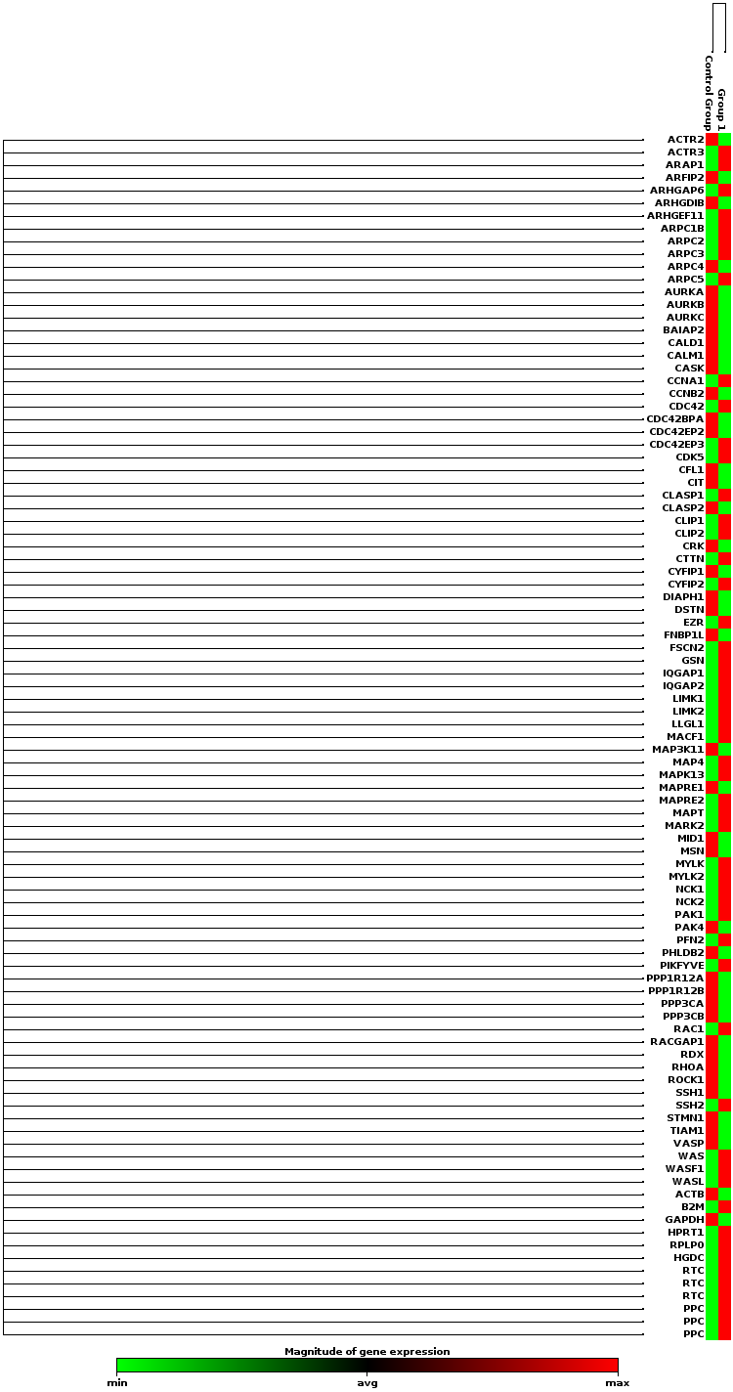
Supplementary Figure 2: Alterations of the Cytoskeletal regulators upon treatment of Meningioma Primaries with Cpd22 (2.5uM)

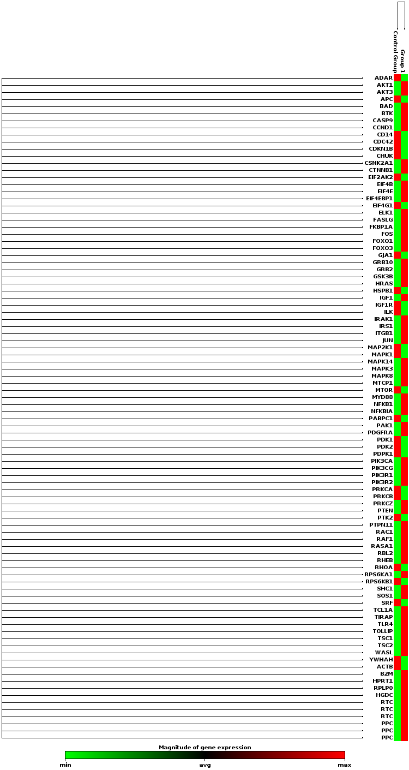

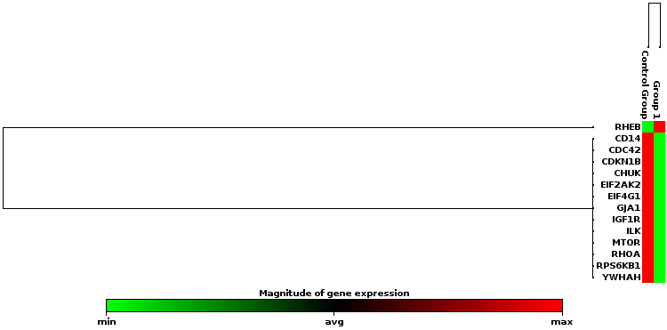
Supplementary Figure 3: Alterations of the PI3-Akt components upon treatment of Meningioma Primaries with Cpd22 (2.5uM)

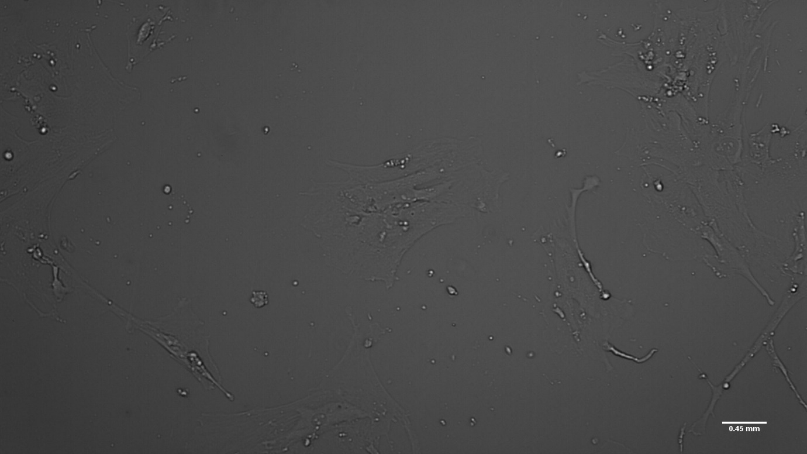
A. Untreated Meningioma Primaries (No Drug)

B. Treated Meningioma Primaries (2.5uM Cpd22 for 24 Hrs.)

Supplementary Figure 4:
Cell Images: Treated vs Untreated cell lines as seen under light microscope post treatment with ILK inhibitor Cpd22
Supplementary Figure 5: SRM Analysis outcomes in various grades of meningioma and non tumor controls

Supplementary Figure 6: Label free based mass spectrometry analysis enabled identification of several components of Integrin pathway, key candidates enumerated(p values ≤ 0.05) as tabulated below. Curated from Supplementary data table 2

Annexure to Supplementary Figure 6:
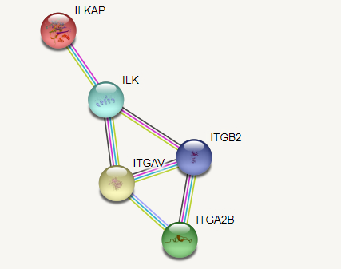
Table stating the datapoints for the key components of Integrin pathway and Interaction as procured from STRING DB®
Gene Symbol | MGI | MGII | p value
ITGAV | 25.615 | 24.577 | 0.02456
ITGB2 | 25.881 | 25.363 | 0.00001
ITGA2B | 23.999 | 23.668 | 0.01773
ITGA2 | 25.863 | 25.625 | 0.00044
ILKAP | 23.264 | 19.161 | 0.02130
ITGAX | 24.438 | 23.421 | 0.03862
ADAM17 | 22.397 | 23.553 | 0.01068

