Supplementary Materials
S1
We adapted the original Verb generation task (Prabhakaran, Green, and Gray, 2014). The following items were presented in the main trials which were translated from English to German language. Highlighted items were dropped in the MSE analysis part due to language translation problem. For example, ‘sofa’ and ‘couch’ in German language are synonyms; same reason applies for ‘säugling’ and ‘baby’. And the item ‘zu hause’ was not properly translated for the noun ‘home’, and hence was dropped from the analysis.
Items | English Verison | German Version
1 | Golf | Golf
2 | Church | Kirche
3 | House | Haus
4 | Tree | Baum
5 | Clay | Lehm
6 | Infant | Säugling
7 | Lamp | Lampe
8 | Office | Büro
9 | Cannon | Kanone
10 | Key | Schlüssel
11 | Taxi | Taxi
12 | Razor | Rasierer
13 | Blade | Klinge
14 | Hair | Haare
15 | Fist | Faust
16 | Shoe | Schuh
17 | Drug | Droge
18 | Poem | Gedicht
19 | Finger | Finger
20 | Birth | Geburt
21 | Horn | Horn
22 | Boot | Stiefel
23 | Artist | Künstler
24 | Soup | Suppe
25 | Rock | Stein
26 | Bucket | Korb
27 | Pan | Pfanne
28 | Couch | Couch
29 | Soap | Seife
30 | Candle | Kerze
31 | Ship | Schiff
32 | Cart | Karren
33 | Coal | Kohle
34 | Dish | Geschirr
35 | Rose | Rose
36 | Tool | Werkzeug
37 | Flower | Blume
38 | Drum | Schlagzeug
39 | Muscle | Muskel
40 | Canoe | Kanu
41 | Card | Karte
42 | Pill | Tablette
43 | Tune | Melodie
44 | Needle | Nadel
45 | Feet | Füße
46 | Belt | Gürtel
47 | Glass | Glas
48 | Store | Laden
49 | Coffee | Kaffee
50 | Pillow | Kissen
51 | Money | Geld
52 | Leaf | Blätter
53 | Ring | Ring
54 | Sofa | Sofa
55 | Manual | Handbuch
56 | Bread | Brot
57 | Baby | Baby
58 | Street | Straße
59 | Snow | Schnee
60 | Shovel | Schaufel
61 | Phone | Telefon
62 | Oven | Ofen
63 | Grass | Gras
64 | Paper | Papier
65 | Home | zu Hause
66 | Debt | Schulden
67 | Note | Notiz
68 | Letter | Brief
69 | Hole | Loch
70 | Oath | Eid
71 | Tongue | Zunge
72 | Music | Musik
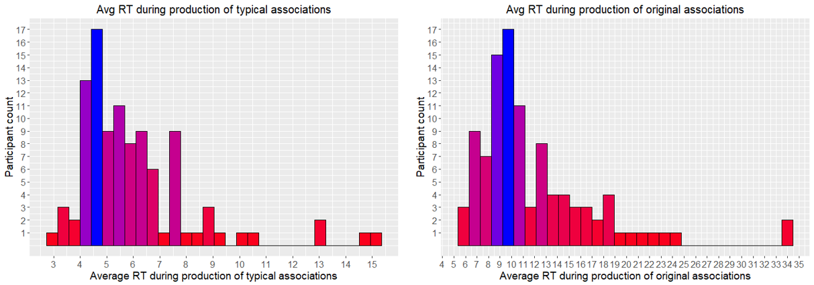
Figure S1: Distribution of average response times (Avg RT) in seconds across all participants which was required to produce typical and original associations. Different colors of the bars represent frequency of the data.
S2
Correlation matrices between four different segments of the MSE values for standard length of the trials and varied trial length for frontal electrodes and 5,10,15, and 20 time scales. Dark brown areas show stronger correlation between the different segments which shows that the standardized length or variable length of the trials do not make difference. Hence, in order to keep the maximum trial length, we select varied trial length for all of the datasets.
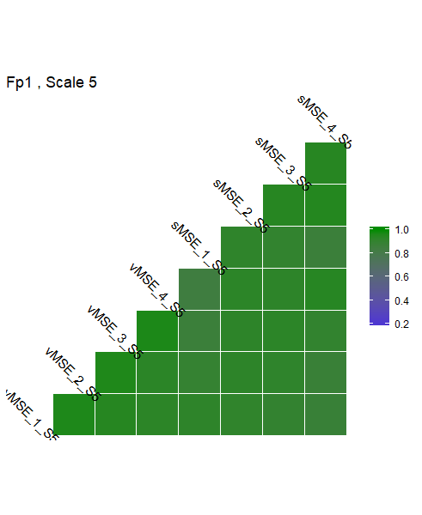
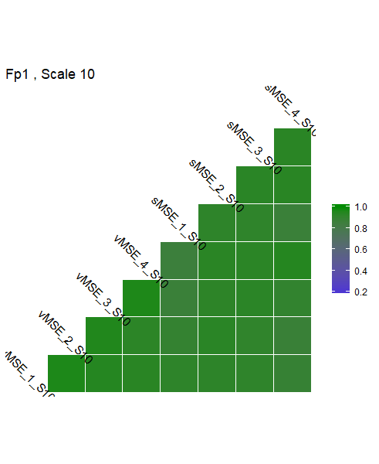
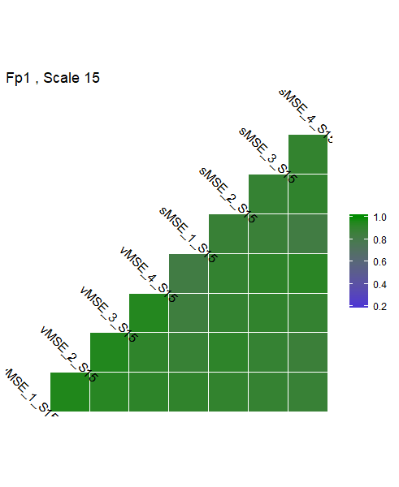
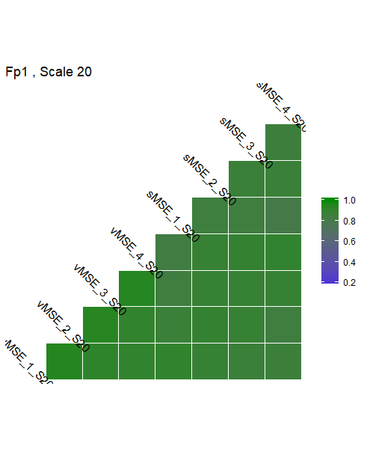

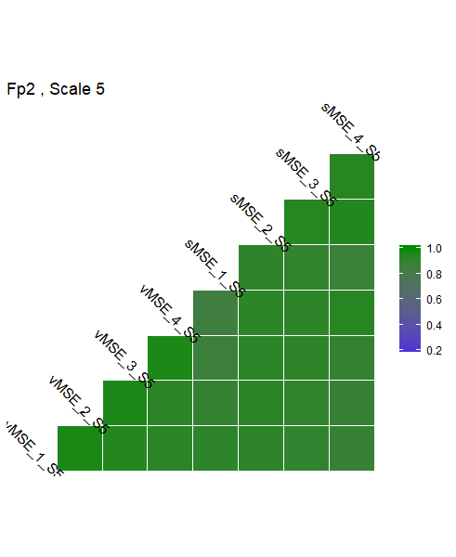
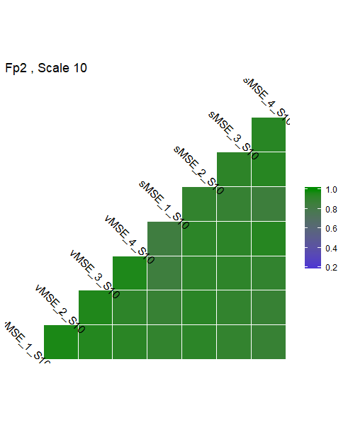
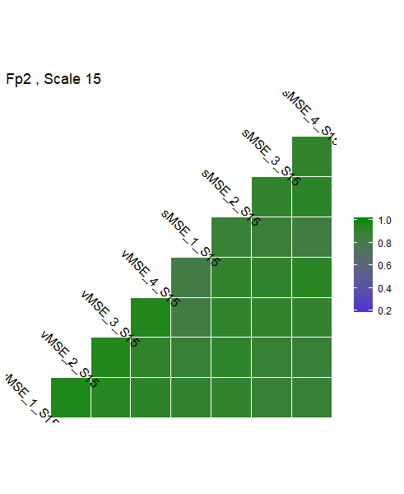
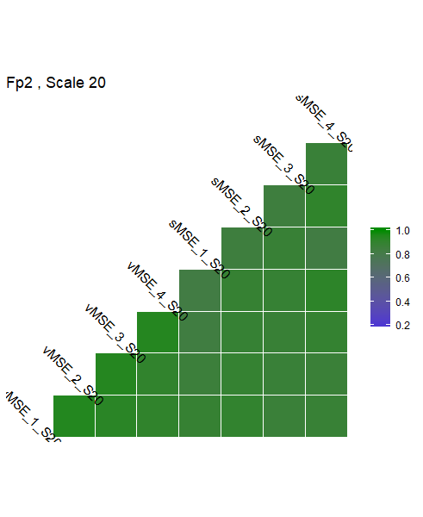

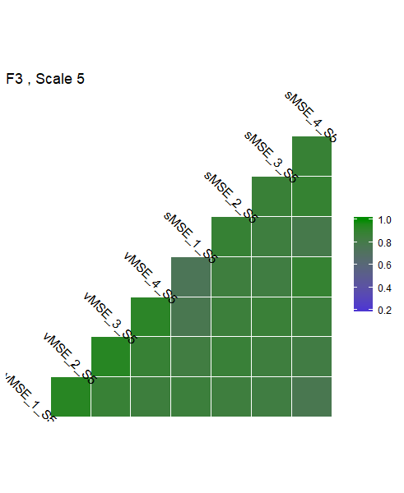
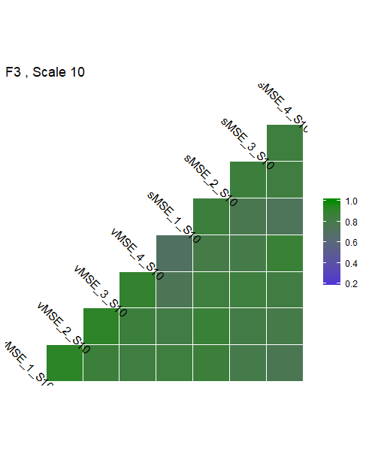
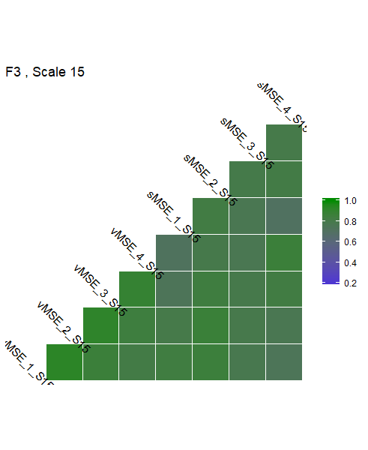
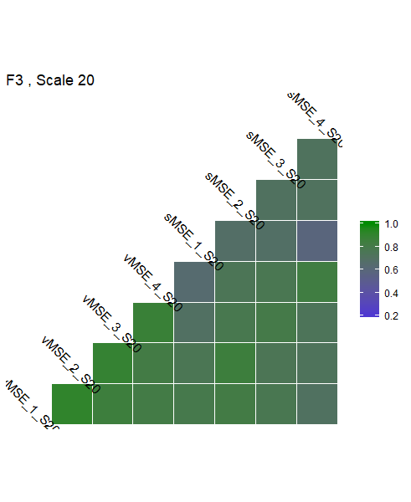

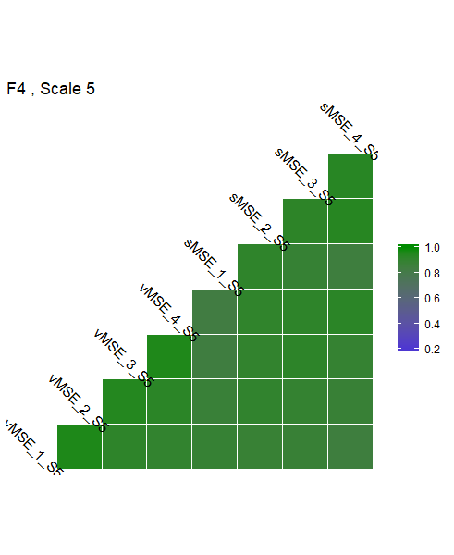
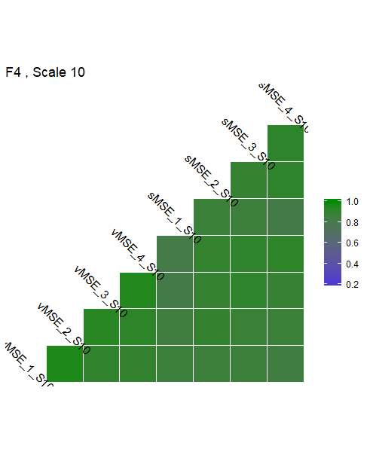
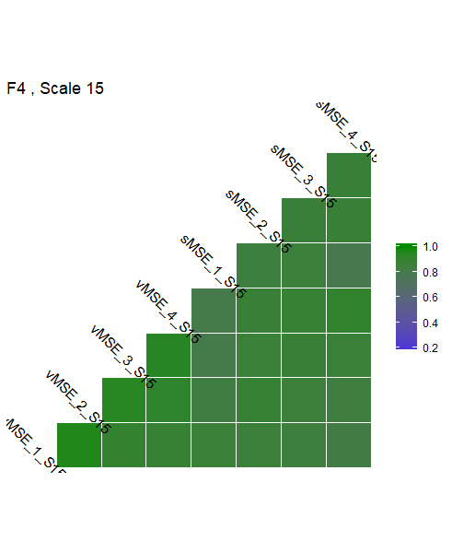
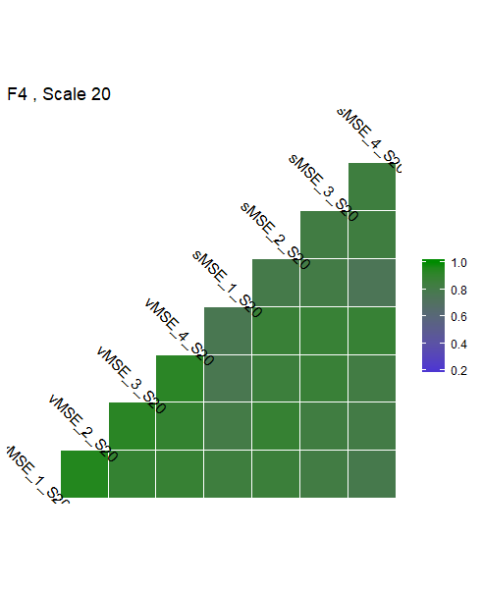

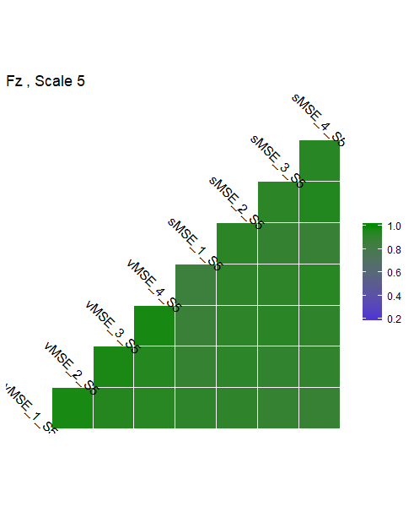
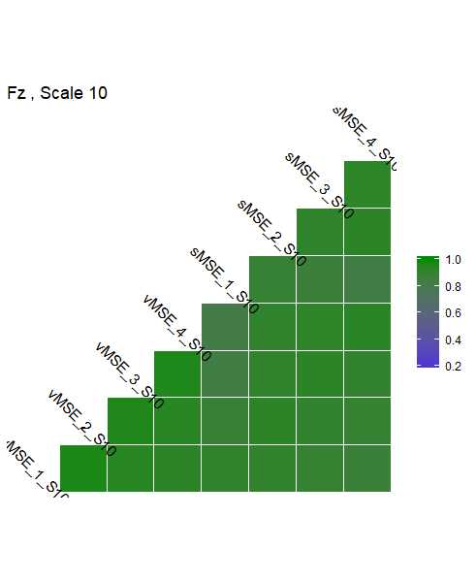
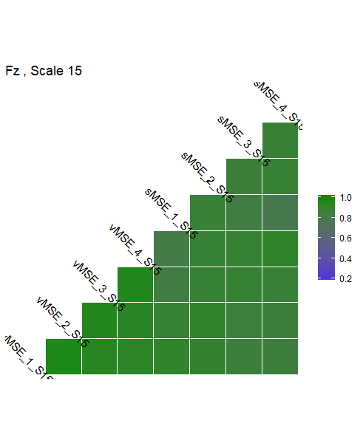
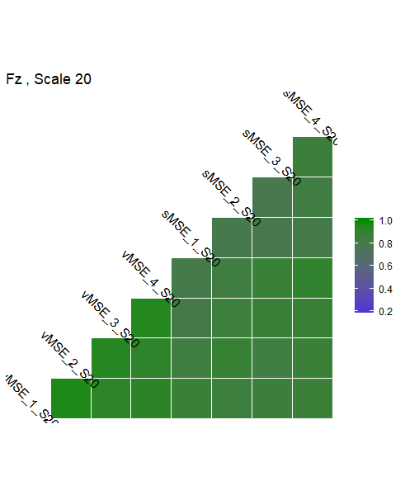

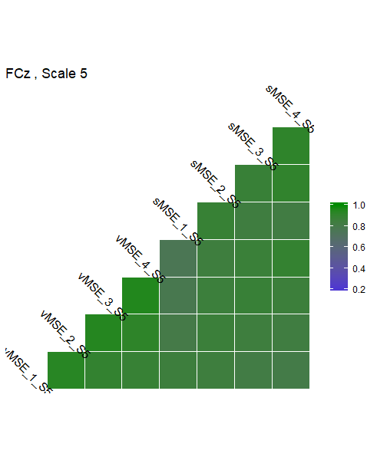
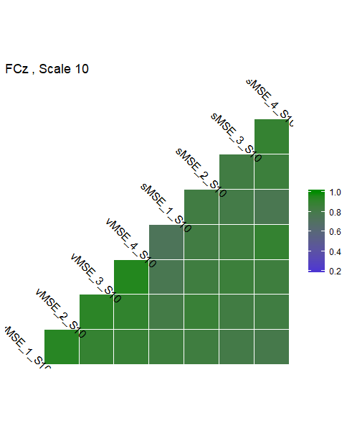
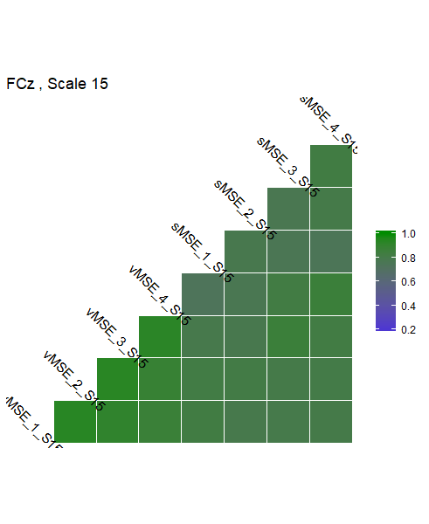
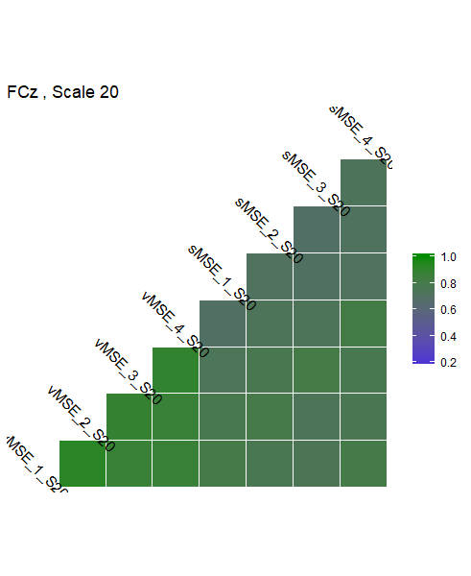
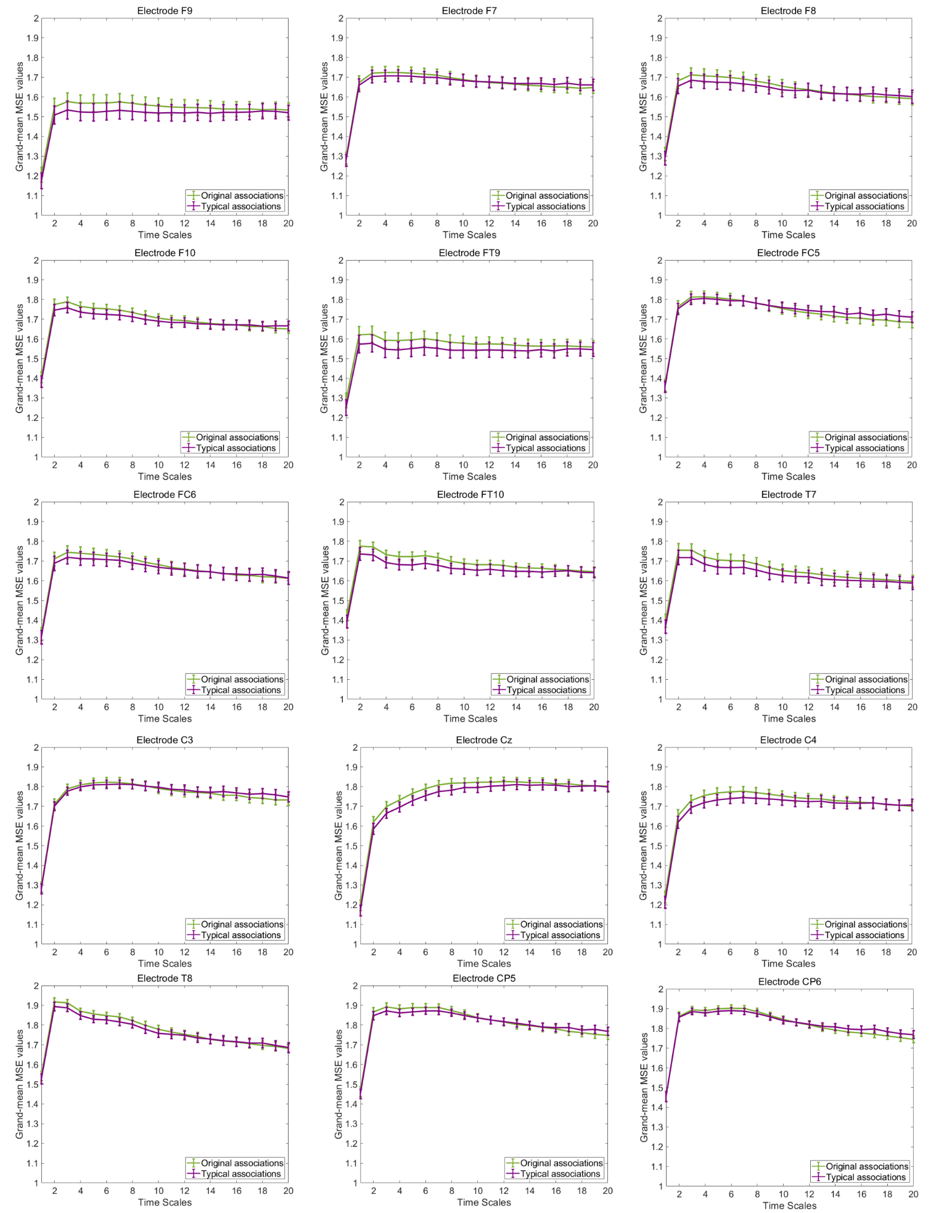
S3
Figure S2: Correlation matrix plots between standard length and variable length MSE segments. vMSE_1_S5 represents first segment of MSE for scale 5; sMSE_2_S10 represents second segments of MSE for scale 10. Correlation between different lengths of MSE are stronger (<=.70).
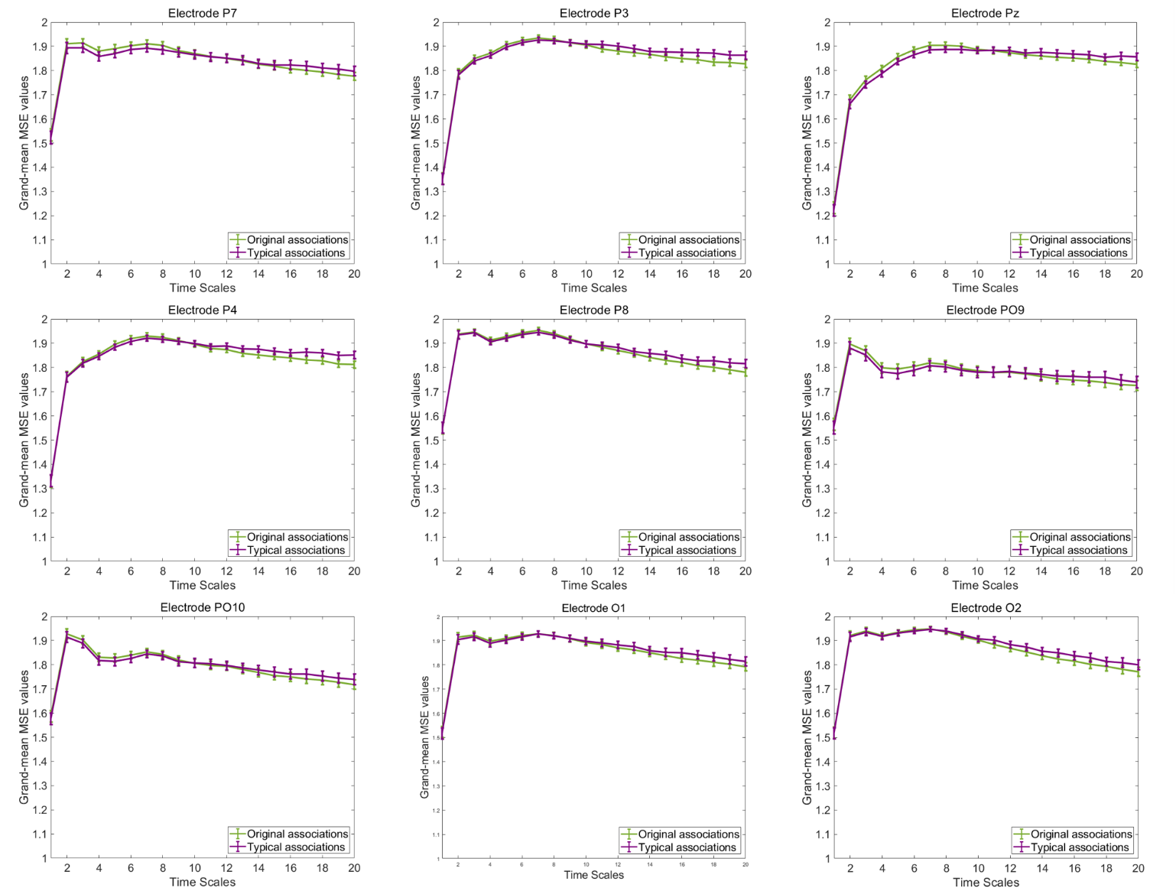
Figure S3: Grand-mean MSE during typical and original associations at remaining 24 electrodes across 20 time scales. The MSE is slightly larger in the originality condition mostly at frontal electrodes at small (1-5), and medium (6-15) time scales but show opposite pattern in parietal electrodes at higher scales. Error bars represent 1 SE.
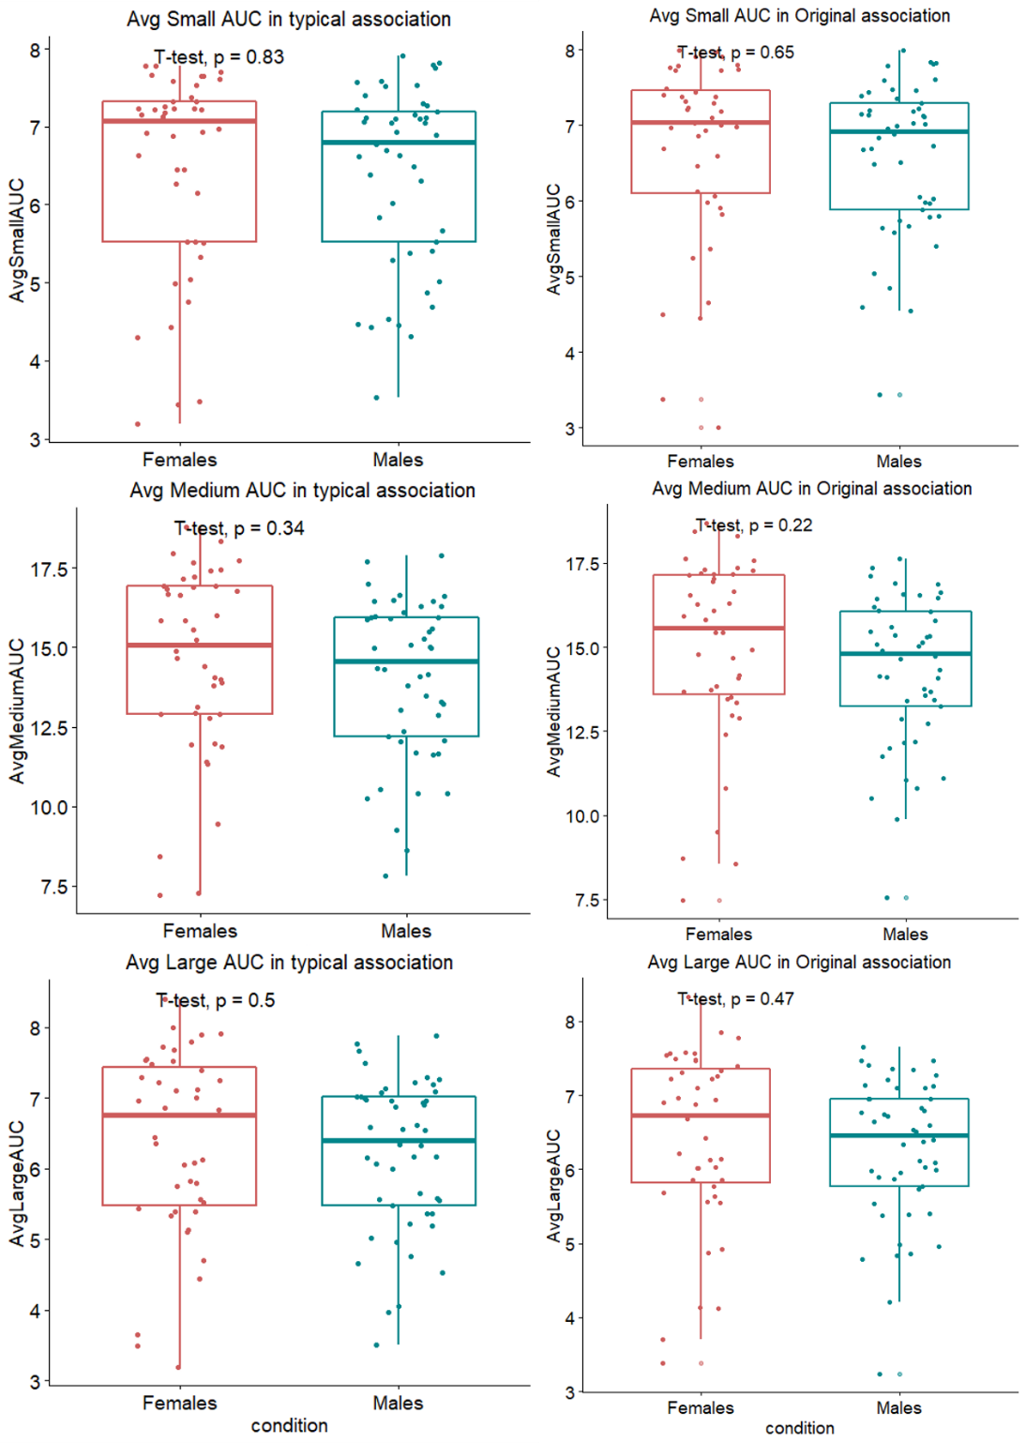
S4
Figure S4: Mean differences in MSE in original and typical associations computed using t-test showing no statistically substantial higher mean MSE in females as compared to males in none of the experimental conditions. Red color shows MSE in females and blue signifies males.The reults show that females tend to have higher mean MSE in both original and typical associations but none of the results are statistically significant.Therefore, there are no sex differecnes in MSE in the two experimental conditions.
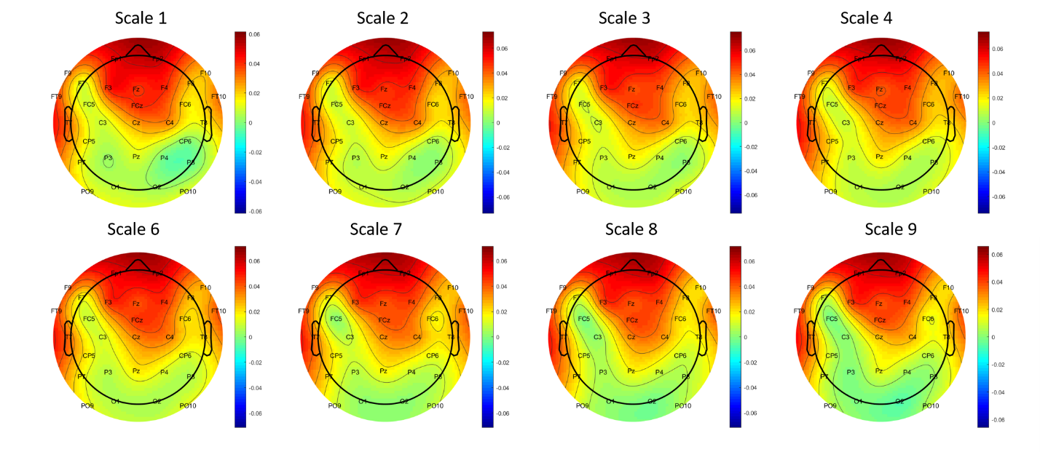
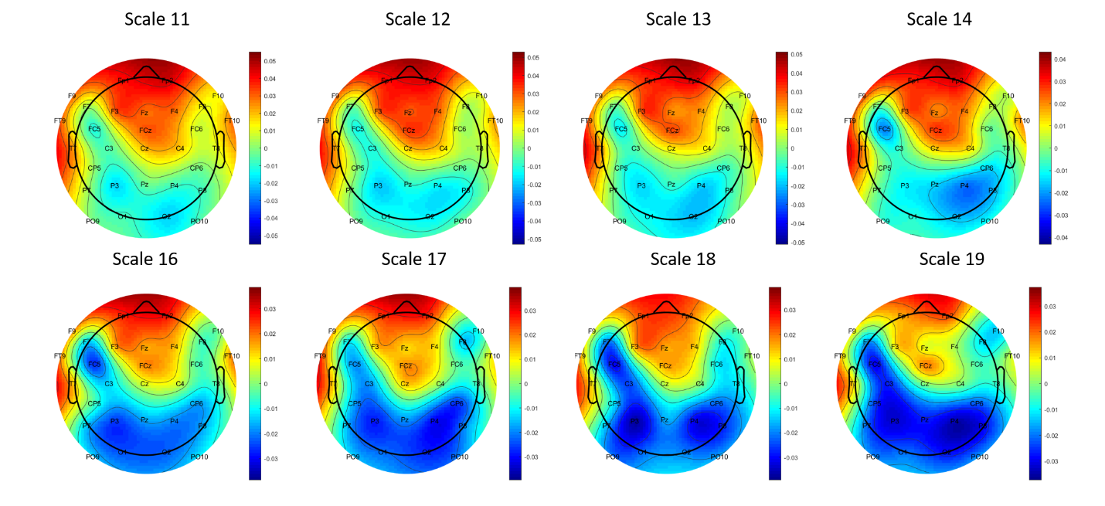
S5
Figure S5: Topographic plots of grand-mean MSE based on average MSE difference values between original and typical association across the temporal scales from 1-4,6-9,11-14, and 16-19. Together with Fig. 5 for temporal scale 5, 10, 15 and 20, these distributions illustrate that the positive difference in MSE between the two-word generation conditions occur at frontal regions and the negative difference is prominent in parietal regions.

Model | Correlation of the difference score with human rated originality scores during
 | Typical associations | Original associations
Small Parietal AUC | -0.054 (p=0.7) | 0.206(p=0.1)
Medium Parietal AUC | 0.013 (p=0.9) | 0.115 (p=0.5)
Large Parietal AUC | 0.185 (p=0.4) | -0.206 (p=0.3)
S6
Table S6: Relationship between the difference scores for AUC values calculated for parietal ROIs and human rated originality scores in typical and original associations.

